CS 427

Homework 3

Baker, Alex

# Problem 1

open = {A(g=0, h=366, f=366)}

closed = {}

open = {S(g=140, h=253, f=393), T(g=118, h=329, f=447), Z(g=75, h=374, f=449)}

closed = {A}

open = {RV(g=140+80=220, h=193, f=413), F(g=140+99=239, h=176, f=415), T(g=118, h=329, f=447), Z(g=75, h=374, f=449)}

closed = {A, S}

open = {F(g=140+99=239, h176, f=415), P(g=140+80+97=317, h=100, f=417), T(g=118, h=329, f=447), Z(g=75, h=374, f=449), C(g=140+80+146=366, h=160, f=526)}

closed = {A, S, RV}

open = {P(g=140+80+97=317, h=100, f=417), B(g=140+99+211=450, h=0, f=450), T(g=118, h=329, f=447), Z(g=75, h=374, f=449), C(g=140+80+146=366, h=160, f=526)}

closed = {A, S, RV, F}

open = {B(g=140+80+91+101=412, h=0, f=412), B(g=140+99+211=450, h=0, f=450), T(g=118, h=329, f=447), Z(g=75, h=374, f=449), C(g=140+80+146=366, h=160, f=526)}

closed = {A, S, RV, F, P}

open = {B(g=140+99+211=450, h=0, f=450), T(g=118, h=329, f=447), Z(g=75, h=374, f=449), C(g=140+80+146=366, h=160, f=526)}

closed = {A, S, RV, F, P, B}

Path = {A, S, RV, P, B}

# Problem 2

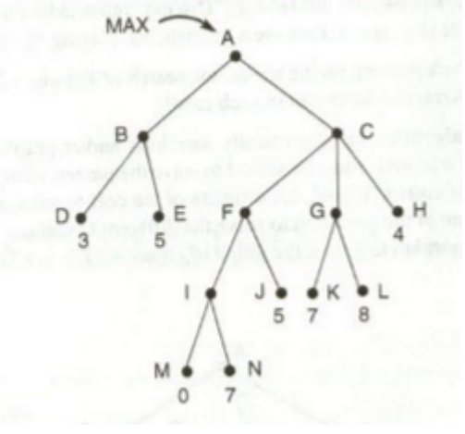

Min

Max

Min

Max

0

5

3

8

3

4

3

4

# Problem 3



Min

Max

Min

Max

α=-∞,3,7

β=∞,5

α=-∞,3

β=∞,0

α=-∞,3,5

β=∞

α=-∞,3,5

β=∞,7,4

α=-∞,3,4

β=∞

α=-∞

β=∞,3

# Problem 4



α=-∞,4

β=∞,5,3

α=-∞,5

β=∞,4

α=-∞,4

β=∞

Min

Max

Min

Max

α=-∞,8

β=∞,12

α=-∞

β=∞

α=-∞

β=∞,4

A different pruning occurs because the alpha and beta values differ when moving from left to right.