**Data Base Schema**



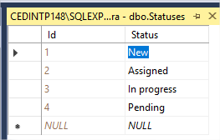

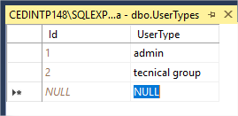

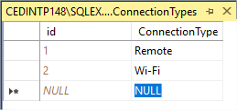

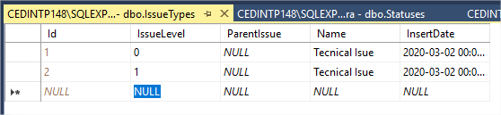

**Front End**

**LogIn**



**DashBoard**

**In datagrid sunt afisate toate problemele, grupate dupa starea lor**

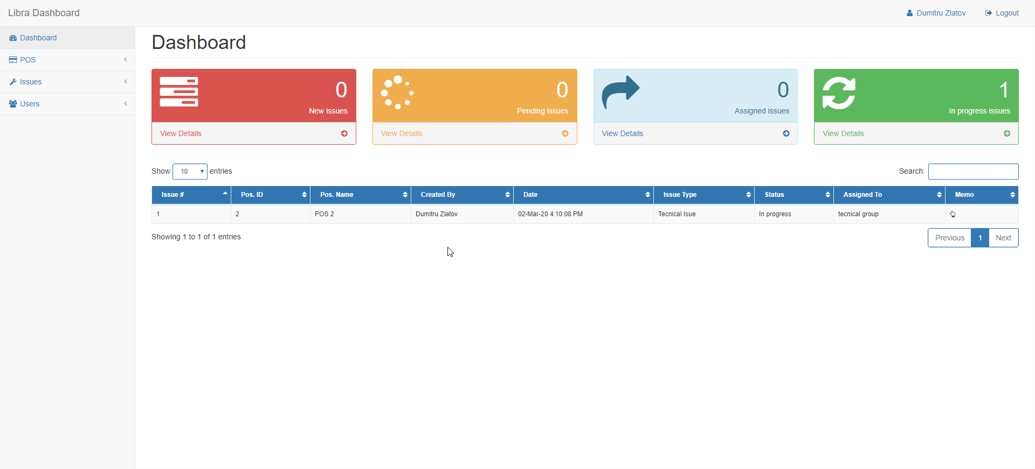

**USERS>ADD**

**Meniul users este visibil doar cind USER este ADMIN**

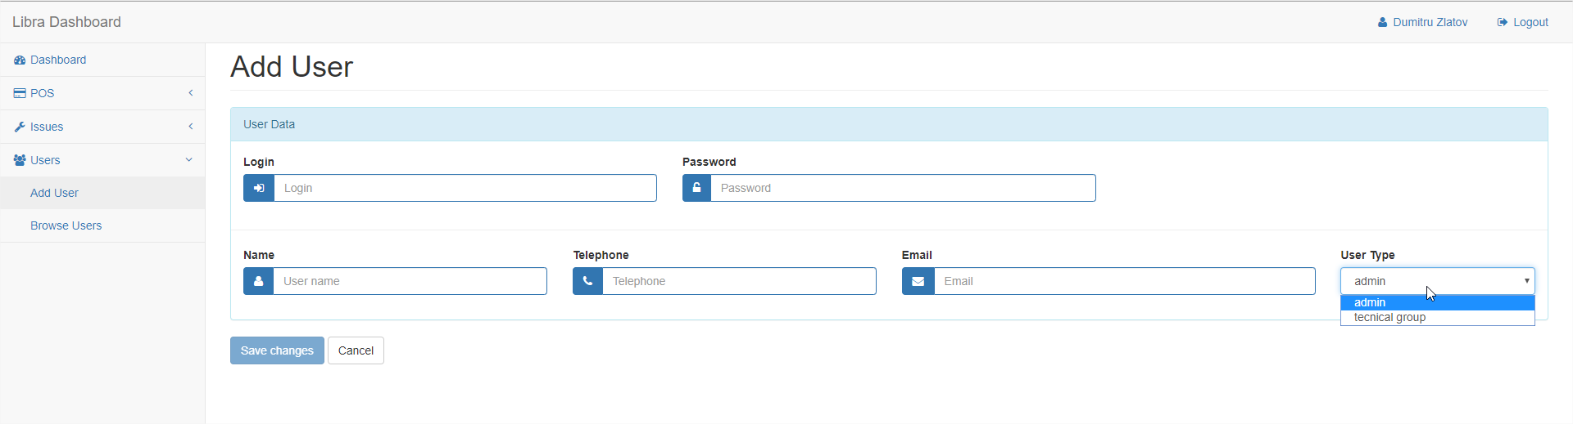

**USERS>BROWSE**

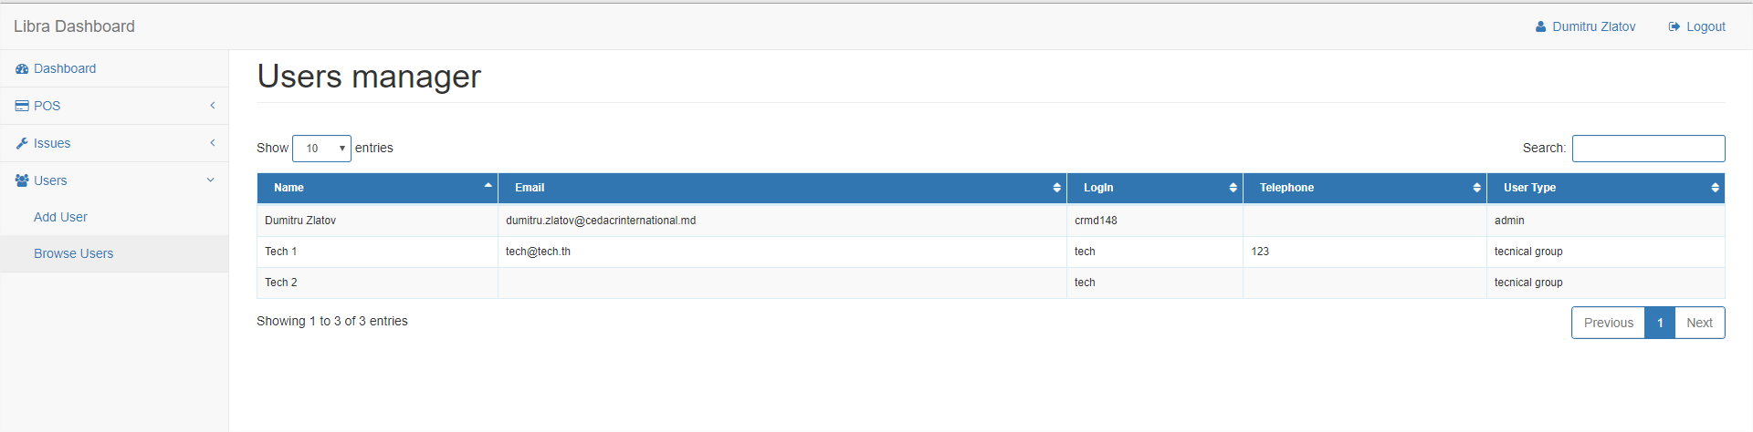

**USERS>DETAIL**

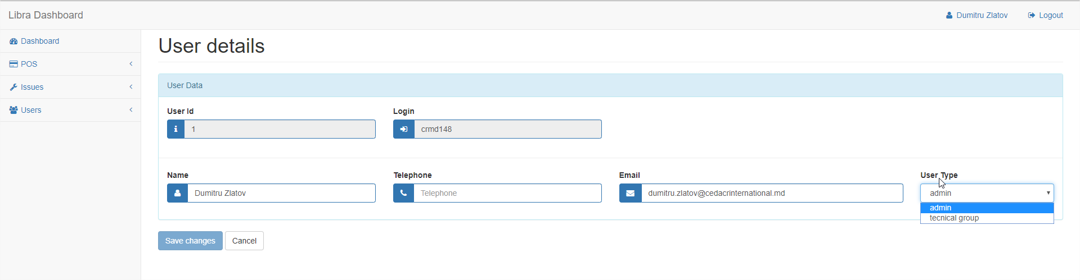

**POS>ADD**

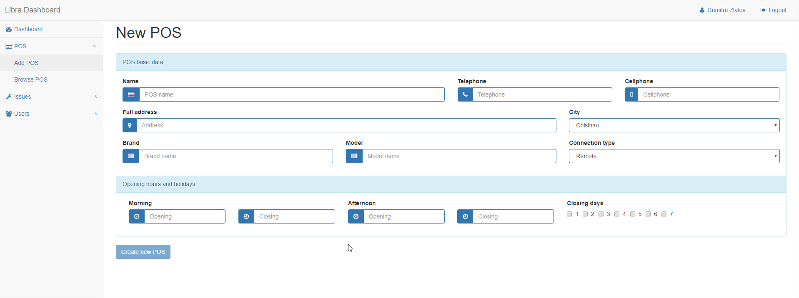

**POS>BROWSE**

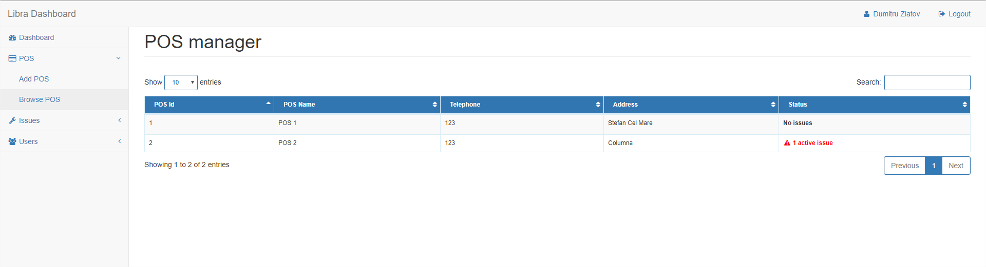

**POS>DETAIL**

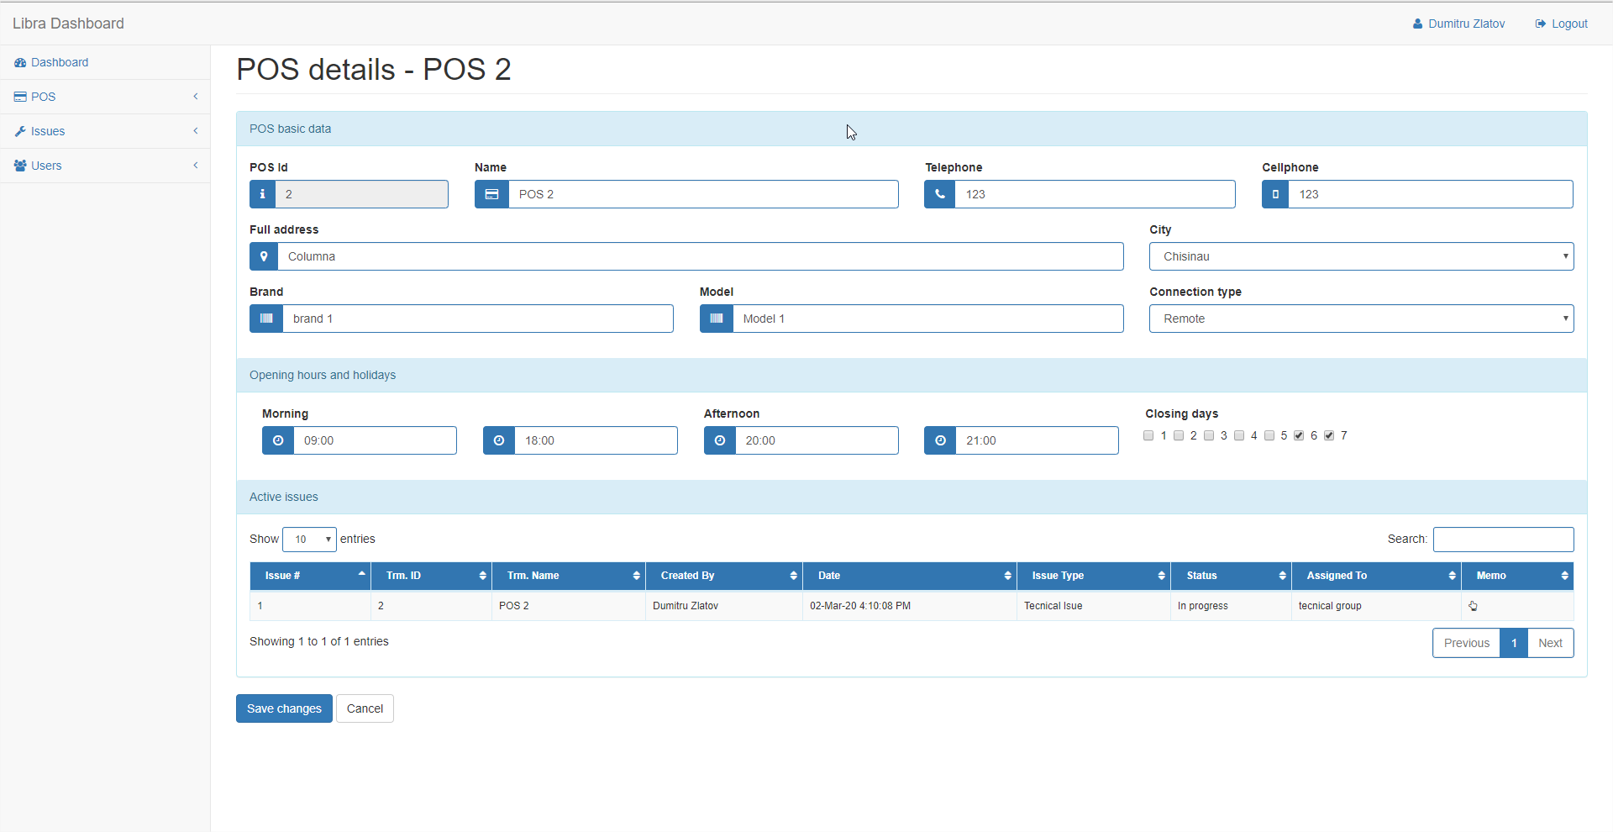

**ISSUE>ADD**

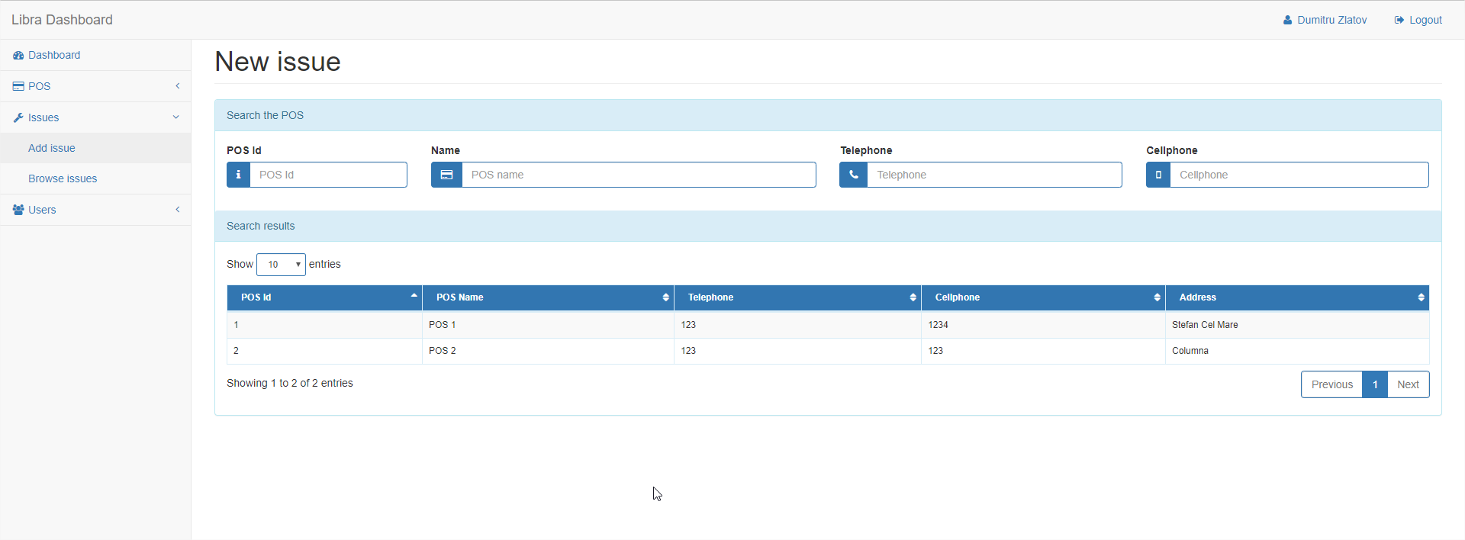

**ISSUE>ADD> DBL CLICK ON POS**

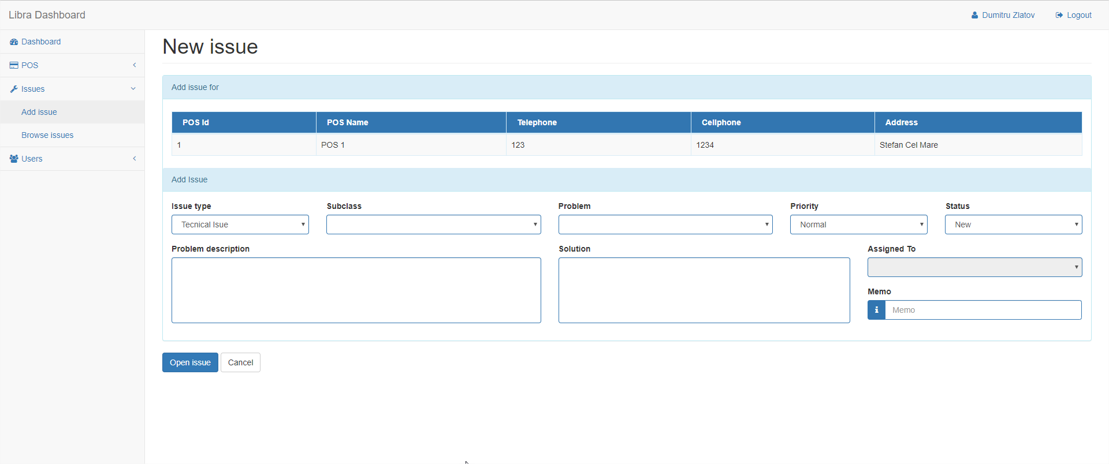

**ISSUE>BROWSE**

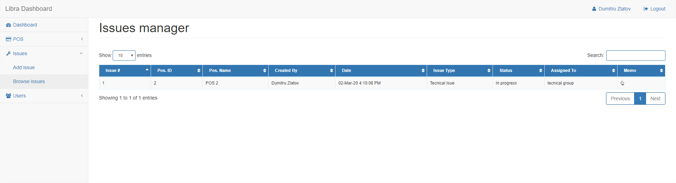

**ISSUE>DETAIL (DBL CLICK)**

