CSS (Cascading Style Sheets)

It’s used to change the appearance of our HTML elements

Css-selector= Esto nos dice que una computadora cuyos elemenyos en la pagina nosotros estamos etiquetando con nuestro Css, ejemplo los botones

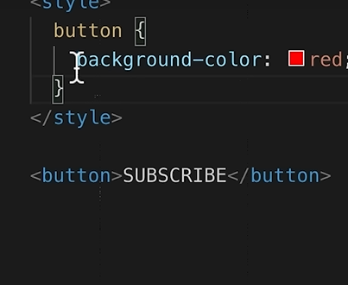

Como no es posible aprender todas las propiedades se puede buscar en Google **css round corners** y alli existen algunas sugerencias de cual usar

* En css space=margin

LESSON 3

HOVERS, TRANSITIONS AND SHADOWS (VUELOS, TRANSICIONES Y SOMBRAS)

Pseudo class hovers: básicamente a;ade estilos extras en ciertas ocaciones

Pseudo class actívate: cuando hacemos click en el elemento podemos establecer un color una vez dado clic

Transitions propiety: es una propiedad que nos indica en que tiempo deseo que se efectue las pseudo class

Shadows: son sombras que se colocan en los botones cuando se acerca el mouse sobre el (hover)

Lesson 4 Chrome DevTools & CSS Box Model

What are the Chrome dev Tools?

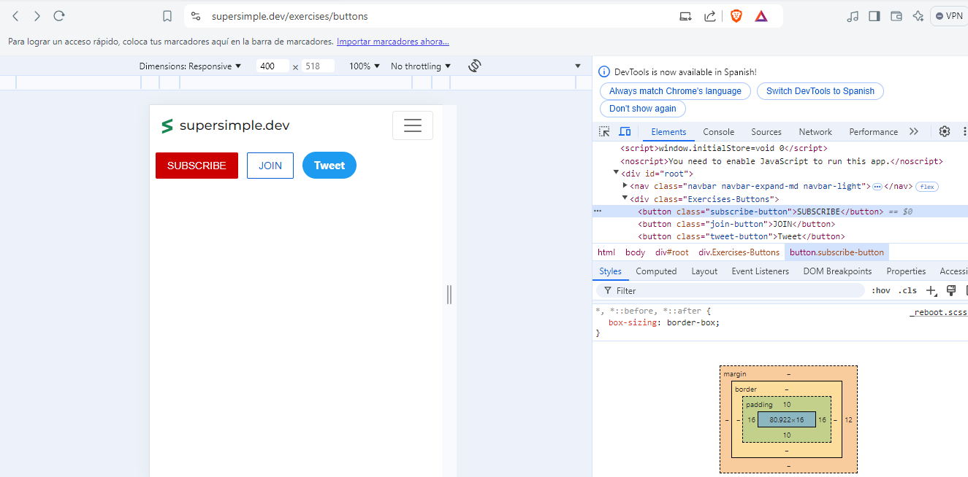Lesson 5 Text Styles

Html entity: Nos permite escribir caracteres especiales en html como checkmark o punto medio

Lesson 6 images

Propiedades de imagen en css

 object-fit: cover; 🡪 mantiene las dimensiones de height and width pero mantiene su forma

object-position: left; 🡪 mantiene las dimensiones de height and width pero la imagen se proyecta desde la izquierda

object-position: right; 🡪 mantiene las dimensiones de height and width pero la imagen se proyecta desde la derecha

lesson 7

images y texboxes

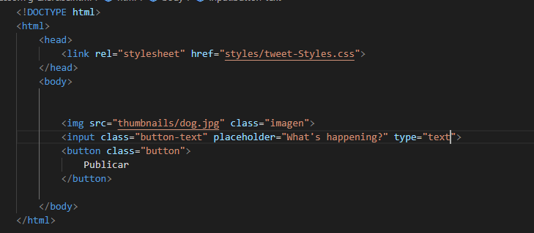

Lesson 8 CSS Display Property

In hrml there are three types of elements:

1. Block element= a block element takes up the entire line example paragraph is a block element
2. Inline-block element: only takes up as much space as needed. An example of an inline block element is the image element and the input element,
3. Inline element: are basically just text elements. They appear within a line of text. So If you remember, we briefly introduce the element <strong>, <span>

We can use a CSS property called display to easily awitch between block and inline block. So let’s see how that would work.

Switching block => inline-block

Lesson 9 The <dive> Element

What is a div?

Div is just a box

<div>= just a box

<div> is a blick element

Why is it used so much?

The key feature of a div is that t can contain any other elements inside

<div> = containers

Lesson 10 Nested Layouts Tecnique

The basic idea is that there are two types of layouts

1. Veritical Layaout : the items are on the top of each other

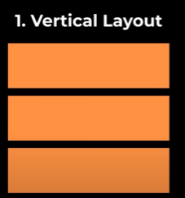

1. Horizontal Layout : looks like this where items are beside each other.

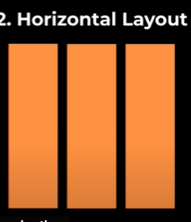

Lesson 11 –css grid

Inline styles : otra forma de poner stilos de css dentro de la línea de html

What is a grid?

A grid is a layout that has rows and colums, For example,this a two by three grid

We have two rows and three colums. This is a one by two grid.

Lesson 12- Flexbox

Se usa flexbox para crear layouts . FlexBox is similar toc ss grid, but is more flexible

So, we focus on content size first, we use a flex box. When we want to create a grid, we use grid. And for most other situations, for example, this horizontal layout that we created in the layers technique, we can use either grid or flexbox. In most situations, they do the same thing

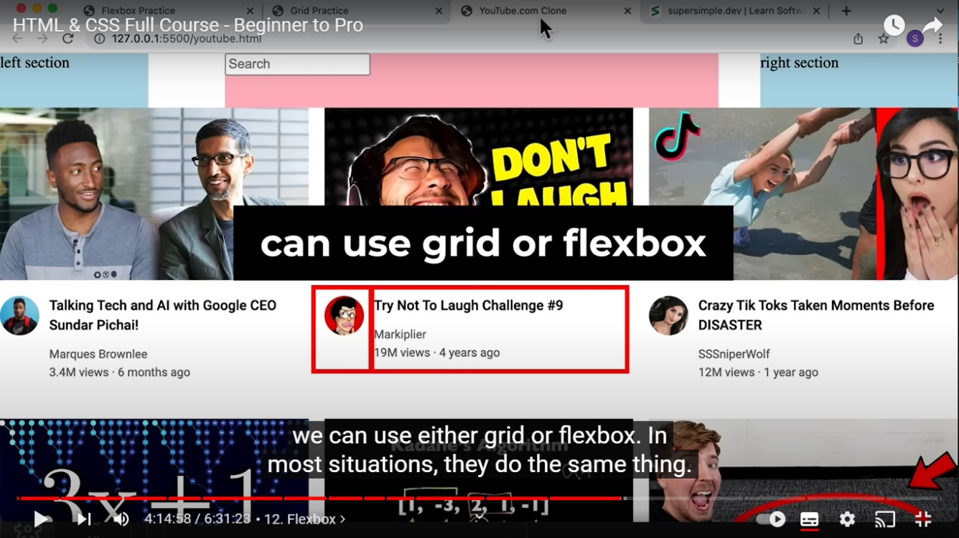

Lesson 13- Nested Flexbox

Flex-shrink:0; = don’t shrink

Width: 0 ; =shrink

Lesson 14 -CSS Position

Lesson 15- Position Absolute and Relativo

Fixed=placed in the browser windows which doesn’t move when we scroll

Abosolute=placed on the page which does move when we scroll

Position absolute