Awesome Logger
Log monitoring and notification system. The system allows its users to monitor intranet application logs and receive notifications if specific events occur.
More information about the project https://github.com/alexey-ernest/awesome-logger

Technologies
- .Net Framework 4.5
- ASP.NET MVC 5 and WebApi frameworks
- MSSQL as data storage and Entity Framework as ORM
- Microsoft Unity for IoC
- HTML5/CSS3/Bootstrap and JavaScript/jQuery/Angular.js for Single-Page-Application (SPA)
- Microsoft Service Bus for Windows Server as communication channel and queue

Architecture
The system is built using Event-Driven-Architecture (EDA) and Service-Oriented-Architecture (SOA) principles. The system is broken up into small micro-services, independent separated pieces with single responsibility. Each service owns its data (different data storages can be used for each micro-service), can be versioned, updated and deployed separately and can be scaled up horizontally independently if needed.
Because subscriptions data and notification data have a very different frequency and purpose, I've decided to split theses APIs into two micro-services: Subscriptions API and Notification Service.
The system is distributed and designed without Single-Point-Of-Failure (SPOF). Each component can be scaled and load balanced. For Audit DB NoSQL database is recommended because of high load and log-like structure (heavy write, no changes, low read). Cassandra can be perfectly meet this data usage pattern.
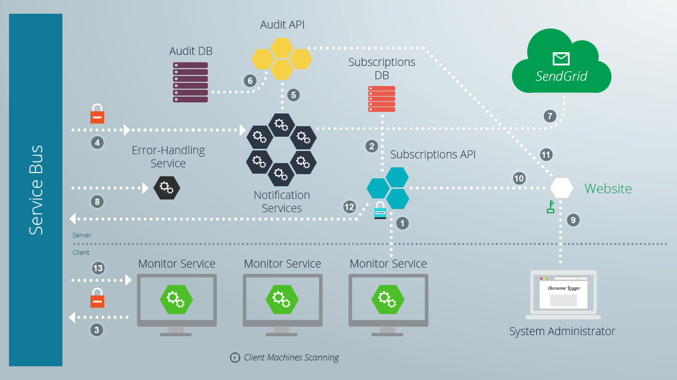

- When a Monitor Service starts its makes a request to Subscriptions API to get subscription parameters for client machine. For security reasons Subscriptions API should use SSL to encrypt messages. Also, communication between client and API is protected with access token, which is specified in configuration files on both sides: for Monitor Service its an AccessToken in App.config, for Subscriptions API service its an ExternalAccessToken in Web.config.
- Subscription API executes query agains Subscriptions DB to find any subscription parameters for client machine. If there are any API sends them to client machine and Monitor Service starts parsing logs.
- If Monitor Service finds any match, it emits special message Pattern Match Found to Service Bus. Connection between Service Bus and publishers/subscribers is encrypted and configured while installation process.
- One or many Notification Services listening to Pattern Match Found messages compete for message processing. If there are many messages generated you can simple install more Notification Services.
- When the service receives notification message, its first tries to make an audit record on the Audit API service. If the service failed to make an audit record its return message to the Service Bus queue, so another Notification Service could be luckier.
- If the reason of Audit API failure is duplicate conflict in Audit DB, the service just removes the message from the Service Bus and starts listening for other messages.
- After successful commitment of the audit record, the service sends notification using external email service. In our case it is an easy to use SendGrid service. You can specify username/password for your SendGrid account at the App.config of the NotificationService.
- If an error occurred while parsing/monitoring log files in Monitor Service, the service emits special type of event into the Service Bus so special service Error-Handling Service could process this error. Typically, Error-Handling Service just logging error messages so an admin can view them later.
- The system has a web-based user interface (Web UI or Website) to create/update/delete subscriptions. Only one user System Administrator can access this interface. Username/password settings for administrator account can be configured in Web.config of the Web project. For security reasons SSL should be used to encrypt data between Web UI and administrator PC.
- When System Administrator successfully log on to the Website, the site proxying requests and using secret AccessToken making requests to Subscription API.
- Administrator can even view all notifications for each subscriptions from AuditDB.
- When Administrator creates new subscription or modify existing through Web UI, Subscriptions API detects those changes and emits special kind of Update Subscription event to Service Bus.
- Monitor Service receives Update Subscription event and restarts itself by retrieving new configuration from Subscriptions API.
Using Service Bus as a communication channel makes the system robust and fault-tolerant. If one of the services fails, no messages will be lost and after recovering subscribers will receive all unprocessed messages.

Components
The system consists of several services and website. All components are loosely coupled and can be deployed and upgraded independently.

Website
ASP.NET MVC application implemented as a Single-Page-Application using Angular.js.
Enter username/password for admin and click Sign in. Default credentials specified in Web.config: admin/admin
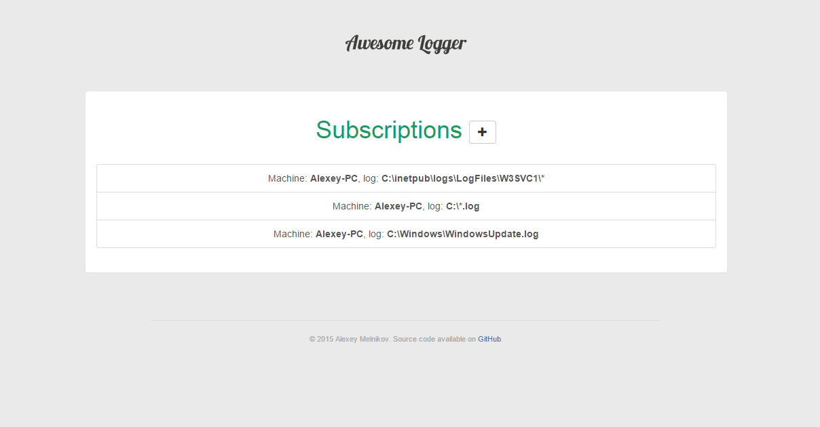

System Administrator
User who knows username/login for Administrator Account.
- Using computer and web browser opens Website main page
- Will be redirected to Log in page if not yet authorized
- Enters Administrator credentials and submits the form
- Will be redirected to Subscriptions page

Subscriptions API
Implemented as a RESTful API HTTP service (ASP.NET WebApi application).
Unlike most of WCF bindings HTTP API is supported by major of clients. The service is implemented in micro-service architecture, has minimum dependencies and does not share its data with other components.
This API is consumed by Website for managing subscriptions by Administrator and by Monitor Service to retrieve subscription params. For accessing this API you need AccessToken which is specified on configuration file. For Read-Write access there is a dedicated AccessToken using in Website->API communication. For Monitor->API communication there is a different AccessToken.
Address | HTTP Method | Description
/ | GET | Returns queryable collection of subscriptions.
/ | POST | Creates new subscription.
/{id} | GET | Returns subscriptions by id.
/{id} | PUT | Updates subscriptions by id.
/{id} | DELETE | Deletes subscription by id.
/machine/{name} | GET | Retrieves all subscriptions by machine name.

Subscriptions DB
Data storage for persisting subscription parameters. MS SQL database used in this project because of ease of integration in .NET stack.

Audit API
Implemented as a RESTful API HTTP service (ASP.NET WebApi).
Unlike most of WCF bindings HTTP API is supported by major of clients. The service is implemented in micro-service architecture, has minimum dependencies and does not share it's data with other components.
This API is consumed internally by Website for displaying Subscription History and by Notification Service for creating audit records. For accessing this API you need AccessToken which is specified on configuration file.
Address | HTTP Method | Description
/ | POST | Records pattern-match event.
/?m={m}&s={s}&p={p}&e={e} | GET | Returns queryable collection of pattern matches: {m} - machine name, {s} - search path, {p} - pattern to match, {e} - email to send notifications to.

Audit DB
Data storage for recording found pattern matches. MS SQL database used in this project because of ease of integration in .NET stack. However, for log-structured data: many writes, read-only, few reads, its recommended to use NoSQL DBMS such as Cassandra.

Error-Handling Service
Implemented as a Console Application. Can also be installed as a Windows Service. Listens for error messages and logs them into the Windows Event Log.

Notification Service
Implemented as a Console Application. Should be installed as a Windows Service. Listens for notification messages then trying to create an audit record using Audit API and send email using third-party service SendGrid.
- If audit request failes due to duplicate conflict exception, message should be dropped from Service Bus.
- If audit request failes due to some other error, message should be returned to Service Bus. Another NotificationService instance will try to process it.
- If audit record committed, then service will try to send email (if SendGrid credentials specified in App.config).

Monitor Service
Implemented as a Console Application. Should be installed as a Windows Service.
- Retrieves related subscription parameters from Subscriptions API immediately after start.
- Listen for messages about subscription update. If related subscription updated, monitor stops all parsers and retrieves fresh subscription parameters from Subscriptions API.
- Scans files in specified directory, which fit file search criteria. For instance, C:\logs\* will scan all files in directory, C:\logs\*.log will only scan for files with extension .log
- Parses files by reading line by line and testing against subscription's pattern. If line matches the pattern, parser emits corresponding message to Service Bus.
- Listens for system events to be notified for changes according monitoring files. If file modified, renamed or created, the parser scans it again.

Log Generator Service
Implemented as a Console Application for testing purposes. Generates log files by reading user input.

Service Bus
Service Bus is used as a robust messaging service for loosely coupled message-driven components of the system.
There are three topics and three message types in the system:
- Notifications topic for queuing pattern-match notifications for sending. Monitor Service emits these messages and Notification Service handles them.
- Errors topic for emitting messages about errors occurred in the system. Error-Handling Service then logs them to Windows Event Log.
- Subscriptions topic for sending messages about subscription updates. Subscriptions API track changes and emits messages. Monitor Services handles these messages only if machine names of the subscription and client machine match.

Client Machine
Machine with installed Monitor Service

SendGrid
Third-party cloud email service. Can be easily replaced with other one.

How to Install
Please read Readme.txt

Contacts
For all questions, you can reach me via alexey.ernest@gmail.com

