Release Notes
Developer: Alexey Kvitko | Date: 2014/09/09
Project Manager: Alexey Kvitko
Application Name: Fake Version Control
Application Version: 1.0
Contents

1. Build Description 2
1. Initial Files 2
1. PostgeSQL9.2 Configuration 2
2. Installation Instructions for web Application 3

Overview

- The J Spring 3, Hibernate and ExtJS 4.2 MVC, technology was used for the application development.
- FireFox, Chrome, Opera,Internet Explorer are the supported browser
- Minimal screen resolution is 1024 x 768
- Apache Tomcat 7.0
- Apache Maven 3.0.4
- JDK 1.7 was used
- Operation systems: Windows
- The PostgreSQL9.2 was used as DataBase

Build Description

Build Description

This build represents…
( Initial release ( Added functionality
( Requests For Change(s) ( Correction of Defect(s)

Application Files

Initial Files
File Location | File Name | Version Label
https://github.com/alexeyKvitko/fvc | *.* | BUILD 1.0.0

Installation

PostgeSQL9.2 Configuration
  - JDBC Data Source
Property | Value (example)
Name | dev
Password | dev_pswd
Database Type | PostgreSQL9.2
Database Driver | org.postgresql.Driver
Database Name | fvcdb
Host | Localhost
Port | 5432

Installation Instructions for web Application
- Clone github repository from url: https://github.com/alexeyKvitko/fvc

- Change if it necessary host and port in ../fvc/src/main/webapp/WEB-INF/jdbc.properties
- Create database on PostgreSQL9.2 server using “DB_Release_notes” document
- Build and deploy FVC application using Apache Maven on Apache TomCat 7.0 server.
- To verify the application, please copy the source java files from this project in to the root directory on the disk “c:\”.

Screenshots

- Main screen:
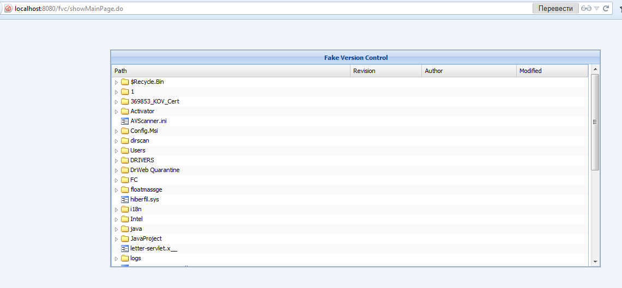
2)Popup menu
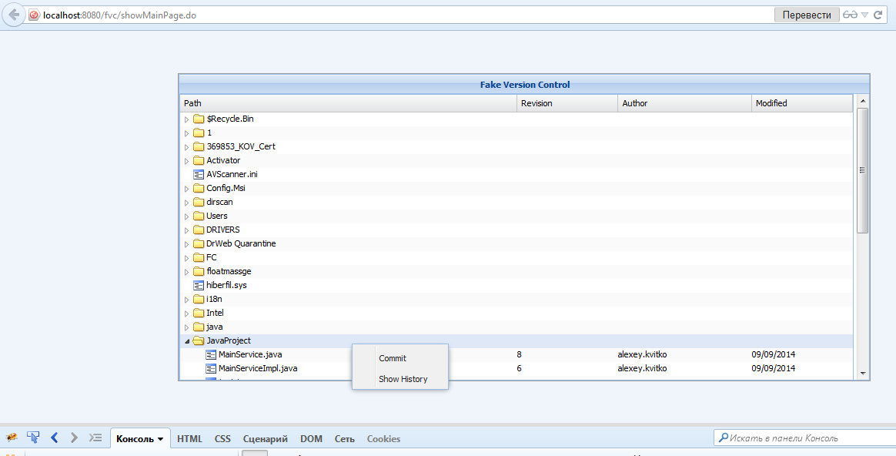
3) Confirm commit dialog
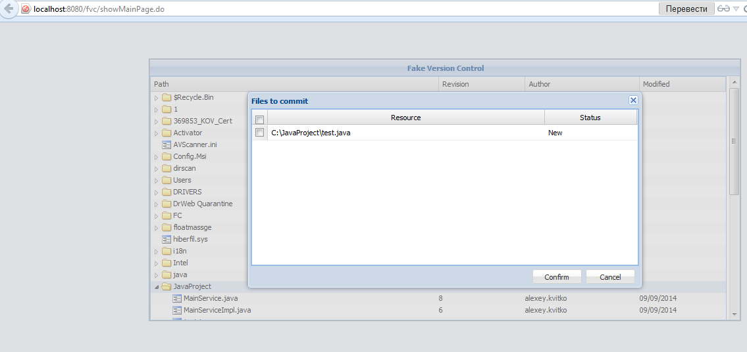
4) Show history
