Business Modelling Techniques 3

Analysis 4

01. Acceptance and Evaluation Criteria 4

02. Business Rules Analysis 5

03. Data Mining 7

04. Decision Analysis 8

05. Document Analysis 10

06. Financial Analysis 12

07. Interface Analysis 13

08. Non-Functional Requirements Analysis 14

09. Observation 17

010. Process Analysis 19

011. Root Cause Analysis 20

Collaboration 21

012. Brainstorming 22

013. Collaborative Games 24

014. Focus Groups 25

015. Interviews 27

016. Mind Mapping 29

017. Workshops 30

Modeling 35

018. Concept Modeling 35

019. Data Dictionary 38

020. Data Flow Diagrams 39

021. Data Modeling 40

022. Decision Modeling 43

023. Functional Decomposition 44

024. Glossary 46

025. Process Modeling 47

026. Prototyping 50

027. Sequence Diagrams 52

028. State Modeling 53

029. Use Cases and Scenarios 54

030. User Stories 56

Project Management 58

031. Backlog Management 58

032. Estimation 60

033. Item Tracking 61

034. Lessons Learned 63

035. Metrics and Key Performance Indicators (KPIs) 65

036. Prioritization 66

037. Reviews 67

038. Risk Analysis and Management 68

039. Roles and Permissions Matrix 70

040. Scope Modeling 70

041. Stakeholder List, Map, or Personas 72

042. Survey or Questionnaire 80

043. Vendor Assessment 82

Strategy 84

044. Balanced Scorecard 84

045. Benchmarking and Market Analysis 86

046. Business Capability Analysis 88

047. Business Cases 90

048. Business Model Canvas 93

049. Organizational Modeling 94

050. SWOT Analysis 96

# Business Modelling Techniques

Enterprise Architect provides a sophisticated and flexible Business Analysis Modelling platform that can be used by the analyst and others from strategic planning through to product support.  
It has extensive support for a wide range of business Modelling techniques and allows these techniques to be used in isolation or together to create compelling and expressive models that will delight audiences, including high level executives and technology developers alike.  
The techniques can be used by any discipline, including managers, architects, designers, implementers, testers and more, but they are particularly useful for the Business Analysts.  
This topic provides a description of fifty of the most commonly used Business Analysis techniques and describes the most important tools that can be used to perform the technique, with links to more detailed explanations about how to use the individual tools.

It is conveniently aligned with the BABOK Guide v3 and so provides welcomed help for the Business Analyst and explains practically how to use Enterprise Architect to perform the techniques described in the Guide.  
For example, all analysts will understand the importance of Stakeholder Modelling to the success of an endeavour, but typically find it difficult to know where to start and how to create useful models to communicate with stakeholders, and to represent their concerns and interests in a model.  
The ‘Stakeholder List, Map, or Personas’ techniques list more than ten tools that can be used to help model stakeholders, leaving the analyst free to choose whatever is most appropriate for their initiative.  
This diagram shows the use of a Boundary element to create an Onion diagram representing the stakeholders’ influence on an initiative.

# Analysis

Analysis techniques are fundamental to the craft of business analysis and provide a way of examining a situation and determining the needs and formulating possible solutions to the problem or opportunity.  
Enterprise Architect can be used to perform a variety of analysis techniques and provides a formidable set of tools that give the analyst the power to perform the techniques ultimately aimed at delivering value to the stakeholders.  
The subject of the analysis can be strategic, tactical or solution concerns and regardless of the type of stakeholder or audience a powerful set of models can be constructed to communicate the findings and decisions to the stakeholders from the executive level down to implementation teams.

## Acceptance and Evaluation Criteria

Enterprise Architect can be used to define both Acceptance and Evaluation Criteria and expressive reports can be created that can be used to communicate with important stakeholders.  
Acceptance criteria are expressed in a testable form and high level criteria must be able to be broken down into statements that can be tested or measured.  
Enterprise Architect is the ideal tool to define and record values for the criteria.  
If detailed numerical analysis needs to be performed to determine overall scores Enterprise Architects scripting interface could be used or the elements could be exported to a spreadsheet.

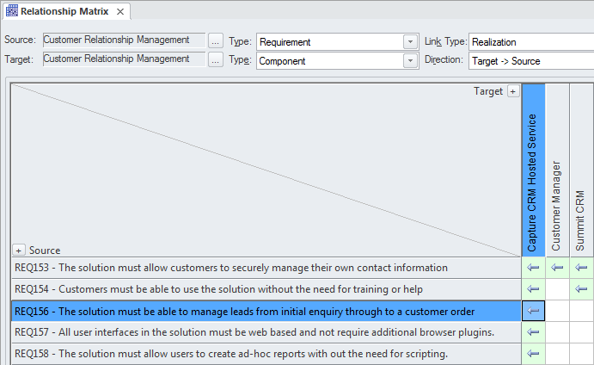

## Business Rules Analysis

Policies and Business Rules are critical to the success of an organisation; they inform the way that processes are performed and guide operational business decision making.  
Modeling the Policies and Business Rules in Enterprise Architect helps you to link business rules to the policies that define them, and in turn to business goals.  
Enterprise Architect allows all these elements to be created and managed, and analysis can be performed using a number of tools to determine implementation of the rules and how a particular business or technical solution implements the business rules and therefore the policies.

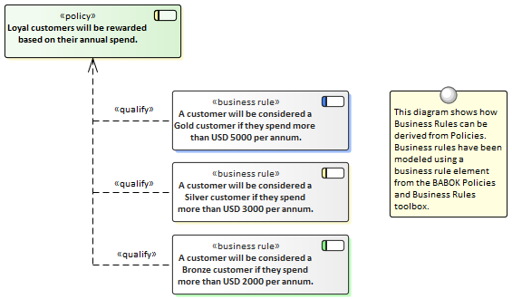

This section lists the main tools available in Enterprise Architect that can be used to perform this business analysis technique.  
There is also a wide range of additional tools that a modeler might find suitable when applying the technique in a particular context.  
The complete list of tools is available from the topic *Business Modeling Tools.*

Business Rule Model

The Business Rules Model provides a way of formally defining business rules, the way they are sequenced and the domain elements they relate to.

Learn More: [Business Rules Model](http://www.sparxsystems.com/enterprise_architect_user_guide/13.5/guidebooks/tools_ba_business_rules_model.html)

Relationship Matrix

The **Relationship Matrix** is a powerful and compelling tool for visualizing the relationships between two sets of elements.  
Business Rules can be related to a number of different sets of elements, including Policies Use Cases, User Stories, Functional Requirements and Business Processes.  
A number of different Matrices could be created with the Business Rules on one axis and a different set of elements on the other axis in each of the matrices.  
The Matrices can conveniently be saved as resources and also exported to a Spreadsheet file.

Learn More: [Relationship Matrix](http://www.sparxsystems.com/enterprise_architect_user_guide/13.5/guidebooks/tools_ba_relationship_matrix.html)

Stereotyping

A Business Rule is not defined as an element type in any of the built-in Toolbox palettes but can be created as a type using the Unified Modeling Language (UML) extension mechanism of Stereotypes.  
It is typically a model administrator or librarian that will set up the Stereotype but it can be applied by any modeler by setting the name in the 'Stereotype' field in the element's property sheet.

Learn More: [Stereotyping](http://www.sparxsystems.com/enterprise_architect_user_guide/13.5/guidebooks/tools_ba_stereotyping.html)

Traceability Window

The Traceability Window is a useful window that allows a modeler to visualize the connections between elements in the repository.  
This is useful to show how Business Rules are connected to other elements in the model and in turn how those elements are connected.  
Business rules can be related to a wide range of elements including Policies, Requirements, Business Process and more and all of these relationships would be visible through the traceability window.

Learn More: [Traceability Window](http://www.sparxsystems.com/enterprise_architect_user_guide/13.5/guidebooks/tools_ba_traceability_window.html)

Specification Manager

The **Specification Manager** is the primary tool for working with text based elements such as Policies and Business Rules.  
These and other elements can be created directly in the Specification Manager and their name and descriptive text can be added in a compelling Word Processor or Spreadsheet like view.  
Other built-in properties such as status, version and phase can be managed directly in the columns of the Specification Manager and where property lists are available these can be chosen or changed from drop down lists.  
Additional properties in the form of **Tagged Values** can also be managed from within the Specification Manager.  
The Policies and Business Rules visible in the Specification Manager can be included on diagrams if necessary and linked to other modeling elements.  
Changing any of the Requirement's details in the Specification Manager will update the element in all other locations such as diagrams and windows and vice versa.

Learn More: [Specification Manager](http://www.sparxsystems.com/enterprise_architect_user_guide/13.5/guidebooks/tools_ba_specification_manager.html)

## Data Mining

Data mining typically examines large amounts of data from a variety of points of view in an attempt to discover useful patterns and relationships in the data that will facilitate decision making.  
This data resides outside the Enterprise Architect repository and the analysis will typically be undertaken by specialist tools; however, there are several tools available in Enterprise Architect that can help.  
Requirements can be used to define the goals and scope of data mining, Class Diagrams can be used to define the information to be mined, and the **Database Builder** can be used to define the tables where data exists, or alternatively to define views that are needed for the data mining.  
The Database Builder could also be used to run SQL queries on live databases to find patterns and relationships in the data.  
An Artifact could be used to create an element representing the results with a hyperlink to an external file that contains the results of the data mining exercise.

This section lists the main tools available in Enterprise Architect that can be used to perform this business analysis technique.  
There are also many additional tools that a modeler might find suitable when applying the technique in a particular context.  
The complete list of tools is available from the topic *Business Modeling Tools*.

Class Diagram

Class diagrams can be used to define the information that needs to be mined and to provide a conceptual view of the data for business and non-technical stakeholders.  
The Classes in the diagrams can be related to goals and requirements defined in the Requirements diagram and also to tables in diagrams representing the Database Tables and Views.

Learn More: [Class Diagram](http://www.sparxsystems.com/enterprise_architect_user_guide/13.5/guidebooks/tools_ba_class_diagram.html)

Database Builder

The **Database Builder** can be used to define the tables where data exists or alternatively to define views which are needed for the data mining.  
The Database schemas can be reversed engineered into the repository and then analyzed to define how they can be used as part of the data mining effort.

The Database Builder could also be used to run SQL queries on live databases to find patterns and relationships in the data.

Learn More: [Database Builder](http://www.sparxsystems.com/enterprise_architect_user_guide/13.5/guidebooks/tools_ba_database_builder.html)

Requirements Diagram

A **Requirements Diagram** can be used to create a visual representation of the requirements used to define the goals and scope of data mining.  
This will act as a guide to direct the effort of data mining and ensure that the correct data is analyzed.

Learn More: [Requirements Diagram](http://www.sparxsystems.com/enterprise_architect_user_guide/13.5/guidebooks/tools_ba_requirements_diagram.html)

Artifact

An Artifact could be used to create an element representing the data mining with a hyperlink to an external file that contains the results of the data mining exercise.  
This is a powerful mechanism that allows the data mining results to be launched directly from the repository even though they are stored and maintained in another system.

Learn More: [Artifact](http://www.sparxsystems.com/enterprise_architect_user_guide/13.5/guidebooks/tools_ba_artifact.html)

## Decision Analysis

Enterprise Architect has support for decision modeling and helps you to display the definition of the problem and the possible solutions graphically.  
There is a range of tools that can be used to model decisions, including Decision Tables, Decision Trees, models of pros and considerations, and computer based simulations.  
A **Requirements Diagram** can be used to create a visual representation of the information, knowledge, and decision making involved in a more complex business decision.  
Business rules models can be used to show the rules that are used to make part of a complex decision.  
These can in turn be linked to Business Processes to show where and when the decisions are made.  
If detailed numerical analysis is required, models can be exported to a spreadsheet.

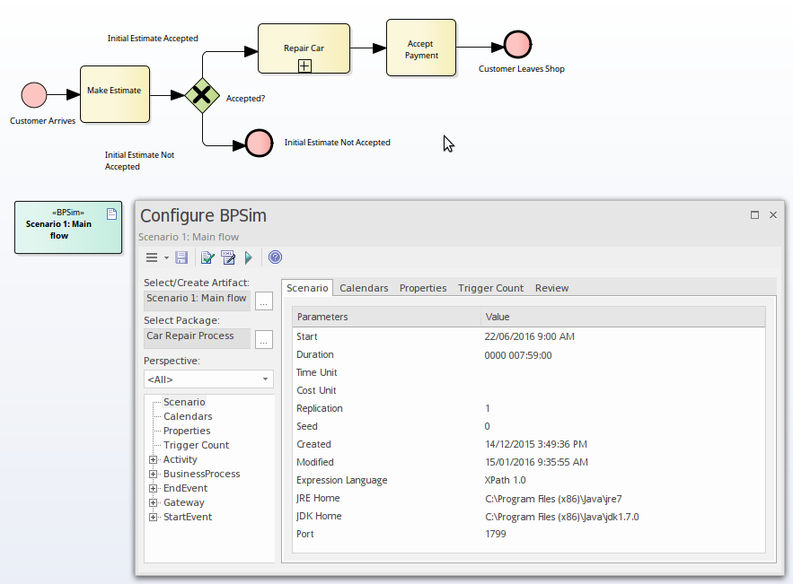

This section lists the main tools available in Enterprise Architect that can be used to perform this business analysis technique.  
There is also a wide range of additional tools that a modeler might find suitable when applying the technique in a particular context.  
The complete list of tools is available from the topic *Business Modeling Tools*.

Decision Table

The **Decision Table Editor** can be used simply to record the conditions and the conclusions that form the basis of decision making.  
Alternatively implementation code can be generated using the Enterprise Architect Simulation Library (EASL) code generation macros.  
It uses a clear and understandable interface allowing the analyst to enter conditions, condition value columns, defined values that act as a decision point, and one or more conclusions.

Learn More: [Decision Table Editor](http://www.sparxsystems.com/enterprise_architect_user_guide/13.5/guidebooks/tools_ba_decision_table_editor.html)

Decision Tree

A Decision Tree is a diagram that is part of the Strategic Modeling Technology and uses a visual notation to represent a series of decisions and possible outcomes.  
It can be used in either a descriptive or predictive manner to visualize outcomes and decision points.  
It is particularly useful when a complex or intractable decision needs to be formally recorded.  
The diagram or elements such as the outcomes can be linked to other elements in the repository such as solution options.

Learn More: [Decision Tree Diagram](http://www.sparxsystems.com/enterprise_architect_user_guide/13.5/guidebooks/tools_ba_decision_tree_diagram.html)

Business Process Simulation (BPSim)

The BPSim facility provides a way of simulating processes written in Business Process Model and Notation (BPMN) providing valuable results that can be used in decision analysis.  
The BPMN models are augmented with extra data as parameters to the simulation.  
It allows structural and capacity analysis to be performed providing for pre and post execution optimization.  
Enterprise Architect allows you to construct the Process models and enter the appropriate data which is then sent to an internal or external BPSim Simulation engine.

Learn More: [Business Process Simulation](http://www.sparxsystems.com/enterprise_architect_user_guide/13.5/guidebooks/tools_ba_business_process_simulation.html)

Business Rules Model

A Business Rules Model can be used to define the conditions under which business rules are applied.  
The Business Rules and the Rule Tasks can be related to Policies, Requirements, Business Processes and other model elements creating an articulated model that shows how the business rules are applied in a given context.

Learn More: [Business Rules Model](http://www.sparxsystems.com/enterprise_architect_user_guide/13.5/guidebooks/tools_ba_business_rules_model.html)

Requirements Diagram

A **Requirements Diagram** can be used to create a visual representation of the information, knowledge, and decision making involved in a more complex business decision.  
The diagram can also be used to define the problem statement clearly and to propose alternate propositions.

Learn More: [Requirements Diagram](http://www.sparxsystems.com/enterprise_architect_user_guide/13.5/guidebooks/tools_ba_requirements_diagram.html)

Artifact

An Artifact can be used as a placeholder for a Decision Analysis file or web address such as a spreadsheet or document that resides external to the repository.  
The Artifact element can be hyper-linked to the external document allowing it to be launched from within Enterprise Architect.  
This provides a convenient way to reference the document inside the model for example by linking other elements such as Requirements to the document.

Learn More: [Artifact](http://www.sparxsystems.com/enterprise_architect_user_guide/13.5/guidebooks/tools_ba_artifact.html)

Import and Export Spreadsheets

The Spreadsheet Import and Export facility can be used to export modeling data out of Enterprise Architect so that analysis can be done outside the tool.  
Alternatively it can be used to import information into Enterprise Architect such that representations of the decisions can be created inside the tool.  
A specification that describes the mapping between column in the spreadsheet (csv file) and fields in Enterprise Architect must be created before a transfer of data can be made.

Learn More: [Import and Export Spreadsheets](http://www.sparxsystems.com/enterprise_architect_user_guide/13.5/guidebooks/tools_ba_import_and_export_spreadsheets.html)

## Document Analysis

Document Analysis is supported in Enterprise Architect by a number of facilities, including the ability to represent or store the source documents inside the model, and being able to record the findings of the analysis and link them to the document sources.  
Enterprise Architect has a fully featured document editor built into the core product, which allows documents to be created directly in the tool or imported into the tool.  
The document can also be represented as a document element inside the model, which can be linked to a document (or URL) that lives outside the model.  
The information and insight gained in the analysis can be linked to the documents and presented visually or in documentation.

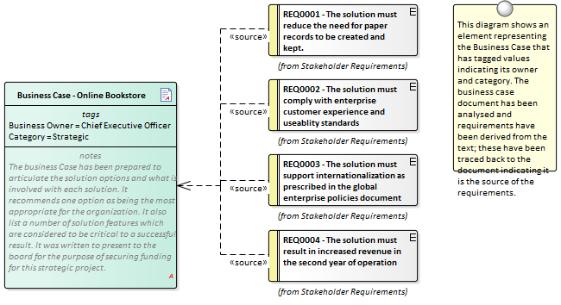

This section lists the main tools available in Enterprise Architect that can be used to perform this business analysis technique.  
There is also a wide range of additional tools that a modeler might find suitable when applying the technique in a particular context.  
The complete list of tools is available from the topic *Business Modeling Tools*.

Maintenance Items

When analyzing a Document Maintenance items can be used to record a variety of items including Defects, Changes, Issues, Tasks, Decisions and Events.  
These Items can be added to an Artifact or any other element that represents the document being analyzed.  
Applicable metadata can be stored against each item including its Name, Description, Status, Priority, who it was Raised by, Completion details and more.

Learn More: [Maintenance Items](http://www.sparxsystems.com/enterprise_architect_user_guide/13.5/guidebooks/tools_ba_maintenance_items.html)

Artifact

The documents that need to be analyzed will typically be stored in a file system or in an external document repository.  
An Artifact can be used as a placeholder (or proxy) for the document that is being analyzed and the external document can be launched from Enterprise Architect regardless of its location.  
This is a powerful mechanism that allows **Discussions** or Maintenance Items to be added to the element effectively recording the document analysis in the Enterprise Architect Repository along with the other modeling elements such as Requirements, Business Rules, System Components and more.

Learn More: [Artifact](http://www.sparxsystems.com/enterprise_architect_user_guide/13.5/guidebooks/tools_ba_artifact.html)

Document Artifact

The Document Artifact provides a location to record analysis, discussions and comments about the document under analysis.  
The documents that need to be analyzed will typically be stored in a file system or in an external document repository.  
A Document Artifact can be used as a placeholder (or proxy) for the document that is being analyzed and the external document can be launched from Enterprise Architect regardless of its location.  
The Document Artifact also has a word processor file where structured analysis can be written.

Learn More: [Document Artifact](http://www.sparxsystems.com/enterprise_architect_user_guide/13.5/guidebooks/tools_ba_document_artifact.html)

Element Discussions

The **Element Discussion window** is a useful tool for adding discussions or comments about a document.  
This could be used in conjunction with the Artifact element that represents the external document to be analyzed.  
It is a convenient facility that allows commentary to be made on elements without contaminating the notes with discussions that ultimately don't contribute to the integrity of the model.  
A **Discussions** summary window conveniently displays the Discussions for all elements in the repository.

Learn More: [Element Discussions](http://www.sparxsystems.com/enterprise_architect_user_guide/13.5/guidebooks/tools_ba_element_discussions.html)

## Financial Analysis

Formal financial analysis would typically be conducted outside of Enterprise Architect but less formal analysis can be recorded inside the repository.  
Either way, Enterprise Architect has tools that can assist in modeling the financial analysis information and relating it to other parts of the model such as solution options.  
An Artifact can be used as a placeholder for documents or web based information that resides outside the repository such as a Spreadsheet or a Word Process Document.  
A hyperlink can be used to provide quick access to the external file from within the model.  
The Document Artifact facility can be used to create a word processor document inside the repository and define the analysis with links to other parts of the model such as Components or other architectural elements that describe the solution options.

Artifact

An Artifact can be used as a placeholder for a Financial Analysis file or web address such as a spreadsheet or document that resides external to the repository.  
The Artifact element can be hyper-linked to the external document allowing it to be launched from within Enterprise Architect.  
This provides a convenient way to reference the document inside the model for example by linking other elements such as Requirements to the document.

Learn More: [Artifact](http://www.sparxsystems.com/enterprise_architect_user_guide/13.5/guidebooks/tools_ba_artifact.html)

Document Artifact

A Document Artifact can be used to create Financial Analysis information, conveniently storing the document inside the repository.  
A template could be specified for the document, which could be reused for other initiatives.  
Other model elements that exemplify some aspect of the Financial Analysis, such as features and solution options, can be dragged into the document as links.

Learn More: [Document Artifact](http://www.sparxsystems.com/enterprise_architect_user_guide/13.5/guidebooks/tools_ba_document_artifact.html)

## Interface Analysis

Any complex system will typically have a number of interfaces; these can be any of a wide range of types, including user interfaces, component interfaces, application programming interfaces and hardware interfaces.  
Enterprise Architect has built-in facilities to model all these types of interfaces and they can be connected into a single articulated model.  
There is support for a wide range of user interfaces including applications, web pages, and hand held devices such as Tablets and Phones, including devices such as iPhones, Android and Windows phones.  
Business interfaces such as people outside the organization or business processes can also be modeled.

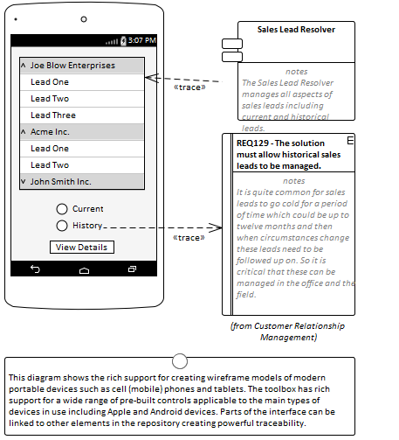

Component Diagram

A system is typically composed of a number of subsystems which are often connected to each other through know interfaces.  
These interfaces are where data or control signals are exchanged between the Components.  
These can be modeled using the Unified Modeling Language Interface element that allows operations and services to be defined.  
Components can expose these Interfaces graphically in a diagram as Provided or Required interfaces allowing the Components to be connected.

Learn More: [Component Diagram](http://www.sparxsystems.com/enterprise_architect_user_guide/13.5/guidebooks/tools_ba_component_diagram.html)

Deployment Diagram

Hardware Nodes and Devices need to interface to other Nodes and Devices through published Interfaces.  
These can be described with UML Ports that can be used to describe aspects of the interface such as IP Addresses and Protocols.  
These describe the physical or virtual connections between the various pieces of hardware that make up the system.

Learn More: [Deployment Diagram](http://www.sparxsystems.com/enterprise_architect_user_guide/13.5/guidebooks/tools_ba_deployment_diagram.html)

Wireframe Diagram

Wire Frame diagrams allow a modeler to create powerful and expressive models of the user interface for a variety of hand held devices, including Apple, Android and Windows phones and tablets.  
Screen dialogs and web pages can also be modeled.  
The physical appearance of the devices themselves can be represented and configured by the use of a number of **Tagged Values**.  
Patterns can be used to automatically create a base model for a device.  
A range of controls are available applicable to each type of device including Android Widgets, Apple Controls and Windows Tiles.

Learn More: [Wireframe Diagram](http://www.sparxsystems.com/enterprise_architect_user_guide/13.5/guidebooks/tools_ba_wire_frame_diagram.html)

## Non-Functional Requirements Analysis

Enterprise Architect is a sophisticated requirements development and management platform allowing any type of requirement to be modeled including built in support for Non-Functional requirements or quality attributes as they are sometimes called.  
These requirements typically express how well the behavior expressed by the functional requirements must perform.  
Enterprise Architect has a purpose built element to model these important requirements and a facility to link them to any other elements including Use Cases, User Stories and Functional Requirements.  
These relationships can be displayed in a variety of diagrams and windows or generated out to documentation making them available to project stakeholders who are not working in the repository.  
There is also the opportunity to reuse these requirements across multiple projects or programs of work.

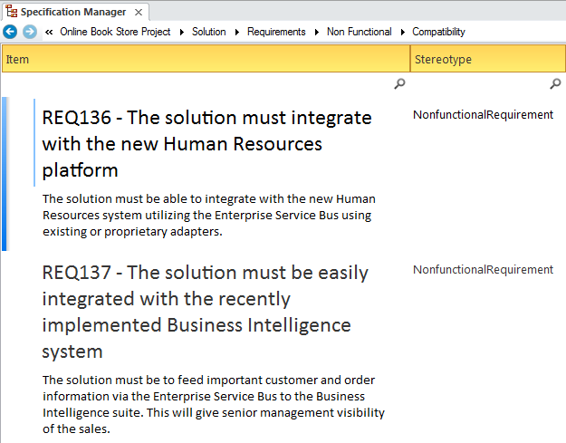

Specification Manager

The **Specification Manager** is the primary tool for working with text based elements such as Non Functional Requirements.  
These and other requirements can be created directly in the Specification Manager and their names and descriptive text can be added in a compelling Word Processor or Spreadsheet like format.  
Other built-in properties such as status, version and phase can be managed directly in the columns of the Specification Manager and where property lists are available these can be chosen or changed from drop down lists.  
Additional properties in the form of **Tagged Values** can also be managed from within the Specification Manager.  
The Non-Functional Requirements visible in the Specification Manager can be included on diagrams if necessary and linked to other modeling elements.  
Changing any of the Requirement's details in the Specification Manager will update the element in all other locations such as diagrams and vice versa, since there is a single element in the Repository that is visible in many views.

Learn More: [Specification Manager](http://www.sparxsystems.com/enterprise_architect_user_guide/13.5/guidebooks/tools_ba_specification_manager.html)

Requirements Diagram

The Requirements diagram can be used to model Non Functional Requirements.  
These requirements are often displayed using a package element showing the category of the requirement.  
In other diagrams the modeler can show the Non Functional requirements linked to other elements such as Use Cases and User Stories or Functional Requirements.  
Traces could also be created between the Non Functional Requirements and system components or Interfaces that implement the requirements.

Learn More: [Requirements Diagram](http://www.sparxsystems.com/enterprise_architect_user_guide/13.5/guidebooks/tools_ba_requirements_diagram.html)

Documentation

Enterprise Architect has a powerful and flexible documentation generator that can produce Docx and RTF Word Processor files, PDF and HTML reports.  
The Non Functional Requirements stored in the repository can be conveniently generated and included in documentation.  
The Requirements can be included under headings in the report that group the Non Functional requirements by quality attributes such as Extensibility, Maintainability and more.  
A sophisticated template facility exists that provides a range of in-built templates and allows the user to create their own templates defining styles, images and a wide range of other formatting options.

Learn More: [Documentation](http://www.sparxsystems.com/enterprise_architect_user_guide/13.5/guidebooks/tools_ba_documentation.html)

Element Discussions

Team members will often want to comment on or question the definition or details of a Non Functional Requirement.  
The Element Discussion facility provides a perfect mechanism for conducting these conversations about Non Functional Requirements.  
The discussions are posted in a purpose built window and are kept separate from the notes and details of the element.  
This ensures that the Requirements definition is not 'polluted' with comments that are intended for modelers rather than other stakeholders.  
As the discussions are posted a summary window conveniently displays the latest entries across the entire repository.

Learn More: [Element Discussions](http://www.sparxsystems.com/enterprise_architect_user_guide/13.5/guidebooks/tools_ba_element_discussions.html)

Relationship Matrix

The **Relationship Matrix** is a powerful and compelling tool for visualizing the relationships between two sets of elements.  
The Non Functional Requirements can be related to a number of different sets of elements including Use Cases, User Stories, Functional Requirements and System Components and the Interfaces that implement them.  
A number of different Matrices could be created with the Non Functional Requirements on one axis and a different set of elements on the other axis in each of the matrices.  
The Matrices can conveniently be saved as resources and also exported to a Spreadsheet file.

Learn More: [Relationship Matrix](http://www.sparxsystems.com/enterprise_architect_user_guide/13.5/guidebooks/tools_ba_relationship_matrix.html)

Import and Export Spreadsheets

It is common for analyst to have started their modeling of Requirements including Non Functional Requirements in a Spreadsheet or to want to manipulate existing elements in a Spreadsheet.  
Enterprise Architect has a flexible and configurable tool for importing and exporting elements from a CSV file which can be imported and exported from a Spreadsheet.  
Any type of element can be imported or exported to the spreadsheet file but it is particularly common to use the facility with Requirements including Non Functional Requirements.  
Names, Description, built-in properties and extended properties in the form of **Tagged Values** can be imported or exported.  
The tool provides a flexible Specification window where the mapping between element properties and the columns in the Spreadsheet and other parameters can be defined and saved.  
Essentially the columns of the spreadsheet define the properties and each element is specified in a row.

Learn More: [Import and Export Spreadsheets](http://www.sparxsystems.com/enterprise_architect_user_guide/13.5/model_domains/tools_req_import_and_export_spreadsheets.html)

Baselines

The Baseline Tool is used as a type of backup and recovery tool and can capture a snapshot of the Non Functional Requirements at a point in time and then at a later time the repository can be compared to this (or another baseline) for the purpose of determining what has changed.  
It is possible to revert the current model back to a state captured in the baseline at the level of a granular change.

Learn More: [Baselines](http://www.sparxsystems.com/enterprise_architect_user_guide/13.5/tools_ba_import_and%20export_spreadsheets.html)

## Observation

Observations are used to illicit information and provide understanding and clarification by viewing a person performing a process in its context.  
Typically the observations are recorded with paper notes and photography but Enterprise Architect can assist with preparing for the observation by detailing the objectives and the planning approach.  
The results of the observation including scanned notes and photographic images can be stored in Enterprise Architect, ensuring that they are available to all modelers.  
The results of the observation, including process diagrams and statements of how a process could be improved, can be modeled in Enterprise Architect and linked to a variety of elements.  
Tools and material used by the process performer such as scanners and procedure manuals can also be modeled in Enterprise Architect.

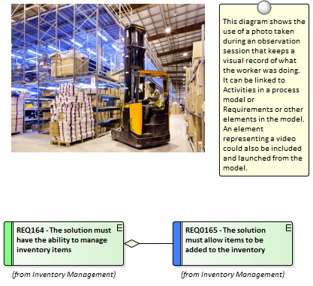

Image Manager

The **Image Manager** is a tool for managing images such as photos and screen shots and other pictures in a variety of formats.  
Often when observations are made an analyst will take one or more photos of a user in situ in their work environment.  
An analyst might also capture screen shots of the current applications the user is working with.  
All these digital assets can be imported into the Image Manager and then applied to elements in diagrams as an alternate image.  
Alternatively a picture contained in the Clipboard can be pasted directly into a diagram.

Learn More: [Image Manager](http://www.sparxsystems.com/enterprise_architect_user_guide/13.5/guidebooks/tools_ba_image_manager.html)

Artifact

An analyst might take a photograph or video of a user in their work environment as a way of recording the steps the user is performing to complete a task.  
This can provide a valuable resource for analyzing a complex sequence of tasks.  
While a photo or screen shot in a range of formats can be stored in the **Image Manager** a video file would have to reside on disk or in a system outside the Enterprise Architect repository.  
The Artifact element can be used as a proxy for the videos inside the repository allowing the video (or other file) to be launched directly from Enterprise Architect.  
This can be achieved by dragging the file onto a diagram or by creating an Artifact and assigning the Video as a file in the Properties sheet of the element.

Learn More: [Artifact](http://www.sparxsystems.com/enterprise_architect_user_guide/13.5/guidebooks/tools_ba_artifact.html)

Document Artifact

A document Artifact is a word processor type of file available inside Enterprise Architect and can be used to plan an observation including its purpose and details of the user's environment.  
It can also be used to record the observations themselves ensuring that the details are easily accessible to other modelers and close to other modeling elements.  
Elements and diagrams in the repository can be dragged into the Document Artifact as links to things like a Concept Model or Business Processes and Business Rules that might be related to the user's tasks.  
Other related files can be imported into the **Image Manager** or linked to from an Artifact.

Learn More: [Document Artifact](http://www.sparxsystems.com/enterprise_architect_user_guide/13.5/guidebooks/tools_ba_document_artifact.html)

Calendar

The **Calendar** provides a convenient way to record and present important temporal information such as events and meetings in calendar format inside the repository.  
Observation sessions can be entered into the Calendar and setup as recurring if needed.  
Event subtypes can be configured to add Observation as a Meeting Type.

Learn More: [Calendar](http://www.sparxsystems.com/enterprise_architect_user_guide/13.5/guidebooks/tools_ba_calendar.html)

Model Mail

**Model Mail** can be used to notify and remind people of a planned observation session and to notify them after the session about outcomes, decisions and required actions.  
Links to model elements, diagrams, Matrices, Team Reviews and a variety of other items can be added.

Learn More: [Model Mail](http://www.sparxsystems.com/enterprise_architect_user_guide/13.5/guidebooks/tools_ba_model_mail.html)

## Process Analysis

Enterprise Architect allows processes to be modeled and these models can be analyzed to assess them for how effective and efficient they are and to view any opportunities for change or improvement.  
There is a powerful element discussion facility allowing modelers to discuss processes and analyze the processes collaboratively even when the modelers are geographically dispersed.  
Enterprise Architect also has a powerful simulation facility to simulate the models and derive information about the models identifying any points in the process that can be improved.



Business Process Simulation (BPSim)

The BPSim facility provides a way of simulating processes written in Business Process Model and Notation (BPMN) providing valuable results that can be used in processes analysis.  
The BPMN models are augmented with extra data as parameters to the simulation.  
It allows structural and capacity analysis to be performed providing for pre and post execution optimization.  
Enterprise Architect allows you to construct the Process models and enter the appropriate data which is then sent to an internal or external BPSim Simulation engine.

Learn More: [Business Process Simulation](http://www.sparxsystems.com/enterprise_architect_user_guide/13.5/guidebooks/tools_ba_business_process_simulation.html)

Element Discussions

The **Element Discussion window** is a convenient facility that allows commentary to be made on processes (or any element) without contaminating the notes with discussions that ultimately don't contribute to the integrity of the model.  
The Element Discussion window allows a modeler to initiate a discussion and for others to reply.  
It is a perfect way for stakeholders and analysts to discuss aspects of a process as its being analysed.

A **Discussions** summary window conveniently displays the Discussions for all elements in the repository.

Learn More: [Element Discussions](http://www.sparxsystems.com/enterprise_architect_user_guide/13.5/guidebooks/tools_ba_element_discussions.html)

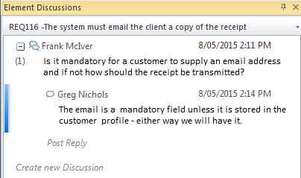

Maintenance Items

Element Maintenance Items can be used with Business Processes to capture problems, changes, issues, tasks, events and decision that affect an individual Activities or whole Processes.

Learn More: [Maintenance Items](http://www.sparxsystems.com/enterprise_architect_user_guide/13.5/guidebooks/tools_ba_maintenance_items.html)

## Root Cause Analysis

Enterprise Architect has a number of tools that can assist with Root Cause Analysis, allowing the context of the problem to be identified and the analysis of the causes to be modeled.  
One or more Issue elements can be used to describe the Problem Statement in detail, including the context of the problem, which might be business or technology processes or application components or hardware.

A decision diagram can be used as a way of describing the causes using the Five Whys approach.

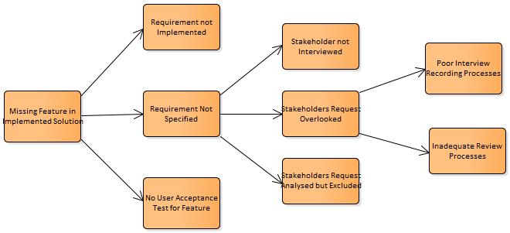

Maintenance Items

One or more Issue Maintenance Items can be used to record a problem statement that helps to formally describe the problem.  
These can be added to the repository at any level from a high level package such as a Functional Requirements Package down to an individual Requirement level or for any other element type.  
Applicable metadata can be stored against each item including its Name, Description, Status, Priority, who it was Raised by, Completion details and more.

Learn More: [Maintenance Items](http://www.sparxsystems.com/enterprise_architect_user_guide/13.5/guidebooks/tools_ba_maintenance_items.html)

Decision Tree

A Decision Tree is a diagram that is part of the Strategic Modeling Technology and uses a visual notation to represent a series of decisions and possible outcomes.  
It can be used in either a descriptive or predictive manner to visualize outcomes and decision points.  
The Decision Tree diagram can be used to create a Five Whys diagram starting with the problem and fanning out.

Learn More: [Decision Tree Diagram](http://www.sparxsystems.com/enterprise_architect_user_guide/13.5/guidebooks/tools_ba_decision_tree_diagram.html)

Requirements Diagram

The Requirements diagram can be used to model the problem statement and the context of the problem, using an Issue element available from the 'Requirements' Toolbox pages.  
Other elements that are relevant to the problem - such as things that are impacted by the problem - can be recorded on the diagram.  
These can include Business Capabilities, Business Processes or Technology Capabilities, Services, Applications or Hardware.

Learn More: [Requirements Diagram](http://www.sparxsystems.com/enterprise_architect_user_guide/13.5/guidebooks/tools_ba_requirements_diagram.html)

# Collaboration

Collaboration techniques are critical to the success of any initiative.  
The ability of team members to work together and to share their thoughts, ideas, analysis and designs contributes greatly to the success of any initiative.  
Enterprise Architect has been built from the ground up as a collaborative modelling platform that allows people from a variety of disciplines and backgrounds to share their ideas and contribute to moving stakeholder value from a promise through to the implementation of a system feature that delivers that value.  
There are a wide variety of techniques and Enterprise Architect has tools that can assist an analyst when performing these techniques.

## Brainstorming

Enterprise Architect can be used for all aspects of Brainstorming, from session planning and definition of evaluation criteria to recording the ideas during the session and their evaluation during wrap up.  
The Document Artifact allows the modeler to create a document that is stored in the repository and available to all modelers.  
It can be used to describe the Brainstorming session, recording such things as the definition of the area of interest, timing and stakeholders.  
This document can be sent by model mail to all stakeholders.  
A Mind Mapping diagram can be used to record the ideas that emerge during the session, allowing them to be presented visually in a compelling and neutral format.  
In the wrap up Checklists can be used to asses each idea against the evaluation criteria.

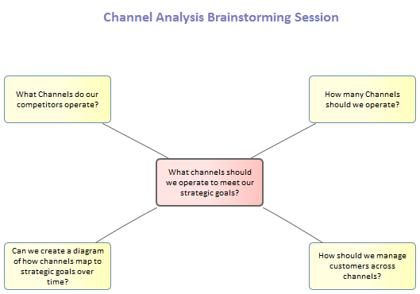

This section lists the main tools available in Enterprise Architect that can be used to perform this business analysis technique.  
There is also a wide range of additional tools that a modeler might find suitable when applying the technique in a particular context.  
The complete list of tools is available from the topic *Business Modeling Tools*.

Document Artifact

The Document Artifact is like a word processor file available inside the repository and it is a convenient way of creating a plan for a Brainstorming Session.  
It can also be used to record the discussions, ideas and information that surfaces during the session.  
It has the advantage of being able to reference elements and diagrams contained in the **Project Browser** by the creation of hyperlinks.  
Built-in templates can be used for the document or user defined templates can be created and reused if required with other Brainstorming sessions.

Learn More: [Document Artifact](http://www.sparxsystems.com/enterprise_architect_user_guide/13.5/guidebooks/tools_ba_document_artifact.html)

Mind Mapping Diagram

A **MindMapping Diagram** is a productive way to capture the ideas that are expounded during a Brainstorming session.  
With a Central Topic defined, Main Topics can be added to structure thoughts and then Topics are added as new ideas emerge.  
The **Notes window** could be kept open and used to record the details of ideas.  
Alternatively the **Element Discussions window** could be used to record the discussions and dialogs.

Learn More: [Mind Mapping](http://www.sparxsystems.com/enterprise_architect_user_guide/13.5/guidebooks/tools_ba_mind_mapping_diagram.html)

Element Discussions

Element Discussion provide a convenient way of recording what is being discussed in a Brainstorming session.  
If a plan for the Brain storming session has been created using a Document Artifact a scribe could record the discussion using the Document Artifact element.  
Alternatively if a Mind Mapping diagram is being used detailed discussion could be recorded against the topics in the Mind Mapping diagram.

Learn More: [Element Discussions](http://www.sparxsystems.com/enterprise_architect_user_guide/13.5/guidebooks/tools_ba_element_discussions.html)

Calendar

The **Calendar** can be used to schedule a Brainstorming session and model users can see this meeting in the context of the other events scheduled for the project.

Learn More: [Calendar](http://www.sparxsystems.com/enterprise_architect_user_guide/13.5/guidebooks/tools_ba_calendar.html)

Model Mail

**Model Mail** is a perfect way to let people know about a planned Brainstorming session and also to inform them when the results of the session have been completed.  
If a plan has been developed for the Brainstorming session in a Document Artifact this can be attached by inserting a link to the element using the Insert Quick Link function.  
Any other material such as diagrams matrices can also be attached in the same way.

Learn More: [Model Mail](http://www.sparxsystems.com/enterprise_architect_user_guide/13.5/guidebooks/tools_ba_model_mail.html)

Checklist

A Checklist can be used to assess each of the ideas against predefined evaluation criteria.  
The Checklist items can be configured to express the criteria and provide a compelling visual representation of the quality of the ideas.

Learn More: [Checklist](http://www.sparxsystems.com/enterprise_architect_user_guide/13.5/model_domains/tools_req_requirements_checklist.html)

## Collaborative Games

Collaborative games are aimed at encouraging stakeholders to collaborate with the intent of getting a common understanding of a problem or solution.  
Enterprise Architect has a Document Artifact that can be used to define the game, including its purpose, the process and the rules.  
The outcomes or decisions that result from running the game can either be entered into the document or modeled in a diagram.  
The outcomes can be sent to each participant using the **Model Mail** feature, and the element discussion facility can be used to discuss the outcomes and any actions that are required.

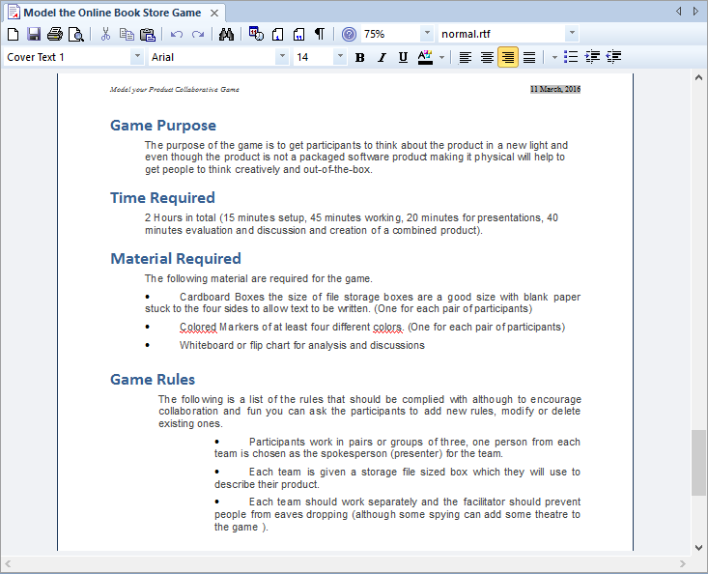

This section lists the main tools available in Enterprise Architect that can be used to perform this business analysis technique.  
There is also a wide range of additional tools that a modeler might find suitable when applying the technique in a particular context.  
The complete list of tools is available from the topic ‘Business Modeling Tools’.

Document Artifact

The Document Artifact is a convenient element that allows a word processor document to be created inside the repository.  
This can be used to create the objectives and definition of the game and its rules.  
The logistics including setup and required materials and briefings for the game facilitator can also be included.  
The document can contain the list of participants and links to relevant elements in the repository can be created by dragging element diagrams and other items into the document.  
The outcomes of the game and subsequent discussion can all be entered into the document.

Learn More: [Document Artifact](http://www.sparxsystems.com/enterprise_architect_user_guide/13.5/guidebooks/tools_ba_document_artifact.html)

Calendar

The **Calendar** provides a way to record and present important temporal information such as events and meetings in calendar format.  
Collaborative Games can be entered into the Calendar and setup as recurring if needed.  
Event subtypes can be configured to add Collaborative Games as a Meeting Type.

Learn More: [Calendar](http://www.sparxsystems.com/enterprise_architect_user_guide/13.5/guidebooks/tools_ba_calendar.html)

Model Mail

**Model Mail** can be used to notify and remind people of a Collaborative Game and to notify them after the game has been played about outcomes and decisions and required actions.  
Links to model elements and diagrams, matrices, team reviews and a variety of other items can be added.

Learn More: [Model Mail](http://www.sparxsystems.com/enterprise_architect_user_guide/13.5/guidebooks/tools_ba_model_mail.html)

## Focus Groups

Focus Groups are a powerful and inclusive way of eliciting ideas and opinions about a product or service; Enterprise Architect has the facilities to plan and conduct the sessions, record the ideas and distribute the results.  
The meeting planning and logistics can be detailed in the focus group plan document, a discussion guide can be created to assist the facilitator with pre-defined questions, and both these documents can be written inside the tool using a Document element.  
The ideas and opinions can also be recorded during the sessions in the form of a Mind Map, and these can be analyzed and the results disseminated to the participants and a wider audience.  
A convenient Project Calendar can be used to record the times for the focus group meeting, and a **Model Mail** message could be sent to remind the participants of the meeting.

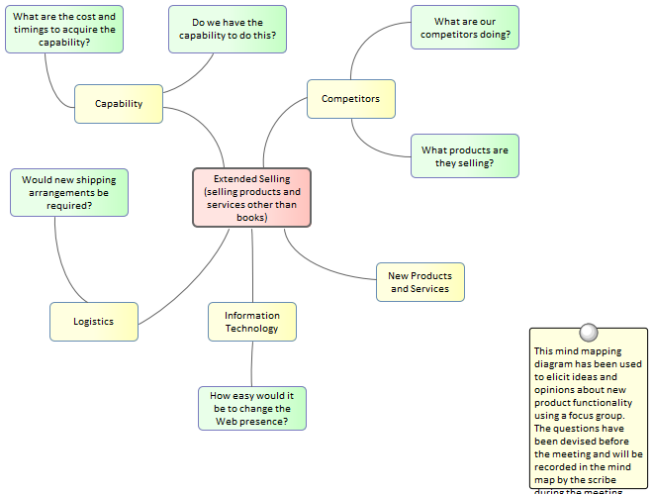

Document Artifact

A Document Artifact can be used as an alternative to using a **MindMapping Diagram** for recording the information, opinion and ideas collected during a Focus Group meeting.  
A template could be specified for the document and the details of the session recorded in the Document.  
Other model elements that have relevance or importance to the Focus Group discussions can be dragged into the document as links.  
The Document Artifact can also be used to plan the Focus Group meeting describing things such as the objective, timings and the list of participants.

Learn More: [Document Artifact](http://www.sparxsystems.com/enterprise_architect_user_guide/13.5/guidebooks/tools_ba_document_artifact.html)

Mind Mapping Diagram

A Mind Mapping diagram can be used to record the stakeholder's statements during a Focus Group meeting.  
A Central Topic can be created that represents the theme of the meeting and if it has been planned and structured, Main Topics can be added prior to the commencement of the meeting.  
It is useful to have a scribe creating the **MindMapping Diagram** as it allows the facilitator to interact with the stakeholders.  
If the screen is projected it allows the stakeholders to visualize the information, opinions and ideas as they are recorded.

Learn More: [Mind Mapping Diagram](http://www.sparxsystems.com/enterprise_architect_user_guide/13.5/guidebooks/tools_ba_mind_mapping_diagram.html)

Calendar

The **Calendar** provides a way to record and present important temporal information such as events and meetings in calendar format.  
Focus Groups can be entered into the Calendar and setup as recurring if needed.  
Event subtypes can be configured to add Focus Groups as a Meeting Type.

Learn More: [Calendar](http://www.sparxsystems.com/enterprise_architect_user_guide/13.5/guidebooks/tools_ba_calendar.html)

Element Discussions

**Element Discussions** are a useful way to enter comments made by stakeholders or others in a Focus Group meeting.  
They can be entered for any element in the Repository including Packages so could be entered at the level of an individual element such as a Requirement or for a group of Requirements such as the Security Requirements Package.

Learn More: [Element Discussions](http://www.sparxsystems.com/enterprise_architect_user_guide/13.5/guidebooks/tools_ba_element_discussions.html)

Model Mail

**Model Mail** can be used to notify and remind people of a Focus Group Meeting and to notify them after the meeting about outcomes and decisions and required actions.  
Links to model elements and diagrams, matrices, team reviews and a variety of other items can be added.

Learn More: [Model Mail](http://www.sparxsystems.com/enterprise_architect_user_guide/13.5/guidebooks/tools_ba_model_mail.html)

## Interviews

An interview is a common technique used to elicit information from one or more participants and Enterprise Architect can be used from the planning phase to define the logistics and questions, during the interview itself to record the answers, and during the analysis and dissemination to publish the results.  
When the interview is structured a list of proposed and alternate questions could be defined in a Document created inside the model.  
The Project Calendar can be used to record the time the meeting will be conducted and **Model Mail** could be used to remind people of the time.

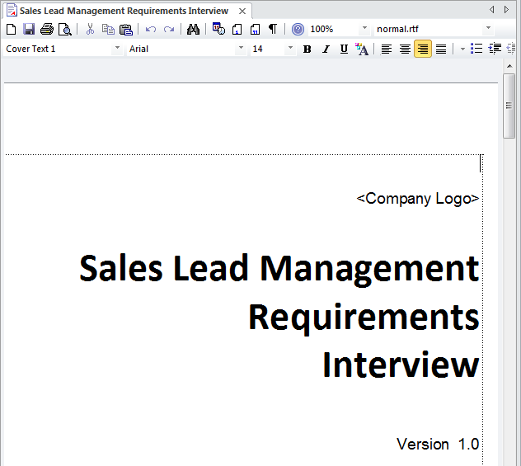

Document Artifact

A Business Analyst will typically plan an interview and define the approach and if it is a structured interview a list of questions will be defined in advance of the interview.  
A Document Artifact can be used as a place to store this information directly inside the model.  
A template could be specified for the document and the answers to structured or unstructured question recorded into the Document.  
Other model elements that exemplify some aspect of the interview, such as topics of discussion can be dragged into the document as links.

Learn More: [Document Artifact](http://www.sparxsystems.com/enterprise_architect_user_guide/13.5/guidebooks/tools_ba_document_artifact.html)

Calendar

The **Calendar** provides a way to record and present important temporal information such as events and meetings in calendar format.  
Interviews can be entered into the Calendar and setup as recurring if needed.  
Event subtypes can be configured to add Interviews as a Meeting Type.

Learn More: [Calendar](http://www.sparxsystems.com/enterprise_architect_user_guide/13.5/guidebooks/tools_ba_calendar.html)

Element Discussions

**Element Discussions** are a useful way to enter comments made by stakeholders or others in a Interview.  
They can be entered for any element in the Repository including Packages so could be entered at the level of an individual element such as a Requirement or for a group of Requirements such as the Security Requirements Package.

Learn More: [Element Discussions](http://www.sparxsystems.com/enterprise_architect_user_guide/13.5/guidebooks/tools_ba_element_discussions.html)

Model Mail

**Model Mail** can be used to notify and remind people of an Interview and to notify them after the interview about outcomes and decisions and required actions.  
Links to model elements and diagrams, matrices, team reviews and a variety of other items can be added to Model Mail messages.

Learn More: [Model Mail](http://www.sparxsystems.com/enterprise_architect_user_guide/13.5/guidebooks/tools_ba_model_mail.html)

## Mind Mapping

Enterprise Architect has a flexible and easy to use Mind Mapping diagram which can be used for structuring thoughts or for note taking in a variety of situations from stakeholder workshops, focus groups, interviews and collaborative games.  
They can be used to map the thoughts and ideas of an individual or a group of people and provide a non-confronting and appealing way of recording information.  
The power of Enterprise Architect can be used to create the Mind Map but then other elements such as a set of Requirements that have been derived from analysis of the Mind Map can be linked back to elements in the Mind Map to show how the Requirements trace back to ideas expressed in a workshop.  
This provides a powerful analysis audit trail of the provenance of Requirements or other solution precursors such as Capabilities, Goals, Business Objectives and more.

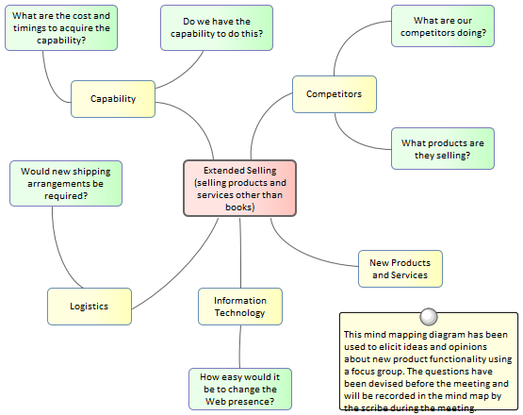

Mind Mapping Diagram

A Mind Mapping diagram can be used to record a wide range of information in a compelling format that mimics the way we think about ideas as a graph of thoughts.  
It can also be used in Workshops, Focus Groups and other meetings with Stakeholders or team members as a note taking tool.  
Other elements in the model can be connected to the Topics and Sub Topics in the Mind Mapping diagram to create powerful and expressive relationships between the ideas and their specification or implementation.

Learn More: [Mind Mapping Diagram](http://www.sparxsystems.com/enterprise_architect_user_guide/13.5/guidebooks/tools_ba_mind_mapping_diagram.html)

Traceability Window

The Traceability Window is a useful window that allows a modeler to visualize the connections between elements in the repository.  
This is useful when used with elements in a MindMapping diagram to show how the topics are related to each other but also to view how the topics and sub topics are related to other elements in the repository such as Requirements or System Components.

Learn More: [Traceability Window](http://www.sparxsystems.com/enterprise_architect_user_guide/13.5/guidebooks/tools_ba_traceability_window.html)

## Workshops

Enterprise Architect has a range of tools that can assist with planning, scheduling and conducting workshops.  
Depending how formal a workshop is, a plan might be required and an Agenda and Minutes might also be necessary.  
This can be achieved using a Document Artifact.  
A **Calendar** could be used to record the date, time and location of the meeting.  
Model mail could be used to invite people to the workshop and to let them know when the minutes have been completed.  
Links to important information in the model can also be added to a mail message.  
During the workshop Mind Maps could be drawn and **Element Discussions** posted, new concepts or Glossary terms recorded and Slide Shows presented.

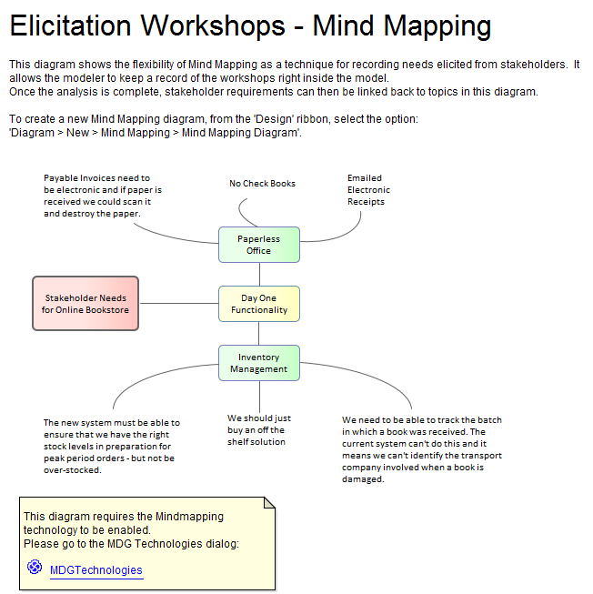

Mind Mapping Diagram

A Mind Mapping diagram can be used to record the stakeholder's statements during an elicitation workshop.  
The statements are not categorized but simply recorded and later during the analysis phase of Requirement's development they can be converted to the appropriate elements or retained and the Requirements can be traced back to the topics effectively creating a record of how the Requirement was derived.  
This is a powerful technique that shields the stakeholders from needing to know the modeling languages and allows them to concentrate on articulating their needs, it also frees the analyst up from concerns about which element to use to model the statements.  
The derivation of requirements from mind mapping topics is usually performed in the analysis phase of the Requirement's Development process.

Learn More: [Mind Mapping Diagram](http://www.sparxsystems.com/enterprise_architect_user_guide/13.5/guidebooks/tools_ba_mind_mapping_diagram.html)

Element Discussions

The **Element Discussion window** is a convenient facility that allows commentary to be made on elements without contaminating the notes with discussions that ultimately don't contribute to the integrity of the model.  
Modelers often place notes on diagrams or write questions in the element notes fields and these are distracting and must be removed when formal documentation is generated from the model.  
The Element Discussion window allows a modeler to initiate a discussion and for others to reply.  
It is a perfect way for discussing requirements.

A **Discussions** summary window conveniently displays the Discussions for all elements in the repository.

Learn More: [Element Discussions](http://www.sparxsystems.com/enterprise_architect_user_guide/13.5/guidebooks/tools_ba_element_discussions.html)



Document Artifact

A Business Analyst will typically plan a workshop and define the approach, and if it is a structured interview a list of questions will be defined in advance of the workshop.  
A Document Artifact can be used as a place to store this information directly inside the model.  
A template could be specified for the document and the answers to structured or unstructured question recorded into the Document.  
Other model elements that exemplify some aspect of the workshop, such as topics of discussion, can be dragged into the document as links.

Learn More: [Document Artifact](http://www.sparxsystems.com/enterprise_architect_user_guide/13.5/guidebooks/tools_ba_document_artifact.html)

Model Views

**Model Views** provide alternate views of the elements and diagrams stored in the **Project Browser**.  
The Slide show is particularly useful for presenting a series of diagrams during a workshop and solves the problem of needing to remember the location of the diagrams in the Project Browser.  
Any number of slide shows can be created and diagrams can be added regardless of their type or location in the Project Browser.  
The progression from slide to slide can be automated or triggered manually.

Learn More: [Model Views](http://www.sparxsystems.com/enterprise_architect_user_guide/13.5/guidebooks/tools_ba_model_views.html)

Concept Model

A Concept Model will act as a guiding model for discussions with many stakeholders and ideally a skeleton model should be created prior to the commencement of any workshop.  
The Concept Model should be kept simple and domain elements should be given a name and a description or a responsibility and initially only important connections should be made between elements.  
As the workshop progresses new elements will be uncovered and can be added directly to the model giving the stakeholders confidence that their needs and concerns are being addressed and managed well.  
Enterprise Architect allows domain models to be created using the **UML Class** diagram.

Learn More: [Class Diagram](http://www.sparxsystems.com/enterprise_architect_user_guide/13.5/guidebooks/tools_ba_class_diagram.html)

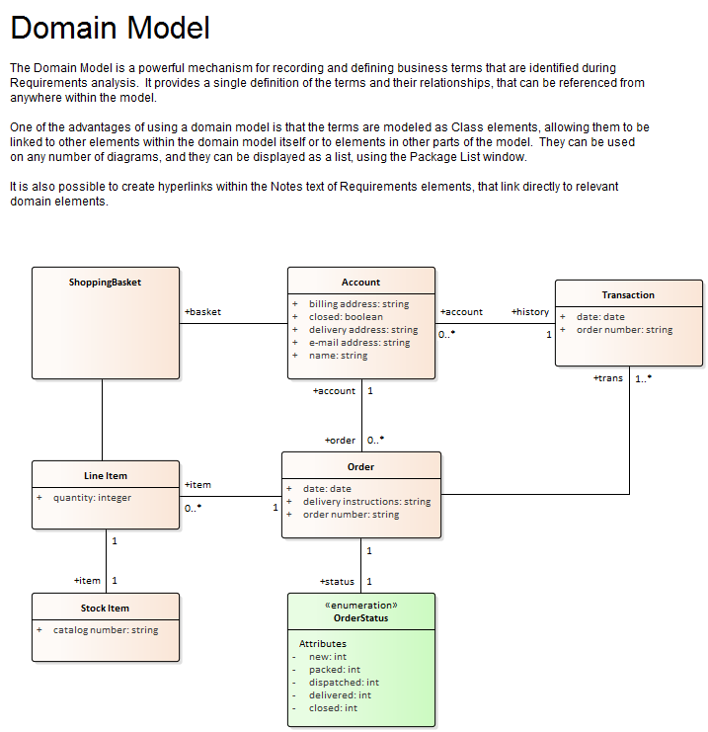

Glossary

Prior to a workshop an analyst can populate the **Project Glossary** with the existing terms and their meanings that have been gleaned from reading project documentation such as a Business Case or Vision Document.  
During the workshops, as new terms are uncovered they can be added to the Glossary and their definitions can be discussed and entered or deferred till later in the analysis phase.

Learn More: [Glossary](http://www.sparxsystems.com/enterprise_architect_user_guide/13.5/guidebooks/tools_ba_glossary.html)

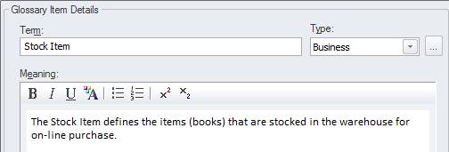

Calendar

The **Calendar** provides a way to record and present important temporal information such as events and meetings in calendar format.  
Workshops can be entered into the Calendar and setup as recurring if needed.  
Event subtypes can be configured to add Workshop as a Meeting Type.

Learn More: [Calendar](http://www.sparxsystems.com/enterprise_architect_user_guide/13.5/guidebooks/tools_ba_calendar.html)

Model Mail

**Model Mail** can be used to notify and remind people of a workshop and to notify them after the workshop about outcomes and decisions and required actions.  
Links to model Elements, Diagrams, Matrices, Team Reviews and a variety of other items can be added.

Learn More: [Model Mail](http://www.sparxsystems.com/enterprise_architect_user_guide/13.5/guidebooks/tools_ba_model_mail.html)

# Modeling

Modeling techniques are at the core of what a business analyst will use to describe the problem, opportunity or a number of candidate solutions.  
This set of techniques provide a way for the analyst to clarify their own thoughts but also to communicate with stakeholders using diagrams, matrices, lists, documents and other visual mechanisms.  
Enterprise Architect is a powerful modeling platform that supports a wide range of languages, methodologies and standards.  
Regardless of whether a team is using an iterative and incremental process or a more traditional process there are tools to support the techniques.  
The Agile analyst will find tools to support User Stories and the more traditional analyst will find tools to support Use Cases and scenarios and more.

## Concept Modeling

A Concept Model is an implementation-independent representation of the nouns that are important for an organisation, domain or industry.  
It is a business model and should not be confused with information or data models.  
Enterprise Architect has tools to create and maintain this model, with the flexibility to present the model graphically in a diagram or textually in a list view, a published document or a web page.  
The elements in the Concept Model can be linked to any number of up-process or down-process elements, such as business goals and capabilities.

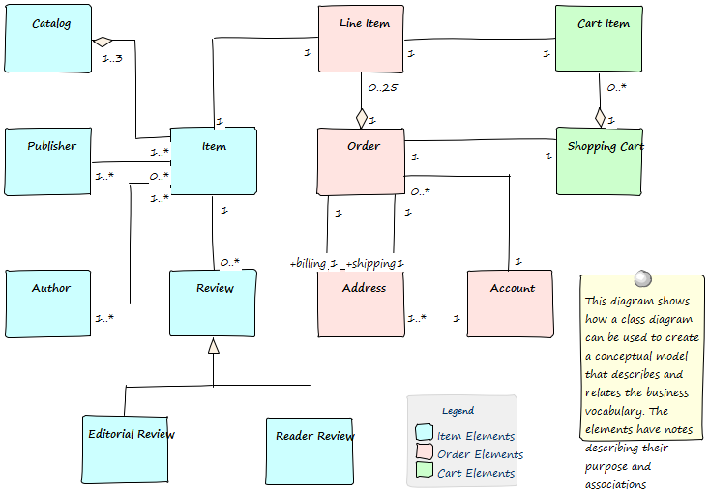

This section lists the main tools available in Enterprise Architect that can be used to perform this business analysis technique.  
There is also a wide range of additional tools that a modeler might find suitable when applying the technique in a particular context.  
The complete list of tools is available from the *Business Modeling Tools* Help topic.

Class Diagram

A **Class Diagram** can be used to model important concepts in the domain.  
The concepts are modeled using UML Classes and Names, Descriptions and other details such as Attributes can be entered for each Class.  
The concepts can be related to each other using relationships such as the Association and Generalization.  
These concepts can then be used throughout the model as a type of Glossary, including in element notes where they can be referenced.

Learn More: [Class Diagram](http://www.sparxsystems.com/enterprise_architect_user_guide/13.5/guidebooks/tools_ba_class_diagram.html)

Project Glossary

The Glossary is a purpose-built tool for managing important concepts and their meanings, which can be included in documentation.  
If words defined in the Glossary are used in element or diagram notes they will automatically appear as hyperlinks and the meaning will conveniently appear in a pop-up window.

Learn More: [Glossary](http://www.sparxsystems.com/enterprise_architect_user_guide/13.5/guidebooks/tools_ba_glossary.html)

Entity Relationship Diagram

An Entity Relationship Diagram is a conceptual or abstract model of information for a system often created as a precursor for the development of a database schema.  
The Entities and their attributes can be modeled and the relationships between one or more Entities can be drawn.

Learn More: [Entity Relationship Diagram](http://www.sparxsystems.com/enterprise_architect_user_guide/13.5/guidebooks/tools_ba_entity_relationship_diagram.html)

National Information Exchange Modeling (NIEM)

Niem is an XML-based information exchange framework that is the result of collaboration between all levels of American government.  
Enterprise Architect has extensive support for the framework allowing organizations to create subsets of the standard for the purpose of exchanging standards compliant messages.  
Conceptual models can be transformed into Niem compliant representations.

Learn More: [National Information Exchange Modeling (NIEM)](http://www.sparxsystems.com/enterprise_architect_user_guide/13.5/model_domains/niem.html)

Ontology Definition Metamodel

Ontologies are a useful and formal way of describing the concepts in a domain and include the names and definition of the types, their properties, and their relationships with each other.  
Enterprise Architect implements the Object Management Group's Ontology Definition Metamodel (ODM) and supports both the Resource Description Framework (RDF) and the Web Ontology Language (OWL).

Learn More: [MDG Technology for ODM](http://www.sparxsystems.com/enterprise_architect_user_guide/13.5/model_domains/mdg_technology_for_odm.html)

Schema Composer

The **Schema Composer** is a powerful tool that can be used to define a range of formal schemas from a model.  
The tool allows a Conceptual model such as a Class diagram to be converted to a formal XML schema without the user needing to understand the underlying complexity of the XML machinery.

Learn More: [Schema Composer](http://www.sparxsystems.com/enterprise_architect_user_guide/13.5/guidebooks/tools_ba_schema_composer.html)

Documentation

Enterprise Architect has a powerful and flexible documentation generator that can produce Docx and RTF Word Processor files, PDF and HTML reports.  
The terms defined in the Glossary or the Classes used to define the concepts can both be conveniently generated and included in documentation.  
In the case of terms defined in the Glossary, this includes the term Name, Description and Type.  
In the case of terms defined as Classes it includes the term Name, Description and a variety of other information including Attributes, **Tagged Values** and Connections with other terms.  
A sophisticated template facility exists that provides a range of in-built templates and allows the user to create their own defining styles, images and a wide range of other formatting options.

Learn More: [Documentation](http://www.sparxsystems.com/enterprise_architect_user_guide/13.5/guidebooks/tools_ba_documentation.html)

Visual Filters

Visual Filters can be used to hide or dim parts of the diagram so that other parts can be emphasized.  
This is particularly useful when presenting a **Class Diagram** of the important concepts.to a team in a meeting or demonstration.  
Context Filtering is easy to setup and will emphasize the currently selected diagram element and its directly connected elements.

Learn More: [Visual Filters](http://www.sparxsystems.com/enterprise_architect_user_guide/13.5/guidebooks/tools_ba_visual_filters.html)

## Data Dictionary

A data dictionary, or metadata repository as it is sometime called, is used to define a standard definition of data elements so that stakeholders can use and apply the data elements consistently and these can be shared by a number of solutions.  
These data elements are often stored in a spreadsheet, word processing tool or even a purpose built meta-data repository.  
With Enterprise Architect, the definitions can be stored in the same repository as the solutions and can be referenced by all stakeholders, including business and technical roles.  
A data dictionary can be created that defines data elements, including details such as names, aliases descriptions and allowable values, and including whether multiple values are permissible.  
There is also the ability to create examples of usage (Class Instances) that are derived from the definition, which can help some stakeholders understand the element defined in the dictionary.

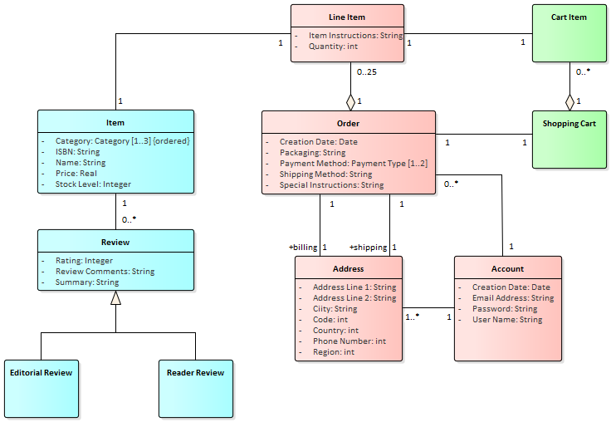

This section lists the main tools available in Enterprise Architect that can be used to perform this business analysis technique.  
There is also a wide range of additional tools that a modeler might find suitable when applying the technique in a particular context.  
The complete list of tools is available from the topic *Business Modeling Tools*.

Class Diagram

A **Class Diagram** can be used to model important data elements in the domain.  
The elements are modeled using UML Classes and Names, Aliases, Descriptions and other details such as Attributes can be entered for each Class.  
The elements can be related to each other using relationships such as the Association and Generalization.  
These elements can then be used throughout the model as a data dictionary, including in element notes where they can be referenced.

Learn More: [Class Diagram](http://www.sparxsystems.com/enterprise_architect_user_guide/13.5/guidebooks/tools_ba_class_diagram.html)

Database Builder

The **Database Builder** can be used to create a Data Dictionary.  
The elements are modeled as Tables and Names, Aliases, Descriptions and other details such as Attributes can be entered for each table.  
The Attributes can be given Names and Descriptions and other details such as the number of allowable values can be defined.

Learn More: [Database Builder](http://www.sparxsystems.com/enterprise_architect_user_guide/13.5/guidebooks/tools_ba_database_builder.html)

Entity Relationship Diagram

An Entity Relationship Diagram can be used to define the elements of a Data Dictionary.  
There are a number of different representations that can be used but the style used in Enterprise Architect uses rectangles to represent Entities, ellipses to represent Attributes and diamonds to represent connections between Entities.

Learn More: [Entity Relationship Diagram](http://www.sparxsystems.com/enterprise_architect_user_guide/13.5/guidebooks/tools_ba_entity_relationship_diagram.html)

Documentation

Enterprise Architect has a powerful and flexible documentation generator that can produce Docx and RTF Word Processor files, PDF and HTML reports.  
The elements defined in the data dictionary can be conveniently generated and included in documentation.  
This includes the element Name, Alias, Description, Type and a variety of other information including Attributes, **Tagged Values** and Connections with other elements.  
A sophisticated template facility exists that provides a range of in-built templates and allows the user to create their own, defining styles, images and a wide range of other formatting options.

Learn More: [Documentation](http://www.sparxsystems.com/enterprise_architect_user_guide/13.5/guidebooks/tools_ba_documentation.html)

## Data Flow Diagrams

These diagrams show how data flows through an information system, which processes or external entities create or consume the data, and where it is stored.  
They do not detail the sequencing between processes, which would be represented by process models.  
Enterprise Architect provides a **Data Flow Diagram** that modelers can use to create expressive diagrams with click-through drill-down from the Concept diagram right through to the lowest level diagram.

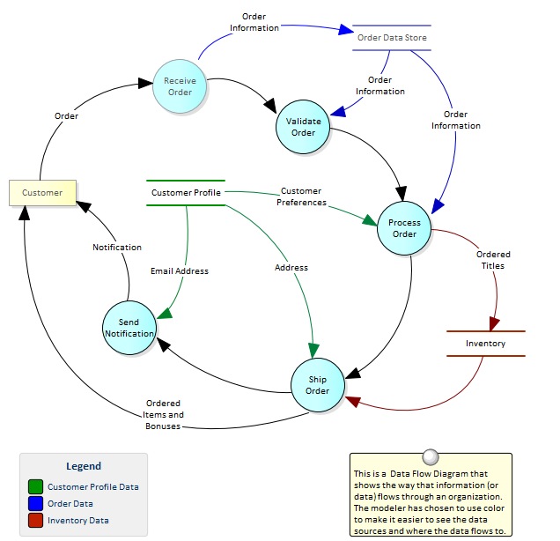

This section lists the main tools available in Enterprise Architect that can be used to perform this business analysis technique.  
There is also a wide range of additional tools that a modeler might find suitable when applying the technique in a particular context.  
The complete list of tools is available from the topic *Business Modeling Tools*.

Data Flow Diagram

The **Data Flow Diagram** (DFD) is part of the Structured Systems Analysis and Design Method and is used to show the way that data flows through a system including the Processes, Data Stores and Entities that relate to the data.

Learn More: [Data Flow Diagram](http://www.sparxsystems.com/enterprise_architect_user_guide/13.5/guidebooks/tools_ba_data_flow_diagram.html)

## Data Modeling

Enterprise Architect has profound support for Data Modeling.  
Data models describe the things that are important in a domain or solution, and their attributes (or columns), including their types and the relationships between them.  
Data modeling can be done for a number of reasons, including to clarify and communicate and also to implement a solution on a particular technology platform.  
Data modeling can occur at a number of different levels, from the conceptual data models that are analogous to concept models and are used for clarifying and communicating, through logical data models that include data normalization to physical models used for implementation.  
Enterprise Architect has a number of diagrams such as the Class diagram and the Data Modeling diagram that can be used to visualize the models, and a number of purpose built tools such as the **Database Builder** and the **Schema Composer** that will assist a modeler to be highly productive.

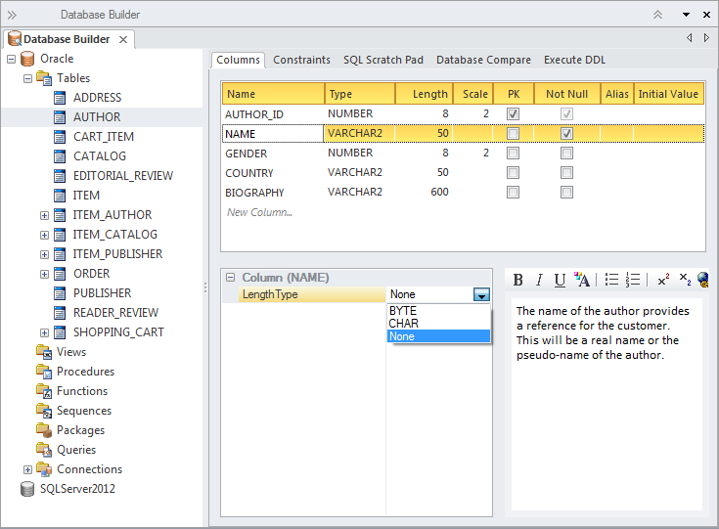

This section lists the main tools available in Enterprise Architect that can be used to perform this business analysis technique.  
There is also a wide range of additional tools that a modeler might find suitable when applying the technique in a particular context.  
The complete list of tools is available from the topic *Business Modeling Tools*.

Class Diagram

Conceptual data models can be defined using a **Class Diagram** and these often provide an abstract (conceptual) precursor for logical and physical data models.  
These information models can be created at any level of detail ranging from a simple list of elements to elements related to each other with connectors and containing Attributes.

Learn More: [Class Diagram](http://www.sparxsystems.com/enterprise_architect_user_guide/13.5/guidebooks/tools_ba_class_diagram.html)

Database Builder

The **Database Builder** is the primary tool for working with live databases and the data models that represent them.  
The tool can be used to model a database from scratch including a wide range of database objects such as Tables, Views, Stored Procedures and more.  
Databases can be generated from the data models and data models can be reversed engineered from live database connections.  
A modeler can work with the database objects in tabular form or in a diagram.

Learn More: [Database Builder](http://www.sparxsystems.com/enterprise_architect_user_guide/13.5/guidebooks/tools_ba_database_builder.html)

Entity Relationship Diagram

An Entity Relationship Diagram is a conceptual or abstract model of information for a system often created as a precursor for the development of a database schema.  
The Entities and their attributes can be modeled and the relationships between one or more Entities can be drawn.

Learn More: [Entity Relationship Diagram](http://www.sparxsystems.com/enterprise_architect_user_guide/13.5/guidebooks/tools_ba_entity_relationship_diagram.html)

Generate or Import XML Schema

XML schemas are typically used as a standards-based data definition for the exchange of information between systems or parts of systems.  
Enterprise Architect has support for modeling schemas and generating schemas (xsd) documents based on these models.  
There is also the ability to reverse engineer a schema document into a schema model.

Learn More: [Generate or Import XML Schema](http://www.sparxsystems.com/enterprise_architect_user_guide/13.5/guidebooks/tools_ba_xml_schema_generation_and_import.html)

Model Transformation

Model transformations are a powerful productivity tool that can be used with data modeling.  
The transformation engine has a number of built-in but configurable templates which can be used to transform a conceptual class model into a logical or physical database schema.  
The generated schema can then also be generated to Database Manipulation Language (DDL) and or using the **Schema Composer** applied directly to an existing database.

Learn More: [Model Transformation](http://www.sparxsystems.com/enterprise_architect_user_guide/13.5/guidebooks/tools_ba_model_transformation.html)

Schema Composer

The **Schema Composer** allows a modeler to work with industry standard schema definitions to create the structure for messages flowing between organizations, systems, or parts of systems.  
The Schema Composer supports a number of international standard models and hides much of the underlying complexity inherent with working with complex schemas.  
It also supports the generation of the messages in a number of formats, including **XSD**, RDFS and JSON.

Learn More: [Schema Composer](http://www.sparxsystems.com/enterprise_architect_user_guide/13.5/guidebooks/tools_ba_schema_composer.html)

Visual Filters

Visual Filters can be used to hide or dim parts of the diagram so that other parts can be emphasized.  
This is particularly useful when presenting a Data Modeling diagram to a team in a meeting or demonstration.  
Context Filtering is easy to setup and will emphasize the currently selected diagram element and its directly connected elements.

Learn More: [Visual Filters](http://www.sparxsystems.com/enterprise_architect_user_guide/13.5/guidebooks/tools_ba_visual_filters.html)

## Decision Modeling

Enterprise Architect can be used for decision modeling at any level.  
It provides tools such as the **Decision Table** and Decision Tree to model simple decisions, and a **Requirements Diagram** can be used to show the breakdown of a complex decision into parts that can be linked by dependencies.  
Business Rules can be referenced as a source of the business logic for making decisions.

This section lists the main tools available in Enterprise Architect that can be used to perform this business analysis technique.  
There is also a wide range of additional tools that a modeler might find suitable when applying the technique in a particular context.  
The complete list of tools is available from the topic *Business Modeling Tools*.

Requirements Diagram

A **Requirements Diagram** used to model decisions is a visual representation of the information, knowledge, and decision making involved in a more complex business decision.  
Decisions can be represented by stereotyped Classes and take a set of inputs and select from a defined set of possible outputs.  
Business rules and other mechanism for defining business logic can be included.  
Inputs to decisions can be Classes representing the data that is needed as input to the decision.  
An Artifact can be used to represent the source document or parties from which the necessary decision logic has been determined.

Learn More: [Requirements Diagram](http://www.sparxsystems.com/enterprise_architect_user_guide/13.5/guidebooks/tools_ba_requirements_diagram.html)

Decision Table

The **Decision Table Editor** can be used simply to record the conditions and the conclusions that form the basis of decision making.  
Alternatively implementation code can be generated using the Enterprise Architect Simulation Library (EASL) code generation macros.  
It uses a clear and understandable interface allowing the analyst to enter conditions, condition value columns, defined values that act as a decision point, and one or more conclusions.

Learn More: [Decision Table Editor](http://www.sparxsystems.com/enterprise_architect_user_guide/13.5/guidebooks/tools_ba_decision_table_editor.html)

Decision Tree

A Decision Tree is a diagram that is part of the Strategic Modeling Technology and uses a visual notation to represent a series of decisions and possible outcomes.  
It can be used in either a descriptive or predictive manner to visualize outcomes and decision points.  
It is particularly useful when a complex or intractable decision need to be formally recorded.  
The diagram or elements such as the outcomes can be linked to other elements in the repository such as solution options.

Learn More: [Decision Tree Diagram](http://www.sparxsystems.com/enterprise_architect_user_guide/13.5/guidebooks/tools_ba_decision_tree_diagram.html)

## Functional Decomposition

Enterprise Architect has been built as a platform for managing models of complex systems including business, information and technology systems.  
The tool allows business concepts such as outcomes, capabilities and processes to be decomposed.  
Information models can be broken down from high level concepts to details and technology models of components and devices can also be decomposed.  
There are a wide range of tools for working with and representing these models starting with the **Project Browser** that displays elements in a hierarchy allowing the user to expand or collapse levels thus revealing or hiding detail.  
Decomposition can also be represented in diagrams using elements such as the Aggregation connector on a single diagram or the ability to drill down through a whole chain of connected diagrams from a high level element in a value chain down to the low level processes.

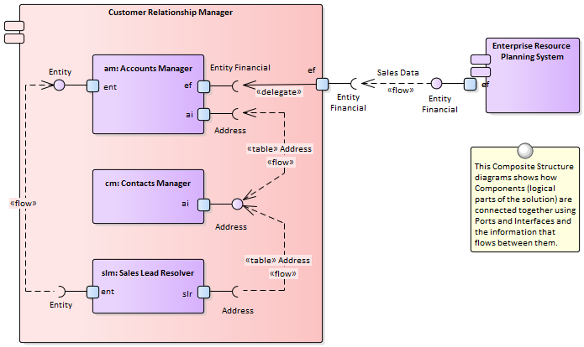

Component Diagram

The composition of a system can be shown using a **Component Diagram** where systems are displayed in a hierarchy including drill down to other Component Diagrams.  
This allows a complex system that is made up of a number of subsystems to be modeled.

Learn More: [Component Diagram](http://www.sparxsystems.com/enterprise_architect_user_guide/13.5/guidebooks/tools_ba_component_diagram.html)

Organizational Chart Diagram

The Organizational Chart Diagram is part of the Strategic Modeling group of diagrams and shows the structure of an organization including officials, roles responsibilities, business units or departments.  
The roles or departments can be displayed in a diagram using a tree layout or in a list view.  
Any number of **Tagged Values** can be added to the elements or connectors to add additional information as required.  
The diagram can be used to show the decomposition of an organization by roles or business units.

Learn More: [Organizational Chart Diagram](http://www.sparxsystems.com/enterprise_architect_user_guide/13.5/guidebooks/tools_ba_organizational_chart_diagram.html)

Project Browser

Functional Decomposition can be achieved by creating a feature hierarchy using the **Project Browser** without the need to create a diagram.  
A system Feature is a good way to capture the high level capabilities of a system and these can be created directly in the Project Browser.  
Additional features can be added under each first level feature creating a second level of features.  
These second level features can have features nested under them creating a third level.  
The resulting tree of Features provides a useful way of describing Functional Decomposition that can be presented to and reviewed by stakeholders.

Learn More: [Project Browser](http://www.sparxsystems.com/enterprise_architect_user_guide/13.5/guidebooks/tools_ba_project_browser.html)

Requirements Diagram

Functional Decomposition can be achieved by using a Requirements diagram to create a hierarchy of system features.  
A system Feature is a good way to capture the high level capabilities of a system, and these can be broken down to a number of levels using a tree structure created with an Aggregation or Composition Relationship.  
This provides a compelling representation of scope that can be reviewed by the stakeholders and used as a guide through the initiative.  
Gaps and out-of-scope features should be identified as early as possible and the tree amended to reflect these.  
Out of Scope features could be left as part of the tree but annotated in some way to indicate that they are out of scope such as by using a stereotype or by using color with a diagram legend.

Learn More: [Requirements Diagram](http://www.sparxsystems.com/enterprise_architect_user_guide/13.5/guidebooks/tools_ba_requirements_diagram.html)

BPMN Business Process Diagram

The **BPMN Business Process** Diagram is useful for modeling business processes that form part of a process hierarchy.  
Enterprise Architect allows the modeler to define a decomposition of processes that can be drilled down to from a higher level.  
It allows a modeler to document the business process including the way a process starts, what work is performed and how it ends.  
Gateways and connecting lines determine the sequence of activities.  
The **Business Process Diagram** is emerging as an important standard for modeling business processes.

Learn More: [Business Process Diagram](http://www.sparxsystems.com/enterprise_architect_user_guide/13.5/guidebooks/tools_ba_bpmn_business_process_diagram.html)

Specification Manager

The **Specification Manager** is the primary tool for working with text based elements such as Features, Requirements and Components.  
These and other elements can be created directly in the Specification Manager and their name and descriptive text can be added in a compelling Word Processor or Spreadsheet like format.  
Other built-in properties such as status, version and phase can be managed directly in the columns of the Specification Manager and where property lists are available these can be chosen or changed from drop down lists.  
Additional properties in the form of **Tagged Values** can also be managed from within the Specification Manager.  
The Specification Manager will reflect the hierarchical structure of elements and can use level numbering if this has been turned on.

Learn More: [Specification Manager](http://www.sparxsystems.com/enterprise_architect_user_guide/13.5/guidebooks/tools_ba_specification_manager.html)

UML Activity Diagram

The Activity diagram, which is part of the Unified Modeling Language, is a useful alternative to other diagrams such as Flow Charts and Business Process Diagrams.  
They allow a modeler to describe the sequence of behaviors including how they start, what work is performed and decisions that change the flow and the way the process ends.

Learn More: [Activity Diagram](http://www.sparxsystems.com/enterprise_architect_user_guide/13.5/guidebooks/tools_ba_uml_activity_diagram.html)

ArchiMate Business Process Diagram

Allows the high level description of a business process showing what triggers the process and the order of processes.  
If detailed representations are required **BPMN Business Process** diagrams or **UML Activity** diagrams can be used.

Learn More: [ArchiMate](http://www.sparxsystems.com/enterprise_architect_user_guide/13.5/model_domains/archimate.html)

## Glossary

Enterprise Architect supports two different ways of creating a glossary.  
The most obvious way is to use the built-in **Project Glossary** which is available from the Publish ribbon.  
This provides a convenient way for modelers to store terms and their associated meanings grouped by user defined categories.  
An alternative (and perhaps more sophisticated) method is to create a Class diagram of the terms, linking the elements to create relationships between the terms.

Enterprise Architect has a convenient Project Glossary that can be used to store a list of terms and their definitions.  
The terms can be grouped into any number of user defined categories such as business, technical, domain specific grouping such as medical, scientific, or aviation.  
The power of having the terms defined in the model is realized when modelers write description in model elements as these will be linked automatically to terms defined in the Project Glossary.



Project Glossary

The Glossary is a purpose built tool for managing project terms and their meanings which can be included in documentation.  
If words defined in the Glossary are used in element or diagram notes they will automatically appear as hyperlinks and the meaning will conveniently appear in a pop-up window.

Learn More: [Glossary](http://www.sparxsystems.com/enterprise_architect_user_guide/13.5/guidebooks/tools_ba_glossary.html)

Class Diagram

A **Class Diagram** can be used to model important concepts in the domain.  
The concepts are modeled using UML Classes and Names, Descriptions and other details such as Attributes can be entered for each Class.  
The concepts can be related to each other using relationships such as the Association and Generalization.  
These concepts can then be used throughout the model as a type of Glossary, including in element notes where they can be referenced.

Learn More: [Class Diagram](http://www.sparxsystems.com/enterprise_architect_user_guide/13.5/guidebooks/tools_ba_class_diagram.html)

Documentation

Enterprise Architect has a powerful and flexible documentation generator that can produce Docx and RTF Word Processor files, PDF and HTML reports.  
The terms defined in the Glossary or the Classes used to define the concepts can both be conveniently generated and included in documentation.  
In the case of terms defined in the Glossary, this includes the term Name, Description and Type.  
In the case of terms defined as Classes, it includes the term Name, Description and a variety of other information including Attributes, **Tagged Values** and Connections with other terms.  
A sophisticated template facility exists that provides a range of in-built templates and allows the user to create their own, defining styles, images and a wide range of other formatting options.

Learn More: [Documentation](http://www.sparxsystems.com/enterprise_architect_user_guide/13.5/guidebooks/tools_ba_documentation.html)

## Process Modeling

A process model can be used to model a wide range of sequential activities including business processes, system processes or even the flow through an algorithm in a programming module.  
Enterprise Architect supports a variety of ways to model processes including the Unified Modeling Language (UML) Activity diagrams, Business Process Model and Notation (BPMN) Business Process Diagrams and Flow Charts as part of the Strategic Diagramming set.  
These can be drawn at any level and drill down functionality is provided allowing a modeler to click through from a high level diagram such as a value chain down to the task level representations.  
The process elements can be linked to a wide range of other elements including: Business Rules, Polices, Standard Operating Procedures and Use Cases or User Stories.

The tool supports both Current State and Future State modeling and transitions can be modeled showing the time sequence of changes between the current state and the future state.  
Enterprise Architect also has the ability to run model simulations from these models allowing powerful insights to be gained that will assist with improving efficiency and effectiveness.

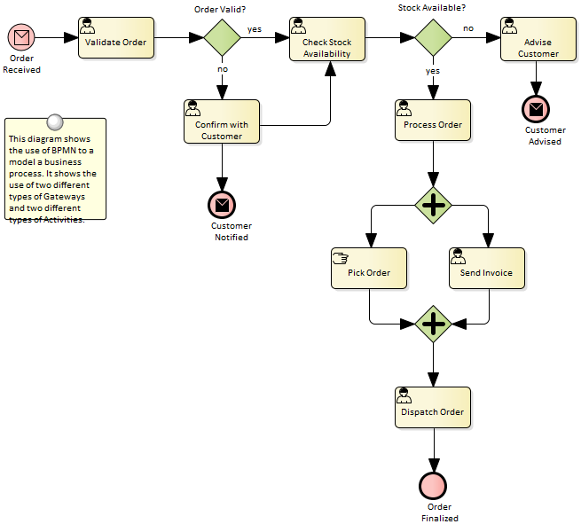

Enterprise Architect supports a number of different languages and techniques for performing Process Modeling.  
The choice of language will depend on what has been defined as a standard by the organization or pragmatic considerations such as what the customer or subject matter experts will be most comfortable with.

BPMN Business Process Diagram

Business Process Diagrams are part of the Business Process Model and Notation (BPMN) standard and allow a modeler to document a business process, including the way the process starts, what work is performed and how it ends.  
Gateways and connecting lines determine the sequence of activities.  
Current state and Future state process models can be created and managed in Enterprise Architect.  
The diagrams can be organized into a process hierarchy allowing drill down from high level to lower level diagrams.  
BPMN is emerging as an important standard for modeling business processes and has gained much traction with business and technical communities.  
It can be automatically generated to the Business Process Execution Language (BPEL), which is an XML based language that can be ingested by a number of orchestration engines.

Learn More: [Business Process Modeling](http://www.sparxsystems.com/enterprise_architect_user_guide/13.5/guidebooks/tools_ba_bpmn_business_process_diagram.html)

UML Activity Diagram

Activity diagrams are one of the Behavioral Unified Modeling Language diagrams and allow a modeler to describe the sequence of behaviors including how they start, what work is performed and decisions that change the flow and the way the process ends.  
They are a useful alternative to using other diagrams such as flow charts and business process diagrams.  
The syntax of activity diagrams when Actions and Pins are used can be drawn at the execution level and express detailed system semantics.

Learn More: [Activity Diagram](http://www.sparxsystems.com/enterprise_architect_user_guide/13.5/guidebooks/tools_ba_uml_activity_diagram.html)

Flowcharts

A flow chart can be used to represent a process, workflow or algorithm and is a general purpose diagram for representing a sequence of steps and decisions.  
Connecting lines determine the sequence of the steps in the flow chart.  
Flow charts are an easy to understand representation of the steps in a process.  
The syntax of the diagrams are much easier to understand than their more advanced cousins: the **BPMN Business Process** Diagram and the **UML Activity** diagrams.

Learn More: [Flow Chart Diagram](http://www.sparxsystems.com/enterprise_architect_user_guide/13.5/guidebooks/tools_ba_flow_chart_diagram.html)

ArchiMate Process Diagram

Allows the high level description of a business process showing what triggers the process and the order of processes.  
If detailed representations are required **BPMN Business Process** diagrams or **UML Activity** diagrams should be used.

Learn More: [ArchiMate](http://www.sparxsystems.com/enterprise_architect_user_guide/13.5/model_domains/archimate.html)

Data Flow Diagram

A **Data Flow Diagram** provides a diagrammatic representation of the way data (information) flows through an information system.  
It shows where the data originates and where it is consumed and stored.  
These diagrams typically show the functions (or processes) that operate on the data but do not indicate timing or sequencing.

Learn More: [Data Flow Diagrams](http://www.sparxsystems.com/enterprise_architect_user_guide/13.5/guidebooks/tools_ba_data_flow_diagram.html)

Business Rules Analysis

Business Rules are often associated with the Activities described in a process model and best practice suggests they should be managed separately from the Activities but they should be linked to the Activities they apply to.

Learn More: [Business Rules Model](http://www.sparxsystems.com/enterprise_architect_user_guide/13.5/guidebooks/tools_ba_business_rules_model.html)

Organizational Chart Diagram

The activities (steps) in a business process are typically performed by a role in the organization (or by a system on behalf of a role).  
Thus an Organizational Chart will provide a useful source for these roles and will help the analyst to express the relationship between the steps in the process and the roles that perform them.  
It is also common for a business unit or stakeholder to be responsible for a process and these units or roles can be related to the Activities either using diagram relationships or **Tagged Values**.

Learn More: [Organizational Chart Diagram](http://www.sparxsystems.com/enterprise_architect_user_guide/13.5/guidebooks/tools_ba_organizational_chart_diagram.html)

Baselines

The Baseline Tool is used as a type of comparison and backup and recovery tool.  
The tool can capture a snapshot of the Process Models at a point in time and then at a later time the repository can be compared to this (or another baseline) for the purpose of determining what has changed.  
It is possible to revert the current model to a state captured in the baseline at the level of a granular change.  
This is a useful tool when working with Processes or any other model that typically has sign off milestones.  
**Baselines** are typically taken at important milestones and given a memorable name such as 'After Stakeholder Final Workshop'.  
Baselines can be applied at the Package level and can be applied regardless of what type of elements are contained in the Package.

Learn More: [Baseline Tool](http://www.sparxsystems.com/enterprise_architect_user_guide/13.5/guidebooks/tools_ba_baseline_tool.html)

Visual Filters

Visual Filters can be used to hide or dim parts of the diagram so that other parts can be emphasized.  
This is particularly useful when presenting a Business Process diagram to a team in a meeting or demonstration.  
Context Filtering is easy to setup and will emphasize the currently selected diagram element and its directly connected elements.

Learn More: [Visual Filters](http://www.sparxsystems.com/enterprise_architect_user_guide/13.5/guidebooks/tools_ba_visual_filters.html)

## Prototyping

Enterprise Architect has a variety of facilities that can assist with prototyping and in many ways everything in the tool is a kind of prototype.  
Whiteboard and hand drawn diagram styles can be used to create appealing mockups of information.  
There is also a powerful facility to create user interface pages and screens and wire frame models for web or client applications including user controls such as drop down lists bullets and check boxes.  
The wire framing feature supports modern hand held devices such as phones and tablets including Apple and Android devices.  
There is a diagram slide-show that allows an analyst to present a complete mockup of the screens that would be part of a scenario.  
Evolutionary prototypes can also be developed by generating code from the system models in Enterprise Architect.



Model Views

The **Model Views** facility provides a useful Slide Show folder where any number of diagrams can be added to a slide show.  
This is a useful tool for presenting prototypes particularly when there are a number of diagrams that describe the user interface in different states such as how the interface responds to a button click.  
The slide show can be configured to run automatically with a specified time interval or slide progression can be performed manually.  
Any number of slide shows can be created and they could be used for a variety of purposes such as showing the interface on different devices, phones, tablets or computers.

Learn More: [Model Views](http://www.sparxsystems.com/enterprise_architect_user_guide/13.5/guidebooks/tools_ba_model_views.html)

Wire Frame Diagram

Wire Frame Diagrams allow a modeler to create powerful and expressive models of the user interface for a variety of hand held devices including Apple, Android and Windows phones and tablets.  
Screen dialogs and web pages can also be modeled.  
The physical appearance of the devices themselves can be represented and configured by the use of a number of **Tagged Values**.  
Patterns can be used to automatically create a base model for a device.  
A range of controls are available applicable to each type of device including Android Widgets, Apple Controls and Windows Tiles.

Learn More: [Wireframe Diagram](http://www.sparxsystems.com/enterprise_architect_user_guide/13.5/guidebooks/tools_ba_wire_frame_diagram.html)

Visual Filters

Visual Filters can be used to hide or dim parts of the diagram so that other parts can be emphasized.  
This is particularly useful when presenting a prototype to a team in a meeting or demonstration, allowing irrelevant elements to be filtered out.  
Context Filtering is easy to set up and will emphasize the currently selected diagram element and its directly connected elements.

Learn More: [Visual Filters](http://www.sparxsystems.com/enterprise_architect_user_guide/13.5/guidebooks/tools_ba_visual_filters.html)

## Sequence Diagrams

Enterprise Architect has a full and rigorous implementation of the Unified Modeling Language static and dynamic diagrams including the **Sequence Diagram**.  
These diagrams are useful for a range of purposes where the Classifiers (or Instances) that participate in achieving an outcome interact together, sending and receiving messages.  
A common use is to show how a Use Case or Scenario will be implemented, or how a series of system components interact.  
The messages can have parameters defined that can be used to define the payloads that are contained in the message.

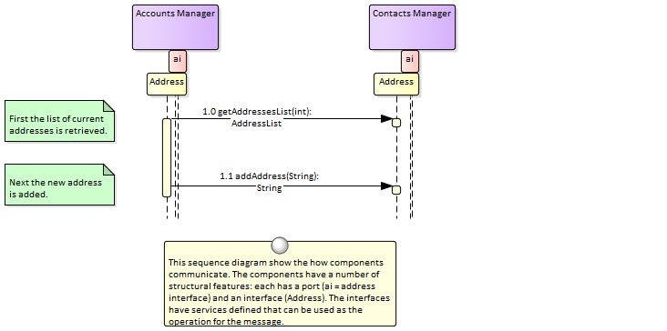

Sequence Diagram

Enterprise Architect provides support for creating and viewing Sequence diagrams.  
These can be modeled at a classifier or an instance level.  
Element or Object lifelines can be displayed and they can be created and destroyed.  
Synchronous and Asynchronous messages are supported that can be related to classifier operations, including the sending of parameters and return values.  
Fragments are supported and can be used to create highly expressive diagrams.  
Ports and Interfaces can be represented on the diagrams, allowing complex solution architectures and designs to be modeled.  
There is also a facility to automatically create Sequence diagrams from a running system's stack trace, which allows powerful analysis to be performed and comprehensive and accurate documentation to be generated.

Learn More: [Sequence Diagram](http://www.sparxsystems.com/enterprise_architect_user_guide/13.5/guidebooks/tools_ba_sequence_diagram.html)

## State Modeling

Enterprise Architect has a full and rigorous implementation of the Unified Modeling Language static and dynamic diagrams including the State diagram.  
Any entity in the system can have a **StateMachine diagram** and these can be conveniently located under the entity in the **Project Browser**.  
The tool has rich support for many of the powerful aspects of these machines including the ability to generate code directly from the diagrams.  
The StateMachine diagrams can also be automatically converted into a State Table.

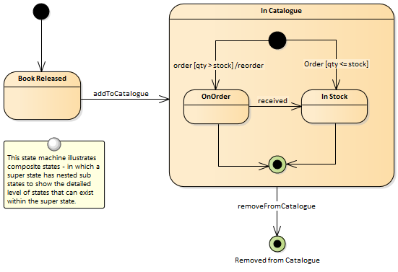

StateMachine Diagram

A **StateMachine diagram** is a powerful way of presenting information about the lifetime of a business or technical entity.  
It can be used to describe the important conditions (States) that occur in an entity's lifetime or cycles.  
Typically only entities that have important stages in their lifetime are modeled with StateMachine diagrams.  
The entity is said to transition from one State to another as specified by the StateMachine.  
Triggers and Events can be described that allow the state transition to occur and Guards can be defined that restrict the change of state.  
Each State can define the behaviors that occur on entry, during and exit from the State.

Enterprise Architect allows the StateMachine diagram to be automatically converted to a State Table.  
The State Table Editor is often a more intuitive way of working with the StateMachine for some users.

The StateMachine can be exported to a Spreadsheet file allowing the States and Transitions to be anlayzed.

There is also support for simulation of the StateMachine and the creation of an Executable StateMachine that can be used to generate a language specific behavioral 'engine' for multiple software products on multiple platforms.

Learn More: [StateMachine Diagram](http://www.sparxsystems.com/enterprise_architect_user_guide/13.5/guidebooks/tools_ba_state_machine_diagram.html)

Visual Filters

Visual Filters can be used to hide or dim parts of the diagram so that other parts can be emphasized.  
This is particularly useful when presenting the **StateMachine diagram** to a team in a meeting or demonstration.  
Context Filtering is easy to setup and will emphasize the currently selected diagram element and its directly connected elements.

Learn More: [Visual Filters](http://www.sparxsystems.com/enterprise_architect_user_guide/13.5/guidebooks/tools_ba_visual_filters.html)

## Use Cases and Scenarios

Enterprise Architect has a full and rigorous implementation of Use Cases and Scenarios including being able to create Use Case Diagrams that include Scenarios.  
The Use Cases and Scenarios can be included on a number of other diagrams to show how business processes are automated or which component realizes the Use Case.  
There is also an innovative editor where the detailed steps of Use Cases and Scenarios can be created and these can be generated to documentation thus completely dispensing with the need to create Word Processor files to document Use Cases.  
The steps can also be automatically generated to a number of diagram types including Activity and Sequence diagrams.  
The generated diagrams can be synchronized with the steps if they change and the diagrams redrawn.

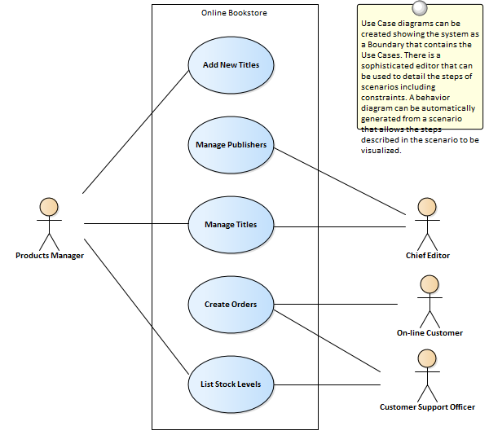

Scenario Builder

The **Scenario Builder** is a productive and unique tool and editor that allows the analyst to work with the text of Use Cases and Scenarios directly inside the model.  
Many analysts will be familiar with creating long and voluminous Word Processor documents describing the details of Use Cases.  
With the Scenario Builder the descriptions and steps of Scenarios can be entered directly into the repository and linked to other elements.  
Alternate and Exception paths can be defined including branch and re-entry points.  
Diagrams representing the steps in a scenario can be generated and automatically synchronized.  
Constraints including Preconditions and Post-conditions can be defined and Test Cases automatically generated.  
Elements that have a relationship to the selected Use Case are listed in a convenient Context Reference list.

Learn More: [Scenario Builder](http://www.sparxsystems.com/enterprise_architect_user_guide/13.5/http://sparxsystems.com/enterprise_architect_user_guide/13.0/guidebooks/tools_ba_scenario_builder.html)

Use Case Diagram

The **Use Case Diagram** is a simple and powerful way of describing the goals the users of a system (or entity) want to achieve.  
It describes who wants to achieve a particular goal but not how the goal will be delivered.  
Use Case diagrams can be simple or structured and relationships such as Include, Extend and Generalization can be added to refine the model.  
A system (or entity) boundary can be added with a descriptive name showing clearly that Use Cases reside inside the system and Actors outside.

Learn More: [Use Case Diagram](http://www.sparxsystems.com/enterprise_architect_user_guide/13.5/guidebooks/tools_ba_use_case_diagram.html)

Relationship Matrix

The **Relationship Matrix** can be used to define and display the relationships that exist between Use Cases and other model elements including up-process and down-process elements.  
The up-process elements could include Business Processes, Stakeholder, Functional or Non-Functional Requirements, Business Use Cases and more.  
The down-process elements could include Components, Building Blocks, Test Cases and Experience models and more.

Learn More: [Relationship Matrix](http://www.sparxsystems.com/enterprise_architect_user_guide/13.5/guidebooks/tools_ba_relationship_matrix.html)

Traceability Window

The Traceability Window automatically displays the relationships that exist between Use Cases and other model elements including up-process and down-process elements.  
The traceability tree view can be conveniently expanded to see deeper relationships and elements displayed in the window can be located in all diagrams in which they appear.

Learn More: [Traceability Window](http://www.sparxsystems.com/enterprise_architect_user_guide/13.5/guidebooks/tools_ba_traceability_window.html)

Specification Manager

The **Specification Manager** can be used as an alternate tool for working with Actors and Use Cases.  
The names, descriptions and properties of the Actors, Use Cases and Scenarios can be conveniently created, viewed and edited in a list resembling a Word Processor or Spreadsheet presentation.

Learn More: [Specification Manager](http://www.sparxsystems.com/enterprise_architect_user_guide/13.5/guidebooks/tools_ba_specification_manager.html)

Documentation

Even though the **Scenario Builder** provides a productive way of defining Use Cases and Scenarios, there will be situations where formal documentation is required describing the Use Case.  
The **Document Generator** can be used to create high quality corporate documentation using a built-in Use Case Report template, or an analyst can define their own custom template.  
An HTML report can also be created, allowing click-through and drill-down.

Learn More: [Documentation](http://www.sparxsystems.com/enterprise_architect_user_guide/13.5/guidebooks/tools_ba_documentation.html)

## User Stories

Enterprise Architect has a purpose built User Story element that can be used to create a story.  
It is possible to link the User Story element to any number of other elements including business Goals, Objectives high level stakeholder requirements and detailed requirements resulting from grooming the story, constraints and more.  
These relationships can be conveniently viewed in diagrams or in the **Traceability window**.  
The **Specification Manager** is the perfect tool for working with the text of the User Story and provides a welcomed alternative to diagrams for those more familiar with working with word processors and spreadsheets.

Specification Manager

The **Specification Manager** can be used as an alternate tool for working with User Stories.  
The names, descriptions and properties of the User Stories can be conveniently created, viewed and edited in a list resembling a Word Processor or Spreadsheet presentation.  
Additional information entered as **Tagged Values** can also be viewed as columns in the Specification Manager.  
Information in the list can be filtered and the elements can be located in diagrams.

Learn More: [Specification Manager](http://www.sparxsystems.com/enterprise_architect_user_guide/13.5/guidebooks/tools_ba_specification_manager.html)

Documentation

User Stories will often be used by a number of different team members; some people - particularly those working on the business side - might prefer to work with the User Stories in document format.  
The **Document Generator** can be used to create high quality User Stories directly from the model, using built-in templates or user defined templates.

The User Stories can also be automatically generated to HTML, allowing the stories to be viewed through a Browser or incorporated with an Intranet or Extranet site

Learn More: [Documentation](http://www.sparxsystems.com/enterprise_architect_user_guide/13.5/guidebooks/tools_ba_documentation.html)

Relationship Matrix

The **Relationship Matrix** can be used to define and display the relationships that exist between User Storiesand other model elements including up-process and down-process elements.  
The up-process elements could include: Business Processes, Stakeholder, Functional or Non-Functional Requirements and more.  
The down-process elements could include: Components, Building Blocks, Test Cases and Experience models and more.

Learn More: [Relationship Matrix](http://www.sparxsystems.com/enterprise_architect_user_guide/13.5/guidebooks/tools_ba_relationship_matrix.html)

Traceability Window

The Traceability Window automatically displays the relationships that exist between User Stories and other model elements including up-process and down-process elements.  
The traceability tree view can be conveniently expanded to see deeper relationships and elements displayed in the window can be located in all diagrams in which they appear.

Learn More: [Traceability Window](http://www.sparxsystems.com/enterprise_architect_user_guide/13.5/guidebooks/tools_ba_traceability_window.html)

Documentation

The **Document Generator** can be used to create high quality corporate documentation using built-in Report templates or an analyst can define their own custom template.  
A html report can also be created allowing click-through and drill-down.

Learn More: [Documentation](http://www.sparxsystems.com/enterprise_architect_user_guide/13.5/guidebooks/tools_ba_documentation.html)

# Project Management

Project Management techniques are critical for the successful delivery of a project or initiative.  
There are a wide range of techniques used to organise a team ranging from very informal techniques such as Backlog Management used with Agile teams to very prescriptive techniques such as Risk Analysis and Management used in large and highly structured organisations.  
Enterprise Architect provides a wide range of tools to support a variety of project management techniques that can be used with any methodology or process.  
The tools allow project management information to sit beside or be connected to the underlying models which ensures that project management information is not separate from the analysis information and models.

## Backlog Management

Enterprise Architect has a number of facilities that can be used to manage backlogs.  
The most straight forward of these is the use of the built-in 'Priority' property (attribute) that can be used to categorize requirements based on a set of user-defined categories.  
Every element also has a 'Phase' and a 'Version' field that could be used for backlog management.

The **Specification Manager** allows the requirements to be visualized and grouped by their priority or any other property such as Complexity, Version, Phase or a **Tagged Value**.  
The elements, regardless of type can also be ordered in the **Project Browser**.

The **Package Browser** provides a convenient list view which is an alternative to using the Specification Manager and allows elements to be sorted and grouped by one of more properties.

**Model Views** can also be used to create one or more lists of elements that can be freely ordered and managed irrespective of the elements' location in the Project Browser.

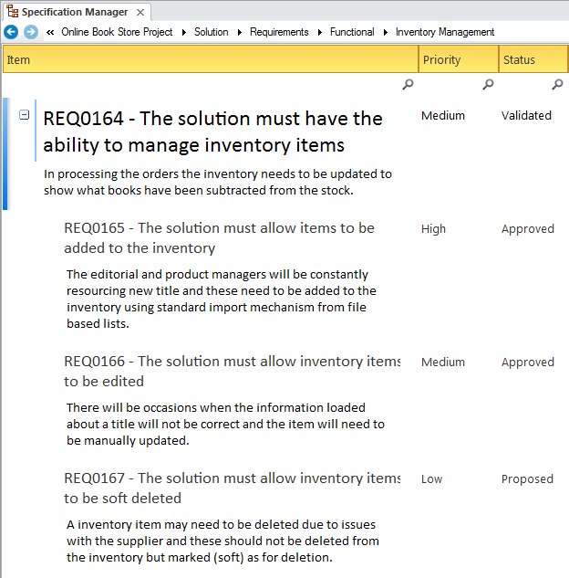

Element Properties

Every element in the Repository has a number of built-in properties such as 'Version' and 'Phase' that can be useful for defining and working with Backlogs.  
Some elements such as Requirements have a number of additional properties including 'Priority' that can be used.  
The 'Phase' and the 'Version' are free text fields so could be used to specify a group of elements for a sprint, release or iteration.  
The 'Priority' property can be given a discrete value defined in a list such as: 'High', 'Medium', 'Low'.

Learn More: [Element Properties](http://www.sparxsystems.com/enterprise_architect_user_guide/13.5/guidebooks/tools_ba_requirement_properties.html)

Model Views

In the **Model Views** Facility any number of Favorites Folders can be created that can be used as a Backlog and can contain an ordered list of any number of elements.  
Elements can simply be dragged from the **Project Browser** and dropped into the appropriately named Favorites folder.  
The elements can be of the same or different types and can be freely ordered within the list.  
A number of other folders could be used to represent sprints, releases or iterations.

Learn More: [Model Views](http://www.sparxsystems.com/enterprise_architect_user_guide/13.5/guidebooks/tools_ba_model_views.html)

Project Browser

The **Project Browser** can be used to manage a Backlog by simply ordering the elements in the tree view.  
This can be achieved using the **Up Arrow** button and **Down Arrow button** in the Project Browser header bar, or a tree item's context menu.  
This provides a simple but compelling way of ordering a list of elements as part of a backlog management.  
(The 'Allow Free Sorting' setting must be enabled on the 'General' page of the 'Preferences' dialog before items can be sorted in the Project Browser.)

Learn More: [Project Browser](http://www.sparxsystems.com/enterprise_architect_user_guide/13.5/guidebooks/tools_ba_project_browser.html)

Specification Manager

The **Specification Manager** is a powerful tool for working with requirements (or any other element) in a spreadsheet or word processor style of view.  
It provides a convenient text based interface that allows the properties of a set of elements to be viewed and edited as a group.  
The list of elements can be filtered based on any properties or **Tagged Values**, which provides a convenient way of working with element lists for backlogs.

Learn More: [Specification Manager](http://www.sparxsystems.com/enterprise_architect_user_guide/13.5/guidebooks/tools_ba_specification_manager.html)

Package Browser

The **Package Browser** provides a convenient way of viewing the elements in a package in a spreadsheet like list with rows and columns or as a Gantt chart showing resource allocation over time.  
The list view displays the elements in a selected package as rows with their properties viewable and editable in columns.  
The elements in the list can be sorted or grouped by one or more properties allowing for example high Priority, low Complexity requirements for Phase 3.1 to be grouped.

Learn More: [Package Browser](http://www.sparxsystems.com/enterprise_architect_user_guide/13.5/guidebooks/tools_ba_package_browser.html)

## Estimation

Enterprise Architect has a built-in tool for creating estimates of project effort and cost using Use Cases and Actors, based on Karner's 'Use Case Points Method'.  
The Use Cases and Actors are assigned a complexity and then user-defined environment and technical complexity factors are applied, with weightings to calculate the effort and cost.  
A metrics report can be created and included in a project's documentation.

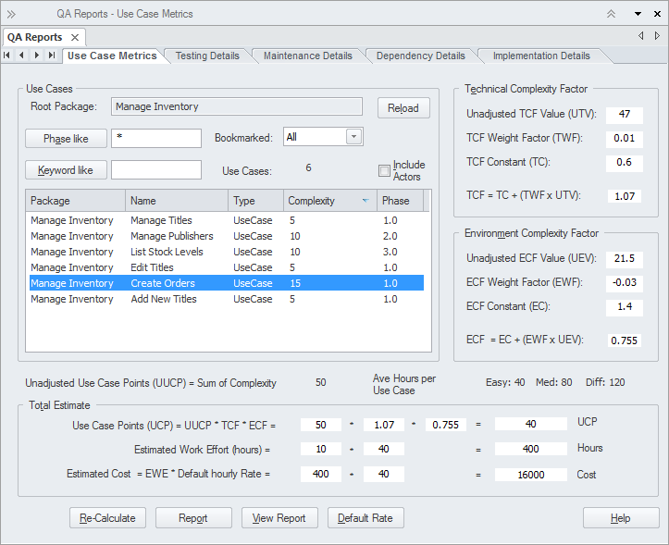

This section lists the main tools available in Enterprise Architect that can be used to apply this business analysis technique.  
There is also a wide range of additional tools that a modeler might find suitable when applying the technique in a particular context.  
The complete list of tools is available from the topic *Business Modeling Tools*.

Use Case Estimation

Use Case Estimation can be used to calculate the required effort to complete an initiative or part of an initiative.  
Environmental and Technical complexity factors can be defined and given weights and values that determine how they influence the effort that is calculated for an initiative.

Learn More: [Use Case Estimation](http://www.sparxsystems.com/enterprise_architect_user_guide/13.5/guidebooks/tools_ba_use_case_estimation.html)

## Item Tracking

Enterprise Architect is a powerful modeling platform that has an impressive range of ancillary tools over and above its core modeling functionality to assist the modeler working in a dynamic business environment.  
The implementation of a solution will take time and stakeholders will have concerns and issues that won't have been present at the time they articulated their needs and requirements.  
These can be recorded in the model either at the level of the model or at the level of an individual element such as a requirement or any other element.

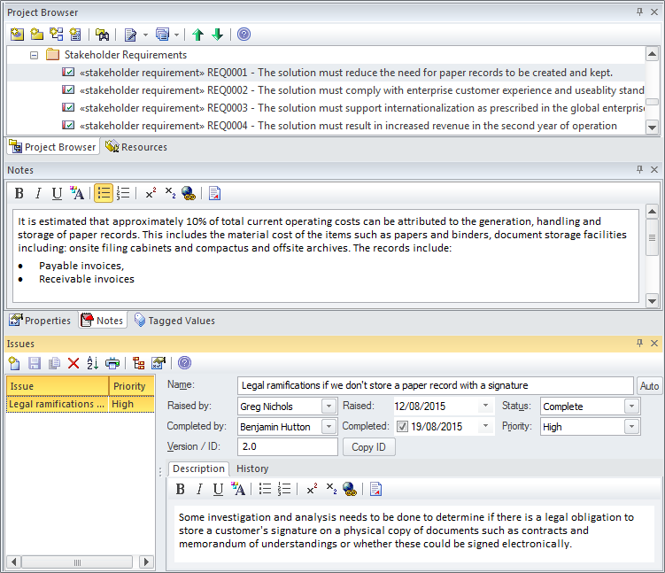

Element Browser

The **Element Browser** is a tree view window that displays one element at a time and presents the details of the element including its name, Attributes, Constraints, Relationships, **Tagged Values** and more.  
In addition Maintenance Items are displayed and an edit window can be launched to edit the items.

Learn More: [Element Browser](http://www.sparxsystems.com/enterprise_architect_user_guide/13.5/guidebooks/tools_ba_element_browser.html)

Maintenance Items

Maintenance items can be used to record a variety of items including Defects, Changes, Issues, Tasks, Decisions and Events.  
These can be added to the repository at any level from a high level package such as a Functional Requirements Package down to an individual Requirement level or for any other element type.  
Applicable metadata can be stored against each item including its Name, Description, Status, Priority, who it was Raised by, Completion details and more.

Learn More: [Maintenance Items](http://www.sparxsystems.com/enterprise_architect_user_guide/13.5/guidebooks/tools_ba_maintenance_items.html)

Documentation

Enterprise Architect has a powerful and flexible documentation generator that can produce Docx and RTF Word Processor files, PDF and HTML reports.  
Maintenance Items such as Issues, Defects and Decisions and more stored in the repository can be conveniently generated and included in documentation.  
The Maintenance Items can be included under the elements they apply to, including high level Packages and low level elements.  
A sophisticated template facility exists that provides a range of in-built templates and allows the user to create their own, defining styles, images and a wide range of other formatting options.

QA Reports can also show the Maintenance Items aggregated across the repository, allowing filtering and Item type restrictions to be defined.

Learn More: [Documentation](http://www.sparxsystems.com/enterprise_architect_user_guide/13.5/guidebooks/tools_ba_documentation.html)

## Lessons Learned

Many processes and methodologies include a post project review phase, where projects can be analyzed and reviewed for successes, failures and opportunities for improvement that would benefit future projects.  
Enterprise Architect has a flexible **Team Review** facility that allows any part of a model or practice to be reviewed, including things such as naming conventions, modeling style, modeling language usage and correctness and any other dimension of a project.  
This facility is typically used during the execution of a project such as at important milestones or every week or month, and can also be used at the end of a project to gain value insights into how to improve future projects.  
There is the ability to dynamically reference any part of the models, such as elements, Packages and diagrams and these can be conveniently added to the review by dragging and dropping them from the **Project Browser**.  
There is a flexible built-in word processor where text can be created and formatted, making it available right inside the modeling environment.

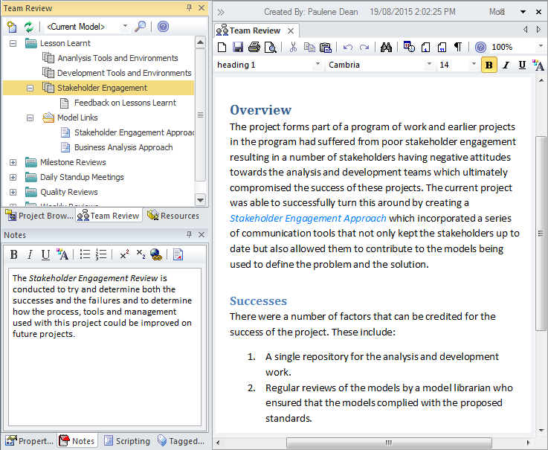

Document Artifact

A Document Artifact can be used as an alternative to using the **Team Review** facility for recording the Lessons Learnt.  
A template could be specified for the document and the details of the session recorded into the Document.  
Other model elements that represent successes, failures or have some importance to the lessons can be dragged into the document as links.

Learn More: [Document Artifact](http://www.sparxsystems.com/enterprise_architect_user_guide/13.5/guidebooks/tools_ba_document_artifact.html)

Team Review

The **Team Review** facility is a powerful tool for assisting with a Lessons learned session regardless of the format of the session.  
Creating and recording a Lessons Learnt session directly in the model is useful as it allows a reviewer to include links which reference parts of the repository such as Requirements or Components.  
There is a word processor document available that can be used to describe aspects of the review and a template can be used to define the structure of the document.  
Any number of categories can be set up for the sessions and topics and documents can be added to these to form a hierarchy.  
Resources such as XML files and Images can be added under the Category, Topic or Document.  
A new Lessons Learnt Team Review could be set up at important project milestones.

Learn More: [Team Review](http://www.sparxsystems.com/enterprise_architect_user_guide/13.5/guidebooks/tools_ba_team_reviews.html)

Calendar

The **Calendar** provides a way to record and present important temporal information such as events and meetings in calendar format.  
Lesson Learned sessions can be entered into the Calendar and setup as recurring if needed.  
Event subtypes can be configured to add Lessons Learned as a Meeting Type.

Learn More: [Calendar](http://www.sparxsystems.com/enterprise_architect_user_guide/13.5/guidebooks/tools_ba_calendar.html)

Model Mail

**Model Mail** can be used to notify and remind people of a Lesson Learned session and to notify them after the session about outcomes and decisions and required actions.  
Links to model elements and diagrams, matrices, team reviews and a variety of other items can be added.

Learn More: [Model Mail](http://www.sparxsystems.com/enterprise_architect_user_guide/13.5/guidebooks/tools_ba_model_mail.html)

## Metrics and Key Performance Indicators (KPIs)

Enterprise Architect provides a facility to create and view Metrics which can be assigned to any element including packages and elements representing solutions.  
A number of Metric Types have been provided in the base product but these types can be changed to suit an organization's needs.  
Alternatively if more detail is required a requirement could be used to create the Metric and a number of **Tagged Values** added to record the detailed information.

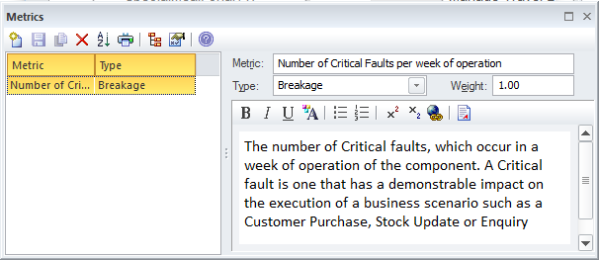

Element Project Management Metric

Project Management Metrics can be added to any element in the repository.  
Typically they will be added to elements like solution Components as a way of indicating how effective it is in meeting the objectives and how well it is performing.  
These details can be added to the notes of the Metric.

Learn More: [Project Management Items](http://www.sparxsystems.com/enterprise_architect_user_guide/13.5/guidebooks/tools_ba_project_management_items.html)

Tagged Values

When detailed properties need to be assigned to a metric an element such as a Requirement could be Stereotyped as a metric and a number of **Tagged Values** could be added to record this information.

Learn More: [Tagged Values](http://www.sparxsystems.com/enterprise_architect_user_guide/13.5/guidebooks/tools_ba_tagged_values.html)

## Prioritization

Prioritization allows business analysis information - including Requirements, Business Rules and Processes - to be put into order of relative importance.  
Enterprise Architect has a range of features that can assist including: Priority and Difficulty for Requirements, and Complexity and Phase and Version for all elements.  
There is also a convenient **Model Views window** that allows elements to be presented in a group filtered by any criteria such as priority or phase.  
Elements in a Package in the **Project Browser** can be ordered according to priority, allowing a simple but effective ordered list; this is typically done with elements such as Features in Feature driven development.

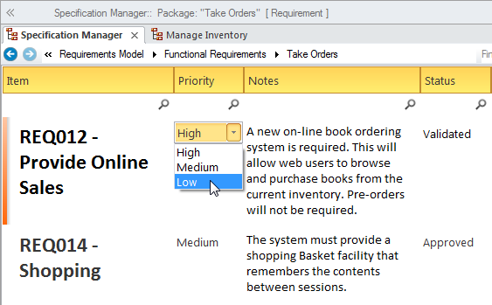

Element Properties

Elements have a number of properties that can be assigned to form the basis of prioritization.  
These include Status, Phase, Version, Complexity and for Requirements Difficulty and Priority.  
Any number of other properties can be created using **Tagged Values** and these can use pre-defined values with user interface controls like drop-down lists or spin controls.  
These properties can form the basis for search criteria to return a set of prioritized elements.

Learn More: [Requirement Properties](http://www.sparxsystems.com/enterprise_architect_user_guide/13.5/guidebooks/tools_ba_requirement_properties.html)

Model Search

The **Model Search** facility can be used to find a set of elements that meet a particular set of criteria.  
This is useful when prioritizing elements such as Requirements, Features, User Stories, Scenarios and other elements.  
A modeler can use a built-in search but would more typically devise their own search using the powerful Query Builder or if required the SQL Editor or an Add-in Search.  
When the search is run a list of elements is returned that meet the conditions and parameters defined in the search.  
The search can be saved and run again at any time.  
The elements returned in the search can be located in the **Project Browser** and diagrams, and a diagram can then be saved as a Pattern.

Learn More: [Model Search](http://www.sparxsystems.com/enterprise_architect_user_guide/13.5/guidebooks/tools_ba_model_search.html)

Model Views

**Model Views** is a facility that allows a modeler to create lists of elements in alternate views to the way they are organized in the **Project Browser**.  
Any number of Favorite folders can be created and these can be grouped into one or more higher level folders.  
This provides a mechanism for manually defining prioritization by simply dragging elements from the Project Browser into the Favorites folder and ordering them using the up and down arrow keys in the toolbar.  
Alternatively elements can be listed using a built-in or user defined search which can be used to select elements from anywhere in the repository based on properties such as Complexity, Version, Phase and user defined properties defined in **Tagged Values**

Learn More: [Model Views](http://www.sparxsystems.com/enterprise_architect_user_guide/13.5/guidebooks/tools_ba_model_views.html)

Project Browser

The **Project Browser** provides a way to prioritize elements by simply changing their order within a Package or containing element.  
This can be achieved using the **Up Arrow** button and **Down Arrow button** in the Project Browser header bar, or a tree item's context menu.  
This provides a simple but compelling way of prioritizing elements such as Requirements, Features, User Stories and more, based on any criteria.  
(The 'Allow Free Sorting' setting must be enabled on the 'General' page of the 'Preferences' dialog before items can be sorted in the Project Browser.)

Learn More: [Project Browser](http://www.sparxsystems.com/enterprise_architect_user_guide/13.5/guidebooks/tools_ba_project_browser.html)

Tagged Values

Any number of other properties can be created using **Tagged Values** and these can use pre-defined values with user interface controls like drop-down lists or spin controls.  
These properties can form the basis for search criteria to return a set of prioritized elements.

Learn More: [Tagged Values](http://www.sparxsystems.com/enterprise_architect_user_guide/13.5/guidebooks/tools_ba_tagged_values.html)

## Reviews

Enterprise Architect has a flexible review facility called a **Team Review**, which allows any type of review to be conducted including: inspections, formal and informal walk-throughs, single issue reviews, desk checks and pass-arounds.  
One of the powerful aspects of the Team Review facility is that it is right in the model, and elements - such as the work product being reviewed or related artifacts - can be attached to the review and reviewers and others can open them from the review window.  
Any amount of text can be added in a document editor, allowing reviews to be described and published.

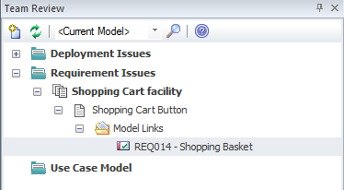

Team Review

The **Team Review** facility is a powerful tool for assisting with a review.  
Creating and recording a team review directly in the model is useful as it allows a reviewer to include links which reference parts of the repository such as Requirements or Components.  
There is a word processor document available that can be used to describe aspects of the review and a template can be used to define the structure of the document.  
Any number of categories can be set up for the reviews and topics and documents can be added to these to form a hierarchy.  
Resources such as XML files and Images can be added under the Category, Topic or Document.  
Model Links allow elements and diagrams to be dragged and dropped from the **Project Browser** creating links to these elements from the review.

Learn More: [Team Review](http://www.sparxsystems.com/enterprise_architect_user_guide/13.5/guidebooks/tools_ba_team_reviews.html)

Calendar

The **Calendar** provides a way to record and present important temporal information such as events and meetings in calendar format.  
Reviews can be entered into the Calendar and setup as recurring if needed.  
Event subtypes can be configured to add Review as a Meeting Type.

Learn More: [Calendar](http://www.sparxsystems.com/enterprise_architect_user_guide/13.5/guidebooks/tools_ba_calendar.html)

Model Mail

**Model Mail** can be used to notify and remind people of a Review and to notify them after the review about outcomes and decisions and required actions.  
Links to model elements and diagrams, matrices, team reviews and a variety of other items can be added.

Learn More: [Model Mail](http://www.sparxsystems.com/enterprise_architect_user_guide/13.5/guidebooks/tools_ba_model_mail.html)

## Risk Analysis and Management

Enterprise Architect supports the modeling of risks at the project or the element level.  
A project manager or senior analyst will typically define risks at the project level, whereas a business analyst, while they might assist with project risks, would typically record risks at the level of requirements and modular units of the system such as components.

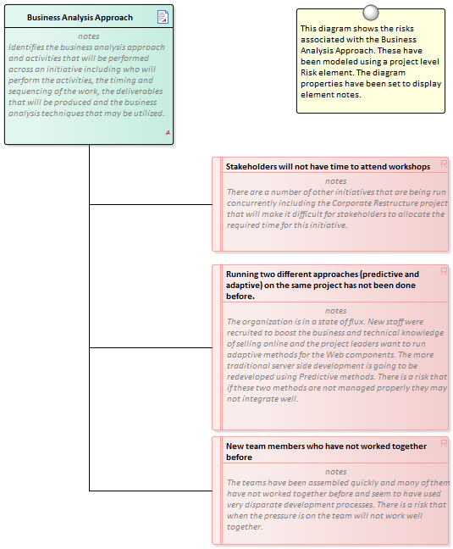

Project Management Items

Risks can be assigned to any element in the repository and these can be managed through the Risks Window which is part of the Project Maintenance group of windows.

Learn More: [Project Management Items](http://www.sparxsystems.com/enterprise_architect_user_guide/13.5/guidebooks/tools_ba_project_management_items.html)

Risk Taxonomy

The Risk Taxonomy can be used to formally define risks and associated metadata applied universally across one or more initiatives.  
This includes definitions of Threats, Loss type, Contact Frequency, Loss Magnitude, Risks and more.

Learn More: [Risk Taxonomy](http://www.sparxsystems.com/enterprise_architect_user_guide/13.5/guidebooks/tools_ba_risk_taxonomy.html)

Requirements Diagram

A **Requirements Diagram** can be created and any number of Risk elements can be added to the diagram.  
Modeling the risks using an element allows the Risks to be connected to other modeling elements by diagram relationships.  
This can be useful when the Risk applies to more than one elements or when it is of concern to one or more stakeholders.

Learn More: [Requirements Diagram](http://www.sparxsystems.com/enterprise_architect_user_guide/13.5/guidebooks/tools_ba_requirements_diagram.html)

## Roles and Permissions Matrix

Enterprise Architect has a powerful and flexible **Relationship Matrix** that can be used to visualize coverage of any two dimensions including Activities and Roles.  
Roles and Activities can be grouped into Packages and displayed in a matrix view with visual indicators showing if an Activity has a Role covering it.  
The matrix can be saved to the Resources window and recalled at any time.  
The matrix can be included in automatically generated reports or exported to a spreadsheet file for further analysis.  
The Organization Chart diagram can be used to assist in the analysis of roles used in the matrix.

Organizational Chart

The Organizational Chart Diagram can be used to assist with the analysis of roles that are used for the roles and permission matrix.  
The diagram is part of the Strategic Modeling group of diagrams and shows the structure of an organisation including officials, roles, responsibilities, business units or departments.  
The roles or business units can be displayed in a diagram using a tree layout or in a list view.

Learn More: [Organization Chart Diagram](http://www.sparxsystems.com/enterprise_architect_user_guide/13.5/guidebooks/tools_ba_organizational_chart_diagram.html)

Relationship Matrix

Enterprise Architect has a powerful and flexible **Relationship Matrix** that can be used to visualize coverage of any two dimensions including Activities and Roles.  
The matrix is particularly useful for displaying information to managers and non-technical stakeholders.  
Roles and Activities can be grouped into Packages and displayed in a matrix view with visual indicators showing if an activity has a role covering it.  
The matrix can be saved and included in automatically generated reports or exported to a spreadsheet file for further analysis

Learn More: [Relationship Matrix](http://www.sparxsystems.com/enterprise_architect_user_guide/13.5/guidebooks/tools_ba_relationship_matrix.html)

## Scope Modeling

Enterprise Architect has a number of facilities that can be used to model scope depending on the type of depiction required.  
Probably the most simple is the use of a Boundary element which can be used to separate elements that are part of the scope - inside the Boundary and those that are not part of the scope -outside the boundary.  
The Boundary element is also formally part of the Unified Modeling Language (UML) and can be used to define a system boundary as part of a Use Case diagram where the Use Cases lie inside the Boundary and the Actors lie outside.  
Scope can also be modeled using Features which are used to define conditions a system must have and are typically arranged hierarchically.  
The features can be defined in the **Project Browser** and also displayed on a **Requirements Diagram**.

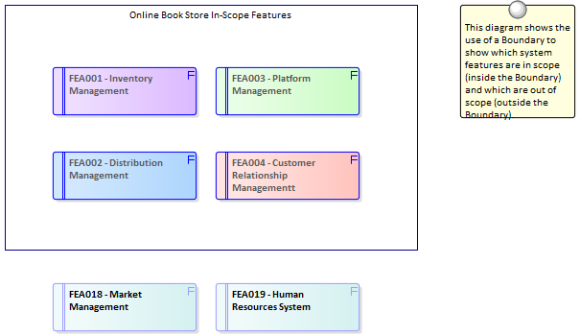

Scope Boundary

Enterprise Architect has a convenient and flexible Boundary element that can be used to represent the boundary of a system.  
It is a rectangular element that can be resized and styled to suit the elements that are in scope and will thus reside inside the Boundary.  
Out-of-scope elements could be placed outside the boundary to ensure that stakeholders are clear about what is in and out of scope.  
The elements placed inside the boundary could be Requirements, Features, Components or any other element type that would help indicate scope.

Learn More: [Boundary](http://www.sparxsystems.com/enterprise_architect_user_guide/13.5/guidebooks/tools_ba_boundary.html)

Use Case Diagrams

A Use Case diagram provides a convenient way of describing the scope of a System (or Entity).  
A System Boundary is used to mark the extent of the system and Actors (humans or systems that gain value from the system) are positioned outside the Boundary and Use Cases (the goals the Actors intend to achieve) are positioned inside the Boundary.  
It is not necessary to complete the detailed steps of the Use Cases but the Scenarios should be described to a level that will assist stakeholders in understanding the scope of the system.

Learn More: [Use Case Diagram](http://www.sparxsystems.com/enterprise_architect_user_guide/13.5/guidebooks/tools_ba_use_case_diagram.html)

User Stories

User Stories provide a useful way of describing the goals that users are trying to achieve.  
These are written from the users' perspective and typically describe things they need to achieve as part of their role.  
Collectively they provide a high level definition of the scope of the system or initiative.  
While the User Stories are not typically analyzed until close to implementation their high level descriptions provide a way of planning and determining what will be implemented as part of an iteration.

Learn More: [User Stories](http://www.sparxsystems.com/enterprise_architect_user_guide/13.5/guidebooks/tools_ba_user_story.html)

Project Browser

A feature hierarchy can be created using the **Project Browser** without the need to create a diagram.  
A system Feature is a good way to capture the high level capabilities of a system and these can be created directly in the Project Browser.  
Additional features can be added under each first level feature creating a second level of features.  
These second level features can have features nested under them creating a third level.  
The resulting tree of Features provides a useful way of describing system scope that can be presented to and reviewed by stakeholders.  
It is sometimes useful to list out-of-scope Features and a separate package could be created in the Project Browser to contain these.

Learn More: [Project Browser](http://www.sparxsystems.com/enterprise_architect_user_guide/13.5/guidebooks/tools_ba_project_browser.html)

Requirements Diagram

Requirements diagrams can be used to create a hierarchy of system Features.  
A system Feature is a good way to capture the high level capabilities of a system and these can be broken down to a number of levels using a tree structure using an Aggregation or Composition Relationship.  
This provides a compelling representation of scope that can be reviewed by the stakeholders and used as a guide through the initiative.  
Gaps and out-of-scope Features should be identified as early as possible and the tree amended to reflect these.  
Out of Scope Features could be left as part of the tree but annotated in some way to indicate that they are out of scope such as by using a stereotype or by using color with a diagram legend.

As an alternative representation, Features could also be nested inside each other in the diagram down to a number of levels.  
This method has the advantage that the Features will be automatically nested underneath each other as child elements in the **Project Browser**.

Learn More: [Requirements Diagram](http://www.sparxsystems.com/enterprise_architect_user_guide/13.5/guidebooks/tools_ba_requirements_diagram.html)

## Stakeholder List, Map, or Personas

Enterprise Architect has a wide range of tools that can be used to model Stakeholders and Personas and a variety of diagramming techniques can be used to display the information in an engaging way.  
The results of stakeholder analysis can be presented in a number of ways including Stakeholder lists, matrices and diagrams.  
The diagrams can show the stakeholders' influence on an initiative, the impact they have and their relationship to each other.

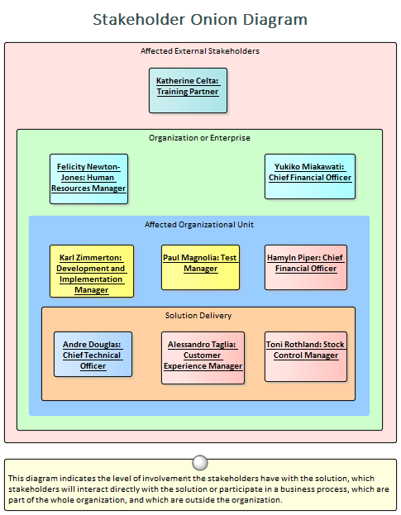

Class Diagram

The Class diagram can be used to create visual representations of the stakeholders including how they are related to each other.  
An alternate image can be used to make the diagrams more appealing and to visually represent stakeholder groups.

Learn More: [Class Diagram](http://www.sparxsystems.com/enterprise_architect_user_guide/13.5/guidebooks/tools_ba_class_diagram.html)

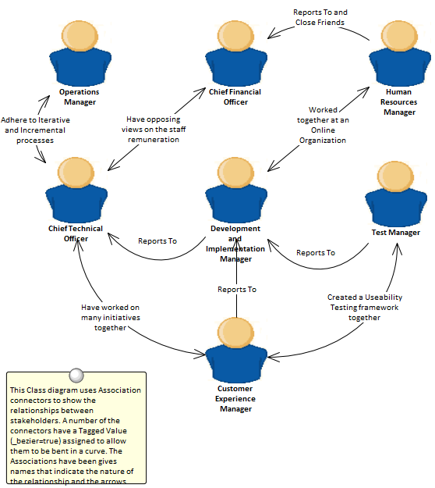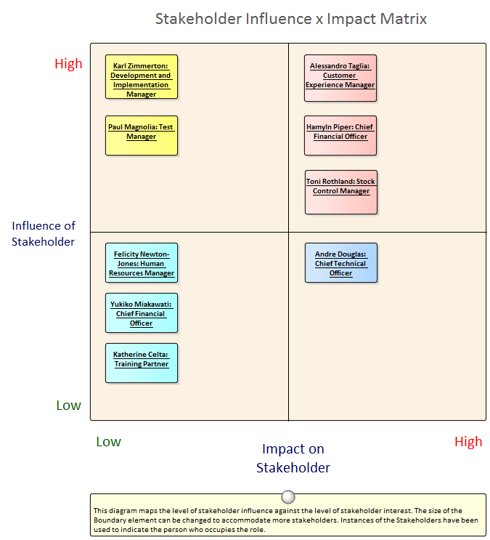

Component Diagram

The **Component Diagram** can be used to show the relationship between stakeholders and parts of the solution that affect them or that they have an interest in or a concern about.  
The diagram could explain the reason for their interest which helps Analysts and others to notify the stakeholders when important milestones are reached.

Learn More: [Component Diagram](http://www.sparxsystems.com/enterprise_architect_user_guide/13.5/guidebooks/tools_ba_component_diagram.html)

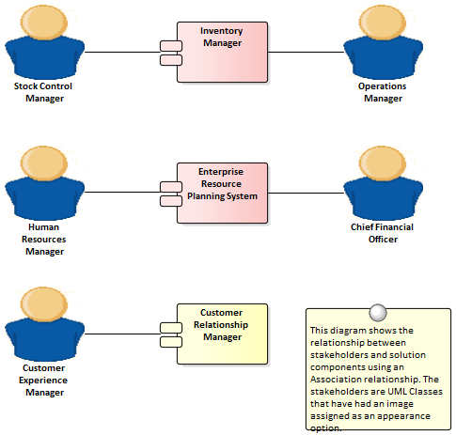

Boundary

The Boundary element can be used to group stakeholders visually.  
This is a powerful mechanism and can be used to create an onion diagram showing the relative influence that groups of stakeholders have on an initiative.

Learn More: [Boundary](http://www.sparxsystems.com/enterprise_architect_user_guide/13.5/guidebooks/tools_ba_boundary.html)

Element Appearance

Many of the stakeholders will be managers or non technical staff who will benefit from viewing diagrams with graphics.  
Images from the standard Image Library could be used or an organization is free to create their own graphics to represent individual stakeholders or stakeholder groups.

Learn More: [Element Appearance](http://www.sparxsystems.com/enterprise_architect_user_guide/13.5/guidebooks/tools_ba_element_appearance.html)

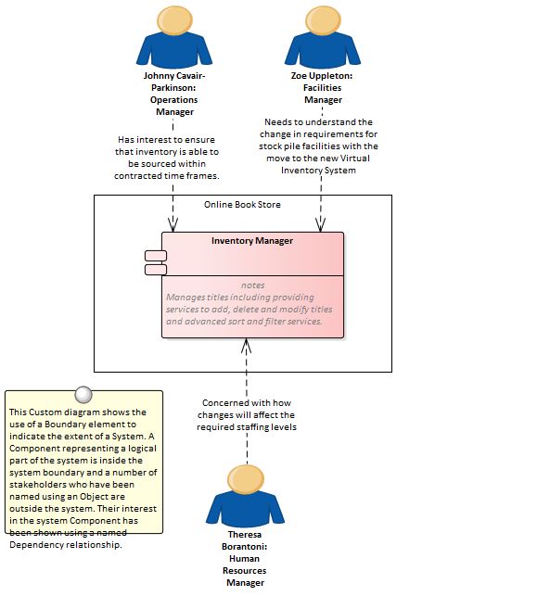

Image Manager

The Image Library is a global store of images in the repository that can be applied to any number of diagram elements.  
The images can be in a variety of formats and when used to change the appearance of an element they create a compelling diagram that is often more appealing to managers or non-technical audiences.  
Where possible it is recommended to store a vector based image so that it can be effectively scaled in a diagram.  
The images can also be used when defining the metafile for a stereotype.

Learn More: [Image Manager](http://www.sparxsystems.com/enterprise_architect_user_guide/13.5/guidebooks/tools_ba_image_manager.html)

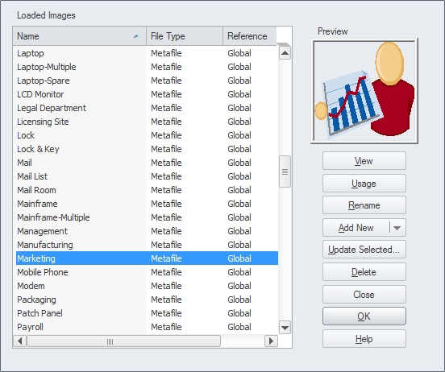

Model Mail

**Model Mail** can be used to communicate with stakeholders, to alert them of important events that are relevant to them and advise them of outcomes, decisions and required actions.  
Links to model elements, diagrams, matrices, Team Reviews and a variety of other items can be added to a mail message.

Learn More: [Model Mail](http://www.sparxsystems.com/enterprise_architect_user_guide/13.5/guidebooks/tools_ba_model_mail.html)

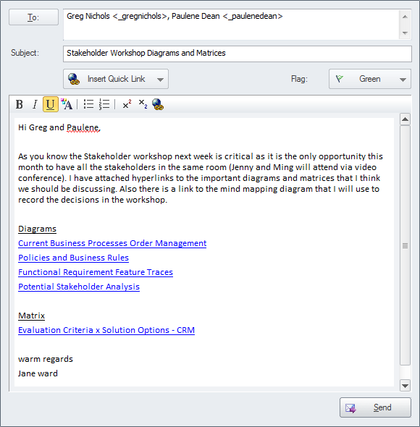

Organizational Chart Diagram

An Organization Chart Diagram is a useful tool to show the structural and organizational relationship between stakeholders and to understand reporting lines in an enterprise or department.

Learn More: [Organizational Chart Diagram](http://www.sparxsystems.com/enterprise_architect_user_guide/13.5/guidebooks/tools_ba_organizational_chart_diagram.html)

Relationship Matrix

A **Relationship Matrix** can be used to present a number of views of the stakeholders.  
The matrix is a spreadsheet like view which is often more appealing to many managers and non-technical audiences.  
Any number of matrices can be created that relate stakeholders to other models elements including other stakeholders.

Learn More: [Relationship Matrix](http://www.sparxsystems.com/enterprise_architect_user_guide/13.5/guidebooks/tools_ba_relationship_matrix.html)

Requirements Diagram

The Requirements diagram is useful for showing the relationship between stakeholders and their Requirements and allowing communication about the way the Requirements are managed.  
Diagrams that display traces between the Requirement and the solution Components will also be important for ensuring that the stakeholders understand how their problems or opportunities are being solved.

Learn More: [Requirements Diagram](http://www.sparxsystems.com/enterprise_architect_user_guide/13.5/guidebooks/tools_ba_requirements_diagram.html)

Specification Manager

The **Specification Manager** is a useful tool for working with lists inside Enterprise Architect which makes it the perfect tool for working with lists of stakeholders and personas.

Learn More: [Specification Manager](http://www.sparxsystems.com/enterprise_architect_user_guide/13.5/guidebooks/tools_ba_specification_manager.html)

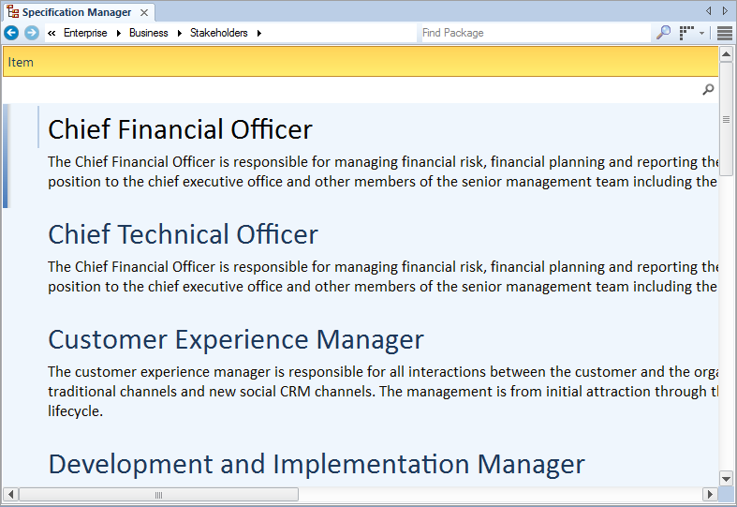

Calendar

The **Calendar** is a useful tool for communicating information about project milestones and events which will facilitate good communication with the stakeholders.  
This includes providing hyper-linked references to the parts of the model including matrices and diagrams that are of interest to them.

Learn More: [Calendar](http://www.sparxsystems.com/enterprise_architect_user_guide/13.5/guidebooks/tools_ba_calendar.html)

## Survey or Questionnaire

Enterprise Architect has a range of tools that can assist with planning, creating and conducting a Survey or Questionnaire.  
Depending on how formal a Survey or Questionnaire is, a plan might be required.  
The plan and the Survey questions can be created using a Document Artifact.  
A **Calendar** could be used to record the date, time and location of the Survey or Questionnaire including the required completion date.  
**Model Mail** could be used to keep in contact with the respondents.

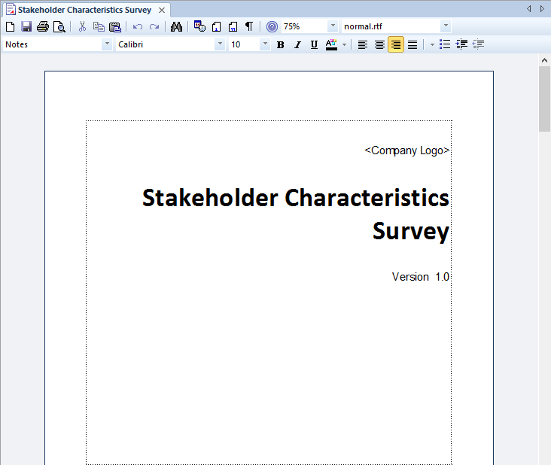

Document Artifact

The Document Artifact is like a Word Processor file that can be created directly inside the repository and it is a convenient way of creating a Survey or Questionnaire.  
The Survey or Questionnaire plan can be created as well as a document with the actual questions that need to be completed.  
The document can be exported to a conventional word processor file if required.

Learn More: [Document Artifact](http://www.sparxsystems.com/enterprise_architect_user_guide/13.5/guidebooks/tools_ba_document_artifact.html)

Calendar

The **Calendar** provides a way to record and present important temporal information such as events and meetings in Calendar format.  
Survey or Questionnaire can be entered into the Calendar and setup as recurring if needed.  
Event subtypes can be configured to add a Survey or Questionnaire as a Meeting Type.

Learn More: [Calendar](http://www.sparxsystems.com/enterprise_architect_user_guide/13.5/guidebooks/tools_ba_calendar.html)

Model Mail

**Model Mail** can be used to notify and remind people of a Survey or Questionnaire and to notify them after the Survey or Questionnaire about outcomes and decisions and required actions.  
Links to model elements, diagrams, Matrices, Team Reviews and a variety of other items can be added.

Learn More: [Model Mail](http://www.sparxsystems.com/enterprise_architect_user_guide/13.5/guidebooks/tools_ba_model_mail.html)

## Vendor Assessment

The type of Vendor Assessment undertaken will typically depend on the sizes of the organizations involved and the level of formality required.  
Enterprise Architect has a number of tools that can assist with performing the analysis of vendors ranging from the creation of a Request for Information/Quote/Tender /Proposal using a Document Artifact to simply defining the criteria using Non Functional Requirements.  
There are a number of other tools that could be used including the Documentation Generator to create the Request documents directly from the model.  
The **Specification Manager** is useful for creating and managing the Non Functional Requirements and **Element Discussions** provide a convenient place for analysts to discuss the results of the Vendor Assessment .

Requirements Diagram

The Requirements diagram can be used to model Non Functional Requirements representing the service levels expected from a third party or vendor.  
These Requirements are often displayed using a package element showing the category of the requirement.  
In other diagrams the modeler can show the Non Functional Requirements linked to other elements such as Use Cases and User Stories or Functional Requirements.  
Traces could also be created between the Non Functional Requirements and system Components or Interfaces that describe the Vendor's offering.

Learn More: [Requirements Diagram](http://www.sparxsystems.com/enterprise_architect_user_guide/13.5/guidebooks/tools_ba_requirements_diagram.html)

Document Artifact

Whether a Request for Information (RFI), Request for Quote (RFQ), Request for Tender (RFT), Request for Proposal (RFP) is required or just a simple document a Document Artifact can be used as a place to create this information directly inside the model.  
A template could be specified for the document allowing sections to be defined and reused with different Vender Assessments for the same or different initiatives.  
Other model elements that exemplify some aspect of the assessment, such as Requirement, Constraints or Business Rules can be dragged into the document as links.

Learn More: [Document Artifact](http://www.sparxsystems.com/enterprise_architect_user_guide/13.5/guidebooks/tools_ba_document_artifact.html)

Stereotyping

A Performance Measure is not defined as an element type in any of the built-in Toolbox palettes but can be created as a type using the Unified Modeling Language (UML) Stereotype extension mechanism.  
The defined Stereotype can then be applied to a Requirement or Class to create a Performance Measure that can be added to the model.  
In the case of Requirements a new Requirement Type can be added.

Learn More: [Stereotyping](http://www.sparxsystems.com/enterprise_architect_user_guide/13.5/guidebooks/tools_ba_stereotyping.html)

Specification Manager

The **Specification Manager** is the primary tool for working with text based elements such as Non Functional Requirements, used to define service levels expected of a third party.  
These and other requirements can be created directly in the Specification Manager and their names and descriptive text can be added in a compelling Word Processor or Spreadsheet like format.  
Other built-in properties such as status, version and phase can be managed directly in the columns of the Specification Manager, and where property lists are available these can be chosen or changed from drop down lists.  
Additional properties in the form of **Tagged Values** can also be managed from within the Specification Manager.  
The Non-Functional Requirements visible in the Specification Manager can be included on diagrams if necessary, and linked to other modeling elements.  
Changing any of the Requirement's details in the Specification Manager will update the element in all other locations such as diagrams, and vice versa, since there is a single element in the Repository that is visible in many views.

Learn More: [Specification Manager](http://www.sparxsystems.com/enterprise_architect_user_guide/13.5/guidebooks/tools_ba_specification_manager.html)

Documentation

Enterprise Architect has a powerful and flexible documentation generator that can produce Docx and RTF Word Processor files, PDF and HTML reports.  
Request for Information (RFI), Request for Quote (RFQ), Request for Tender (RFT), Request for Proposal (RFP) and Non Functional Requirements stored in the repository can be conveniently generated and included in documentation.  
A sophisticated template facility exists that provides a range of built-in templates and allows the user to create their own templates defining styles, images and a wide range of other formatting options to assist with the creation of Vendor Assessment documentation.

Learn More: [Documentation](http://www.sparxsystems.com/enterprise_architect_user_guide/13.5/guidebooks/tools_ba_documentation.html)

Element Discussions

Team members will often want to comment on or question the definition or details of a Non Functional Requirement or a Document Artifact describing the Vendor Assessment.  
The Element Discussion facility provides a perfect mechanism for conducting these conversations.  
The discussions are posted in a purpose built window and are kept separate from the notes and details of the element.  
This ensures that the Requirements definition is not 'polluted' with comments that are intended for modelers rather than other stakeholders.  
As the discussions are posted a **Discussion Review** window conveniently displays the latest entries across the entire repository.

Learn More: [Element Discussions](http://www.sparxsystems.com/enterprise_architect_user_guide/13.5/guidebooks/tools_ba_element_discussions.html)

# Strategy

Strategic thinking provides a plan for how an organisation needs to adapt in the context of a changing and often competitive environment, typically caused by disruptive business and technology forces.  
Strategic techniques help the analyst to discover, analyse and communicate the strategic concerns of executive level stakeholders.  
The resulting models and artifacts will form the context for all other analysis work allowing analysts to understand the business reason for an initiative.  
Enterprise Architect provides a wide range of tools that can be used to perform the Strategic techniques these include tools such as the Balanced Scorecard, Business Cases and Organisational modelling all of which can be linked to the opportunity and solution models allowing traceability from the executive level right through to the implementation artefacts that describe a solution.

## Balanced Scorecard

Balanced Scorecard is a strategic planning and monitoring mechanism to ensure that business activity aligns with strategic goals and where it is found not to align to adjust the business activities in an attempt to improve performance.  
The idea was originally expounded by Robert Kaplan and David Norton as a performance measurement framework that created a more 'balanced' view of organizational performance by adding a number of non-financial performance measures to traditional financial metrics.  
It was discovered that just focusing on financial measures was not sufficient for modern enterprises in the information age and so three additional measures were added.  
The balanced scorecard suggests that an organization should be viewed from these four perspectives:

* The Learning & Growth Perspective
* The Business Process Perspective
* The Customer Perspective
* The Financial Perspective

Metrics should be defined for each perspective and data collected and analyzed on a regular and ongoing basis to provide the information required by managers to intervene by adjusting business activity in an attempt to increase performance.

Enterprise Architect has a useful extension for strategic modeling which allows a series of strategic diagrams to be created including a Balanced Scorecard.  
Like many of the strategic diagrams a Balanced Scorecard can be conveniently created from a diagram Pattern available from the Strategic Modeling toolbox group.

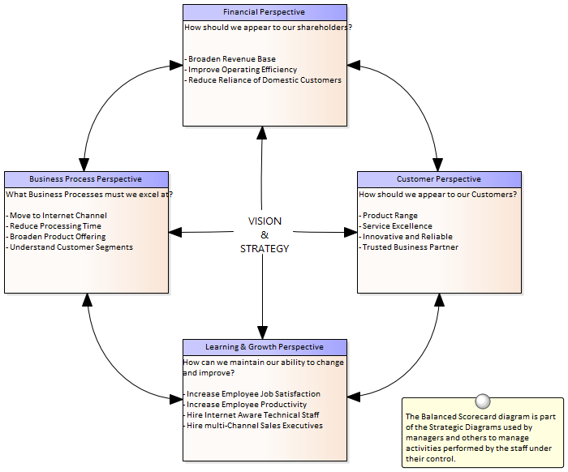

This section lists the main tools available in Enterprise Architect that can be used to perform this technique.  
There are also many additional tools that a modeler might find suitable when applying the technique in a particular context.  
The complete list of tools is available from the topic *Business Modeling Tools*.

Balanced Scorecard Diagram

A **Balanced Scorecard Diagram** can be created at any level from an organization level through to an initiative (project) level and any number of diagrams can be created.  
The diagrams and the elements they contain can be placed into a Package at appropriate levels in the **Project Browser**.  
The Toolbox page for the diagram comes with a time saving Balanced Scorecard pattern that can be used to create the elements and the diagram ready for the analyst to complete.  
All four dimensions are supported and Objectives, Measures, Targets and Initiatives can be added as text and formatted as required.

Learn More: [Balanced Scorecard Diagram](http://www.sparxsystems.com/enterprise_architect_user_guide/13.5/guidebooks/tools_ba_balanced_scorecard.html)

Documentation

Enterprise Architect has a powerful and flexible documentation generator that can produce Docx and RTF Word Processor files, PDF and HTML reports.  
Any Balanced Scorecard stored in the repository can be conveniently generated and included in documentation.  
The formatting used to describe the Objectives, Measures Targets and Initiatives can also be carried through to the documentation.  
A sophisticated template facility exists that provides a range of in-built templates and allows the user to create their own templates, defining styles, images and a wide range of other formatting options.

Learn More: [Documentation](http://www.sparxsystems.com/enterprise_architect_user_guide/13.5/guidebooks/tools_ba_documentation.html)

Baselines

The Baseline Tool is used as a type of backup and recovery tool and can capture a snapshot of the Balanced Scorecard at a point in time and then at a later time the repository can be compared to this (or another baseline) for the purpose of determining what has changed.  
It is possible to revert the current model back to a state captured in the baseline at the level of a granular change.

Learn More: [Baselines](http://www.sparxsystems.com/enterprise_architect_user_guide/13.5/tools_ba_import_and%20export_spreadsheets.html)

## Benchmarking and Market Analysis

Enterprise Architect is a flexible platform that can be used to assist the analyst with both Benchmarking and Market Analysis, as it has convenient tools for recording research findings and has the ability to express these in diagrams and documentation generated from the model.  
Request for Information (RFI) documents could be generated directly from the model and the powerful **Relationship Matrix** can be used to demonstrate gaps between current and best practice.

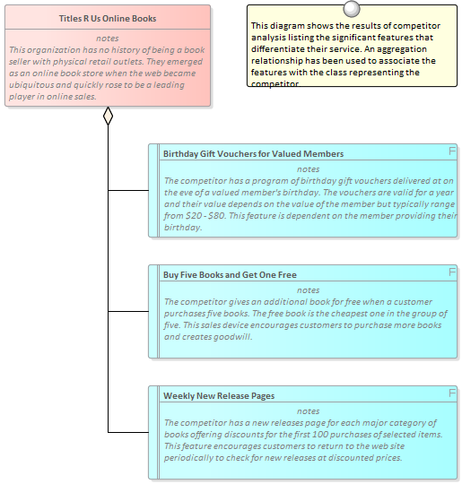

This section lists the main tools available in Enterprise Architect that can be used to perform this business analysis technique.  
There is also a wide range of additional tools that a modeler might find suitable when applying the technique in a particular context.  
The complete list of tools is available from the topic *Business Modeling Tools*.

Relationship Matrix

The **Relationship Matrix** is a powerful and compelling tool for visualizing the relationships between two sets of elements.  
Business Capabilities can be related to a number of different sets of elements including Use Cases, User Stories, Functional Requirements and Business Processes.  
A number of different Matrices could be created with the Business Capabilities on one axis and a different set of elements on the other axis in each of the matrices.  
The Matrices can conveniently be saved as resources and also exported to a Spreadsheet file.

Learn More: [Relationship Matrix](http://www.sparxsystems.com/enterprise_architect_user_guide/13.5/guidebooks/tools_ba_relationship_matrix.html)

Stereotyping

A Business Capability is not defined as an element type in any of the built-in Toolbox palettes but can be created as a type using the Unified Modeling Language (UML) extension mechanism of Stereotypes.  
The defined Stereotype can then be applied to a Class to create a Capability that can be added to the model.

Learn More: [Stereotyping](http://www.sparxsystems.com/enterprise_architect_user_guide/13.5/guidebooks/tools_ba_stereotyping.html)

Documentation

Enterprise Architect has a powerful and flexible documentation generator that can produce Docx and RTF Word Processor files, PDF and HTML reports.  
Benchmarking and Market analysis diagrams and elements can be included in the documentation, and Relationship Matrices can also be added.  
A sophisticated template facility exists that provides a range of in-built templates and allows the user to create their own templates defining styles, images and a wide range of other formatting options.

Learn More: [Documentation](http://www.sparxsystems.com/enterprise_architect_user_guide/13.5/guidebooks/tools_ba_documentation.html)

## Business Capability Analysis

Capabilities can be modeled in Enterprise Architect as part of the tool's support for Business Architecture.  
The capabilities can be modeled to determine how well the organisation is performing in its achievement of business goals or objectives.  
The **Relationship Matrix** can be used to provide a clear view of how the capabilities are meeting current and future goals and objectives.

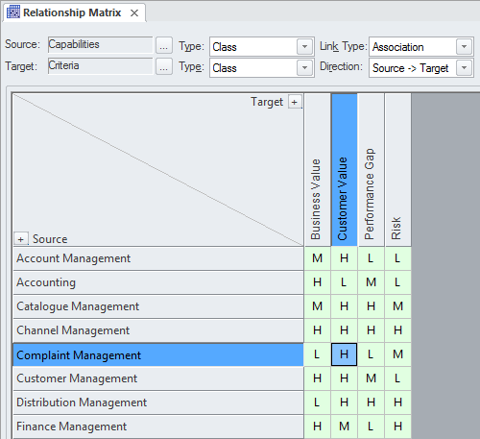

This section lists the main tools available in Enterprise Architect that can be used to perform this business analysis technique.  
There is also a wide range of additional tools that a modeler might find suitable when applying the technique in a particular context.  
The complete list of tools is available from the topic *Business Modeling Tools*.

Relationship Matrix

The **Relationship Matrix** is a powerful and compelling tool for visualizing the relationships between two sets of elements.  
Business Capabilities can be related to a number of different sets of elements including Use Cases, User Stories, Functional Requirements and Business Processes.  
A number of different Matrices could be created with the Business Capabilities on one axis and a different set of elements on the other axis in each of the matrices.  
The Matrices can conveniently be saved as resources and also exported to a Spreadsheet file.  
Overlays can be added to the matrix cells expressing things like the degree of compliance, effectively adding another dimension to the matrix.

Learn More: [Relationship Matrix](http://www.sparxsystems.com/enterprise_architect_user_guide/13.5/guidebooks/tools_ba_relationship_matrix.html)

Roadmap Diagram

A Roadmap Diagram can be used to show how Capabilities change over time and to represent phases in the lifecycle of the Capabilities.  
The diagram has a Legend that is integrated with the elements on the diagram and can be used to express concepts such as Capability Definition, Acquisition, Support and Retirement.  
Colors can be assigned to the dimensions defined in the Legend and the time scale of the diagrams can be configured to suit the temporal scale of the Capability model.

Learn More: [Roadmap Diagram](http://www.sparxsystems.com/enterprise_architect_user_guide/13.5/guidebooks/tools_ba_roadmap_diagram.html)

Class Diagram

Capabilities can be modeled using a Stereotyped **UML Class** element.  
Stereotyping is one of the extension mechanism available as part of the UML and allows a type to be created that represents a Business Capability.  
These can be added to a **Class Diagram** and connected by aggregation relationships to show a tree of Capabilities down to any level.  
The Capabilities can also have connections to a number of other elements including Goals, Objectives Applications and more.

Learn More: [Class Diagram](http://www.sparxsystems.com/enterprise_architect_user_guide/13.5/guidebooks/tools_ba_class_diagram.html)

Project Browser

A Business Capability Hierarchy can be created directly in the **Project Browser** without the need to create a diagram.  
A **UML Class** is a good way to capture the Business Capabilities of an organization and these can be created directly in the Project Browser.  
Additional Capabilities can be added under each first level Capability creating a second level.  
These second level Capabilities can have Capabilities nested under them creating a third level.  
The resulting tree of Capabilities provides a useful way of describing Functional Decomposition that can be presented to and reviewed by stakeholders.

Learn More: [Project Browser](http://www.sparxsystems.com/enterprise_architect_user_guide/13.5/guidebooks/tools_ba_project_browser.html)

Stereotyping

A Business Capability is not defined as an element type in any of the built-in Toolbox palettes but can be created as a type using the Unified Modeling Language (UML) extension mechanism of Stereotype.  
The defined Stereotype can then be applied to a Class to create any number of Capabilities that can be added to the model.

Learn More: [Stereotyping](http://www.sparxsystems.com/enterprise_architect_user_guide/13.5/guidebooks/tools_ba_stereotyping.html)

Visual Filters

Visual Filters can be used to hide or dim parts of the diagram so that other parts can be emphasized.  
This is particularly useful when presenting a Capability Model **Class Diagram** to a team in a meeting or demonstration.  
Context Filtering is easy to setup and will emphasize the currently selected diagram element and its directly connected elements.

Learn More: [Visual Filters](http://www.sparxsystems.com/enterprise_architect_user_guide/13.5/guidebooks/tools_ba_visual_filters.html)

## Business Cases

Enterprise Architect has a number of different mechanisms for creating and disseminating a Business Case, depending on the formality required.  
A business case articulates the benefits that will be achieved by taking a particular approach; it outlines possible solutions, analyzes constraints, risks and assumptions, and recommends a solution.

It is typically created as a document but when the change does not warrant the effort required to produce a document it can be created as a series of diagrams.  
Enterprise Architect has a Document Artifact element that helps the modeler to create a document directly inside the repository, which can be disseminated using **Model Mail** or saved as a document external to the repository.  
If the Business Case was created and is stored outside Enterprise Architect, for example in a corporate repository, a copy of the document can be saved inside the repository or an artifact can be created that hyperlinks to the external document.

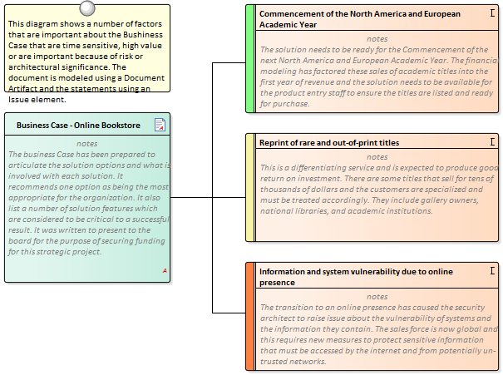

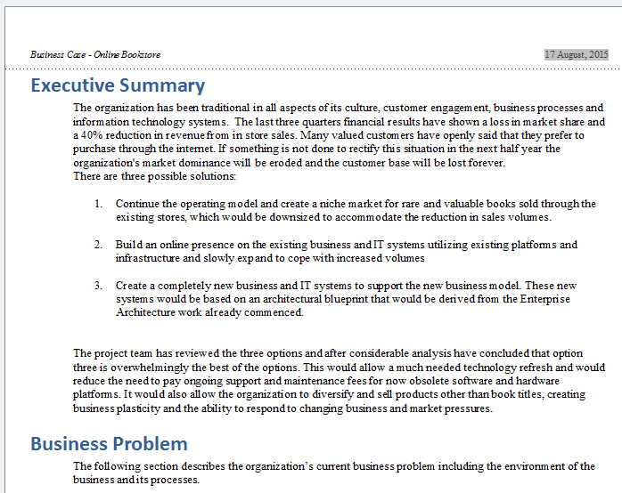

This section lists the main tools available in Enterprise Architect that can be used to perform this business analysis technique.  
There is also a wide range of additional tools that a modeler might find suitable when applying the technique in a particular context.  
The complete list of tools is available from the topic *Business Modeling Tools.*

Artifact

An Artifact can be used as a placeholder for an external document.  
The Artifact element can be hyper-linked to the external document allowing it to be launched from within Enterprise Architect.  
This provides a convenient way to reference the document inside the model for example by linking other elements such as Requirements to the document.

Learn More: [Artifact](http://www.sparxsystems.com/enterprise_architect_user_guide/13.5/guidebooks/tools_ba_artifact.html)

Document Artifact

A Document Artifact can be used to create a Business Case, conveniently storing the document inside the repository.  
A template could be specified for the document, which could be reused for other initiatives.  
Other model elements that exemplify some aspect of the Business Case, such as features and solution options, can be dragged into the document as links.

Learn More: [Document Artifact](http://www.sparxsystems.com/enterprise_architect_user_guide/13.5/guidebooks/tools_ba_document_artifact.html)

Documentation

Enterprise Architect has a powerful and flexible documentation generator that can produce Docx and RTF Word Processor files, PDF and HTML reports.  
A Business Case could be generated directly from Enterprise Architect incorporating diagrams matrices and other artifacts into the document from the repository.

Learn More: [Documentation](http://www.sparxsystems.com/enterprise_architect_user_guide/13.5/guidebooks/tools_ba_documentation.html)

Model Mail

**Model Mail** is a convenient way to let people know about a Business Case.  
If a plan has been developed using a Document Artifact, this can be attached by inserting a link to the element using the 'Insert Quick Link' function.  
Any other material such as diagrams and matrices can also be attached in the same way.

Learn More: [Model Mail](http://www.sparxsystems.com/enterprise_architect_user_guide/13.5/guidebooks/tools_ba_model_mail.html)

## Business Model Canvas

The Business Model Canvas and the other canvases that might have been derived from it have become powerful devices for recoding, analyzing and presenting ideas.  
Enterprise Architect can be used to create these powerful visual devices and the elements on the canvas can be linked to other modeling elements such as goals, capabilities and market analysis models.

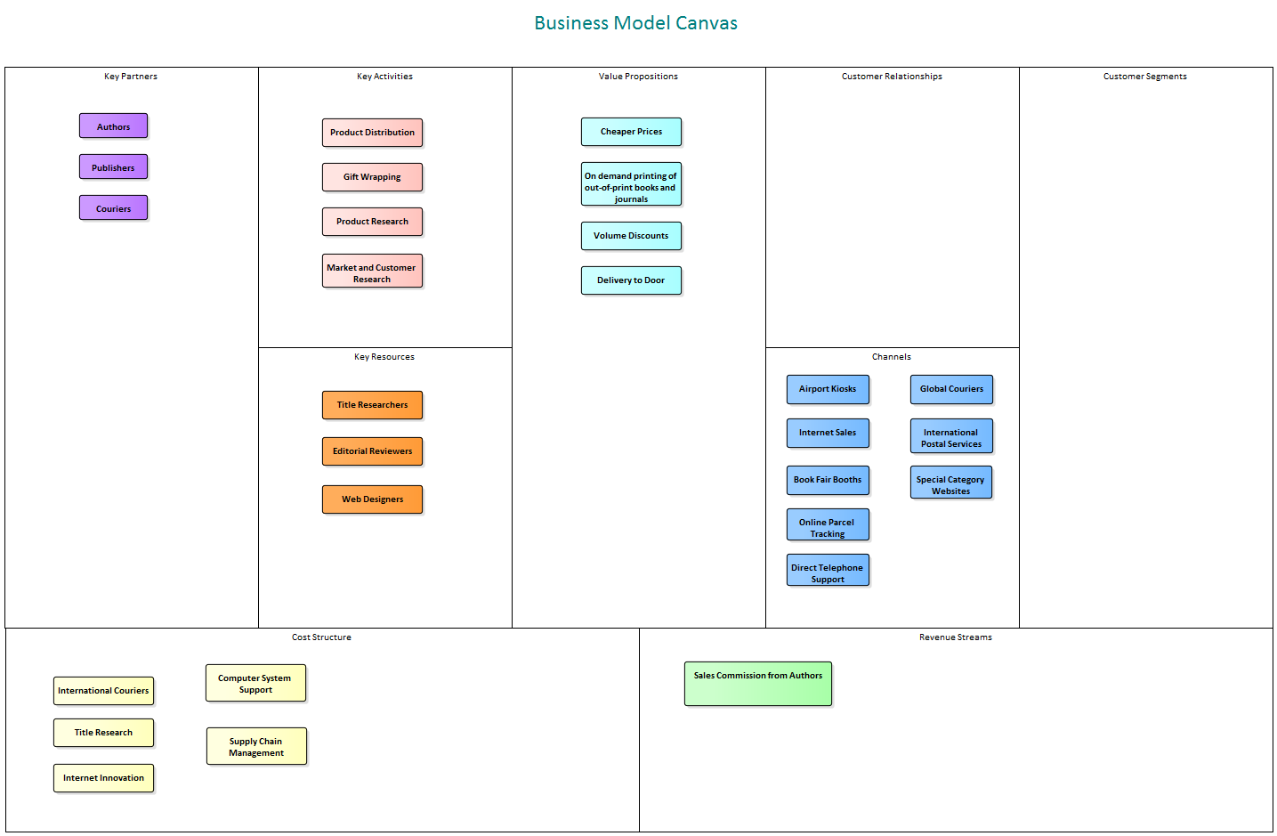

This section lists the main tools available in Enterprise Architect that can be used to perform this business analysis technique.  
There is also a wide range of additional tools that a modeler might find suitable when applying the technique in a particular context.  
The complete list of tools is available from the topic *Business Modeling Tools*.

Requirements Diagram

A **Class Diagram** can be used to create a Business Model Canvas using a number of Boundary elements that can be juxtaposed with each other to define the sections of the canvas.  
Classes can be used to add the detail in each section and these can be given names and detailed descriptions.

Learn More: [Requirements Diagram](http://www.sparxsystems.com/enterprise_architect_user_guide/13.5/guidebooks/tools_ba_requirements_diagram.html)

Boundary

A number of Boundaries can be added and aligned to create the cells for the Business Model Canvas.  
The Boundary elements can be resized and juxtaposed to each other to create the layout of the canvas.  
Elements can then be added to represent the content in each section.  
The appearance of the elements can also be changed to make the diagram more compelling.

Learn More: [Boundary](http://www.sparxsystems.com/enterprise_architect_user_guide/13.5/guidebooks/tools_ba_boundary.html)

Element Appearance

The appearance of elements can be changed in a number of ways to make the Canvas more compelling this includes changing the fill and border and font colors of the elements and the font style and even replacing the default element presentation with an alternate graphical image.

Learn More: [Element Appearance](http://www.sparxsystems.com/enterprise_architect_user_guide/13.5/guidebooks/tools_ba_element_appearance.html)

## Organizational Modeling

Enterprise Architect has an Org Chart diagram as part of its strategic modeling diagram set that allows organizational structures to be modeled and the roles in the org chart can be linked to any number of model elements including Vision Statements, Business Goals, Objectives, Processes and Stakeholder Requirements.  
There is also a useful mechanism to show the different people who occupy the roles over time using Instances of the Classes.

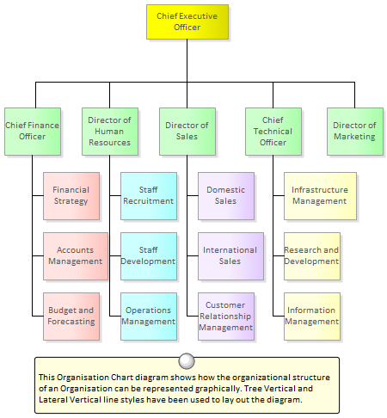

Organizational Chart

The Organizational Chart Diagram is part of the Strategic Modeling group of diagrams and shows the structure of an organisation including officials, roles, responsibilities, business units or departments.  
The roles or business units can be displayed in a diagram using a tree layout or in a list view.  
Any number of **Tagged Values** can be added to the elements or connectors to add additional information as required.  
The elements that make up the organizational chart can then be used in other parts of the model such as assigning business owners to business processes, business rules, systems and more.

Learn More: [Organizational Chart Diagram](http://www.sparxsystems.com/enterprise_architect_user_guide/13.5/guidebooks/tools_ba_organizational_chart_diagram.html)

Baselines

The Baseline Tool is used as a type of backup and recovery tool and can capture a snapshot of the Package that contains the Organizational Chart at a point in time and then at a later time the current Package can be compared to this (or another baseline) for the purpose of determining what has changed.  
Changes that are not desirable can be overridden by the values contained in the baseline at a granular level thus restoring the model back to the state that existed at the time the baseline was captured.

Learn More: [Baselines](http://www.sparxsystems.com/enterprise_architect_user_guide/13.5/model_domains/tools_req_baseline_tool.html)

## SWOT Analysis

Enterprise Architect has a number of facilities that will assist the analyst and other stakeholders in performing a SWOT Analysis, regardless of the purpose or the level of the analysis.  
Each of the dimensions can be represented as a **UML Class** named appropriately, and notes added using a bulleted format to record the details.  
If a SWOT matrix is required it can be created using a Boundary with two vertical and two horizontal swimlanes.  
The SWOT Analysis can be generated out to a document to reach a wider audience if required or to comply with documentation standards.

Class Diagram

Each of the dimensions can be represented as a **UML Class** named appropriately, and notes added using a bulleted format to record the details.  
The basis for the SWOT Analysis could be represented using a Text element positioned in the middle of the four Classes.  
The elements' appearance could be changed to make the diagram more appealing.

See Also: [Class Diagram](http://www.sparxsystems.com/enterprise_architect_user_guide/13.5/guidebooks/tools_ba_class_diagram.html)

Element Appearance

The elements' appearance can be altered to make them more appealing to an audience of managers or non-technical stakeholders.  
This includes changing the elements' borders and fill colors and fonts to make them distinctive.

Learn More: [Element Appearance](http://www.sparxsystems.com/enterprise_architect_user_guide/13.5/guidebooks/tools_ba_element_appearance.html)

Boundary

Enterprise Architect has a convenient and flexible Boundary element that can be used to represent a SWOT Matrix.  
It is a rectangular element that can be configured to have a number of vertical and horizontal swimlanes that can be used to create the cells of the matrix.  
For example, the top left cell in the matrix could be used to define SO (Strengths Opportunities) strategies with the Strengths to the left and the Opportunities above.

Learn More: [Boundary](http://www.sparxsystems.com/enterprise_architect_user_guide/13.5/guidebooks/tools_ba_boundary.html)

Element Discussions

Analysts and Stakeholders will often want to comment on or question the analysis being performed.  
The Element Discussion facility provides a perfect mechanism for conducting these conversations about Strengths, Weaknesses, Opportunities and Threats.  
The discussions are posted in a purpose built window and are kept separate from the notes and details of the element.  
This ensures that the SWOT Analysis is not 'polluted' with comments that are intended for modelers rather than other stakeholders.  
As the discussions are posted a summary window conveniently displays the latest entries across the entire repository.

Learn More: [Element Discussions](http://www.sparxsystems.com/enterprise_architect_user_guide/13.5/guidebooks/tools_ba_element_discussions.html)

Documentation

The **Document Generator** can be used to create high quality corporate documentation using built-in templates or an analyst can define their own custom template.  
A html report can be created allowing click-through and drill-down.  
The SWOT Analysis diagram and the Classes representing Strengths, Weaknesses, Opportunities and Threats can be included in the documentation.

Learn More: [Documentation](http://www.sparxsystems.com/enterprise_architect_user_guide/13.5/guidebooks/tools_ba_documentation.html)