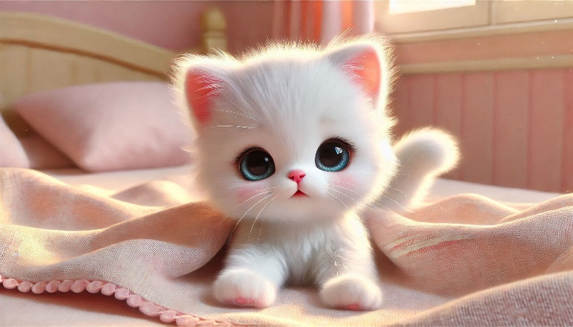

Scene 1 (0-5 seconds): "Morning start"  
1. Promt for images: "Small fluffy kitten with snow-white fur, a tiny pink nose, and big round blue eyes. Its ears are slightly pointed with delicate pink insides, and its soft tail curls beside it. The kitten is waking up in a cozy bed with a pastel-colored blanket, stretching its small paws and yawning. Soft morning light fills the pastel-toned bedroom, enhancing the warm and serene atmosphere."

2. Promt for animation: "Kitten stretches its paws, yawning widely, and slowly wakes up, its eyes blinking. The bed moves slightly as the kitten stretches."

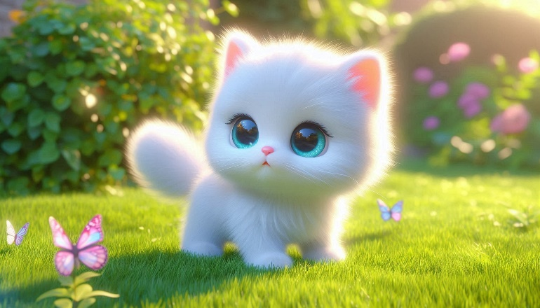

Scene 2 (5-10 seconds): "Meeting with a butterfly"  
1. Promt for images: "Snow-white fluffy kitten with a tiny pink nose and round blue eyes standing in a sunny garden. Its small ears, with pink insides, twitch slightly. The kitten’s delicate paws rest on vibrant green grass, and its soft, bushy tail curls lightly. It gazes in awe at a colorful butterfly flying nearby. The scene is bathed in warm sunlight, with lush greenery and a bright blue sky."

2. Promt for animation:"The butterfly flutters around the kitten, and the kitten’s head follows it in awe. A soft breeze moves the grass around the kitten."

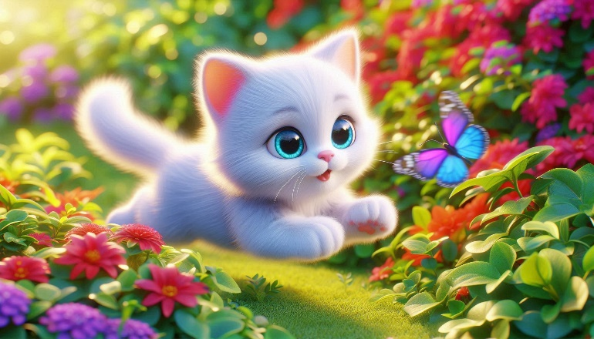 Scene 3 (10-15 seconds): "Chasing a butterfly"  
1. Promt for images:: "Fluffy snow-white kitten with a pink nose, bright blue eyes, and slightly pointed ears chasing a colorful butterfly. Its small paws are mid-air as it leaps energetically through vibrant bushes and flowers. Leaves swirl around, and its soft, bushy tail follows its movement. The kitten’s fur glows in the sunlight, and the garden is alive with rich, vibrant colors."

2. Promt for animation:: "The kitten leaps energetically through the bushes and flowers, with leaves scattering in the air around it. The kitten’s paws move quickly and its tail sways in the motion."

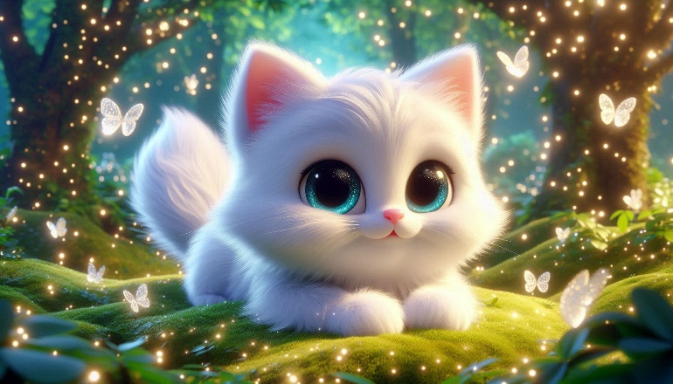

Scene 4 (15-20 seconds): "The Magic Forest"  
1. Promt for images: "Snow-white kitten with silky, fluffy fur, a small pink nose, and round, glimmering blue eyes. Its delicate paws rest gently on glowing moss in a magical forest, surrounded by sparkling trees and luminous plants. The kitten’s ears, with soft pink insides, perk up as a butterfly lands gently on its nose. Its fluffy tail is curled around its body, and it smiles softly. The entire scene is filled with soft magical light, creating a dreamlike atmosphere."

2. Promt for animation: "The kitten's nose twitches as the butterfly lands on it. The kitten smiles widely, and soft magical sparkles fill the air around them."

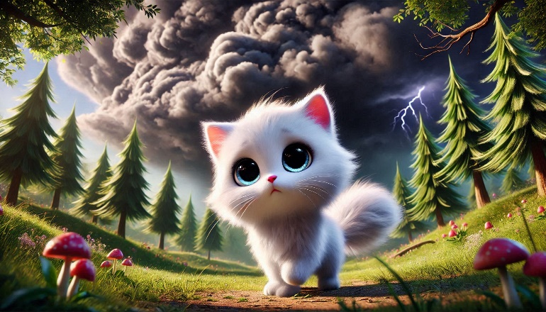 Scene 5 (20-25 seconds): "The Unpredictable Storm"

1. Promt for images: "Snow-white kitten with a tiny pink nose, round blue eyes, and fluffy fur, standing in the middle of a forest clearing. Dark clouds form overhead, casting a shadow on the kitten and the magical forest. The wind begins to blow, and the trees sway. The kitten looks slightly nervous, its fur fluffed up in response to the sudden storm. Lightning flashes in the background."

2. Promt for animation:"The kitten stands still, its fur blowing in the wind. The leaves rustle, and the kitten’s eyes dart around nervously as the storm approaches."

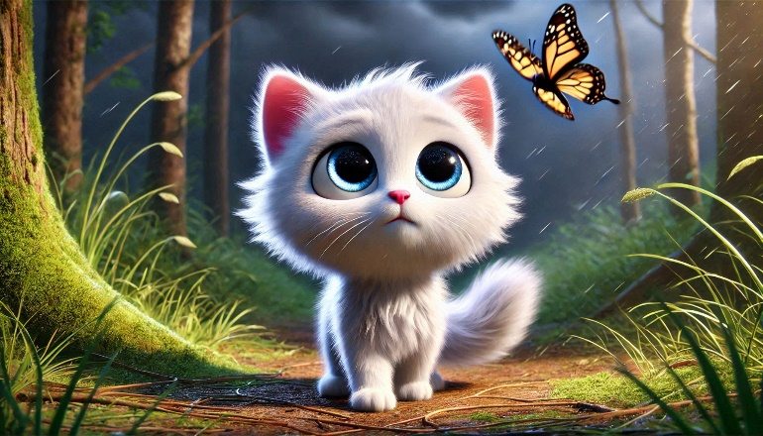

Scene 6 (25-30 seconds): "Overcoming Fear"  
1. Promt for images: "Snow-white kitten with a tiny pink nose, round blue eyes, and fluffy fur, standing in the middle of a forest clearing. The kitten, now more confident, looks up to see the butterfly reappearing through the storm. Its wings flutter bravely, unaffected by the weather. The kitten's fur is slightly tousled from the wind, but its eyes shine with courage. The dark clouds begin to part, and a soft light shines down on the kitten and the butterfly. The forest seems calmer."

2. Promt for animation: "The kitten's body relaxes as the butterfly flies by, and the storm clears. The kitten steps forward confidently, its tail held high, its fur softening. The kitten’s movements are more purposeful, expressing bravery."

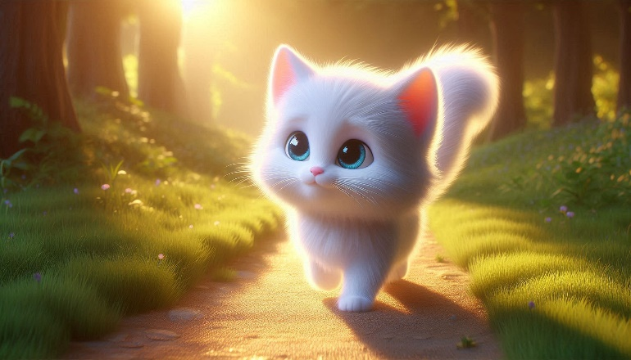

Scene 7 (30-35 seconds): "Coming home with a lesson"  
1. Promt for images: "Fluffy snow-white kitten with a tiny pink nose and bright blue eyes, its fur now smooth and shining. The kitten walks along a sunlit path leading home, its tail held high with pride. The forest around it is peaceful, with the soft golden light of the sunset creating a warm, reassuring atmosphere. The kitten’s expression is calm, thoughtful, and content, reflecting the lesson learned."

2. Promt for animation: "The kitten walks confidently along the path, its tail swishing with pride. The forest around it is calm and serene, with the kitten moving gracefully. The light gently illuminates the kitten’s soft fur, reflecting its newfound wisdom."

**Story:**

"The kitten woke up, he was ready to start a new day.He saw a butterfly in the forest. She fluttered among the flowers, and the kitten enthusiastically began to follow her.The kitten jumped and ran around, trying to catch up with the butterfly.But suddenly a storm started. The kitten got scared and his heart started beating faster.Through the rain, the butterfly appeared again. She flew despite the thunderstorm, and the kitten calmed down.He realized that he shouldn't be afraid.The kitten returned home, brave and wise. He realized that every fear can be overcome with determination."