**TO DO App**

The ToDO App is developed in **Ionic 4 for** the front end and a **Node JS** for the back end.

The Node JS uses the Cosmos JavaScript SDK <https://www.npmjs.com/package/@azure/cosmos>

and is responsible for communicating with Azure Cosmos.

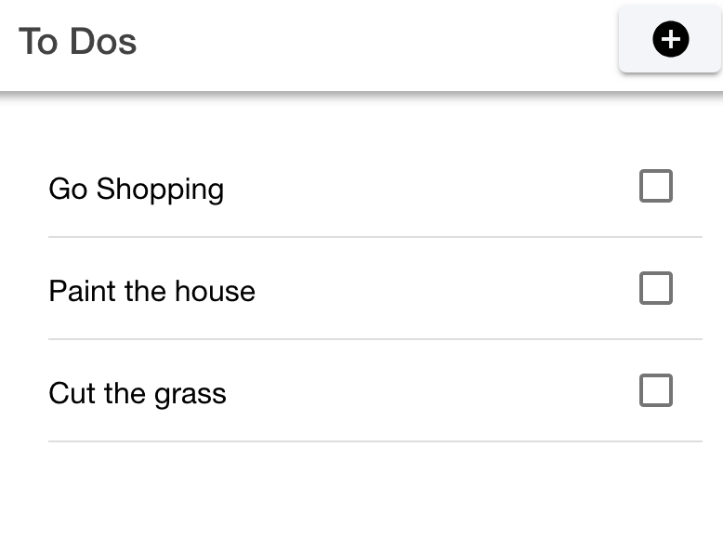

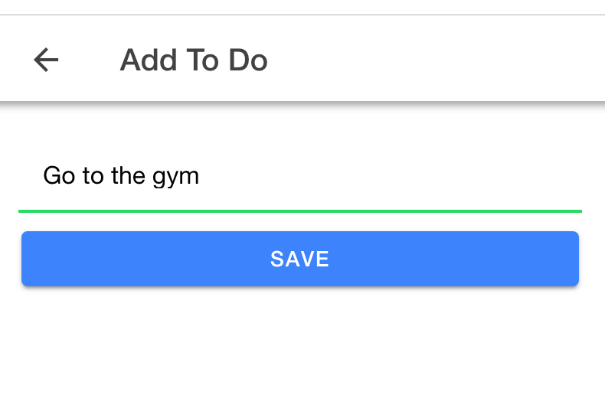

**Back End**

The back end is in Node.JS. The code for the back end is in a folder called **ToDo-Node**

Cosmos connection configuration is in this folder in a file called **config.js.** Changes to cosmos configuration values should be made in this file.

**Front End**

Front end is in a folder called **toDo**. Once you have the back end running, you can run the front end by using the command **ionic-serve**. If running outside the development environment, the node URL should be updated. The configuration for this URL is in **Environment.ts** file

**Cosmos DB Set Up**

Document structure in Azure

|  |
| --- |
| {  "title": "Cut the grass",  "complete": false  } |
| **Partition Key**: title |