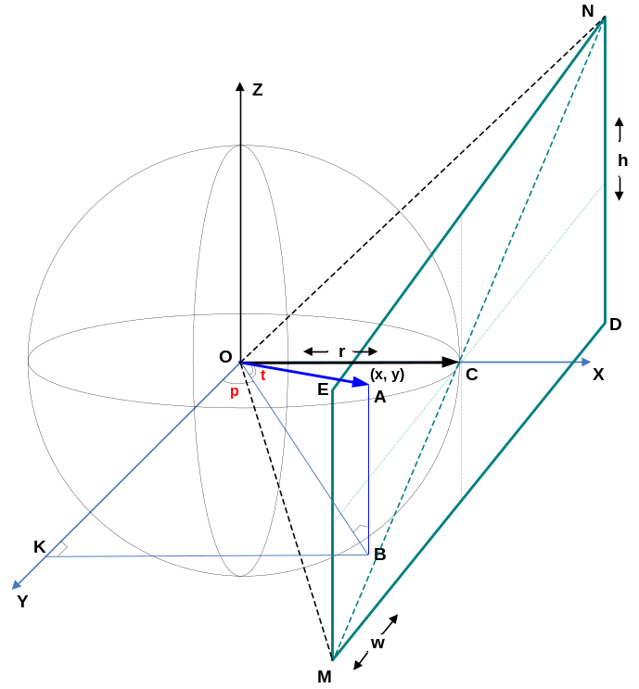
In order to find out required polar coordinates A(p, t) of arbitrary point belonging to projection plane A(x, y) we had created the model consisting of sphere, placed to origin and projection plane MEND. MEND bounds are well known, - it is width and height of the applet’s window in pixels: w, h. Placement in 3D-space also is well known: plane is collinear to the coordinate plane ZY and is touching to sphere in C(r ,0, 0). The center of MEND is coinciding with the touching point. We will find A(p, t) for arbitrary point A(x, y) located on MEND for case, when camera orientation (pan ,tilt) is zero (0, 0). The common case, when (pan !=0, tilt != 0) will be got from particular case, when (pan=0, tilt=0) by means of coordinate system transformation: rotation of the Y and Z coordinate axises on (tilt, pan).

Step 1.
For the beginning, we find sphere radius r. Angle NOM=Fov (field of view) of the camera is known. Look to rectangular triangle MOC. His legs are MC and OC = r, and hypotenuse is OM. Angle MOC = Fov/2. MC=MN/2. In rectangular triangle MEN on base of Pythagor’s theorem: 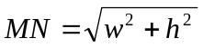. For triangle MOC we can write down relation for tangent of MOC: 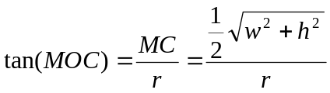. As the result, we can easily express 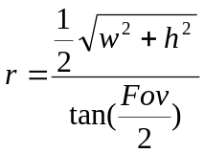.

Step 2.
Now we look to vector OA. His coordinates in coordinate system O can be found as projections over coordinate axises: 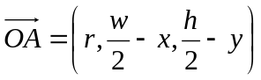. x = r, since points A and C are located on the same plane. y and x can be calculated taking in account what A(x, y) on the projection plane is based relatively of the left top corner N. Therefore in order to calculate (x, y) inside of the coordinate system O, we should translate them subtract them from coordinates of the point C(w/2, h/2). From now we will naming coordinates of the OA vector as (vx, vy, vz).

Step 3.
In order to expand particular case (pan=0, tilt=0) up to generic case (pan!=0, tilt!=0) we need to recalculate vector OC from O coordinate system into rotated 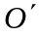 coordinate system. 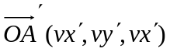 coordinates will be found by means of multiplication: vector OA multiplied on double rotation matrix. This matrix can be found by multiplication of two rotation matrixes: around Y and Z axises by (pan, tilt):
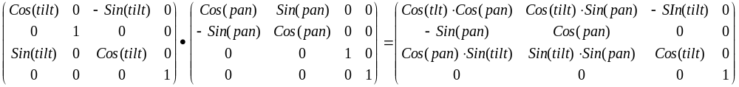.

Step4.
Having multiplied vector OA(vx, vy, vz, 1) from the right-side to the double rotation matrix we have got:
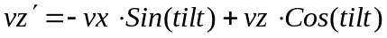.

Step5.
Now we will find the tilt angles of the relatively Z and Y axises (p, t). They are sought angles.
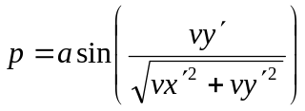, 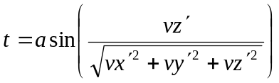.
p should be corrected for the second and third coordinate quarter. Having recalculated p from radians to degrees we will do the following:
if 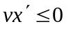and 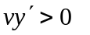, then p = 180 – p;
if 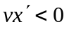and 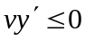, then p = -180 – p.

