Cassandra

I had the pleasure of reading Cassandra: The Definitive Guide. It has been a while since I read a book and have realised that there are so many topics that I was not aware of. I love those moments. I thought I would share some of these topics with the rest of you.

Apache Cassandra is an open source, distributed, decentralised, elastically scalable, highly available, fault-tolerant, tunable consistent, column-oriented database that bases its distribution design on Amazon’s Dynamo and its data model on Google’s Bigtable. Created at Facebook, it is now used at some of the most popular sites on the Web.

Why NoSQL?

As data and transaction volumes started to grow, companies realised that they needed to scale their solutions.

So companies try to address these challenges by trying to make it fit the relational model:

- Add more hardware or upgraded to faster hardware.
- Simplifying database schema, denormalising the schema, relaxing durability and referential integrity.
- Introducing various query caching layers, separating read-only from write-dedicated replicas.
- Data partitioning.

These solutions came to the rise of what is now known as NoSQL. Scaling these kind of solutions we need to think about them in a different way. To understand large-scale distributed systems we need to understand the CAP theorem.

Brewer’s CAP Theorem

The theorem states that within a large-scale distributed data system, there are three requirements that have a relationship of sliding dependency: Consistency, Availability, and Partition Tolerance.

Consistency – All database clients will read the same value for the same query, even given con- current updates.
Availability – All database clients will always be able to read and write data.
Partition Tolerance – The database can be split into multiple machines; it can continue functioning in the face of network segmentation breaks.

Brewer’s theorem is that in any given system, you can strongly support only two of the three. Cassandra focuses on Availability and Partition-Tolerance.

Cassandra Data Model
The Cassandra data model can be thought of as a Distributed Hash Table. The basic concepts are:

- Column – It's a tuple (triplet) that contains a name, a value and a timestamp.
- Column Families – A column family is a container for rows, analogous to the table in a relational system. Each row in a column family can be referenced by its key.
- Rows – This is just multiple columns grouped together.

- Super Columns – columns whose values are columns; that is, a super column is a (sorted) associative array of columns.
- Keyspaces – A keyspace is the first dimension of the Cassandra hash, and is the container for column families.
- Cluster – the machines (nodes) in a logical instance. Clusters can contain multiple keyspaces.

The following diagram paints a pretty picture:

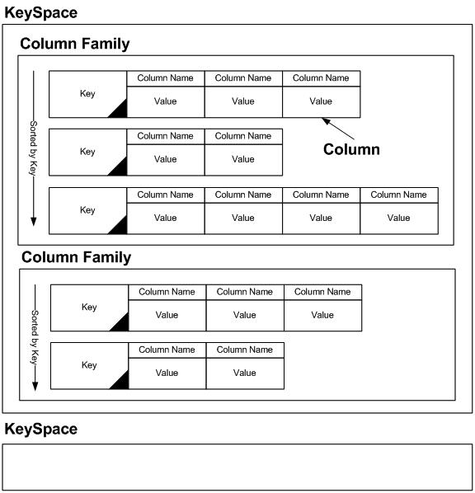

Cassandra Architecture

The Cassandra architecture is very interesting. This is the part of the book that I really enjoyed as there were concepts that I have never heard of.
A Cassandra instance is a collection of independent nodes that are configured together into a cluster. In a Cassandra cluster, all nodes are peers, meaning there is no master node or centralised management process. A node joins a Cassandra cluster based on certain aspects of its configuration.

System Keyspace

Peer-to-Peer

Gossip and Failure Detection

Anti-Entropy and Read Repair

Memtables, SSTables, and Commit Logs

Hinted Handoff

Compaction

Bloom Filters

Tombstones

Staged Event-Driven Architecture (SEDA)

