Delivery 1. Geographic task

**Introduction :**

In groups of 3 or 4 people deliver the geographic task with the US elections or any other (previously negotiated with the professor) country elections dataset.

The delivery shall include:

* the complete HTML,CSS, JS and image files to locally view the visualization.
* The source of the dataset. An explanation of the data and attributes and any manipulation done to the primary data
* A list of the used charts and the motivation behind their selection including goals and perception principles

An explanation of the duties of each member of the group.

## 1.-Dataset description:

For this assignment we used the US-2016-elections data and the “County Facts” data proposed for the assignment. The source of this data is “USA Census bureau “ (<https://www.census.gov/geo/maps-data/data/tiger-cart-boundary.html>).

US-2016-elections data contain data of the primary elections of 2016, by state, county, party, candidate, number of votes to the candidate and the fraction of votes by party.

The “County Facts” data, contains general information for each county (for example population, percentage of people in function of age, percentage of women, average salary, percentages of population in function of race… )

In order to use the data for our purposes we have done some manipulations on them. Those manipulations are explained in the following section.

## 2.-Charts :

We present two charts, in where we show the US map with data on it.

**Chart 1 :** **U.S. 2016 primary elections - Republican vs. Democrat vote:**

In this chart we show the votes for each party (Democrat or Republican) at each county.

Each county is filled with a color depending on the proportion of votes received for each party. The colors go from red (as the Republican Party color) to blue (as the Democrat Party color). A region with more than 50% of votes to the Democrats is filled with blue color and the regions with more than 50% of votes to the Republicans, the region is filled with red color. This proportion also determines the intensity of the filled color, for example a region with 65% of votes to Democrats will be colored with a more intense blue than a region with 52% of votes to Democrats. In this way, the regions with a high proportion of votes for a party are emphasized. The details on the colors meaning can be seen on the legend that appears on the chart.

Focusing on a county will trigger a tooltip with the name of the county and the proportion of the winning party.

Clicking on a county, will trigger an infobox with the count of votes for each party.

The data used for this chart is the data of the “USA Census Bureau”, where we have manipulated the data in order to have the total of votes for each party, and the proportion of these votes over the total of votes.

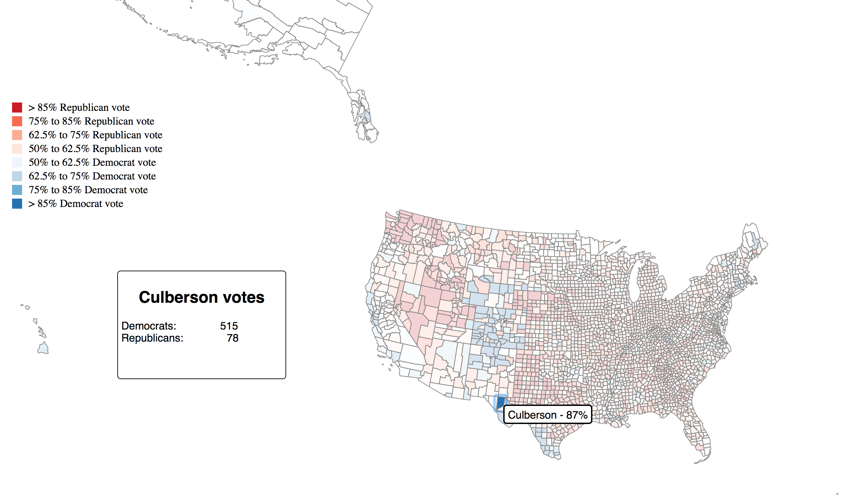

Figure Chart Democrats VS Republicans

**Chart 2 : U.S. 2016 primary elections - Winner Candidates**

In this chart we show the winner Candidate in each county in the US, for the primary elections in 2016.

Each county is filled with a different color associated with the winning candidate (In this case selected colors are arbitrary and don’t follow a logic such in the previous chart).

Focusing on a county will trigger a tooltip with the name of the county and a picture of the winner candidate of the county.

Clicking on a county will trigger an infobox with information on the county. The information shown is the winner candidate, the percentage of the Educated People, and the proportion of Black and White people (using the same label of black and white as in the facts csv). With this information what we want to show is the education and ethnic profile of voters of each candidate.

The data used for this chart is the “County Facts” used for the information of ethnicity and studies of people of each county and the winner candidate for each county. Some manipulations have been done on both datasets in order to obtain the percentages of the facts and also on the “US election 2016” dataset to compute the winner candidate of each county, and ultimately to merge both datasets.

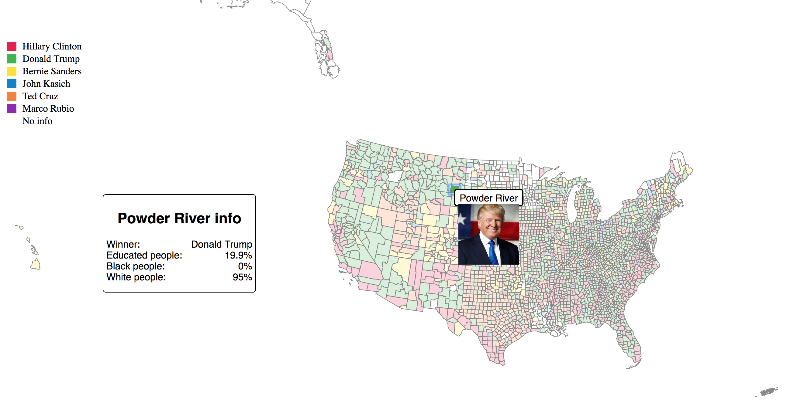

Figure Candidate Winner chart

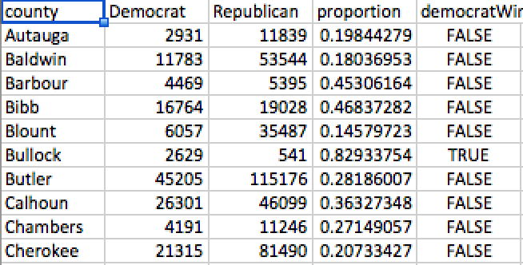

Figure Modified Dataset for Democrats VS Republicans chart

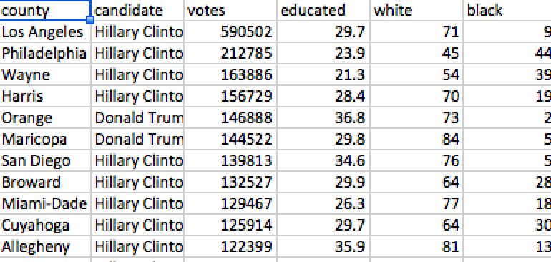

Figure Modified dataset for Winner Candidates chart

## 3.-Members duties :

We have divided our forcework into two groups, each one focusing on one chart:

Alex Ferrer : Data exploration / manipulation and focus on Democrats VS Republicans chart.

Markos Gavalas : Lead Developer focus on the Democrats VS Republicans Chart.

Montse Brufau : Lead Developer focus on the Winner Candidate Chart.

Jonatan Piñol : Data exploration / manipulation focus on the Winner Candidate Chart.