Alex Field

CS3550

A4 Northwinds Questions

* 1. The current strategy for delete and update is “no action”.

1.2 I would implement on delete the customer field goes “null” and updating a customer cascading to this table.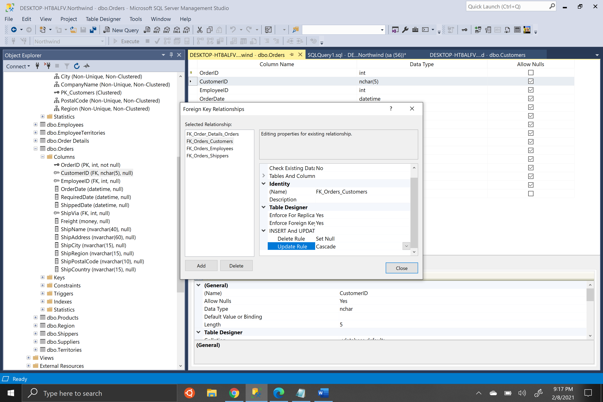

1.3 Update cascade working:

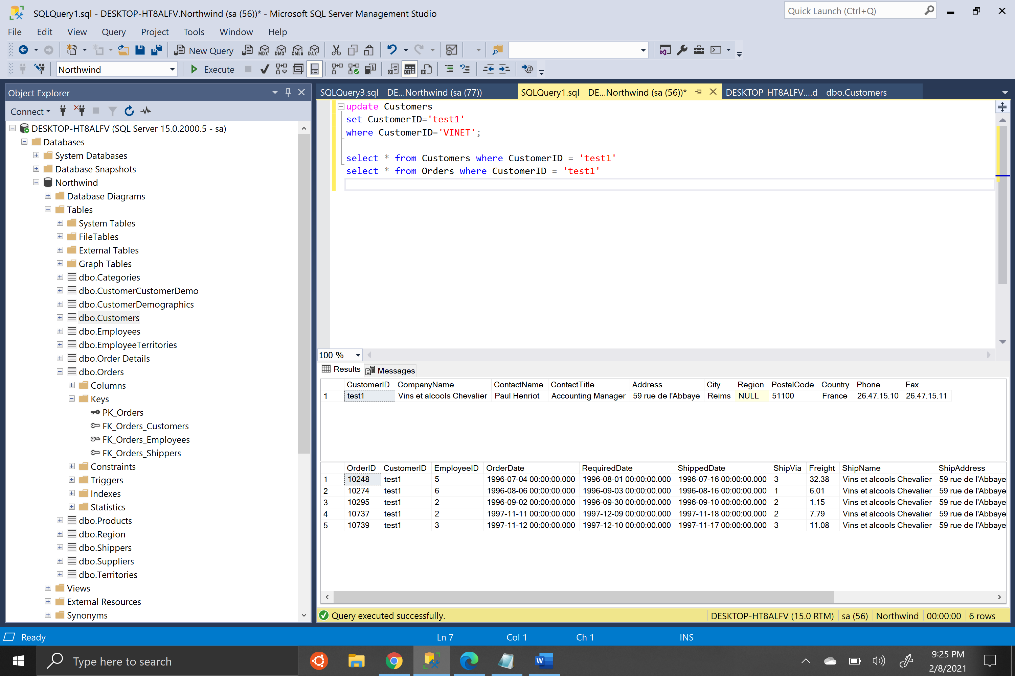

Working on null delete rule:

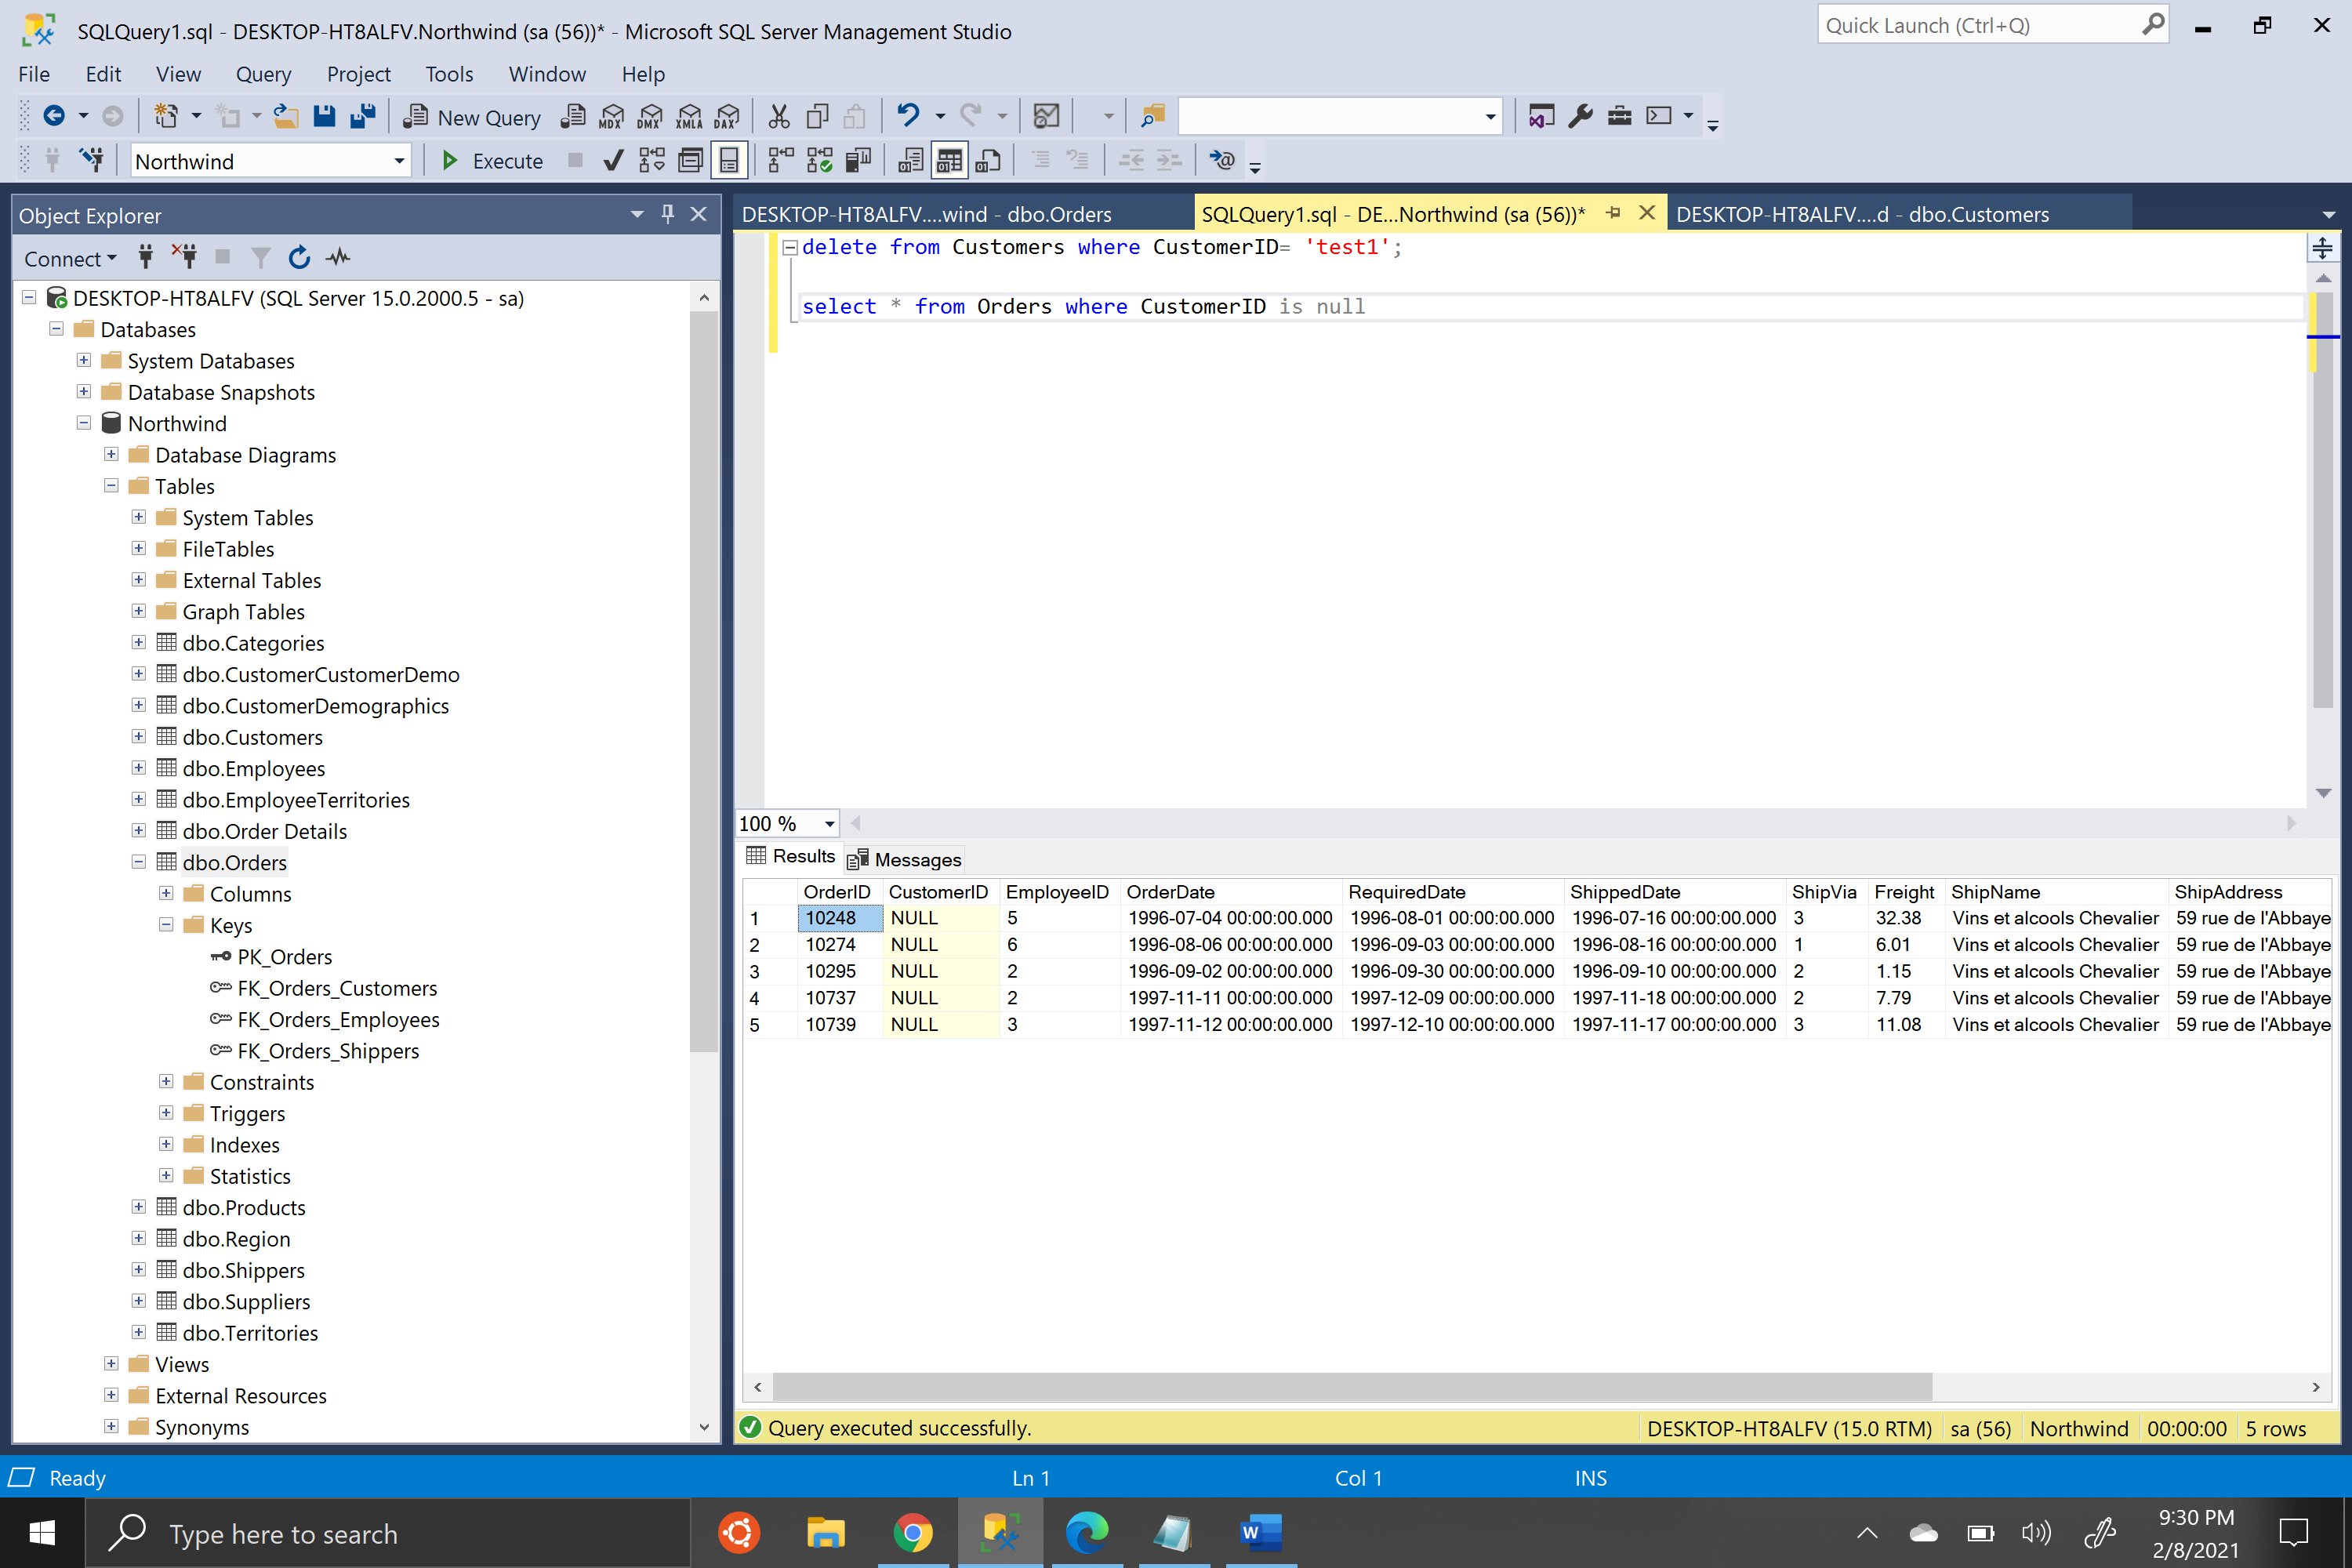

1.4 Currently if a shipper is deleted / updated it is listed for “no action”

1.5 I would change it to set null on delete, and cascade on update as seen below:

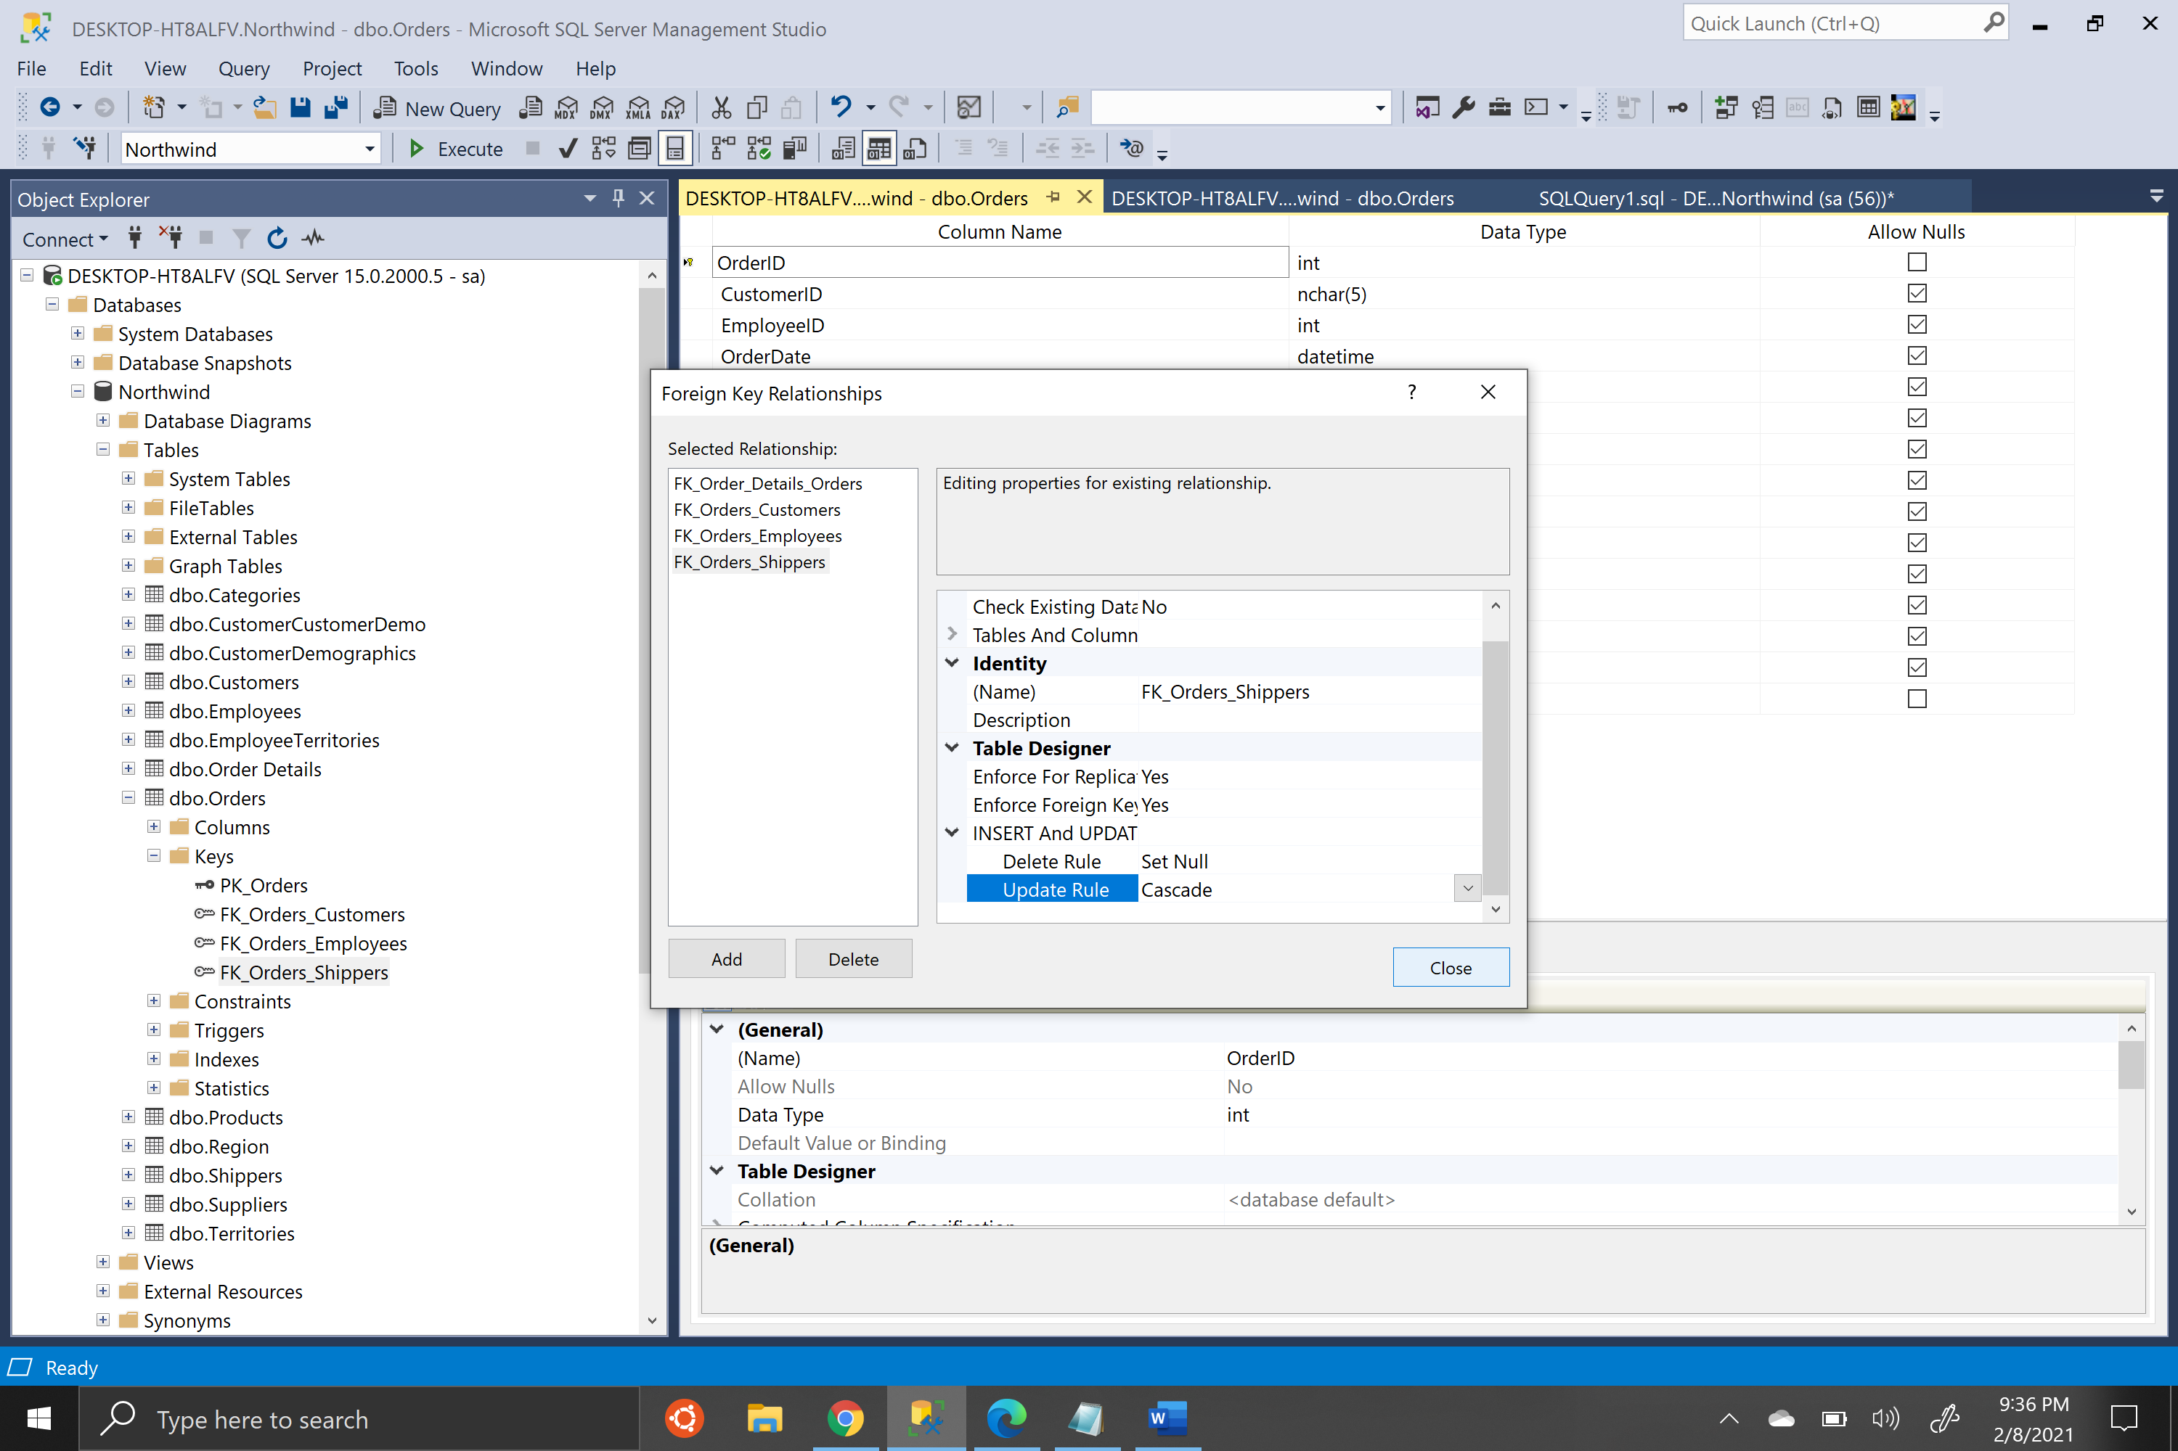

1.6 For update, I have found that it is currently setup to not allow updates to the PK in the Shippers table, so the update rules are irrelevant.

For delete, here is the null action working

