vvdocker

<https://www.youtube.com/watch?v=2Bxh5FNGznQ>

<https://docker-curriculum.com/#prerequisites>

when you using docker to connect to db

what if you didn’t mapping, you kind of lost the table and record if you shut down

but currently my sqledge seems don’t do any mapping.

<https://setapp.com/how-to/install-sql-server>

<https://www.youtube.com/watch?v=Aqg0Cl9rfRQ>

Mongo db

<https://www.youtube.com/watch?v=uklyCSKQ1Po>

docker php apache, mysql

<https://www.youtube.com/watch?v=ZlOPCsZpKQY&list=PLCakfctNSHkGYdA82WDUKF3WGyONpGiEw&index=2>

## AI

<https://github.com/xiezhy6/GP-VTON>

this one have links

<https://github.com/geyuying/PF-AFN>

<https://reveryai.notion.site/Developer-API-Get-Started-Guide-39c7519585bd4b128b7af8a3ffa975d5>

10/15

I use VITON as my conda env

Now,I try the VITON-HD

<https://github.com/shadow2496/VITON-HD>

note: we need to preprocess the data we input into the model

we need segment the clothes from background and

parse the human body

in order to make the model run

## HR-VITON(new version of VITON-HD)

<https://github.com/sangyun884/HR-VITON>

First, test on small set

img | cloth

05006_00.jpg 11001_00.jpg

02532_00.jpg 14096_00.jpg

python3 test_generator.py --occlusion --cuda True --test_name my_test1 --tocg_checkpoint ./checkpoints/mtviton.pth --gpu_ids 0 --gen_checkpoint checkpoints/gen.pth --datasetting unpaired --dataroot ../data/zalando-hd-resized --data_list test_pairs_01.txt

this one skip right now, because we lack of viton dataset

C-VTION

<https://github.com/benquick123/C-VTON#c-vton-context-driven-image-based-virtual-try-on-network>

10/18

## need to preprocessing data

<https://github.com/sangyun884/HR-VITON/blob/main/Preprocessing.md>

cudnn fix?

<https://github.com/opencv/opencv/issues/16380>

this make sense

<https://medium.com/@hotakoma/could-not-find-cudnn-missing-cudnn-library-cudnn-include-dir-required-is-at-least-version-7-5-a4645285d5e>

ADD this in cmakelist

/usr/local/cuda-10.1/include

set(CUDNN_INCLUDE "/usr/local/cuda-10.1/include")

/usr/local/cuda-10.1/lib64/libcudnn.so

set(CUDNN_LIBRARY "/usr/local/cuda-10.1/lib64/libcudnn.so")

I add the cudnn path in the cache.txt, hope it will work

– this fixed, after install package on linux

-- Could NOT find GFlags (missing: GFLAGS_INCLUDE_DIR GFLAGS_LIBRARY)

-- Could NOT find Glog (missing: GLOG_INCLUDE_DIR GLOG_LIBRARY)

<https://zhuanlan.zhihu.com/p/453179183>

CMake Warning at /usr/share/cmake-3.16/Modules/FindProtobuf.cmake:499 (message):

Protobuf compiler version doesn't match library version 3.21.12

try to fix this

fix: just ‘apt install protobuf-compiler’

open cv built from resource

<https://docs.opencv.org/4.x/d7/d9f/tutorial_linux_install.html>

the model need manually put in

<https://github.com/CMU-Perceptual-Computing-Lab/openpose/issues/1224>

follow these

<https://amir-yazdani.github.io/post/openpose/>

now have to ‘make’

need to install these

sudo apt-get install libboost-all-dev

fix: hdf5

local:

wget https://support.hdfgroup.org/ftp/HDF5/releases/hdf5-1.10/hdf5-1.10.7/src/hdf5-1.10.7.tar.gz

tar -xvzf hdf5-1.10.7.tar.gz

cd hdf5-1.10.7

./configure --prefix=$HOME/local

make

make install

OR:

export HDF5_ROOT=/path/to/hdf5

cmake ..

OR:

some package could install

sudo apt-get install libhdf5-dev

sudo apt install libopencv-dev python3-opencv

# ENV:

HRVITON: this env can run the HR-VITON

hrv: try to conda install opencv

# some command:

cmake -S ./ -B ./build

my cudnn

/usr/local/cuda-10.1/targets/x86_64-linux/lib/libcudnn.so.7

export CUDNN_ROOT=/usr/local/cuda-10.1/targets/x86_64-linux/lib/

export CUDNN_LIBRARY=/usr/local/cuda-10.1/targets/x86_64-linux/lib/libcudnn.so.7

export LD_LIBRARY_PATH=/usr/local/cuda-10.1/targets/x86_64-linux/lib/libcudnn.so.7

make clean

cmake ..

make -j5

11/6

# preProcessed data

| openpose | completed |
| --- | --- |
| image-parse-v3 | completed |
| image-parse-agnostic-v3.2 | not yet |
| agnostic-v3.2 | not yet |
| image-densepose | fail |
|  |  |

# Openpose

it seems like our openpose built successfully

run this at openpose root, and it will generate .json

./build/examples/openpose/openpose.bin --image_dir /home/lintzuh@kean.edu/virtualTryOn/data/zalando-hd-resized/test/tzuTest/image --hand --disable_blending --display 0 --write_json /home/lintzuh@kean.edu/virtualTryOn/data/zalando-hd-resized/test/tzuTest/openpose_json --num_gpu 1 --num_gpu_start 0 --render_pose 0

<https://github.com/CMU-Perceptual-Computing-Lab/openpose/blob/master/doc/01_demo.md#different-outputs-json-images-video-ui>

## run this it will generate json and the rendered img:

./build/examples/openpose/openpose.bin --image_dir /home/lintzuh@kean.edu/virtualTryOn/data/zalando-hd-resized/test/tzuTest/image --hand --disable_blending --display 0 --write_json /home/lintzuh@kean.edu/virtualTryOn/data/zalando-hd-resized/test/tzuTest/openpose_json --num_gpu 1 --num_gpu_start 0 --write_images /home/lintzuh@[kean.edu/virtualTryOn/data/zalando-hd-resized/test/tzuTest/openpose_img](http://kean.edu/virtualTryOn/data/zalando-hd-resized/test/tzuTest/openpose_img)

# Human Parse

must run in tf env

right now, the model can run, but in order to used in our program we must check other details

<https://github.com/Engineering-Course/CIHP_PGN>

# DensePose:

Detectron

it said it was using

<https://github.com/facebookresearch/detectron2/blob/main/projects/DensePose/doc/TOOL_APPLY_NET.md>

<https://www.youtube.com/watch?v=289UY_IBEZk>

<https://www.youtube.com/watch?v=jdip_6vTw0s>

After loggin into docker linux

/home/dtron2_user/tryon/detectron2/projects/DensePose

python apply_net.py show configs/densepose_rcnn_R_50_FPN_s1x.yaml https://dl.fbaipublicfiles.com/densepose/densepose_rcnn_R_50_FPN_s1x/165712039/model_final_162be9.pkl testImage dp_segm -v --output testoutput/test.jpg

but that is just viz, and it contain the background

I add some line in .py, to use specific cuda

su

use datatest.py to extract label

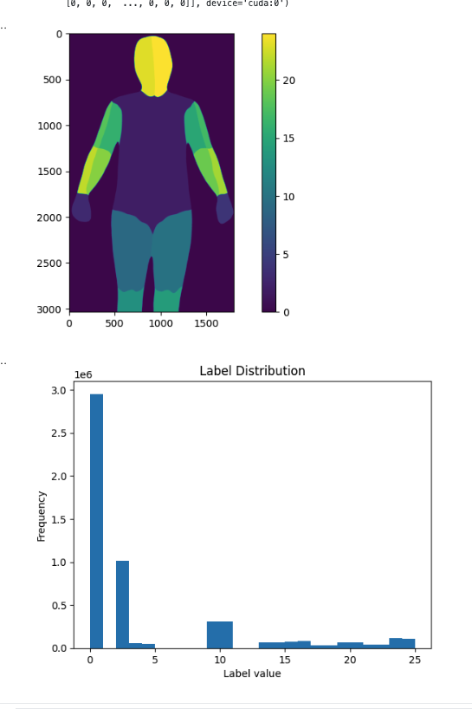

but right now, the problem in our virtual tryon program, does it really read this file, but if what format, is the label we provided or what, and why is 25, what does the label mean??

I feel like you just keep going and then if this denspose doesn’t work we come back to fix

11/8

problem right now,

the output of detron will cut the image to the object, it doesn’t have the whole image size

I fixed that using the bounding box

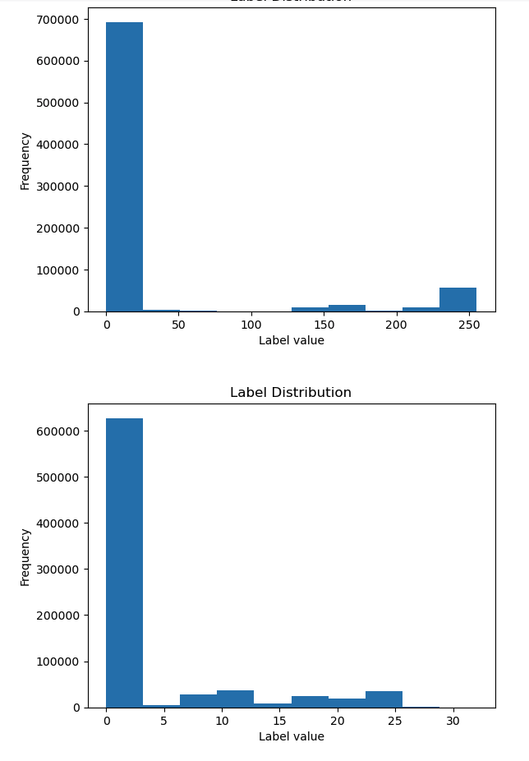

|  |  |
| --- | --- |

their pixel values is different!!

# some info:

<https://www.youtube.com/watch?v=HmKUCPRKNos>

<https://towardsdatascience.com/building-a-deep-learning-image-captioning-model-on-azure-b14ce4682fbf>

12/05

<https://thebooth.azurewebsites.net/>

# Applynet

cd detectron2/projects/DensePose

python apply_net.py dump configs/densepose_rcnn_R_50_FPN_s1x.yaml \

https://dl.fbaipublicfiles.com/densepose/densepose_rcnn_R_50_FPN_s1x/165712039/model_final_162be9.pkl \

"image*.jpg" --output results.pkl -v

ok , I modify how they viz/base.py

denspose_result.py

Right now

, the result wii save as final_visualized_image  
And we need manually do a lot of thing but the mask it work!!!

python apply_net.py show configs/densepose_rcnn_R_50_FPN_s1x.yaml \

https://dl.fbaipublicfiles.com/densepose/densepose_rcnn_R_50_FPN_s1x/165712039/model_final_162be9.pkl \

/data/shared/test/image/image.jpg bbox,dp_segm -v

| openpose | completed |
| --- | --- |
| image-parse-v3 | completed |
| image-parse-agnostic-v3.2 | completed |
| agnostic-v3.2 | completed |
| image-densepose | completed |

Image-parse-v3

python inf_pgn.py -i /home/lintzuh@[kean.edu/virtualTryOn/HR-VITON/CIHP_PGN/datasets/tryon](http://kean.edu/virtualTryOn/HR-VITON/CIHP_PGN/datasets/tryon)

python get_parse_agnostic.py --data_path /home/lintzuh@kean.edu/virtualTryOn/data/zalando-hd-resized/test/tzuTest/smallTestSet --output_path ./agnosticTzuTest

But I get black image, probably is not for viz

# Docker

first, Install docker

<https://docs.docker.com/engine/install/ubuntu/>

I followed these instructions, and <https://www.youtube.com/watch?v=ILdziITdSag>

to add myself(non sudo user) could use the docker

I modify the /etc/gshadow and /etc/group

to let me inside docker group but still I didn’t add to docker group

but we can use ‘newgrp docker’ to add group into this session

and then ‘docker run hello-world’ could test it out

second,install NVIDIA Container Toolkit

<https://docs.nvidia.com/datacenter/cloud-native/container-toolkit/latest/install-guide.html>

Third, since at kean server, we do have NVIDIA driver

so we just skip that and start testing

https://docs.nvidia.com/datacenter/cloud-native/container-toolkit/latest/sample-workload.html

sudo docker run --rm --runtime=nvidia --gpus all ubuntu nvidia-smi

and it works!!

https://www.youtube.com/watch?v=jdip_6vTw0s

Detectron2 Setup with Docker: Simplify Computer Vision - Fix Bugs & Dependencies (2023)

<https://www.youtube.com/watch?v=289UY_IBEZk>

the command:

<https://drive.google.com/file/d/1gIv-gdXND5JQ-e_-72fR5OVveMFl7Z1a/view>

dtron2_user password: 123

ssh connect

ssh -p 65111 dtron2_user@knet-lambda

some script:

python get_parse_agnostic.py --data_path /home/lintzuh@kean.edu/virtualTryOn/data/zalando-hd-resized/test/tzuTest/test --output_path ./agnosticTzuTest

./build/examples/openpose/openpose.bin --image_dir /home/lintzuh@kean.edu/virtualTryOn/data/zalando-hd-resized/test/tzuTest/smallTestSet/image --hand --disable_blending --display 0 --write_json /home/lintzuh@kean.edu/virtualTryOn/data/zalando-hd-resized/test/tzuTest/smallTestSet/openpose_json --num_gpu 1 --num_gpu_start 0 --write_images /home/lintzuh@kean.edu/virtualTryOn/data/zalando-hd-resized/test/tzuTest/smallTestSet/openpose_img

python inf_pgn.py -i /home/lintzuh@kean.edu/virtualTryOn/HR-VITON/CIHP_PGN/datasets/tryon

python3 test_generator.py --occlusion --cuda True --test_name my_test1203_02 --tocg_checkpoint ./checkpoints/mtviton.pth --gpu_ids 0 --gen_checkpoint checkpoints/gen.pth --datasetting unpaired --dataroot /home/lintzuh@kean.edu/virtualTryOn/data/zalando-hd-resized/test/tzuTest --data_list test1203.txt

# Azure

1. install Azure CLI

<https://learn.microsoft.com/en-us/cli/azure/install-azure-cli-macos>

Question: How to deploy

1. <https://learn.microsoft.com/en-us/Azure/machine-learning/how-to-deploy-and-where?view=azureml-api-1&tabs=azcli>

<https://stackoverflow.com/questions/76531783/mlmodel-local-deployment-with-azure-python-sdk>

<https://learn.microsoft.com/en-us/azure/machine-learning/how-to-deploy-online-endpoints?view=azureml-api-2&tabs=python>

<https://learn.microsoft.com/en-us/azure/machine-learning/how-to-manage-models?view=azureml-api-2&tabs=python%2Cuse-local#register-your-model-as-an-asset-in-machine-learning-by-using-the-sdk>

<https://www.youtube.com/watch?v=zhsCbdYQOJ8>

todo:

1. 11/3 I send the support to increase the quota of using gpu
2. if free, set up your own web server

Question:

1. make sure see your azure charge

## 12/05

1. construct a web server and a mysql server

12/06

1. docker
2. <https://github.com/GaryClarke/docker-php>
3. <https://github.com/vastevenson/php-docker-full-stack/blob/main/docker-compose.yml>
4. docker command

docker ps

* see what container is running

# docker command

enter docker image

docker exec -it my_container /bin/bash

docker restart [container_name_or_id]

docker-compose up --build -d

docker-compose up

docker-compose build --no-cache

docker-compose build --no-cache bgn

docker-compose up -d --no-deps bgn

docker-compose logs openpose

docker-compose up -d openpose

docker-compose logs detectron2

docker stats

docker-compose up -d detectron2

docker restart php-docker-full-stack-detectron2-1

docker-compose logs bgn

*In summary, if you have made changes to your Dockerfile or to any files used in building your Docker images, you should use docker-compose up --build to ensure your changes are incorporated into the images. If no changes have been made and you simply want to start your services, docker-compose up is sufficient.*

docker logs 103775e1d158

update the docker-compose version

so, it could use device tag and use pgu

1. construct dtron container

docker exec -it my_container /bin/bash

go inside and

pip install torch==1.10.1+cu111 torchvision==0.11.2+cu111 torchaudio==0.10.1 -f https://download.pytorch.org/whl/cu111/torch_stable.html

docker volume ls

Recreate the Volume:

docker-compose down

docker volume rm php-docker-full-stack_shared-data

docker-compose up.

openpose service

/home/lintzuh@kean.edu/virtualTryOn/flaskApp/app.py

under env flask

parse service

/home/lintzuh@[kean.edu/virtualTryOn/HR-VITON/CIHP_PGN/api_script.py](http://kean.edu/virtualTryOn/HR-VITON/CIHP_PGN/api_script.py)

under env testG

detron2 service

/home/lintzuh@kean.edu/virtualTryOn/php-docker-full-stack/dtron/api_script.py

to do

1. create a volume folder

since the

netstat -tuln | grep 5002

netstat -tuln | grep 5002

1. some issue

openpose will regenerate the whole folder

python inf_pgn.py -i /home/lintzuh@kean.edu/virtualTryOn/projectData/test/image -o /home/lintzuh@[kean.edu/virtualTryOn/projectData/test](http://kean.edu/virtualTryOn/projectData/test)

python3 test_generator.py --occlusion --cuda True --test_name /home/lintzuh@kean.edu/virtualTryOn/projectData/test/Mytest/test1211_04 --tocg_checkpoint ./checkpoints/mtviton.pth --gpu_ids 0 --gen_checkpoint checkpoints/gen.pth --datasetting unpaired --dataroot /home/lintzuh@kean.edu/virtualTryOn/data/zalando-hd-resized/test/tzuTest --data_list test1203.txt --output_dir /home/lintzuh@kean.edu/virtualTryOn/projectData/test/Output

/home/lintzuh@kean.edu/virtualTryOn/projectData/test

python inf_pgn.py -i /home/lintzuh@kean.edu/virtualTryOn/projectData/test/image -o /home/lintzuh@kean.edu/virtualTryOn/projectData/test

python inf_pgn_project.py -i /home/lintzuh@kean.edu/virtualTryOn/projectData/test/image -o /home/lintzuh@kean.edu/virtualTryOn/projectData/test

python get_parse_agnostic.py --data_path /home/lintzuh@kean.edu/virtualTryOn/projectData/test/ --output_path /home/lintzuh@kean.edu/virtualTryOn/projectData/test/image-parse-agnostic-v3.2

ss -ltnp | grep ':5002'