Computational Methods for Finance
Assignment 1
Aloke Mukherjee
http://math.nyu.edu/~atm262/fall06/compmethods/a1/

1. FFT Method

Use FFT method to price a European call option for the following parameters:
Spot price, S0 = $100; Strike price K = 90; risk-free interest rate, r = 5.25%;
dividend rate, q = 2%; Maturity, T = 2 years and volatility, σ = 25%.

The price is $21.3468. Matlab output below comparing the FFT price with the price from the Black-Scholes closed formula:

EDU>> So=100;K=90;r=0.0525;q=0.02;T=2;sigma=.25;
EDU>> help bscf
function y = bscf(u, params);

Black-Scholes characteristic function.

inputs:
u - points at which to evaluate the function
params - model-specific parameters
1 - log of stock price (s)
2 - risk-free interest rate (r)
3 - cost of carry / dividend (q)
4 - volatility of underlying (sigma)
5 - maturity (T)

output:
y - value of characteristic function at points in u

2006 aloke mukherjee

EDU>> params = [log(So) r q sigma T];
EDU>> help fftprice
function [y, strikes, prices] =
fftprice(r, T, cf, params, K);

inputs:
r - risk-free rate
T - time to maturity
cf - model-specific characteristic function
params - parameters for characteristic function
K - strike to evaluate (can be an array)

outputs:
y - option values at given strikes (interpolated using spline)
strikes - actual log-spaced strikes for range defined by K
prices - calculated prices at log-spaced strikes

2006 aloke mukherjee

EDU>> [y,strikes,prices]=fftprice(r,T,@bscf,params,K);
EDU>> y

y =

21.3468

EDU>> help bs
[y, delta, gamma, vega] = BS(So, T, K, r, q, sigma, otype);

Return the Black-Scholes value of a put/call given
So - initial stock price
T - time to maturity
K - strike
r - annual risk-free rate
q - dividend rate
sigma - volatility of the stock
otype - 'put' or 'call' (defaults to call)

So can be a vector or sigma (not both)
all other args should be scalar

EDU>> [ybs, delta, gamma, vega]=bs(So,T,K,r,q,sigma,'call');
EDU>> ybs

ybs =

21.3468

Code:

The implementation consists of three M-files
fftprice.m – sets up the variables and runs FFT to produce the call prices
fftpsi.m – implements the Fourier transform of the dampened call price
bscf.m – implements the Black-Scholes characteristic function for the log of the stock price.

Note that the code is written so that a different characteristic function can easily be substituted.

fftprice.m
function [y, strikes, prices] = fftprice(r, T, cf, params, K);

% function [y, strikes, prices] =
% fftprice(r, T, cf, params, K);
%
% inputs:
% r - risk-free rate
% T - time to maturity
% cf - model-specific characteristic function
% params - parameters for characteristic function
% K - strike to evaluate (can be an array)
%
% outputs:
% y - option values at given strikes (interpolated using spline)
% strikes - actual log-spaced strikes for range defined by K
% prices - calculated prices at log-spaced strikes
%
% 2006 aloke mukherjee

% set up parameters
N=4096; % number of points in FFT
lambda=.01; % spacing of log-strikes
eta=2*pi/lambda/N; % spacing of integration grid
% FFT requires:
% lambda * eta = 2*pi/N
b=N*lambda/2; % log-strikes range -b to b
j=1:N; % useful indices
etas=eta/3*(3 + (-1).^j - ((j-1)==0)); % simpsons rule
vj=eta*(j-1); % evaluate characteristic
% function at these points
ku=-b+lambda*((1:N)-1); % range of N strikes
alpha=1.25; % dampening factor

% calculate points in frequency domain and invert the transform to
% get call prices
xj=exp(i*b*vj).*fftpsi(vj, r, T, cf, alpha, params).*etas;
cku=(exp(-alpha * ku)/pi).*real(fft(xj,N));

% use K (given array of strikes) to restrict the range of
% of log-strikes and prices and do interpolation to find
% option values for the values in K
strikes=exp(ku);
rangemin=max(find(strikes < min(K)));
rangemax=min(find(strikes > max(K)));
range = rangemin-3:rangemax+3;
strikes=strikes(range);
prices=cku(range);
y = spline(strikes,prices,K);

fftpsi.m
function y = fftpsi(v, r, T, cf, a, params);

% y = fftpsi(v, r, T, cf, params);
%
% Psi(v) function referred to in Carr/Madan FFT paper. It
% is the fourier transform of the dampened call price. See
% formula (6) in http://www.imub.ub.es/events/sssf/vgfrier7.pdf.
%
% inputs:
% v - points at which to evaluate the function
% r - risk-free rate
% T - time to maturity
% @cf - model-specific characteristic function (e.g. bscf)
% a - dampening factor alpha
% params - parameters to model-specific characteristic function
% (note: r, T are in params as well, they should agree)
%
% outputs:
% y - value of the function at points in v
%
% 2006 aloke mukherjee

y = exp(-r*T)*cf(v - (a + 1)*i, params)./(a*a + a - v.*v + i*(2*a + 1)*v);

bscf.m
function y = bscf(u, params);

% function y = bscf(u, params);
%
% Black-Scholes characteristic function.
%
% inputs:
% u - points at which to evaluate the function
% params - model-specific parameters
% 1 - log of stock price (s)
% 2 - risk-free interest rate (r)
% 3 - cost of carry / dividend (q)
% 4 - volatility of underlying (sigma)
% 5 - maturity (T)
%
% output:
% y - value of characteristic function at points in u
%
% 2006 aloke mukherjee

v = params(4)*params(4); % variance
y = exp((i*u*(params(1)+(params(2)-params(3)-v/2)*params(5))) - (.5*v*params(5)*u.*u));

2. Finite differences

For the following parameters: Spot price, S0 = $100; Strike price K =
{90, 100, 110}; risk-free interest rate, r = 5.25%; dividend rate, q = 2%; Maturity,
T = 1 year and volatility, σ = 25%, solve the Black-Scholes PDE
numerically to price a European put.

Boundary condition I.
lim V (S, t) = Ke^{−r(T−t)} − Se^{−q(T−t)}
S→0
lim V (S, t) = 0
S→∞

Boundary condition II.
lim ∂²V/∂S² = 0
S→0
lim ∂²V/∂S² = 0
S→∞

a) Comparison of prices and greeks

Explicit
dS=2, dt=0.001
 | Closed-Form | BC I | BC II
K=90 | 4.1546 | 4.1565 | 4.1565
Δ | -0.2444 | -0.2447 | -0.2447
Γ | 0.0124 | 0.0124 | 0.0124
Vega | 31.1074 | 31.0935 | 31.0935
K=100 | 8.1081 | 8.1094 | 8.1094
Δ | -0.3915 | -0.3916 | -0.3916
Γ | 0.0151 | 0.0151 | 0.0151
Vega | 37.8533 | 37.8610 | 37.8610
K=110 | 13.5580 | 13.5589 | 13.5589
Δ | -0.5393 | -0.5393 | -0.5393
Γ | 0.0155 | 0.0155 | 0.0155
Vega | 38.7939 | 38.7951 | 38.7951

Implicit
dS=0.1, dt=0.001
 | Closed-Form | BC I | BC II
K=90 | 4.1546 | 4.1536 | 4.1536
Δ | -0.2444 | -0.2444 | -0.2444
Γ | 0.0124 | 0.0124 | 0.0124
Vega | 31.1074 | 31.1192 | 31.1192
K=100 | 8.1081 | 8.1068 | 8.1068
Δ | -0.3915 | -0.3915 | -0.3915
Γ | 0.0151 | 0.0151 | 0.0151
Vega | 37.8533 | 37.8478 | 37.8478
K=110 | 13.5580 | 13.5570 | 13.5570
Δ | -0.5393 | -0.5394 | -0.5394
Γ | 0.0155 | 0.0155 | 0.0155
Vega | 38.7939 | 38.7903 | 38.7903

Crank-Nicolson
dS=0.1, dt=0.001
 | Closed-Form | BC I | BC II
K=90 | 4.1546 | 4.1546 | 4.1546
Δ | -0.2444 | -0.2444 | -0.2444
Γ | 0.0124 | 0.0124 | 0.0124
Vega | 31.1074 | 31.1252 | 31.1252
K=100 | 8.1081 | 8.1081 | 8.1081
Δ | -0.3915 | -0.3915 | -0.3915
Γ | 0.0151 | 0.0151 | 0.0151
Vega | 37.8533 | 37.8534 | 37.8534
K=110 | 13.5580 | 13.5580 | 13.5580
Δ | -0.5393 | -0.5393 | -0.5393
Γ | 0.0155 | 0.0155 | 0.0155
Vega | 38.7939 | 38.7976 | 38.7976

Multi-level
dS=0.1, dt=0.001
 | Closed-Form | BC I | BC II
K=90 | 4.1546 | 4.1546 | 4.1546
Δ | -0.2444 | -0.2444 | -0.2444
Γ | 0.0124 | 0.0124 | 0.0124
Vega | 31.1074 | 31.1252 | 31.1252
K=100 | 8.1081 | 8.1081 | 8.1081
Δ | -0.3915 | -0.3915 | -0.3915
Γ | 0.0151 | 0.0151 | 0.0151
Vega | 37.8533 | 37.8534 | 37.8534
K=110 | 13.5580 | 13.5580 | 13.5580
Δ | -0.5393 | -0.5393 | -0.5393
Γ | 0.0155 | 0.0155 | 0.0155
Vega | 38.7939 | 38.7976 | 38.7976

b) Stability condition for explicit finite differences

The explicit method has an interpretation similar to the binomial tree. The time k+1 value of the option is a probabilistic blending of three prior states. This interpretation leads to the stability condition that the coefficients of the time k terms can be interpreted as probabilities and should therefore be positive. The Vj+1 coefficient is always positive. The Vj-1 coefficient is positive as long as σ²S_{min}/dS > (r-q) for S_{min} > 0 which is generally the case. The only constraint on dt and dS is the coefficient of the Vj term. For this to be positive the following relation must hold: dt < 1/(r + σ²S_{max}²/dS²)

The first graph below demonstrates that the solution is stable if dt satisfies this condition. The second graph shows the effect of instability on the solution. The magnitude and range affected by oscillation increase with dt.

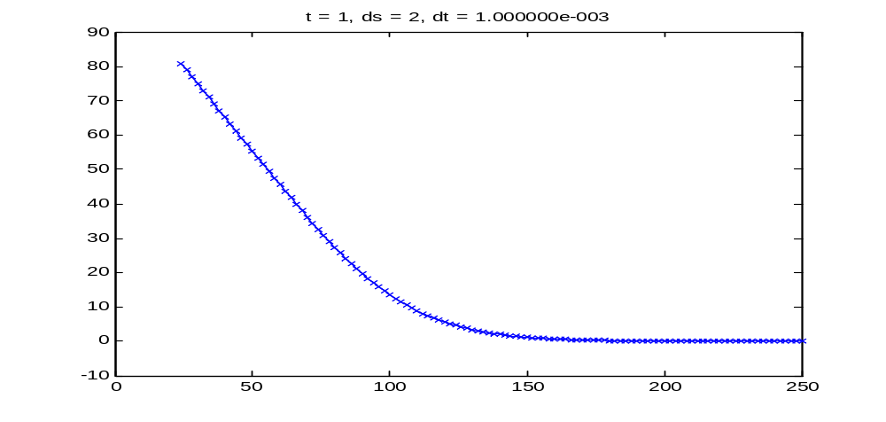
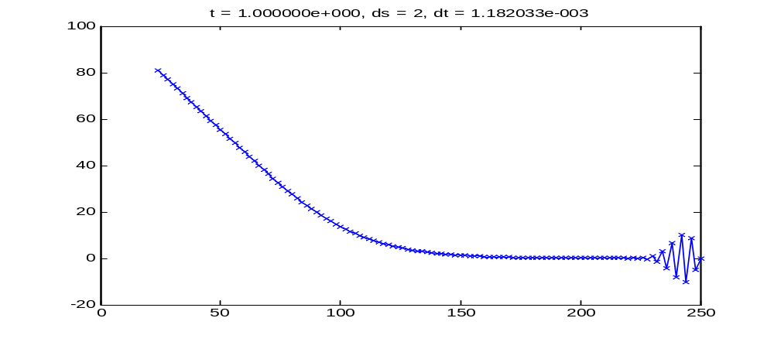

c) Oscillation of Crank-Nicolson for certain timesteps

See the following graphs for dS = 0.1, dt = 0.2 showing the option value at time 0.2 and 0.4 respectively. There is a discontinuity at the strike price and the solution around this point oscillates back and forth as time “advances”.

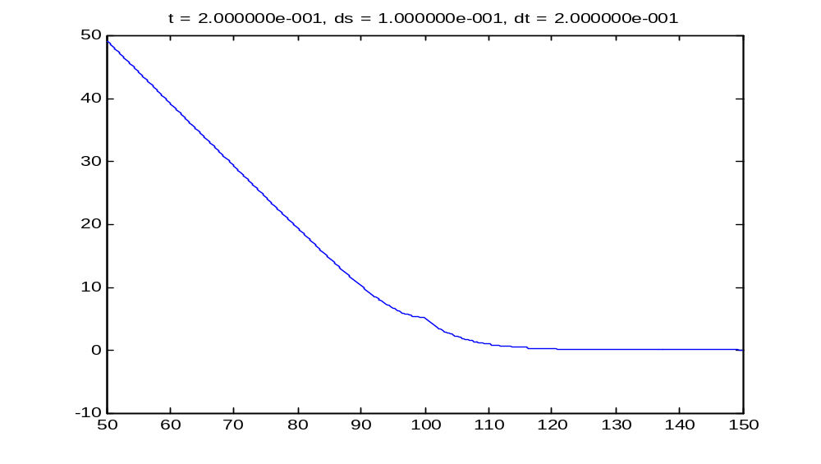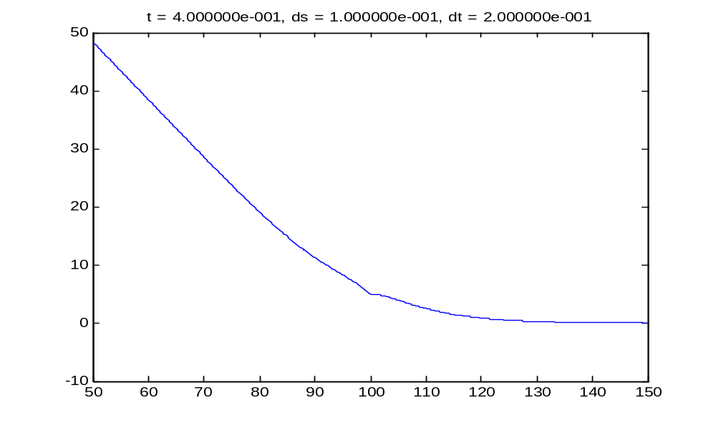

d) Which boundary conditions would you prefer?

I would prefer boundary conditions II (zero gamma). Looking at the numerical results, results for both types of boundary condition were identical to the reported level of accuracy. BC II however removes the need to explicitly set the boundary values in each iteration since the constraint is included in the tridiagonal matrix. This increases the algorithm’s efficiency and makes it less dependent on the option being priced, for example no change is required to price call options.

Code for question 2:

The implementation consists of the following M-files
bsexp.m – explicit finite differences
bsimp.m – implicit finite differences
bscranky.m – Crank Nicholson finite differences
bsmulti.m – multi-level finite differences

The implicit methods use the tridiagonal solver implemented by Baris Sumengen (http://www.barissumengen.com/myblog/index.php?id=6).

bsexp.m
function [y, delta, gamma, vega] = bsexp(S, K, r, q, T, sigma, BC, ds, dt);

% function [y, delta, gamma, vega] = bsexp(S, K, r, q, T, sigma, BC, ds, dt);
%
% Price a european put option using the Black-Scholes
% PDE solved using explicit finite differences.
%
% inputs:
% S - current spot
% K - strike
% r - risk-free rate
% q - dividend rate
% T - time to expiry
% sigma - volatility of underlying
% BC - OPTIONAL boundary conditions
% 1 - dirichlet (default) - limiting values for put
% 2 - neumann - second derivatives go to zero
% ds - OPTIONAL spacing of stock grid
% dt - OPTIONAL spacing of time grid (if T/dt is not an integer dt will
% be adjusted so that it is)
%
% outputs:
% y - current price of the option
% delta - change in option price with increase in S
% gamma - change in delta with increase in S
% vega - change in option price with increase in sigma
%
% 2006 aloke mukherjee

% note: we solve the PDE backwards in time, t below
% is time to expiry (e.g. tau) so that t = 0 corresponds to the final
% time and we can use the payoff as our "initial" condition

% default to dirichlet boundary conditions
if (nargin < 7)
BC = 1;
end

% beyond Smin, Smax return known limiting values for the put
Smin = .25 * S;
Smax = 2.5 * S;
if (S < Smin)
y = K*exp(-r*T)-S*exp(-q*T);
return;
end;
if (S > Smax)
y = 0;
return;
end;

% grid setup -
% set spacing of stock grid, adjust Smin and Smax so that the
% range has integer number of divisions and that the spot falls
% on the grid (for calculating greeks)
% if time spacing not specified, set it based on stability condition
% for explicit method for Black-Scholes, also adjust dt so that T/dt
% is an integer
if (nargin < 8)
ds = min(.1*K,5);
end
Nless = ceil((S-Smin)/ds);
Nmore = ceil((Smax-S)/ds);
Smin = S - Nless*ds;
Smax = S + Nmore*ds;
N = Nless + Nmore + 1;
% time spacing
if (nargin < 9)
dt = 1/(r + sigma*sigma*Smax*Smax/ds/ds);
end
M = ceil(T/dt) + 1;
dt = T/(M - 1);

% Vj,k+1 can be expressed as AjVj-1,k + BjVj,k + CjVj+1,k
% create Aj, Bj and Cj
Sj = (Smin:ds:Smax)';
f1 = Sj*(r - q)*dt/2/ds;
f2 = (Sj.*Sj)*sigma*sigma*dt/ds/ds;
Aj = -f1 + f2/2;
Bj = 1 - f2 - r*dt;
Cj = f1 + f2/2;

% verify assertion of all positive coefficients
if (min(Aj) < 0 || min(Bj) < 0 || min(Cj) < 0)
warning('unstable - found coefficients less than zero - A %f B %f C %f', min(Aj), min(Bj), min(Cj));
end;

% boundary condition - set finite difference approximation of
% second derivative to zero and change coefficients appropriately
if (BC == 2)
Bj(1) = 2*Aj(1) + Bj(1);
Cj(1) = -Aj(1) + Cj(1);
Aj(end) = Aj(end) - Cj(end);
Bj(end) = Bj(end) + 2*Cj(end);
end

% create sparse matrix which when applied to Vk gives Vk+1
% following two lines correct for the way spdiags takes
% elements from arrays longer than the diagonal
Aj(1:end-1) = Aj(2:end);
Cj(2:end) = Cj(1:end-1);
G = spdiags([Aj Bj Cj], -1:1, N, N);

% initialize our "initial" condition, plus do the correction suggested
% by Hirsa when K is a gridpoint
Vj = max(K - Sj, 0);
Vj(find(Sj == K)) = ds/8;

% iterate solution through time, if pause is uncommented
% the solution will be graphed over time
for t = dt:dt:T
plot(Sj, Vj, 'x-');
title(sprintf('t = %d, ds = %d, dt = %d', t, ds, dt));
Vj = G * Vj;

% implement boundary condition I
if (BC == 1)
Vj(1) = K*exp(-r*t)-Smin*exp(-q*t);
Vj(end) = 0;
end

% pause(1);
end;

% calculate option value for given spot price
y = interp1(Sj, Vj, S);

% calculate delta, gamma using finite difference approximations
spotindex = find(Sj == S);
delta = .5*(Vj(spotindex + 1) - Vj(spotindex - 1))/ds;
gamma = (Vj(spotindex - 1) - 2*Vj(spotindex) + Vj(spotindex + 1))/ds/ds;

% only calculate vega if it was requested
if (nargout == 4)
dsigma = .001;
% go backwards so we don't have a problem with stability of dt
yminus = bsexp(S, K, r, q, T, sigma - dsigma, BC, ds, dt);
vega = (y - yminus)/dsigma;
end

bsimp.m
function [y, delta, gamma, vega] = bsimp(S, K, r, q, T, sigma, BC, ds, dt);

% function [y, delta, gamma, vega] = bsimp(S, K, r, q, T, sigma, BC, ds, dt);
%
% Price a european put option using the Black-Scholes
% PDE solved using implicit finite differences.
%
% inputs:
% S - current spot
% K - strike
% r - risk-free rate
% q - dividend rate
% T - time to expiry
% sigma - volatility of underlying
% BC - OPTIONAL boundary conditions
% 1 - dirichlet (default) - limiting values for put
% 2 - neumann - second derivatives go to zero
% ds - OPTIONAL spacing of stock grid
% dt - OPTIONAL spacing of time grid (if T/dt is not an integer dt will
% be adjusted so that it is)
%
% outputs:
% y - current price of the option
% delta - change in option price with increase in S
% gamma - change in delta with increase in S
% vega - change in option price with increase in sigma
%
% 2006 aloke mukherjee

% note: we solve the PDE backwards in time, t below
% is time to expiry (e.g. tau) so that t = 0 corresponds to the final
% time and we can use the payoff as our "initial" condition

% default to dirichlet boundary conditions
if (nargin < 7)
BC = 1;
end

% beyond Smin, Smax return known limiting values for the put
Smin = .25 * K;
Smax = 2.5 * K;
if (S < Smin)
y = K*exp(-r*T)-S*exp(-q*T);
return;
end;
if (S > Smax)
y = 0;
return;
end;

% grid setup -
% set spacing of stock grid, adjust Smin and Smax so that the
% range has integer number of divisions and that the spot falls
% on the grid (for calculating greeks)
% if time spacing not specified, set it as a fraction of T, also
% adjust dt so that T/dt is an integer
if (nargin < 8)
ds = min(.1*K,5);
end
Nless = ceil((S-Smin)/ds);
Nmore = ceil((Smax-S)/ds);
Smin = S - Nless*ds;
Smax = S + Nmore*ds;
N = Nless + Nmore + 1;
% time spacing
if (nargin < 9)
dt = .01*T;
end
M = ceil(T/dt) + 1;
dt = T/(M - 1);

% Vj,k can be expressed as AjVj-1,k+1 + BjVj,k+1 + CjVj+1,k+1
% create Aj, Bj and Cj
Sj = (Smin:ds:Smax)';
f1 = Sj*(r - q)*dt/2/ds;
f2 = (Sj.*Sj)*sigma*sigma*dt/ds/ds;
Aj = f1 - f2/2;
Bj = 1 + f2 + r*dt;
Cj = -f1 - f2/2;

% boundary condition - set finite difference approximation of
% second derivative to zero and change coefficients appropriately
if (BC == 2)
Bj(2) = 2*Aj(2) + Bj(2);
Cj(2) = -Aj(2) + Cj(2);
Aj(end-1) = Aj(end-1) - Cj(end-1);
Bj(end-1) = Bj(end-1) + 2*Cj(end-1);
end

% initialize our "initial" condition, plus do the correction suggested
% by Hirsa when K is a gridpoint
Vj = max(K - Sj, 0);
Vj(find(Sj == K)) = ds/8;

for t = dt:dt:T
% we are trying to solve for v (value at next step) in
% Mv = w
% w is the known state at t - dt plus a column vector
% required to incorporate the boundary conditions
% M is a tridiagonal matrix composed of A,B,C values above
w = Vj(2:N-1);

% incorporates dirichlet boundary conditions
if (BC == 1)
% calculate boundaries at t for put
Vj(1) = K*exp(-r*t)-Smin*exp(-q*t);
Vj(N) = 0;
w(1) = w(1) - Aj(2) * Vj(1);
w(end) = w(end) - Cj(N - 1) * Vj(N);
end

% calculate new state for non boundary points
Vj(2:N-1) = tridiagonal_solve([0; Aj(3:N-1)], Bj(2:N-1), [Cj(2:N-2); 0], w);

% plot(Sj(1+(BC==2):end-(BC==2)), Vj(1+(BC==2):end-(BC==2)), 'x-');
% title(sprintf('t = %d, ds = %d, dt = %d', t, ds, dt));
% pause(1);
end;

y = interp1(Sj, Vj, S);

% calculate delta, gamma using finite difference approximations
spotindex = find(Sj == S);
delta = .5*(Vj(spotindex + 1) - Vj(spotindex - 1))/ds;
gamma = (Vj(spotindex - 1) - 2*Vj(spotindex) + Vj(spotindex + 1))/ds/ds;

% only calculate vega if it was requested
if (nargout == 4)
dsigma = .001;
yplus = bsimp(S, K, r, q, T, sigma + dsigma, BC, ds, dt);
vega = (yplus - y)/dsigma;
end

bscranky.m
function [y, delta, gamma, vega] = bscranky(S, K, r, q, T, sigma, BC, ds, dt);

% function y = bscranky(S, K, r, q, T, sigma, BC, ds, dt);
%
% Price a european put option using the Black-Scholes
% PDE solved using the Crank-Nicholson method.
%
% inputs:
% S - current spot
% K - strike
% r - risk-free rate
% q - dividend rate
% T - time to expiry
% sigma - volatility of underlying
% BC - OPTIONAL boundary conditions
% 1 - dirichlet (default) - limiting values for put
% 2 - neumann - second derivatives go to zero
% ds - OPTIONAL spacing of stock grid
% dt - OPTIONAL spacing of time grid (if T/dt is not an integer dt will
% be adjusted so that it is)
%
% outputs:
% y - current price of the option
% delta - change in option price with increase in S
% gamma - change in delta with increase in S
% vega - change in option price with increase in sigma
%
% 2006 aloke mukherjee

% note: we solve the PDE backwards in time, t below
% is time to expiry (e.g. tau) so that t = 0 corresponds to the final
% time and we can use the payoff as our "initial" condition

% default to dirichlet boundary conditions
if (nargin < 7)
BC = 1;
end

% beyond Smin, Smax return known limiting values for the put
Smin = .25 * K;
Smax = 2.5 * K;
if (S < Smin)
y = K*exp(-r*T)-S*exp(-q*T);
return;
end;
if (S > Smax)
y = 0;
return;
end;

% grid setup -
% set spacing of stock grid, adjust Smin and Smax so that the
% range has integer number of divisions and that the spot falls
% on the grid (for calculating greeks)
% if time spacing not specified, set it as a fraction of T, also
% adjust dt so that T/dt is an integer
if (nargin < 8)
ds = min(.1*K,5);
end
Nless = ceil((S-Smin)/ds);
Nmore = ceil((Smax-S)/ds);
Smin = S - Nless*ds;
Smax = S + Nmore*ds;
N = Nless + Nmore + 1;
% time spacing
if (nargin < 9)
dt = .01*T;
end
M = ceil(T/dt) + 1;
dt = T/(M - 1);

% Under Crank-Nicholson, the relationship between time k and k+1
% values is:
% AjVj-1,k+1 + BjVj,k+1 + CjVj+1,k+1 = Zk
% with
% Zk = DjVj-1,k + EjVj,k + FjVj+1,k
% Create Aj, Bj, Cj, Dj, Ej and Fj
Sj = (Smin:ds:Smax)';
f1 = Sj*(r - q)*dt/2/ds;
f2 = (Sj.*Sj)*sigma*sigma*dt/ds/ds;
Aj = (f1/2 - f2/4);
Bj = (1 + f2/2 + r*dt/2);
Cj = (-f1/2 - f2/4);
Dj = -Aj;
Ej = (1 - f2/2 - r*dt/2);
Fj = -Cj;

% boundary condition - set finite difference approximation of
% second derivative to zero and change coefficients appropriately
if (BC == 2)
% this implements neumann bc for implicit (k+1) step
Bj(2) = 2*Aj(2) + Bj(2);
Cj(2) = -Aj(2) + Cj(2);
Aj(end-1) = Aj(end-1) - Cj(end-1);
Bj(end-1) = Bj(end-1) + 2*Cj(end-1);

% this implements neumann bc for explicit (k) step
Ej(2) = 2*Dj(2) + Ej(2);
Fj(2) = -Dj(2) + Fj(2);
Dj(end-1) = Dj(end-1) - Fj(end-1);
Ej(end-1) = Ej(end-1) + 2*Fj(end-1);

% with neumann boundary conditions, first and last elements of
% Vj are not used, we can factor this in by just zeroing the
% edge elements
Dj(2) = 0;
Ej(1) = 0;
% Fj(1) = 0;
% Dj(end) = 0;
Ej(end) = 0;
Fj(end-1) = 0;
end

% create sparse matrix which when applied to Vk gives Zk
% following two lines correct for the way spdiags takes
% elements from arrays longer than the diagonal
Dj(1:end-1) = Dj(2:end);
Fj(2:end) = Fj(1:end-1);
G = spdiags([Dj Ej Fj], -1:1, N, N);

% initialize our "initial" condition, plus do the correction suggested
% by Hirsa when K is a gridpoint
Vj = max(K - Sj, 0);
Vj(find(Sj == K)) = ds/8;

for t = dt:dt:T
% calculate Z
Z = G*Vj;

% we are trying to solve for v (value at next step) in
% Mv = w
% w is Z above plus corrections required to incorporate the
% boundary conditions
% M is a tridiagonal matrix composed of A,B,C values above
w = Z(2:N-1);

% incorporates dirichlet boundary conditions
if (BC == 1)
% calculate boundaries at t for put
Vj(1) = K*exp(-r*t)-Smin*exp(-q*t);
Vj(N) = 0;
w(1) = w(1) - Aj(2) * Vj(1);
w(end) = w(end) - Cj(N - 1) * Vj(N);
end

% calculate new state for non boundary points
Vj(2:N-1) = tridiagonal_solve([0; Aj(3:N-1)], Bj(2:N-1), [Cj(2:N-2); 0], w);

% plot(Sj(1+(BC==2):end-(BC==2)), Vj(1+(BC==2):end-(BC==2)), '-');
% title(sprintf('t = %d, ds = %d, dt = %d', t, ds, dt));
% pause(1);
end;

y = interp1(Sj, Vj, S);

% calculate delta, gamma using finite difference approximations
spotindex = find(Sj == S);
delta = .5*(Vj(spotindex + 1) - Vj(spotindex - 1))/ds;
gamma = (Vj(spotindex - 1) - 2*Vj(spotindex) + Vj(spotindex + 1))/ds/ds;

% only calculate vega if it was requested
if (nargout == 4)
dsigma = .001;
yplus = bscranky(S, K, r, q, T, sigma + dsigma, BC, ds, dt);
vega = (yplus - y)/dsigma;
end

bsmulti.m
function [y, delta, gamma, vega] = bsmulti(S, K, r, q, T, sigma, BC, ds, dt);

% function [y, delta, gamma, vega] = bsmulti(S, K, r, q, T, sigma, BC, ds, dt);
%
% Price a european put option using the Black-Scholes
% PDE solved using multi-level finite differences.
%
% inputs:
% S - current spot
% K - strike
% r - risk-free rate
% q - dividend rate
% T - time to expiry
% sigma - volatility of underlying
% BC - OPTIONAL boundary conditions
% 1 - dirichlet (default) - limiting values for put
% 2 - neumann - second derivatives go to zero
% ds - OPTIONAL spacing of stock grid
% dt - OPTIONAL spacing of time grid (if T/dt is not an integer dt will
% be adjusted so that it is)
%
% outputs:
% y - current price of the option
% delta - change in option price with increase in S
% gamma - change in delta with increase in S
% vega - change in option price with increase in sigma
%
% 2006 aloke mukherjee

% note: we solve the PDE backwards in time, t below
% is time to expiry (e.g. tau) so that t = 0 corresponds to the final
% time and we can use the payoff as our "initial" condition

% default to dirichlet boundary conditions
if (nargin < 7)
BC = 1;
end

% beyond Smin, Smax return known limiting values for the put
Smin = .25 * K;
Smax = 2.5 * K;
if (S < Smin)
y = K*exp(-r*T)-S*exp(-q*T);
return;
end;
if (S > Smax)
y = 0;
return;
end;

% grid setup -
% set spacing of stock grid, adjust Smin and Smax so that the
% range has integer number of divisions and that the spot falls
% on the grid (for calculating greeks)
% if time spacing not specified, set it as a fraction of T, also
% adjust dt so that T/dt is an integer
if (nargin < 8)
ds = min(.1*K,5);
end
Nless = ceil((S-Smin)/ds);
Nmore = ceil((Smax-S)/ds);
Smin = S - Nless*ds;
Smax = S + Nmore*ds;
N = Nless + Nmore + 1;
% time spacing
if (nargin < 9)
dt = .01*T;
end
M = ceil(T/dt) + 1;
dt = T/(M - 1);

% Right-hand-side can be expressed as
% AjVj-1,k+1 + BjVj,k+1 + CjVj+1,k+1
% create Aj, Bj and Cj
Sj = (Smin:ds:Smax)';
f1 = Sj*(r - q)*dt/2/ds;
f2 = (Sj.*Sj)*sigma*sigma*dt/ds/ds;

% coefficients for implicit tridiagonal matrix
Aj = f1 - f2/2;
Bj = 1 + f2 + r*dt;
Cj = -f1 - f2/2;

% coefficients for multi-level tridiagonal matrix
AMj = 2*Aj;
BMj = 2*Bj + 1;
CMj = 2*Cj;

% boundary condition - set finite difference approximation of
% second derivative to zero and change coefficients appropriately
if (BC == 2)
% for implicit step
Bj(2) = 2*Aj(2) + Bj(2);
Cj(2) = -Aj(2) + Cj(2);
Aj(end-1) = Aj(end-1) - Cj(end-1);
Bj(end-1) = Bj(end-1) + 2*Cj(end-1);

% for multi-level steps
BMj(2) = 2*AMj(2) + BMj(2);
CMj(2) = -AMj(2) + CMj(2);
AMj(end-1) = AMj(end-1) - CMj(end-1);
BMj(end-1) = BMj(end-1) + 2*CMj(end-1);
end

% initialize our "initial" condition, plus do the correction suggested
% by Hirsa when K is a gridpoint
Vj = max(K - Sj, 0);
Vj(find(Sj == K)) = ds/8;

% for multi-level need to keep track of one extra timestep
% to generate this take one step using implicit method
Vjminus = Vj;
w = Vj(2:N-1);
if (BC == 1)
Vj(1) = K*exp(-r*dt)-Smin*exp(-q*dt);
Vj(N) = 0;
w(1) = w(1) - Aj(2) * Vj(1);
w(end) = w(end) - Cj(N - 1) * Vj(N);
end
Vj(2:N-1) = tridiagonal_solve([0; Aj(3:N-1)], Bj(2:N-1), [Cj(2:N-2); 0], w);

for t = 2*dt:dt:T
% solving Mv_k+1 = w
% w is a function of k, k-1
w = 4*Vj(2:N-1) - Vjminus(2:N-1);
Vjminus = Vj;

if (BC == 1)
% update boundaries to current timestep and add appropriate
% conditions to w
Vj(1) = K*exp(-r*t)-Smin*exp(-q*t);
Vj(N) = 0;
w(1) = w(1) - AMj(2) * Vj(1);
w(end) = w(end) - CMj(N - 1) * Vj(N);
end

% calculate new state for non boundary points
Vj(2:N-1) = tridiagonal_solve([0; AMj(3:N-1)], BMj(2:N-1), [CMj(2:N-2); 0], w);

% plot(Sj(1+(BC==2):end-(BC==2)), Vj(1+(BC==2):end-(BC==2)), 'x-');
% title(sprintf('t = %d, ds = %d, dt = %d', t, ds, dt));
% pause(1);
end;

y = interp1(Sj, Vj, S);

% calculate delta, gamma using finite difference approximations
spotindex = find(Sj == S);
delta = .5*(Vj(spotindex + 1) - Vj(spotindex - 1))/ds;
gamma = (Vj(spotindex - 1) - 2*Vj(spotindex) + Vj(spotindex + 1))/ds/ds;

% only calculate vega if it was requested
if (nargout == 4)
dsigma = .001;
yplus = bsmulti(S, K, r, q, T, sigma + dsigma, BC, ds, dt);
vega = (yplus - y)/dsigma;
end

3. Implicit finite difference with discrete dividends

Assume that the stock pays a one-time discrete dividend of D = $3.25 in 6 months. What is the price of a European put for the same set of parameters (except dividend yield, q = 0) using just implicit finite differences under the second set of boundary conditions.

The price is $8.7490. Sample output below:

EDU>> [y,d,g,v]=bsimpdd(So,K,r,3.25,.5,T,sigma,1,1e-3)

y =

8.7490

d =

-0.4193

g =

0.0159

v =

38.4428

Code for question 3:

The implementation consists of the following M-files
bsimpdd.m – implicit finite differences adapted for discrete dividend

bsimpdd.m
function [y, delta, gamma, vega] = bsimpdd(S, K, r, D, tD, T, sigma, ds, dt);

% function [y, delta, gamma, vega] = bsimpdd(S, K, r, D, tD, T, sigma, ds, dt);
%
% Price a european put option on a stock with one discrete dividend
% using the Black-Scholes PDE solved using implicit finite
% differences. Boundary conditions are assumed to be that the
% second derivatives go to zero at Smin and Smax.
%
% inputs:
% S - current spot
% K - strike
% r - risk-free rate
% D - amount of dividend from underlying
% tD - timing of dividend (e.g. 1/4 = 3 months from now)
% T - time to expiry
% sigma - volatility of underlying
% ds - OPTIONAL spacing of stock grid
% dt - OPTIONAL spacing of time grid (if T/dt is not an integer dt will
% be adjusted so that it is)
%
% outputs:
% y - current price of the option
% delta - change in option price with increase in S
% gamma - change in delta with increase in S
% vega - change in option price with increase in sigma
%
% 2006 aloke mukherjee

% note: we solve the PDE backwards in time, t below
% is time to expiry (e.g. tau) so that t = 0 corresponds to the final
% time and we can use the payoff as our "initial" condition

% beyond Smin, Smax return known limiting values for the put
Smin = .25 * K;
Smax = 2.5 * K;
if (S < Smin)
y = K*exp(-r*T)-S*exp(-q*T);
return;
end;
if (S > Smax)
y = 0;
return;
end;

% grid setup -
% set spacing of stock grid, adjust Smin and Smax so that the
% range has integer number of divisions and that the spot falls
% on the grid (for calculating greeks)
% if time spacing not specified, set it as a fraction of T, also
% adjust dt so that T/dt is an integer
if (nargin < 8)
ds = min(.1*K,5);
end
Nless = ceil((S-Smin)/ds);
Nmore = ceil((Smax-S)/ds);
Smin = S - Nless*ds;
Smax = S + Nmore*ds;
N = Nless + Nmore + 1;
% time spacing
if (nargin < 9)
dt = .01*T;
end
M = ceil(T/dt) + 1;
dt = T/(M - 1);
Tk = (0:dt:T)';

% convert dividend date into time before expiry
tD = T - tD;
if (isempty(find(Tk == tD)))
error('dividend date %f does not lie on grid 0:%f:%f', tD, dt, T);
end

% Vj,k can be expressed as AjVj-1,k+1 + BjVj,k+1 + CjVj+1,k+1
% create Aj, Bj and Cj
Sj = (Smin:ds:Smax)';
f1 = Sj*r*dt/2/ds;
f2 = (Sj.*Sj)*sigma*sigma*dt/ds/ds;
Aj = f1 - f2/2;
Bj = 1 + f2 + r*dt;
Cj = -f1 - f2/2;

% boundary condition - set finite difference approximation of
% second derivative to zero and change coefficients appropriately
Bj(2) = 2*Aj(2) + Bj(2);
Cj(2) = -Aj(2) + Cj(2);
Aj(end-1) = Aj(end-1) - Cj(end-1);
Bj(end-1) = Bj(end-1) + 2*Cj(end-1);

% initialize our "initial" condition, plus do the correction suggested
% by Hirsa when K is a gridpoint
Vj = max(K - Sj, 0);
Vj(find(Sj == K)) = ds/8;

for t = dt:dt:T
% we are trying to solve for v (value at next step) in
% Mv = w
% w is the known state at t - dt plus a column vector
% required to incorporate the boundary conditions
% M is a tridiagonal matrix composed of A,B,C values above
w = Vj(2:N-1);

% calculate new state for non boundary points
Vj(2:N-1) = tridiagonal_solve([0; Aj(3:N-1)], Bj(2:N-1), [Cj(2:N-2); 0], w);

% implement discrete dividend condition V(S,td-) = V(S-D,td+)
% since we are stepping backwards from expiry we know the
% right-hand side and solve for the left-hand side
if (t == tD)
Vj(2:N-1) = spline(Sj(2:N-1), Vj(2:N-1), Sj(2:N-1) - D);
end

% plot(Sj(2:end-1), Vj(2:end-1), 'x-');
% title(sprintf('t = %d, ds = %d, dt = %d', t, ds, dt));
% pause(1);
end;

y = interp1(Sj, Vj, S);

% calculate delta, gamma using finite difference approximations
spotindex = find(Sj == S);
delta = .5*(Vj(spotindex + 1) - Vj(spotindex - 1))/ds;
gamma = (Vj(spotindex - 1) - 2*Vj(spotindex) + Vj(spotindex + 1))/ds/ds;

% only calculate vega if it was requested
if (nargout == 4)
dsigma = .001;
yplus = bsimpdd(S, K, r, D, tD, T, sigma + dsigma, ds, dt);
vega = (yplus - y)/dsigma;
end

