in any material way once investment is underway
General:
1)
int a; // a is of a value type
int& b = a; // b is of a reference type, modifying b will modify a.
MyClass c; // c is of a value type
MyClass& d = c; // d is of a reference type, modifying d will modify c.
2)
int x[5]={1,2,3,4,5};
std::begin(x), std::end(x) //iterators to the beginning and the end of the array
3) std::max // Returns the largest of a and b. If both are equivalent, a is returned. Eg max('a','z') returns 'z'
4) break
// An example of a standard for loop
for (int i = 1; i < 10; i++)
{
cout << i << '\n';
if (i == 4)
break;
}
1,2,3,4
5) if x is global variable and we have also an x variable called “x” then by doing the following inside main we will invoke the global variable.
cout<<::x

6) In C++ functions inside functions are not allowed. However the declaration of classes inside functions is allowed.

7) In C++ you MUST initialize a reference before declaring it.For example int& I; it won't work.you need to do int&=j;. To conditionally reference an object you can do.
MyObject& ref = (condition) ? MyObject([something]) : MyObject([something else]);
8) When you pass by reference you save copying time. So some times we do this to avoid make copies of an object for performance reasons. When we do this we must take care that the object we are passing by reference will remain unchanged(see const)
9) int*k=nullptr;

10)if ( p != NULL ) ...
if ( p != 0 ) ...
if ( p ) ...
All are identical, in the third case A null pointer is converted to false implicitly; a non-null pointer is converted to true.
11) You can use for like that:

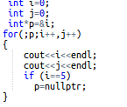

12) If a class member has been defined as protected it is NOT accessible to main() function(same as the private members).Protected members are accessible in the class that defines them and in classes that inherit from that class. Not in main().

Tables:

int *p=new int[5] {1,2,3,5,8};
(initialize a matrix)
cout<<*(p+1);
int *p=new int[]; //error you need to declare the length
but you can have:
dynamic memory allocation
int i=5;
int *p=new int[i];

Vectors:

vector<int>* p=new vector<int>(5)
and do:
p->push_back(5);
p->at(0);//will return 5

Dereferencing operator :int a = 10; int* ptr = &a; printf("%d", *ptr); // With *ptr I'm dereferencing the pointer.Which means, I am asking the value pointed at by the pointer.
Deferenceing a pointer of int---->go back to int.
Deferenceing a pointer in a vector---->go back to vector.
To make it clear you can rewrite:
int a = (*vecPtr)[i];
as
vector<int>& vecRef = *vecPtr; // vector is not copied here
int a = vecRef[i];

cout<<vector.str()

array to vector
int x[] = { 1, 2, 3, 4, 5 };
std::vector<int> v(std::begin(x), std::end(x));

Return vector from function(works fine)
vector<int> testing(vector<int> a)
{
a[0]=1000;
return a;
}
vector by value not working(the manipulations wont take place in main)

Be careful!!!! se example
static const int myints[] ={310,315,275,295,260,270,290,230,255,250};
vector<int> b (myints, myints + sizeof(myints) / sizeof(int) );
testing(&b);
void testing(vector<int>* a)
{
vector<int> c=*a;
c[0]=1000;
}
change it to vector<int> &c=*a; to get main affected

arrays:
- are a builtin language construct;
- come almost unmodified from C89;
- provide just a contiguous, indexable sequence of elements; no bells and whistles;
- are of fixed size; you can't resize an array in C++ (unless it's an array of POD and it's allocated with malloc);
- their size must be a compile-time constant unless they are allocated dynamically;
- they take their storage space depending from the scope where you declare them;
- if dynamically allocated, you must explicitly deallocate them;
- if they are dynamically allocated, you just get a pointer, and you can't determine their size; otherwise, you can use sizeof (hence the common idiom sizeof(arr)/sizeof(*arr), that however fails silently when used inadvertently on a pointer);
- automatically decay to a pointers in most situations; in particular, this happens when passing them to a function, which usually requires passing a separate parameter for their size;
- can't be returned from a function;
- can't be copied/assigned directly;
- dynamical arrays of objects require a default constructor, since all their elements must be constructed first;
std::vector:
- is a template class;
- is a C++ only construct;
- is implemented as a dynamic array;
- grows and shrinks dynamically;
- automatically manage their memory, which is freed on destruction;
- can be passed to/returned from functions (by value);
- can be copied/assigned (this performs a deep copy of all the stored elements);
- doesn't decay to pointers, but you can explicitly get a pointer to their data (&vec[0] is guaranteed to work as expected);
- always brings along with the internal dynamic array its size (how many elements are currently stored) and capacity (how many elements can be stored in the currently allocated block);
- the internal dynamic array is not allocated inside the object itself (which just contains a few "bookkeeping" fields), but is allocated dynamically by the allocator specified in the relevant template parameter; the default one gets the memory from the freestore (the so-called heap), independently from how where the actual object is allocated;
- for this reason, they may be less efficient than "regular" arrays for small, short-lived, local arrays;
- when reallocating, the objects are copied (moved, in C++11);
- does not require a default constructor for the objects being stored;
- is better integrated with the rest of the so-called STL (it provides the begin()/end()methods, the usual STL typedefs, ...)

Constructors:

Multiple constructor signatures:
class Foo{
public:
Foo()
{cout<<"My name is Alex";}
Foo(char* name)
{cout<<"My name is "<<name; }
};

THIS:
Implicit first argument on member function call to the object
Allows objects to access their own address

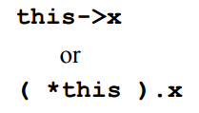

private:
a,b
Foo(char* name,int a,int b)
{cout<<"My name is "<<name;
this->a=a;
this->b=b;
cout<<a;}

Cascading member function calls:
class Time
{
public:
Time( int = 0, int = 0, int = 0 ){};
Time &setHour( int );
Time &setMinute( int );
Time &setSecond( int );
private:
int hour;
int minute;
int second;
};
Time &Time::setHour( int h )
{
hour = ( h >= 0 && h < 24 ) ? h : 0;
return *this;
}
Time &Time::setMinute( int m )
{
minute = ( m >= 0 && m < 60 ) ? m : 0;
return *this;
}
Time &Time::setSecond( int s )
{
second = ( s >= 0 && s < 60 ) ? s : 0;
return *this;
}
int main()
{
Time t;
t.setHour( 18 ).setMinute( 30 ).setSecond( 22 );
return 0;
}

Time( int a, int b, int c )
{
cout<<"say hi";
this->setHour(a).setMinute(b).setSecond(c);
cout<< hour;
};

FRIEND:

Friend function:
class X {
int a;
friend void friend_set(X& p, int i) {
p.a = i; // this is a non-member function
}
public:
void member_set(int i) {
a = i; // this is a member function
}
};

Friend class:
Inside a class, you can indicate that other classes (or simply functions) will have direct access to protected and private members of the class. In the following example, the class in which “friend class” is defined, can access private members of the friend class. The opposite is not true.

class Square;

class Rectangle {
int width, height;
public:
int area ()
{return (width * height);}
void convert (Square a);
};
class Square {
friend class Rectangle;
private:
int side;
public:
Square (int a) : side(a) {}
};
void Rectangle::convert (Square a) {
width = a.side;
height = a.side;
}

USE OF CONST KEYWORD

http://duramecho.com/ComputerInformation/WhyHowCppConst.html
http://stackoverflow.com/questions/5598703/c-const-usage-explanation?rq=1
Object Oriented Programming:
This is illegal unless it's inside a class declaration.

class Class2
{ void Method1() const;
int MemberVariable1;}
You will get a compilation error if you try to change any of the class members inside Method1(), if the latter one is declared as const.

Start reading from right to left. When you meet the word “const”; the const is referring to what it's on the left.
int const * variable
int a=5;
const int b=3;
int const * variable;
b=5;

The above will give compile error(b is already initialized).You must initialize at the time of declaration a const variable. const int b; won't work.
Moreover, you can do that:
int a=5;
int const b=a;

int * const variable;
constant pointer means you cannot change it's address. You can do:
int * const variable=&a;
*variable=6;
variable=&b; //this will give compilation error

void Subroutine4(big_structure_type const &Parameter1);
Parameter1 is a referene to an integer but in this way we ensure that it cannot be changed by Subroutine. We use that to pass large chunk of data into functions without need to copy them and in the same time be sure that they will remain unchanged.

Const return from function.
Another example is
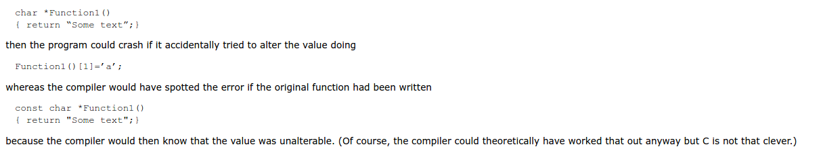

Initialization Lists

eg:
Node(int data, Node* next):data(data), next(next){};

1)
when we have a const private member we have to initialize using list argument.
class B
{
public:
B() : a(3), y(2) // 'a' and 'y' MUST be initialized in an initializer list;
{ // it is an error not to do so
}
private:
A a;
const int y;
};

Structs
a)They are mostly used as data containers.
b)struct defaults to public access and class defaults to private access.
c)You can do() and you an access the member from the outer world:
struct Date
{
private:
int day;
}
Use address a={}; to initialize all the struct members to zero.

Or do:
The “constructor” Date is called immediately to initilize the struct members
struct Date
{
int day;
int month;
int year;
Date()
{
day=5;
month=0;
year=0;
}
};
int main()
{
Date a;
cout<<a.day;
}

Note that by changing the constructor to:
Date(int a,int b,int c)
{
day=a;
month=b;
year=c;
}
you get very similar to class constructor.
You now have to do Date a(1,2,3);

Inheritance
Use subclass's constructor initialization list to call the constructor of the base class.
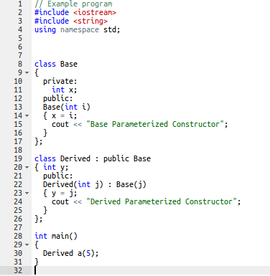

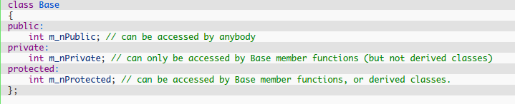
Regarding access from derived classes.

In other words if there is no private member in base class I can initialize all the members using deriveds class constructor.

There are three different ways for classes to inherit from other classes: public, private, and protected.

Public:

All members keep their original access specifications. Private members stay private, protected members stay protected, and public members stay public.
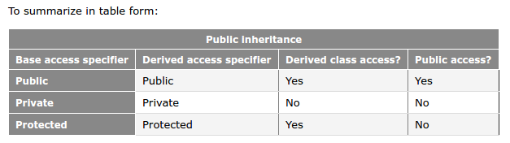

Private:
With private inheritance, all members from the base class are inherited as private. This means private members stay private, and protected and public members become private.

Note that this does not affect that way that the derived class accesses members inherited from its parent! It only affects the code trying to access those members through the derived class.This means that only main() is affected from this change. Derived class can access all the members of the base class normally, following the previous rules.

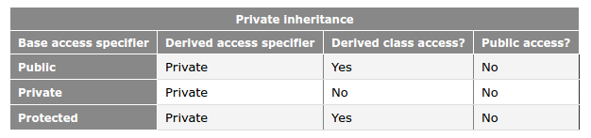

Overriding: How compiler checks to see where a class member is defined?

When a member function is called with a derived class object, the compiler first looks to see if that member exists in the derived class. If not, it begins walking up the inheritance chain and checking whether the member has been defined in any of the inherited classes.
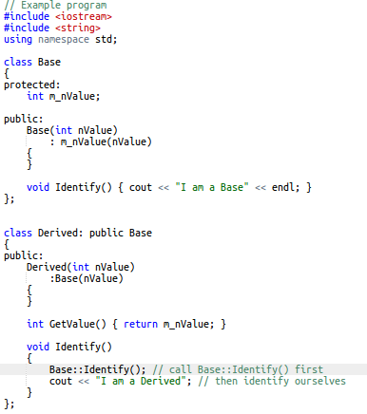
Now if we don't explicitly tell to the compiler to call the Base version of Identify explicitely by using :: eg

Derive a(5);
a.Identify();

The identify of the derived class will be called. If instead in main we do:

Derive a(5);
a.Base::Identify();

The base Identify will be called.

Private and Protected class member functions CANNOT be accessed from main(). The same rules with members are apply

We have the ability to change a base member’s access specifier in the derived class without redefining the member.

In the previous code

