1. We take turn flipping a coin, the first one that get a tail win the game. Is it an even game? if not what is the probability of the first player winning.

Say first player to play is player A and second player to play is player B P(A wins) = 1/2 * P(A wins | tosses tail) + 1/2 * P(A wins | tosses head) with P(A wins | tosses tail) = 1 After the first head toss it's B's turn to play: P(A wins | tosses head) = 1/2 * P(A wins | B tosses head) + 1/2 P(A wins | B tosses tail) = 1/2 * P(A wins | B tosses head) + 1/2 * 0 but P(A wins | B tosses head) = P(A wins) since the game reverts back to the initial state Therefore from the initial equation P(A wins) = 1/2 + 1/2 * 1/2 P(A wins) and P(A wins) = 2/3 First player has probability 2/3 of winning. The game is not even

2) coin toss 3 heads in a row .

0.125

3) A use 5 hours finish a job. B use 8 hours finish it. How long A and B take it together?

40/13

4)**How do you estimate square root of 5?**

Taylor expansion

Newton's method

5**) You have two strings whose only known property is that when you light one end of either string it takes exactly one hour to burn. The rate at which the strings will burn is completely random and each string is different. How do you measure 45 minutes?**

Burn one string from both ends, it will vanish in 1/2 hr. At the same time, burn other string at one end. Once first string has burned completely, burn the second string at other end as well. It will take 15 minutes (in additional to first 30 minutes) for second string to completely burn.

6)

**(1000)^0.5, 35^2 ?**

10sqrt(10)

35=(30+5)^2=900+25+300

**Sqrt(2)=1.41**

**Sqrt(5)=2.236**

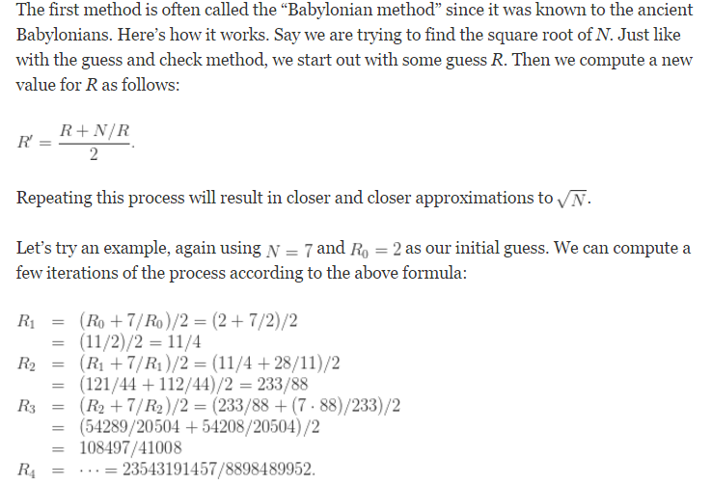

**6) Let’s say that you have 25 horses, and you want to pick the fastest 3 horses out of those 25. In each race, only 5 horses can run at the same time because there are only 5 tracks. What is the minimum number of races required to find the 3 fastest horses without using a stopwatch?**

**Solution: http://www.programmerinterview.com/index.php/puzzles/25-horses-3-fastest-5-races-puzzle/**

Step1) 5 races, 5 horses each

Step2) Run a single race of the 5 fastest horses.

Step3) We can eliminate the 2 slowest of the fastest horses, along with the other horses behind them

Step4) The very best horse is for sure inside the 4 horses. Thus two spots remain.

**7) Flip a coin until either HHT or HTT appears. Is one more likely to appear first? If so, which one and with what probability.**

Start with**: Assume first that we want HHT before HTT, and let P(E) be the probability of this happening.**

<https://dicedcoins.wordpress.com/2012/07/19/flip-hhh-before-htt/>

Intuitively HHT have greater chance to occur. Because, If HH occurs then for sure we only need to wait for a T to get HHT. If we get H, the sequence still exists and we only need to wait for a tail.

In the case of HTT, if after HT we get H, we need to start all over again.

So intuitively the first sequence, HHT, is more likely to occur.

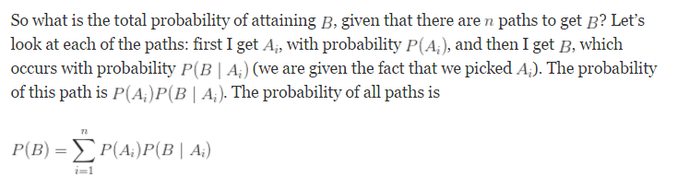

8**) You are a tennis umpire. In order to decide which player serves first, you need to flip a fair coin. Instead, you only find a biased coin with probability 1/3 of getting heads. Can you simulate a fair coin with this biased coin? (Can you do also do the reverse? That is, simulate the biased coin with a fair coin).**

**https://dicedcoins.wordpress.com/2012/07/30/simulate-fair-coins-unfair/**

Fair coin=two outcomes with equal probabilities.

Toss the coin two times.HT and TH occur with equal probability. Ignore HH, TT

*Reverse*: This is actually quite easy. Notice that P(HH) = 1/4 and P(HT or TH) = 2/4. Bam, we’re done: flip the coin twice; map HH to “heads”, and TH or HT to “tails”, and TT means to reflip.

**9**)**What are the assumptions of the Black Scholes model and why are they not realistic?**

**10) Best Time to Buy and Sell Stock**

<http://articles.leetcode.com/2010/11/best-time-to-buy-and-sell-stock.html>

**11) How many coin tosses should be done on average before getting three heads in a row.**

Law of conditional expectation

E(W) = 0.5 * E(W | 1st T) + 0.5 * E(W | 1st H) = 0.5 * (1 + E(W)) + 0.5 * ( 0.5 * E(W | H-&gt;H) + 0.5 * E(W | H-&gt;T) ) = 0.5 * (1+E(W)) + 0.5 * ( 0.5 * (0.5*3 + 0.5*(3+E(W)) ) + 0.5*(2+E(W)) ) Solve the equation in E(W), get E(W)=14

You have already a toss

E(w/HHH)=3

<https://www.quora.com/What-is-the-expected-number-of-coin-flips-until-you-get-two-heads-in-a-row>

**12) What is the most likely value of the sum of two dice? How about three dice?**

First for 2 dice just count. For 2 dice probability of sums is like a symmetric pyramid.

See answer here: <https://dicedcoins.wordpress.com/2012/07/02/most-likely-sum-two-three-dice/>

No we have done the counting for the 2 dice problem.

The three dice problem can be formulated as:

What we get in the first dice(1,2…,6)

**13)** **A simple lottery ticket costs $1. The chance of winning $10 is 1 in 10.**

**a) Is this a fair lottery?**

Yes. Expected winnings are 10$*(1/10)

**b) What is the probability that you if buy 10 tickets, you’ll win (exactly) $10?**

**Warning: just because your expected odds are 1 in 10, it doesn’t mean that you’re guaranteed a win if you play 10 times. It only means that if you play many times, then on average you will win once for every 10 times you play (i.e. 1/10 of the time).**

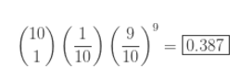

**c) What is the probability that you’ll win at least $10?**

Permutations**:** <http://www.regentsprep.org/regents/math/algebra/apr2/lperm.htm>

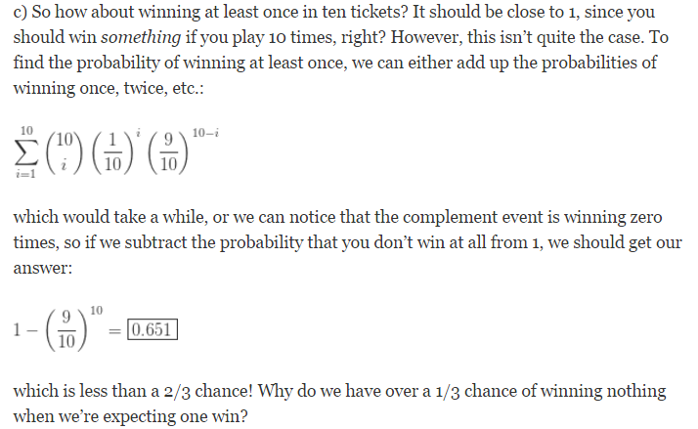

**14) What is 14% of 32? (do this in your head)**

32(10+4)/100=320+128=448/100.

**16) 66 handshakes occur at a party how many people at a party if everyone shakes hands with**

**everyone else.**

**17)You cover(remove) the two squares diagonally opposite on a chessboard, Using domino tiles, that are 2x1 squares, can you cover the remaining squares on the board?**

The easy way is to note that the two squares diagonally opposite have the same colour, and every tile covers one white and one black square.

**18)** **If you know you are about to enter recession, what would you invest in Equity or Fixed Income?**

A recession can be defined as an extended period of significant decline in economic activity including negative gross domestic product (GDP) growth, faltering confidence on the part of consumers and businesses, weakening employment, falling real incomes, and weakening sales and production. This is not exactly the environment that would lead to higher stock prices or a sunny outlook on stocks.

**Stocks**

When investing in stocks during recessionary periods, the relatively safest places to invest are in high-quality companies with long business histories, as these should be companies that can handle prolonged periods of weakness in the market.

For example, companies with strong balance sheets, including those with little debt and strong cash flows, tend to do much better than companies with significant operating leverage (or debt) and poor cash flows. A company with a strong balance sheet/cash flow is better able to handle an economic downturn and should still be able to fund its operations as it moves through the weak economic times. In contrast, a company with a lot of debt may be damaged if it can't handle its debt payments and the costs associated with its continuing operations.

**Fixed Income**

Fixed-income markets are no exception to this line of reasoning. Again, as investors become more concerned about risk, they tend to shy away from it. Practically speaking, this means investors steer clear of credit risk, meaning all corporate bonds (especially high-yield bond) and mortgage-backed securities because these investments have higher default rates than government securities. Again, as the economy weakens, businesses have a more difficult time generating revenues and earnings, which can make debt repayment more difficult and could lead to bankruptcy as a worst-case scenario.

Moreover, as investors sell these assets, they seek safety and move into U.S. Treasury bonds. In other words, the prices of risky bonds go down as people sell (or the yields increase) and the prices on Treasury bonds go up (or the yields decrease).

**19) *If the chances of you seeing a shooting star outside within one hour is 84 percent, what is the chance of you seeing at least one shooting star outside in 30 minutes?***

I'm assuming that the chances of seeing at least one shooting star outside within one hour is 84 percent. I have also assumed that the number of shooting stars you see within a one hour period follows a Poisson distribution with parameter L, which will be determined from the given probability statement. We know that the probability of seeing at least one shooting star in a one hour period is 84 percent, so the probability of not seeing a shooting star in a one hour period is 16 percent. This gives us a formula which will allow us to solve for L: .16=exp(-L). This implies that the Poisson distribution of interest has parameter L=-Ln(.16)~1.83. Now, we can define a new random variable counting the number of shooting stars we see in a half hour period and i**t follows a Poisson distribution with parameter L/2~.92**. So the probability of seeing at least one shooting star with a half hour period is approximately 60 percent.

The probability that you don't see a star in an hour is 1 - 0.84 = 0.16 = 16%. This means that the probability you don't see a star in 30 min is 0.4 (since 0.4 * 0.4 = 0.16). This makes sense if you think of one hour as two subsequent 30 min intervals. So if the probability you don't see a star in 30 min is 40%, then the probability that you see at least one star in 30 min is 60%.

**20)Expected number of rolls to see all six sides on a die.**

The time until the first result appears is 1. After that, the random time until a second (different) result appears is geometrically distributed with parameter of success 5/6,hence with mean 6/5.

**Geometric:**

probability that the **first** occurrence of **success** requires *k*number of independent trials, each with success probability p.



Mean of geometric distribution =1/p.

After that, the random time until a third (different) result appears is geometrically distributed with parameter of success 4/6, hence with mean 6/4. And so on, until the random time of appearance of the last and sixth result, which is geometrically distributed with parameter of success 1/6, hence with mean 6/1.

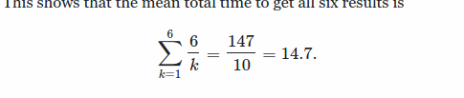

**21)**

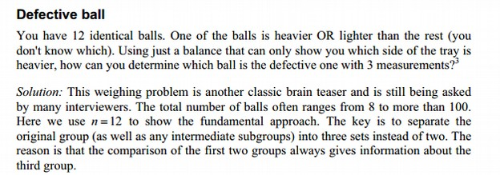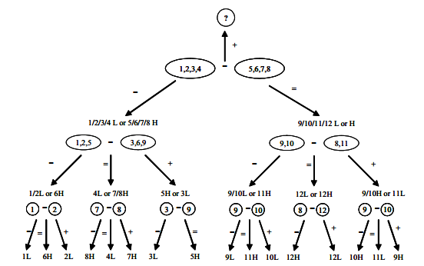

**22)**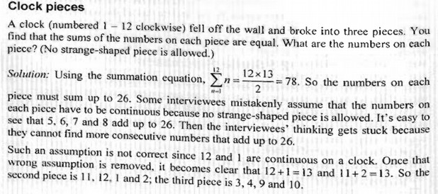

**22)**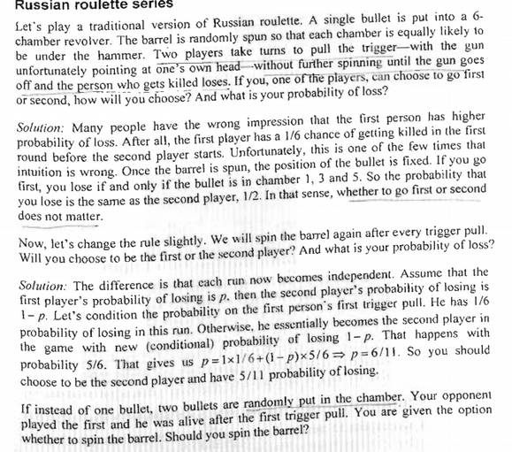

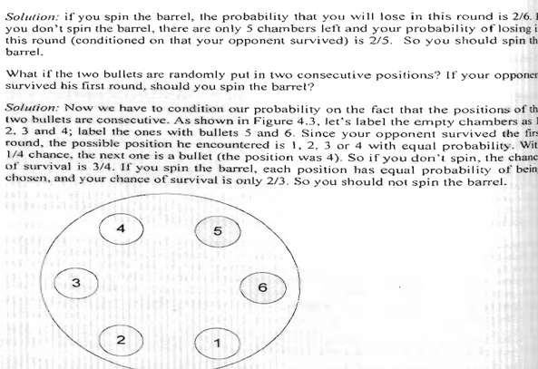

For the last one:

When we spin everything is randon,we lose every information. Thus die=2/6.

**23) 52 cards and Ace**

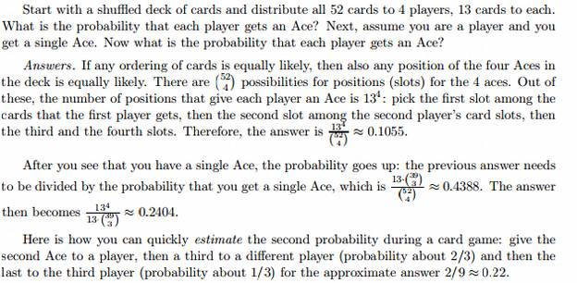

**Intro:**

**In how many ways we can rearrange the 52 cards of a deck?**

**This is a permutaion(χωρις επαναθεση, αλλα μας ενδιαφερει η σειρα)**

**P=52!, given from the permutation formula with k=52.**

**Multiset: A bag of elements in which some of them are identical with each other. Eg**

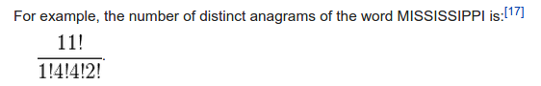

**If every letter was distinct the number of different rearrangment would be 11!.**

**Now is much smaller since we have letter repetitions.**

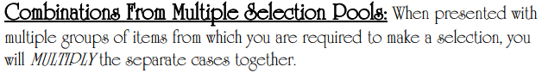

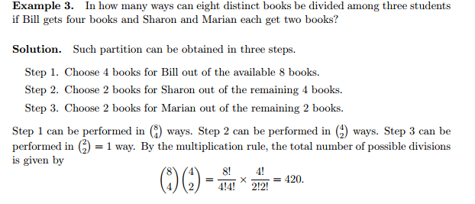

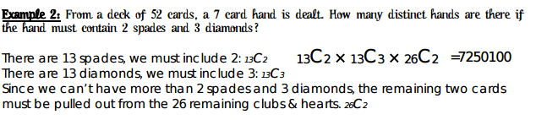

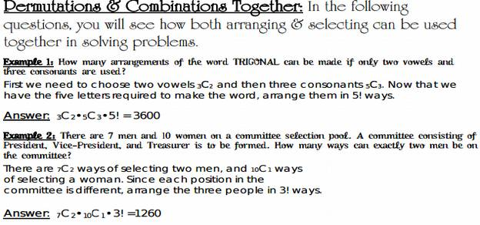

**24)You have two coins, one fair coin and one with heads on both sides. You randomly choose one of the coins and flip it twice. The results are heads and heads. What is the probability that the coin you flipped is a fair coin.**

https://www.quora.com/You-have-two-coins-one-of-which-is-fair-and-comes-up-heads-with-a-probability-1-2-and-the-other-which-is-biased-and-comes-up-heads-with-probability-3-4-You-randomly-pick-coin-and-flip-it-twice-and-get-heads-both-times-What-is-the-probability-that-you-picked-the-fair-coin

**25)You have a spherical balloon that is deflating at a rate such that the radius is decreasing at a constant rate of 4cm/min. At what rate is the balloon deflating when the radius is .25cm.**

**26)You have a circle with a radius of one. What is the probability that two randomly chosen points connected by a chord have a length greater than 1?**

<https://www.quora.com/Two-points-are-chosen-randomly-on-the-circumference-of-a-circle-What-is-the-probability-that-the-distance-between-the-2-points-is-at-least-r-the-radius-of-the-circle>

**27)Calculate the chance of throwing 5 coins and there are at least 3 heads in row**

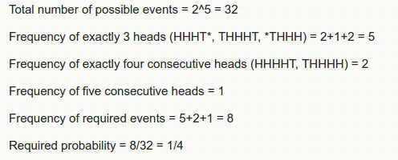

**28)**[**Flip a coin 6 times. What is probability of at least 4 heads?**](http://math.stackexchange.com/questions/800997/flip-a-coin-6-times-what-is-probability-of-at-least-4-heads)

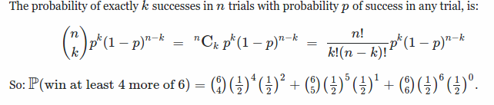

**29)What sum can I expect in rolling a fair die n times?**

