COMP 4097 Mobile Computing Mini-project
Project Title: IBeacon Display Board
Student 1: Lung Lok Fu Francis 14225328
Student 2: Ng Ka Chun 14211084

Problem Definition

Problem Scope
This project aims to provide another channel to see information of societies in HKBU besides the display boards placed on orientation day.

Design Problem
During the registration or orientation day, there are always display boards beside any booth, introducing the clubs or the department. However due to the shortage of space and equipment, those display boards can only provide a few information to the visitors. The information provided is not enough for the visitors to understand the society or to make decision on joining the society. We need to provide more information!

On orientation day, the crowd will arrive. When there are too many people, it is hard for the visitor to closely look around the booths, or to ask questions. Therefore we need to provide a method allowing the visitors to look for information they want, not requiring to move closely to the booth and stand still for a long time.

Alternative Methods

Leaflets
One of the solution is to pass leaflets. Compare to booths, leaflets allow the user to see more information since it is not limited by the area of display boards but the size of paper. If more information is required to be shown, lower the font size and increase the number of paper will do the favor. The method also does not require the visitors to stand in front of the display boards. They only needs to get the leaflet in front of the booth in order to search for the information they need. However, this method is not environmentally friendly. Printing leaflets consume a huge amount of paper resources and will damage the wildlife by chopping woods.

Design Brief
By making use of IBeacon, we can solve the problem. When a visitor is interested on a booth, he receives the BLE signal walking nearby the booth. In this case, the technique sends a webpage or a document describing the details of the society. Hence the information get by the visitors, will not be constricted by the physical size of the booth or the display board. Compare to the traditional method, IBeacon display board is more environmental friendly since it uses less paper and printing materials. It also causes less in long-term since it is a one-time payment to buy IBeacons and set up the system. Lastly, IBeacon display board also has a benefit on promoting and advertising since people will be interested on new techniques.

Functional Requirement
- View society list
- View detail information of a society
- When walking nearby a booth, IBeacon transmit signals and the phone displays detail of the society
- Share the information on social network, including Facebook, Twitter, etc.
- Record the booths that has already visited or applied for memorization

Non-Functional Requirement
- Support all android devices with Bluetooth
- Sense IBeacon signal within 10 meters
- Scanning time for IBeacon no more than 3 seconds

System Design

Use Case Diagram
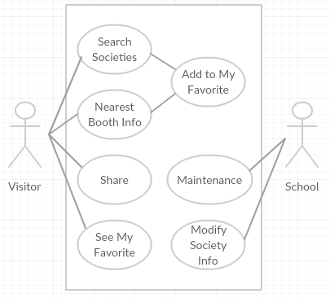

Activity Diagram
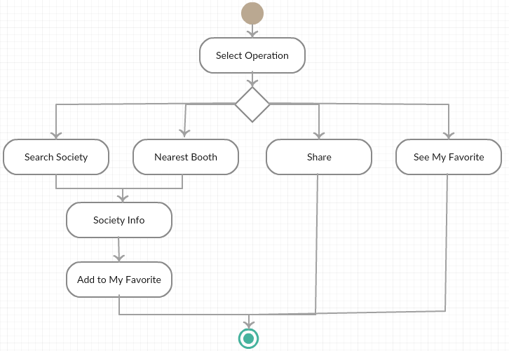

Entity Relationship Diagram
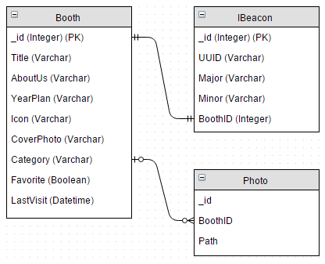

Implementation

Menu
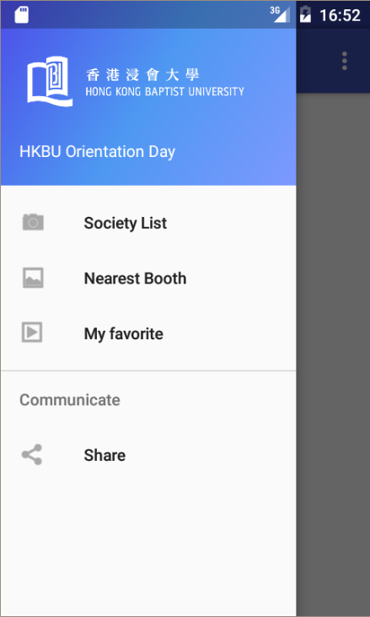

Society List
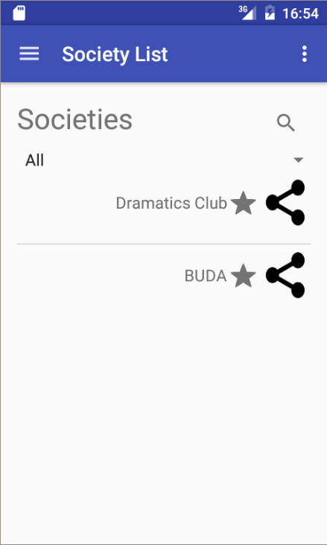

Society Info
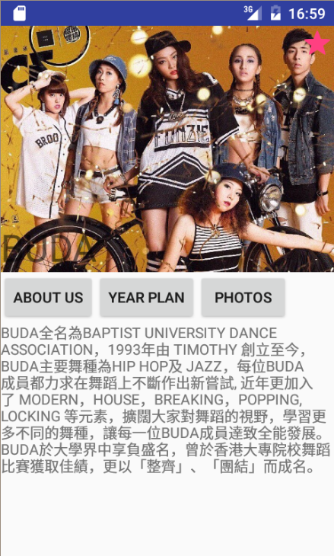

My Favorite
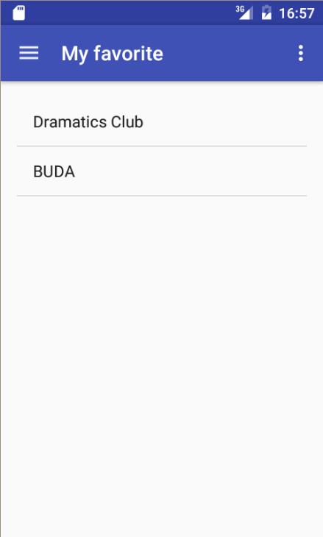

Share
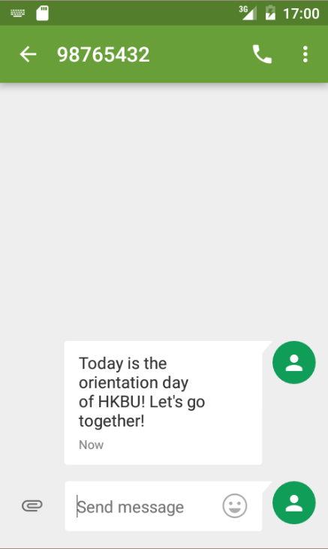

Test Plan

Search Society

Testing Procedure
- Search society based on category
- Search society by keyword
- Press corresponding society for more detail information

Black Box Testing
Input Condition: category, keyword, selection of society

Equivalence Partitioning
Input Partitions | Output Partitions
- Select category | - Display corresponding society
- Search by keyword | - Display corresponding society
- Press a society | - Display detail information of corresponding society

Test Cases
- Select “Art and Culture”
- Enter “Dance”
- Select “Dance Association”

Result
After inputting the above test cases, the society is correctly shown according to the searching criteria. Detail of society is shown if a society is selected.

Nearest Booth

Testing Procedure
- Find the nearest booth
- Move to location where another booth is closer
- View the detail of the society

Black Box Testing
Input Condition: IBeacon distances

Equivalence Partitioning
Input Partitions | Output Partitions
- IBeacon A is closer | - Display information of Booth A
- IBeacon B is closer | - Display information of Booth B
- No IBeacon nearby | - “Scanning”
- View About Us | - About Us
- View Year Plan | - Year Plan
- View Photos | - Photos

Test Cases
- Distance of IBeacon A = 1 m, distance of IBeacon B = 5m
- Distance of IBeacon A = 5 m, distance of IBeacon B = 1m
- No IBeacon
- Select “About Us”
- Select “Year Plan”
- Select “Photos”

Result
After inputting the above test cases, the information of nearest booth is correctly shown.

Share

Testing Procedure
- Share through Whatsapp
- Share through Twitter

Black Box Testing
Input Condition: Different Social Media

Equivalence Partitioning
Input Partitions | Output Partitions
- Whatsapp share | - Share through Whatsapp
- Twitter share | - Share through Twitter

Test Cases
- Whatsapp share
- Twitter share

Result
After inputting the above test cases, the information has been correctly shared through different social media.

My Favorite

Testing Procedure
- Add society to My Favorite
- Look for society in My Favorite, it should be appeared in the list
- Remove the society from My Favorite
- Look for society in My Favorite, it should not be appeared in the list

Black Box Testing
Input Condition: My Favorite Selection

Equivalence Partitioning
Input Partitions | Output Partitions
- Add society to My Favorite | - Corresponding society is displayed in My Favorite
- Remove society from My Favorite | - Corresponding society is removed from My Favorite

Test Cases
- Add Dance Association to My Favorite
- Remove Dance Association from My Favorite

Result
After inputting the above test cases, the information has been correctly shared through different social media.

Division Responsibility
In this project, our group divided our jobs according to the functions. Ng Ka Chun (14211084) is responsible for connecting and implementing IBeacon, whereas Lung Lok Fu (14225328) is responsible for function of searching society, showing detail of a society, bookmarking, and sharing.

Implementation Challenge

IBeacon
This teleology is first invented from apple which means it should have better performance in IOS device. Since we implement it with android platform, some of function cannot be used (ex. sending signal to IBeacon). It limited the design of our application. Although android provided library for detecting IBeacon, we still cost us few days for fixing unexpected errors. Like setting layout for proximity beacon.

Fragment
Unlike the traditional development we learnt in lesson, we try to chase the newest teleology and modern UI design. The main implement the main UI with navigation drawer. Instead of using activity, we implement our pages with fragment to achieve layout consistence. Since we haven’t use it before, we spent lots of time on learning new teleology.

Conclusion
In concluded, the application can effectively and efficiently improve the procedure of an orientation day. It allows the user to view more information of a society ignoring the limit of the size of booths. Since Bluetooth signals spread in a wide range, the user does not need to move to a very close distance in order to search for the detail they want, thus it prevents the crowd concentrated in front of a booth. Compare to traditional method, it is more environmental friendly, and causes less in long term. It also has a good promotion effect by getting use of new technology that has not be popular yet. It is hoped to attract more visitors by using the system.

