Alex Frazier
HW3

1.1
(a) (4 points) Suppose n = 2 i.e. the input is a pair of binary values. Suppose we have a neural network where we don’t have any hidden units and just a single output unit i.e. y = f(w T x + b) is the entire network. What should w, b be if we want to implement boolean AND (i.e. y = 1 only when x = (1, 1)). What about boolean OR?

boolean AND: w = [1, 1], b = -1
boolean OR: w = [1,1], b=0

(b) (1 point) Under the same conditions as above, what boolean function of two variables cannot be represented? You just need to state one, and provide an explanation.

XOR cannot be represented because XOR is not linearly separable and a network with the conditions stated above can only represent linear separable functions.

(c) (4 points) Suppose we now allow a single layer of hidden units i.e. y = f(w T z + b), zj = f(w T j x + bj ). Construct a neural network that can implement the boolean function you mentioned previously that could not be represented before. The number of hidden units is up to you, but try to keep it as simple as possible.

We can implement XOR with two hidden units and the following weight matrix.
Weights Hidden = [1, -1; -1, 1], bj = 0, Weights to output = [1 1], b = 0

(d) (8 points) It turns out that for any number of input boolean variables, a single hidden layer is enough to represent any boolean function. Describe a general scheme that one can use to construct such a neural network for any boolean function (HINT: consider conjunctive normal form or disjunctive normal form).

(e) (3 points) If a single layer is enough to represent all boolean functions, why would you ever want to use multiple hidden layers? What does this suggest about designing deep neural network structures in practice?

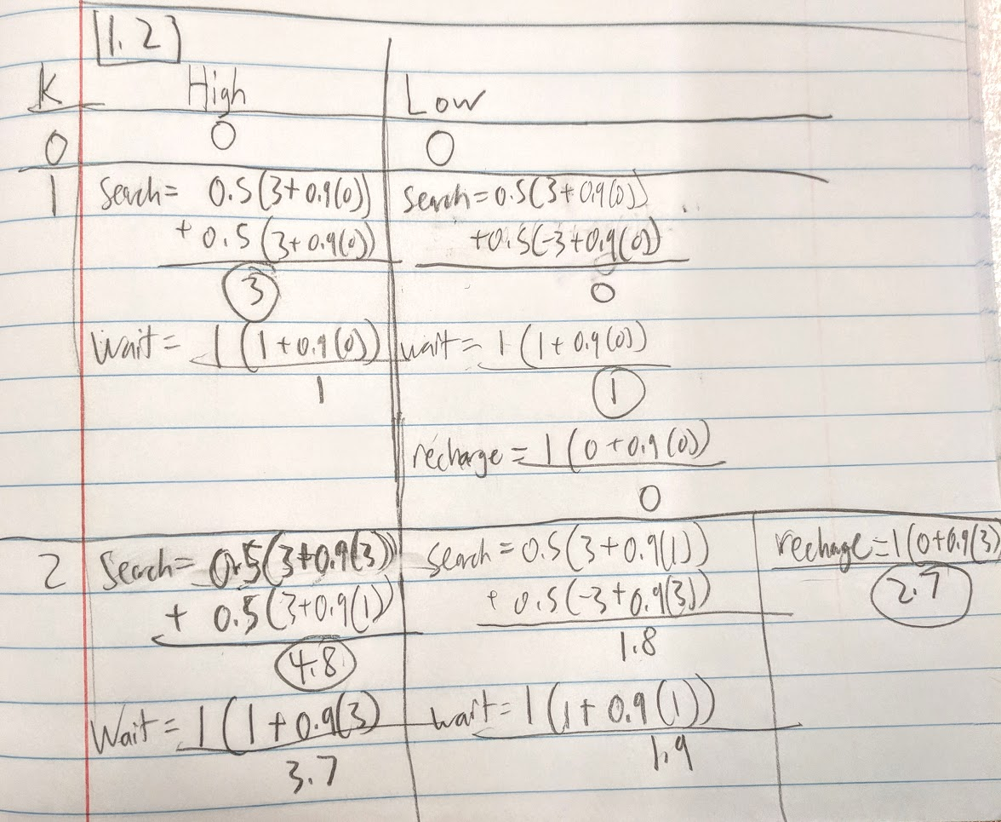
1.2
A.

After two iterations of value iteration, the resulting best action values are 4.8 [search] for High and 2.7 [recharge] for Low.
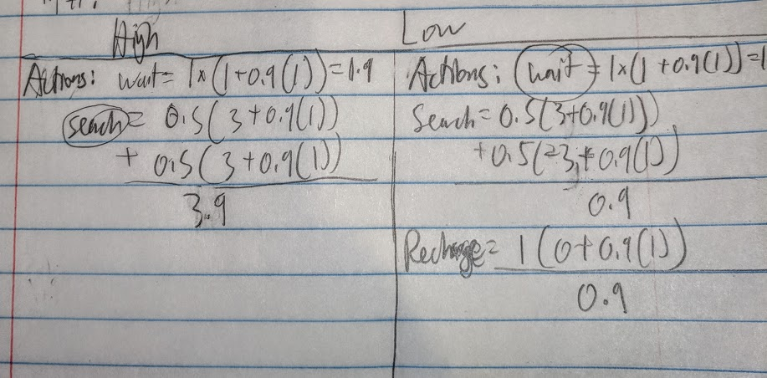
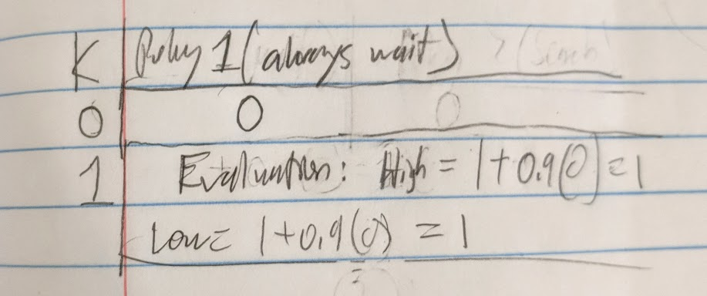
B.

After one iteration of policy iteration we end up with a new policy that if we are in a highly charged state we should search and if we are in a lowly charged state we should wait.

