Parietal lobe
[Video: overview of the cerebrum]

The parietal lobe is a region of the brain located in the superior and posterior region of the head, next to the parietal bone. It occupies about one quarter of each cerebral hemisphere.

Gyri and sulci subdivide the parietal lobe into different parts, each responsible for specific functions. The anterior parietal lobe, specifically the postcentral gyrus, receives most of the somatosensory inputs from the body, whereas the posterior parietal cortex contains unimodal and multimodal association cortices involved in sensory processing, spatial awareness, and language understanding.

In this article, we will discuss the anatomy and the functions of the parietal lobe.

[Green highlight parietal lobe] lobus-parietalis
Key facts about the parietal lobe
Location | Posterior to the frontal lobe (separated by central sulcus)  Anterior to the occipital lobe (separated by parieto-occipital sulcus and preoccipital notch)  Superior to the temporal lobe (separated by lateral sulcus)
Principal gyri | Postcentral gyrus  Superior parietal lobule  Inferior parietal lobule
Functional areas | Primary somatosensory cortex  Associative parietal cortex  Parietooccipital-temporal cortex
Functions | Primary somatosensory cortex: perception of somatic sensation  Associative parietal cortex: processing and integration of somatosensory information  Parietooccipital-temporal cortex: higher-order integration of auditory, visual, and somatosensory information, number processing, spatial awareness, language understanding

Key facts about the lobus parietalis
Location | Posterior to the lobus frontalis (separated by sulcus centralis)  Anterior to the lobus occipitalis (separated by sulcus parietooccipitalis and incisura preoccipitalis)  Superior to the lobus temporalis (separated by sulcus lateralis)
Principal gyri | Gyrus postcentralis  Lobulus parietalis superior  Lobulus parietalis inferior
Functional areas | Primary somatosensory cortex  Associative parietal cortex  Parietooccipital-temporal cortex
Functions | Primary somatosensory cortex: perception of somatic sensation  Associative parietal cortex: processing and integration of somatosensory information  Parietooccipital-temporal cortex: higher-order integration of auditory, visual, and somatosensory information, number processing, spatial awareness, language understanding

[Table of Contents]

Definition and location
The parietal lobe is the brain region located between the frontal and occipital lobes, and superior to the temporal lobe. These sulci define the borders of the parietal lobe:
- Anterior border: central sulcus (of Rolando); separates from the frontal lobe
- Posterior border: parieto-occipital sulcus (superiorly) and preoccipital notch (inferiorly); separates from the occipital lobe
- Inferior border: lateral fissure (of Sylvius); separates from the temporal lobe
The parietal lobe can be divided into different parts. The anterior part corresponds to the post-central gyrus. The posterior parietal cortex occupies the rest of the parietal lobe, and can be further subdivided into the superior and inferior parietal lobules.

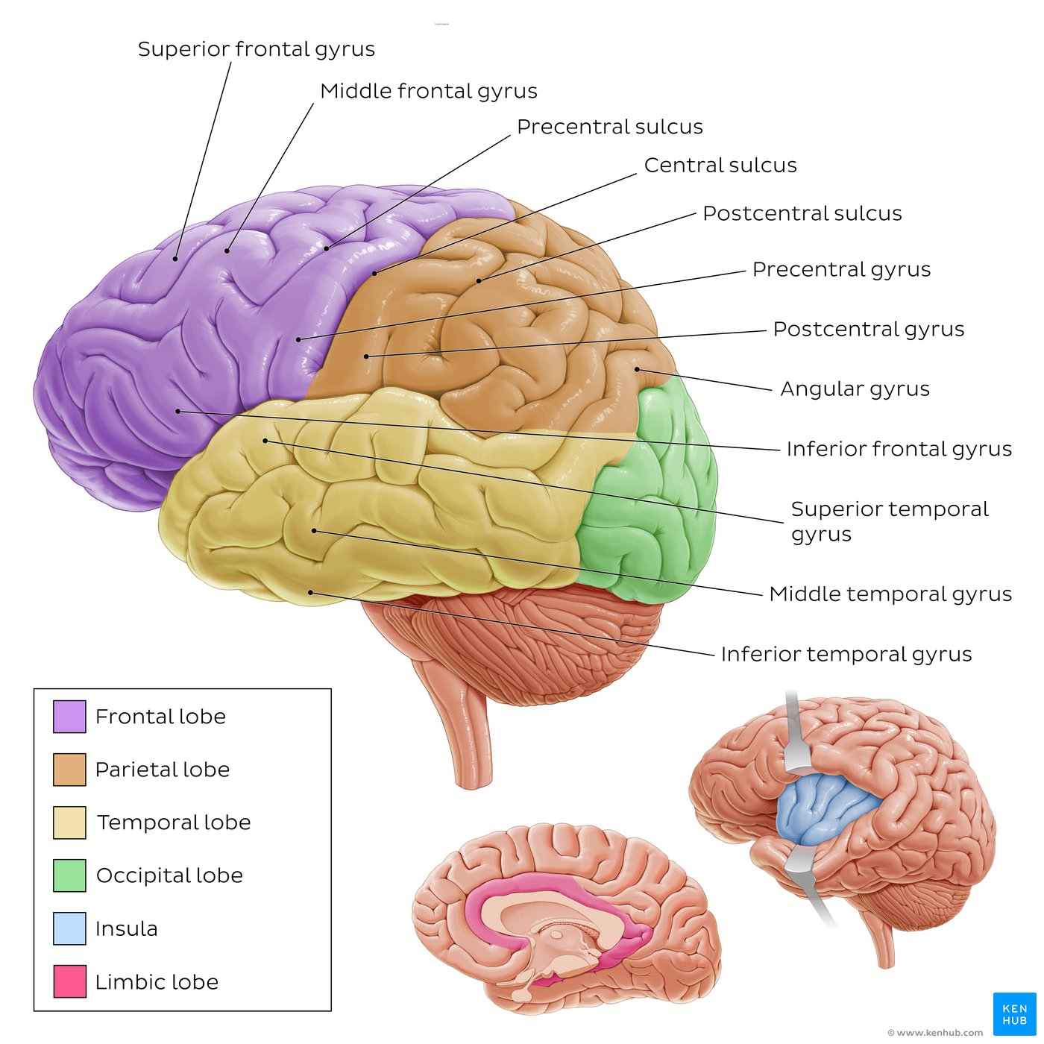
[Anatomy of the brain.]The parietal lobe is located between the frontal, temporal and occipital lobes. Its main gyri and sulci are labeled on the diagram.
[Blue box: If you’re finding neuroanatomy a bit tricky, our brain worksheets and quizzes are here to help!]

Structure

The parietal lobe has three main gyri (postcentral gyrus, superior parietal lobule, inferior parietal lobule) and two sulci (postcentral sulcus, intraparietal sulcus).

The postcentral gyrus is located between the central sulcus and the postcentral sulcus. On the medial surface of the brain, the postcentral gyrus of the parietal lobe and the precentral gyrus of the frontal lobe together form the paracentral lobule, surrounding the central sulcus.

Laterally, the intraparietal sulcus extends from the postcentral sulcus toward the occipital pole, splitting the posterior parietal lobe into the superior and the inferior parietal lobules. The medial aspect of the posterior parietal lobe is also known as precuneus.

The inferior parietal lobule continues to the parieto-temporal intersection and can be further subdivided into two regions: the supramarginal gyrus anteriorly, and the angular gyrus posteriorly.

[Highlights gallery - all terms mentioned above] postcentral-gyrus, sulcus-centralis, sulcus-postcentralis, sulcus-intraparietalis, lobulus-parietalis-superior, lobulus-parietalis-inferior, precuneus, gyrus-supramarginalis, gyrus-angularis

Need to review the anatomy of the brain? Check out these study units.
https://www.kenhub.com/en/study/medial-view-of-the-brain
https://www.kenhub.com/en/study/lateral-views-of-the-brain

Blood supply and drainage
The parietal lobe is supplied by different branches of the internal carotid artery: the middle cerebral artery supplies the majority of the lobe, except for its superior-medial surface, which is supplied by the anterior cerebral artery. The posterior cerebral artery may also contribute to the posterior part of the parietal lobe, close to the parieto-occipital junction. The superficial cerebral veins are mainly responsible for blood drainage.

[Highlights gallery - all terms mentioned above] arteria-cerebri-anterior, arteria-cerebri-media-2, arteria-cerebri-posterior, inferior-cerebral-veins, vena-media-superficialis-cerebri

Functions
The parietal lobe is primarily involved in the perception and processing of somatosensory inputs, integration of sensory information, spatial orientation, mathematics, language understanding and processing. These functions are localized to different regions of the parietal lobe.

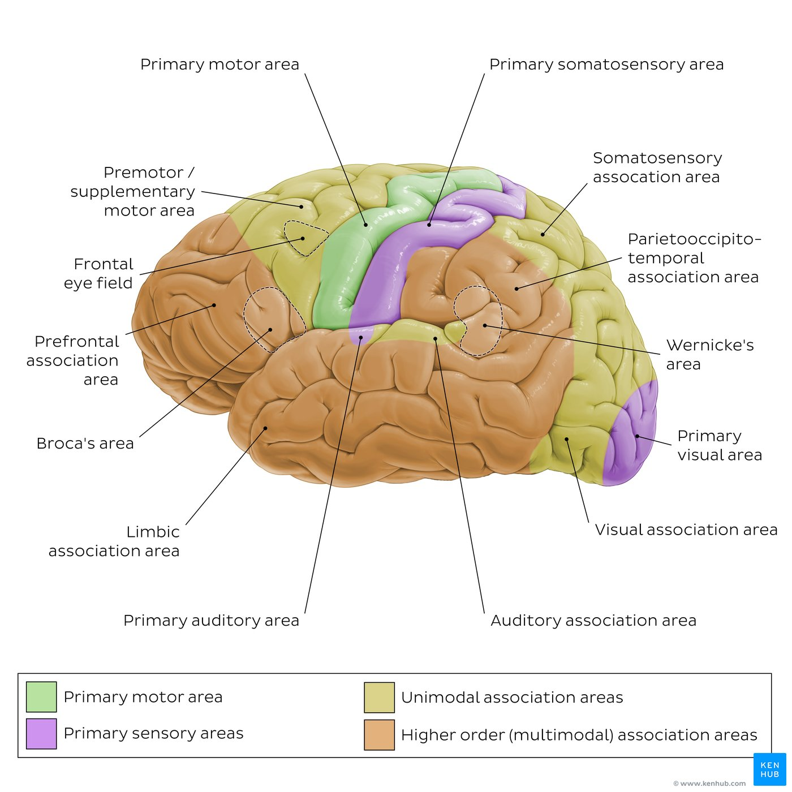
Caption: [Functional areas of the cerebral cortex.] The parietal lobe includes the primary somatosensory area (primary sensory area), the somatosensory association area (unimodal association area), the parietooccipito-temporal area (higher-order association area), and part of Wernicke’s area (higher-order association area).

Primary somatosensory area
The primary somatosensory cortex (Brodmann areas 3, 1, 2) is located in the postcentral gyrus. This cortical region receives somatosensory information like temperature, pain, proprioception and touch. Different parts of the body are mapped on the postcentral gyrus into a somatotopic representation of the human body, referred to as the sensory homunculus. Body regions where sensory stimuli can be identified and localized more precisely, like hands, lips and face, have larger representations than the rest of the body.

[Highlights gallery: Brodmann areas]

Parietal association cortex
Somatosensory information from the primary sensory cortex is integrated and interpreted in the somatosensory association cortex of the superior parietal lobule (Brodmann areas 5 and Brodmann area 7). Different regions of this cortex are responsible for the assessment of distance, the integration of sensory information, and tactile object recognition. These functions are fundamental for movement planning, especially for visual motor coordination of hand movements.

[Highlights gallery: Brodmann areas]

Parietooccipito-temporal association area
The inferior parietal lobule contributes to a large and complex higher order association area known as the parietooccipito-temporal or posterior association area. It plays a key role in the integration of auditory, visual, and somatosensory information. The angular gyrus (Brodmann area 39) is mostly involved in number processing and spatial awareness, whereas the supramarginal gyrus (Brodmann area 40) mainly contributes to language understanding. The inferior parietal lobule is often considered part of Wernicke’s area (or at least functionally associated with it).

[Highlights gallery: Brodmann areas]

Left vs. right parietal lobe
The functions of the parietal lobe are often lateralized. The parietal lobes of the dominant side mainly contribute to mathematical operations and language, whereas sensory visuospatial processing mainly occurs in the non-dominant hemisphere.

Test your knowledge and continue to learn the anatomy of the parietal lobe in this quiz.
[Custom quiz: parietal lobe]

Parietal lobe lesions
Damage to the parietal lobe may lead to loss of somatosensation in the contralateral side of the body, deficits of spatial awareness, and difficulties with language understanding and sentence formation.

- Hemispatial neglect may occur following lesions to the non-dominant parietal lobe. It leads to an inability to interpret the information from half of the visual field despite being able to see normally. Patients with this syndrome often ignore objects placed in the affected space.
- Wernicke’s aphasia (receptive aphasia) may occur following lesions to the dominant parietal lobe, especially if the lesion involves the inferior parietal lobule and also affects the temporal lobe. Patients can speak words understandably, but they don't understand their meaning. This often results in a clearly understandable speech that doesn't make sense, like a "word salad".

Sources
All content published on Kenhub is reviewed by medical and anatomy experts. The information we provide is grounded on academic literature and peer-reviewed research. Kenhub does not provide medical advice. You can learn more about our content creation and review standards by reading our content quality guidelines.

References:

- Netter F, H. (2015) Atlas of Human Anatomy, 5th Edition, Elsevier Saunders
- Drake, R. L., Vogl, A. W., & Mitchell, A. W. M. (2015). Gray's Anatomy for Students (3rd ed.). Philadelphia, PA: Churchill Livingstone.
- Johnson EO, Mytilinaios D, Panagiotopoulos NA, Skandalakis GP, Spinos D, Varthaliti A. Supratentorial dissection of the human brain for neuroscientists. Academia Anatomica International, 2:13-23, 2016
- Hendelman WJ. Atlas of Functional Neuroanatomy. 2nd Ed, Taylor & Francis, 2006
- Seeger W. Atlas of Topographical Anatomy of the Brain and Surrounding Structures: for Neurosurgeons, Neuroradiologists and Neuropathologists. Springer-Verlag, 1978
- Javed K, Reddy V, Lui F. Neuroanatomy, Cerebral Cortex. StatsPearl [Internet], 2023.

