Title: Cytoskeleton
Description: Discover the structure and function of centrioles, cilia, and flagella.

Learning objectives
After completing this study unit, you will be able to:
- Compare the types of cytoskeletal filaments and their functions.
- Describe the structure and function of microvilli, cilia, and flagella.

Introduction/Watch a video
The cytoskeleton is a complex thread-like network of fibrous proteins that spans the cytoplasm. It provides an internal scaffolding and is responsible for maintaining cell structure, resisting mechanical forces, and anchoring organelles. The cytoskeleton also forms tracks for substance transport within the cell, guides cell division and is essential for cell motion.

The cytoskeleton is made up of three main types of filaments:
- Microfilaments are the thinnest filaments. They are made of actin and are located below the cell membrane and throughout the cytoplasm.
- Intermediate filaments can be made of keratin, lamin or other proteins. They are found in the cytoplasm and inside the nuclear envelope.
- Microtubules are the thickest filaments and are made of tubulin. Most microtubules originate from the centrosome and span the entire cell, while others originate from the basal bodies and form the axoneme, which is the core of cilia and flagella.

Cytoskeletal filaments form the core of cellular extensions, which are appendages that protrude from the surface of the cell. They include microvilli (short fingerlike non-motile projections), cilia (non-motile and motile hairlike structures) and flagella (long motile structures with whiplike movements). Cell extensions are primarily useful for nutrient absorption and cell motion.

Watch this video to discover more about how the cytoskeleton contributes to cell integrity and motion.
[LINK TO VIDEO]

Explore concepts

Cytoskeleton and associated structures
The cytoskeleton is a complex thread-like network of fibrous proteins that spans the cytoplasm.

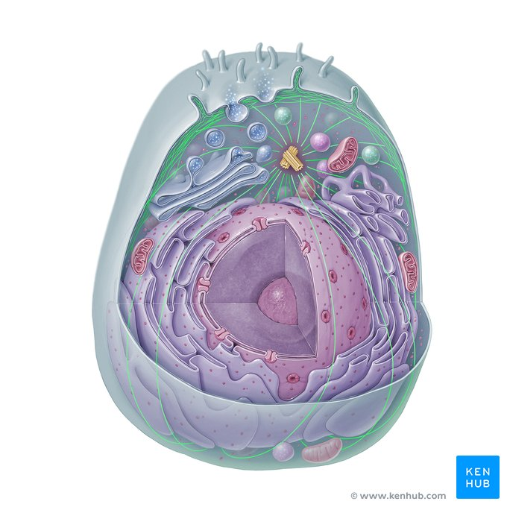
Gallery: Cytoskeleton, microfilament, microtubule, centriole, microvilli

Types of cytoskeletal filaments
The cytoskeleton is made up of microfilaments, intermediate filaments and microtubules.
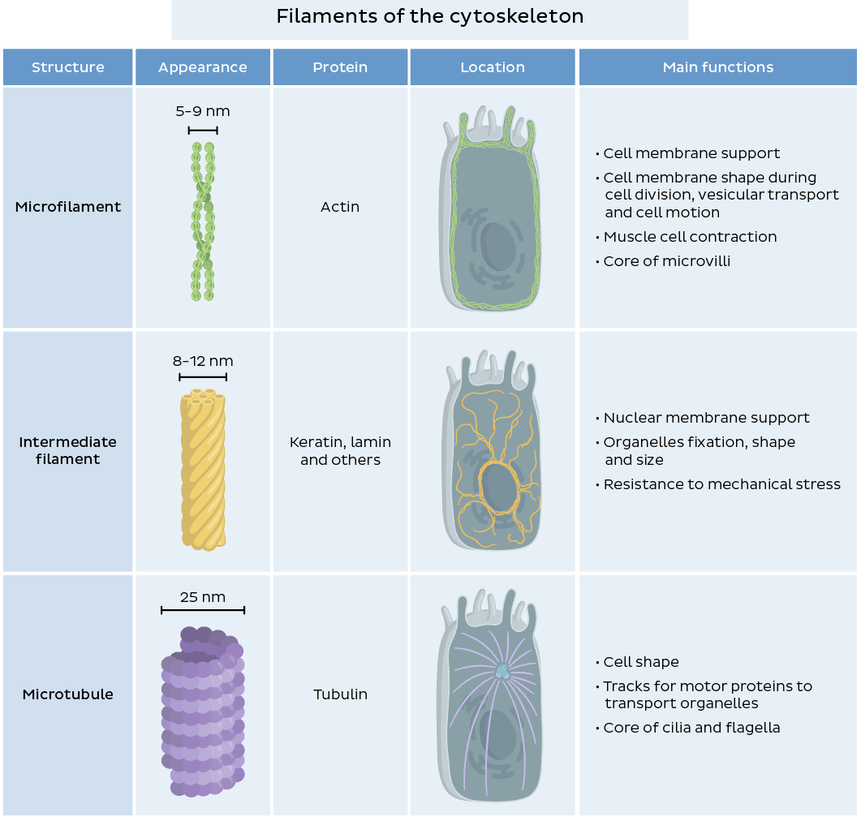[Filaments of the cytoskeleton]Microfilaments, intermediate filaments and microtubules differ in their appearance, composition, size, location and function.

Cellular extensions
Cellular extensions can expand the cell surface area (microvilli) and create motion (cilia, flagella).
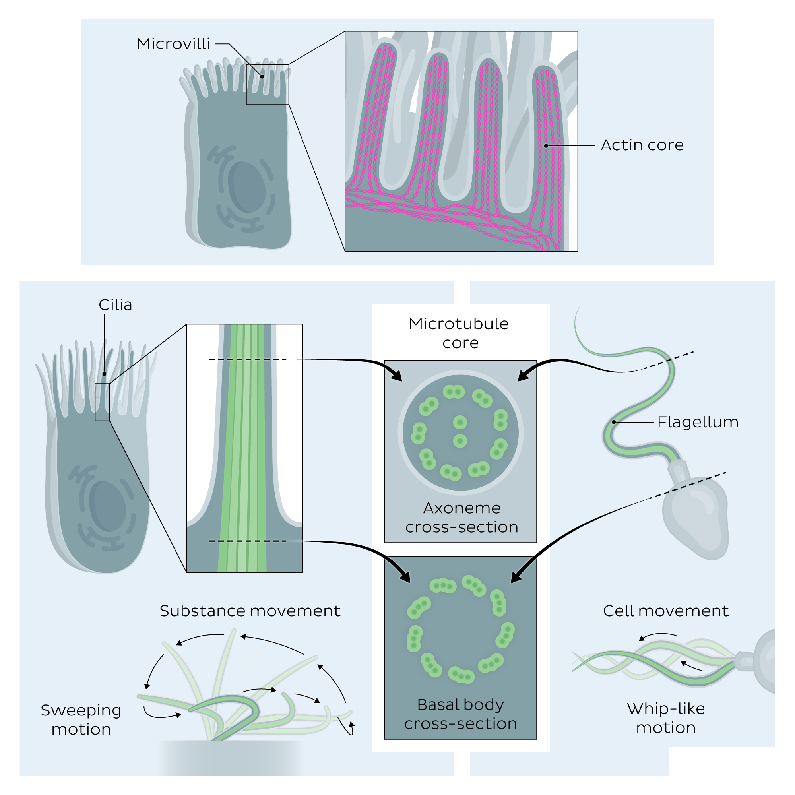[Cellular extensions]Microvilli are supported by a core of actin microfilaments; they expand the cell surface area to facilitate nutrient absorption.
Motile cilia and flagella have a core of microtubules called axoneme, organized in 9 peripheral pairs with two individual microtubules in the center (9+2). They originate from the basal bodies, structures located below the cell membrane, and contain nine triplets of microtubules (9+0).
In motile cilia and flagella, the interaction between motor proteins and microtubules of the axoneme produces movement: cilia sweep fluids and substances along the epithelium, flagella generate whip-like movements to propel the cell.

Take a quiz
Build a solid foundation knowledge of the cytoskeleton with the quiz below!
Cytoskeleton quiz

Summary
Key points about the cytoskeleton
Definition | Thread-like network of fibrous proteins that spans the cytoplasm
Functions | Maintains cell structure, resists mechanical forces, anchors organelles, and assists with substance transport, cell division and cell motion
Main filaments | Microfilaments  Made of actin, 5-9 nm  Support the cell membrane, allow muscle contraction, split the cytoplasm during cell division  Intermediate filaments  Made of keratin, lamin and other proteins, 8-12 nm  Anchor organelles, provide mechanical resistance, support the nuclear envelope  Microtubules  Made of tubulin; originate from centrosome and span entire cell, 25 nm  Provide structural support, act as support for the transport of substances within the cell, organize the mitotic spindle
Cellular extensions | Microvilli  Core of actin microfilaments; expand the surface of cells to improve absorption.  Cilia  Core of microtubules; can be non-motile (often receptors) or motile (sweeping motion to move substances along the cell surface)  Flagella  Core of microtubules; whip-like motion allows free-floating cells like sperm to move
Cellular motion | Microfilaments: crawling motion  Microtubules: ciliary sweeping motion, flagellar whip-like motion
Cellular division | Microfilaments: formation of contractile ring to divide cytoplasm  Microtubules: formation of mitotic spindle, separation of sister chromatids

Related articles
https://www.kenhub.com/en/library/anatomy/cytoskeleton
https://www.kenhub.com/en/library/anatomy/cilia

