SEO title: Cerebral cortex and higher cognitive functions
SEO description: This article discusses the cerebral cortex and higher cognitive functions, including language, memory and sleep. Click now to learn more at Kenhub!

Cerebral cortex and higher cognitive functions

Video: Functional divisions of the nervous system

One of the main functions of our nervous system is the integration of information. For example, what happens when we watch a movie? Several areas of the cerebral cortex match visual and auditory information to help us recognize what is playing out on the screen. Other brain areas filter relevant information from the movie to create new memories. And brain structures responsible for keeping us awake may need to work harder than usual if the light is dim and the movie is boring! These and other higher cognitive functions that occur in the cerebral cortex, together with lower order processes, are responsible for the integration of information within the central nervous system.

Integrative processes of the nervous system can be divided into:
- Higher cognitive functions (or higher order integrative processes) take place in the cerebral cortex and include attention, memory and planning. These are generally related to conscious perceptions.
- Lower order integrative processes take place in subcortical areas and mainly support functions like balance, digestion and respiration. These are generally subconscious.

FIGURE: [Cerebrum, cerebellum, brainstem, spinal cord]Structures of the central nervous system.

Key facts about the cerebral cortex and higher cognitive functions
Higher cognitive functions | Language, memory and learning, attention, problem-solving, sense of self, decision making etc.
Language processing | Broca’s area: speech production (frontal lobe)  Wernicke’s area: language comprehension (temporal lobe)
Memory types | Declarative memory: conscious recall  Non-declarative memory: unconscious skills/tasks
Memory consolidation | Occurs mainly in the hippocampus (declarative memory) and motor circuits (non-declarative memory).
Sleep and wakefulness | Circadian rhythm controlled by the hypothalamus  Sleep stages include non-REM (lighter to deeper) and REM (associated with dreaming and memory consolidation).
Lower order processes | Regulation of breathing and temperature, motor coordination, basic emotional responses, etc

[Table of contents]

Higher order cognitive functions or higher order integrative processes

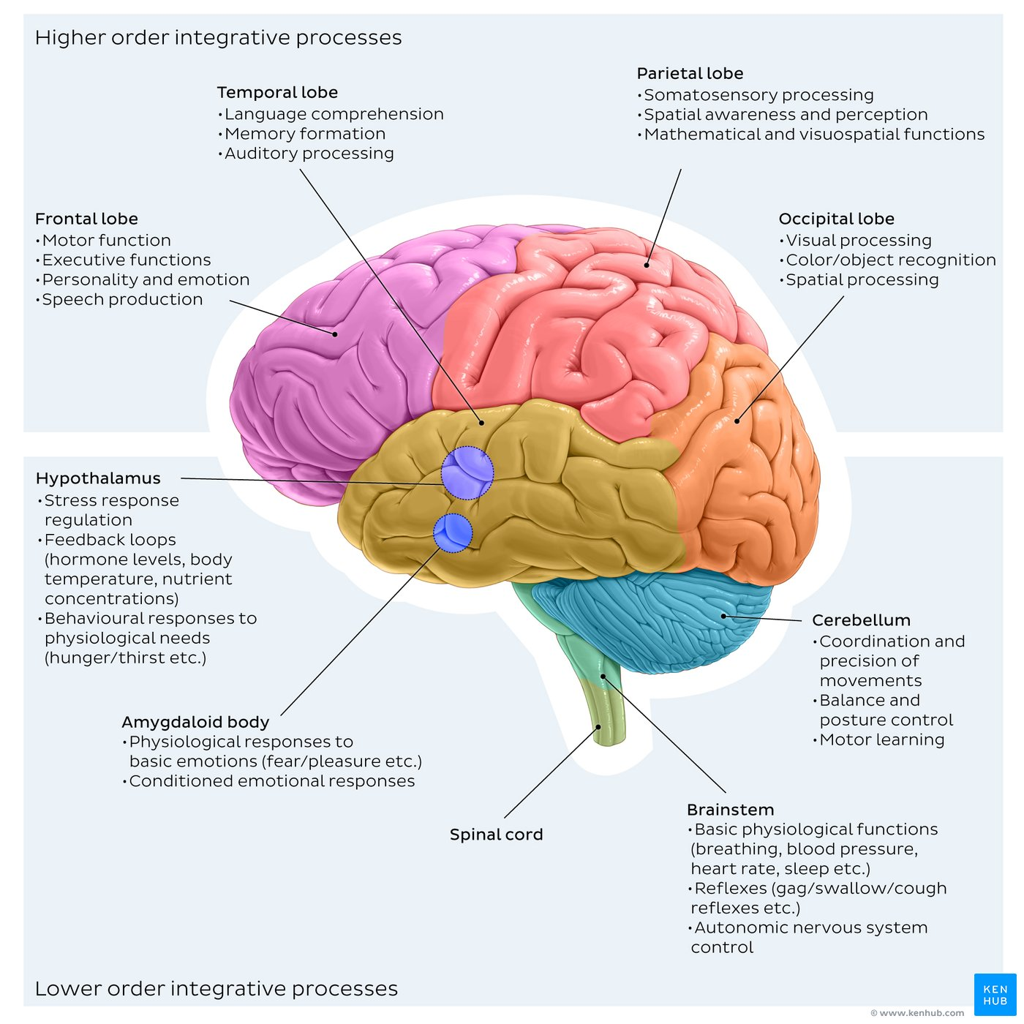
Caption: [Functional divisions of the nervous system: integration]Brain regions responsible for higher cognitive functions and lower order integrative processes.

Functional anatomy of the cerebral cortex

Based on their functions, areas within the cerebral cortex can be divided into primary (sensory or motor), unimodal association and multimodal association (or integration). Primary areas send motor outputs (motor cortex) and receive sensory inputs (eg: somatosensory, auditory and visual cortices). Unimodal association areas further process sensory inputs and motor outputs of the primary areas. Multimodal association areas integrate information from different areas of the brain and mediate higher functions.

FIGURE: [Anatomy of the brain]Frontal lobe, parietal lobe, temporal lobe, occipital lobe

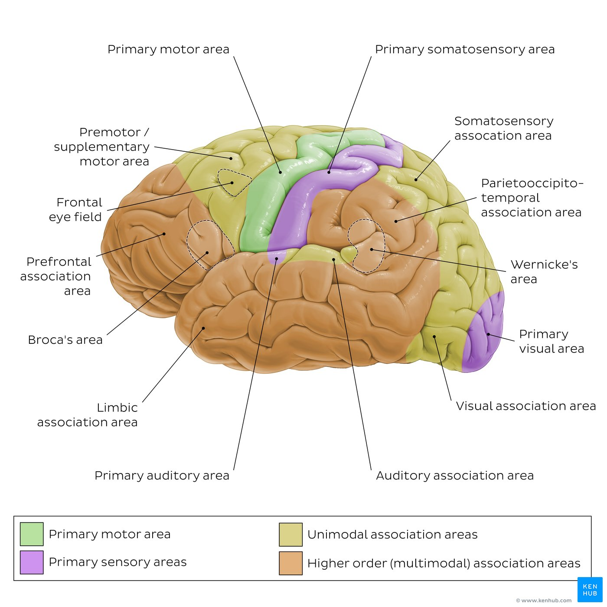
FIGURE: [Functional anatomy of the cerebral cortex]Representation of primary sensory and motor areas, unimodal association and higher order association areas.

Functions are often localized in specific cortical areas. Examples of functions and corresponding primary and unimodal association areas include:
- Movement: motor cortex in the frontal lobe
- Sensory information: somatosensory cortex in the parietal lobe
- Hearing: auditory cortex in the temporal lobe
- Vision: visual cortex in the occipital lobe

BOX: Overview of the cerebrum

Cognition and Language
Cognitive functions include recognizing, processing and responding to environmental stimuli as well as the initiation of voluntary responses. These processes are responsible for higher mental functions like the sense of self, attention, problem-solving and other behaviors. The cortical areas involved in these processes are usually multimodal association areas. Some examples include:
- Personality and movement planning: prefrontal cortex in the frontal lobe
- Spatial awareness: areas in the parietal lobe
- Recognition: areas in the temporal lobe

Some functions are lateralized, meaning that their cortical areas are located in the left or the right hemisphere. For instance, attention and facial recognition tend to be localized in the right hemisphere, whereas language and speech are located in the left hemisphere in most people.

Language is one of the most studied higher mental functions. Two main multimodal integration cortices are involved in language understanding and production. Wernicke’s area is located in the temporal lobe, at the intersection with the parietal lobe, and is responsible for understanding the meaning of language stimuli like written or spoken words. Broca’s area is located in the frontal lobe and is responsible for producing language, for instance choosing the appropriate word order when speaking or writing. Loss of function in either of these areas leads to specific language deficits such as an inability to understand language (receptive aphasia) or produce language (expressive aphasia).

FIGURES: [Cortical areas responsible for language function]

BOX: Study unit on Broadmann areas (talks about aphasia)

Learning and Memory
Whenever we are exposed to new information or try to perform a new motor task, we create new memories. These learning processes occur in multimodal association areas in various regions of the brain. Different types of memory can be defined based on the type of information they contain and for how long the information is stored.

Based on the type of information they contain, memories can be divided into:
- Declarative (or explicit) memory; pieces of information that can be recalled consciously, important for cognitive functions like judgment and evaluation
- Nondeclarative (or implicit) memory; skills and procedures that are mostly unconscious, such as the motor skills required to drink from a cup

Based on storage duration, memories can be divided into:
- Immediate memory; a few seconds
- Short term (working) memory; a few minutes
- Long term memory; months or longer

Highlight box: “Need a refresher on the anatomy of the nervous system? Test yourself with our Nervous system anatomy practice: Quizzes and more!”

The transfer of memories from short to long term is called consolidation. This process likely involves the formation of new connections and changes to synaptic connectivity. An important cellular mechanism is long term potentiation, where repeated stimulation of associated neurons induces structural (growth of neuron dendrites) and chemical (more neurotransmitters released) alterations that strengthen the synaptic connections. Consolidation primarily occurs in the hippocampus and temporal lobe for declarative memory, whereas motor cortex, cerebellum and basal nuclei are more likely to contribute to the consolidation of nondeclarative memories. Long term memories are often stored in the area most relevant for the type of information (eg: visual memories in the occipital lobe, motor memories in the motor circuits).

FIGURES: [Main structures involved in memory consolidation] (Hippocampus, cerebellum, basal nuclei, motor cortex)

Sleep and Wakefulness
At the end of the day, when it is time to rest, we go to sleep. The reason we sleep is unclear, but experts suggest that it may be helpful to reduce our energy demands, to repair our bodies and for functions related to brain plasticity. While sleep is not strictly a higher cognitive function, sleep patterns greatly influence how the brain works. For instance, a lack of sleep often impairs higher cognitive functions, especially attention and decision-making. It is also thought that some sleep phases are important for memory consolidation.

Like other body functions, sleep follows a circadian rhythm, meaning that periods of wakefulness and sleep alternate over 24 hour cycles. A key structure for our circadian rhythms is the suprachiasmatic nucleus of the hypothalamus, which functions as an internal ‘biological clock’ by measuring the passage of time based on how long it takes to degrade a specific protein. Information from the suprachiasmatic nucleus is integrated with inputs from photoreceptors; when the amount of light in the environment decreases and the sleep generation process starts, the suprachiasmatic nucleus activates a pathway that decreases the communication between the thalamus and the cortex. Since most of the sensory pathways relay in the thalamus, this process effectively reduces the amount of sensory information reaching the cortex and therefore reduces consciousness.

FIGURES: [Main structures involved in wakefulness and sleep] (hypothalamus, thalamus, reticular formation, cortex)

Lower order integrative processes
Lower order integrative processes coordinate involuntary functions that can be broadly summarized as:
- Immediate physiological needs. These include the regulation of body temperature, breathing, blood pressure, hunger and thirst. The main anatomical structures involved are the brainstem and the hypothalamus.
- Basic emotional responses. Sensory stimuli that result in basic emotional responses (e.g. fear) are integrated in the amygdala and brainstem to activate efferent pathways (e.g. the sympathetic nervous system to a induce ‘fight or flight’ response).
- Motor coordination. The cerebellum and the spinal cord are two of the main structures involved in the integration of body position and muscle tension during ongoing movement to correct motor output if necessary.

FIGURES: [Main structures involved in lower order processes] (brainstem, amygdala, hypothalamus, cerebellum, spinal cord)

Sources
References:
- Amermann, E. C. (2016). Human anatomy and Physiology (1st edition). Pearson Education.
- Gordon Betts, J., Young, K. A., Wise, J. A., Johnson, E., Poe, B., Kruse, D. H., Korol, O., Johnson, J. E., Womble, M., & DeSaix, P. (2024). Anatomy and Physiology 2e; OpenStax. https://openstax.org/books/anatomy-and-physiology-2e/pages/preface
- Silverthorn, D. U. (2019). Human physiology (8th edition). Pearson Education.

Illustrators:
- Tal Bavli Ziv
- Paul Kim

