Container: Anatomy > Abdomen > Nerves, vessels and lymphatics of the abdomen

Position: 69

Abdominal aorta and its branches

Learning objectives

This study unit will help you to:
- Describe the location and course of the abdominal aorta.
- Identify and describe the unpaired visceral, paired visceral, and posterior parietal branches of the abdominal aorta.
- Identify the important relations of the abdominal aorta.

Watch a video

The abdominal aorta is the main arterial trunk of the abdomen, beginning at the aortic hiatus of the diaphragm at vertebral level T12. It descends within the retroperitoneal space along the posterior abdominal wall, positioned to the left of the inferior vena cava. As it progresses inferiorly, the aorta gradually decreases in diameter while giving off its major visceral and parietal branches.

The abdominal aorta gives off several major branches, which are grouped into unpaired visceral, paired visceral and posterior parietal branches. The unpaired visceral branches include the celiac trunk, superior mesenteric artery and inferior mesenteric artery. The paired visceral branches consist of the middle suprarenal, renal and gonadal arteries. The posterior parietal branches comprise the inferior phrenic arteries, lumbar arteries and the median sacral artery.

Find out more about the abdominal aorta and its branches in the video below!

Embedded video: Abdominal aorta and its branches (in progress)

Take a quiz
Embedded quiz: Abdominal aorta and its branches (in progress)

Use the link below to take a quiz covering all structures of the abdominal wall, or customize your quiz entirely, choosing the terms that you want to be tested on.
Linked custom quiz: /en/custom-quizzes/cq_gtDHxIZbwkobQNrGSynW

Browse atlas
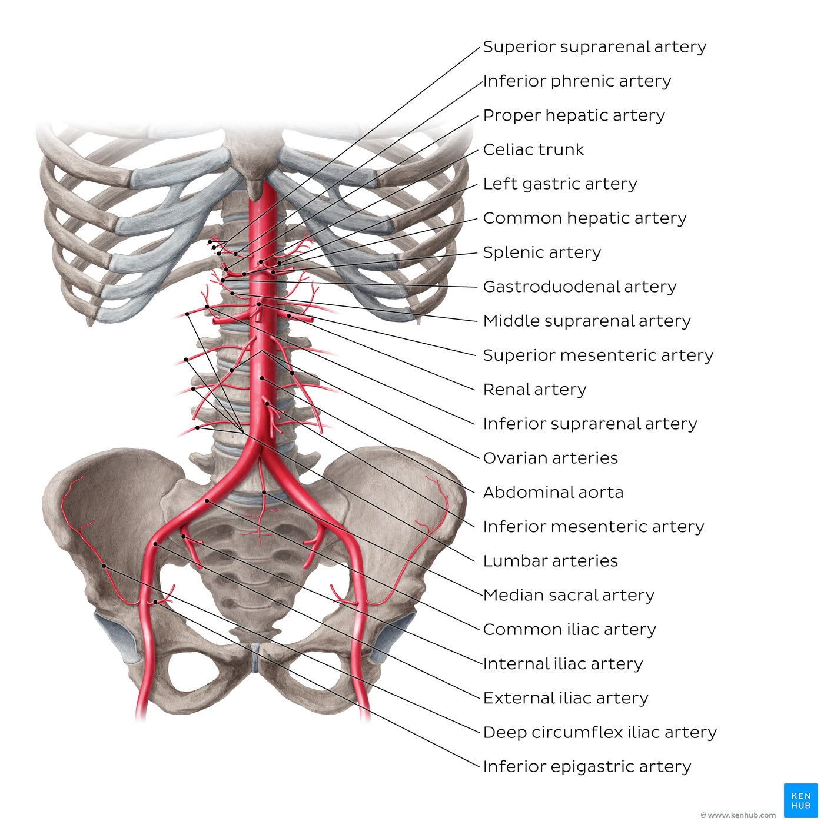
OV: [Abdominal aorta and its branches]Three unpaired visceral arteries can be seen branching from the anterior aspect of the abdominal aorta. The celiac trunk is the most superior of these, arising at the level of vertebra T12 and dividing into the left gastric, splenic and common hepatic arteries, with the latter giving rise to the gastroduodenal and proper hepatic arteries. The superior mesenteric artery arises just below the celiac trunk at the level of vertebra L1, with the inferior mesenteric artery originating further inferiorly at the level of vertebra L3. The paired visceral branches can typically be seen arising from the lateral aspect of the abdominal aorta. Among these are the inferior phrenic arteries (which are often the first branches of the abdominal aorta) as well as the middle suprarenal artery, renal artery and ovarian artery (in females, or testicular artery in males; commonly called the gonadal artery). The superior suprarenal artery branches from the inferior phrenic artery, while the inferior suprarenal artery arises from the renal artery. Posterior parietal branches include four pairs of lumbar arteries, as well as the median sacral artery which descends along the midline. The aorta terminates at the level of vertebra L4 where it bifurcates into the left and right common iliac arteries, each of which further divide into the external iliac artery and internal iliac artery. From the external iliac artery arise the inferior epigastric artery and deep circumflex iliac artery.

Lt OV: [Aorta abdominalis and its major branches]Three unpaired visceral arteries can be seen branching from the anterior aspect of the aorta abdominalis. The truncus coeliacus is the most superior of these, arising at the level of vertebra T12 and dividing into the arteria gastrica sinistra, arteria splenica and arteria hepatica communis, with the latter giving rise to the arteria gastroduodenalis and arteria hepatica propria. The arteria mesenterica superior arises just below the truncus coeliacus at the level of vertebra L1, with the arteria mesenterica inferior originating further inferiorly at the level of vertebra L3. The paired visceral branches can typically be seen arising from the lateral aspect of the aorta abdominalis. Among these are the arteriae phrenicae inferior (which are often the first branches of the aorta abdominalis) as well as the arteria suprarenalis media, arteria renalis and arteria ovarica (in females, or arteria testicularis in males; both commonly called the arteria gonadalis). The arteria suprarenalis superior branches from the arteria phrenica inferior, while the arteria suprarenalis inferior arises from the arteria renalis. Posterior parietal branches include the four pairs of arteriae lumbales, as well as the arteria sacralis mediana which descends along the midline. The aorta terminates at the level of vertebra L4 where it bifurcates into the arteria iliaca communis sinistra and arteria iliaca communis dextra, each of which further divide into the arteria iliaca externa and arteria iliaca interna. From the arteria iliaca externa arise the arteria epigastrica inferior and arteria circumflexa iliaca profunda.

Take a closer look at each of the branches in the atlas gallery below.

abdominal-aorta-30,celiac-trunk-8,left-gastric-artery-11,splenic-artery-18,common-hepatic-artery-13,gastroduodenal-artery-8,proper-hepatic-artery-11,superior-mesenteric-artery-23,inferior-mesenteric-artery-11,inferior-phrenic-artery,superior-suprarenal-artery-1,middle-suprarenal-artery-1,renal-artery-6,inferior-suprarenal-artery-3,ovarian-artery-5,testicular-artery-7,lumbar-arteries-4,median-sacral-artery-6,common-iliac-artery-8,internal-iliac-artery-15,external-iliac-artery-20,inferior-epigastric-artery-17,deep-circumflex-iliac-artery-3

Summary

Key points about the abdominal aorta and its branches
Location | Descends anterior to the vertebral column within the retroperitoneal space of the abdominal cavity.
Origin and termination | Originates as a continuation of the descending thoracic aorta at the aortic hiatus of the diaphragm (T12) and terminates at its bifurcation into the left and right common iliac arteries at the level of the L4 vertebra.
Branches | Unpaired visceral: Celiac trunk, superior mesenteric artery, Inferior mesenteric artery  Paired visceral: Middle suprarenal artery, renal artery, gonadal artery  Posterior parietal: Inferior phrenic artery, lumbar arteries, median sacral artery
Supply | Celiac trunk: Foregut derivatives: stomach, liver, spleen, pancreas, proximal duodenum  Inferior phrenic artery: Diaphragm  Superior mesenteric artery: Midgut derivatives: distal duodenum, jejunum, ileum, cecum, ascending colon, proximal 2/3 of transverse colon  Middle suprarenal artery: Suprarenal gland  Renal artery: Kidney  Gonadal artery: Ovary/testis  Inferior mesenteric artery: Hindgut derivatives: distal 1/3 transverse colon, descending colon, sigmoid colon, rectum  Lumbar arteries: Posterior abdominal wall  Middle sacral artery: Sacrum, coccyx  Common iliac artery: Divides into internal iliac artery (pelvic organs, gluteal region) and external iliac artery (lower limb)

Lt:
Key points about the aorta abdominalis and its branches
Location | Descends anterior to the columna vertebralis within the retroperitoneal space of the cavitas abdominis.
Origin and termination | Originates as a continuation of the aorta thoracica descendens at the hiatus aorticus of the diaphragma (T12) and terminates at its bifurcation into the arteria iliaca communis sinistra and arteria iliaca communis dextra at the level of the L4 vertebra.
Branches | Unpaired visceral: Truncus coeliacus, arteria mesenterica superior, arteria mesenterica inferior  Paired visceral: Arteria suprarenalis media, arteria renalis, arteria gonadalis  Posterior parietal: Arteria phrenica inferior, arteriae lumbales, arteria sacralis mediana
Supply | Truncus coeliacus: Foregut derivatives: gaster, hepar, splen, pancreas, pars proximalis duodeni  Arteria phrenica inferior: Diaphragma  Arteria mesenterica superior: Midgut derivatives: pars distalis duodeni, jejunum, ileum, caecum, colon ascendens, duae partes proximales coli transversi  Arteria suprarenalis media: Glandula suprarenalis  Arteria renalis: Ren  Arteria gonadalis: Ovarium/testis  Arteria mesenterica inferior: Hindgut derivatives: pars distalis tertiae partis coli transversi, colon descendens, colon sigmoideum, rectum  Arteriae lumbales: Posterior abdominal wall  Arteria sacralis mediana: Sacrum and coccyx  Arteria iliaca communis: Divides into arteria iliaca interna (pelvic organs, regio glutea) and arteria iliaca externa (membrum inferius)

Related articles
https://www.kenhub.com/en/library/anatomy/aorta
https://www.kenhub.com/en/library/anatomy/blood-vessels-of-abdomen-and-pelvis
https://www.kenhub.com/en/library/anatomy/nerves-vessels-and-lymphatics-of-the-abdomen

