PROCEDURE
ACC / BIM 360
Review management and File upload

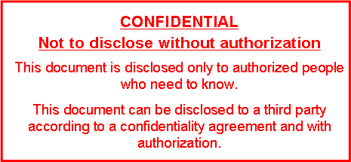

CONTENTS
1. Introduction 3
1.1. Purpose of the application 3
1.2. Scope and objectives 3
2. System requirements 3
3. Configuration 4
3.1. Configuration parameters 4
3.2. Configuration files 4
3.3. Configuration examples 4
4. Application operation 5
4.1. General process description 5
4.2. Error handling 7
4.3. Supported file types 7
5. Authentication and authorization 7
6. Troubleshooting 8

Introduction

Purpose of the application
The purpose of this application is to facilitate work for administrators which must manually update files wasting a lot of time only for these monotonous tasks. This system provides the resources needed to upload one or more files to Autodesk’s clouds seamlessly by stating a few parameters.

Scope and objectives
The aim is to provide administrators with the tools needed so that they can delegate the monotonous task of uploading files to the cloud with automatic coded tasks that can be easily adapted between projects and clouds.
Mainly the system will require administrators to state the name of the project aimed at uploading, the path of the file/s inside the server and where to upload it. After that the system will automatically locate the file/s and will dynamically get the location inside the cloud and upload the files.

System requirements
To use the script, it is necessary to have some software and dependencies installed:
- Python version 3 onward, it’s the main programming language used within the script.
- Any text editor to modify the command used to call the script (Notepad++, Visual Studio Code, …)
- Install the requests and json library using the command “pip install requests json”, must be done once python has been installed. This command may return an error stating that the library json is already installed, just remove “json” from the command and run it again.
- You must have an APS server-to-server application with the Autodesk Cloud Construction API, BIM 360 API and Data Management API enabled.
- You will also need to provision the application within the projects needed or otherwise the hub where the projects reside. This is an essential step as if it’s not done, the script will never be able to find any projects or hubs even if a user has proper access.

Configuration

Configuration parameters
To run the script, a command is needed with several parameters:
- Path to python.exe file location
- The path to the “acc-bim_upload.py” script which will be located depending on where you store the folder.
- The name of the project. This can’t just be the name itself or the code for this project, it must be the one that appears either on ACC or BIM360 project settings.
- The path where the file or files aimed to be uploaded are in the server.
- The internal path of the cloud. To know this, you must open your project using Documents Management, and then browse through the different directories until you find the folder, then specify it as the fifth parameter by stating folder/nested_folder/nested_folder2 and so on until you reach where you want to store the file/s. Your cloud path should ALWAYS start by “Project Files” you will see this on the browser as the first hierarchical folder.
- A Boolean which states if the server path is a folder or a single file.

Configuration files
When successfully running for the first time the script, a .json file will appear inside the scripts folder, this is a configuration file used to store variables that aren’t needed to be updated as more executions with the same parameters occur.
Basically, it saves time and resources once we know internal variables inside the cloud and we can use them without checking their values against the API of Autodesk.

Configuration examples
For a project to be run we first need to state the parameters specified before:
- First, we must specify the python.exe file, this will be located inside the Python installation, most likely within the C disk as in this example: “C:\Python3.7.5\python.exe”
- Let’s say we stored the folder containing the script files inside Downloads, so the second parameter will be something that resembles the following:
"C:\Users\agarcia2\Downloads\ACC-BIM360 File Upload\acc-bim_upload.py"
- Then, we have a project named “Test Project”, you can look that up in your cloud project settings:

- Suppose we want to upload a file named test_project_file.nwd located in \\es002vs0128\Maquetas\Test Project\, we’ll state this as follows:
“\\es002vs0128\Maquetas\Test Project\test_project_file.nwd”
- Finally, we want to save this file in a directory called 4_NAVISWORKS which is located under the Project Files directory, then we’ll specify this parameter as follows:
“Project Files/4_NAVISWORKS”
After all variables known we can then compile everything in a single line that will let us execute the script that uploads the file specified:
Once called, a command prompt will pop up with the line being executed and will upload the file in the location specified within the cloud, once done it will automatically close.

Application operation

General process description
This documentation won’t enter too much into the code’s details, it’s exhaustively commented on and no changes to the code should be made for it to correctly work.
We can identify two separate modules, those being “create_env” and “request_methods”, both modules contain methods that will be called directly from the main module, the “acc-bim_upload”.
“create_env” contains all the API calls needed to obtain variables which describe a hub, a project and a folder in the language of Autodesk’s API.
Then “request_methods” embody all API calls to specifically upload the file, these (as many others) are creating an object from the file to be uploaded, obtaining a url to which to make the upload or making the upload completed.
The “acc-bim_upload” then uses all methods described in the previous modules to create the upload workflow. This workflow is the same described in the “Upload Files to BIM 360 Document Management” tutorial of the official APS BIM 360 API documentation.
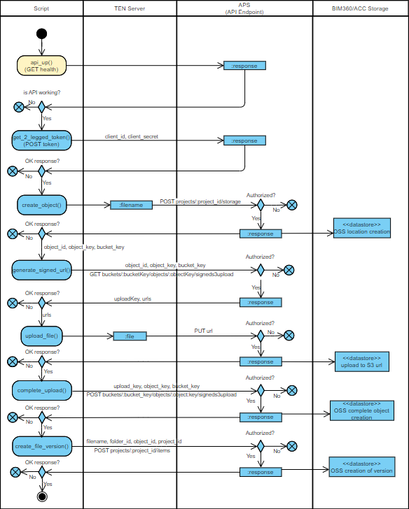
Fig 01. Sequence diagram for the application workflow

Error handling
Any error that might occur will be logged into a log file that will be stored inside /logs with the name being the day of execution. If an error has happened, there are two ways of knowing, either by checking if the file has been updated in the cloud or by checking the log file.
The log file contains all meaningful information about the upload, starting from which project it’s updating, up to all the steps it takes to upload the file, finally at the end the number of errors if any occurred.

Supported file types
As noted in the official documentation, any type of document can be uploaded to the BIM 360 and ACC Project Files folder or to any other nested folder (Plans folder is not included as uploads should only be made to the Project Files or any nested folder beneath Project Files).

Authentication and authorization
For the script to work no specific user needs any special authorization or access to any resource in the cloud. What a user does need is access to the resources to be uploaded. It works this way thanks to the provision of the application that should’ve been done in earlier steps. Through access to the APS application a user can access any resource for which the application has been provisioned.
The application is programmed using 2-legged tokens which basically means that the authorization occurs between two entities, those being the API endpoint and the application, a pure server-to-server application.
To set this up a user will need a client id and a client secret to be able to use this system and it can be obtained through the APS application settings, then in the “const.py” file both variables should be replaced with your own. With that the application will launch with enough permissions.
Only those who have access to the client id and the client secret will be able to access the resources in the cloud, but also only to those resources for which the application has been provisioned.

Troubleshooting
The system has been working for several months with no errors, there has been maintenance work and refactors for it to be used when and if needed.
For any discussion, problems or questions that can arise please contact alex.garcia2@ten.com

