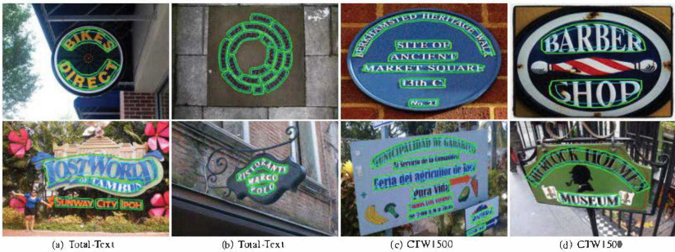

experimental results. The blue contours are boundary proposals, and the green contours are final detection

Table 6. Experimental results on CTW-1500

|  |  |  |  |  |  |
| --- | --- | --- | --- | --- | --- |
| Methods | Ext | R | P | F | FPS |
| TextSnake [l&] | Syn | 85.3 | 67 .9 | 75.6 |  |
| CSE [17] | MLT | 76.1 | 78.7 | 77.4 | 0.38 |
| LOMO[40] | Syn | 76.5 | 85.7 | 80.8 | 4.4 |
| ATRR[35] | Sy- | 80.2 | 80.1 | 80.1 | - |
| SegLink++[28] | Syn | 79.8 | 82.8 | 81.3 | - |
| TextFieId [3?] | Syn | 79.8 | 83.0 | 81.4 | 6.0 |
| MSR[33] | Syn | 79.0 | 84.1 | 81.5 | 4.3 |
| PSENet-1s [33] | MLT | 79.7 | 84.8 | 82.2 | 3.9 |
| DB [12] | Syn | 80.2 | 86.9 | 83.4 | 22.0 |
| CRAFT [2] | Syn | 81.1 | 86.0 | 83.5 | - |
| TextDragon [5] | MLT+ | 82.8 | 84.5 | 83.6 |  |
| PAN [34] | Syn | 81.2 | 86.4 | 83.7 | 39.8 |
| ContourNet [36] |  | 84.1 | 83.7 | 83.9 | 4.5 |
| DRRG [4l] | MLT | 83.02 | 85.93 | 84.45 | = |
| TextPerception[23 | Syn | 81.9 | 87.5 | 84.6 | - |
| Ours |  | 80.57 | 87.66 | 83.97 | 12.08 |
| urs | Syn | 81.45 | 87.81 | 84.51 | 12.15 |
| urs | MLT | 83.60 |  | 8645 85.00 | 12.21 |

CTW1500. In testing, the threshold ths is set to 0.8 Representa ve visible results are shown in Fig 8 (c) anc (d), which indicate our method precisely detects bound- aries of long curvod text with line-level. The quantitative results are listed in Tab. 6. Compared with the previous sate-of-the-art methods [12, 34, 3], our approach achieves

Table 7. Experimentalresults on MSRA-TDS00.

|  |  |  |  |  |
| --- | --- | --- | --- | --- |
| Methods | R | P | F | FPS |
| SegLink[2] | 70.0 | 86.0 | 77.0 | 8.9 |
| PixeILink[4] | 73.2 | 83.0 | 77.8 |  |
| TextSnake [18] | 73.9 | 83.2 | 78.3 | 1.1 |
| TextFieId [37] | 75.9 | 87.4 | 81.3 | 5.2 |
| MSR[38] | 76.7 | 87.4 | 81.7 | - |
| FrSN[r] | 77.1 | 87.6 | 82.0 | - |
| LSE[30] | 81.7 | 84.2 | 82.9 |  |
| CRAFI [2] | 78.2 | 88.2 | 82.9 | 8.6 |
| MCN [le] | 79 | 88 | 83 |  |
| ATRR[35] | 82.1 | 85.2 | 83.6 |  |
| PAN [3] | 83.8 | 84.4 | 84.1 | 30.2 |
| DB[l2] | 79.2 | 91.5 | 84.9 | 32.0 |
| DRRG [41] | 82.30 | 88.05 | 85.08 |  |
| Ours (SynText) | 80.68 | 85.40 | 82.97 | 12.68 |
| Ours(MLT-17)} | 84.54 | 86.62 | 85.57 | 12.31 |

# S. Conclusion

In this paper. we propose a novel adaptive bound ary proposal network for arbirary shape text detection. which adopt an boundary proposal model to generate coarse boundary proposals, and then adopt an adaptive boundary defonnation model combined with GCN and RNN to per