**Hire Purchase System**

Student No: 083482

An Information System Project Documentation Submitted to the Faculty of Information Technology in partial fulfillment of the requirements for the award of Degree in Business Information Technology

29th November 2017

# Declaration

I 083482 declare that this project has not been submitted to any other University for the award of a Degree in Information Technology.

Student Signature:

Sign: Date:

Supervisor’s Signature:

Sign: Date:

# Abstract

Many companies undergo certain problems which bring about weaknesses and competition. Some of the major problems are Stock Management. Stock Management is a problem since many companies are unable to manage their stock well. The system was specifically designed for an organization known as Kenya credit traders which was undergoing the same problem in their store department. The system could also help customers, who buy their product from the store, to easily get access to the system and be able to buy online through hire purchase.

Kenya Credit Traders faced a certain problems caused by the ripple effect of the stock management and also how the system should be designed in order to get rid of the problems.

The purpose of the system was to make work easier for the workers and customers.

The aim was to design a software system that could enable the users to keep track of their products in their store with ease and also enable customers to buy those products available in the store. The methodology that was applicable for the system was waterfall which falls under structured system analysis and design.

# **Table of Contents**

Declaration ii

Abstract iii

**Table of Contents** iv

List of Figures vi

List of Tables vii

Chapter 1: INTRODUCTION 1

1.1 Background 1

1.2 Problem statement 2

1.3 Aim 3

1.4 Specific objectives 3

1.5 Justification 3

1.6 Scope/Limitation 4

Chapter 2 Literature Review 5

2.1 Introduction 5

2.2 Problems in Kenya Supermarket Industry 5

2.3 Technologies used in Managing Stock in Supermarkets in Kenya 5

Chapter 3: Development Methodology 7

3.1 Introduction 7

3.2 Requirements 7

3.2.1.Functional 7

3.2.2Non-functional 8

3.2.3 Narrative 8

3.3 Design 8

System Development Tools and Techniques 8

3.4 Deliverables 9

3.5 Project Milestone/Schedule 10

Chapter 4: System analysis and architectural design. 11

4.1: Introduction. 11

4.2: System Analysis. 11

4.2.1 Functional requirements. 11

4.2.2 Nonfunctional requirements. 11

4.2.3 Narrative. 12

4.3 System Design. 14

Chapter 5: System Development and Testing. 17

5.1 Introduction. 17

5.2 System Development. 17

5.3: Implementation of the system. 18

5.4: System Testing. 18

Chapter 6: Conclusion and Recommendation. 21

6.1 Conclusion. 21

6.2 Recommendations. 21

6.3 Future works. 22

References 23

Appendix A: Gantt chart 24

Appendix A: User Manual 25

# List of Figures

Figure 1:Use case 9

Figure 2: Gantt Chart 13

# List of Tables

Table 1: System Development Tools and Techniques 10

# Chapter 1: INTRODUCTION

## 1.1 Background

As human beings we are faced with a variety of challenges in our daily lives. One of the challenges we are faced with is forgetfulness. We are faced with a lot of data and information and we tend to subconsciously do things and we therefore forget other things (Wick, 2010).

A Stock Management System is a computer based system used in assessing the inventory of a business and making sure its sufficient to meet consumer demand. The system will help the workers remember the amount of stock and where they are allocated. The demands that a stock management [process](http://www.businessdictionary.com/definition/process.html) seeks to satisfy are affected by external and [internal factors](http://www.businessdictionary.com/definition/internal-factors.html), and can be expressed using [purchase order](http://www.businessdictionary.com/definition/purchase-order.html) requests to help maintain appropriate inventory levels (business tales, 2012).

Goods or merchandise kept on the premises of a business or warehouse and available for sale or distribution are known as stock.  Stocks are [bought](http://www.businessdictionary.com/definition/bought.html) and sold on what is called an [exchange](http://www.businessdictionary.com/definition/exchange.html). There are several types of stocks and the two most [typical](http://www.businessdictionary.com/definition/typical.html) forms are [preferred stock](http://www.businessdictionary.com/definition/preferred-stock.html) and [common stock](http://www.businessdictionary.com/definition/common-stock.html)  (business truths, 2010).

A stock management system that specifies the shape and percentage of stocked goods. It is required at different locations within a facility or within many locations of a supply network to precede the regular and planned course of production and stock of materials (Peter, 2009; Peter E. , 2009).

Kenya Credit Traders Limited (KCT) was incorporated and registered on 16th January 1985. Aim was to set up and operate shops in all major towns of the country. Through these shops, the company planned to sell durable household goods on easy hire purchase terms (Beck J. k., n.d.).

The targeted market was mid and low level employees and self-employed people with regular income who are the majority customer of the company. First six shops were opened on 1985. These were KCT 01 – Nairobi, 02-Nyeri, 03-Thika, 04-Meru, 05-Bungoma, 06-Kakamega. Business grew very fast as a result number of shops grew to 60 by 2005 (Beck J. k., 2005).

In addition to durable household goods the company now stocks solar products, water pumps, generators and light industrial articles (Wick, 2010).

As a logical route of growth, Kenya Credit Traders is now in the process of setting up a hire purchase financing arm. This will provide small and medium size loans to customers for purchase of items like vehicle and equipment for a small (Beck J. k., 2005).

There are various activities that take place within the company during its day to day activities. The major activity which is also the main objective is to provide conducive environment and also give customer service to available customers, so that they may appreciate the service provided (Beck J. k., 2005).

The current system of operation is to sell products on hire purchase to the available customers and also deliver the products the customers location if necessary. Some problems of the system are that it requires a lot of man power in order to fulfill certain objectives. Objectives that when the system is automated there will increase in speed in terms of recording received goods. The current system also makes it tedious when one is finding out the number of remaining stock (Beck J. k., n.d.).

## 1.2 Problem statement

You can get more money through various avenues but once time is gone, it’s gone forever. You can’t buy more or borrow more, so time is a limited resource that expires every day. As a business owner, you have to be very careful with this precious resource (Stock in system, 2010).

In Kenya Credit Traders there are certain problems affecting the company. Some of the problems were; workers are unaware of the products in the stores since there were many products were in large quantity in the stores, customers had a hard time travelling from different part of the country just to buy a product on high purchase, customers were unable to know whether the products they require is available in the company.

## 1.3 Aim

The main reason for carrying out this project is in the effort to create a Stock Management system that will help the KCT workers to manage their products well and customers to interact with the system in order to help them buy their products on hire purchase. It will help to manage its day to day activities in terms of receiving products, recording them and taking note of the quantity and also customers to buy products without travelling to the company and enabling them to know if their item is available in the system. This system will help store department which is key department in the Kenya Credit Traders organization to fulfill its objectives and also make their work easier and faster.

## 1.4 Specific objectives

1. To investigate the existing problems with the current stock management system in Kenya.
2. To identify the Technologies used in managing stock in the current supermarkets in Kenya
3. To Design a Stock Management System algorithm.
4. To develop a Stock Management System.

## 1.5 Justification

With the ever-flowing of products in the field of Stock Management system, a great challenge has been presented to the KCT workers when products are required by customers. Hence, an intern or any other person in the stock management field, may have a hard time finding certain products. This, however can be stressful for the interns, time consuming and may make customers to be very uncomfortable waiting for their products. Hence, there is need of a system which will assist the workers and also interns which will save time on the allocation of stock, especially when one is urgently required.

The system will also enable KCT workers to know the available products in the store through this application since it will store all information of the available product in the store.

Nevertheless, it will also assist the customers to be able to buy their products online and save on time since they do not have to go to the company since they will deliver their required product.

## 1.6 Scope/Limitation

Knowledge of inventory makes or breaks performance of any business. Products and services that depend on raw materials, parts and other supplies need consistent inventories to complete business, with cost management to maximize profits. The nature of the business and its industry may suggest the scope of an inventory system, while a system itself has inherent limitations. Most businesses can adjust the inventory process to meet their needs while limiting the impact of system limitations.

Inventories that are counted weekly or monthly, compared with counts from the previous period, and adjusted to include purchases within the period can only generate data at or after the point of counting. This results in a lack of detail in the information about how inventory moves. The nature of a small business may not require such detail, or minimum order quantities of raw materials at aggressive discounts may cover several periods, making such detail unnecessary, so these limitations may be minimal for certain businesses.

While perpetual systems can give current inventory information whenever required, this may come at a cost of time or capital. Scanners and computers may require investment that needs measuring against return. Without periodic verification of actual inventory to perpetual inventory calculations, problems such as theft, spoilage or data entry errors may remain undiscovered. Perpetual inventories can be maintained manually, though this works best with a limited and consistent inventory stock, as each inventory item requires separate tracking of purchase and sale.

The system will be able to identify the existing problems in the current stock management system and also identify the components of the stock management system (Anderson, n.d.).

# Chapter 2 Literature Review

## 2.1 Introduction

This chapter reviews on the existing literature on the current stock management situation in most organizations in Kenya, existing stock management system, the trends in a computerized system, the adoption of a computerized system in other industries in other countries as well. It begins by exploring the challenges that exists in the current stock management system being used and it finally depicts various technologies used in computerized development systems.

## 2.2 Problems in Kenya Supermarket Industry

The current supermarket industry has really grown since most of the low, middle class and high class go to these supermarkets to buy items. According to a study done by a researcher,

In today's highly competitive business environment, organizations are striving to achieve efficiency, cost reduction, effectiveness and economies of scale. Most of these organizations hold inventory so as to meet their customers' needs. However, managing these inventories in order to achieve their objectives has posed great challenge to the firms. Many firms have not yet established how much to invest in inventories and the right inventory levels that hold so as to satisfy customers. Organizations have therefore resorted to using modern inventory techniques such as Vendor Managed Inventory (VMI) so as to overcome these challenges.

### 2.3 Technologies used in Managing Stock in Supermarkets in Kenya

Currently there are different applications and systems that have been developed and used in relation to the inventory management in supermarkets in the country. In the standard method, a supermarket selling cookers etc., keeps its stock in a shop and in an attached warehouse. When stock in the shop are runs low it is replenished from the warehouse. A check is kept on how much stock is in the warehouse. When the warehouse needs new stock, an order is placed with the appropriate suppliers – or with the organization’s main warehouse – and the goods are delivered. The ‘just-in-time’ system takes advantage of a stock information system.

As products pass through the electronic points of sales (EPOS), the relevant data is sent to database containing information about stock levels. When stock falls below a set level more is ordered. Thus only a bare minimum of necessary stock is ordered and there is no need to maintain a large, fully stocked warehouse. In some cases, the system is fully automated, working out how what stock is needed and electronically processing and

Communicating the order. Supermarkets use a computer system called ‘electronic point of sale’ or EPOS. They use this system to monitor and control stock also perform sales analysis, collect data about customers using loyalty cards which offer points whenever money is spent in the store. This data is used to analyze the spending habits of customers and send them offers for the type of products that they buy regularly.

* 1. Stock Management System algorithm.

Strategic assets of the logistics management of the company are, above all, management resources, exceeding similar resources of the competitors; and strategic competencies are strategically significant activities for the company, where the improvement of the system of management of commodity flows takes place. Thus, there is an actual task of working out the algorithm of procurement and inventory management in the distribution network and recommendations for improving the system of inventory management that may eventually become the basis for creating sustainable competitive advantage for the company in the foreseeable future in the market.

* 1. Stock Management System

An effective inventory system is an indispensable component of any retail or manufacturing operation. The primary purpose of a retail inventory system is to accurately maintain a physical count of products, supplies, and materials stored in a warehouse or storeroom. Once established, an inventory system can be used to control and maintain the stored goods, ensuring that inventory is not lost to spoilage or theft.

# Chapter 3: Development Methodology

## 3.1 Introduction

A methodology is the systematic, theoretic analysis of the methods applied to a field study. There are two methodologies which are; structured system analysis and Object oriented analysis and design. The methodology which is applicable for our system is waterfall which falls under structured system analysis. Waterfall methodology is the best since one phase must be completed before moving to the next phase.

The system has certain number of phases before it is completed. The phases are; identifying the problem, finding an applicable system solution that will get rid of the problem, designing an applicable system and also testing the system.

The phases will be followed in this order and hence cannot move to the next phase before the previous phase is completed.

Waterfall is the most applicable since the requirements of the system are very well known.  
The requirements of the stock management system are, for example, knowing what problems are faced in the company. Knowing these problems will enable me to design a system that will get rid of these problems

## 3.2 Requirements

3.2.1.Functional  
The system will be able to manage all stock in the company since it is designed to help out with the problems such as time wastage in finding specific products in the stores  
therefore the system will keep the details of the product including the location.

The system is designed to reduce wastage of the products the system will be able to keep all the product details including the dead stock. Therefore, products will be used before their dead stock date and this will be able to reduce wastage of products.

3.2.2Non-functional  
My system will reduce the burden of work on the workers since it will do most of the work such as locating the products and storing product details. The burden the workers faced could be like going through all the products in all the stores to get certain information such as expiry date. The workers will therefore have to go through all the products and return them in their rightful place.

### 3.2.3 Narrative

The aim of this project is to develop a stock management system that will assist the store department to manage its day to day activities in terms of receiving products, recording of received items, taking note of the expiry dates, taking note of the quantity of the received products.

This helps the store department which is key department in the KCT organization to fulfil its objectives and also make their work easier and faster.

## 3.3 Design

System design is a process of defining the architecture for a system. The hardware store management system is to be designed using data flow diagrams which show flow of data of the system and entity relationship diagrams to show relationships in the database.

## System Development Tools and Techniques

Table 1: System Development Tools and Techniques

|  |  |  |
| --- | --- | --- |
| Development Tool | Use | Explanation |
| Microsoft Word | Documentation | The application was used for the write up of the whole documentation. |
| Microsoft Visio 2007 | DFD, ERD, Gantt chart | This provided all the tools for illustrating all types of diagrams |
| Note pad | Integrated Development Environment | Note pad was used in designing, coding and 4publishing of the system. the system was programmed using HTML |
| MySQL Database Management System | Database | Used for storing data about the hardware management system. |

### 

## 3.4 Deliverables

**Log in–** The users should be logged in the system in order to access the data in the system.

**Sign up -** the users should sign up in order to get access to certain information from the system

**Stock module** – this module provides entry of stock into the database

**View module**: this will allow the users of the system to be able to view data.

**Logout module**- this module will be used by users to exit the application. They will have to log in again after this action.

**Search module-** will be used by customers to look for products in the system.

## 3.5 Project Milestone/Schedule

Figure 1: Gantt Chart

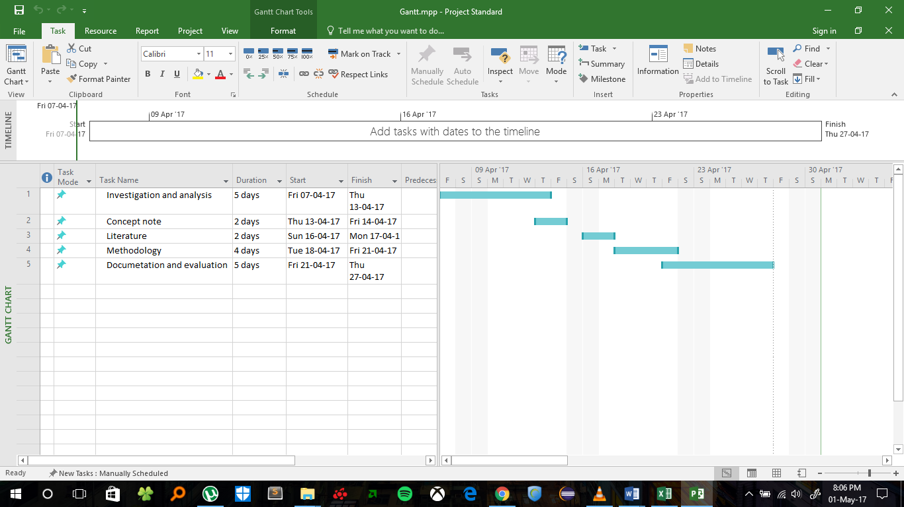

# Chapter 4: System analysis and architectural design.

## 4.1: Introduction.

The focus of the project was to develop a system which captures Kenya Credit Traders’ operations. In this chapter, system requirements and designs are presented.

## 4.2: System Analysis.

System analysis was conducted with an aim of establishing the system requirements and presenting them in a manner that supported system development. Observation was one of the main methods of collecting. Other secondary methods such as books methods were used to collect data. The current methods used in market system and stock management system were both used to ensure customer satisfaction and smooth workflow activities for workers.

### 4.2.1 Functional requirements.

1. Keeping and retrieving product records.
2. Storing and retrieving customer information.
3. Generates reports based on sales.
4. Calculates the deposit based on the total purchase price.
5. Calculates the monthly installments based of the total cart price.

### 4.2.2 Nonfunctional requirements.

Security - the system was made secure by encrypting the passwords stored in in the database for both the customers and workers.

Availability - the hire purchase system is a web-based system that can be accessed by anyone with access to the internet therefore it is available to most people.

Ease of use - the system is easy to use for any client since it has a user-friendly interface.

Portability - the system is portable since it is a web based system therefore it can be accessed at any place with internet connection.

Scalability - the system is capable of functioning even when changes are made in the system.

### 4.2.3 Narrative.

The Hire purchase system was composed of five entities who were; the administrator, manager, secretary, head of department and the customer. The Administrator was able to insert available product details in the system for the customer to see the available products in the system. Incase products left the store, the administrator was able to update the system by updating the product quantity left.

A new customer in need of a particular product could easily create a new account by registering and then login to search for the product needed. The customer could be able to view the product price before buying and see the deposit required to purchase the product. When they agreed to the terms and conditions, the customer could then be able to purchase the product after making payment via M-pesa.

After payments, the customer could be able to view orders in transit and completed orders and be able to give a review for the administrator to see and act on them. If the customer wasn’t satisfied with the product, he/she was able to return the product with a full refund.

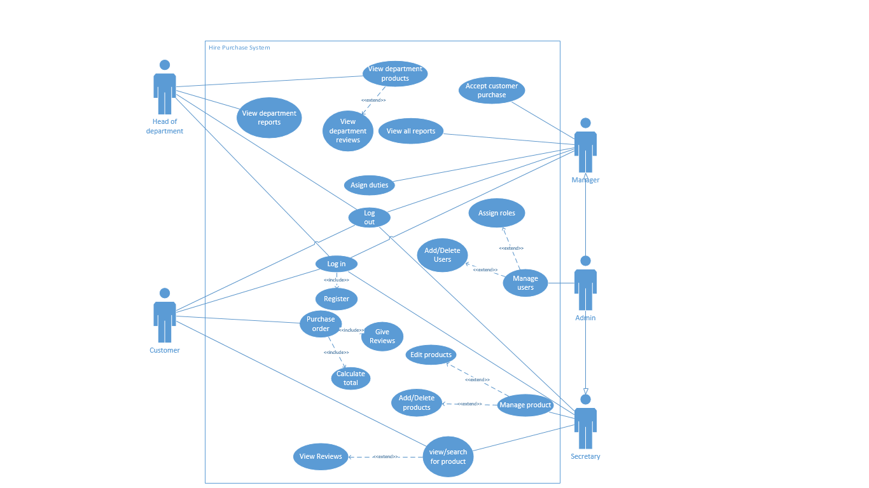

Figure : use case diagram

The use case diagram is used to describe a set of actions that the system can perform. It shows the interaction of various users with different modules of the system.

## 4.3 System Design.

The Kenya Credit Traders Hire purchase system diagrams were designed using Microsoft visio. The diagrams developed are the Sequence diagram, Entity relationship diagram and Class diagram.

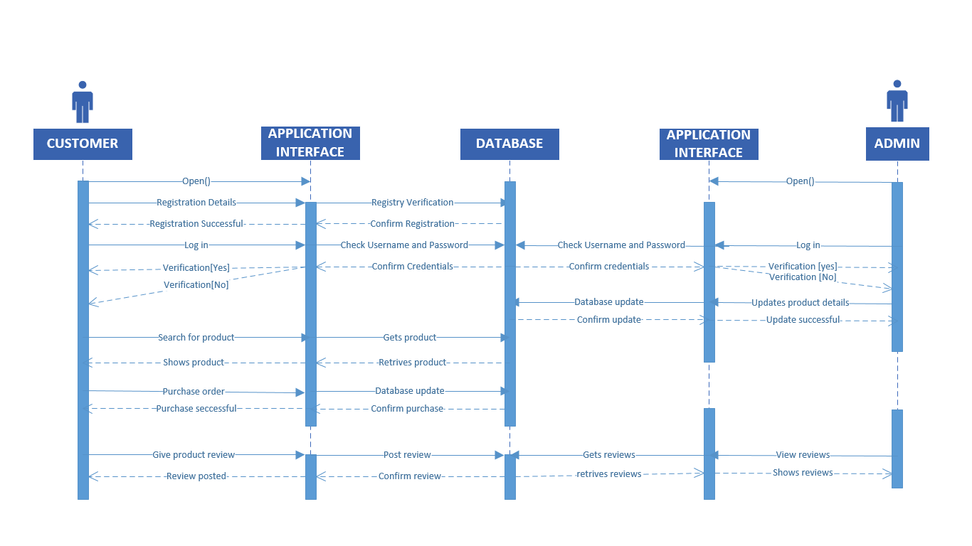

Figure : Sequence diagram

The sequence diagram shows the sequence of events in the system.

The Customer creates a new account by registering where the details are stored in the database after verifications. The customer could then be able to log in the system with the correct password and email. The search function is available for the customer to search for the desired product from the database then retrieves the product. The customer is the able to purchase the product. The database then itself since a customer has made a purchase.

The Administrator will also be able to create a new account by registering where the details a stored in the database. The Administrator is able to edit the database by either adding, deleting or updating product details. The Administrator is also able to see customer reviews after purchases have been made.

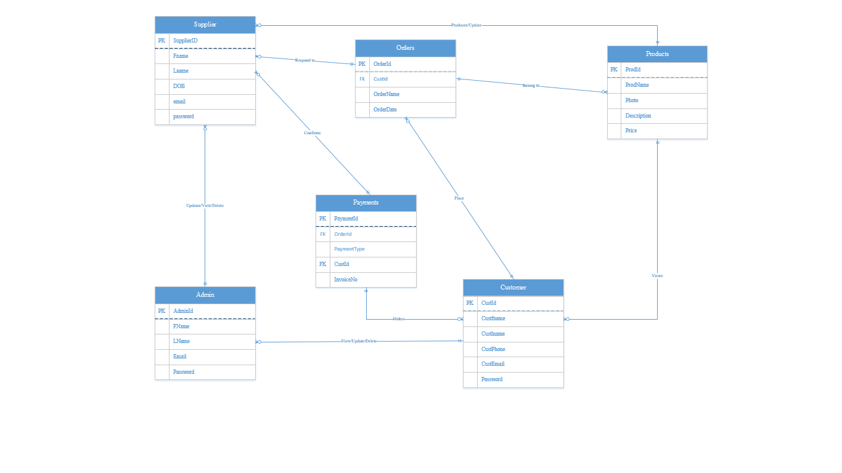

Figure : Entity relationship diagram

Entity relationship diagram.

The system is represented graphically on the Entity relationship diagram. The diagram shows the relationship between the people, various objects and events. The customer purchases a product from the system after making payments, the customer’s address details are used by the deliverer to deliver the product purchased.

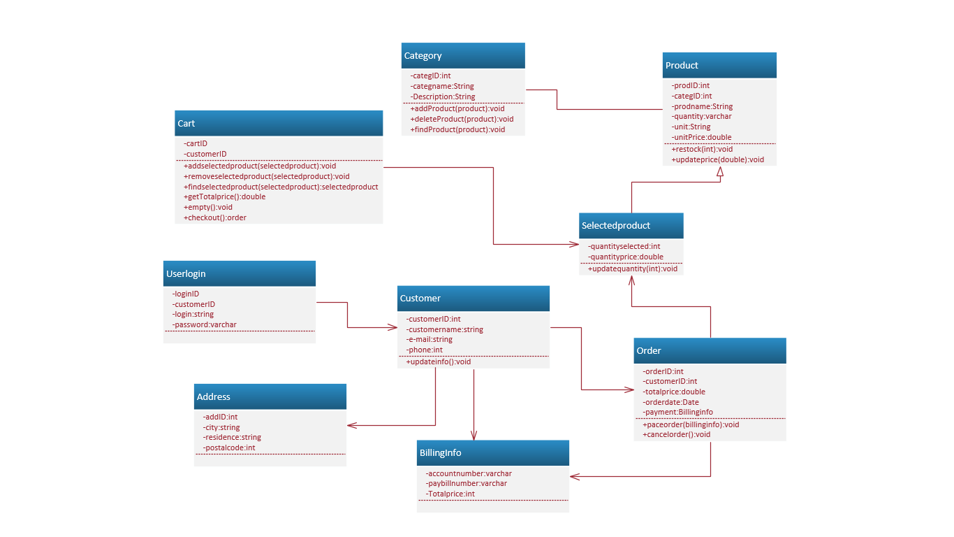

Figure : Class diagram.

Class Diagram provides an overview of the target system by describing the objects and classes inside the system and the relationships between them. The above diagram describes the structure of the hire purchase system by showing the system’s classes, their attributes and the relationships among them

# Chapter 5: System Development and Testing.

## 5.1 Introduction.

The study aimed at developing a hire purchase system for Kenya Credit Traders that will incorporate different functionalities to enable the organization to record transactions, manage its inventory and its staff members.

The system will also enable customers buy products on hire purchase and ensure deliveries are made to the appropriate customer.

Waterfall methodology was used for this system since the system is divided into separate phases and the outcome of one phase acts as the input for the next phase sequentially.

## 5.2 System Development.

Requirements analysis- the various functional requirements were gathered by analyzing customer needs in the Kenya Credit Traders’ organization. The non-functional requirements were added to the system to make it more robust, more secure and since the system developed, is a web-based system it is accessible to majority of the customers.

Design- the system was designed using Microsoft Visio. The Sequence diagram was designed to show the sequence of events in the system. The entity relationship shows the relationship between the people, various objects and events. The Class Diagram provides an overview of the target system by describing the objects and classes inside the system and the relationships between them.

Implementation- the system was implemented using html for creating pages, css for styling the webpages in the system and Php was used to connect the system to the database.

Testing- the system was tested using black box testing whereby various individuals got an opportunity to log in the system to try out the functionalities of the system.

## 5.3: Implementation of the system.

The system was implemented using structured system design approach this is the use of functions to perform various tasks. Various functions were made in the system to make certain activities easier, for example, adding and deleting products in the system than writing and storing documents.

M-pesa payment system was also integrated to the system as the main payment method this would allow customers to be able to purchase products from the system and allow payments and orders to be reflected on the interface page of both administrator and customer.

## 5.4: System Testing.

The system was tested in various ways:

Various individuals got to register in to the system as new customers in order to log in to the system. They were then able to add and remove various products to and from the cart. After adding products into the cart, they were then able to read and understand the billing information which explained the Hire purchase process, the amount of deposit and installments required, required to purchase the required products. The same individuals got to test other various features of the system like editing details and also delete their account.

Some other individuals registered and were able to log in as the administrator and were able to test certain features like adding and deleting various products in the system, view generated reports based on the sales made and also view customer feedback made from their purchases.

Other individuals were able to log in as the manager, secretary and head of department and tested each various feature that they could do.

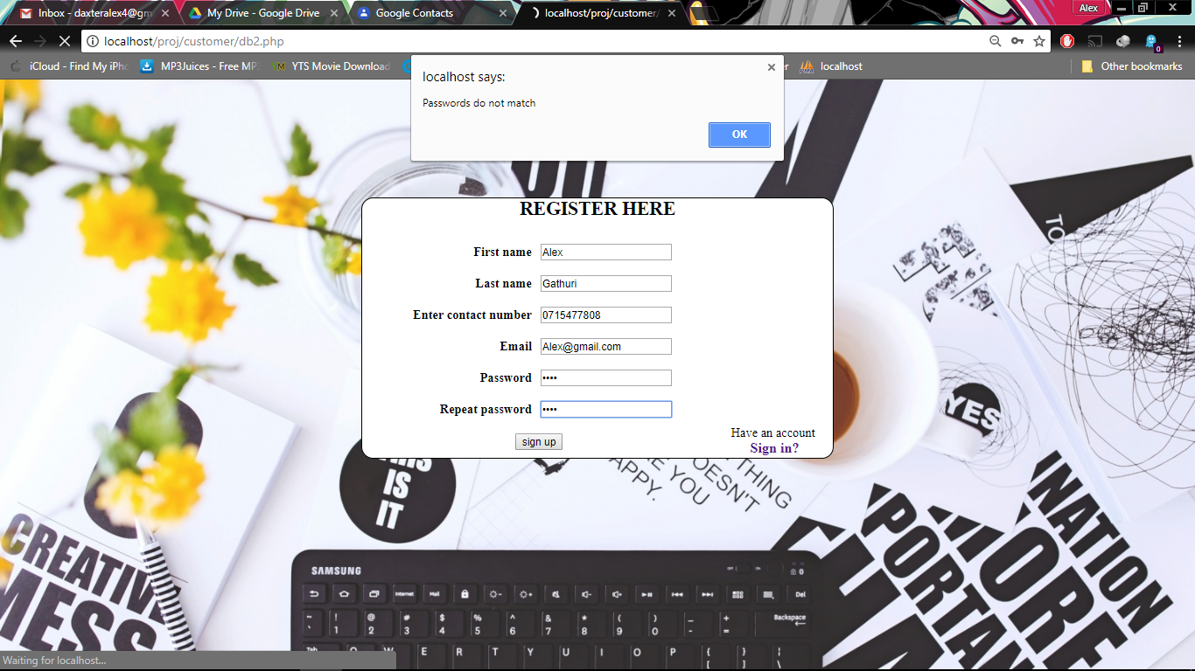

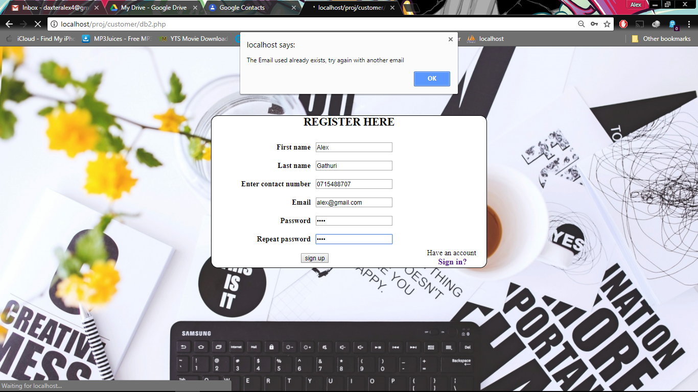

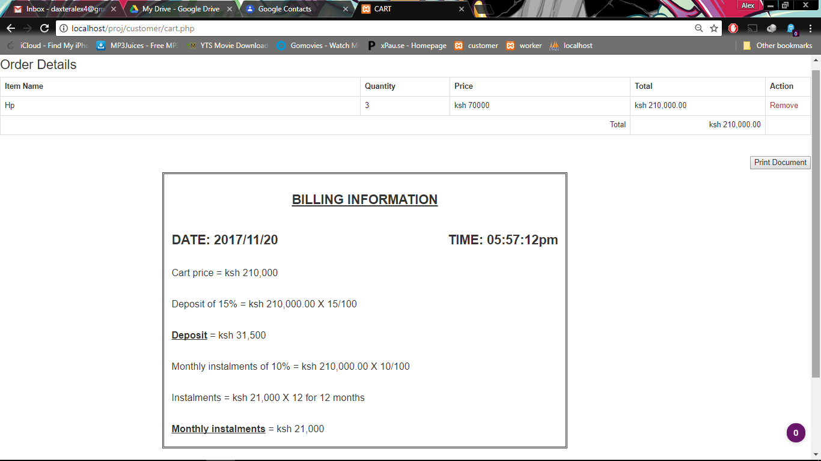

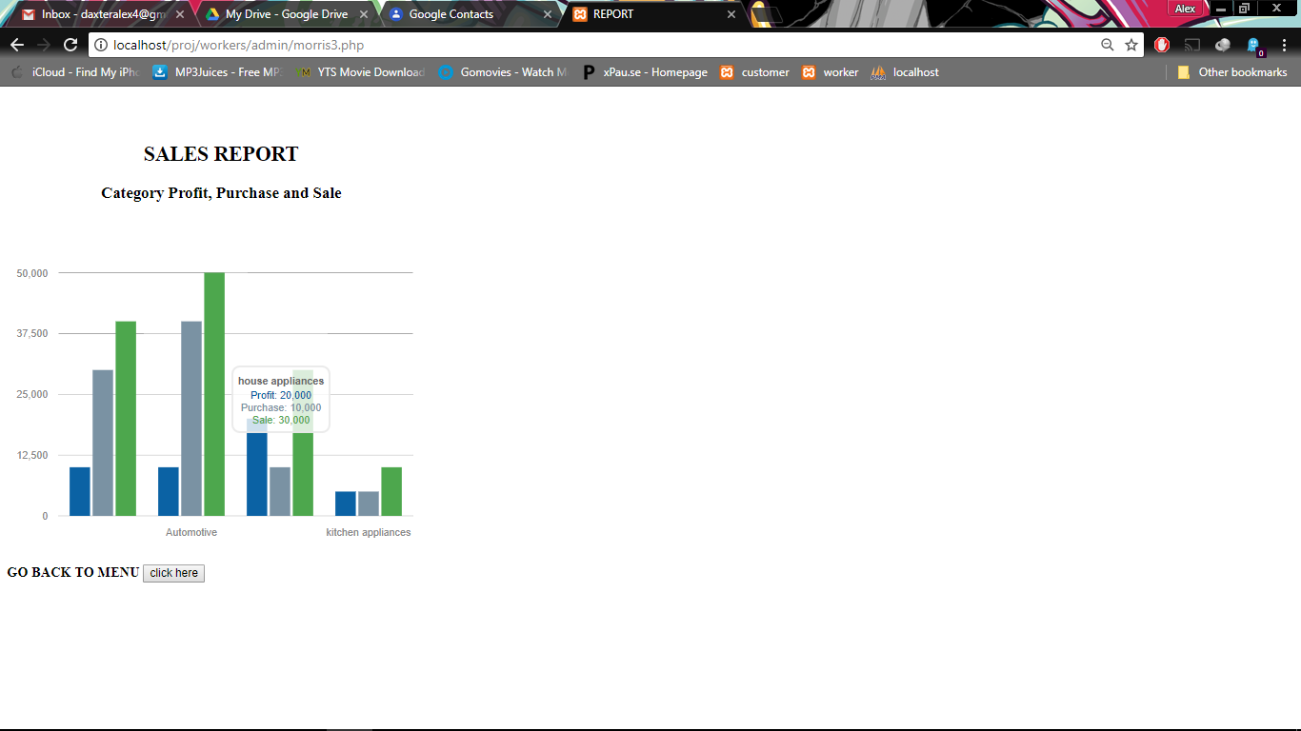

# Chapter 6: Conclusion and Recommendation.

## 6.1 Conclusion.

The Kenya Credit Traders’ hire purchase system was developed successfully with an aim of creating a system that would make it possible for customers to purchase products at a hire purchase for those who are unable to purchase the product all at once. The system made it possible for to view and purchase products without physically going to the Kenya Credit Traders organization themselves. The system also made it possible for workers in the Kenya Credit Traders organization to manage their stock. Workers could be able to know the existing product and their quantity just by logging in instead of counting the products themselves. The system was developed using a couple of programming languages such as PHP, HTML and CSS. The database was made using MySQL. M-pesa was also integrated in the system as the main method of payment. The system design used was structured system analysis design (SSAD). The objectives of the system were all achieved therefore making the development of the system a success.

The developed hire purchase system stores customer information including where they live in order to make deliveries of the products easier.

## 6.2 Recommendations.

The world has become a global village due to the evolution of technology. Majority of the people are therefore able to access the internet which therefore calls for more technological solutions to certain problems in the world. With the development of technology, majority of the people should be able to use certain products like computers and mobile phones.

Program developers can be able to utilize that opportunity to develop certain system that will be able to solve certain problems and be able to create a user friendly interface that will make it easier for people to use.

## 

## 6.3 Future works.

In the near future, Airtel money and other means of payment method will be integrated in the system to facilitate easy payment procedures.

# References

Anderson, T. (n.d.). *Small Business*. Retrieved from Stock system: www.smallbusiness.com

Beck, J. k. (2005).

Beck, J. k. (n.d.). *Business truths*. Retrieved from kenya credit traders coorporation web site: www.kenyacredittraders.com

Crawford, T. (2015, September 17). *Software Development Methodologies*. Retrieved from http://www.itinfo.am: http://www.itinfo.am/eng/software-development-methodologies/

Gary B. Shelly, H. J. (2012). *System Analysis And Design 9th Edition.* Boston: Cengage Learning.

Lockard, R. (2015, September 17). *Inventory System Software Blog*. Retrieved from https://inventorysystemsoftware.wordpress.com:

Crawford, T. (2015, September 17). *Software Development Methodologies*. Retrieved from http://www.itinfo.am: http://www.itinfo.am/eng/software-development-methodologies/

MacEachern, A. (n.d.). Retrieved from investopedia.com: http://www.investopedia.com/ask/answers/forex/best-method-of-forex-analysis.asp

selecting a development approach. (2008, March 27). Retrieved from https://www.cms.gov/research-statistics-data-and-systems/cms-information-technology/xlc/downloads/selectingdevelopmentapproach.pdf

Peter. (2009). *Stock in business*. Retrieved from education truth: http://education.howthemarketworks.com/types-of-investments/stocks

Peter, E. (2009). Stock in business. *Business truths*, 5.

*Stock in system*. (2010). Retrieved from business truths: http://www.businesstruths.com/your-most-important-resource-is-your-time

# Appendix A: Gantt chart

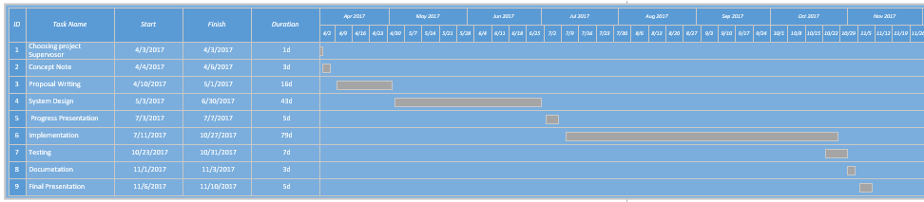

Figure 6: Gantt Chart.

# Appendix A: User Manual

Step 1: Download WAMP or XAMP software from the internet and install it into your computer. Ensure the software is working properly.

Step 2: Import the database from the file and into MYSQL database in your browser from local host

Step 3: From the CD, extract the compressed file and copy it into local disk c:/Xammp/htdocs

Step 4: On your browser open the link http://localhost proj/customer/login.php

Step 1:

Step 1: