Odd Space

GUI Design Document

Chaotic Evil

Òscar Canales, Raul Cano, Denis Deconinck, Carles Garriga, Alex Gesti, Pol Pallarés

**Índex**

**Introduction** **3**

**User Interface** **4**

Main Menu Screen 4

Settings Screen 5

Credits Screen 5

Battle Screen 6

Pause Screen 6

Win/Lose Screen 7

Narrative Screen 8

**References** **9**

# Introduction

In this page you will find any information needed for all the UI elements in our game, ambientation-wise we liked the space/pirates theme as explained in the GDD Narrative Structure and the pixel art style.

We thought of keeping the UI elements as clear as possible so that any player could find it easy to navigate between menus and options. Every element in any UI screen is as self explanatory as it could be so that the players don't have to think and the transitions are as fluid as possible and everything is connected.

# User Interface

## Main Menu Screen

This is the main menu of our game; from here you can:

* Start a new game
* Continue from last save file
* Open the options menu
* Show the credits screen
* Exit the game

The menu also shows an animation of your current ship if the options screen is disabled and you are in the game's title screen.

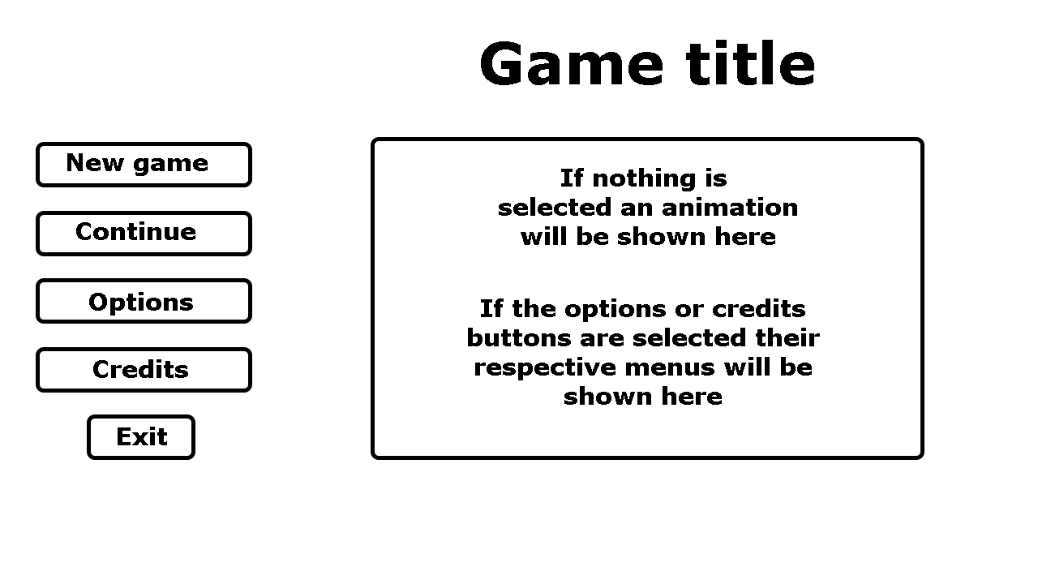

## 

## Settings Screen

From the options menu you can:

* Adjust the volume of the music
* Adjust the volume of the sound effects in the game
* Enable fullscreen mode
* Enable the Vsync feature
* Enable the gamepad configuration

As well as showing the controls for both gamepad and keyboard configurations.

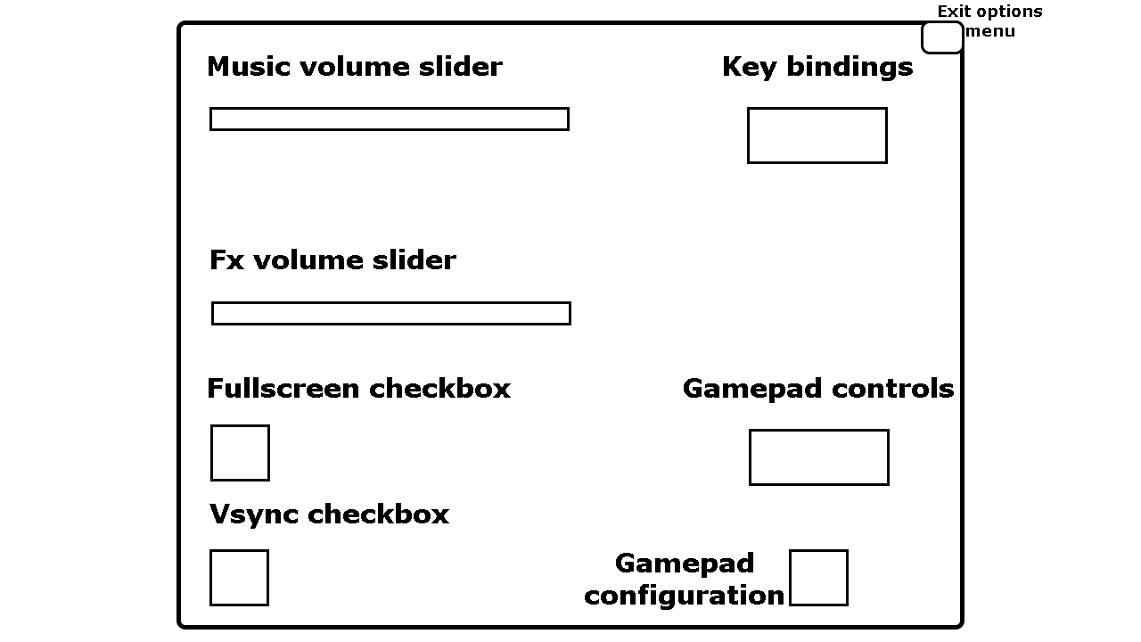

## Credits Screen

The credits screen shows the team members, their roles and a personal quote from each of them.

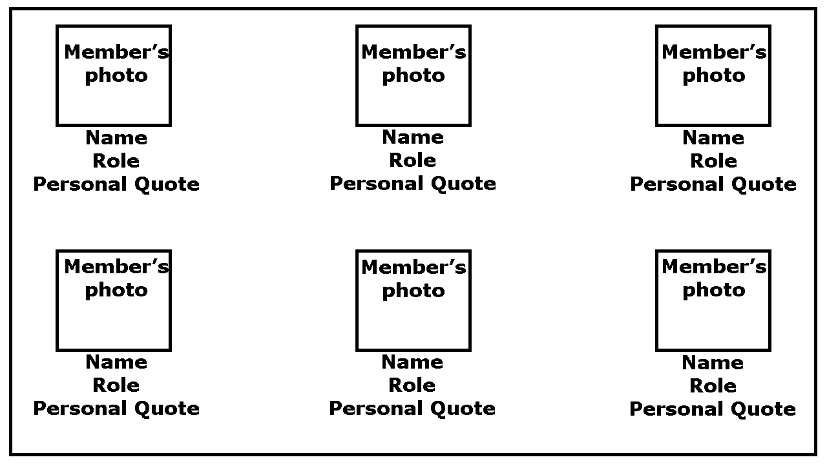

## Battle Screen

In the battle screen you can:

* See your character's possible actions for this turn in the upper left.
* In the upper right section you can access all the special skills the character has learned.
* In the bottom of the screen you can see the team's Health Points and Special Points.

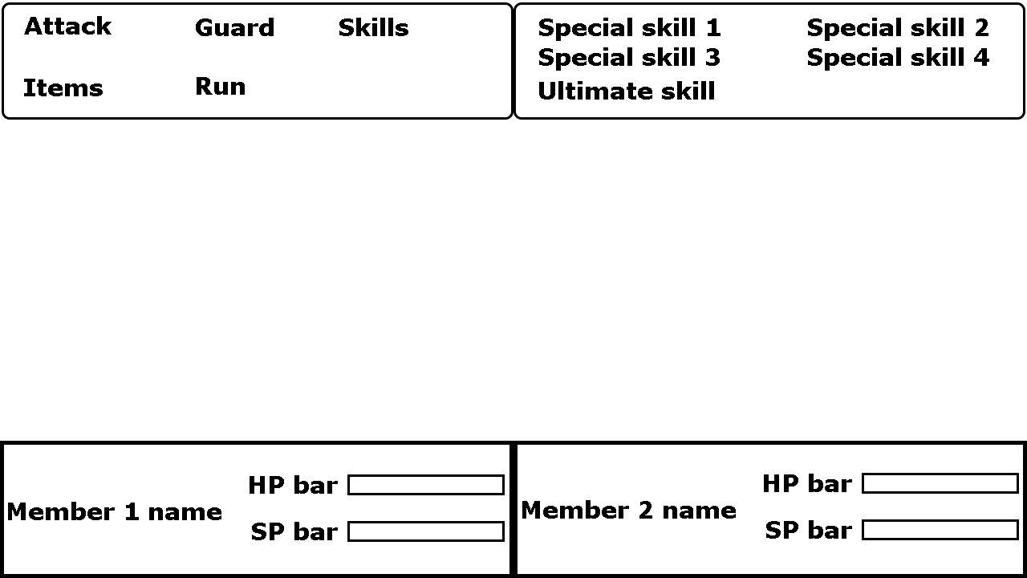

## Pause Screen

From the pause screen you can:

* Resume your game
* Load from the last save file
* Enter the settings menu
* Go back to the game's main title screen

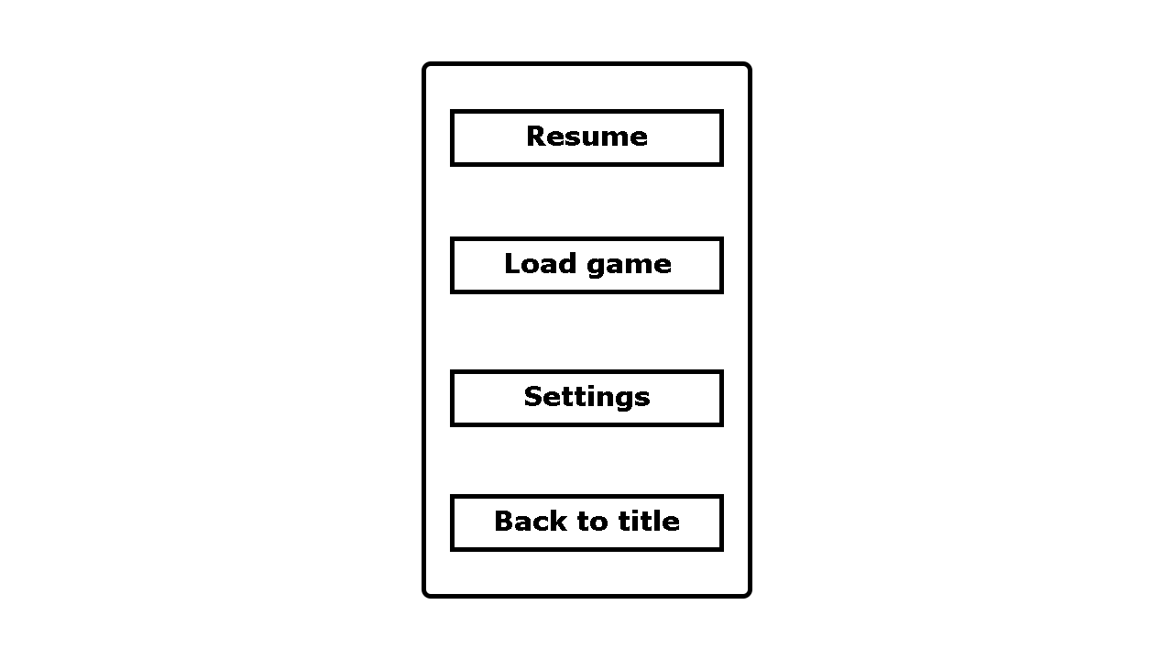

## Win/Lose Screen

The win screen appears at the end of your adventure. It lets you decide if you want to start the game, keeping your level and items previously acquired or exit to the main title.

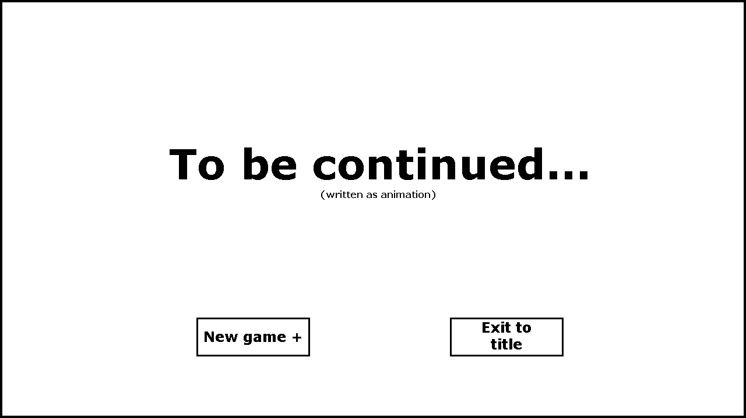

The game over screen triggers upon the team's defeat, it lets you retry from the last saved file or leave to the main menu.

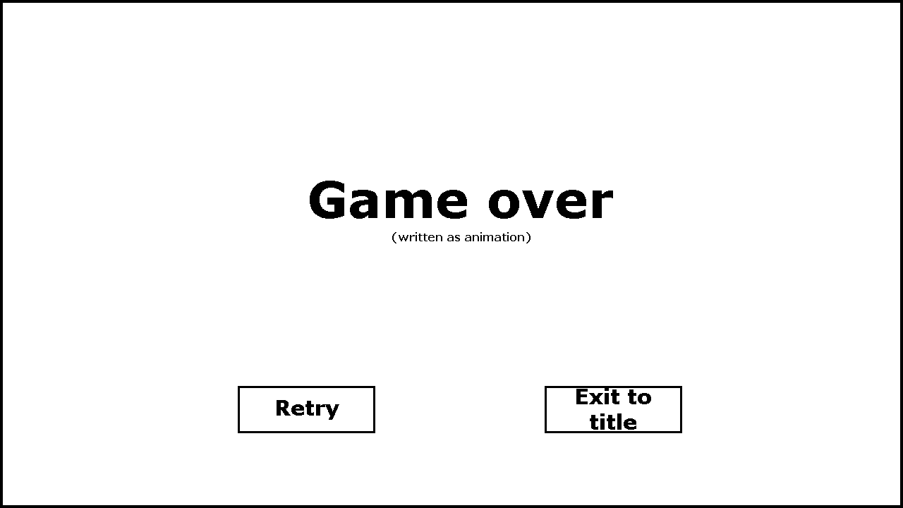

## 

## Narrative Screen

This screen shows up during the cutscenes and any written dialog will be shown below.

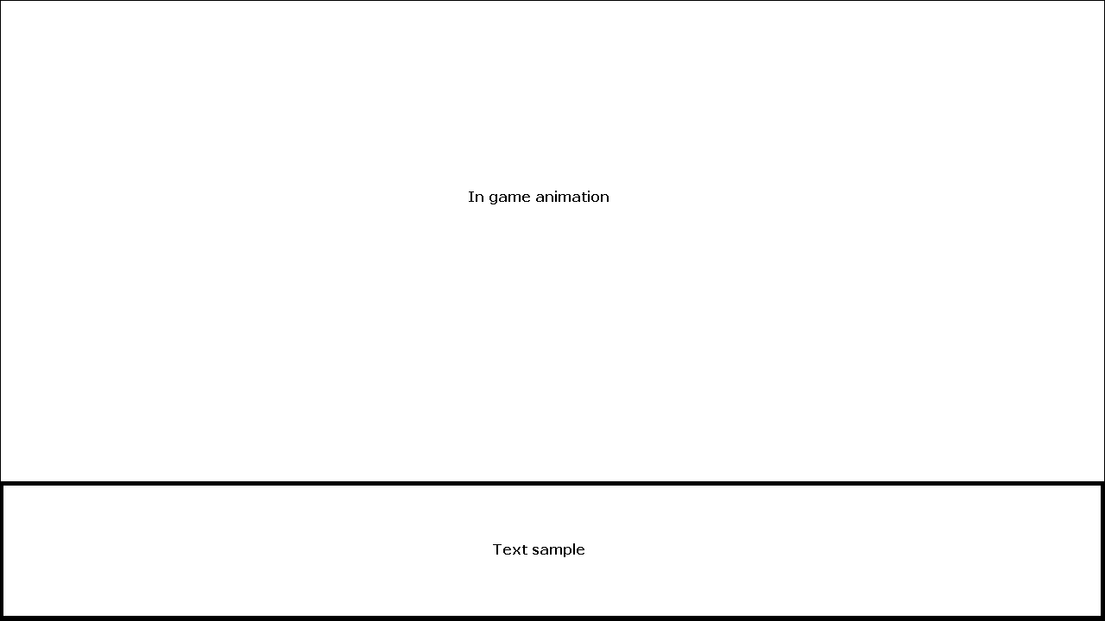

# References

As for the references, we based our UIs on some classic RPG games such as Final Fantasy VII, Mother and Dragon quest.

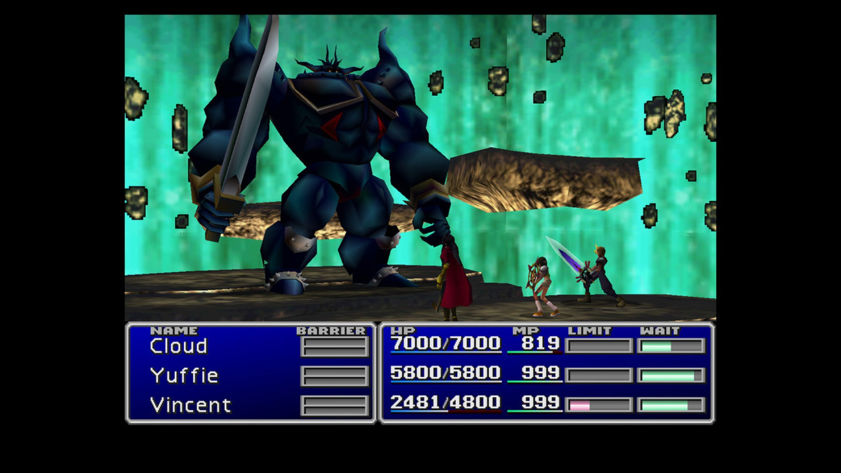

*Final Fantasy VII combat UI*

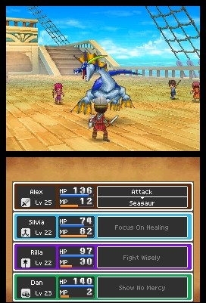

*Dragon Quest combat UI*

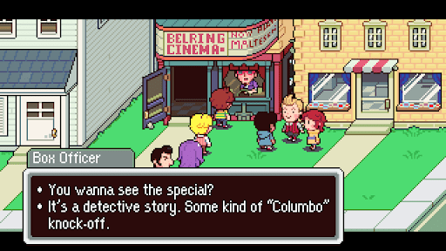

*Mother narrative UI*