Odd Space

QA Workflow

Chaotic Evil

Òscar Canales, Raul Cano, Denis Deconinck, Carles Garriga, Alex Gesti, Pol Pallarés

**Índex**

**Workflow** **3**

Sprint workflow 3

QA Session 4

**Software** **5**

Code Editor 5

Repository Platform 5

Map Editor 5

Sprite Editor 5

Audio Editor 6

Organization 6

**Milestone delivery protocol** **7**

Internal milestone 7

External milestone 7

Vertical slice 7

Alpha 7

Gold 8

**Bug properties** **9**

Properties 9

Issue template 9

**Quality Testing process** **11**

Internal Quality process 11

External Quality Assurance 11

# Workflow

There are 2 different workflows that we will use during production of the game in pre-production, alpha and beta stages.

## Sprint workflow

1. Presentation of what has been done that week by each team member.
2. Compare that to what was planned to do during that week.
3. Analize problems that have appeared and how those have affected the completion of tasks.
4. Propose solutions for said problems and tag them on a high priority rank for the following week.
5. Mark important bugs on github issues with as much information as possible.
6. Advices on how to correct the bugs.
7. Define work and individual tasks for the following week.
8. Record everything on the [Record of the meetings](https://github.com/alexgesti/PROYECTO-2/wiki/Production-Plan#record-of-the-meetings).

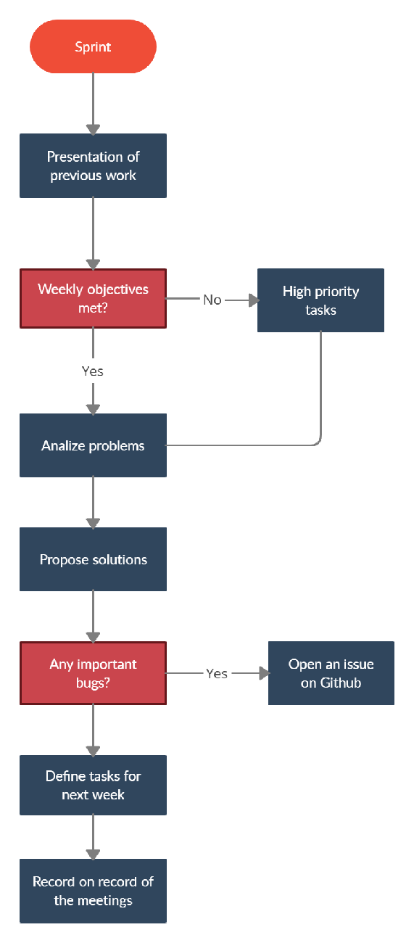

## QA Session

Dates of these sessions are specified in the [General calendar of work](https://github.com/alexgesti/PROYECTO-2/wiki/Production-Plan#general-calendar-of-work)

1. Create a playtesting document.
2. Brief explanation of the game so far.
3. Previous questionnaire to see the type of player
4. Play the game, analyzing every step the tester makes.
5. Complete the playtesting document.
6. Share the results with the team.
7. Talk about them in the next sprint.

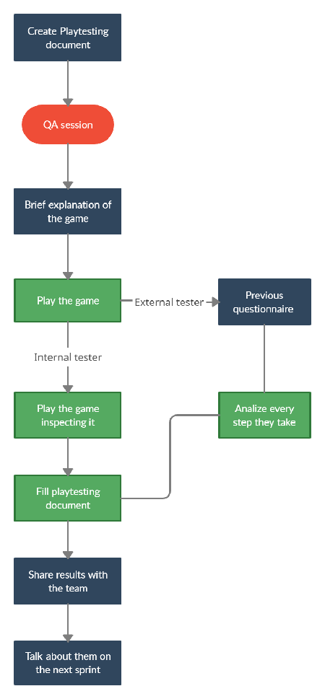

# Software

## Code Editor

* [Microsoft Visual Studio 2019](https://visualstudio.microsoft.com/es/)
  + Owner: Microsoft
  + Explanation of use: coding and creation of the project.
  + File type: .sln, .dll, .lib, .c, .cpp, .h, .exe, …
* [Beyond Compare](https://www.scootersoftware.com/)
  + Owner: Scooter Software
  + Explanation of use: compare various folders or code files.
  + File type: NONE

## Repository Platform

* [GitHub](https://github.com/)
  + Owner: Microsoft
  + Explanation of use: project organization, working platform and repository management, bug report using issues.
  + File type: NONE

## Map Editor

* [Tiled](https://www.mapeditor.org/)
  + Owner: Thorbjørn Lindeije
  + Explanation of use: map creation and edition.
  + File type: .tmx, .xml

## Sprite Editor

* [Aseprite](https://www.aseprite.org/)
  + Owner: David Capello
  + Explanation of use: creation, edition and animation of sprites
  + File type: .png

## Audio Editor

* [rFXGen](https://raylibtech.itch.io/rfxgen)
  + Owner: Raylib Technologies
  + Explanation of use: creation of randomly generated fx.
  + File type: .wav
* [Adobe Audition CC 2019](https://www.adobe.com/es/products/audition.html)
  + Owner: Adobe Creative Cloud
  + Explanation of use: creation and modification of audio files.
  + File type: .ogg, .wav

## Organization

* [HacknPlan](https://hacknplan.com/)
  + Owner: Christian Estévez López
  + Explanation of use: organize tasks individually with full detailed information.
  + File type: NONE

# Milestone delivery protocol

In order to organize the development of the project, our team has two different types of milestones: internal and external ones.

Internal milestones refers to weekly objectives that we try to achieve in order to create the game at the correct pace so we have to crunch as little as possible.

External ones are those set by the university calendar. There are 4: concept discovery, vertical slice, alpha and gold, but we are centering the delivery protocol only for the last 3.

## Internal milestone

Each week, on Saturdays, the team gets reunited to do a sprint meeting. In these, each member will expose the work they have done during the week, and that information will be processed to check if the weekly objectives have been fulfilled.

After that, new objectives for the following week will be set.

You can see the sprint process in more detail in the [sprint workflow](https://github.com/alexgesti/PROYECTO-2/wiki/QA-Workflow/#sprint-workflow).

## External milestone

For the external milestones, our team will conduct 2 QA sessions (friday and saturday) the week before the due date and, after the second one, there will be a sprint meeting to talk about the results of these sessions.

The following week, the one with the milestone deadline, will be dedicated to solve the various issues found in the QA sessions and on saturday, a sprint meeting will be done to check if everything is fixed.

The external milestones that are established as of 14/03/2021 are:

### Vertical slice

* Due date: 18/04/2021
* Content:
  + Basic screens (Logo, Title, Gameplay and Battle)
  + Player movement
  + Combat system

### Alpha

* Due date: 16/05/2021
* Content:
  + Game configuration on Options screen
  + Puzzles and dungeons
  + Stats menu

### Gold

* Due date: 02/06/2021
* Content:
  + Webpage and trailer
  + Game installer
  + Responsive menus

# Bug properties

If a bug appears while coding or testing the game and can't be solved quickly, an issue will be opened on github offering a guide of the bug with plenty of detail. Same will happen if a bug is found in a QA session.

Once the issue is opened, the team will organize how it will be solved, assigning one or more members to that task.

## Properties

A bug, frequently has the following properties:

* Type: defines a category for the bug. It could be a UI bug, a memory leak or a mechanic related one to name a few.
* Frequency: how often the bug happens.
* Step by step of how to reproduce it: is very important to explain this property in detail as it can be key in solving the problem.
* State: what's the bug current state. Is it fixed? been worked on? solved?

## Issue template

As said before, we are using github issues to report bugs. The following is a template showing how we are going to manage these:

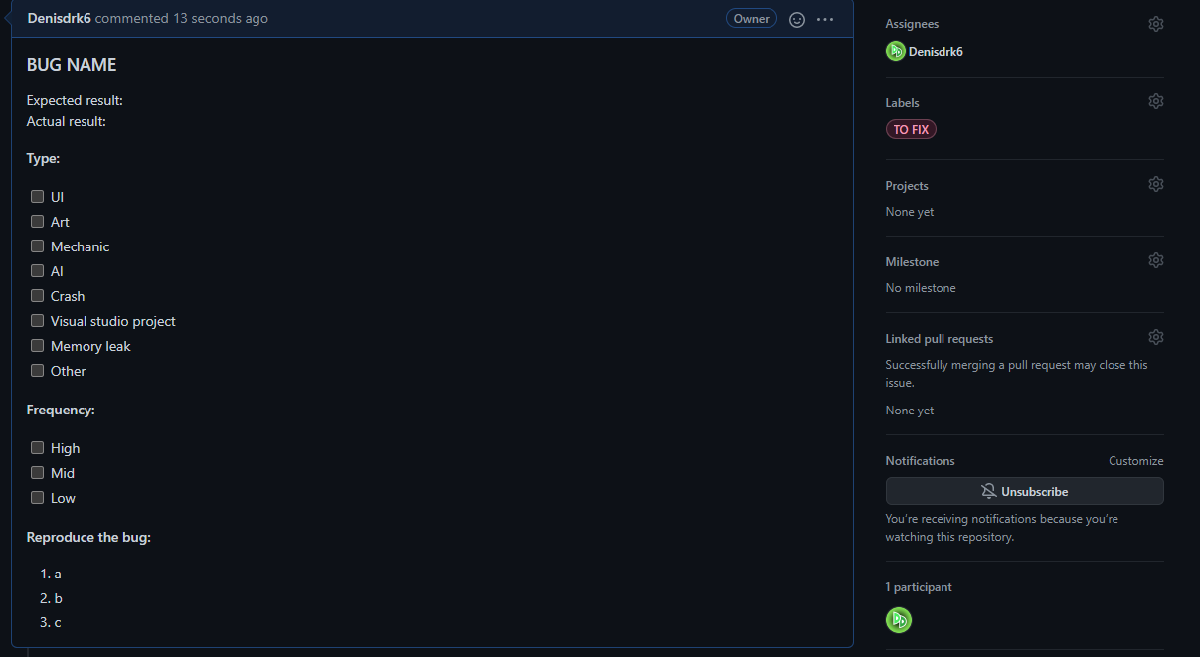

* Bug name: a short name for the bug that makes it easy to understand what it is about.
* Expected result: how it should behave
* Actual result: how it's actually behaving
* Type: category of the bug. What aspect of the game does it affect?
* Frequency: how much does it happen?
* Reproduce the bug: a step by step guide on how to make the bug appear.
* Assignees: the people assigned to solve it.
* Labels: define the state of the bug. There are 3 states:

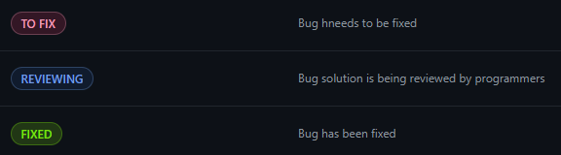

# Quality Testing process

## Internal Quality process

As told above, a week before the delivery of the final product, we will make a testing build to begin on the QA sessions.

Finishing the last sprint meet on Saturday, the team will create a build for Internal QA session on Friday and Saturday.

That build will have the current part of the game working, in case it doesn't work, the lead along with the teammates will erase that part of the code doing the bug or crash and then release a build. Later the lead will upload an issue with the problem and specification on how to repair that bug.

On Friday, 3 teammates, usually 1 coding, 1 designer and lead, will be performing Internal QA sessions 3 times during the day with 3 hours of playtesting. If the lead sees that there is a major bug, the whole team will come to test the game and report the issue, but for minor bugs, they will be reported for later and then, talk with the teammates about that.

The objective of these sessions is to check if the features implemented work as expected and then try to find as many bugs as possible. When the session is finished, the lead will be checking the issues reported and begin to analyze them and communicate to the teammates.

## External Quality Assurance

Finishing the last Internal QA session on Friday, the team will prepare some questions for the externals testers.

On Saturday, 2 teammates, usually 1 designer and the lead, will be performing External QA sessions with 3 different testers during a period of 2-3 hours. If the testers see that there is a major bug, the lead will be communicated immediately and then the whole team will be informed about the issue, but for minor bugs, they will be reported for later and then, talk with the teammates about that.

The objective of these sessions is to check if the features implemented work as expected and then try to find as many bugs as possible. When the session is finished, the lead will be checking the issues reported and begin to analyze them and communicate to the teammates.