Odd Space

Technical Design Document

Chaotic Evil

Òscar Canales, Raul Cano, Denis Deconinck, Carles Garriga, Alex Gesti, Pol Pallarés

**Índex**

**Introduction** **3**

Game Concept 3

Development Team 3

**Technical Goals** **4**

**Code Style** **6**

Naming conventions 6

Define 6

Variables 6

Functions 6

Struct 6

Curly brackets 6

Folder management 7

Project folder 7

**Third Party Tools** **8**

Code Editor 8

Repository Platform 8

Map Editor 8

Sprite Editor 8

Audio editor 9

Organization 9

**External Libraries** **10**

**Performance Budget** **11**

Hardware Baseline 11

**Build Delivery Method** **12**

**Version List** **13**

0.5 Vertical Slice 13

0.8 Alpha 13

1.0 Gold 13

# Introduction

The technical design document will specify the technical guidelines and procedures of our project.

* Code Editor: Visual Studio 2019
* Programming Language: C, C++, XML
* Target Platform: PC
* Management Platform: HacknPlan
* Repository Platform: GitHub
* Project Repository

## Game Concept

“Odd Space” is an RPG with a top down view, where our protagonist has to go through some adventures in which he will face off some enemies in turn based combat, and make friends through them.

## Development Team

* **Leader:** Alex Gesti
* **Manager:** Denis Deconinck
* **Designer:** Pol Pallarés
* **Artists:** Carles Garriga, Alex Gesti
* **Programmers:** Òscar Canales, Raul Cano, Carles Garriga, Pol Pallarés

# Technical Goals

* **Top-Down Tile maps**
* **Turn based combat**
* **Friendly UI**
* **Basic AI**
* **Different worlds to explore**
* **Animated Cutscenes**
* **Dungeons with mini challenges**
* **Particle System**
* **Scripted Dialogs**
* **Inventory System**
* **Scripted Battles**
* **Random Encounters**

To ensure that anyone can enjoy Odd Space, without it being too difficult, we had the idea of having random encounters in specific locations so that the player can grind levels if they can not progress through the game properly. It also solves the problem of players going straight forward to finish the game, creating an artificial obstacle in the path. This is the logic behind the loop of this type of combats:

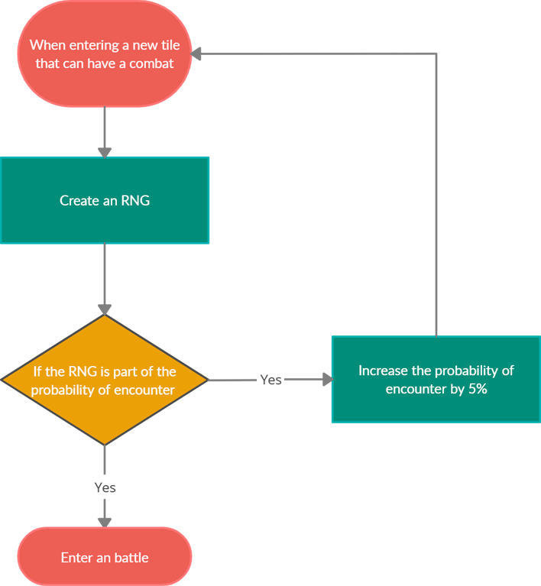

* **Artificial Intelligence**

For the enemies we developed a basic AI loop depending on their health:

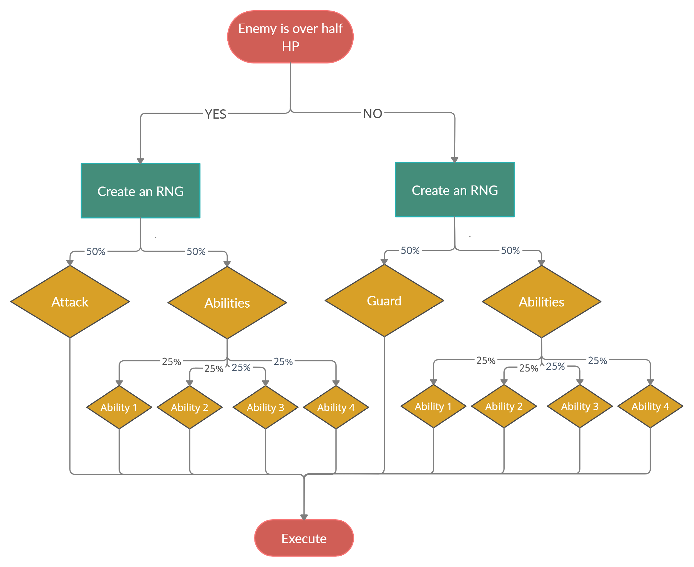

# Code Style

The programming languages used are C, C++ and XML.

## Naming conventions

The names used expresses their purpose.

Ex:

int enemyHp -> expresses the health of an enemy

### Define

The Screaming Snake case used for the defines is a variant of the Snake case where all letters are capital letters.

Ex:

#define WINDOW_H

### Variables

We used the Camel case, the most common style.

Ex:

int enemyHp

### Functions

The style used in the functions is the Pascal case, a cleaner variant of the Camel case.

In this style, the first letter of the name is a capital letter.

Ex:

void Draw();

### Struct

We used the Snake case: the words are separated by “_”.

Ex:

struct pirate_enemy

{

}

### Curly brackets

The brackets should be under its respective part of the code.

Ex:

if (a < b)

{

something;

}

## Folder management

Files are organized in folders according to its function. Files and folders names express their purpose.

### Project folder

Folders use Camel case and files use Snake case.

Ex:

-> characters

-> mainCharacter

-> spritesheet_main_character.png

-> oldMan

-> spritesheet_old_man.png

# Third Party Tools

## Code Editor

* Microsoft Visual Studio 2019
  + Owner: Microsoft
  + Explanation of use: coding and creation of the project.
  + File type: .sln, .dll, .lib, .c, .cpp, .h, .exe, ...
* Beyond Compare
  + Owner: Scooter Software
  + Explanation of use: compare various folders or code files.
  + File type: NONE

## Repository Platform

* Github
  + Owner: Microsoft
  + Explanation of use: project organization, working platform and repository management.
  + File type: NONE

## Map Editor

* Tiled
  + Owner: Thorbjørn Lindeije
  + Explanation of use: map creation and edition
  + File type: .tmx, .tml

## Sprite Editor

* Aseprite
  + Owner: David Capello
  + Explanation of use: creation, edition and animation of sprites
  + File type: .png

## Audio editor

* rFXGen
  + Owner: Raylib Technologies
  + Explanation of use: creation of randomly generated FX
  + File type: .wav
* Adobe Audition CC 2019
  + Owner: Adobe Creative Cloud
  + Explanation of use: creation and modification of audio files
  + File type: .ogg, .wav

## Organization

* HacknPlan
  + Owner: Christian Estévez López
  + Explanation of use: organize tasks individually with fully detailed information
  + File type: NONE

# External Libraries

* Simple DirectMedia Layer
* Electronic Arts Standard Template Library
* pugixml

# Performance Budget

The game must not use more than 256 MB of RAM and run at constant 60fps at a resolution of 1280x720px. This performance should be achieved by the Hardware Baseline.

## Hardware Baseline

|  |  |
| --- | --- |
| **Hardware** | **Requirements** |
| Operating System | Windows 10 64-bit |
| Processor | Intel Pentium N2830 / AMD A6-7000 |
| Memory | 256 MB |
| Graphics | Intel HD Graphics / Radeon R4 series |
| Storage | 1GB |

# Build Delivery Method

Builds will be available in our GitHub Releases page: <https://github.com/alexgesti/PROYECTO-2/releases>

They will be ready some days before the official delivery so we can do some QA on the game.

The game will be updated as the team progressively improves it.

# Version List

In this section all the updates we are doing to the game will be documented here, including all the new and updated features of the game. The game versions between deliveries will be numbered with a number between the corresponding version's number.

## 0.5 Vertical Slice

* God mode
* Battle system
* Logo and title screen
* Save/Load states
* Main game menu
* Canteen screen

## 0.8 Alpha

* Screens transitions
* The states of all controls
* Options screen
* Dungeon screen
* Information menu
* Victory/Lose screens

## 1.0 Gold

* Game installer
* Gamepad configuration
* Pause menu
* The information menu is interactive
* Lose menu