Technical design

1. Project goals

- The system models the operations of a transport company
- Create cohesive and stable data model
- Update and insert data via web interface
- Select and manipulate web content
- Prevent users from accessing content that they’re not authorized to access

2. System architecture/infrastructure

Front-end (in the browser of the user):
1) HTML for the structure of the web page
2) CSS for the design of elements of the web page
3) Native JavaScript and libraries like jQuery
Back-end (on the server of the host of the web page):
1) Back-end logic (Spring Framework)
2) Web application Server (WildFly)
3) ORM (Hibernate)
4) Database (MySql)

Application has client – server architecture and build with Spring MVC technology.

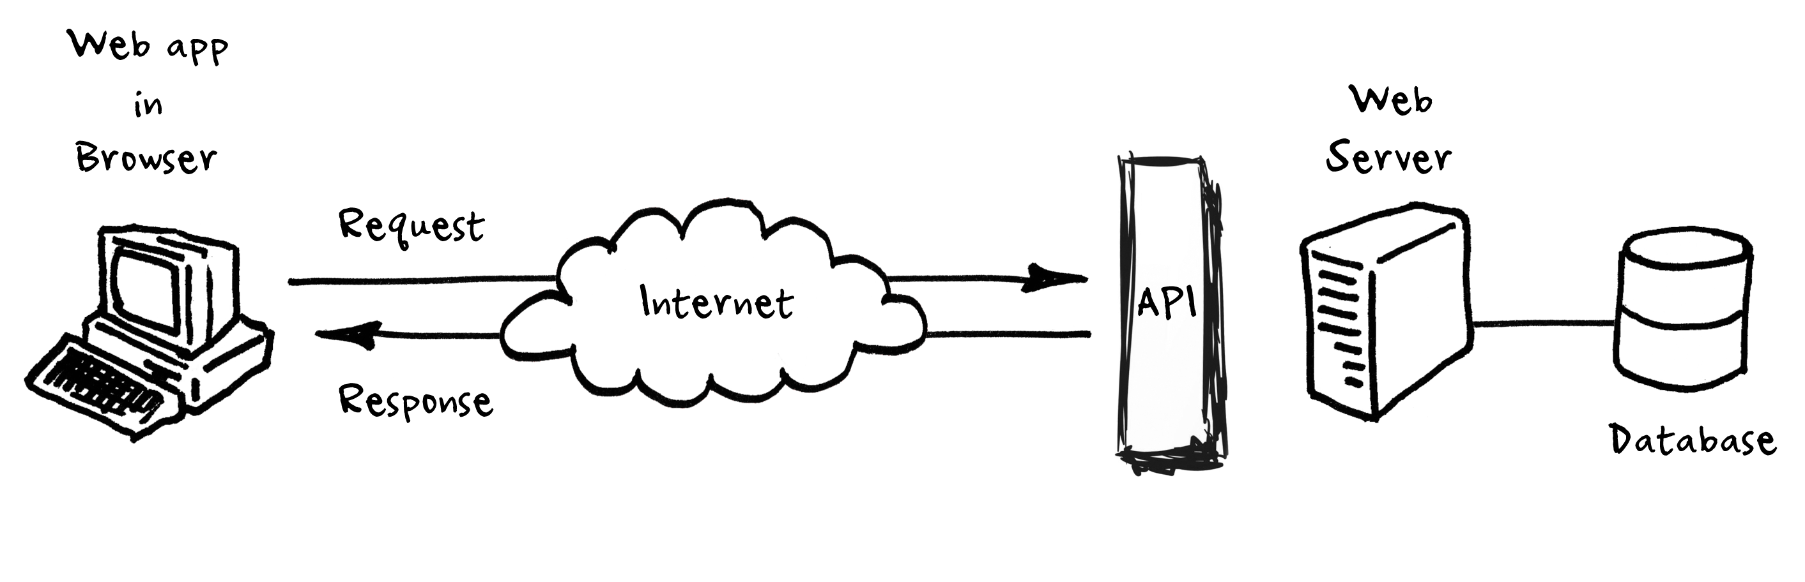

3. UML models

System consist of 5 layers. These layers are Presentation, Application (Controller), Service, Domain and Data Access layers.

I wrote the data access classes for each of the domain classes.
In application I used Java Persistence API (JPA) as the persistence model for object-relational mapping (ORM) with Hibernate as Persistence Provider. I used the EntityManager option (instead of JPA Template) for the persistence concern. This approach has no dependency on Spring and still can be managed using Spring application context. We can also take advantage of Annotations to inject EntityManager using @PersistenceContext and @PersistenceUnit tags. Classes of this layer are tagged with @Repository annotation.

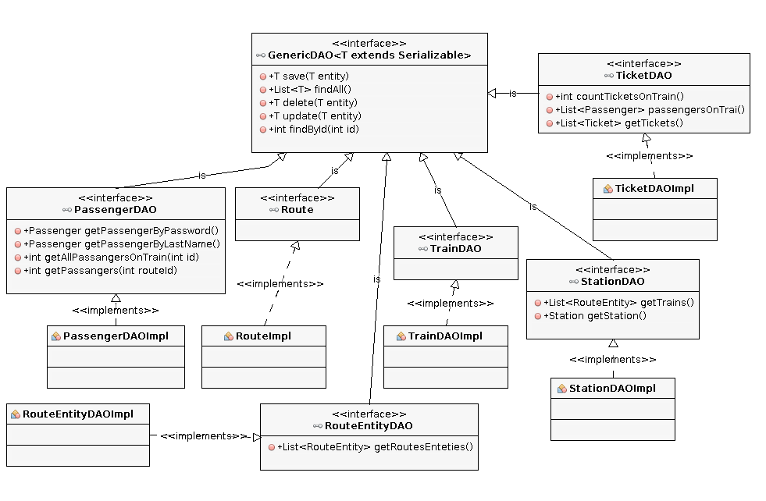

Services is another layer in my application. It is used to provide utility functions in my application as well as providing access to DAO layer.
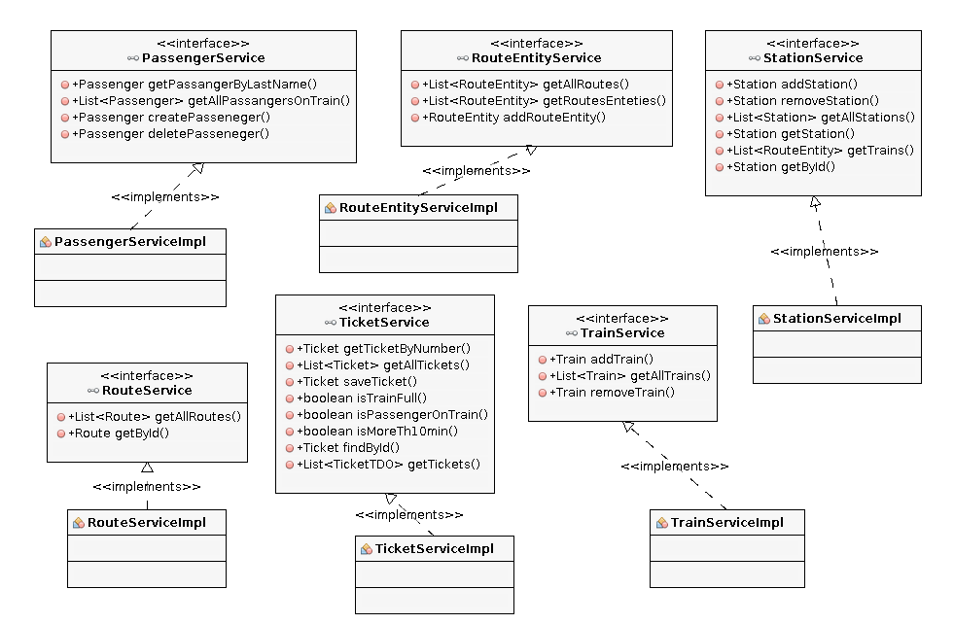

Presentation layer.
Main goal of this is to use HTML to create presentation to the software, via web interface and web components allowing interact with server logic. Two key technologies that the J2EE platform uses are Java servlets and Java Server
Pages (JSP). The model presented in this layer is based largely on the Apache Tiles. Its is a free open-sourced templating framework.
Spring MVC has architecture presented on next slide.

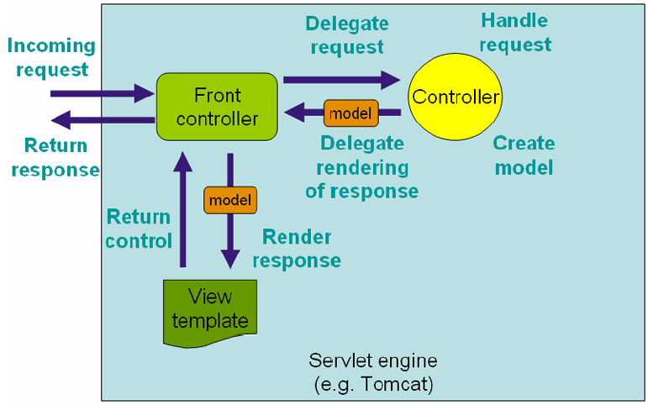

Application security
Provided by Spring Security. It is a Java / Java EE framework, that provides a mechanisms for building systems for authentication and authorization, as well as other security features for enterprise applications that were built using the Spring Framework. The file with the configuration is called security.xml and it is placed in scr/main/recourses directory

Another feature of my application is REST web service.
Representational State Transfer (REST) is a software architecture style consisting of guidelines and best practices for creating scalable web services.
It is accessible on “webService/{dateFrom}/{dateTo}” URL via HTTP protocol.
Here is to variables dateFrom and dateTo which are used for retrieving data from server.

DateFrom – departure date beginning with

DateFrom – departure date finalize to

Providing this two data's in URL we can determine portion of tickets we are interested in.

