Nsight step by step guide example with our function and MATLAB.

Perquisites:

* Install Visual studio BEFORE CUDA toolkit
* Install CUDA toolkit including Nsight

Step 1: open Nsight in visual studio

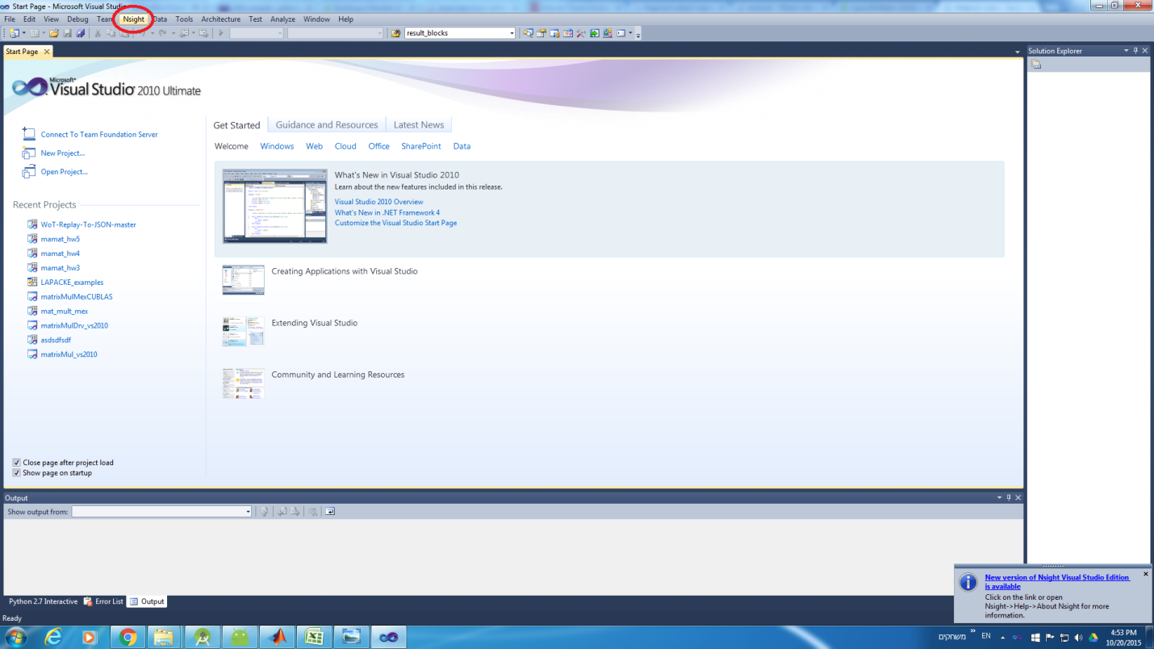

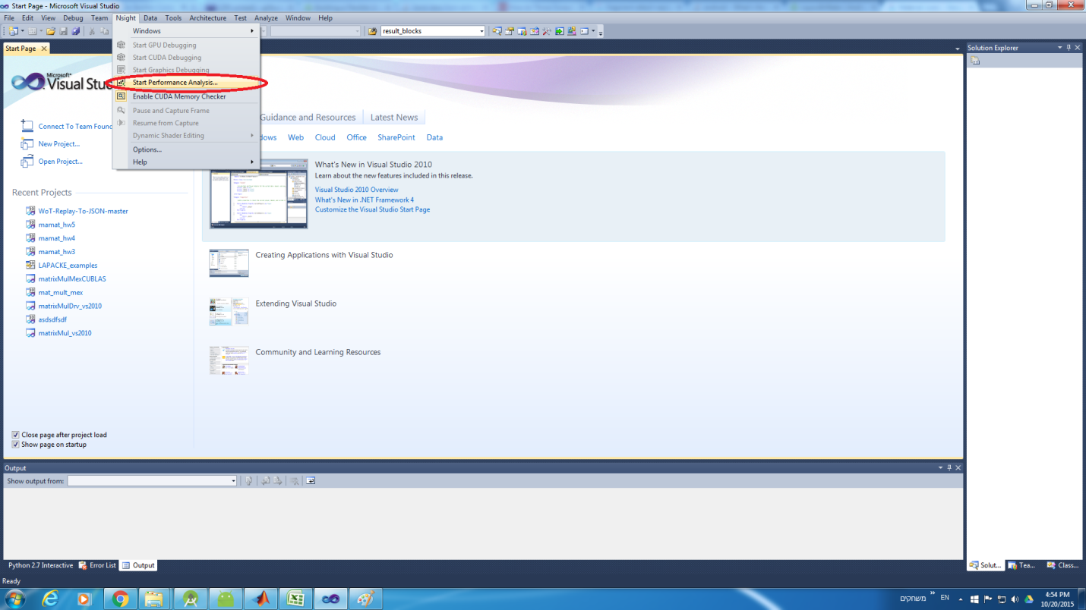

step 2: set up the performance analyzers with MATLAB

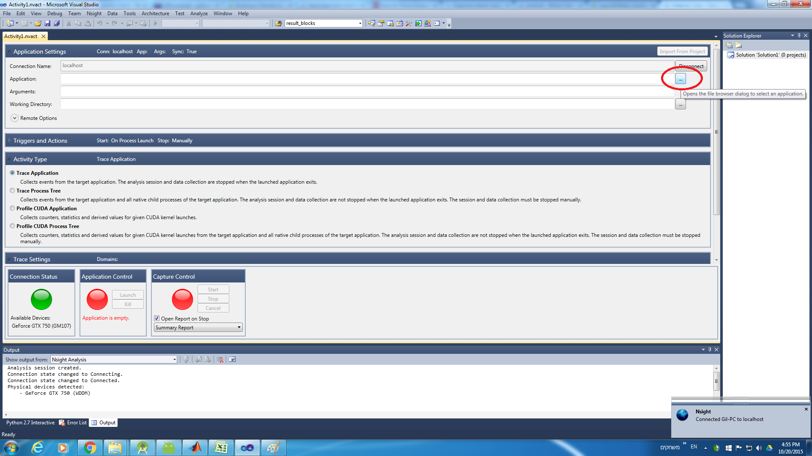

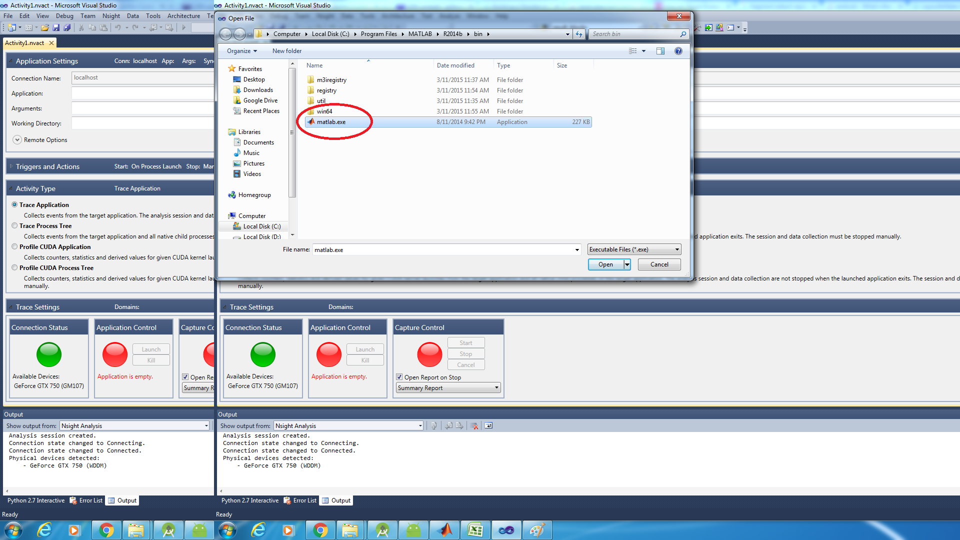

step3: set up Nsight to process the exe child processes so that any CUDArelated libraries will be documented by Nsight.

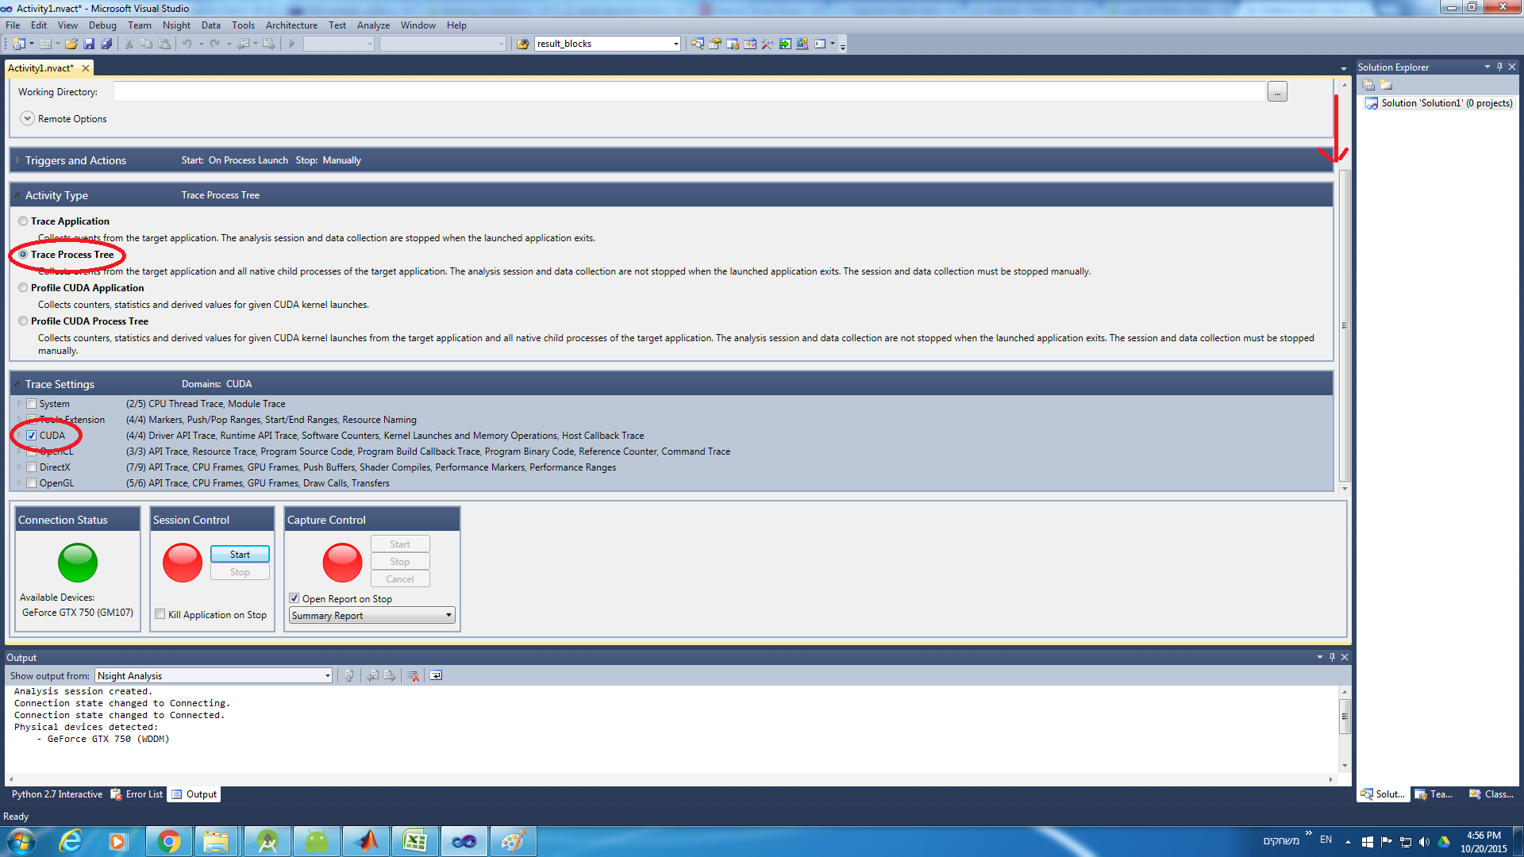

step4 : start MATLAB with Nsight

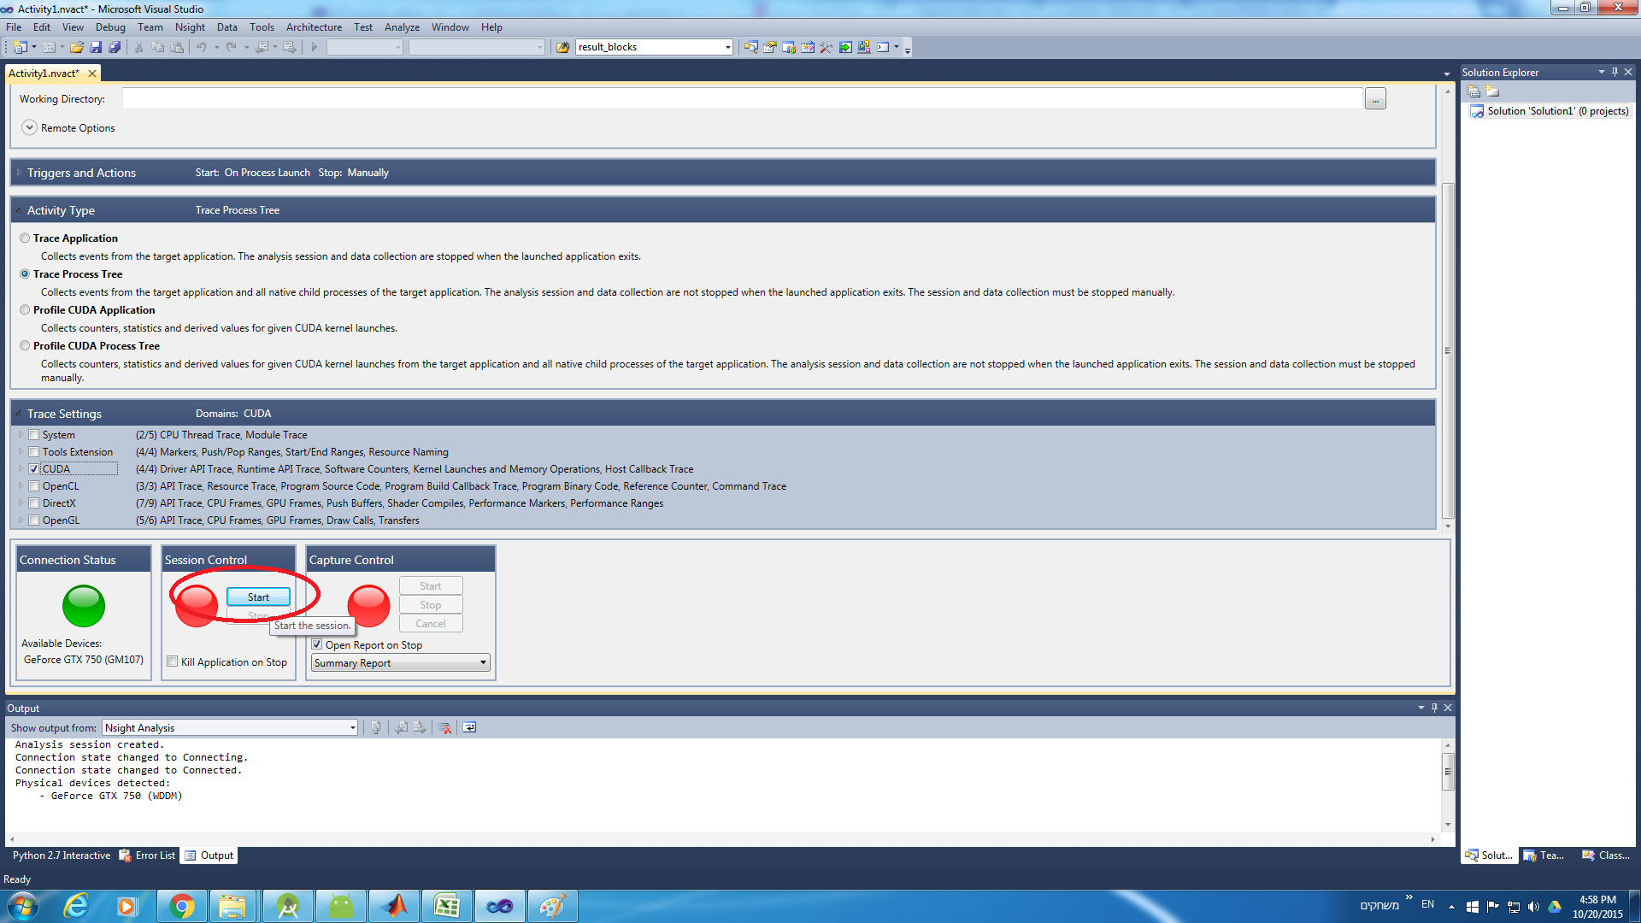

step 5: run MATLAB related CUDA application such as our function

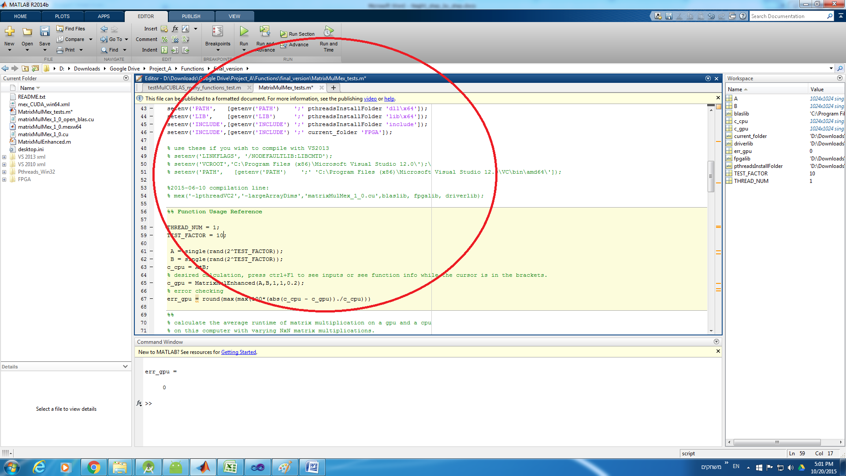

step 6: stop Nsight analysis when you are ready to view the results, note that MATLAB will remain open.

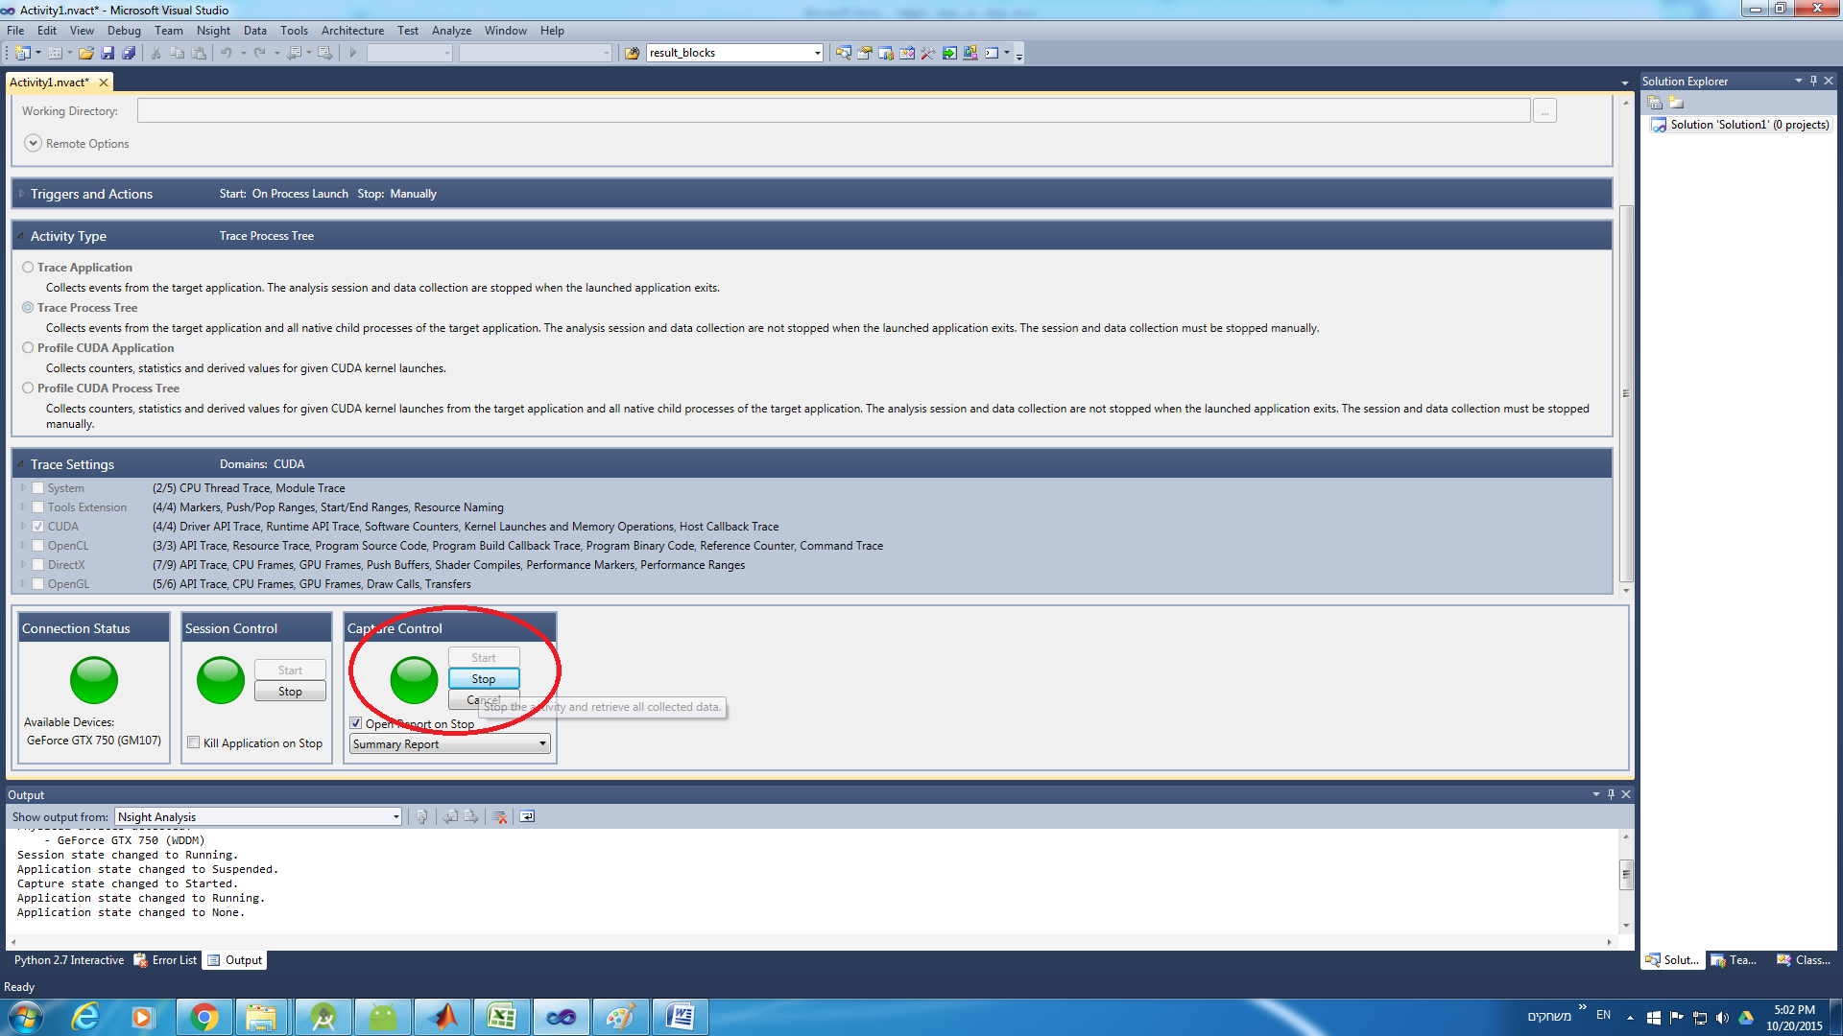

step 7: review the results. the result page will open automatically. the most interesting aspect is usually the time line

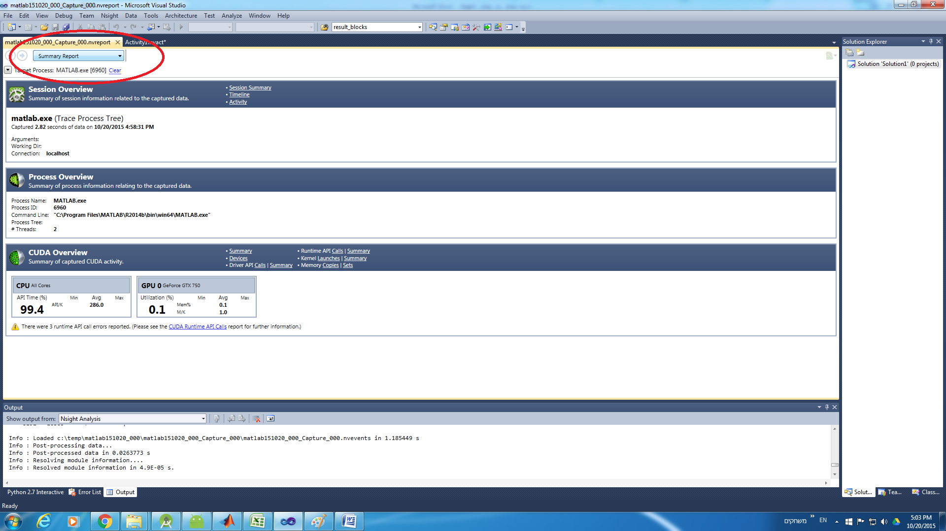

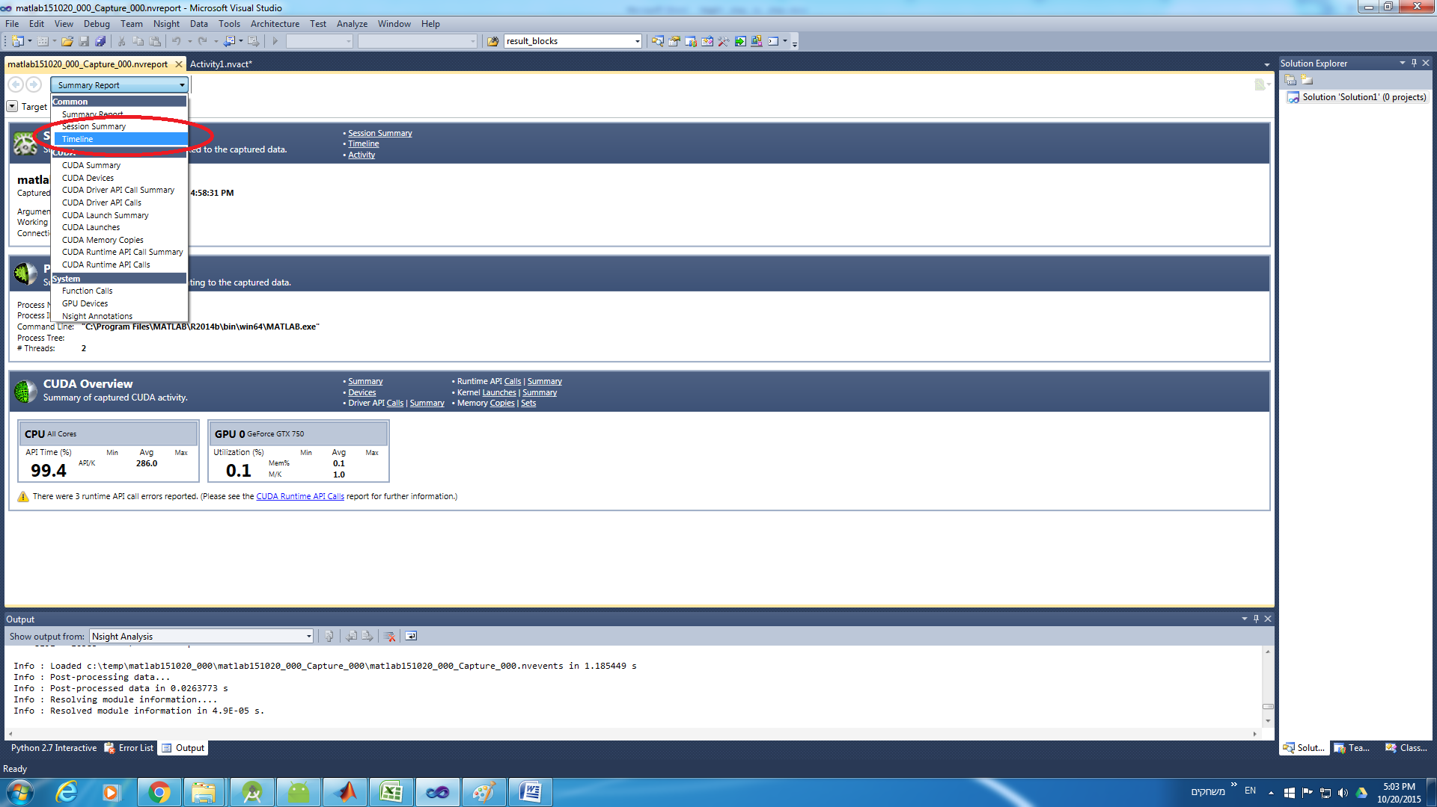

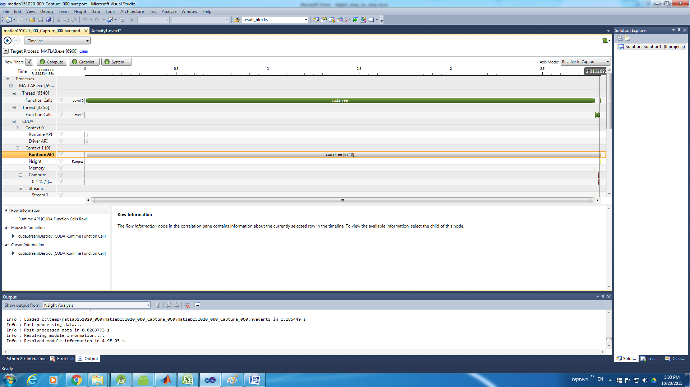

note: you zoom in with ctrl+(mouse scroll up)