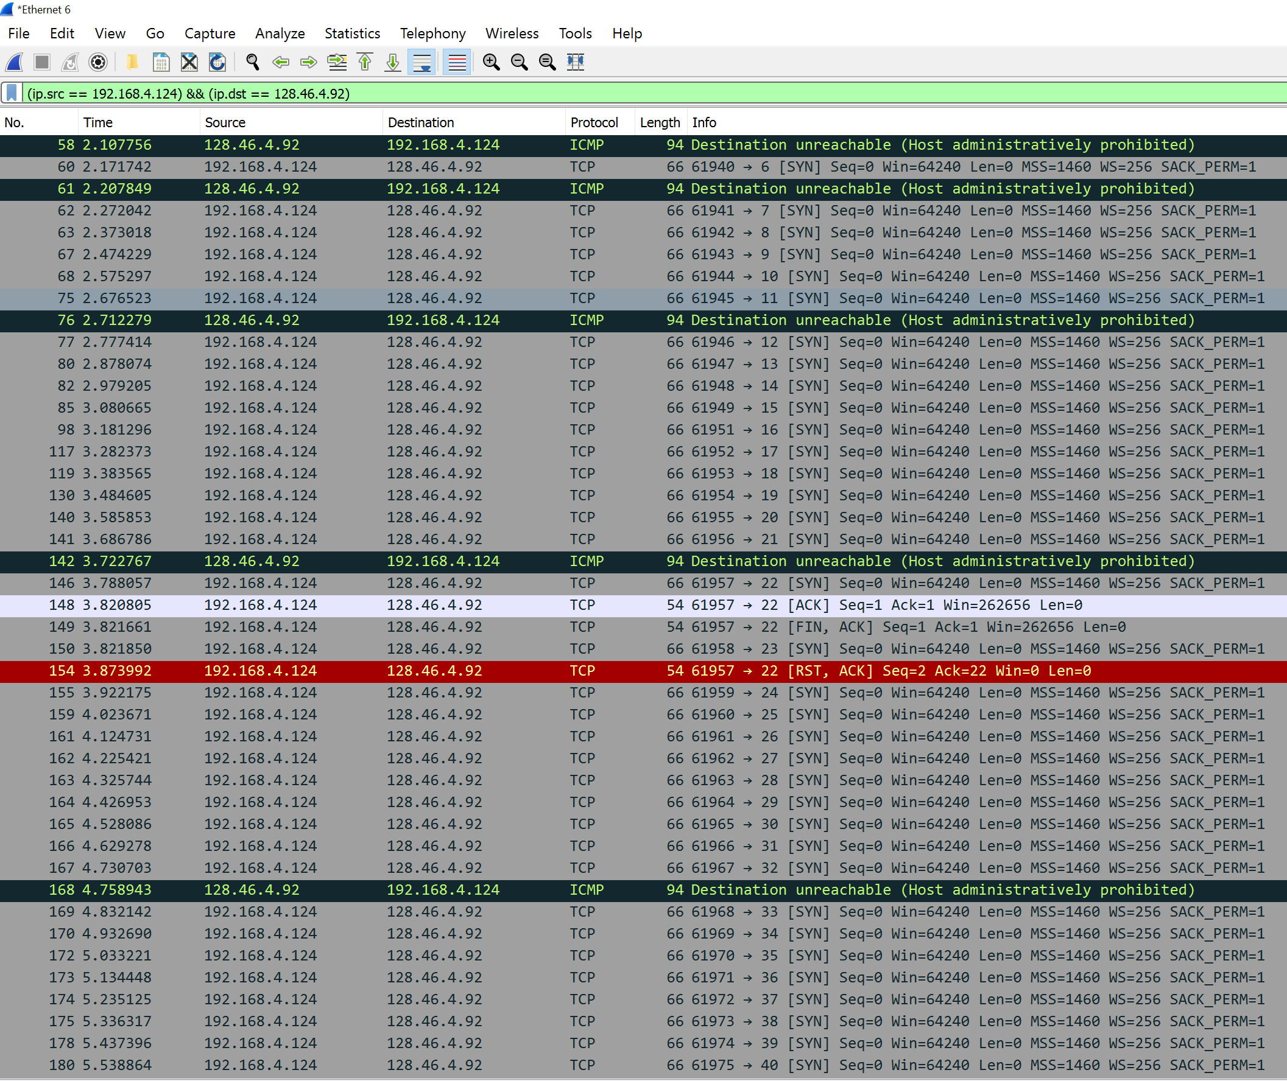This picture shows the Wireshark output of the port scanning process. I had my range set to scan ports 0-200 with the port I was looking to attack as port 22. This screenshot shows not only the scanning process but also the fact that port 22 is in fact open.

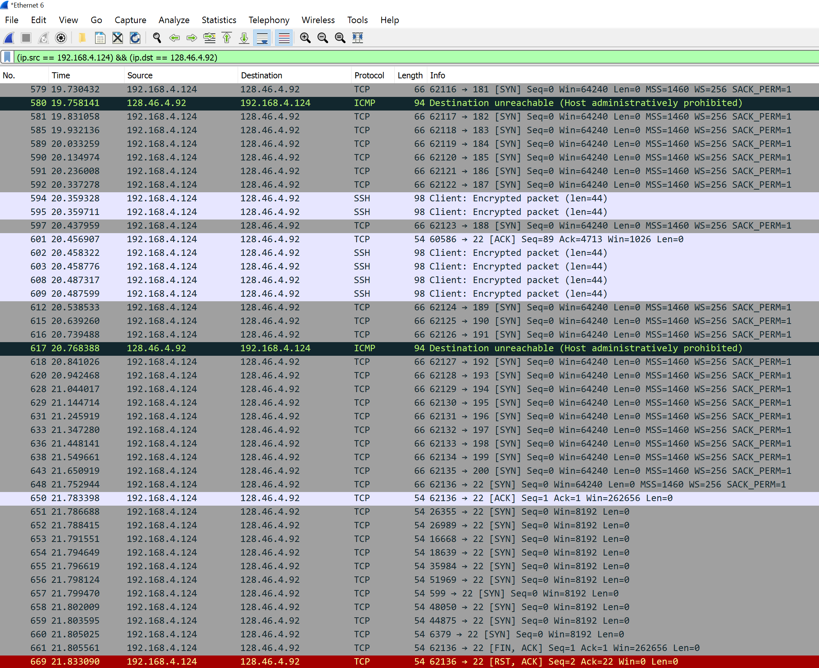

This screenshot shows the actual attack on port 22 (towards the bottom, No. 648 and on), where it sends multiple packets to port 22. The source IP was set as my PC’s IP and the destination IP was set as my ThinLinc ECE IP.