* API to get trending GIFs: /MunterApp/api/gifs ( Search text field empty):

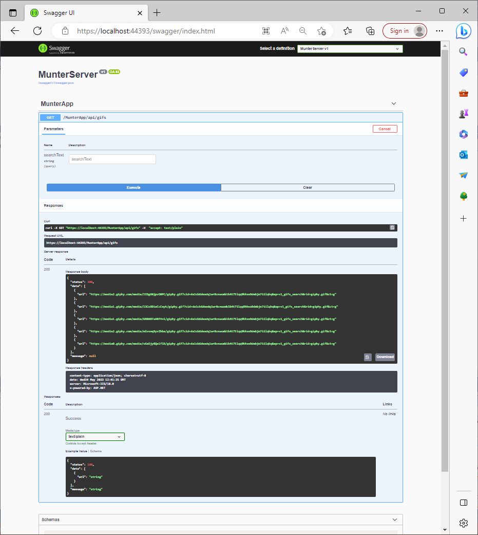

* API to search GIFs: /MunterApp/api/gifs, Search text field ‘funny+cat’:

