Original map (in m, resolution step 0.2 m)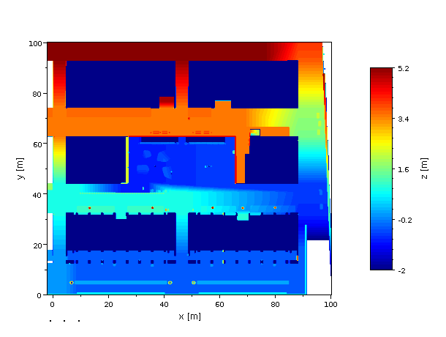

Thresholded map (step 0.5, unit: pixels)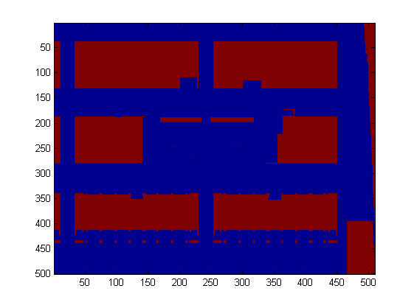
Thresholded map with 0.5m steps (ie averaged of area) 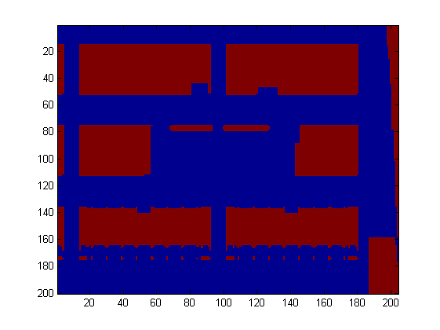
Map: mapbcn_full.txt
Lower left of map
mapb1=loadBCNMap('grid.txt',0.5,20,140,400,480);
(removed last rows, cols) -> 30x40 -> 15m x 20m
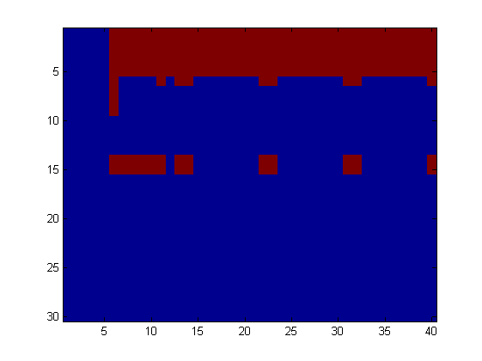
mapbcn1.txt

in center
mapb2=loadBCNMap('grid.txt',0.5,205,305,325,450)
(removed last rows, cols) -> 50x40 -> 25m x 20m

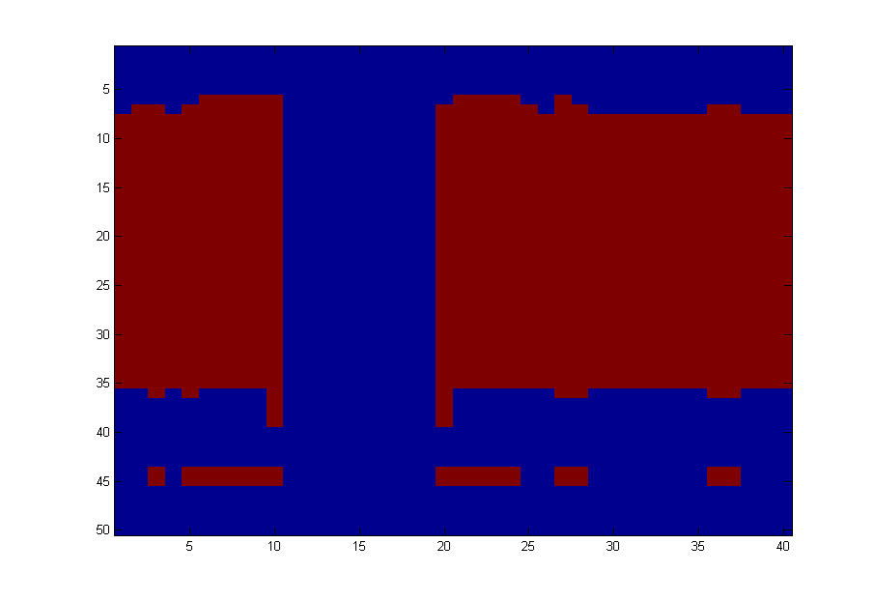

Mid of map
mapb3=loadBCNMap('grid.txt',0.5,195,295,100,210);
44x40 -> 22m x 20m
