Table of Contents

Introduction 1

Policy Landscape 1

Literature Review 2

Theory 3

Data 3

Methodology 7

Results 8

Discussion 13

Limitations 14

Table of Figures

Equation 1 9

Table 1: Panel Years of Data 6

Table 2: Unique Individual Counts by State and Year 6

Table 3: Employment Status for Reference Month 7

Table 4: Occupation Group Summary Statistics 8

Table 5: Person-Month Frequency Table for Education / Employment Type 9

Table 6 9

Table 7: LFP P-Values of Joint Tests for Significance: Months Since Birth * Policy Coefficients 11

Table 8: LFP Sums Months Since Birth * Policy Coefficients 12

Table 9: LFP P-Values of Joint Tests for Significance of Sums 12

Table 10: Employment P-Values of Joint Tests for Significance: Months Since Birth * Policy Coefficients 14

Table 11: Employment Sums of Months Since Birth * Policy Coefficients 15

Table 12: Employment P-Values of Joint Tests for Significance of Sums 15

Table 13: P-Values of Joint Tests for Significance: Months Since Birth * Policy Coefficients 17

Table 14: P-Values of Joint Tests for Significance: Months Since Birth * Policy Coefficients 19

Table 15: P-Values of Joint Tests for Significance: Months Since Birth * Policy Coefficients 20

Introduction

Whether considered or not in the intent of the law, paid family leave policies have the potential to increase labor-force attachments and reduce career interruptions, contributing to the closing of the gender earnings gap. Tanya Byker (2016) estimates the impact of the California and New Jersey paid family leave policies on these labor-market outcomes. Using data from the Survey of Income and Program Participation (SIPP), Byker conducts a difference in difference analysis comparing labor-force participation and employment of women who gave birth in states that enacted a paid family leave policy (California and New Jersey) to women who gave birth in control states (Florida, New York, and Texas). She finds a statistically significant positive effect of paid family leave policies on labor-force participation and employment of women without college degrees.

In this paper, I reproduce Byker’s analysis, testing the robustness of her findings as well as well as extending tests for significance across a greater range of time periods. Based on her hypothesis that paid family leave policies have greater effect on women with less education due to less prior access to paid family leave, I hypothesize that the policy might have differential effects based on occupational group. To test this hypothesis, I matched data on occupation from the SIPP to the individuals in Byker’s sample. I then divide the sample into occupational groups and conduct the difference-in-difference analysis on white-collar workers, blue-collar workers, and individual occupational groups.

Policy Landscape

Since 1993, eligible US workers have had access to 12 weeks of unpaid leave under the Family and Medical Leave Act (FMLA). However, due to firm size and work history requirements, eligibility is far from universal, and typical use is even smaller. In 2012, the Department of Labor estimated that fewer than 60% of workers nationwide were eligible for FMLA leave and only 16% of those eligible workers actually took FMLA leave (Klerman, Daley, and Pozniak 2012). It is perhaps because of the low usage (or the meager benefits) that previous studies have found no effect of FMLA on mothers’ employment outcomes (Han, Ruhm, and Waldfogel 2009).

Enacted in September 2002, the California Paid Family Leave legislation (CA-PFL) went into effect July 2004. Prior to the enactment of the CA-PFL, California mothers were covered by a Temporary Disability Insurance program (TDI) which typically provides mothers with six weeks of compensated leave to be used during pregnancy or immediately after childbirth. Under the CA-PFL, eligible mothers and fathers are both entitled to 6 weeks of paid leave, providing 55% of base pay constrained by a cap on payment ($1,163 per week in 2014 and $1,252 in 2019)[1], with mothers additionally entitled to the benefits of the TDI. The programs are coordinated such that mothers may take leave under the CA-PFL immediately following leave under the TDI.

Officially entitled the Family Temporary Disability Leave law, the New Jersey Paid Family Leave legislation (NJ-PFL) came into effect in July 2009. The NJ-PFL grants 6 weeks of paid leave to eligible mothers and fathers, providing 2/3 of average weekly pay up to a set maximum that has varied over time ($643 in per week in 2014)[2]. Eligible workers are those individuals that have worked at least 20 calendar weeks in New Jersey or that have earned at least $7,150 in the 12 months preceding requested leave.

Under both policies, workers may take leave within 12 months of birth, and leave may be taken concurrently or intermittently. Both policies are funded by a payroll tax on state workers.

Literature Review

In addition to the work of Tanya Byker upon which this paper is primarily based, an insightful literature of other work has helped to inform and contextualize this analysis. Slater, Ruhm, and Waldfogel (2012) estimate the effect of the CA-PFL on leave-taking of mothers following childbirth, as well as their subsequent labor market outcomes. The authors theorize that the policy will increase rates of leave-taking among California mothers, however the predicted effect on employment is ambiguous. If the increase of leave-taking comes primarily from mothers who would otherwise have continued employment, the policy would result in a decrease in work but no change in employment. If the increase of leave-taking comes primarily from mothers who would otherwise have terminated employment, the policy would result in an increase in mothers’ employment in the short-term, with possible positive effects on mothers’ employment in the medium and long term.

To estimate the impact of the CA-PFL, Slater et al. utilize difference-in-difference estimation using yearly data from 1999 to 2010 collected in the March Current Population Survey. The authors find that the CA-PFL doubled use of maternity leave from three weeks on average to six weeks on average. Although they find no statistically significant effect, point estimates suggest that the CA-PFL could indeed increase medium-term employment rates of mothers. Slater, Ruhm and Waldfogel do however find a statistically significant 10 to 17 percent increase in the usual weekly work hours of employed mothers of one-to-three year-old children. The authors propose that this increase could be a result of increased job continuity and the longer work hours associated with the accumulation of firm-specific human capital. They acknowledge however that the mechanism for the increase in work hours is not clear from their study.

Baum and Ruhm (2014) use the 1997 cohort of the National Longitudinal Survey of Youth to investigate the effect of the CA-PFL on various labor market outcomes. The authors find that the CA-PFL raised leave-taking on average by one week for fathers and three weeks for mothers. According to their analysis, the authors find that the largest effect of the CA-PFL on mothers’ leave-taking occurs 6 to 14 weeks after birth. The finding is intuitive, as the CA-PFL can be combined with California’s preexisting Temporary Disability Insurance program, which provides six weeks of paid leave to mothers following childbirth. Baum and Ruhm also find that the policy both increased the probability that a mother has returned to work in the year after birth and raised mothers’ weekly hours of work in the second year after birth. They do not, however, find a statistically significant effect upon mothers’ wages. Baum and Ruhm, similarly to Slater et al., hypothesize that the medium-term increases in employment and work hours reflect increased job continuity among mothers.

Das and Polachek (2015) use data from the March Current Population Survey to explore the impact of the CA-PFL on labor force participation and unemployment outcomes. Using a difference-in-difference framework, the authors find that the CA-PFL increased the labor-force participation of young women in California relative to other states. Das and Polachek also investigate unintended negative consequences of the law, and find that the policy increased the rate and average duration of unemployment for young women relative to other states.

Curtis, Hirsch, and Schroeder (2016) use data from the Quarterly Workforce Indicators to estimate the effect of the CA-PFL on labor market outcomes by examining employment flows and wage offers among new hires. The authors find that although the CA-PFL had little effect on earnings for young women in California, the policy did result in increased labor market churn (defined by the authors as separations, hires, and recalls).

Bartel et al. (2018) use data from the 2000 Census and the 2000 to 2013 waves of the American Community Survey to investigate the effect of the California Paid Family Leave law on fathers’ leave-taking. The authors find that the policy raised leave-taking rates of fathers by 46 percent, although fathers still on average only take 1.5 weeks out of the total 6 weeks of leave for which they are eligible under CA-PFL. In contrast, mothers on average take 9 weeks out of the 12 total weeks for which they are eligible under the combined Temporary Disability Insurance policy and the CA-PFL.

Theory

The California and New Jersey paid family leave policies contain aspects of both a payroll tax and employer mandate. The monetary cost of wage replacement is funded by a payroll tax on workers, while the opportunity cost to the firm of employee time spent on leave fits the model of employer mandate. No matter the policy is framed, as Jonathan Gruber puts it, “the general distinction between payroll taxes and mandates is a false one” (2010). The labor-market effects depend upon tax/benefit linkages, not the particular legislative frame of the policy. In both a payroll tax and employer mandate, there is a cost borne and a benefit received, with incidence of each determined by the elasticities of labor supply and demand.

According to the simple model, the payroll tax creates a wedge between labor supply and demand, reducing both wages and employment of workers, and creating deadweight loss. The conferral of benefits to workers, monetary or otherwise, increases the total value of employment for workers and accordingly increases labor supply and reduces the wedge imposed by the tax. Except for the special case in which employees value benefits at exactly the value of lost wages, there will remain a residual wedge between supply and demand, resulting in lower employment than equilibrium in the absence of the tax.

In the case of the California and New Jersey paid family leave policies, the simple model is complicated by the fact that although the tax is equally imposed upon all workers, the benefits gained are dependent upon worker characteristics. As found by Slater et al. (2012), and Baum and Ruhm (2014), women take paid family leave for longer periods of time and in greater proportion than men. It is possible that young women value the benefits granted by the CA-PFL and NJ-PFL in excess of the cost they bear, leading to an increased labor supply of young women and higher employment compared to the prior equilibrium.

In addition to the monetary cost of payroll taxation, it is important to consider the opportunity cost of employee leave. Although the costs may not be significant in many cases, firms may be required to hire temporary, less productive, replacement labor. If the employee’s firm-specific skills depreciate during leave, firms may also have to the cost. Because young women are most likely to take family leave, firms may discriminate against hiring them in favor of men and older women. The combination of increased labor-force participation of young women and decreased demand for their labor could result in increased unemployment of young women (Das and Polachek 2015).

Paid family leave may have additional effects upon labor-market outcomes of mothers in particular. The benefits of the policy may only be claimed if the individual remains attached to her employer during pregnancy and after childbirth, incentivizing job continuity of mothers. As previous studies have concluded, job continuity is an important factor in the later employment and wages of mothers (Waldfogel 1998). The positive effect of paid family leave policies on job continuity of mothers may therefore lead to positive impacts on labor-force participation, employment, and wages of mothers that are independent of the standard labor-market effects of a payroll tax and benefit.

In view of the various possible shifts in supply and demand it is unclear where the post-policy equilibrium of mothers’ labor-force participation and employment will land. To empirically investigate the effects of California and New Jersey’s paid family leave program on mothers’ labor-market outcomes in various periods of time relative to childbirth, I follow the methodology outlined by Byker (2016).

Data

The data in this paper originates from four panels of the Survey of Income and Program Participation, described in Table 1. Each panel covers a national stratified sample of the U.S. civilian non-institutionalized population and uses a 4-month recall period, with respondents divided into rotation groups with each group interviewed during one month of the four-month period. Each four-month period constitutes a wave of the survey. As respondents to the survey are recorded over differing lengths of time, the dataset constitutes an unbalanced panel.

Table 1: Panel Years of Data

|  |  |  |  |
| --- | --- | --- | --- |
| SIPP Panel | Number of Waves | First Month | Last Month |
| 1996 | 12 | Dec 1996 | Feb 2000 |
| 2001 | 8 | Oct 2000 | Dec 2003 |
| 2004 | 12 | Oct 2003 | Dec 2007 |
| 2008 | 16 | May 2008 | Dec 2013 |

Using data from the four panels, Byker constructed a sample of 2,817 unique persons and 103,624 person-month observations containing all women aged 24 to 45 who gave birth during the time coverage of the SIPP panel and lived within one of the treatment or control states. By connecting information on the date of birth of children with information identifying their mothers, Byker was able to generate a variable identifying the month of childbirth for each mother. Using her constructed sample and the full SIPP dataset, I appended additional information on employment to each observation. In both Byker’s and my own analysis, individuals that moved states are counted in both state categories.

Table 2: Unique Individual Counts by State and Year

|  |  |  |  |  |  |  |
| --- | --- | --- | --- | --- | --- | --- |
|  | California | Florida | New Jersey | New York | Texas |  |
| Year |  |  |  |  |  | Total |
| 1995 | 62 | 23 | 19 | 43 | 48 | 195 |
| 1996 | 319 | 105 | 76 | 166 | 211 | 873 |
| 1997 | 318 | 107 | 74 | 162 | 216 | 873 |
| 1998 | 303 | 97 | 68 | 151 | 208 | 823 |
| 1999 | 283 | 87 | 64 | 140 | 185 | 758 |
| 2000 | 282 | 95 | 58 | 145 | 207 | 787 |
| 2001 | 207 | 76 | 48 | 106 | 149 | 583 |
| 2002 | 201 | 77 | 44 | 96 | 144 | 562 |
| 2003 | 341 | 139 | 91 | 162 | 234 | 963 |
| 2004 | 204 | 99 | 59 | 103 | 143 | 604 |
| 2005 | 201 | 96 | 56 | 103 | 146 | 597 |
| 2006 | 197 | 91 | 52 | 98 | 140 | 576 |
| 2007 | 127 | 69 | 27 | 71 | 80 | 372 |
| 2008 | 222 | 86 | 74 | 86 | 150 | 618 |
| 2009 | 225 | 85 | 75 | 91 | 160 | 631 |
| 2010 | 220 | 86 | 73 | 90 | 163 | 630 |
| 2011 | 218 | 83 | 69 | 83 | 161 | 612 |
| 2012 | 148 | 51 | 41 | 52 | 103 | 395 |
| Total | 1002 | 389 | 276 | 485 | 707 | 2817 |

(Highlighted values indicate the presence of a paid family leave policy.)

Information on labor-force participation and employment is derived from a categorical SIPP variable encoding the employment status of an individual for a given month. Following Byker’s methodology, I reduced this information into three binary variables describing whether a person is in or out of the labor-force, employed or unemployed, and searching for work or not searching for work[3].

Table 3: Employment Status for Reference Month

|  |  |  |
| --- | --- | --- |
| Employment / Labor-force Status | Person-Months | Proportion |
| With a job entire month, worked all weeks (includes individuals on paid leave) | 57,373 | 55.4% |
| With a job entire month, absent from work without pay 1+ weeks, absence not due to layoff | 2,595 | 2.51% |
| With a job entire month, absent from work without pay 1+ weeks, absence due to layoff | 450 | 0.43% |
| With a job at least 1 but not all weeks, no time on layoff and no time looking for work | 1148 | 1.11% |
| With a job at least 1 but not all weeks, remaining weeks on layoff or looking for work | 523 | 0.51% |
| No job all month, on layoff or looking for work all weeks | 3,323 | 3.21% |
| No job all month, at least one but not all weeks on layoff or looking for work | 440 | 0.44% |
| No job all month, no time on layoff and no time looking for work. | 37,756 | 36.4% |
| Missing data | 16 | 0.02% |

The SIPP allows for information on two possible jobs to be recorded for any given month. In the case of an individual holding multiple jobs during a reference month, the job by which the individual earned the most money over the four-month period will be listed as job 1. The job that provided the next most earnings in the four-month period will be listed as job 2. In order to simplify the analysis, only data on job 1 was used in this paper, and each individual was placed into occupations groups according to job 1.

An important aspect of the data is that the SIPP changed the encoding of occupations after the 2001 panel. The 1996 and 2001 panels of the SIPP encode occupations according to the 1990 Census Bureau occupational classification scheme, while the 2004 and 2008 panels utilize the classification scheme from the 2000 Census. This means that pre-2004 panel occupations cannot be directly matched to 2004 and later panel occupations. However, both types of occupation coding systems could still be placed into general occupation groups (specified by the Standard Occupational Classification system). Individuals were placed into occupation groups according to their occupation most recently recorded before birth.[4] I then codified each occupation group as either ‘white collar’ or ‘blue collar’. The results of this processing are reported in Table 4.

Table 4: Occupation Group Summary Statistics

|  |  |  |  |  |  |
| --- | --- | --- | --- | --- | --- |
| Code | Pre-birth Occupation Group | White Collar / Blue Collar | Count | Proportion | Percent College Graduate |
| 11 | Management | White Collar | 131 | 7.06% | 51.1% |
| 13 | Business and Finance | White Collar | 86 | 4.63% | 64.8% |
| 15 | Computer Science and Mathematics | White Collar | 38 | 2.05% | 80.5% |
| 17 | Architecture and Engineering | White Collar | 24 | 1.29% | 78.3% |
| 19 | Life, Physical, And Social Science | White Collar | 16 | 0.86% | 80.0% |
| 21 | Community and Social Service | White Collar | 43 | 2.32% | 81.1% |
| 23 | Law | White Collar | 20 | 1.08% | 68.9% |
| 25 | Education, Training, and Library | White Collar | 195 | 10.5% | 79.2% |
| 27 | Arts, Design, Entertainment, Sports | White Collar | 28 | 1.51% | 81.9% |
| 29 | Healthcare Practitioners and Technicians | White Collar | 169 | 9.12% | 61.3% |
| 31 | Healthcare Support | White Collar | 81 | 4.37% | 12.7% |
| 41 | Sales and Related Occupations | White Collar | 190 | 10.2% | 41.4% |
| 43 | Office and Administrative Support | White Collar | 424 | 22.9% | 20.8% |
| 33 | Protective Service | Blue Collar | 78 | 0.70% | 28.5% |
| 35 | Food Preparation and Serving | Blue Collar | 89 | 4.80% | 6.00% |
| 37 | Building/Grounds Cleaning and Maintenance | Blue Collar | 54 | 2.91% | 6.80% |
| 39 | Personal Care and Service | Blue Collar | 78 | 4.2% | 14.3% |
| 45 | Farming, Fishing, and Forestry | Blue Collar | 25 | 1.35% | 1.63% |
| 47 | Construction and Extraction | Blue Collar | 6 | 0.32% | 0.00% |
| 49 | Installation, Maintenance, and Repair | Blue Collar | 5 | 0.27% | 12.7% |
| 51 | Production | Blue Collar | 80 | 4.31% | 11.2% |
| 53 | Transportation and Material Moving | Blue Collar | 20 | 1.08% | 10.5% |
|  | Unclassified | N/A | 39 | 2.11% | N/A |
|  |  | Total Unique Individuals | 1854 |  |  |

Is the segmentation by educational attainment and the segmentation by occupation type capturing the same subpopulations? The cross tabulation below indicates that while there is overlap, the two segmentations indeed divide the sample differently.

Table 5: Person-Month Frequency Table for Education / Employment Type

|  |  |  |  |
| --- | --- | --- | --- |
|  | White collar | Blue collar | Totals |
| Less than College | 29101 (69.2%) | 12722 (30.8%) | 41823 (100%) |
| College Educated | 25484 (95.1%) | 1208 (4.9%) | 26692 (100%) |
| Totals | 54585 | 13930 | 68515 |

Person Frequency Table for Education / Employment Type

Table

|  |  |  |  |
| --- | --- | --- | --- |
|  | White collar | Blue collar | Totals |
| Less than College | 807 | 340 | 1147 |
| College Educated | 685 | 37 | 722 |
| Totals | 1445 | 370 | 1815 |

Methodology

*Yits* : Labor-force outcome for woman *i* living in state *s* in period *t*

αi : Individual fixed effects

*λt* : Year Indicators

*θs* : State Indicators

$\sum{B_{it}^{j}}$: Months Since Birth Indicators[5]

Equation

The specification above is a variation of generalized difference-in-difference regression used by Byker to estimate the effect of the paid family leave policy on labor-market outcomes of mothers. Specifically, the specification is used to estimate the effect of the paid family leave policy on three labor-market outcomes: probability of participating in the labor-force, probability of being employed, and probability of looking for work. The individual fixed effects control for confounding from unobserved characteristics of each individual. The interacted year and state indicators control for time trends in each state that may confound the estimation of the effect of the policy on the outcome of interest. The year X months since birth dummies control for differences in the pattern of the outcome variable across years, while the state X months since birth dummies control for differences in the pattern of the outcome variable across states. Each of the βj coefficients represents the individual effect of the policy on the probability of the labor-market outcome for each month, controlling for the effects on all other months.

Following the specification outlined by Byker (2016). I estimate Equation 1 for each of the five sample groups of interest: full sample, college educated and non-college educated, blue-collar and white-collar, with labor-force participation as the dependent variable. I then repeat the process using the ‘working’ and ‘looking for work’ variables. The point estimates of the interacted ‘months since birth’ indicators and the policy variable are visualized in the figures of the Results section. As the effect of the policy for a given month is unlikely to be significantly different from the effect of the policy for any other given month, I follow Byker’s method of using joint tests for significance over staggered seven month periods.

The difference-in-difference specification used in this study implies a number of assumptions about the data. First and foremost is the assumption of parallel trends. The parallel trends assumption is violated if there exists unobserved time-varying confounding. Essentially, for the estimates to be unbiased, the assumption must hold that the treatment group would have followed a parallel time trend as the control group if the treatment had not taken place. As we cannot observe the counterfactual, we have no empirical method to confirm this assumption.

Another important assumption is the exogeneity of treatment. The estimation is unbiased only if the assignment of treatment is not caused in any way by the outcome variable. In this case, it is likely that the assumption holds, as is unlikely that policy-makers enacted paid leave policies as a result of any particular pattern of mothers’ labor force participation.

Unbiased difference-in-difference estimation requires the assumption that pre-treatment outcomes are not affected by treatment. That is, we assume that mothers do not anticipate the implementation of a paid leave policy and adjust their labor force participation accordingly. It is quite possible that this assumption is violated in this analysis. Mothers expecting shortly before the implementation of a paid leave policy, who would otherwise have dropped out of the labor-force, may have stayed in the labor-force anticipating eligibility for paid leave once the policy came into effect. However, if the proportion of mothers who were pregnant in the 9 months before the implementation of a paid leave policy is small compared to the total sample, the effect on the DiD coefficients is likely to also be small.

Results

Each figure depicts the point estimates of the difference in difference coefficients estimated via Equation 1. The tables following each figure contain the p-values statistical tests of joint significance of staggered seven month periods. The point estimates for months -24 to -18 are set to zero as there are used as the reference period in the regression.

Figure

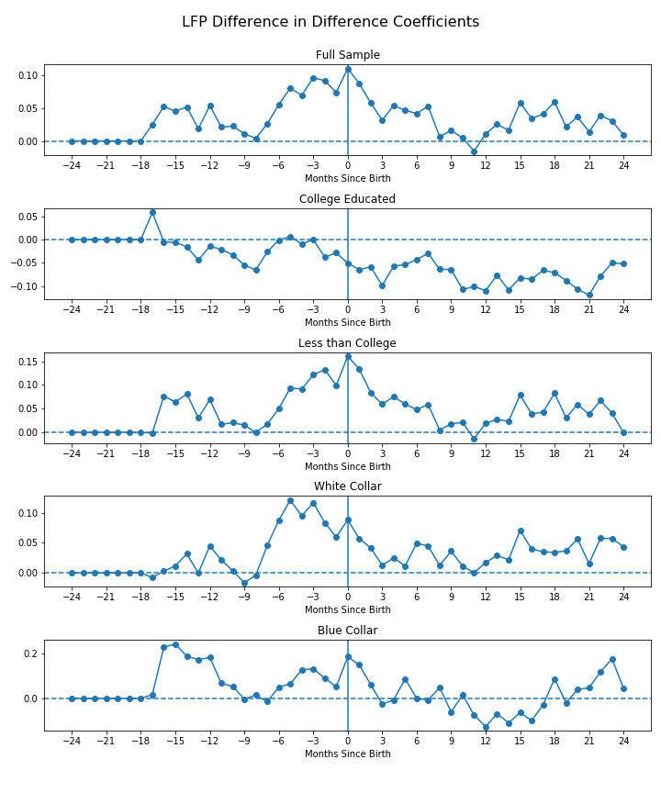

Table 7: LFP P-Values of Joint Tests for Significance: Months Since Birth * Policy Coefficients

|  |  |  |  |  |  |
| --- | --- | --- | --- | --- | --- |
| Months Since Birth | Full Sample | College Educated | Less Than College | White Collar | Blue Collar |
| -17 to -12 | 0.26 | 0.33 | 0.12 | 0.42 | 0.20 |
| -15 to -9 | 0.22 | 0.52 | 0.36 | 0.28 | 0.31 |
| -12 to -6 | 0.36 | 0.55 | 0.55 | 0.12 | 0.36 |
| -9 to -3 | 0.16 | 0.71 | 0.27 | 0.02** | 0.82 |
| -6 to 0 | 0.12 | 0.95 | 0.03** | 0.11 | 0.31 |
| -3 to +3 | 0.04** | 0.75 | 0.02** | 0.17 | 0.16 |
| 0 to + 6 | 0.16 | 0.51 | 0.25 | 0.36 | 0.14 |
| +3 to +9 | 0.55 | 0.56 | 0.68 | 0.59 | 0.36 |
| +6 to +12 | 0.41 | 0.62 | 0.49 | 0.59 | 0.34 |
| +9 to +15 | 0.13 | 0.56 | 0.20 | 0.31 | 0.51 |
| +12 to + 18 | 0.15 | 0.63 | 0.13 | 0.46 | 0.51 |
| +15 to +21 | 0.24 | 0.93 | 0.14 | 0.68 | 0.65 |
| +18 to +24 | 0.29 | 0.72 | 0.24 | 0.63 | 0.35 |
| -17 to 0 | 0.11 | 0.58 | 0.01 | 0.08 | 0.14 |
| 0 to 24 | 0.05 | 0.63 | 0.07 | 0.37 | 0.18 |

Table 8: LFP Sums Months Since Birth * Policy Coefficients

|  |  |  |  |  |  |
| --- | --- | --- | --- | --- | --- |
| Months Since Birth | Full Sample | College Educated | Less Than College | White Collar | Blue Collar |
| -17 to -12 | 0.25 | -0.03 | 0.32 | 0.08 | 1.03 |
| -15 to -9 | 0.23 | -0.19 | 0.30 | 0.10 | 0.90 |
| -12 to -6 | 0.19 | -0.22 | 0.19 | 0.18 | 0.35 |
| -9 to -3 | 0.34 | -0.15 | 0.39 | 0.45 | 0.37 |
| -6 to 0 | 0.58 | -0.12 | 0.75 | 0.65 | 0.70 |
| -3 to +3 | 0.55 | -0.34 | 0.79 | 0.46 | 0.64 |
| 0 to + 6 | 0.43 | -0.43 | 0.62 | 0.29 | 0.45 |
| +3 to +9 | 0.25 | -0.41 | 0.32 | 0.19 | 0.04 |
| +6 to +12 | 0.12 | -0.52 | 0.15 | 0.17 | -0.20 |
| +9 to +15 | 0.12 | -0.65 | 0.17 | 0.19 | -0.48 |
| +12 to + 18 | 0.25 | -0.60 | 0.31 | 0.25 | -0.40 |
| +15 to +21 | 0.27 | -0.62 | 0.37 | 0.29 | -0.03 |
| +18 to +24 | 0.21 | -0.56 | 0.32 | 0.30 | 0.49 |
| -17 to 0 | 0.91 | -0.35 | 1.14 | 0.78 | 1.84 |
| 0 to 24 | 0.90 | -1.88 | 1.26 | 0.90 | 0.38 |

Table 9: LFP P-Values of Joint Tests for Significance of Sums

|  |  |  |  |  |  |
| --- | --- | --- | --- | --- | --- |
| Months Since Birth | Full Sample | College Educated | Less Than College | White Collar | Blue Collar |
| -17 to -12 | 0.18 | 0.90 | 0.24 | 0.70 | 0.08 |
| -15 to -9 | 0.39 | 0.54 | 0.44 | 0.76 | 0.22 |
| -12 to -6 | 0.53 | 0.55 | 0.68 | 0.62 | 0.65 |
| -9 to -3 | 0.33 | 0.71 | 0.45 | 0.26 | 0.66 |
| -6 to 0 | 0.13 | 0.79 | 0.18 | 0.12 | 0.44 |
| -3 to +3 | 0.18 | 0.51 | 0.17 | 0.32 | 0.52 |
| 0 to + 6 | 0.32 | 0.47 | 0.30 | 0.57 | 0.67 |
| +3 to +9 | 0.59 | 0.54 | 0.61 | 0.72 | 0.97 |
| +6 to +12 | 0.81 | 0.47 | 0.82 | 0.76 | 0.86 |
| +9 to +15 | 0.82 | 0.41 | 0.80 | 0.75 | 0.69 |
| +12 to + 18 | 0.65 | 0.47 | 0.67 | 0.69 | 0.74 |
| +15 to +21 | 0.64 | 0.48 | 0.63 | 0.66 | 0.98 |
| +18 to +24 | 0.72 | 0.54 | 0.69 | 0.65 | 0.69 |
| -17 to 0 | 0.21 | 0.69 | 0.29 | 0.34 | 0.31 |
| 0 to 24 | 0.61 | 0.47 | 0.60 | 0.65 | 0.92 |

The analysis on the full sample yields positive and jointly significant effects for three months before birth to three months after birth. There are no significant effects of the policy on labor-force participation for college educated women, while there are positive and jointly significant effects for non-college educated women in the six months before birth to month of birth time period as well as the three months before birth to three months after birth time period. There are additionally positive and jointly significant effects of the policy on labor-force participation for white collar workers in the nine months before birth to three months before birth time period. The analysis yielded no significant effects of the paid family leave policy on labor-force participation of blue-collar workers.

Figure

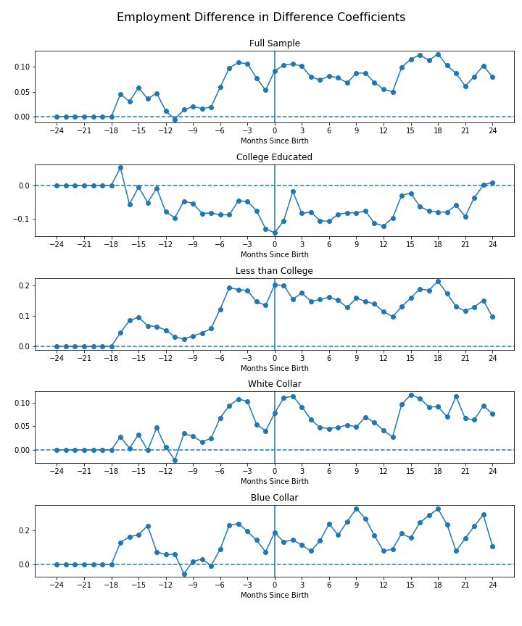

Table 10: Employment P-Values of Joint Tests for Significance: Months Since Birth * Policy Coefficients

|  |  |  |  |  |  |
| --- | --- | --- | --- | --- | --- |
| Months Since Birth | Full Sample | College Educated | Less Than College | White Collar | Blue Collar |
| -17 to -12 | 0.63 | 0.27 | 0.76 | 0.84 | 0.72 |
| -15 to -9 | 0.74 | 0.71 | 0.82 | 0.70 | 0.44 |
| -12 to -6 | 0.79 | 0.69 | 0.49 | 0.62 | 0.77 |
| -9 to -3 | 0.21 | 0.88 | 0.02** | 0.58 | 0.26 |
| -6 to 0 | 0.21 | 0.62 | 0.02** | 0.67 | 0.28 |
| -3 to +3 | 0.35 | 0.52 | 0.08* | 0.57 | 0.62 |
| 0 to + 6 | 0.83 | 0.58 | 0.32 | 0.85 | 0.43 |
| +3 to +9 | 0.77 | 0.96 | 0.33 | 0.96 | 0.18 |
| +6 to +12 | 0.67 | 0.89 | 0.33 | 0.97 | 0.13 |
| +9 to +15 | 0.25 | 0.67 | 0.50 | 0.36 | 0.14 |
| +12 to +18 | 0.28 | 0.72 | 0.34 | 0.45 | 0.36 |
| +15 to +21 | 0.54 | 0.95 | 0.46 | 0.59 | 0.32 |
| +18 to +24 | 0.52 | 0.93 | 0.26 | 0.73 | 0.13 |
| -17 to 0 | 0.41 | 0.55 | 0.08 | 0.80 | 0.52 |
| 0 to 24 | 0.80 | 0.93 | 0.41 | 0.95 | 0.19 |

Table 11: Employment Sums of Months Since Birth * Policy Coefficients

|  |  |  |  |  |  |
| --- | --- | --- | --- | --- | --- |
| Months Since Birth | Full Sample | College Educated | Less Than College | White Collar | Blue Collar |
| -17 to -12 | 0.23 | -0.15 | 0.41 | 0.12 | 0.82 |
| -15 to -9 | 0.18 | -0.34 | 0.37 | 0.13 | 0.56 |
| -12 to -6 | 0.13 | -0.53 | 0.37 | 0.16 | 0.20 |
| -9 to -3 | 0.43 | -0.49 | 0.82 | 0.44 | 0.80 |
| -6 to 0 | 0.59 | -0.62 | 1.16 | 0.55 | 1.15 |
| -3 to +3 | 0.64 | -0.61 | 1.19 | 0.59 | 0.99 |
| 0 to + 6 | 0.64 | -0.65 | 1.19 | 0.55 | 1.03 |
| +3 to +9 | 0.57 | -0.63 | 1.07 | 0.40 | 1.32 |
| +6 to +12 | 0.52 | -0.67 | 1.00 | 0.36 | 1.50 |
| +9 to +15 | 0.56 | -0.55 | 0.94 | 0.46 | 1.27 |
| +12 to + 18 | 0.68 | -0.49 | 1.08 | 0.58 | 1.36 |
| +15 to +21 | 0.73 | -0.48 | 1.16 | 0.66 | 1.47 |
| +18 to +24 | 0.64 | -0.34 | 1.01 | 0.58 | 1.41 |
| -17 to 0 | 0.88 | -1.13 | 1.77 | 0.75 | 2.03 |
| 0 to 24 | 2.22 | -1.84 | 3.79 | 1.89 | 4.66 |

Table 12: Employment P-Values of Joint Tests for Significance of Sums

|  |  |  |  |  |  |
| --- | --- | --- | --- | --- | --- |
| Months Since Birth | Full Sample | College Educated | Less Than College | White Collar | Blue Collar |
| -17 to -12 | 0.27 | 0.62 | 0.15 | 0.66 | 0.18 |
| -15 to -9 | 0.52 | 0.37 | 0.36 | 0.73 | 0.46 |
| -12 to -6 | 0.68 | 0.22 | 0.44 | 0.71 | 0.81 |
| -9 to -3 | 0.25 | 0.31 | 0.12 | 0.31 | 0.35 |
| -6 to 0 | 0.14 | 0.25 | 0.04** | 0.25 | 0.21 |
| -3 to +3 | 0.13 | 0.32 | 0.04** | 0.26 | 0.32 |
| 0 to + 6 | 0.15 | 0.33 | 0.05* | 0.32 | 0.33 |
| +3 to +9 | 0.24 | 0.41 | 0.09* | 0.50 | 0.24 |
| +6 to +12 | 0.30 | 0.41 | 0.13 | 0.56 | 0.21 |
| +9 to +15 | 0.28 | 0.51 | 0.17 | 0.47 | 0.30 |
| +12 to + 18 | 0.22 | 0.58 | 0.14 | 0.38 | 0.28 |
| +15 to +21 | 0.21 | 0.62 | 0.13 | 0.34 | 0.27 |
| +18 to +24 | 0.29 | 0.74 | 0.19 | 0.43 | 0.30 |
| -17 to 0 | 0.25 | 0.28 | 0.10 | 0.43 | 0.26 |
| 0 to 24 | 0.22 | 0.53 | 0.11 | 0.39 | 0.25 |

There are positive and jointly significant effects of paid family leave policy on employment for women without a college degree in three overlapping time periods: nine months before birth to three months before birth, six months before birth to month of birth, and three months before birth to three months after birth. The analyses conducted on the full sample, college educated women, and white collar and blue collar workers yielded no significant effects.

Figure

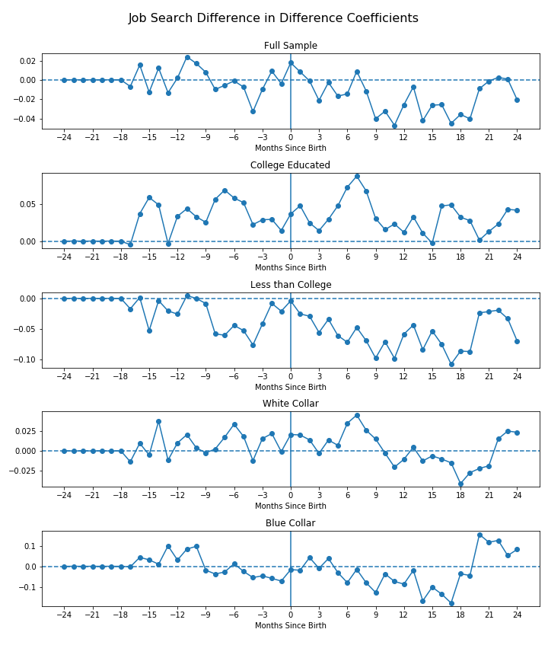

Table 13: Unemployment P-Values of Joint Tests for Significance: Months Since Birth * Policy Coefficients

|  |  |  |  |  |  |
| --- | --- | --- | --- | --- | --- |
| Months Since Birth | Full Sample | College Educated | Less Than College | White Collar | Blue Collar |
| -17 to -12 | 0.34 | 0.19 | 0.34 | 0.19 | 0.83 |
| -15 to -9 | 0.57 | 0.29 | 0.69 | 0.40 | 0.51 |
| -12 to -6 | 0.76 | 0.33 | 0.43 | 0.63 | 0.42 |
| -9 to -3 | 0.28 | 0.56 | 0.11 | 0.17 | 0.86 |
| -6 to 0 | 0.07* | 0.43 | 0.18 | 0.06* | 0.74 |
| -3 to +3 | 0.11 | 0.34 | 0.21 | 0.24 | 0.65 |
| 0 to + 6 | 0.37 | 0.18 | 0.21 | 0.61 | 0.60 |
| +3 to +9 | 0.06* | 0.13 | 0.07* | 0.61 | 0.12 |
| +6 to +12 | 0.07* | 0.13 | 0.04** | 0.50 | 0.14 |
| +9 to + 15 | 0.07* | 0.93 | 0.02** | 0.63 | 0.25 |
| +12 to + 18 | 0.22 | 0.61 | 0.11 | 0.83 | 0.26 |
| + 15 to + 21 | 0.81 | 0.45 | 0.28 | 0.94 | 0.15 |
| +18 to +24 | 0.53 | 0.75 | 0.16 | 0.44 | 0.38 |
| -17 to 0 | 0.18 | 0.31 | 0.27 | 0.11 | 0.55 |
| 0 to 24 | 0.08* | 0.39 | 0.04 | 0.70 | 0.28 |

Table 14: Unemployment Sums of Months Since Birth * Policy Coefficients

|  |  |  |  |  |  |
| --- | --- | --- | --- | --- | --- |
| Months Since Birth | Full Sample | College Educated | Less Than College | White Collar | Blue Collar |
| -17 to -12 | 0.00 | 0.17 | -0.12 | 0.03 | 0.21 |
| -15 to -9 | 0.04 | 0.24 | -0.11 | 0.05 | 0.33 |
| -12 to -6 | 0.03 | 0.32 | -0.19 | 0.09 | 0.14 |
| -9 to -3 | -0.06 | 0.31 | -0.34 | 0.07 | -0.20 |
| -6 to 0 | -0.03 | 0.24 | -0.25 | 0.10 | -0.26 |
| -3 to +3 | 0.00 | 0.20 | -0.19 | 0.09 | -0.18 |
| 0 to + 6 | -0.03 | 0.27 | -0.28 | 0.11 | -0.07 |
| +3 to +9 | -0.10 | 0.35 | -0.44 | 0.14 | -0.30 |
| +6 to +12 | -0.16 | 0.31 | -0.51 | 0.09 | -0.50 |
| +9 to + 15 | -0.22 | 0.12 | -0.51 | -0.03 | -0.61 |
| +12 to + 18 | -0.21 | 0.18 | -0.51 | -0.09 | -0.72 |
| + 15 to + 21 | -0.18 | 0.17 | -0.45 | -0.14 | -0.22 |
| +18 to +24 | -0.10 | 0.18 | -0.34 | -0.05 | 0.45 |
| -17 to 0 | 0.00 | 0.64 | -0.49 | 0.17 | 0.05 |
| 0 to 24 | -0.43 | 0.83 | -1.43 | 0.07 | -0.64 |

Table 15: Unemployment P-Values of Joint Tests for Significance of Sums

|  |  |  |  |  |  |
| --- | --- | --- | --- | --- | --- |
| Months Since Birth | Full Sample | College Educated | Less Than College | White Collar | Blue Collar |
| -17 to -12 | 0.98 | 0.27 | 0.51 | 0.87 | 0.53 |
| -15 to -9 | 0.81 | 0.19 | 0.63 | 0.79 | 0.44 |
| -12 to -6 | 0.83 | 0.09* | 0.39 | 0.66 | 0.77 |
| -9 to -3 | 0.72 | 0.13 | 0.14 | 0.71 | 0.71 |
| -6 to 0 | 0.87 | 0.26 | 0.31 | 0.64 | 0.63 |
| -3 to +3 | 1.00 | 0.37 | 0.47 | 0.68 | 0.75 |
| 0 to + 6 | 0.87 | 0.23 | 0.27 | 0.63 | 0.90 |
| +3 to +9 | 0.61 | 0.13 | 0.11 | 0.56 | 0.62 |
| +6 to +12 | 0.41 | 0.20 | 0.07* | 0.72 | 0.44 |
| +9 to + 15 | 0.26 | 0.61 | 0.07* | 0.89 | 0.35 |
| +12 to + 18 | 0.33 | 0.47 | 0.10 | 0.71 | 0.29 |
| + 15 to + 21 | 0.43 | 0.56 | 0.17 | 0.58 | 0.77 |
| +18 to +24 | 0.68 | 0.55 | 0.34 | 0.86 | 0.62 |
| -17 to 0 | 1.00 | 0.16 | 0.35 | 0.72 | 0.96 |
| 0 to 24 | 0.54 | 0.33 | 0.15 | 0.93 | 0.78 |

The analysis of the effect of paid family leave policies on unemployment (probability of not having a job but looking for one) using the full sample yielded negative and jointly significant effects in the time period of six months before birth to month of birth, as well as the three staggered time periods between three months after birth to fifteen months after birth. There was no significant effect of paid family leave on unemployment for college educated women. In contrast, there are negative and jointly significant effects of paid family leave policies on unemployment of women without a college degree three months after birth to nine months after birth, six months after birth to twelve months after birth, and nine months after birth to 15 months after birth. The analysis of the effect of the policies on unemployment for white-collar workers yielded positive and jointly significant effects in the period of six months before birth to month of birth. The analysis of blue-collar workers yielded no significant effects.

Figure

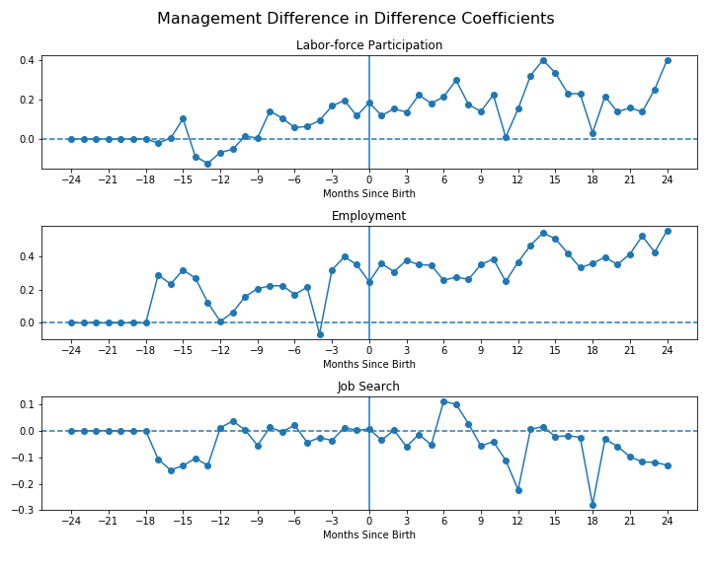

Table 16: Management P-Values of Joint Tests for Significance: Months Since Birth * Policy Coefficients

|  |  |  |  |
| --- | --- | --- | --- |
| Months Since Birth | Labor-force Participation | Working | Looking |
| -17 to -12 | 0.32 | 0.13 | 0.55 |
| -15 to -9 | 0.63 | 0.29 | 0.59 |
| -12 to -6 | 0.72 | 0.86 | 0.73 |
| -9 to -3 | 0.52 | 0.53 | 0.80 |
| -6 to 0 | 0.73 | 0.40 | 0.90 |
| -3 to +3 | 0.82 | 0.36 | 0.65 |
| 0 to + 6 | 0.67 | 0.58 | 0.40 |
| +3 to +9 | 0.40 | 0.72 | 0.43 |
| +6 to +12 | 0.19 | 0.44 | 0.48 |
| +9 to + 15 | 0.09* | 0.07* | 0.69 |
| +12 to + 18 | 0.21 | 0.26 | 0.52 |
| + 15 to + 21 | 0.33 | 0.42 | 0.71 |
| +18 to +24 | 0.35 | 0.43 | 0.81 |
| -17 to 0 | 0.55 | 0.25 | 0.87 |
| 0 to +24 | 0.12 | 0.33 | 0.58 |

Table 17: Management Sums of Months Since Birth * Policy Coefficients

|  |  |  |  |
| --- | --- | --- | --- |
| Months Since Birth | Labor-force Participation | Working | Looking |
| -17 to -12 | -0.19 | 1.24 | -0.61 |
| -15 to -9 | -0.21 | 1.14 | -0.37 |
| -12 to -6 | 0.20 | 1.05 | 0.03 |
| -9 to -3 | 0.63 | 1.29 | -0.13 |
| -6 to 0 | 0.88 | 1.63 | -0.07 |
| -3 to +3 | 1.07 | 2.35 | -0.11 |
| 0 to + 6 | 1.21 | 2.24 | -0.04 |
| +3 to +9 | 1.36 | 2.21 | 0.05 |
| +6 to +12 | 1.21 | 2.14 | -0.19 |
| +9 to + 15 | 1.58 | 2.86 | -0.43 |
| +12 to + 18 | 1.69 | 2.98 | -0.55 |
| + 15 to + 21 | 1.33 | 2.77 | -0.53 |
| +18 to +24 | 1.33 | 3.02 | -0.83 |
| -17 to 0 | 0.90 | 3.74 | -0.68 |
| 0 to +24 | 5.04 | 9.40 | -1.23 |

Table 18: Management P-Values of Joint Tests for Significance of Sums

|  |  |  |  |
| --- | --- | --- | --- |
| Months Since Birth | Labor-force Participation | Working | Looking |
| -17 to -12 | 0.82 | 0.14 | 0.48 |
| -15 to -9 | 0.85 | 0.31 | 0.69 |
| -12 to -6 | 0.84 | 0.39 | 0.97 |
| -9 to -3 | 0.56 | 0.36 | 0.87 |
| -6 to 0 | 0.44 | 0.28 | 0.92 |
| -3 to +3 | 0.33 | 0.12 | 0.87 |
| 0 to + 6 | 0.29 | 0.14 | 0.96 |
| +3 to +9 | 0.28 | 0.17 | 0.95 |
| +6 to +12 | 0.37 | 0.21 | 0.83 |
| +9 to + 15 | 0.24 | 0.09* | 0.65 |
| +12 to + 18 | 0.24 | 0.08* | 0.61 |
| + 15 to + 21 | 0.36 | 0.11 | 0.62 |
| +18 to +24 | 0.35 | 0.10 | 0.40 |
| -17 to 0 | 0.71 | 0.21 | 0.73 |
| 0 to +24 | 0.26 | 0.10 | 0.69 |

For women who worked in management occupations prior to giving birth, the difference in difference analysis yielded positive and jointly significant effects of paid family leave on labor-force participation and employment in the period of nine to fifteen months after birth. There were no significant effects of the paid leave policies on the probability of looking for work.

Figure

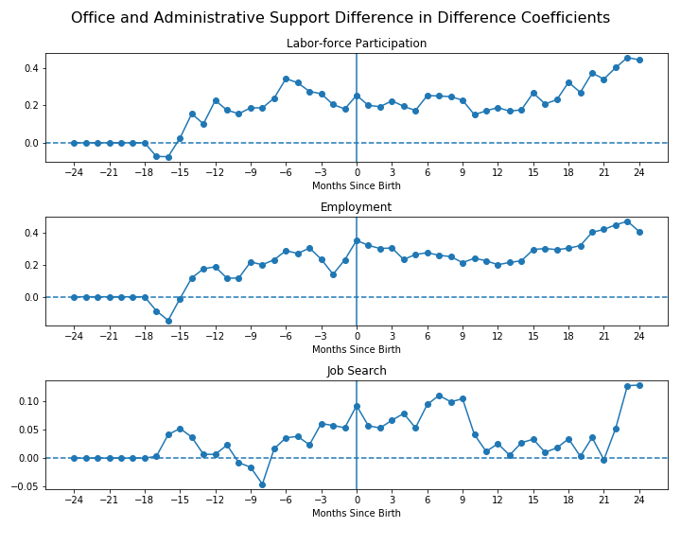

Regressions for Office and Administrative Support Occupational Group

Table : P-Values of Joint Tests for Significance: Months Since Birth * Policy Coefficients

|  |  |  |  |
| --- | --- | --- | --- |
| Months Since Birth | Labor-force Participation | Working | Looking |
| -17 to -12 | 0.06* | 0.09* | 0.88 |
| -15 to -9 | 0.18 | 0.60 | 0.80 |
| -12 to -6 | 0.34 | 0.61 | 0.55 |
| -9 to -3 | 0.41 | 0.70 | 0.42 |
| -6 to 0 | 0.34 | 0.17 | 0.53 |
| -3 to +3 | 0.32 | 0.23 | 0.62 |
| 0 to + 6 | 0.24 | 0.59 | 0.55 |
| +3 to +9 | 0.51 | 0.68 | 0.76 |
| +6 to +12 | 0.35 | 0.83 | 0.60 |
| +9 to + 15 | 0.19 | 0.82 | 0.68 |
| +12 to + 18 | 0.35 | 0.79 | 0.73 |
| + 15 to + 21 | 0.04** | 0.48 | 0.57 |
| +18 to +24 | 0.02** | 0.32 | 0.25 |
| 0 to +24 | 0.09* | 0.93 | 0.62 |

For women who worked in office and administrative support occupations prior to giving birth, the difference in difference analysis yielded jointly significant effects (at the 10% level) of paid family leave on labor-force participation and employment in the period of seventeen to twelve months after birth. However, the point estimates range from negative to positive values, so the evidence to support any particular direction of effect is weakened. There are additionally positive and jointly significant effects on labor-force participation in the period of 15 to 21 months after birth as well as 18 to 24 months after birth. There were no significant effects of the paid leave policies on the probability of looking for work.

Discussion

A further difficulty in interpreting the effect of paid family leave on employment outcomes is due to the nature of the specification. While a binary encoding is intuitive for labor-force participation, using a binary encoding of ‘working’ and ‘looking for work’ does not allow for a nuanced interpretation of effects. A change in the probability of working or looking for work reflects both changes in labor-force participation and changes in employment. Under the specification used for example, it is unclear whether the increase in probability of working for women without a college degree is due to women remaining employed when they would have otherwise dropped out of the labor-force, or women remaining employed when they would have otherwise become unemployed. If I were to redo this study from the beginning, I would use a multinomial logistic regression model to identify the relative changes of probability of each labor-market outcome compared to each other possible outcome.

Limitations

Empirical analysis of employer mandates is often difficult to examine with rigor due to the limitations of available data. Segmenting individual level data like the Survey of Income and Program Participation by geographical location and time period leads to small sample sizes and low statistical power. Aggregate data, on the other hand, lacks the granularity necessary to estimate the effect of the mandate on the subpopulations that are likely to be affect most by the mandate.

**Conclusion**

**References**

Bartel, A., Baum, C., Rossin-Slater, M., Ruhm, C., & Waldfogel, J. (2014). California’s Paid Family Leave Law: Lessons from the First Decade. Federal Publications. Retrieved from https://digitalcommons.ilr.cornell.edu/key_workplace/1594

Bartel, A. P., Rossin‐Slater, M., Ruhm, C. J., Stearns, J., & Waldfogel, J. (2018). Paid Family Leave, Fathers’ Leave-Taking, and Leave-Sharing in Dual-Earner Households. Journal of Policy Analysis and Management, 37(1), 10–37. https://doi.org/10.1002/pam.22030

Baum, C. L., & Ruhm, C. J. (2014). The Effects of Paid Family Leave in California on Labor Market Outcomes. Journal of Policy Analysis and Management, 35(2), 333–356. https://doi.org/10.1002/pam.21894

Byker, T. S. (2016). Paid Parental Leave Laws in the United States: Does Short-Duration Leave Affect Women’s Labor-Force Attachment? American Economic Review, 106(5), 242–246. https://doi.org/10.1257/aer.p20161118

—— (2016). The Opt-Out Continuation: Education, Work, and Motherhood from 1984 to 2012. RSF: The Russell Sage Foundation Journal of the Social Sciences, 2(4), 34–70. https://doi.org/10.7758/RSF.2016.2.4.02

Curtis, E. M., Hirsch, B. T., & Schroeder, M. C. (2016). Evaluating Workplace Mandates with Flows Versus Stocks: An Application to California Paid Family Leave. Southern Economic Journal, 83(2), 501–526. https://doi.org/10.1002/soej.12150

Das, T., & Polachek, S. W. (2015). Unanticipated Effects of California’s Paid Family Leave Program. Contemporary Economic Policy, 33(4), 619–635. https://doi.org/10.1111/coep.12102

Gruber, Jonathan. (2000). "Payroll Taxation, Employer Mandates, and the Labor Market." In Employee Benefits and Labor Markets in Canada and the United States, William T. Alpert, and Stephen A. Woodbury, eds. Kalamazoo, MI: W.E. Upjohn Institute for Employment Research, pp. 183–228. https://doi.org/10.17848/9780880995511.ch4

Han, W.-J., Ruhm, C., & Waldfogel, J. (2009). Parental leave policies and parents’ employment and leave-taking. Journal of Policy Analysis and Management, 28(1), 29–54. https://doi.org/10.1002/pam.20398

Klerman, J. A., Daley, K., & Pozniak, A. (2012). Family and Medical Leave in 2012: Technical Report (contract #GS10FOO86K). Cambridge, MA: Abt Associates. Retrieved from U.S. Department of Labor website: http://www.dol.gov/asp/evaluation/fmla/FMLATechnicalReport.pdf

Rossin‐Slater, M., Ruhm, C. J., & Waldfogel, J. (2013). The Effects of California’s Paid Family Leave Program on Mothers’ Leave-Taking and Subsequent Labor Market Outcomes. Journal of Policy Analysis and Management, 32(2), 224–245. https://doi.org/10.1002/pam.21676

Waldfogel, J. (1998). Understanding the “Family Gap” in Pay for Women with Children. Journal of Economic Perspectives, 12(1), 137–156. https://doi.org/10.1257/jep.12.1.137

1. In terms of 2019 dollars
2. In terms of 2019 dollars
3. If an individual is away on paid leave, she is encoded by the SIPP as employed and working all weeks.
4. As some individuals were classified as unemployed or out of the labor-force immediately prior to birth or had missing data on occupation, the month relative to birth used to extract this information differs from individual to individual.
5. Months -24 to -18 are omitted to serve as a reference period