User Guide

1. Install plugin com.alex.example.fixlicense, copy it into the dropins folder of your Eclipse installation.
2. Edit the license.txt and license_inline.txt files find from the plugin folder, set their contents as you wish.
3. After restart Eclipse, you will find a new menu named “License” added to your Eclipse IDE, if you can not see the menu, then the plugin hasn’t been loaded correctly, please fix it firstly, basically you need guarantee all the dependencies exist.

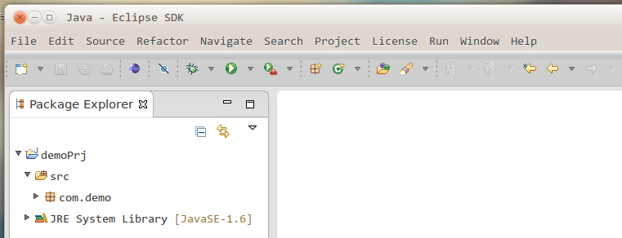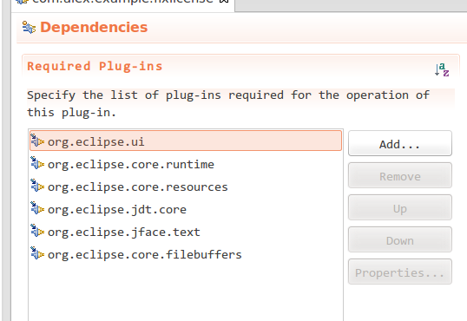

1. As default, the utility will scan all projects exist in your Eclipse workspace, for those projects you won’t fix the license, just close them before scanning, for projects exist in other workspace, you can import them first.
2. Invoke the “Fix License” command under the “License” menu, that all.
3. Below is an example on what happened.

Before

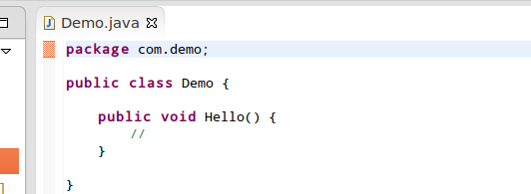

After

