Crowfunding en el Mercado de Capitales Colombiano - Proyecto de Estadística para la Analítica de Datos

Sergio Castañeda, Guillermo Castillo, Alexander Guecha

24/04/2022

knitr::opts_chunk$set(echo = T)

BdCrowfunding<-read.table(file.choose(), header = T, sep = ";")

# ANÁLISIS EXPLORATORIO DE LOS DATOS

## Resumen univariado de variables cualitativas

### Variable: SectorCamp

SectorCampaña_= BdCrowfunding$SectorCamp  
SCtabla=data.frame(table(SectorCampaña_))  
porcentaje=prop.table(SCtabla[,2])  
SCtabla2= cbind(SCtabla, porcentaje)  
cum_frequencia=cumsum(SCtabla2[,2])  
SCtabla3= cbind(SCtabla2, cum_frequencia)  
cum_porcentaje=cumsum(SCtabla3[,3])  
SCtabla4= cbind(SCtabla3, cum_porcentaje)  
SCtabla4

## SectorCampaña_ Freq porcentaje cum_frequencia cum_porcentaje  
## 1 Comercio 2445 0.086475207 2445 0.08647521  
## 2 ConstrucciÃ³n y Materiales 1932 0.068331329 4377 0.15480654  
## 3 Educacion 151 0.005340596 4528 0.16014713  
## 4 EnergÃ­as 2531 0.089516871 7059 0.24966400  
## 5 Entretenimiento 180 0.006366273 7239 0.25603028  
## 6 Logistica 2085 0.073742661 9324 0.32977294  
## 7 Movilidad y transporte 1040 0.036782910 10364 0.36655585  
## 8 Publicidad 125 0.004421023 10489 0.37097687  
## 9 RSE 938 0.033175355 11427 0.40415222  
## 10 Salud 3637 0.128634081 15064 0.53278631  
## 11 Servicios Alimenticios 6206 0.219494942 21270 0.75228125  
## 12 Servicios especializados 372 0.013156964 21642 0.76543821  
## 13 TecnologÃ­a 4885 0.172773573 26527 0.93821178  
## 14 Telecomunicaciones 1463 0.051743651 27990 0.98995544  
## 15 Turismo 284 0.010044564 28274 1.00000000

knitr::kable(  
 (SCtabla4)  
)

| SectorCampaña_ | Freq | porcentaje | cum_frequencia | cum_porcentaje |
| --- | --- | --- | --- | --- |
| Comercio | 2445 | 0.0864752 | 2445 | 0.0864752 |
| ConstrucciÃ³n y Materiales | 1932 | 0.0683313 | 4377 | 0.1548065 |
| Educacion | 151 | 0.0053406 | 4528 | 0.1601471 |
| EnergÃ­as | 2531 | 0.0895169 | 7059 | 0.2496640 |
| Entretenimiento | 180 | 0.0063663 | 7239 | 0.2560303 |
| Logistica | 2085 | 0.0737427 | 9324 | 0.3297729 |
| Movilidad y transporte | 1040 | 0.0367829 | 10364 | 0.3665558 |
| Publicidad | 125 | 0.0044210 | 10489 | 0.3709769 |
| RSE | 938 | 0.0331754 | 11427 | 0.4041522 |
| Salud | 3637 | 0.1286341 | 15064 | 0.5327863 |
| Servicios Alimenticios | 6206 | 0.2194949 | 21270 | 0.7522812 |
| Servicios especializados | 372 | 0.0131570 | 21642 | 0.7654382 |
| TecnologÃ­a | 4885 | 0.1727736 | 26527 | 0.9382118 |
| Telecomunicaciones | 1463 | 0.0517437 | 27990 | 0.9899554 |
| Turismo | 284 | 0.0100446 | 28274 | 1.0000000 |

colors <- c(2, 3, 4, 5, 6, 7, 8, 9, 10, 11, 12, 13, 14, 15, 16)  
BPSectorCampaña <- barplot(prop.table(table(BdCrowfunding$SectorCamp)),col= colors,  
 main="Frecuencias relativas por sector de campaña",ylim=c(0,0.25),ylab ="Frecuencias Relativas",las=2 )

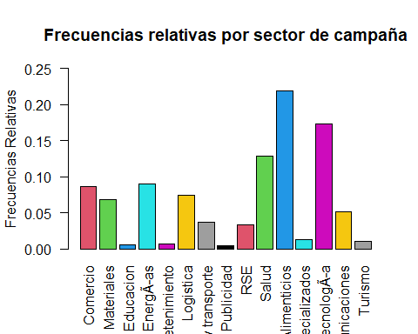

pie(SCtabla4[,3],labels=SCtabla4[,1], clockwise=TRUE,radius=1,border="black",main="Diagrama de Sectores")

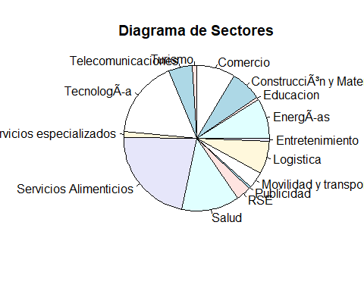

### Variable: Campaña

Campaña= BdCrowfunding$Camp  
Ctabla=data.frame(table(Campaña))  
porcentaje=prop.table(Ctabla[,2])  
Ctabla2= cbind(Ctabla, porcentaje)  
cum_frequencia=cumsum(Ctabla2[,2])  
Ctabla3= cbind(Ctabla2, cum_frequencia)  
cum_porcentaje=cumsum(Ctabla3[,3])  
Ctabla4= cbind(Ctabla3, cum_porcentaje)  
Ctabla4

## Campaña Freq porcentaje cum_frequencia cum_porcentaje  
## 1 8B-57 137 0.004845441 137 0.004845441  
## 2 93-44 284 0.010044564 421 0.014890005  
## 3 Ab-2 100 0.003536818 521 0.018426823  
## 4 Ad-65 125 0.004421023 646 0.022847846  
## 5 Al-1 143 0.005057650 789 0.027905496  
## 6 AL-66 315 0.011140978 1104 0.039046474  
## 7 AL-76 279 0.009867723 1383 0.048914197  
## 8 Al-92 1379 0.048772724 2762 0.097686921  
## 9 An-89 393 0.013899696 3155 0.111586617  
## 10 Ao-46 430 0.015208319 3585 0.126794935  
## 11 As-60 413 0.014607059 3998 0.141401995  
## 12 As-64 411 0.014536323 4409 0.155938318  
## 13 Au-38 132 0.004668600 4541 0.160606918  
## 14 Be-73 85 0.003006296 4626 0.163613214  
## 15 Bi-25 210 0.007427318 4836 0.171040532  
## 16 Ce-59 309 0.010928768 5145 0.181969300  
## 17 CK-39 231 0.008170050 5376 0.190139351  
## 18 Co-31 278 0.009832355 5654 0.199971705  
## 19 Co-51 144 0.005093018 5798 0.205064724  
## 20 Co-75 641 0.022671005 6439 0.227735729  
## 21 De-16 97 0.003430714 6536 0.231166443  
## 22 De-28 86 0.003041664 6622 0.234208106  
## 23 De-35 83 0.002935559 6705 0.237143666  
## 24 De-4 77 0.002723350 6782 0.239867016  
## 25 Di-33 148 0.005234491 6930 0.245101507  
## 26 Di-71 162 0.005729646 7092 0.250831152  
## 27 Di-78 188 0.006649218 7280 0.257480371  
## 28 Ec-80 339 0.011989814 7619 0.269470185  
## 29 ED-47 77 0.002723350 7696 0.272193535  
## 30 Ed-49 151 0.005340596 7847 0.277534130  
## 31 El-74 945 0.033422933 8792 0.310957063  
## 32 El-77 112 0.003961236 8904 0.314918299  
## 33 FA-37 418 0.014783900 9322 0.329702200  
## 34 Fe-68 163 0.005765014 9485 0.335467214  
## 35 Fi-7 79 0.002794086 9564 0.338261300  
## 36 Fu-55 164 0.005800382 9728 0.344061682  
## 37 Ge-52 794 0.028082337 10522 0.372144019  
## 38 Ge-69 863 0.030522742 11385 0.402666761  
## 39 Ge-96 278 0.009832355 11663 0.412499116  
## 40 Go-19 146 0.005163755 11809 0.417662870  
## 41 Go-97 223 0.007887105 12032 0.425549975  
## 42 Ha-30 172 0.006083327 12204 0.431633303  
## 43 Ha-63 1401 0.049550824 13605 0.481184127  
## 44 Im-32 70 0.002475773 13675 0.483659900  
## 45 La-42 412 0.014571691 14087 0.498231591  
## 46 Le-70 412 0.014571691 14499 0.512803282  
## 47 Le-79 649 0.022953951 15148 0.535757233  
## 48 Ma-40 67 0.002369668 15215 0.538126901  
## 49 Ma-56 331 0.011706869 15546 0.549833770  
## 50 Ma-99 288 0.010186037 15834 0.560019806  
## 51 Mi-17 76 0.002687982 15910 0.562707788  
## 52 MI-20 88 0.003112400 15998 0.565820188  
## 53 Mi-23 202 0.007144373 16200 0.572964561  
## 54 Mi-98 152 0.005375964 16352 0.578340525  
## 55 MO-67 79 0.002794086 16431 0.581134611  
## 56 No-84 174 0.006154064 16605 0.587288675  
## 57 Oa-27 102 0.003607555 16707 0.590896230  
## 58 Or-6 69 0.002440405 16776 0.593336634  
## 59 Pa-3 91 0.003218505 16867 0.596555139  
## 60 Pa-62 276 0.009761618 17143 0.606316757  
## 61 Pi-41 81 0.002864823 17224 0.609181580  
## 62 Pl-11 63 0.002228196 17287 0.611409776  
## 63 Pl-45 108 0.003819764 17395 0.615229540  
## 64 Pr-15 190 0.006719955 17585 0.621949494  
## 65 Pr-22 135 0.004774705 17720 0.626724199  
## 66 Pr-5 126 0.004456391 17846 0.631180590  
## 67 Qu-9 75 0.002652614 17921 0.633833204  
## 68 Re-26 372 0.013156964 18293 0.646990168  
## 69 Re-88 186 0.006578482 18479 0.653568650  
## 70 Re-90 96 0.003395346 18575 0.656963995  
## 71 Ro-54 572 0.020230601 19147 0.677194596  
## 72 Ro-95 1743 0.061646743 20890 0.738841338  
## 73 Sa-12 231 0.008170050 21121 0.747011389  
## 74 Sa-18 75 0.002652614 21196 0.749664002  
## 75 Sa-8 129 0.004562496 21325 0.754226498  
## 76 SA-86 143 0.005057650 21468 0.759284148  
## 77 Se-13 170 0.006012591 21638 0.765296739  
## 78 Se-58 417 0.014748532 22055 0.780045271  
## 79 Se-93 341 0.012060550 22396 0.792105822  
## 80 SM-29 238 0.008417628 22634 0.800523449  
## 81 Sm-72 341 0.012060550 22975 0.812583999  
## 82 St-94 338 0.011954446 23313 0.824538445  
## 83 Su-34 180 0.006366273 23493 0.830904718  
## 84 Su-43 192 0.006790691 23685 0.837695409  
## 85 SU-82 95 0.003359977 23780 0.841055387  
## 86 Sy-83 72 0.002546509 23852 0.843601896  
## 87 T4-50 450 0.015915682 24302 0.859517578  
## 88 T4-85 942 0.033316828 25244 0.892834406  
## 89 Ti-21 180 0.006366273 25424 0.899200679  
## 90 To-10 246 0.008700573 25670 0.907901252  
## 91 To-81 595 0.021044069 26265 0.928945321  
## 92 Tr-91 918 0.032467992 27183 0.961413313  
## 93 Tu-36 270 0.009549409 27453 0.970962722  
## 94 Va-61 104 0.003678291 27557 0.974641013  
## 95 Ve-14 133 0.004703968 27690 0.979344981  
## 96 Ve-24 137 0.004845441 27827 0.984190422  
## 97 Ve-48 108 0.003819764 27935 0.988010186  
## 98 Ve-53 142 0.005022282 28077 0.993032468  
## 99 Ve-87 197 0.006967532 28274 1.000000000

knitr::kable(  
 (Ctabla4)  
)

| Campaña | Freq | porcentaje | cum_frequencia | cum_porcentaje |
| --- | --- | --- | --- | --- |
| 8B-57 | 137 | 0.0048454 | 137 | 0.0048454 |
| 93-44 | 284 | 0.0100446 | 421 | 0.0148900 |
| Ab-2 | 100 | 0.0035368 | 521 | 0.0184268 |
| Ad-65 | 125 | 0.0044210 | 646 | 0.0228478 |
| Al-1 | 143 | 0.0050577 | 789 | 0.0279055 |
| AL-66 | 315 | 0.0111410 | 1104 | 0.0390465 |
| AL-76 | 279 | 0.0098677 | 1383 | 0.0489142 |
| Al-92 | 1379 | 0.0487727 | 2762 | 0.0976869 |
| An-89 | 393 | 0.0138997 | 3155 | 0.1115866 |
| Ao-46 | 430 | 0.0152083 | 3585 | 0.1267949 |
| As-60 | 413 | 0.0146071 | 3998 | 0.1414020 |
| As-64 | 411 | 0.0145363 | 4409 | 0.1559383 |
| Au-38 | 132 | 0.0046686 | 4541 | 0.1606069 |
| Be-73 | 85 | 0.0030063 | 4626 | 0.1636132 |
| Bi-25 | 210 | 0.0074273 | 4836 | 0.1710405 |
| Ce-59 | 309 | 0.0109288 | 5145 | 0.1819693 |
| CK-39 | 231 | 0.0081701 | 5376 | 0.1901394 |
| Co-31 | 278 | 0.0098324 | 5654 | 0.1999717 |
| Co-51 | 144 | 0.0050930 | 5798 | 0.2050647 |
| Co-75 | 641 | 0.0226710 | 6439 | 0.2277357 |
| De-16 | 97 | 0.0034307 | 6536 | 0.2311664 |
| De-28 | 86 | 0.0030417 | 6622 | 0.2342081 |
| De-35 | 83 | 0.0029356 | 6705 | 0.2371437 |
| De-4 | 77 | 0.0027234 | 6782 | 0.2398670 |
| Di-33 | 148 | 0.0052345 | 6930 | 0.2451015 |
| Di-71 | 162 | 0.0057296 | 7092 | 0.2508312 |
| Di-78 | 188 | 0.0066492 | 7280 | 0.2574804 |
| Ec-80 | 339 | 0.0119898 | 7619 | 0.2694702 |
| ED-47 | 77 | 0.0027234 | 7696 | 0.2721935 |
| Ed-49 | 151 | 0.0053406 | 7847 | 0.2775341 |
| El-74 | 945 | 0.0334229 | 8792 | 0.3109571 |
| El-77 | 112 | 0.0039612 | 8904 | 0.3149183 |
| FA-37 | 418 | 0.0147839 | 9322 | 0.3297022 |
| Fe-68 | 163 | 0.0057650 | 9485 | 0.3354672 |
| Fi-7 | 79 | 0.0027941 | 9564 | 0.3382613 |
| Fu-55 | 164 | 0.0058004 | 9728 | 0.3440617 |
| Ge-52 | 794 | 0.0280823 | 10522 | 0.3721440 |
| Ge-69 | 863 | 0.0305227 | 11385 | 0.4026668 |
| Ge-96 | 278 | 0.0098324 | 11663 | 0.4124991 |
| Go-19 | 146 | 0.0051638 | 11809 | 0.4176629 |
| Go-97 | 223 | 0.0078871 | 12032 | 0.4255500 |
| Ha-30 | 172 | 0.0060833 | 12204 | 0.4316333 |
| Ha-63 | 1401 | 0.0495508 | 13605 | 0.4811841 |
| Im-32 | 70 | 0.0024758 | 13675 | 0.4836599 |
| La-42 | 412 | 0.0145717 | 14087 | 0.4982316 |
| Le-70 | 412 | 0.0145717 | 14499 | 0.5128033 |
| Le-79 | 649 | 0.0229540 | 15148 | 0.5357572 |
| Ma-40 | 67 | 0.0023697 | 15215 | 0.5381269 |
| Ma-56 | 331 | 0.0117069 | 15546 | 0.5498338 |
| Ma-99 | 288 | 0.0101860 | 15834 | 0.5600198 |
| Mi-17 | 76 | 0.0026880 | 15910 | 0.5627078 |
| MI-20 | 88 | 0.0031124 | 15998 | 0.5658202 |
| Mi-23 | 202 | 0.0071444 | 16200 | 0.5729646 |
| Mi-98 | 152 | 0.0053760 | 16352 | 0.5783405 |
| MO-67 | 79 | 0.0027941 | 16431 | 0.5811346 |
| No-84 | 174 | 0.0061541 | 16605 | 0.5872887 |
| Oa-27 | 102 | 0.0036076 | 16707 | 0.5908962 |
| Or-6 | 69 | 0.0024404 | 16776 | 0.5933366 |
| Pa-3 | 91 | 0.0032185 | 16867 | 0.5965551 |
| Pa-62 | 276 | 0.0097616 | 17143 | 0.6063168 |
| Pi-41 | 81 | 0.0028648 | 17224 | 0.6091816 |
| Pl-11 | 63 | 0.0022282 | 17287 | 0.6114098 |
| Pl-45 | 108 | 0.0038198 | 17395 | 0.6152295 |
| Pr-15 | 190 | 0.0067200 | 17585 | 0.6219495 |
| Pr-22 | 135 | 0.0047747 | 17720 | 0.6267242 |
| Pr-5 | 126 | 0.0044564 | 17846 | 0.6311806 |
| Qu-9 | 75 | 0.0026526 | 17921 | 0.6338332 |
| Re-26 | 372 | 0.0131570 | 18293 | 0.6469902 |
| Re-88 | 186 | 0.0065785 | 18479 | 0.6535686 |
| Re-90 | 96 | 0.0033953 | 18575 | 0.6569640 |
| Ro-54 | 572 | 0.0202306 | 19147 | 0.6771946 |
| Ro-95 | 1743 | 0.0616467 | 20890 | 0.7388413 |
| Sa-12 | 231 | 0.0081701 | 21121 | 0.7470114 |
| Sa-18 | 75 | 0.0026526 | 21196 | 0.7496640 |
| Sa-8 | 129 | 0.0045625 | 21325 | 0.7542265 |
| SA-86 | 143 | 0.0050577 | 21468 | 0.7592841 |
| Se-13 | 170 | 0.0060126 | 21638 | 0.7652967 |
| Se-58 | 417 | 0.0147485 | 22055 | 0.7800453 |
| Se-93 | 341 | 0.0120606 | 22396 | 0.7921058 |
| SM-29 | 238 | 0.0084176 | 22634 | 0.8005234 |
| Sm-72 | 341 | 0.0120606 | 22975 | 0.8125840 |
| St-94 | 338 | 0.0119544 | 23313 | 0.8245384 |
| Su-34 | 180 | 0.0063663 | 23493 | 0.8309047 |
| Su-43 | 192 | 0.0067907 | 23685 | 0.8376954 |
| SU-82 | 95 | 0.0033600 | 23780 | 0.8410554 |
| Sy-83 | 72 | 0.0025465 | 23852 | 0.8436019 |
| T4-50 | 450 | 0.0159157 | 24302 | 0.8595176 |
| T4-85 | 942 | 0.0333168 | 25244 | 0.8928344 |
| Ti-21 | 180 | 0.0063663 | 25424 | 0.8992007 |
| To-10 | 246 | 0.0087006 | 25670 | 0.9079013 |
| To-81 | 595 | 0.0210441 | 26265 | 0.9289453 |
| Tr-91 | 918 | 0.0324680 | 27183 | 0.9614133 |
| Tu-36 | 270 | 0.0095494 | 27453 | 0.9709627 |
| Va-61 | 104 | 0.0036783 | 27557 | 0.9746410 |
| Ve-14 | 133 | 0.0047040 | 27690 | 0.9793450 |
| Ve-24 | 137 | 0.0048454 | 27827 | 0.9841904 |
| Ve-48 | 108 | 0.0038198 | 27935 | 0.9880102 |
| Ve-53 | 142 | 0.0050223 | 28077 | 0.9930325 |
| Ve-87 | 197 | 0.0069675 | 28274 | 1.0000000 |

BPCampaña <- barplot(prop.table(table(BdCrowfunding$Camp)),main="Frecuencias relativas por campaña",ylim=c(0,0.07),ylab ="Frecuencias Relativas",las=2 )

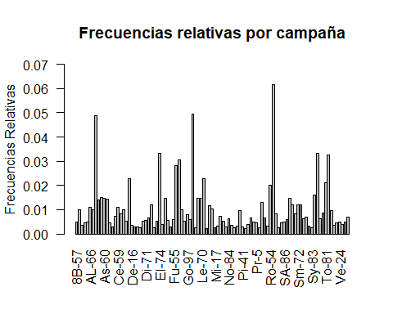

pie(Ctabla4[,3],labels=Ctabla4[,1], clockwise=TRUE,radius=1,border="black",main="Diagrama de Sectores")

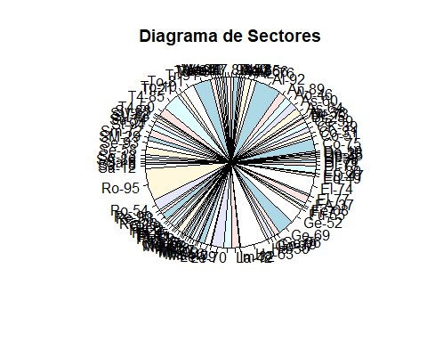

### Variable: Calidad Tributaria

CalidadTributaria= BdCrowfunding$CalidadTributaria  
CTtabla=data.frame(table(CalidadTributaria))  
porcentaje=prop.table(CTtabla[,2])  
CTtabla2= cbind(CTtabla, porcentaje)  
cum_frequencia=cumsum(CTtabla2[,2])  
CTtabla3= cbind(CTtabla2, cum_frequencia)  
cum_porcentaje=cumsum(CTtabla3[,3])  
CTtabla4= cbind(CTtabla3, cum_porcentaje)  
CTtabla4

## CalidadTributaria Freq porcentaje cum_frequencia cum_porcentaje  
## 1 AUTO RETENEDOR 310 0.01096414 310 0.01096414  
## 2 DECLARANTE 14150 0.50045979 14460 0.51142392  
## 3 GRAN CONTRIBUYENTE 292 0.01032751 14752 0.52175143  
## 4 NO CONTRIBUYENTE 9761 0.34522883 24513 0.86698026  
## 5 NO DECLARANTE 3761 0.13301974 28274 1.00000000

knitr::kable(  
 (CTtabla4)  
)

| CalidadTributaria | Freq | porcentaje | cum_frequencia | cum_porcentaje |
| --- | --- | --- | --- | --- |
| AUTO RETENEDOR | 310 | 0.0109641 | 310 | 0.0109641 |
| DECLARANTE | 14150 | 0.5004598 | 14460 | 0.5114239 |
| GRAN CONTRIBUYENTE | 292 | 0.0103275 | 14752 | 0.5217514 |
| NO CONTRIBUYENTE | 9761 | 0.3452288 | 24513 | 0.8669803 |
| NO DECLARANTE | 3761 | 0.1330197 | 28274 | 1.0000000 |

colors <- c(2, 3, 4, 5, 6)  
BPCalidadTributaria <- barplot(prop.table(table(BdCrowfunding$CalidadTributaria)), col= colors,main="Frecuencias relativas por Calidad Tributaria",ylim=c(0,0.55),ylab ="Frecuencias Relativas",las=1 )

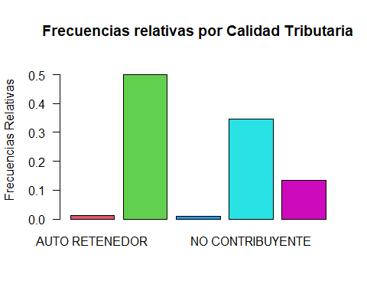

pie(CTtabla4[,3],labels=CTtabla4[,1], clockwise=TRUE,radius=1,border="black",main="Diagrama de Sectores")

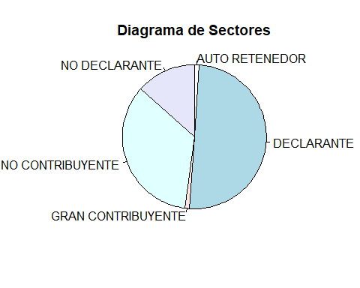

### Variable: Pais

Pais= BdCrowfunding$Pais  
Ptabla=data.frame(table(Pais))  
porcentaje=prop.table(Ptabla[,2])  
Ptabla2= cbind(Ptabla, porcentaje)  
cum_frequencia=cumsum(Ptabla2[,2])  
Ptabla3= cbind(Ptabla2, cum_frequencia)  
cum_porcentaje=cumsum(Ptabla3[,3])  
Ptabla4= cbind(Ptabla3, cum_porcentaje)  
Ptabla4

## Pais Freq porcentaje cum_frequencia cum_porcentaje  
## 1 Australia 25 8.842046e-04 25 0.0008842046  
## 2 Austria 10 3.536818e-04 35 0.0012378864  
## 3 Brazil 6 2.122091e-04 41 0.0014500955  
## 4 Chile 17 6.012591e-04 58 0.0020513546  
## 5 China 1 3.536818e-05 59 0.0020867228  
## 6 Colombia 28078 9.930678e-01 28137 0.9951545590  
## 7 Ecuador 3 1.061045e-04 28140 0.9952606635  
## 8 France 3 1.061045e-04 28143 0.9953667681  
## 9 Germany 5 1.768409e-04 28148 0.9955436090  
## 10 Mexico 14 4.951546e-04 28162 0.9960387635  
## 11 Netherlands Antilles 14 4.951546e-04 28176 0.9965339181  
## 12 New Zealand 2 7.073637e-05 28178 0.9966046545  
## 13 Panama 18 6.366273e-04 28196 0.9972412817  
## 14 Peru 1 3.536818e-05 28197 0.9972766499  
## 15 Qatar 5 1.768409e-04 28202 0.9974534908  
## 16 Saudi Arabia 13 4.597864e-04 28215 0.9979132772  
## 17 Spain 10 3.536818e-04 28225 0.9982669590  
## 18 United States 47 1.662305e-03 28272 0.9999292636  
## 19 Uruguay 2 7.073637e-05 28274 1.0000000000

knitr::kable(  
 (Ptabla4)  
)

| Pais | Freq | porcentaje | cum_frequencia | cum_porcentaje |
| --- | --- | --- | --- | --- |
| Australia | 25 | 0.0008842 | 25 | 0.0008842 |
| Austria | 10 | 0.0003537 | 35 | 0.0012379 |
| Brazil | 6 | 0.0002122 | 41 | 0.0014501 |
| Chile | 17 | 0.0006013 | 58 | 0.0020514 |
| China | 1 | 0.0000354 | 59 | 0.0020867 |
| Colombia | 28078 | 0.9930678 | 28137 | 0.9951546 |
| Ecuador | 3 | 0.0001061 | 28140 | 0.9952607 |
| France | 3 | 0.0001061 | 28143 | 0.9953668 |
| Germany | 5 | 0.0001768 | 28148 | 0.9955436 |
| Mexico | 14 | 0.0004952 | 28162 | 0.9960388 |
| Netherlands Antilles | 14 | 0.0004952 | 28176 | 0.9965339 |
| New Zealand | 2 | 0.0000707 | 28178 | 0.9966047 |
| Panama | 18 | 0.0006366 | 28196 | 0.9972413 |
| Peru | 1 | 0.0000354 | 28197 | 0.9972766 |
| Qatar | 5 | 0.0001768 | 28202 | 0.9974535 |
| Saudi Arabia | 13 | 0.0004598 | 28215 | 0.9979133 |
| Spain | 10 | 0.0003537 | 28225 | 0.9982670 |
| United States | 47 | 0.0016623 | 28272 | 0.9999293 |
| Uruguay | 2 | 0.0000707 | 28274 | 1.0000000 |

colors <- c(2, 3, 4, 5, 6, 7, 8, 9, 10, 11, 12, 13, 14, 15, 16, 17, 18, 19, 20)  
BPPais <- barplot(prop.table(table(BdCrowfunding$Pais)), col= colors,main="Frecuencias relativas por País",ylim=c(0,1.5),ylab ="Frecuencias Relativas",las=2 )

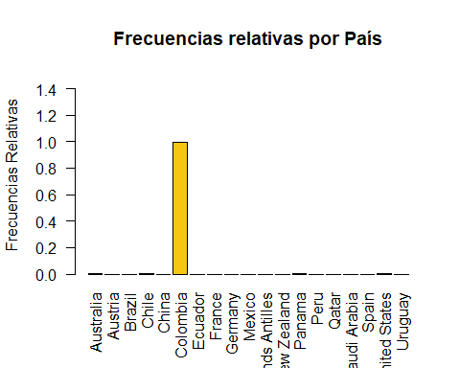

pie(Ptabla4[,3],labels=Ptabla4[,1], clockwise=TRUE,radius=1,border="black",main="Diagrama de Sectores")

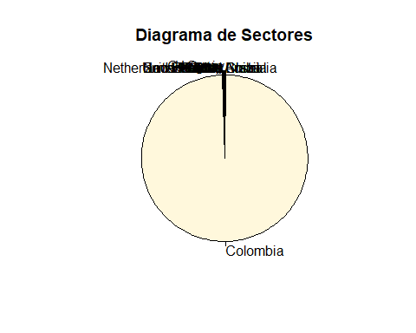

### Variable: Sector Económico

SectorEconomico= BdCrowfunding$SectorEconomico  
SEtabla=data.frame(table(SectorEconomico))  
porcentaje=prop.table(SEtabla[,2])  
SEtabla2= cbind(SEtabla, porcentaje)  
cum_frequencia=cumsum(SEtabla2[,2])  
SEtabla3= cbind(SEtabla2, cum_frequencia)  
cum_porcentaje=cumsum(SEtabla3[,3])  
SEtabla4= cbind(SEtabla3, cum_porcentaje)  
SEtabla4

## SectorEconomico Freq porcentaje  
## 1 ACUEDUCTO 7 2.475773e-04  
## 2 ADMINISTRACIÃ“N PÃšBLICA Y DEFENSA 133 4.703968e-03  
## 3 AGROINDUSTRIA 211 7.462687e-03  
## 4 ALOJAMIENTO Y SERVICIOS DE COMIDA 136 4.810073e-03  
## 5 AUTOMOTRIZ 62 2.192827e-03  
## 6 COMERCIO AL POR MAYOR 187 6.613850e-03  
## 7 COMERCIO AL POR MENOR 636 2.249416e-02  
## 8 CONSTRUCCIÃ“N 343 1.213129e-02  
## 9 EDUCACIÃ“N 1098 3.883426e-02  
## 10 FINANCIERO 412 1.457169e-02  
## 11 INDUSTRÃ\215AS CREATIVAS Y CULTURALES 240 8.488364e-03  
## 12 INFORMACIÃ“N Y COMUNICACIONES 2761 9.765155e-02  
## 13 INMOBILIARIAS 195 6.896796e-03  
## 14 INVESTIGACIÃ“N Y CIENCIAS 5198 1.838438e-01  
## 15 MANTENIMIENTO DE EQUIPOS 67 2.369668e-03  
## 16 MANTENIMIENTO Y CUIDADO TEXTIL 8 2.829455e-04  
## 17 MANUFACTURA 638 2.256490e-02  
## 18 MINERÃ\215A 276 9.761618e-03  
## 19 OTROS SERVICIOS 131 4.633232e-03  
## 20 PERSONA NATURAL 12830 4.537738e-01  
## 21 REPARACIÃ“N DE ACCESORIOS PARA EL HOGAR 1 3.536818e-05  
## 22 REPARACIÃ“N DE ENSERES 2 7.073637e-05  
## 23 SALUD 776 2.744571e-02  
## 24 SEGUROS DE SERVICIOS SOCIALES DE RIESGOS PROFESIONALES 1 3.536818e-05  
## 25 SERVICIOS ADMINISTRATIVOS 1478 5.227417e-02  
## 26 SERVICIOS DOMÃ‰STICOS 47 1.662305e-03  
## 27 SERVICIOS ENERGÃ‰TICOS 61 2.157459e-03  
## 28 TRANSPORTE Y ALMACENAMIENTO 339 1.198981e-02  
## cum_frequencia cum_porcentaje  
## 1 7 0.0002475773  
## 2 140 0.0049515456  
## 3 351 0.0124142322  
## 4 487 0.0172243050  
## 5 549 0.0194171323  
## 6 736 0.0260309825  
## 7 1372 0.0485251468  
## 8 1715 0.0606564335  
## 9 2813 0.0994906982  
## 10 3225 0.1140623895  
## 11 3465 0.1225507533  
## 12 6226 0.2202023060  
## 13 6421 0.2270991016  
## 14 11619 0.4109429158  
## 15 11686 0.4133125840  
## 16 11694 0.4135955295  
## 17 12332 0.4361604301  
## 18 12608 0.4459220485  
## 19 12739 0.4505552805  
## 20 25569 0.9043290656  
## 21 25570 0.9043644338  
## 22 25572 0.9044351701  
## 23 26348 0.9318808800  
## 24 26349 0.9319162481  
## 25 27827 0.9841904223  
## 26 27874 0.9858527269  
## 27 27935 0.9880101860  
## 28 28274 1.0000000000

knitr::kable(  
 (SEtabla4)  
)

| SectorEconomico | Freq | porcentaje | cum_frequencia | cum_porcentaje |
| --- | --- | --- | --- | --- |
| ACUEDUCTO | 7 | 0.0002476 | 7 | 0.0002476 |
| ADMINISTRACIÃ“N PÃšBLICA Y DEFENSA | 133 | 0.0047040 | 140 | 0.0049515 |
| AGROINDUSTRIA | 211 | 0.0074627 | 351 | 0.0124142 |
| ALOJAMIENTO Y SERVICIOS DE COMIDA | 136 | 0.0048101 | 487 | 0.0172243 |
| AUTOMOTRIZ | 62 | 0.0021928 | 549 | 0.0194171 |
| COMERCIO AL POR MAYOR | 187 | 0.0066139 | 736 | 0.0260310 |
| COMERCIO AL POR MENOR | 636 | 0.0224942 | 1372 | 0.0485251 |
| CONSTRUCCIÃ“N | 343 | 0.0121313 | 1715 | 0.0606564 |
| EDUCACIÃ“N | 1098 | 0.0388343 | 2813 | 0.0994907 |
| FINANCIERO | 412 | 0.0145717 | 3225 | 0.1140624 |
| INDUSTRÃAS CREATIVAS Y CULTURALES | 240 | 0.0084884 | 3465 | 0.1225508 |
| INFORMACIÃ“N Y COMUNICACIONES | 2761 | 0.0976516 | 6226 | 0.2202023 |
| INMOBILIARIAS | 195 | 0.0068968 | 6421 | 0.2270991 |
| INVESTIGACIÃ“N Y CIENCIAS | 5198 | 0.1838438 | 11619 | 0.4109429 |
| MANTENIMIENTO DE EQUIPOS | 67 | 0.0023697 | 11686 | 0.4133126 |
| MANTENIMIENTO Y CUIDADO TEXTIL | 8 | 0.0002829 | 11694 | 0.4135955 |
| MANUFACTURA | 638 | 0.0225649 | 12332 | 0.4361604 |
| MINERÃA | 276 | 0.0097616 | 12608 | 0.4459220 |
| OTROS SERVICIOS | 131 | 0.0046332 | 12739 | 0.4505553 |
| PERSONA NATURAL | 12830 | 0.4537738 | 25569 | 0.9043291 |
| REPARACIÃ“N DE ACCESORIOS PARA EL HOGAR | 1 | 0.0000354 | 25570 | 0.9043644 |
| REPARACIÃ“N DE ENSERES | 2 | 0.0000707 | 25572 | 0.9044352 |
| SALUD | 776 | 0.0274457 | 26348 | 0.9318809 |
| SEGUROS DE SERVICIOS SOCIALES DE RIESGOS PROFESIONALES | 1 | 0.0000354 | 26349 | 0.9319162 |
| SERVICIOS ADMINISTRATIVOS | 1478 | 0.0522742 | 27827 | 0.9841904 |
| SERVICIOS DOMÃ‰STICOS | 47 | 0.0016623 | 27874 | 0.9858527 |
| SERVICIOS ENERGÃ‰TICOS | 61 | 0.0021575 | 27935 | 0.9880102 |
| TRANSPORTE Y ALMACENAMIENTO | 339 | 0.0119898 | 28274 | 1.0000000 |

colors <- c(2, 3, 4, 5, 6, 7, 8, 9, 10, 11, 12, 13, 14, 15, 16, 17, 18, 19, 20,21,22,23,24,25,26,27,28,29)  
BPSectorEconomico <- barplot(prop.table(table(BdCrowfunding$SectorEconomico)), col= colors,main="Frecuencias relativas por Sector Económico",ylim=c(0,0.5),ylab ="Frecuencias Relativas",las=2 )

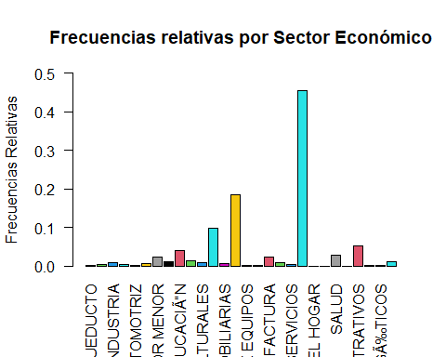

pie(SEtabla4[,3],labels=SEtabla4[,1], clockwise=TRUE,radius=1,border="black",main="Diagrama de Sectores")

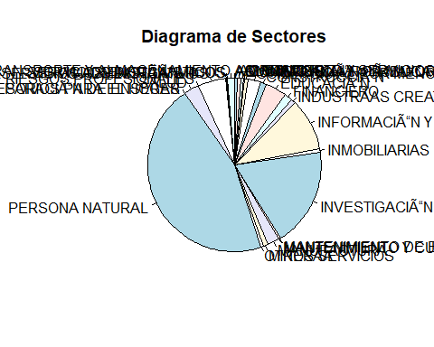

### Variable: Tipo Inversionista

TipoInversionista= BdCrowfunding$TipoInversionista  
TItabla=data.frame(table(TipoInversionista))  
porcentaje=prop.table(TItabla[,2])  
TItabla2= cbind(TItabla, porcentaje)  
cum_frequencia=cumsum(TItabla2[,2])  
TItabla3= cbind(TItabla2, cum_frequencia)  
cum_porcentaje=cumsum(TItabla3[,3])  
TItabla4= cbind(TItabla3, cum_porcentaje)  
TItabla4

## TipoInversionista Freq porcentaje cum_frequencia cum_porcentaje  
## 1 CALIFICADO 66 0.0023343 66 0.0023343  
## 2 NO CALIFICADO 28208 0.9976657 28274 1.0000000

knitr::kable(  
 (TItabla4)  
)

| TipoInversionista | Freq | porcentaje | cum_frequencia | cum_porcentaje |
| --- | --- | --- | --- | --- |
| CALIFICADO | 66 | 0.0023343 | 66 | 0.0023343 |
| NO CALIFICADO | 28208 | 0.9976657 | 28274 | 1.0000000 |

colors <- c(2, 3)  
BPTipoInversionista <- barplot(prop.table(table(BdCrowfunding$TipoInversionista)), col= colors,main="Frecuencias relativas por Tipo de Inversionista",ylim=c(0,1),ylab ="Frecuencias Relativas",las=2 )

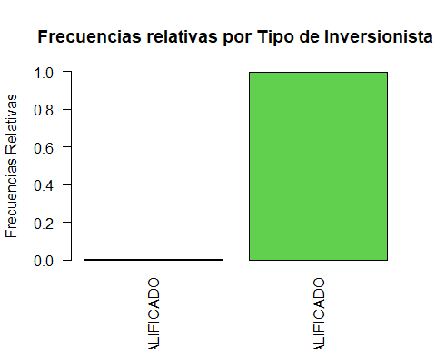

pie(TItabla4[,3],labels=TItabla4[,1], clockwise=TRUE,radius=1,border="black",main="Diagrama de Sectores")

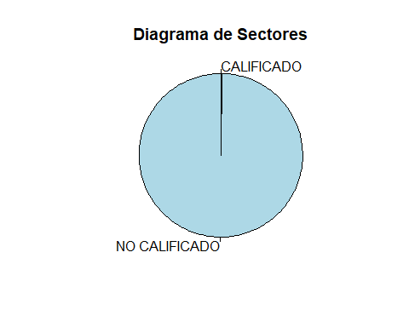

### Variable: Propósito

Proposito = BdCrowfunding$Proposito  
PTtabla=data.frame(table(Proposito))  
porcentaje=prop.table(PTtabla[,2])  
PTtabla2= cbind(PTtabla, porcentaje)  
cum_frequencia=cumsum(PTtabla2[,2])  
PTtabla3= cbind(PTtabla2, cum_frequencia)  
cum_porcentaje=cumsum(PTtabla3[,3])  
PTtabla4= cbind(PTtabla3, cum_porcentaje)  
PTtabla4

## Proposito Freq porcentaje cum_frequencia  
## 1 Apoyar el crecimiento de empresas colombianas 3523 0.12460211 3523  
## 2 Aprender de financiaciÃ³n 1189 0.04205277 4712  
## 3 Diversificar mi portafolio de inversiÃ³n 9856 0.34858881 14568  
## 4 Hacer crecer mi dinero 13236 0.46813327 27804  
## 5 Hacer parte de la comunidad a2censo - 470 0.01662305 28274  
## cum_porcentaje  
## 1 0.1246021  
## 2 0.1666549  
## 3 0.5152437  
## 4 0.9833770  
## 5 1.0000000

knitr::kable(  
 (PTtabla4)  
)

| Proposito | Freq | porcentaje | cum_frequencia | cum_porcentaje |
| --- | --- | --- | --- | --- |
| Apoyar el crecimiento de empresas colombianas | 3523 | 0.1246021 | 3523 | 0.1246021 |
| Aprender de financiaciÃ³n | 1189 | 0.0420528 | 4712 | 0.1666549 |
| Diversificar mi portafolio de inversiÃ³n | 9856 | 0.3485888 | 14568 | 0.5152437 |
| Hacer crecer mi dinero | 13236 | 0.4681333 | 27804 | 0.9833770 |
| Hacer parte de la comunidad a2censo - | 470 | 0.0166230 | 28274 | 1.0000000 |

colors <- c(2, 3,4,5,6)  
BPProposito <- barplot(prop.table(table(BdCrowfunding$Proposito)), col= colors,main="Frecuencias relativas por Tipo de Inversionista",ylim=c(0,0.5),ylab ="Frecuencias Relativas",las=2 )

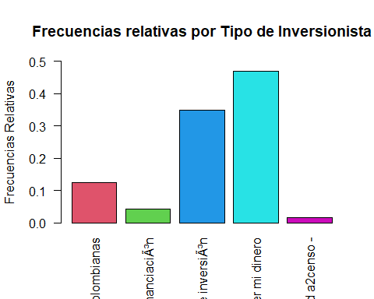

pie(PTtabla4[,3],labels=PTtabla4[,1], clockwise=TRUE,radius=1,border="black",main="Diagrama de Sectores")

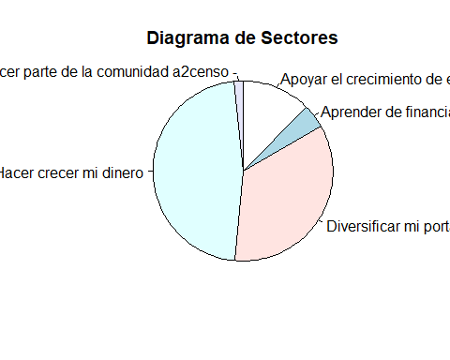

### Variable: Ingresos Mes

library(fdth)

##   
## Attaching package: 'fdth'

## The following objects are masked from 'package:stats':  
##   
## sd, var

IMtabla <- fdt(BdCrowfunding$IngresosMes,K=5)  
  
knitr::kable(  
 (IMtabla)  
)

| Class limits | f | rf | rf(%) | cf | cf(%) |
| --- | --- | --- | --- | --- | --- |
| [0,694375000) | 28107 | 0.9940935 | 99.4093513 | 28107 | 99.40935 |
| [694375000,1.38875e+09) | 131 | 0.0046332 | 0.4633232 | 28238 | 99.87267 |
| [1.38875e+09,2.083125e+09) | 34 | 0.0012025 | 0.1202518 | 28272 | 99.99293 |
| [2.083125e+09,2.7775e+09) | 0 | 0.0000000 | 0.0000000 | 28272 | 99.99293 |
| [2.7775e+09,3.471875e+09) | 0 | 0.0000000 | 0.0000000 | 28272 | 99.99293 |
| [3.471875e+09,4.16625e+09) | 0 | 0.0000000 | 0.0000000 | 28272 | 99.99293 |
| [4.16625e+09,4.860625e+09) | 0 | 0.0000000 | 0.0000000 | 28272 | 99.99293 |
| [4.860625e+09,5.555e+09) | 0 | 0.0000000 | 0.0000000 | 28272 | 99.99293 |
| [5.555e+09,6.249375e+09) | 0 | 0.0000000 | 0.0000000 | 28272 | 99.99293 |
| [6.249375e+09,6.94375e+09) | 1 | 0.0000354 | 0.0035368 | 28273 | 99.99646 |
| [6.94375e+09,7.638125e+09) | 0 | 0.0000000 | 0.0000000 | 28273 | 99.99646 |
| [7.638125e+09,8.3325e+09) | 0 | 0.0000000 | 0.0000000 | 28273 | 99.99646 |
| [8.3325e+09,9.026875e+09) | 0 | 0.0000000 | 0.0000000 | 28273 | 99.99646 |
| [9.026875e+09,9.72125e+09) | 0 | 0.0000000 | 0.0000000 | 28273 | 99.99646 |
| [9.72125e+09,1.0415625e+10) | 0 | 0.0000000 | 0.0000000 | 28273 | 99.99646 |
| [1.0415625e+10,1.111e+10) | 1 | 0.0000354 | 0.0035368 | 28274 | 100.00000 |

|  | x |
| --- | --- |
| start | 0 |
| end | 11110000000 |
| h | 694375000 |
| right | 0 |

plot(IMtabla,type='fh',main="Histograma de frecuencias absolutas",  
 xlab="Ingresos Mes",ylab="Conteos",col="red")

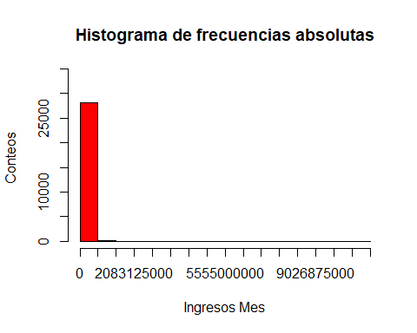

plot(IMtabla,type='fp',main="Poligono de frecuencias absolutas",  
 xlab="Ingresos Mes",ylab="Conteos",col="black",lwd=2)

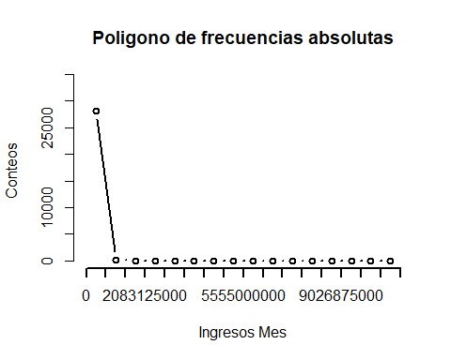

### Variable: Patrimonio

POtabla <- fdt(BdCrowfunding$Patrimonio,breaks="Sturges",right=F)  
  
knitr::kable(  
 (POtabla)  
)

| Class limits | f | rf | rf(%) | cf | cf(%) |
| --- | --- | --- | --- | --- | --- |
| [0,6.3125e+08) | 25794 | 0.9122869 | 91.2286907 | 25794 | 91.22869 |
| [6.3125e+08,1.2625e+09) | 1591 | 0.0562708 | 5.6270779 | 27385 | 96.85577 |
| [1.2625e+09,1.89375e+09) | 454 | 0.0160572 | 1.6057155 | 27839 | 98.46148 |
| [1.89375e+09,2.525e+09) | 266 | 0.0094079 | 0.9407937 | 28105 | 99.40228 |
| [2.525e+09,3.15625e+09) | 37 | 0.0013086 | 0.1308623 | 28142 | 99.53314 |
| [3.15625e+09,3.7875e+09) | 44 | 0.0015562 | 0.1556200 | 28186 | 99.68876 |
| [3.7875e+09,4.41875e+09) | 28 | 0.0009903 | 0.0990309 | 28214 | 99.78779 |
| [4.41875e+09,5.05e+09) | 6 | 0.0002122 | 0.0212209 | 28220 | 99.80901 |
| [5.05e+09,5.68125e+09) | 0 | 0.0000000 | 0.0000000 | 28220 | 99.80901 |
| [5.68125e+09,6.3125e+09) | 2 | 0.0000707 | 0.0070736 | 28222 | 99.81609 |
| [6.3125e+09,6.94375e+09) | 18 | 0.0006366 | 0.0636627 | 28240 | 99.87975 |
| [6.94375e+09,7.575e+09) | 2 | 0.0000707 | 0.0070736 | 28242 | 99.88682 |
| [7.575e+09,8.20625e+09) | 0 | 0.0000000 | 0.0000000 | 28242 | 99.88682 |
| [8.20625e+09,8.8375e+09) | 1 | 0.0000354 | 0.0035368 | 28243 | 99.89036 |
| [8.8375e+09,9.46875e+09) | 16 | 0.0005659 | 0.0565891 | 28259 | 99.94695 |
| [9.46875e+09,1.01e+10) | 15 | 0.0005305 | 0.0530523 | 28274 | 100.00000 |

|  | x |
| --- | --- |
| start | 0.0000e+00 |
| end | 1.0100e+10 |
| h | 6.3125e+08 |
| right | 0.0000e+00 |

### Variable: Monto Inversión

MItabla <- fdt(BdCrowfunding$MontoInversion, start=50000, end=156752000, h=31030000)  
  
knitr::kable(  
 (MItabla)  
)

| Class limits | f | rf | rf(%) | cf | cf(%) |
| --- | --- | --- | --- | --- | --- |
| [50000,31080000) | 28247 | 0.9990451 | 99.9045059 | 28247 | 99.90451 |
| [31080000,62110000) | 22 | 0.0007781 | 0.0778100 | 28269 | 99.98232 |
| [62110000,93140000) | 2 | 0.0000707 | 0.0070736 | 28271 | 99.98939 |
| [93140000,124170000) | 1 | 0.0000354 | 0.0035368 | 28272 | 99.99293 |
| [124170000,155200000) | 1 | 0.0000354 | 0.0035368 | 28273 | 99.99646 |

|  | x |
| --- | --- |
| start | 50000 |
| end | 156752000 |
| h | 31030000 |
| right | 0 |

### Variable: Edad

Edtabla <- fdt(BdCrowfunding$Edad, start=2, end=90, h=17.6)  
  
knitr::kable(  
 (Edtabla)  
)

| Class limits | f | rf | rf(%) | cf | cf(%) |
| --- | --- | --- | --- | --- | --- |
| [2,20) | 18 | 0.0006366 | 0.0636627 | 18 | 0.0636627 |
| [20,37) | 16271 | 0.5754757 | 57.5475702 | 16289 | 57.6112329 |
| [37,55) | 9653 | 0.3414091 | 34.1409068 | 25942 | 91.7521398 |
| [55,72) | 2064 | 0.0729999 | 7.2999929 | 28006 | 99.0521327 |
| [72,90) | 267 | 0.0094433 | 0.9443305 | 28273 | 99.9964632 |

|  | x |
| --- | --- |
| start | 2.0 |
| end | 90.0 |
| h | 17.6 |
| right | 0.0 |

### Variable: Cantidad Inversiones

CItabla <- fdt(BdCrowfunding$CantidadInversiones, k=5)  
  
knitr::kable(  
 (CItabla)  
)

| Class limits | f | rf | rf(%) | cf | cf(%) |
| --- | --- | --- | --- | --- | --- |
| [0.99,17.962) | 21989 | 0.7777110 | 77.7710971 | 21989 | 77.77110 |
| [17.962,34.934) | 4756 | 0.1682111 | 16.8211077 | 26745 | 94.59220 |
| [34.934,51.906) | 1102 | 0.0389757 | 3.8975737 | 27847 | 98.48978 |
| [51.906,68.878) | 342 | 0.0120959 | 1.2095919 | 28189 | 99.69937 |
| [68.878,85.85) | 85 | 0.0030063 | 0.3006296 | 28274 | 100.00000 |

|  | x |
| --- | --- |
| start | 0.990 |
| end | 85.850 |
| h | 16.972 |
| right | 0.000 |