User Manual:

Running pagerank analysis:

There is a runnable jar called FinalProgram.jar in the folder.

Open up terminal and type in “java –jar FinalProgram.jar” to run the program

Please make sure ‘test.txt’ is in the same directory as the .jar file.

https://i.gyazo.com/53e63b87774916e9cfb0f0c90e332277.png

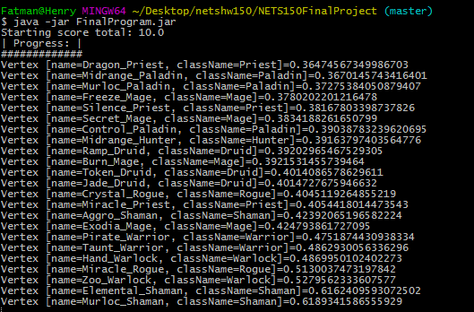

An interactive graph will show up and there will be a progress bar. Wait until the progress bar completes to get the page rank for each class.

The graph is slightly messy, but you can interact with it. Use the scroll bars to move around.

There is an image of this graph under images folder called “interactive_graph”

A bar graph will show up and present the classes and their perspective page ranks. You may have to enlarge the bar graph to see the names.

There is an image of this bar graph under images folder called “pagerank_graph”