Homework #3
Due February 6

Consider a three-group representation of a thermal reactor spectrum composed of a fission spectrum, a 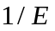 spectrum and a Maxwell spectrum:
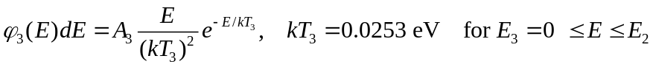
- Find the normalization constants 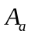, 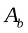 and 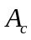 such that the spectrum is continuous at the group boundaries and the integration over the whole energy range is unity. Evaluate the group-wise integrals numerically if necessary.
- Find the average velocities in individual groups (, 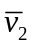 and 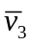).
- Find the one-group values of and 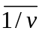 using the three-group values , and .
- Define a one-group 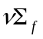 based on the three-group values 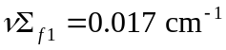, 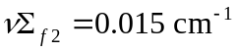, and 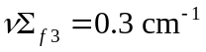.
- Calculate the generation time  with and . Discuss the results.

