Student ID: 20556803
The Psychology of Economic and Business Decisions (BUSI2051)
Instrumental Rational Choice application exercise
Word count: 299 (the six paragraphs below; header, figure captions, references and appendix excluded).
Last autumn I withdrew from final-round interviews at Marshall Wace, a headline £120,000 against £38,000 at PwC. I decided on the phone, in minutes, and could not undo it. Elster’s Instrumental Rational Choice (IRC) model locates the failure.
IRC begins with the full set of options. I saw two: accept and lose my placement, degree and ACA, or decline. A third never occurred to me: asking Marshall Wace to hold the role for eight months. My option set was incomplete from the start.
My preferences were financial security, the ACA, worthwhile work, and a career not narrowed at twenty-one. Elster (2007) treats preferences as given, so wanting the money was not itself a failure. On these alone, declining was defensible.
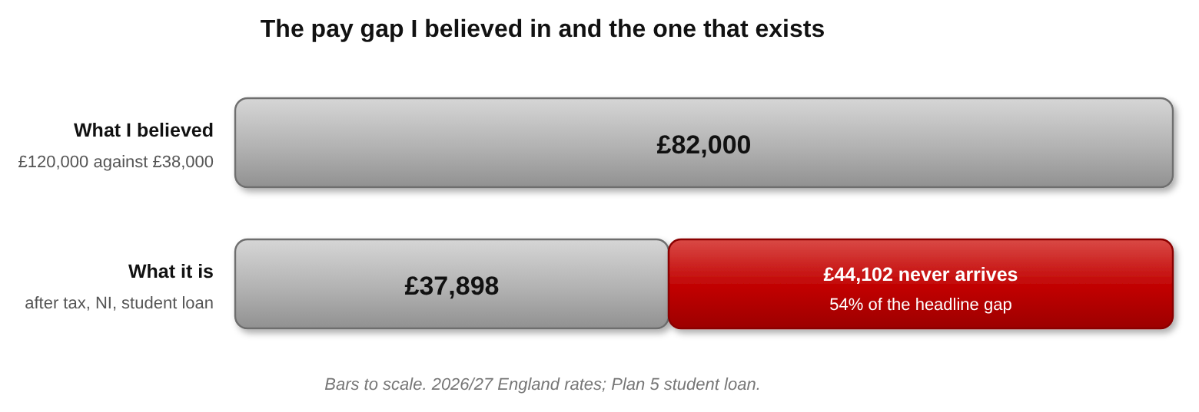
Figure 1: the gap I believed in against the gap that exists.
My expectations are where it falls apart. I believed the gap was £82,000 a year and the weeks ran to sixty hours. The hours were right; the gap was £37,898 after tax, National Insurance and student loan, wrong by £44,102. Worse, that figure argued for accepting, yet I declined. Elster (2007, p. 191) requires that an action follow from the beliefs justifying it.
The evidence behind it was a headline figure, nothing more. Twenty minutes of arithmetic would have corrected it; I am training as an accountant. I never did it, because I had already settled on declining, a preference steering the search rather than evidence steering the belief.
What moved me was £27,000 of tuition, spent either way. IRC has no box for it: it values actions only by what follows. Nor can it say how much search is enough (Hargreaves Heap et al., 1992, p. 15). Conlisk (1996, p. 687) shows why: pricing deliberation needs deliberation, “an infinite and seemingly intractable regress”. My preferences steered the search, the search misled the belief, and the action ignored it.
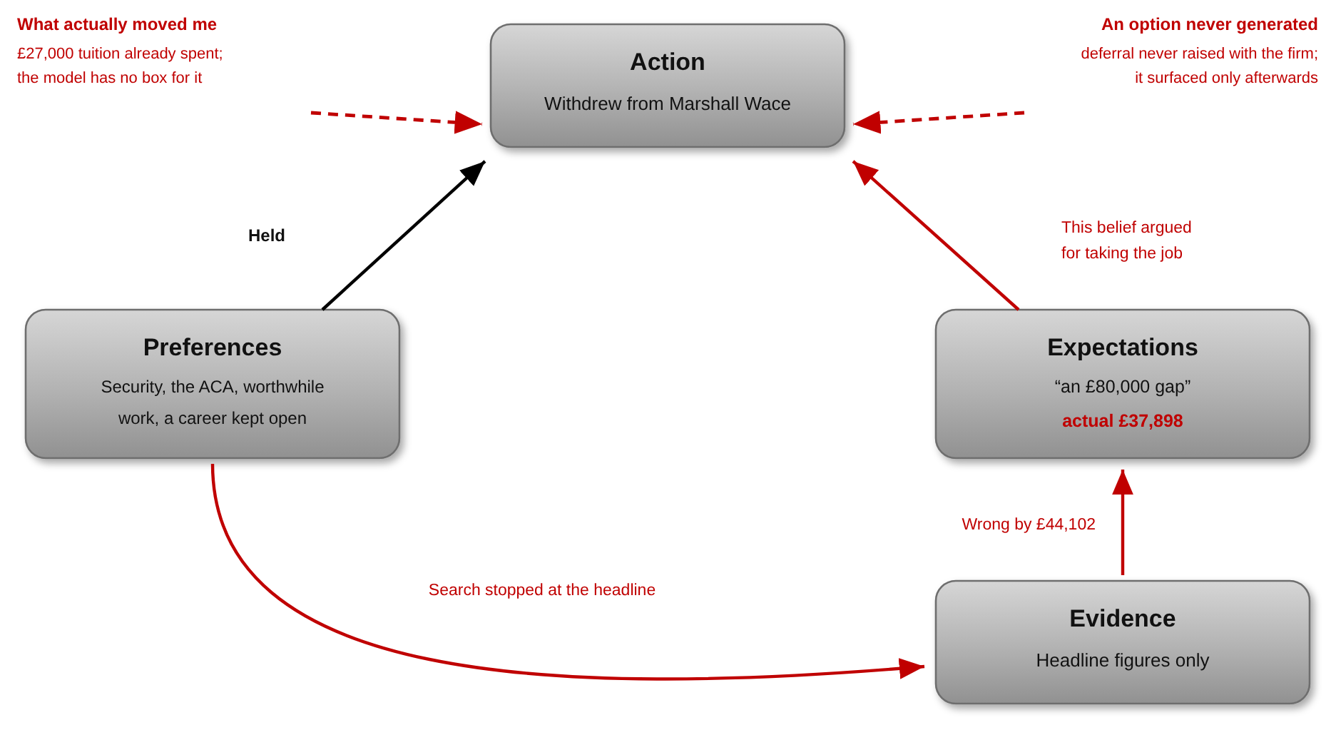
Figure 2: Elster’s components, applied to my decision.
References
Conlisk, J. (1996) ‘Why bounded rationality?’, Journal of Economic Literature, 34(2), pp. 669–700.
Elster, J. (2007) Explaining Social Behavior: More Nuts and Bolts for the Social Sciences. Cambridge: Cambridge University Press.
Hargreaves Heap, S., Hollis, M., Lyons, B., Sugden, R. and Weale, A. (1992) The Theory of Choice: A Critical Guide. Oxford: Blackwell.

Appendix: Generative AI Prompts
This appendix records the prompts used with CoPilot during drafting. Responses are omitted as the brief does not require them. The prompts include initial instructions and subsequent corrections.
Prompt 1 (initial mapping)
here is my decision and all the facts. not long ago I withdrew from final round interviews at marshall wace for a fund accountant role paying around £120k. compare this to £38k at PwC where I am on placement working towards the ACA. This is my mapping, my action, accept and lose the placement the degree and the ACA or decline and a third option I never raised which I should have, which was asking them to hold the role for eight months. Preferences are outlined as the following financial security, the ACA, worthwhile work, a career not narrowed at 21. Expectations, an £80,000 gap and sixty hour weeks. Evidence, the headline figures only I never ran the tax. Don’t change my mapping, don’t add anything I haven’t told you, and don’t put words in my mouth. Tell me where my wording is unclear and tighten it to 300 words without losing any of my points.
Correction 1
I don’t want to use my lecturer’s own words, I want to use his framework.
Prompt 2 (critical evaluation)
critically evaluate where and why my decision making process failed to match IRC, using the components of the model. tie the deviations to specific critiques, elster’s points on preferences as given and on actions following from the beliefs that justify them and Hargreaves heap’s argument about not knowing how much search is enough until the search is done. explain how these weaknesses appear in the options I considered, the beliefs I held about the £80,000 gap, the evidence I ignored, and the role of sunk costs.
Correction 2
I did not ask about deferring, actually. This wasn’t an option I did not explore until I spoke to my parents.
Prompt 3 (diagram specification)
right i want to build the diagrams myself now so here is exactly what i want. im giving you all the facts and numbers and the framework from my module, you just draw it. the framework is elster’s four components from my lectures action, preferences, expectations, evidence. the layout in every lecture is action at the top, preferences bottom left, expectations bottom right, evidence underneath expectations. arrows go preferences to action, expectations to action, preferences to evidence, and evidence to expectations both ways. use that layout dont invent your own.
Correction 3
I mean the general layout, not exactly.
Prompt 4 (formatting)
now put this into a word document the way it has to be submitted. verdana 11, 1.5 line spacing, 2.5cm margin. put the figures in with a caption underneath each one.
Prompt 5 (proofreading)
proofread this for me. check the spelling and the grammar, and tell me anywhere it doesn’t sound like proper british english. I want a short note on anything you change word choice and phrasing included so I can see what was actually wrong rather than just taking it.
Other corrections
Did you include this?
You are getting very technical now. Let’s slow down.

