[your student ID]
Instrumental Rational Choice application exercise
Word count: 294
Decision: In autumn 2026 I withdrew from final-round interviews at Marshall Wace, a fund accountant role worth £120,000 against £38,000 at PwC.
Action: Accept, losing my placement, degree and ACA; or decline. A third existed: ask Marshall Wace to hold the role eight months. I never raised it, on the phone to them.
Preferences:
- Financial security
- The ACA
- Worthwhile work
- A career not narrowed at twenty-one
Evidence:
- Pay: headline only, £120,000 against £38,000.
- Tax: the real gap is £37,898; the £40,000 bonus is worth £15,600.
- Hours: sixty against forty; 3.2 times becomes 1.5 net hourly.
- Qualification: the ACA travels, the role is niche.
- Search: twenty minutes of arithmetic, not done.
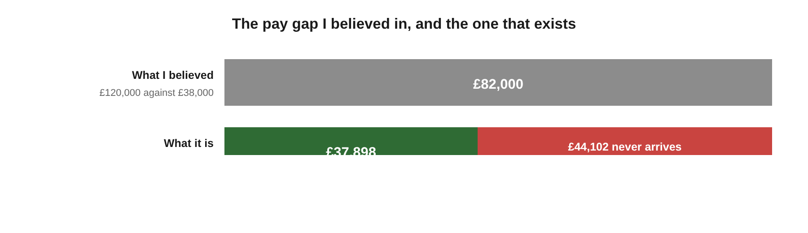
Figure 1: believed gap against real gap.
Expectations: I expected an £80,000 advantage and sixty-hour weeks. The second was right, the first wrong by half. I never tested whether they would wait.
Preference | Marshall Wace | PwC
Security | +£37,898 net | certain
ACA | only likely | yes
Worthwhile work | yes | no
Career open | niche | portable

IRC Prediction: A rational agent with my preferences weighs £37,898 net against a portable qualification and twenty extra hours, and declines. But only after testing the deferral.
Why my decision deviated:
I withdrew. The outcome was probably right, the reasoning was not. Elster (2007, p. 191) asks that an action follow from the beliefs that justify it: doing right by accident is not reasoning well.
- Evidence to expectations: the search stopped at the headline, so my figure was wrong by £44,102.
- Expectations to action: that figure argued for accepting. I withdrew anyway.
- Outside the model: what moved me was tuition already paid, spent either way.
- The model's limit: it asks for the right amount of searching without saying what that is (Hargreaves Heap, 1992).
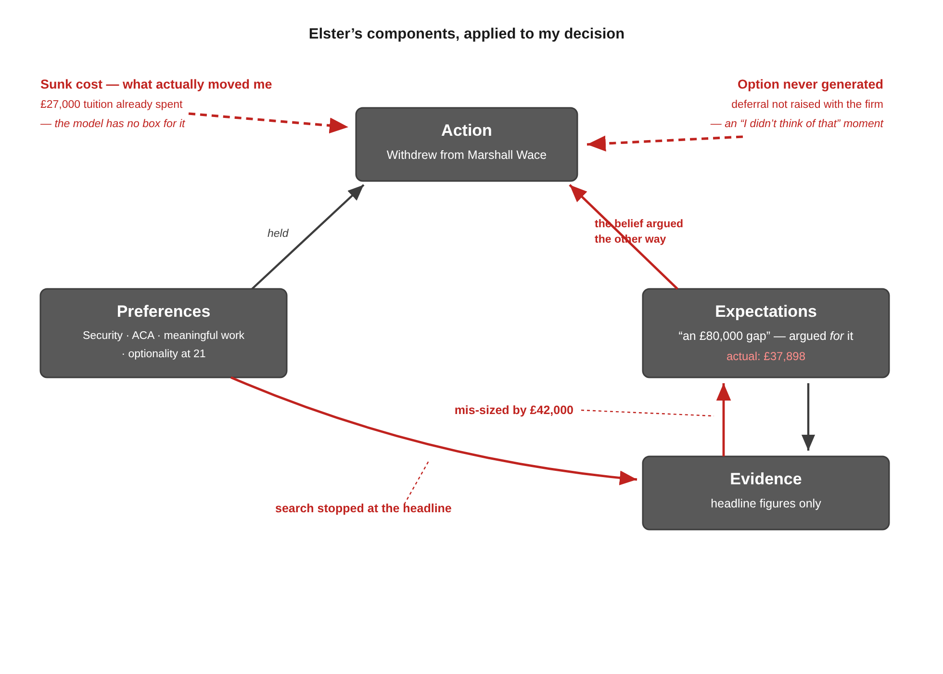
Figure 2: my decision mapped onto the model.
References
Elster, J. (2007) Explaining Social Behavior: More Nuts and Bolts for the Social Sciences. Cambridge: Cambridge University Press.
Hargreaves Heap, S., Hollis, M., Lyons, B., Sugden, R. and Weale, A. (1992) The Theory of Choice: A Critical Guide. Oxford: Blackwell.

