SQL SERVER · CONCURRENCY · INTERNAL BRIEFING

Read Committed Snapshot Isolation, explained
Why turning on RCSI is usually the single biggest, cheapest win against blocking and deadlocks in a SQL Server database, what it actually changes under the hood, and the handful of code patterns the dev team needs to check before we flip it.

IF YOU HAVE 30 SECONDS (MANAGERS)
Today, when one user is writing a row, everyone who wants to read that row waits. When a report is reading, writers wait. Those waits stack up into timeouts and deadlock errors.
RCSI makes SQL Server keep a copy of the last committed version of a row, so readers read the copy and never wait for writers. It is one database setting, no application rewrite, and it is already the default in Azure SQL Database.

IF YOU WRITE THE SQL (DEVELOPERS)
Your SELECTs stop taking shared locks and read the last committed version instead. Blocking between readers and writers goes away; writer-vs-writer blocking stays.
You must review any "read a value, then decide, then write" logic: it now reads a snapshot, so use UPDLOCK where the read is really a reservation. And you can finally delete NOLOCK.

Contents

1. How reads work today (default READ COMMITTED)
Out of the box, SQL Server guarantees that a SELECT only ever returns committed data. Since 1989 it has enforced that with locks:
- A writer (INSERT, UPDATE, DELETE) takes an exclusive lock on each row it changes and keeps it until its transaction commits or rolls back.
- A reader takes a shared lock on each row as it reads it. Shared and exclusive locks are incompatible, so if the row is being changed, the reader stops and waits.
- The wait is invisible to the application. The query simply takes longer. If it takes longer than the command timeout (30 s by default in .NET), the application sees an error.
The desk analogy: one paper document on a shared desk. While someone is editing it, nobody can read it. While someone is reading it, nobody can edit it. Everyone queues at the desk.
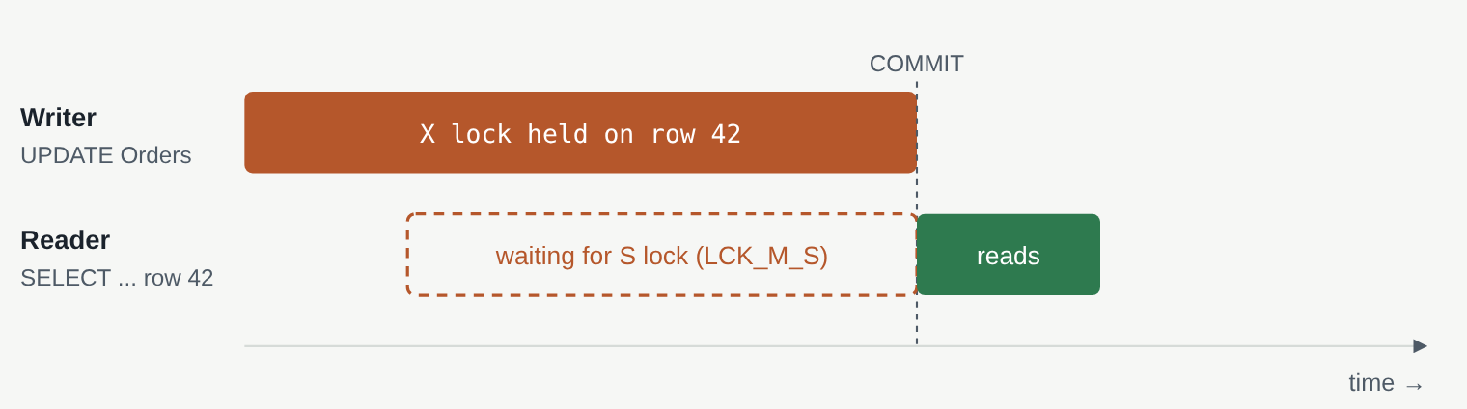
Default behaviour. The reader arrives while the writer's transaction is open and cannot proceed until the writer commits. Every reader touching that row queues behind it; every writer arriving behind those readers queues too.

2. What RCSI changes
RCSI (READ_COMMITTED_SNAPSHOT) keeps the same guarantee, "you only see committed data", but enforces it with row versions instead of shared locks.
- When a writer changes a row, SQL Server first copies the previous committed version of that row into the version store in tempdb, then modifies the row in place. The row carries a 14-byte pointer to its old version.
- A reader no longer takes shared locks. When it reaches a row that is currently being changed, it follows the pointer and reads the last committed version. It gets the answer that was true at the moment its statement started.
- Old versions are cleaned up automatically once no running statement can still need them.
Back to the desk: the editor takes the document away to work on it, but leaves a photocopy of the last signed-off version on the desk. Readers read the photocopy. Nobody queues, and nobody ever sees half-finished edits.
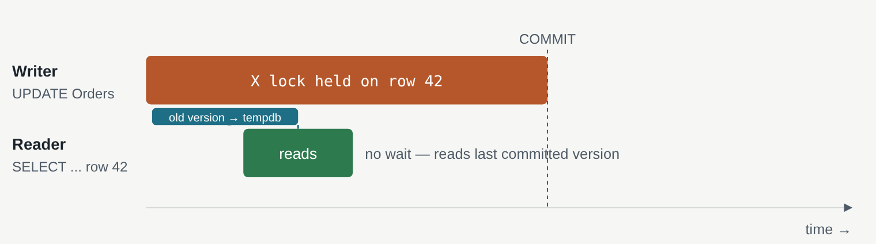
Same two sessions with RCSI on. The writer still holds its exclusive lock, but the reader is served from the version store and finishes immediately. The reader sees the row as it was before the update; it will see the new value the next time it runs.

3. Why blocking drops
Blocking is nothing more than one session holding a lock that another session needs. RCSI removes one entire side of that equation: readers hold nothing that a writer needs, and readers need nothing that a writer holds.
Situation | Default READ COMMITTED | With RCSI
Reader arrives while a writer holds the row | Reader waits | Reader proceeds (reads old version)
Writer arrives while a reader holds the row | Writer waits | Writer proceeds (reader holds no lock)
Long report scans a table while OLTP writes to it | Writes queue behind the scan, users see timeouts | Both run at full speed
Two readers on the same row | No wait | No wait
Two writers on the same row | Second writer waits | Second writer waits (unchanged)

In a typical OLTP workload, 80–95 % of statements are reads. Removing reader/writer contention therefore removes most of the blocking chains you see in sp_WhoIsActive or in the blocked-process reports. The waits that disappear are the LCK_M_S waits (readers waiting for shared locks) and a large share of LCK_M_X / LCK_M_U waits (writers waiting behind readers).
What does not change: writers still block writers. Two transactions updating the same row, or a big UPDATE that escalates to a table lock, behave exactly as before. RCSI is not a licence to run long write transactions.

4. Why deadlocks drop
A deadlock is a blocking chain that forms a circle: A waits for B, B waits for A, and neither can ever finish. SQL Server detects it, picks a victim, rolls it back, and the application receives error 1205. Every deadlock is lost work plus a retry, and if the application does not retry, a failed user action.
The most common deadlock shape in real systems is not two writers fighting. It is a writer and a reader, each touching two tables in different order. Here is the textbook case:
Step | Session A (order update) | Session B (customer screen)
1 | BEGIN TRAN; UPDATE Orders SET Status='Shipped' WHERE OrderID=42;  Takes X lock on Orders row 42
2 |  | BEGIN TRAN; UPDATE Customers SET LastSeen=GETDATE() WHERE CustomerID=7;  Takes X lock on Customers row 7
3 | SELECT Email FROM Customers WHERE CustomerID=7;  Needs S lock on Customers row 7 → waits for B
4 |  | SELECT Status FROM Orders WHERE OrderID=42;  Needs S lock on Orders row 42 → waits for A
5 | Circle closed. SQL Server kills one session with error 1205.
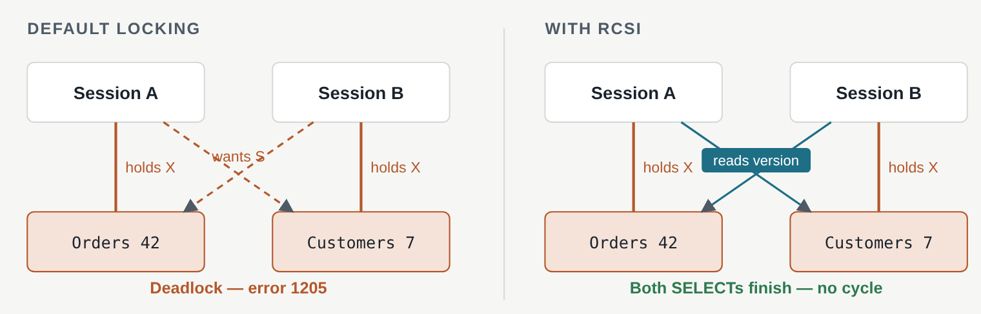
Left: each session holds an exclusive lock and asks for a shared lock the other side is holding out. Right: the two SELECTs never ask for shared locks, so no session ever waits, and the circle cannot form.
With RCSI, steps 3 and 4 just read the last committed version of the row and carry on. Both transactions commit. The deadlock is not "handled better"; it simply cannot happen, because a reader never joins the waiting circle.
To be precise about what remains: deadlocks where every participant is trying to modify something (two updates in opposite table order, an update plus an insert hitting the same index, a key-lookup deadlock between two updates) are still possible. In practice, on systems converted to RCSI, the majority of deadlocks disappear, and the rest are pure write-ordering problems that are easier to reason about and fix.

5. Why not just use NOLOCK
Many codebases already "solve" reader blocking by sprinkling WITH (NOLOCK) on queries. It looks similar because readers stop waiting, but it is a different and worse mechanism.
 | NOLOCK (READ UNCOMMITTED) | RCSI
Reader waits for writers? | No | No
Can return uncommitted data (later rolled back)? | Yes — dirty reads | Never
Can return the same row twice or skip rows during page splits? | Yes | No
Can fail with error 601 ("data movement")? | Yes | No
Consistent view of the whole statement? | No | Yes — as of statement start
Where it is applied | Hint by hint, every query, forever | Once, at database level
Cost | Wrong numbers in reports; invoices showing totals that never existed | Some tempdb space and I/O

RCSI is the correct replacement for NOLOCK. After it is enabled, the existing hints do no harm, but they should be removed over time because they still permit dirty reads.

6. What it costs and what to watch

tempdb becomes the version store
Every update or delete now writes the previous version of the row to tempdb. This adds some I/O and tempdb space. On healthy hardware the overhead is usually a few percent of CPU and is more than repaid by the waits that vanish. What can hurt is a long-running transaction: as long as any statement that started before it is still running, SQL Server cannot clean up versions, so tempdb grows. A forgotten open transaction from a client that never committed can, over hours, fill tempdb. We will monitor it (queries in section 8).

Reads are "as of statement start"
A reader gets the last committed version as of the moment its statement began. For 99 % of queries that is exactly what you want. It matters only when a read is really a decision to write: "is this username taken?", "is there stock left?", "which is the next ticket in the queue?". Under RCSI two sessions can both read "yes, stock is 1", and both proceed to sell it. Section 7 shows how to write those.

14 bytes per changed row
Rows modified since RCSI was enabled carry a 14-byte version pointer. This is negligible except on very narrow, very hot tables.

Triggers and read-your-own-writes
Inside a trigger, reads of the same table still see the current data, and any statement always sees its own transaction's changes. Nothing to fix here; it is listed only because people ask.

Availability Group readable secondaries already do this
Queries on a readable secondary replica always run under snapshot isolation, so if we already report from a secondary, that workload will not change at all.

7. Code patterns the dev team must review
Search the codebase for these before we enable RCSI in production. Everything else needs no change.

Pattern A: check, then insert (uniqueness, "reserve if free")
-- BEFORE: under RCSI two sessions can both see "not exists" and both insert.
IF NOT EXISTS (SELECT 1 FROM dbo.Reservations WHERE SeatID = @SeatID)
INSERT dbo.Reservations (SeatID, UserID) VALUES (@SeatID, @UserID);

-- AFTER: UPDLOCK makes the read behave as a write, HOLDLOCK keeps the range locked.
BEGIN TRAN;
IF NOT EXISTS (SELECT 1 FROM dbo.Reservations WITH (UPDLOCK, HOLDLOCK) WHERE SeatID = @SeatID)
INSERT dbo.Reservations (SeatID, UserID) VALUES (@SeatID, @UserID);
COMMIT;
-- Best of all: a unique index on SeatID, and let the second INSERT fail and be handled.

Pattern B: read a balance or stock level, then update it
-- BEFORE: the read is a snapshot; the update may act on a stale number.
SELECT @Qty = QtyOnHand FROM dbo.Stock WHERE ProductID = @P;
IF @Qty >= @Wanted
UPDATE dbo.Stock SET QtyOnHand = QtyOnHand - @Wanted WHERE ProductID = @P;

-- AFTER: check and write in one statement; the WHERE is evaluated under the lock.
UPDATE dbo.Stock
SET QtyOnHand = QtyOnHand - @Wanted
WHERE ProductID = @P AND QtyOnHand >= @Wanted;
IF @@ROWCOUNT = 0 -- not enough stock ...

Pattern C: queue tables ("give me the next unprocessed row")
-- Dequeue atomically. READPAST skips rows another worker already holds.
WITH nxt AS (
SELECT TOP (1) * FROM dbo.WorkQueue WITH (UPDLOCK, READPAST, ROWLOCK)
WHERE Status = 'New' ORDER BY QueueID
)
UPDATE nxt SET Status = 'Processing', WorkerID = @Worker
OUTPUT inserted.*;

Pattern D: counters and "next number" tables
Any hand-rolled sequence (SELECT MAX(ID)+1, or a NextValue row that is read then updated) must use UPDLOCK on the read, or be replaced by an IDENTITY column or a SEQUENCE object. The single-statement form UPDATE ... SET @new = NextValue = NextValue + 1 is also safe.

Pattern E: NOLOCK hints
Leave them for the first release, then remove them in a follow-up. Each one is a potential wrong answer that RCSI has already made unnecessary.
RULE OF THUMB
If a SELECT only shows data, RCSI is pure upside and nothing changes. If a SELECT decides whether to write, it needs UPDLOCK, or the check should move into the WHERE clause of the write itself.

8. Rollout plan
- Baseline. Capture one week of wait stats, deadlock count (from the system_health session) and top blocking chains so we can show the before/after.
- Code review. Dev team searches for the patterns in section 7 and fixes them. These fixes are correct under both isolation modes, so they can ship ahead of the switch.
- tempdb check. Confirm tempdb has headroom and its files are on fast storage; enable an alert at 70 % usage.
- Enable in test/UAT, run the full regression suite and a load test. The switch needs a moment with no other connections:
ALTER DATABASE [OurDb] SET READ_COMMITTED_SNAPSHOT ON WITH ROLLBACK IMMEDIATE;

-- verify
SELECT name, is_read_committed_snapshot_on FROM sys.databases WHERE name = 'OurDb';

- Enable in production during a low-traffic window. It takes seconds; the ROLLBACK IMMEDIATE kicks open sessions, which is why we pick the window.
- Monitor for two weeks.
-- version store size and longest running transaction (the thing that can grow it)
SELECT SUM(version_store_reserved_page_count) * 8 / 1024 AS version_store_MB
FROM sys.dm_db_file_space_usage;

SELECT TOP (5) session_id, transaction_begin_time,
DATEDIFF(minute, transaction_begin_time, GETDATE()) AS open_minutes
FROM sys.dm_tran_active_snapshot_database_transactions
ORDER BY transaction_begin_time;

-- did the lock waits go away?
SELECT wait_type, waiting_tasks_count, wait_time_ms / 1000 AS wait_s
FROM sys.dm_os_wait_stats
WHERE wait_type LIKE 'LCK[_]M[_]%' ORDER BY wait_time_ms DESC;

- Rollback is the same statement with OFF. No data is changed by the setting; it only changes how reads are served.

9. FAQ
Is this the same as SNAPSHOT isolation?
No. Both use the version store. RCSI gives each statement a consistent view and is a database-wide default that needs no code changes. SNAPSHOT isolation gives a whole transaction one consistent view, must be requested per session with SET TRANSACTION ISOLATION LEVEL SNAPSHOT, and can fail with update conflicts (error 3960). We are proposing RCSI only.
Will users see stale data?
Only in the sense that they always have: a screen shows what was committed when the query ran. Under locking they would have waited and then seen the newer value; under RCSI they see the value from a few milliseconds earlier without waiting. Refreshing shows the new value.
Does it change the results of any correct query?
For reads that merely display data, the results are the same or more consistent. For reads that drive a write decision, see section 7. Nothing else is affected: constraints, triggers, foreign keys and identity behave as before.
Why is this the default in Azure SQL Database?
Because for the overwhelming majority of applications it is strictly better than lock-based read committed. Microsoft chose it as the default for new Azure SQL databases for that reason; on-premises and Managed Instance keep the legacy default only for backward compatibility.
Does it fix slow queries?
Not directly. A query that was slow because it was waiting gets fast. A query that was slow because it scans a hundred million rows is still slow; it just no longer makes everyone else wait too.
What is the risk if we do nothing?
Blocking and deadlocks scale with load. Every growth in users or data makes the lock queues longer. The alternatives are adding NOLOCK (wrong answers) or rewriting every access path to hold locks for less time (months of work). RCSI is a one-line change that removes the root cause for readers.
Prepared for the dev team and engineering management. Applies to SQL Server 2005 and later, Azure SQL Managed Instance, and SQL Server on AWS RDS/EC2. Azure SQL Database already runs with RCSI on.

