# Easiest way to open the notebooks is:

* Right click
* Open with
* “Google Colaboratory”

# If that doesn’t work, you can:

# Right click

1. Download the notebooks to your local pc
2. [Start a new Colab browser tab](http://colab.research.google.com)
3. Click on “UPLOAD”:

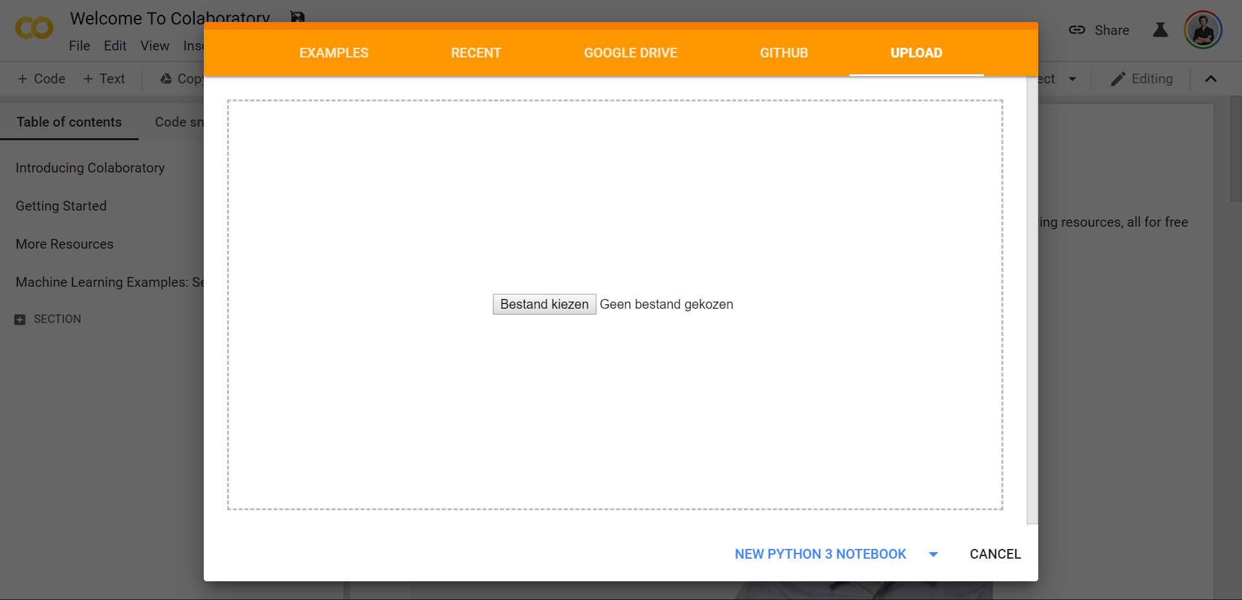

1. Upload the notebooks manually