Seeing far.

An essay for PSYC3013 students, by Alex Holcombe. Endnotes denoted by [^]

You bird-brain!

That’s not a compliment, and a look at the skull of a bird will tell you why. There’s not much space for a brain in bird skulls. The problem isn’t just the size of the skull. Much of the large skull (for a bird) of a hawk or an eagle is taken up by its eye sockets

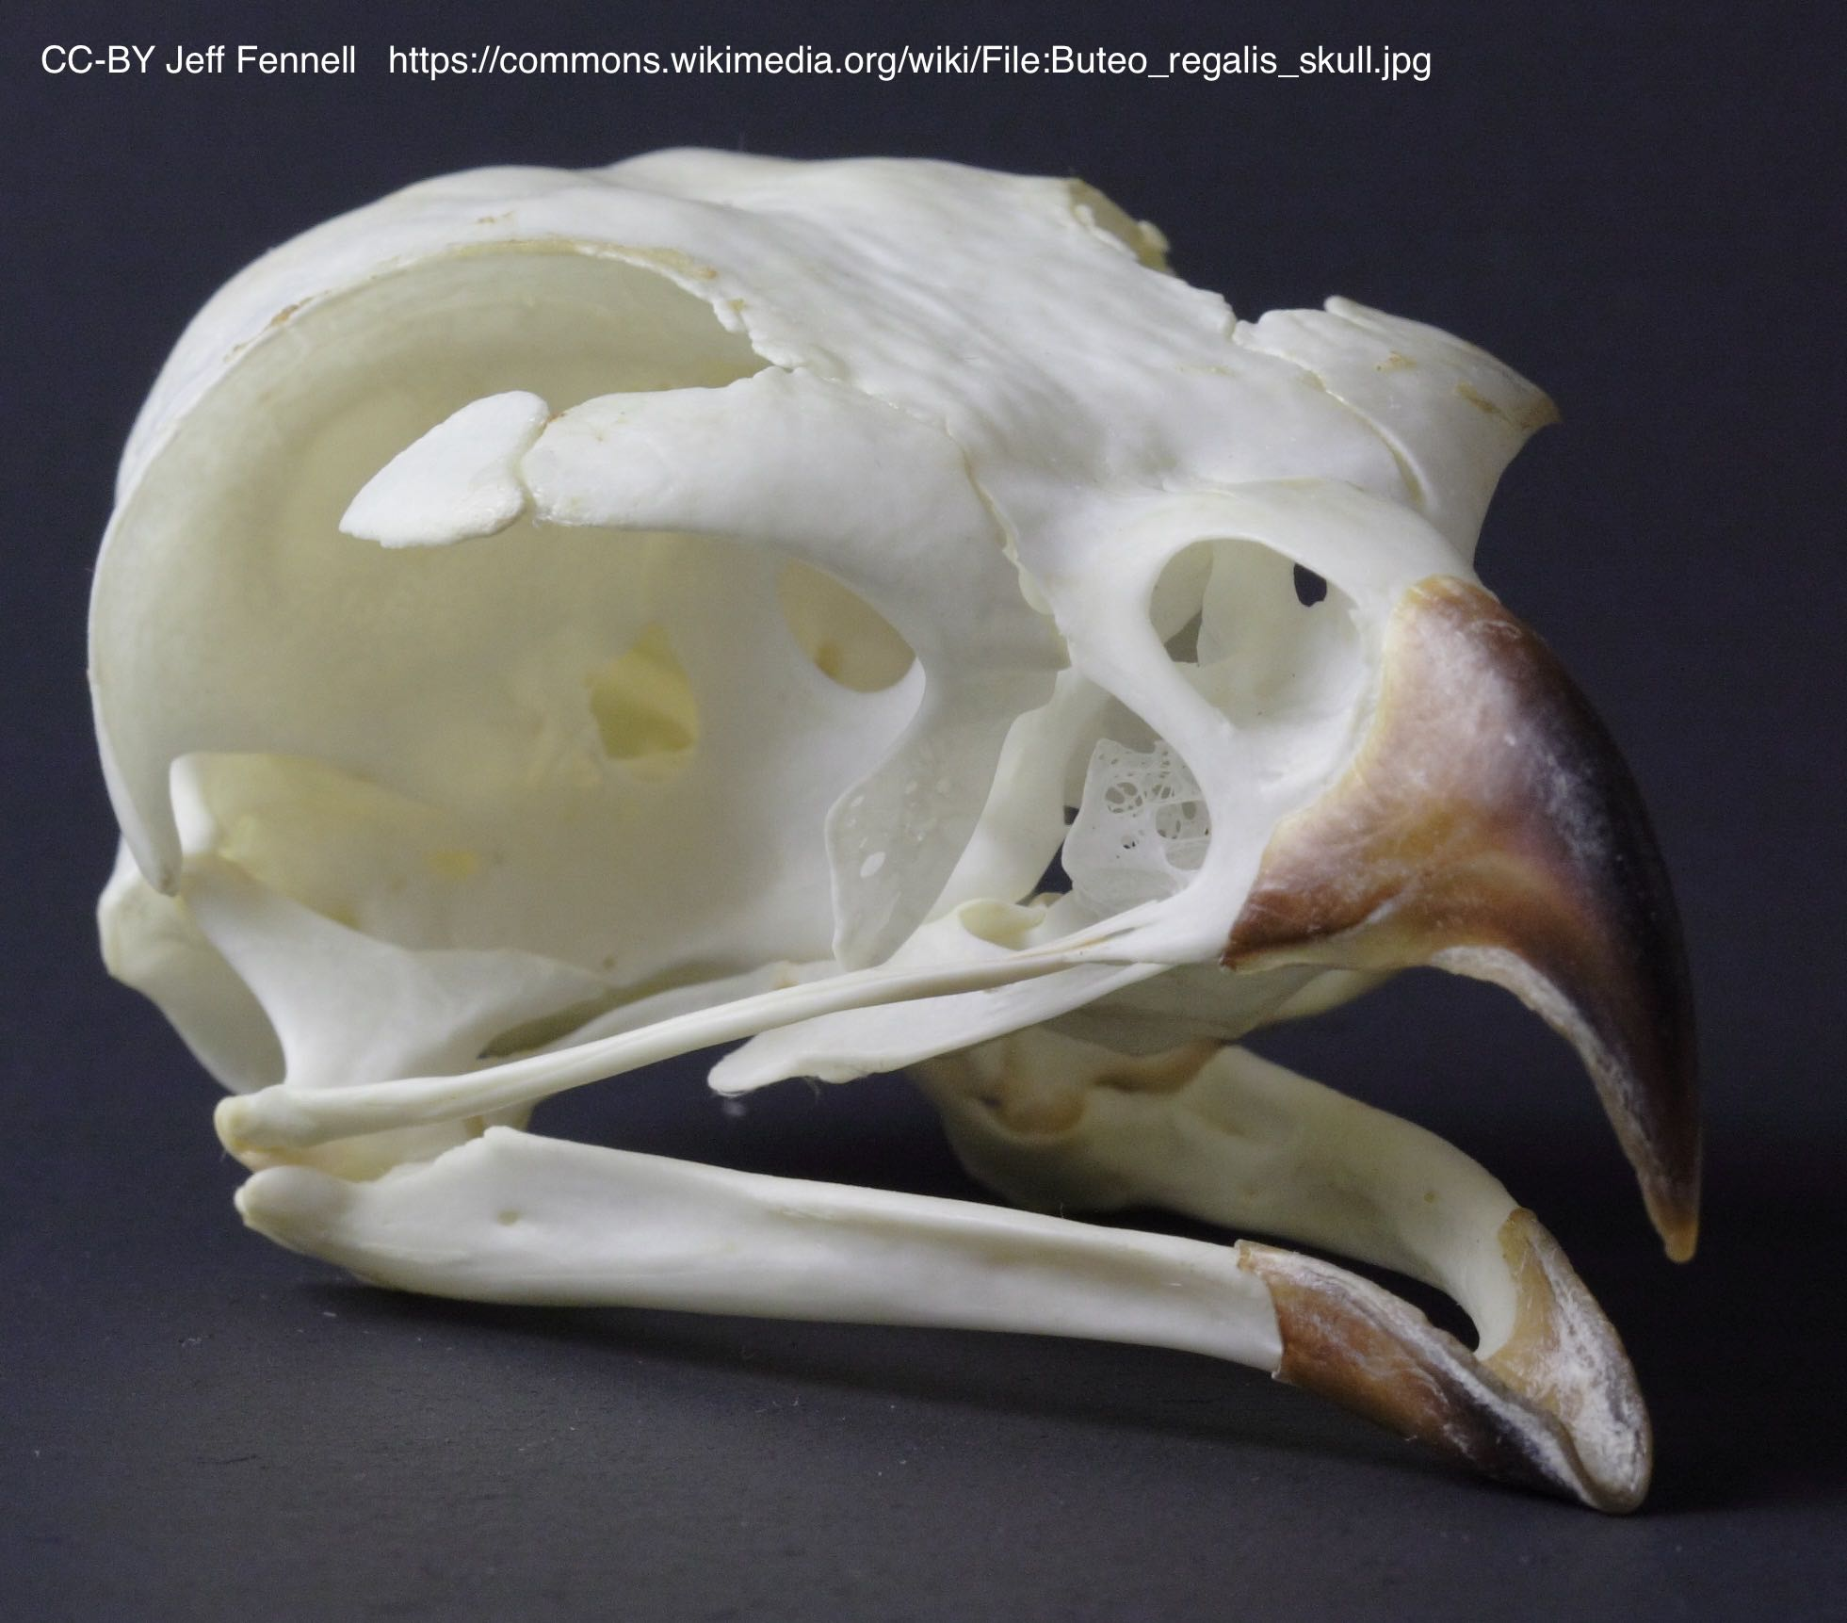

The skull of an American ferruginous hawk.

That makes sense, because many birds of prey rely heavily on vision to find their meals. Just how good is their vision? At the zoo, I’ve seen some interesting attempts to explain this.

Almost every self-respecting city has a zoo, and judging from its motto, ‘America’s Finest City’, San Diego has a particularly high level of self-esteem. While many will argue with that, the zoo in San Diego is recognized as one of the world’s best. On one visit, next to a hawk’s enclosure I saw a small sign. The sign was not a description of the bird and its various characteristics. That was elsewhere; *this* sign pointed to a tree that was quite some distance away - perhaps one hundred meters. High in that tree was a mock-up of an old newspaper. The text, including the headline, was far too distant to be legible. But according to the sign, if the hawk could read, its vision was so good that it would be able to read the headline!

At a private zoo outside my current home of Sydney, Australia, there is nothing so dramatic as a newspaper perched on a faraway tree. However, I have seen this sign mounted on the cage of a wedge-tailed eagle.

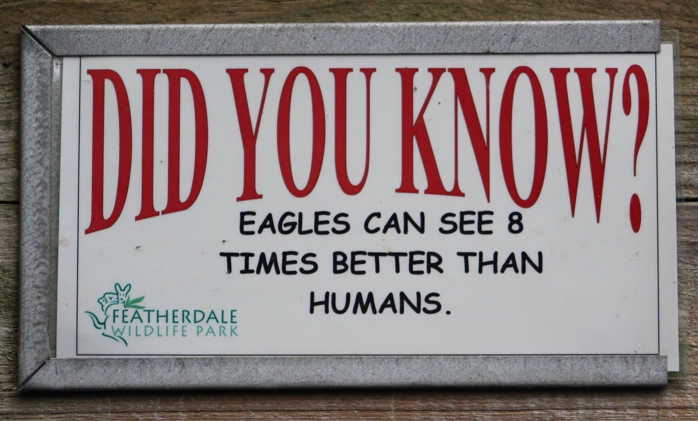

The notion that eagles, hawks, and falcons have extraordinary visual powers is not limited to zoos; it runs deep in human culture. In English you’ll hear people threaten to “watch you like a hawk” or describe a far-seeing sentry as “eagle-eyed”. Czech speakers prefer to compare those with good vision to falcons (*ostříž*), while in Hindi particularly acute sight is referred to as hawk vision (*baaz ki nazar*). It seems that for a very long time people have believed that birds of prey can see better than we can.

As soon as our ancestors were advanced enough to imagine ourselves in another’s shoes, they would have looked up at eagles with envy. Not only can the soaring birds rapidly cover large distances, they also seem to hunt from an altitude from which we might see little. It is easy to imagine them spotting shrews and mice from very large distances, and swooping down to grab the tasty critters long before we could get to them.

With some ingenuity, people learned to trap birds and use their eyes for our own purposes. In the deserts of Arabia, the traditional method of the Bedouins began with finding a favored perch of a saker or peregrine falcon. During their migration to Africa, the falcons would sometimes spend some mornings on the top of a particular desert dune, looking out for prey. Two Bedouins would ride out on a camel at first light, bringing a pigeon with them. While keeping the camel between themselves and the bird, one of the men would bury the other man, leaving only the head and one arm out of the sand, which were both concealed by strategically placed branches. The man in the sand held the pigeon in his hand, with string tied around its legs. When the sand-covered man was ready, the other Bedouin rode off quickly on the camel, and simultaneously the other man let the pigeon fly, while holding on to the string. From the falcon’s point of view, it appeared that the departure of the camel and its rider had disturbed a pigeon, one that was struggling to fly properly.

The falcon would soon pounce on the fluttering, fat pigeon. Unable to carry the pigeon away, due to the string still tethering it, the falcon would settle down and start to eat it. One more little detail of the whole arrangement was important to ensure success here. The Bedouins had set themselves up upwind of the falcon, so that when the pigeon flew away from the falcon, it would end up even more upwind. The falcon would fall on it upwind, and start munching on it upwind, thus unable to smell the man buried in the sand. The man would then pull on the string very slowly, causing the pigeon carcass to inch its way towards him. When the pigeon and falcon were in reach of both of the man’s arms, he would grab at the falcon’s legs and throw a cloth over its head.

Once trained by the falconer- a grueling process involving keeping the bird close for 24 hours a day - the houbara hunt could begin. The houbara bustard looks a bit like a cross between a turkey and a road runner, but can fly quite well. Typically, a bustard’s tracks would be found by the falconer early in the morning, and followed, by camel, as far as they could be seen. During the day, the houbara typically hides under a bush, and it could be flushed by the approach of the hunters. The falcon would then be unhooded and thrown into the air. Having been trained with houbara feathers attached to a food reward, the falcon would enthusiastically pursue the slower houbara. Talons extended, the falcon would collide with the bustard. After much slashing of claws and snapping of beaks, the bustard was subdued, with the falcon standing next to it on the sands, tearing at its flesh. At this point, a Bedouin might satisfy his feathered friend by throwing it the bustard’s brains, after slitting open the skull. The hood was then slipped back onto the falcon and returned to his roost on the tribesman’s wrist[^ArabianSands].Back at home, the houbara would be buried in the embers of a fire and slow-cooked. The challenge in hunting the houbara was thus not one of visual limitations. The advantage of the falcon over the man was in its speed and its flight.

When travelling in Oman, the English explorer Sir Wilfred Thesiger tells of spending a day hunting with the locals. His group set off in the morning by camel, accompanied by salukis - Persian greyhounds, who helped sniff out and flush the houbara. According to the Guinness Book of World Records, salukis are the fastest breed of dog. With a top speed of around 68 km/hour, about twice as fast as the fastest human, over long distances they’ll pass their greyhound cousins. But they were often left in the desert’s dust by the animals that several members of the Omani hunting party carried on their wrists - peregrine falcons, or *shahin* in Arabic.

When a falcon stoops, it is a spectacle, like a bolt from the blue. An essential part of a falcon’s natural hunting behavior, the “stoop” is the characteristic way the falcon dives from altitude. The favorite prey of peregrine falcons is other birds, which is one reason it has evolved to have such speed. The simplest way to achieve a high speed is to start very high, and then drop. The peregrine falcon soars to heights far above the typical altitude of its prey. Peering down, it keeps watch, and upon seeing suitable prey in the clear, the falcon will begin its downward stoop. The feet are tucked in, and the wings folded tight against its body, and the creature, plummeting through the air, looks more like a torpedo than a living animal.

In its spiral-shaped dive, a peregrine can reach speeds over 380 km/hour, or 236 mph. If the targeted bird is lucky enough to spot the incoming falcon, it has no hope of outrunning the falcon; all it can do is dodge. Special baffles in its nostrils keep the 300 km / hr of airspeed from tearing its lungs, and a second tear gland is specialized for keeping the eye moist as the air rushes by its eyeballs [^FalconStoopEyes]. At its dizzying speed, the force of a direct collision with the body of their prey could knock the falcon out or seriously injure it. The falcon instead aims to tear through a wing of its target using an extended talon. On many an occasion, the victim never sees the plummeting marauder, but suddenly finds itself thrown into a spin and barely able to fly.

As wondrous a creature as a peregrine falcon is, the Bedouins told Sir Wilfred that its sight does not match its speed. The Bedouins considered the saker falcon be the superior hunter. Rather than flying high and then plummeting down onto its prey, the saker falcon comes in from about the same height as its victims, pursuing them over grasslands or over desert dunes[^SakerFalcon]. And as Sir Wilfred experienced, the hunting style of the Bedouins is more like that of a saker than a peregrine.

Over the thousands of years that humans have kept falcon and other hunting birds, they have amassed a wealth of knowledge about the capabilities and behaviour of birds and other animals. According to many of these traditions, eagles, hawks, and falcons can see farther than we - these beliefs have become embedded in the languages that we speak. However, are these traditional beliefs true, or are they a sort of old-wives’ tale? Well, but many tales told by old wives are true, even some that were long pooh-poohed by scientists. For example, young mothers are sometimes told by their elders that suffering from heartburn during pregnancy was a sign that your baby would be born with a full head of hair. The nurse and researcher Kathleen Costigan had, for years, told her patients that this was bunk. But when she did a proper scientific study using patients at Johns Hopkins Hospital, she found evidence that it was true[^HeartburnHair]. On the other hand, old wives also say that severe morning sickness means you’re having a boy, but formal study of the topic found that the opposite was true - more nausea means a higher chance of having a girl[^MorningSickness]. Ideas, once concocted, sometimes take on a life of their own, with all the mothers who ended up with a girl unable to keep the alluring story about boys and morning sickness from continuing to circulate (and perhaps not wishing to strain the relationship with their mothers, and mothers-in-law).

Whether a story is about birds or babies, what’s really needed is a well-planned test of the matter. And that’s what science is all about – creating knowledge through repeatable, careful observation and experiment. Such observations are typically made repeatable, and thus more verifiable, when they are performed in a controlled situation. While falconers had stories of birds appearing to spot things from very far away, until such a thing could be repeated by others, the possibility remained that the story was just a story. Or that the falconers had the wrong interpretation – a bird that seemed to spot a mouse from far away had perhaps not spotted it at all, but simply turned in that direction on a whim, and lucked upon the mouse.

How small a detail can a falcon see? The world needed a vision test for birds. But what would such a thing look like?

Our visual experience is coarse. We see objects – a table, a chair – as monolithically solid, even though they are lattices of discrete atoms, with much empty space in between. The atomic structure of ordinary things is too fine for us to apprehend. But then what exactly is the smallest thing that you might be able to see?

You’re probably familiar with the Snellen eye test even if you haven’t heard its name. Developed by a Dutch ophthalmologist in 1862, it is a tall chart with rows of boldface letters printed on it. As one goes down the chart, the letters get smaller. The smaller the letters one can read, the better is one’s vision. So, this test reveals the smallest size at which one can read letters printed in Snellen’s typeface. Although this is a very good indicator of the smallest detail that a person can see, it doesn’t directly answer our question of *the* smallest thing that you can see.

We need to think a bit more about vision, light, and the size of things to really answer the question. If you look at an eye chart, while wearing glasses or contact lenses if you need them, you won’t be able to read the letters on the bottom row. No human can; not without a telescope. But can you see the letters? Most probably, you can still see the letters, you just can’t read them. You can get the same effect by taking a blank sheet of paper and drawing a small letter on it in black ink. As you walk away from the paper, you’ll quickly reach a point where you can’t read the letter anymore. But you might have to walk pretty far before the letter disappeared entirely. And, you’d be hard pressed to say exactly when you couldn’t see it anymore, as it would seem to only very gradually fade into oblivion.

No matter how far you travel from an object, if it is sufficiently different from its background, it may never disappear. Consider the stars above. Each star is a gargantuan object. However, other than the sun, every star is so distant that it occupies only a tiny point on the heavenly firmament. Indeed, from our perspective they correspond to a point that is nearly infinitesimal. Astronomers and vision scientists quantify exactly how infinitesimal a point is is by calculating the *angle* the star occupies from where we stand. If you extend your left arm straight out, and then sweep it to stick straight out to your front, you’ve gone through ninety degrees of visual angle. When you stand across the street from a bus, it might occupy a full ninety degrees. Walk away from it, and its visual angle will decrease. At our distance from it, the moon occupies only one half of one degree, and the largest features on the moon occupy only a few tenths of a degree. But that’s big enough for us to see them.

However, the largest star (other than the sun) spans, from our perspective, less than one-sixtieth of the angle spanned by the moon. We do not see the actual parts of the star, in the way that we see parts of the moon. Instead, all we are seeing is blur of the star’s tiny point of light. Look towards a star and you only marginally see a star. You see a light - a starry light. The angle spanned by a star is small enough to fall in the spaces in between your photoreceptors. But no matter how tiny the point of light is, our eye’s optics will blur the light into something broad enough to tickle our photoreceptors. Nothing is truly too small to see. Make it bright enough, and place it against a dark background, and we’ll see it, if only by its blur.

Clearly, minimum size is not a good measure of keenness of vision. Then what is a good measure? The Bedouins and other desert Arabs used the stars as a test for vision – but not by asking people whether they could see an individual, isolated star. The tradition was to ask people to look at Mizar, which belongs to the constellation known in modern Western cultures as the Big Dipper. Mizar is the second star from the end of the handle. To someone with poor vision, that’s all there is to it, a single star marking that bit of the handle of the dipper. However, to a person with good vision, two stars can be seen. Very close to Mizar (one-fifth of a degree away) is a second star, Alcor. The name these Arabs used for Alcor is *Suha*, which means the “neglected” one. For people with poor visual *acuity*, the ability to see fine details, Alcor is indeed neglected, because in their perception it can blur together with Mizar. Hence in this Arab eye test, the greater blur associated with poor vision directly results in the inability to see something[^ArabEyeTest]. A Japanese myth imputes to this test a much broader diagnostic power. Alcoa is referred to as the lifespan star or "jumyouboshi" (寿命星), and it is said that one who could not see this star would die by year's end[^MizarWikipedia].

The degree of blur that prevents some people from distinguishing Alcor and Mizar is today less of a problem because it usually results from the type of focusing problem that is today remedied by glasses, contacts, or laser surgery. However, even the best-focusing human’s eye will create some blur, and so will the best camera, even with a perfect lens. This degree of blur is not enough to blur together Alcor and Mizar, but other details are lost. As we described at the beginning of this chapter, for an individual star, at our distance its light spans only a very small angle or point, which our eye blurs into a broader circle.

As science advanced, details of Alcor and Mizar could be seen that were beyond the ken of human vision. Galileo was one of the first to turn the newly-invented telescope towards the sky. A student of Galileo’s asked him to take a look at Mizar. Galileo was surprised to see that through his telescope, Mizar itself appeared not as one, but as two stars. With the naked eye, these two bodies are blurred into a single spot of light. So Mizar and Alcor are one star to a person with poor vision, Mizar is one star to everyone viewing it without a telescope, and to those with a decent telescope, Mizar is two stars, not-so-creatively named Mizar A and Mizar B. For two hundred fifty years, this was the end of the matter. But in 1889, it was discovered that Mizar A is itself two stars that are very close together. This wasn’t discovered with a telescope, as even the most powerful could not resolve Mizar A into two. Instead, that Mizar A is two, a “binary system”, was inferred from measurements of its spectrum. A star is a collection of hot gasses, and these gasses emit light at different wavelengths. But these wavelengths are shifted towards red if a star is moving away from us, and towards blue if the star is moving towards us. Two stars that form a binary system orbit each other, and thus when one is moving towards us the other is often moving away from us, yielding a characteristic pattern when the spectrum is measured.

The telescope’s ability to see that Mizar is not a single object shows that additional visual detail is certainly available, but we simply aren’t set up to see it. We sometimes describe people as having “perfect” vision, but that’s a bit silly, as that means only that they are doing well for a human. There is a whole world all around us of fascinating details that we cannot see. When, over 300 years ago, Antoni van Leeuwenhoek first looked through a powerful magnifying glass at a sample of plaque scratched off an old man’s teeth, he was stunned by the “many very little living animalcules, very prettily a-moving”. Today we know that such microbes are calling cards that can be found almost everywhere, on your skin as well as inside your mouth.

The story of Mizar and Alcor illustrates that the scale at which we lose individual details can be captured by the angular separation at which two things blur together. Scientists have used this principle, and taken it to its limit, to create a new vision test used in laboratories across the world. And unlike the test of the stars, or Snellen’s letter-chart test, this one can be used with animals as well as people.

There’s a problem with the Alcor and Mizar test of visual acuity – it’s possible to cheat. Just hearing the test described may clue one into the answer - that Alcor and Mizar are two stars, not one!

Cheaters aside, unfortunately psychological experiments have shown that even the most honest may be unable to prevent their prior knowledge from influencing a report of what they see. When squinting up at a star, one can imagine the stream of consciousness of a test-taker going something like “it looks like only one star, but actually, I see a little hint of a little bump on the side.. ah yes, I think I can make out that there’s two stars there!”. It’s very easy to fool oneself, and a rigorous vision test should not allow self-fooling to affect the results.

To bring us closer to a rigorous test of visual acuity, rather than two stars placed close together, consider a pair of vertical bars. When side-by-side and close together enough, the bars will appear to blur into one. A basic test of vision, then, is to present just two very closely-spaced bars or present just one bar, and ask the viewer to judge whether they are looking at two bars or at one. To avoid the situation of having a single correct answer, scientists prefer a choice format, where both displays are shown, and the viewer is asked to point out which one contains two bars instead of one. Explaining this two-bar test to someone is easy… as long as that someone is not a bird, a young child, or a monkey.

I ride my bicycle to work. For most of the route I try to stay as close to the curb as possible, out of the path of the cars and trucks. However, the side of the road, where it meets the curb, is occasionally punctuated by storm drain covers. Some of them look like this:

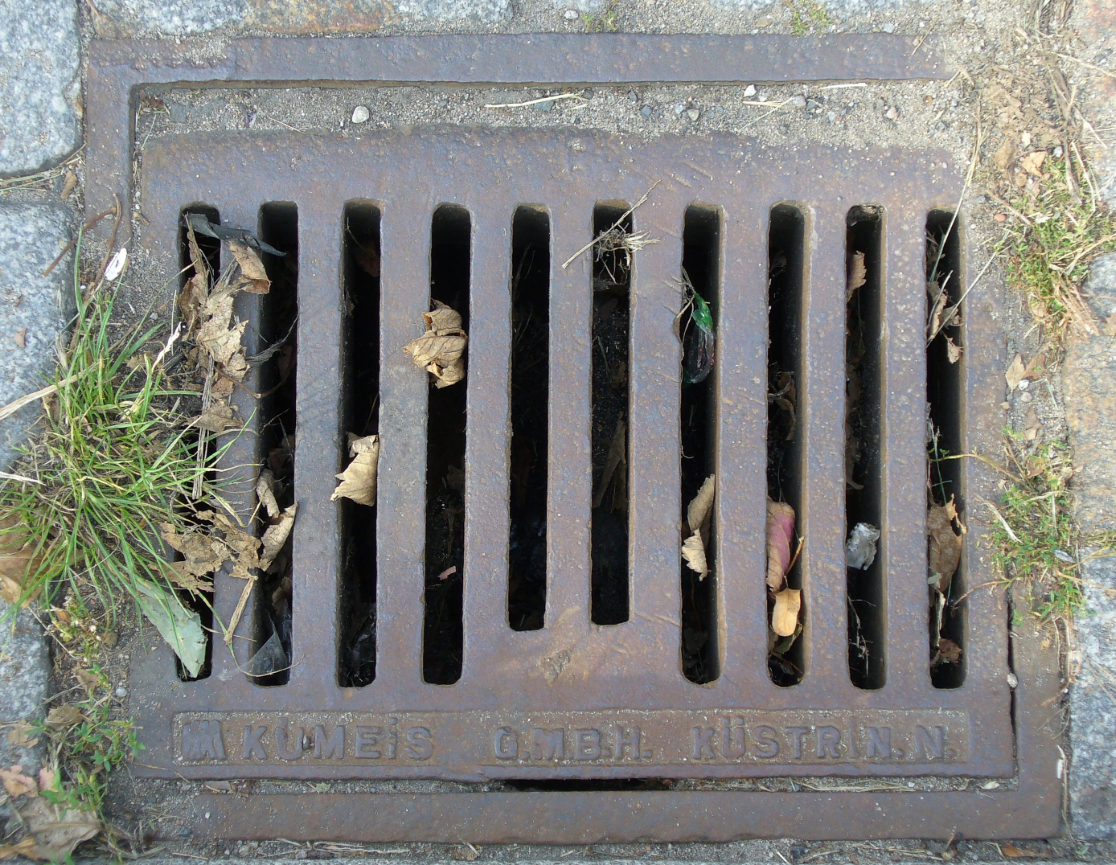

The bars of these iron gratings often run in the same direction as the road, making them a perfect trap for my bicycle. If I were to ride directly over the grating, my front tire could easily fall a few inches into one of the spaces and get stuck, causing me to fly over the handlebars. In the face of such near-certain injury, I usually swerve a bit toward the center of the road, and take my chances with the cars and trucks.

The point is that a grating is like a whole array of lines, rather than just two lines side-by-side. If you walk far away enough from the picture of the grating, you’ll see something that makes it ideal for a vision test. Geometrically, the visual angle separating the bars dwindles. When this angle is small enough, the bars will be too fine for your visual resolution, and you will see a uniform, solid rectangle rather than a series of bars.

When used in a visual acuity test, a person is shown the grating at a particular scale. Above or below the array of bars is placed a uniform rectangle. The person is then told to indicate where the bars are, on the top or on the bottom. When the grating is so fine that it exceeds the person’s acuity, then she’ll be unable to see which stimulus has the bars. She’ll have to guess. She may get lucky if asked to make the judgment only once or a few times, but after enough trials with random switching of whether the bars are on the top or on the bottom, it will soon be clear whether she is guessing where the bars are or truly perceiving it.

The visual difference between a large grating and a large uniform rectangle is very conspicuous, which is good for work with children and animals. Training an animal or small child to respond to one but not the other could nevertheless be difficult or time-consuming. The test can be further improved by making the bars brighter than the display’s background and making the spaces between the bars dimmer than the background *by the same amount* as the bars are brighter. With this type of grating, when it is too fine to be seen, it simply disappears and becomes identical to the background! The eye of the viewer, when he is unable to see the bars, is effectively averaging together the brightness of the bars with the darkness of the spaces in between, and their average is the same as the background.

Testing a human infant or animal’s visual acuity is now very simple. Both babies and animals like to look at things. Give them a choice between looking at a grating and looking at nothing, and usually they’ll look at the grating. Using this “preferential looking” test, researchers have worked out the finest grating that babies can see.

[^ArabEyeTest]:Bohigian, G. M. (2008). An Ancient Eye Test—Using the Stars. Survey of ophthalmology, 53(5), 536-539.

[^MizarWikipedia]:Mizar and Alcor. (2016, June 23). In Wikipedia, The Free Encyclopedia. Retrieved 09:45, August 18, 2016, from https://en.wikipedia.org/w/index.php?title=Mizar_and_Alcor&oldid=726638523

[^FalconStoopEyes]:<http://www.ncbi.nlm.nih.gov/pmc/articles/PMC1771963/>

[^ArabianSands]:

[^SakerFalcon]:<https://en.wikipedia.org/wiki/Saker_falcon>

[^HeartburnHair]:Costigan, K. A., Sipsma, H. L., & DiPietro, J. A. (2006). Pregnancy folklore revisited: the case of heartburn and hair. *Birth, 33*(4), 311-314.

[^MorningSickness]:Askling, J., Erlandsson, G., Kaijser, M., Akre, O., & Ekbom, A. (1999). Sickness in pregnancy and sex of child. The Lancet, 354(9195), 2053.