Dependent t-test

Daniel Lakens, [D.Lakens@tue.nl](mailto:D.Lakens@tue.nl)

This document summarizes a comparison between two independent groups, comparing precision between the LeftCanon and RightCanon conditions. This script can help to facilitate the analysis of data, and the word-output might prevent copy-paste errors when transferring results to a manuscript.

Researchers can base their statistical inferences on Frequentist or robust statistics, as well as on Bayesian statistics. Effect sizes and their confidence intervals are provided, thus inviting researchers to interpret their data from multiple perspectives.

## Checking for outliers, normality, equality of variances.

### Outliers

Boxplots can be used to identify outliers. Boxplots give the median (thick line), and 25% of the data above and below the median (box). End of whiskers are the maximum and minimum value when excluding outliers (which are indicated by dots). Code adapted from [Sandy Muspratt](https://github.com/SandyMuspratt/ScatterBoxPlot/blob/master/mtcars%20marginal%20boxplots.R).

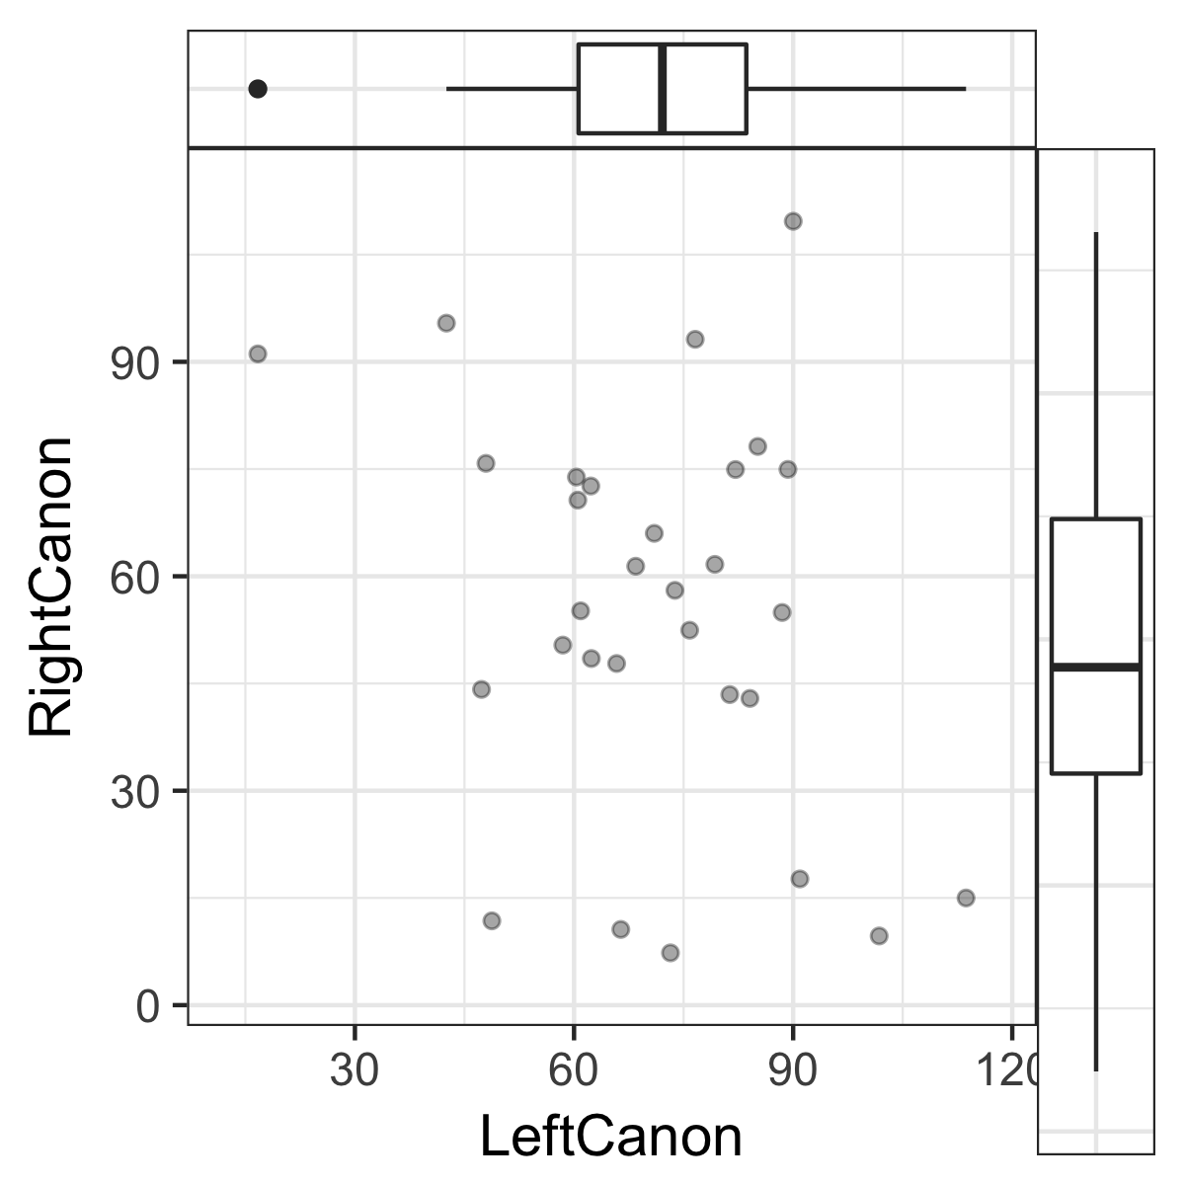

## Normality assumption

The dependent *t*-test assumes that *difference* scores are normally distributed and that the variances of the two groups are equal. It does *not* assume the data within each measurement (so within the LeftCanon and RightCanon condition) are normally distributed. If the normality assumption is violated, the Type 1 error rate of the test is no longer controlled, and can substantially increase beyond the chosen significance level. Formally, a normality test based on the data is incorrect, and the normality assumption should be tested on additional (e.g., pilot) data. Nevertheless, a two-step procedure (testing the data for normality, and using alternatives for the traditional *t*-test if normality is violated) works well (see [Rochon, Gondan, & Kieser, 2012](http://www.biomedcentral.com/1471-2288/12/81)).

### Tests for normality

[Yap and Sim (2011, p. 2153)](http://www.tandfonline.com/doi/pdf/10.1080/00949655.2010.520163) recommend: "If the distribution is symmetric with low kurtosis values (i.e. symmetric short-tailed distribution), then the D'Agostino-Pearson and Shapiro-Wilkes tests have good power. For symmetric distribution with high sample kurtosis (symmetric long-tailed), the researcher can use the JB, Shapiro-Wilkes, or Anderson-Darling test." The Kolmogorov-Smirnov (K-S) test is often used, but no longer recommended, and not included here.

If a normality test rejects the assumptions that the data is normally distributed (with *p* < .05) non-parametric or robust statistics have to be used (robust analyses are provided below).

**The normality assumption was rejected in 0 out of 4 normality tests (Anderson-Darling, D'Agostino-Pearson, and Shapiro-Wilk).**

|  |  |
| --- | --- |
| Test Name | *p*-value |
| Shapiro-Wilk | *p* = 0.474 |
| D'Agostino-Pearson | *p* = 0.58 |
| Anderson-Darling | *p* = 0.2 |
| Jarque-Berra | *p* = 0.869 |

In very large samples (when the test for normality has close to 100% power) tests for normality can result in significant results even when data is normally distributed, based on minor deviations from normality. In very small samples (e.g., n = 10), deviations from normality might not be detected, but this does not mean the data is normally distributed. Always look at a plot of the data in addition to the test results.

### Histogram, kernel density plot (black line) and normal distribution (red line) of difference scores

The density (or proportion of the observations) is plotted on the y-axis. The grey bars are a histogram of the difference scores. Judging whether data is normally distributed on the basis of a histogram depends too much on the number of bins (or bars) in the graph. A kernel density plot (a non-parametric technique for density estimation) provides an easier way to check the normality of the data by comparing the shape of the density plot (the black line) with a normal distribution (the red dotted line, based on the observed mean and standard deviation). For dependent t-tests, the main DV is the *difference score*, and therefore the difference score should be normally distributed.

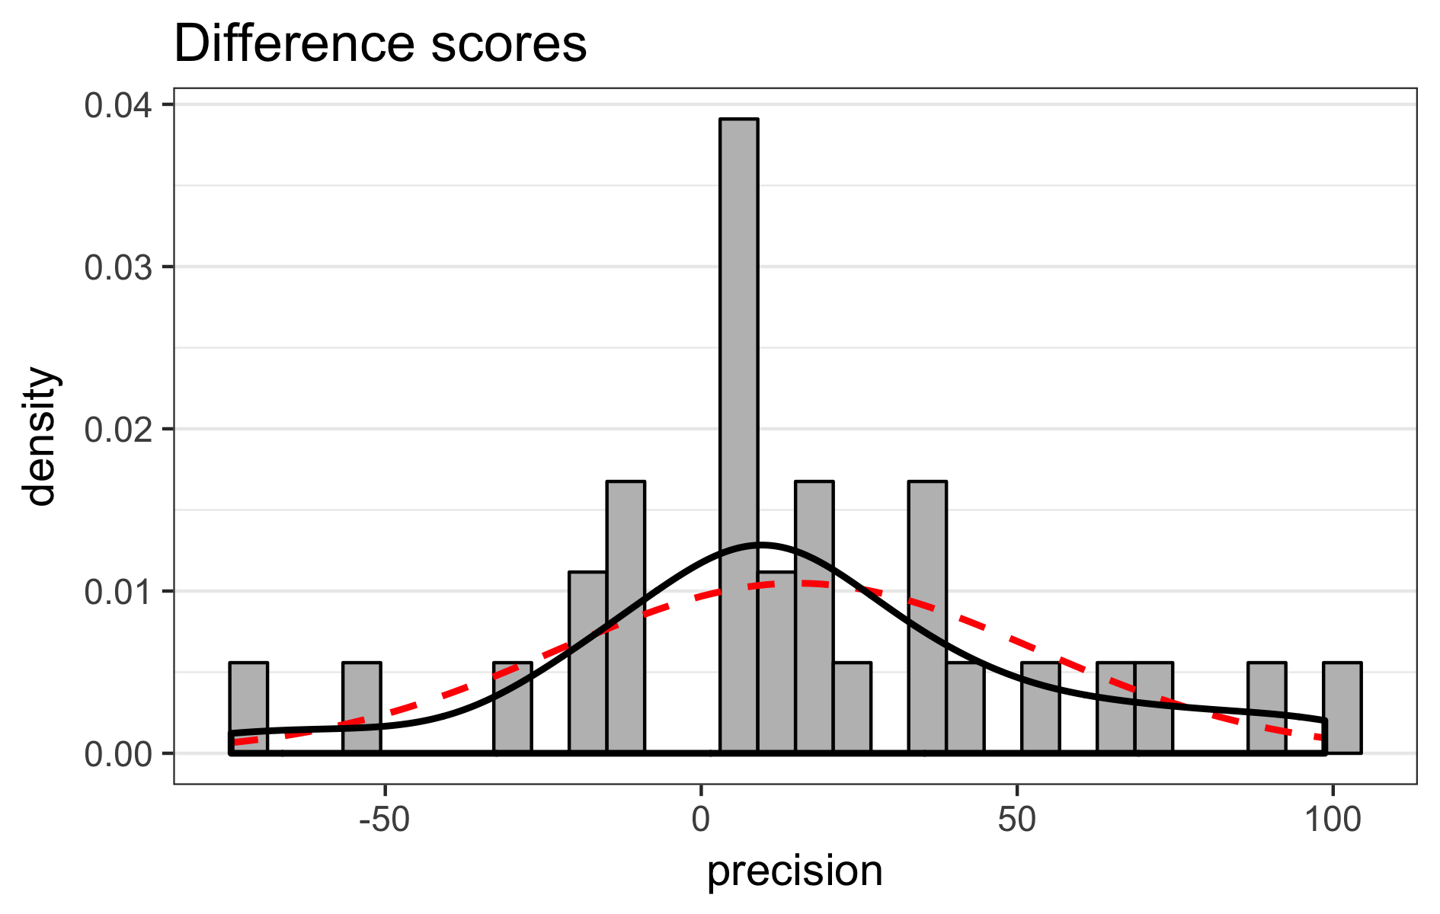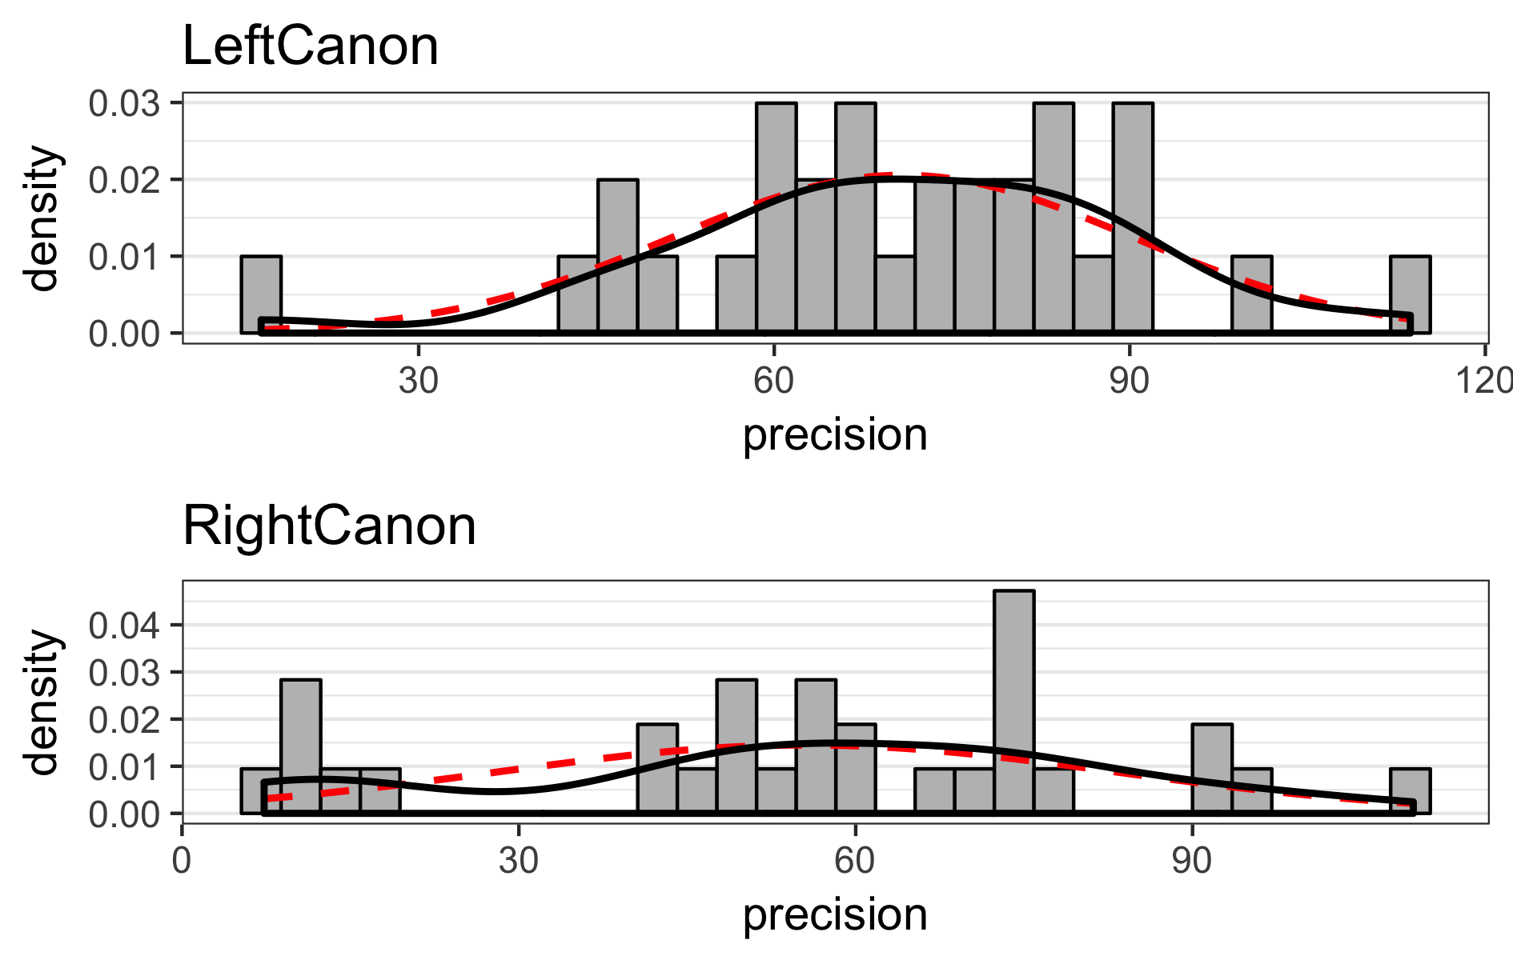

## Q-Q-plot

In the Q-Q plot for the difference scores the points should fall on the line. Deviations from the line in the upper and lower quartiles indicates the tails of the distributions are thicker or thinner than in the normal distribution. An S-shaped curve with a dip in the middle indicates data is left-skewed (more values to the right of the distribution), while a bump in the middle indicates data is right-skewed (more values to the left of the distribution). For interpretation examples, see [here](http://emp.byui.edu/BrownD/Stats-intro/dscrptv/graphs/qq-plot_egs.htm).

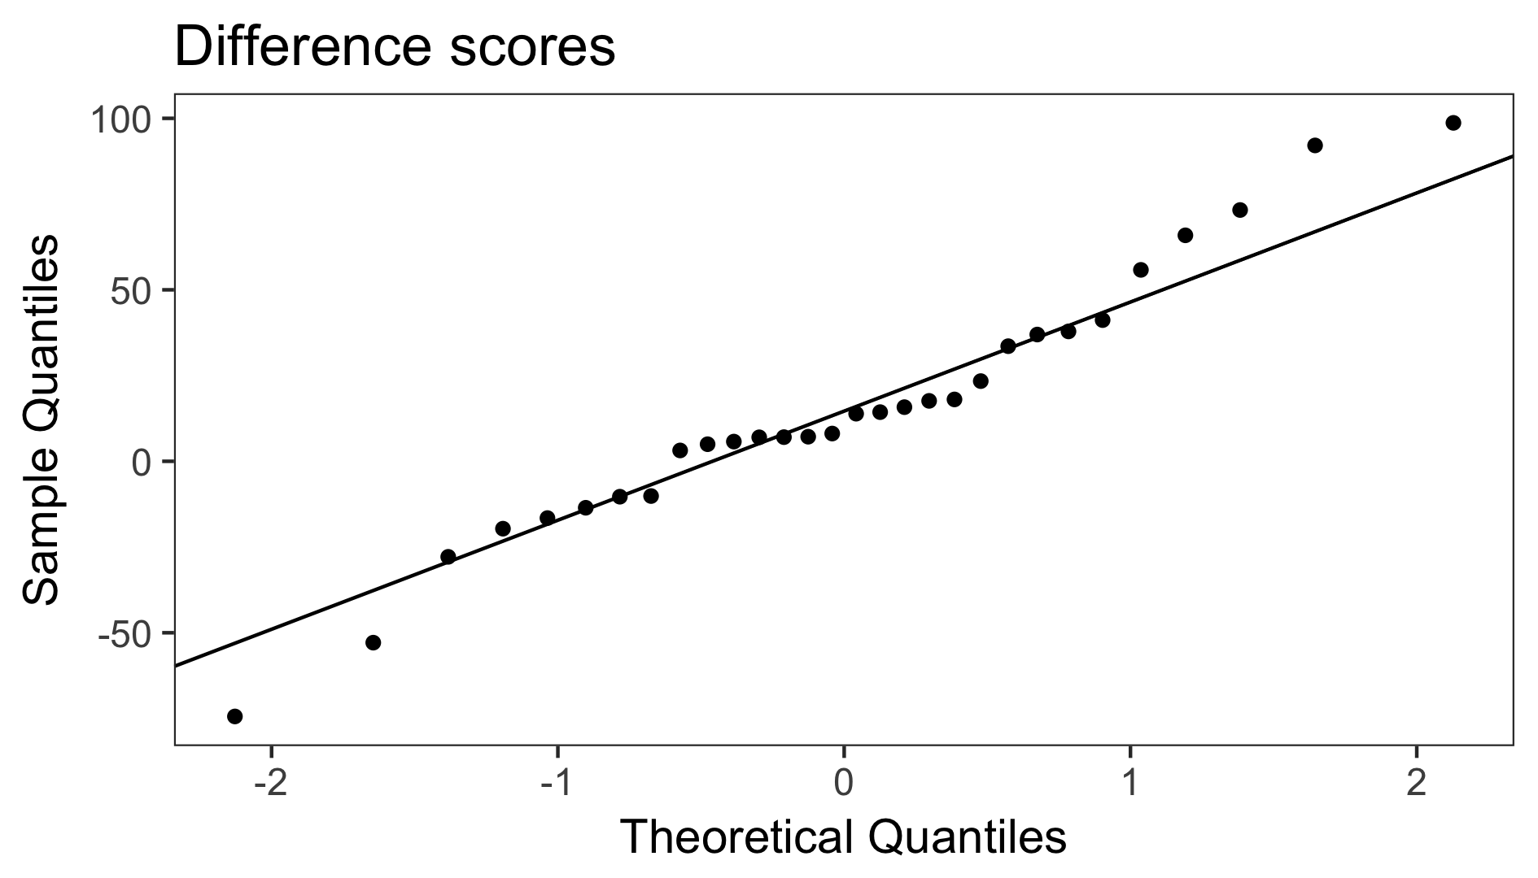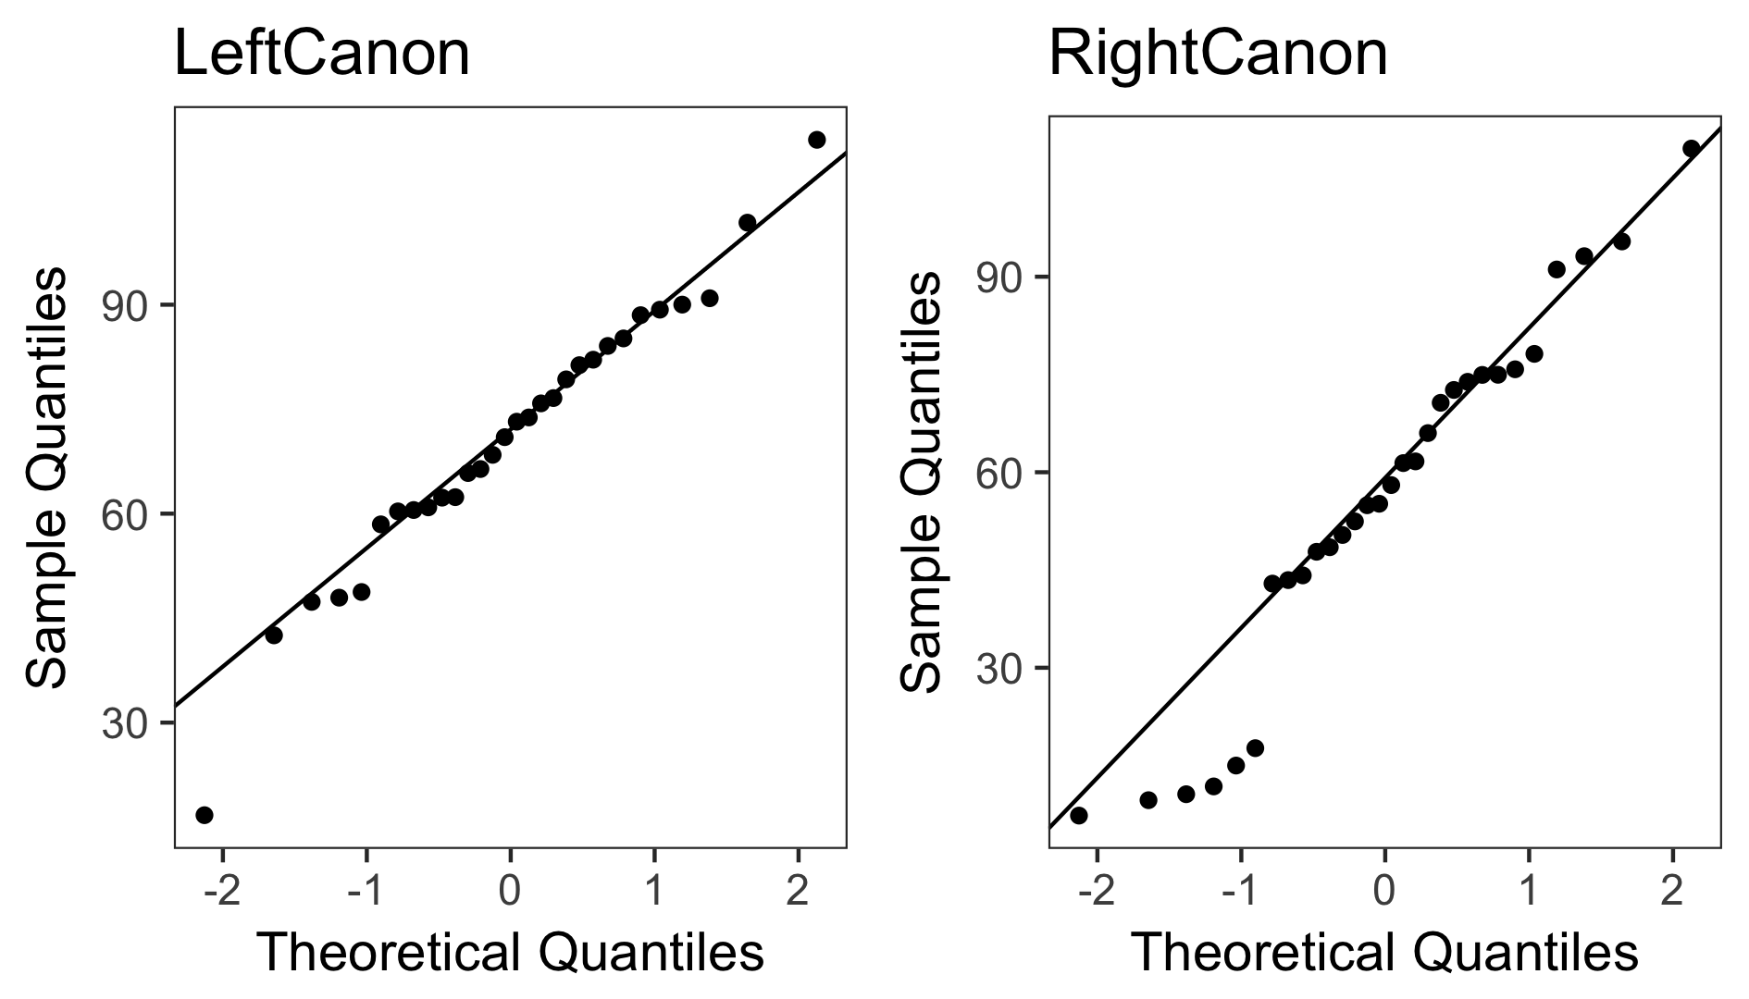

## Equal variances assumption

In addition to the normality assumption, a second assumption of the *t*-test is that variances in both groups are equal. The variance is the standard deviation, squared, and the assumption is thus that the variance in the LeftCanon condition (377.12) equals that in the RightCanon condition (756.61). [Markowski & Markowski (1990)](http://www.jstor.org/stable/2684360) show that if sample sizes are equal, violations of the equal variance assumption do not lead to unsatisfactory performance (defined as actual significance levels falling outside a 0.03-0.07 boundary for a nominal alpha level of 0.05).

### Levene's test

This equality of variances assumption is typically examined with Levene's test, although in small samples, Levene's test can have low power, and thus fail to reject the null-hypothesis that variances are equal, even when they are unequal. Levene's test for equality of variances (*p* = 0.083) indicates that the assumption that variances are equal is not rejected.

## Comparing the two sets of data

Before looking at the results of the Frequentist statistics and the Robust statistics, decide which of these answer the question you are interested in. Choosing between these two options depending on the outcome of the statistical test inflates the Type 1 error rate. You can always report Bayesian statistics.

### Frequentist statistics

A *p*-value is the probability of obtaining the observed result, or a more extreme result, assuming the null-hypothesis is true. It is not the probability that the null-hypothesis or the alternative hypothesis is true (for such inferences, see Bayesian statistics below). In repeated sampling, 95% of future 95% confidence intervals can be expected to contain the true population parameters (e.g, the mean difference or the effect size). Confidence intervals are not a statement about the probability that a single confidence interval contains the true population parameter, but a statement about the probability that future confidence intervals will contain the true population parameter. Hedges' *g* (also referred to as *d*unbiased, see Borenstein, Hedges, Higgins, & Rothstein, 2009) is provided as best estimate of Cohen's *d*, but the best estimate of the confidence interval is based on *d*av (as recommended by Cumming, 2012). Hedges's *g* and the 95% CI around the effect size are calculated using the MBESS package by ([Kelley (2007](http://dx.doi.org/10.3758/BF03192993)). The common language effect size expresses the probability that in any random pairing of two observations from both groups, the observation from one group is higher than the observation from the other group, see [McGraw & Wong, 1992](http://dx.doi.org/10.1037/0033-2909.111.2.361). In a dependent *t*-test, the effect size Cohen's *d* can be calculated by using a standardizer that controls for the correlation between observations (*d*av) or not (*d*z). Both are provided, but *d*av (or actually it's unbiased estimate, *g*av) is recommended. For a discussion, see [Lakens, 2013](http://journal.frontiersin.org/Journal/10.3389/fpsyg.2013.00863/full). Default interpretations of the size of an effect as provided here should only be used as a last resort, and it is preferable to interpret the size of the effect in relation to other effects in the literature, or in terms of its practical significance.

#### Results

The mean precision of participants in the LeftCanon condition (*M* = 70.85, *SD* = 19.42) was greater than the mean of participants in the RightCanon condition (*M* = 55.64, *SD* = 27.51, *r* = -0.29). The difference between measurements (*M* = 15.2, *SD* = 38.06, 95% CI = [0.99;29.42]) was analyzed with a dependent *t*-test, *t*(29) = 2.19, *p* = 0.037, Hedges' *g* = 0.62, 95% CI [0.04;1.23] (or *d*z = 0.4, 95% CI [0.02;0.77]). This can be considered a medium effect. The observed data is surprising under the assumption that the null-hypothesis is true. The Common Language effect size (McGraw & Wong, 1992) indicates that after controlling for individual differences, the likelihood that a persons precision in the LeftCanon condition is greater than the precision in the RightCanon condition is 66%.

### Bayesian statistics

Bayesian statistics can quantify the relative evidence in the data for either the alternative hypothesis or the null hypothesis. Bayesian statistics require priors to be defined. In the Bayes Factor calculation reported below, a non-informative Jeffreys prior is placed on the variance of the normal population, while a Cauchy prior is placed on the standardized effect size (for details, [see Morey & Rouder, 2011](http://drsmorey.org/bibtex/upload/Morey:Rouder:2011.pdf)). Calculations are performed using the [BayesFactor package](http://cran.r-project.org/web/packages/BayesFactor/BayesFactor.pdf). Default interpretations of the strength of the evidence are provided but should not distract from the fact that strength of evidence is a continuous function of the Bayes Factor. A second popular Bayesian approach relies on estimation, and the mean posterior and 95% higest density intervals (HDI) are calculated following recommendations by [Kruschke, (2013)](http://www.indiana.edu/~kruschke/BEST/BEST.pdf) based on vague priors. According to Kruschke (2010, p. 34): 'The HDI indicates which points of a distribution we believe in most strongly. The width of the HDI is another way of measuring uncertainty of beliefs. If the HDI is wide, then beliefs are uncertain. If the HDI is narrow, then beliefs are fairly certain.' To check the convergence and fit of the HDI simulations, the Brooks-Gelman-Rubin scale reduction factor for the difference score should be smaller than 1.1 (it is 0.9999864) and the effective sample size should be larger than 10000 (it is 59240). Thus, the HDI simulation is acceptable.

#### Results

The JZS BF10 (with r scale = 0.5) = 1.79. This indicates the data are 1.79 (or loge BF =0.58) times more probable under the alternative hypothesis, than under the null hypothesis. This data provides anecdotal evidence for H1. The posterior mean difference is 14.66, 95% HDI = [0.6; 28.85].

### Robust statistics

Values in the tails of the distribution can have a strong influence on the mean. If values in the tails differ from a normal distribution, the power of a test is reduced and the effect size estimates are biased, even under slight deviations from normality (Wilcox, 2012). One way to deal with this problem is to remove the tails in the analysis by using *trimmed means*. A recommended percentage of trimming is 20% from both tails (Wilcox, 2012), which means inferences are based on the 60% of the data in the middle of the distribution. Yuen's method can be used to compare trimmed means (when the percentage of trimming is 0%, Yuen's method reduces to Welch's *t*-test). The equivalent of Cohen's *d* for within designs is not yet available, so the explanatory effect size is reported ([Wilcox & Tian, 2011](http://dx.doi.org/10.1080/02664763.2010.498507)). Explanatory power (Xi, replace in the output below by the Greek lowercase Xi symbol) is the robust equivalent of omega squared (unbiased eta squared, or *r* squared), and thus related to *d*z in size, not to *d*av. The effect size convention of small, medium, and large corresponds approximately to Xi = 0.15, 0.35 and 0.50.

#### Results

The 20% trimmed mean precision of participants in the LeftCanon condition (*M* = 71.64) was greater than the 20% trimmed mean of participants in the RightCanon condition (*M* = 58.55). The difference in precision between the conditions (*M* = 13.09, 95% CI [12.74;13.44]) was analyzed using the Yuen-Welch test for 20% trimmed means, *t*(17) = 2.37, *p* = 0.030, Xi = 0.44. The observed data is surprising under the assumption that the null-hypothesis is true. This can be considered a medium effect.

### *Figure 1*. Means, violin plot, and two-tiered 95% within (crossbars) and between (endpoints of lines) confidence intervals following Morey (2008) and Baguley (2012).

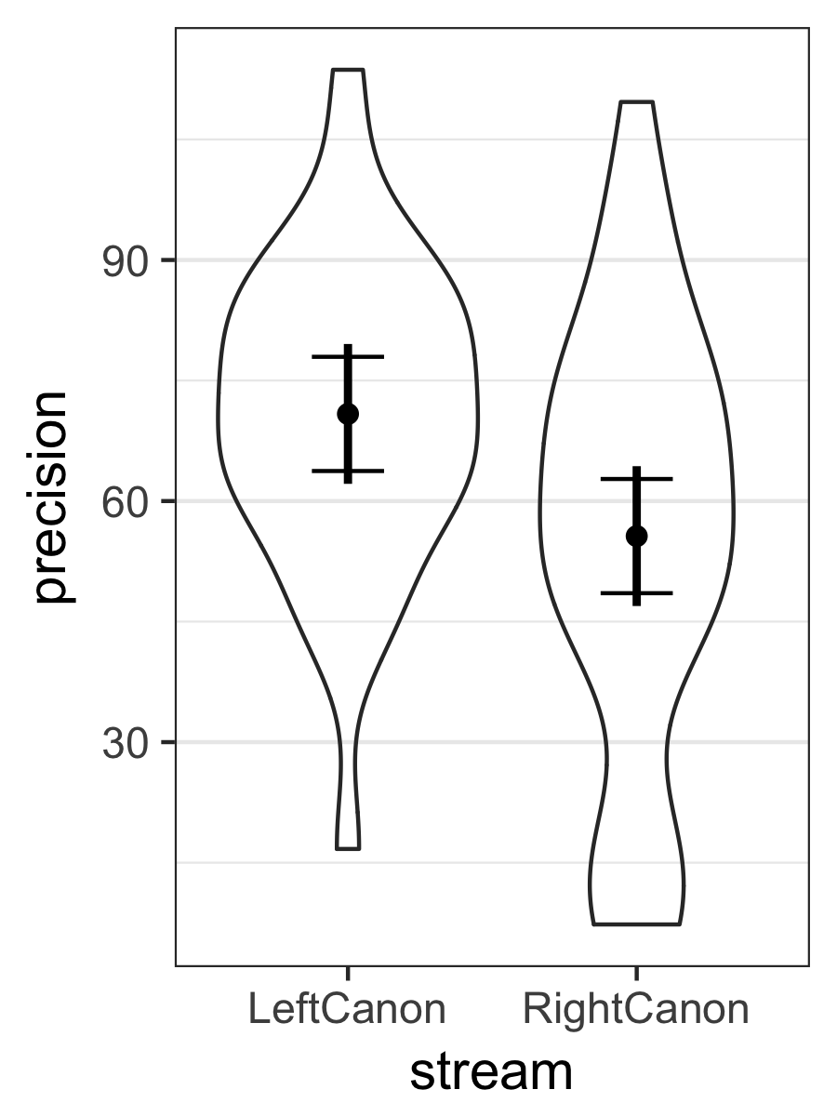

### *Figure 2*. Means, datapoints, and 95% CI (between & within)

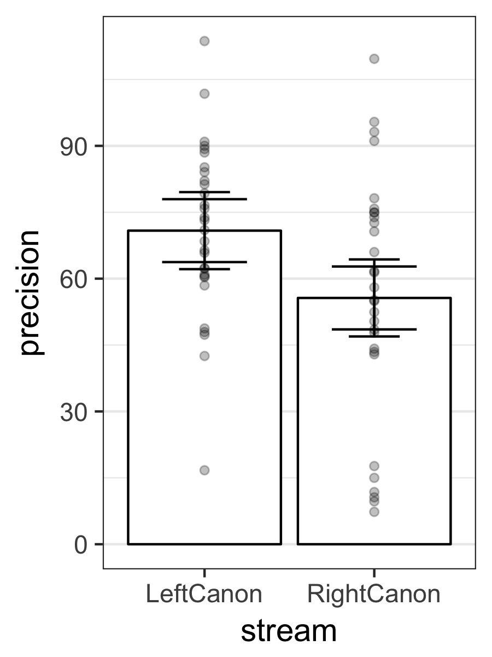

### *Figure 3*. Bar chart displaying means and 95% CI (between and within)

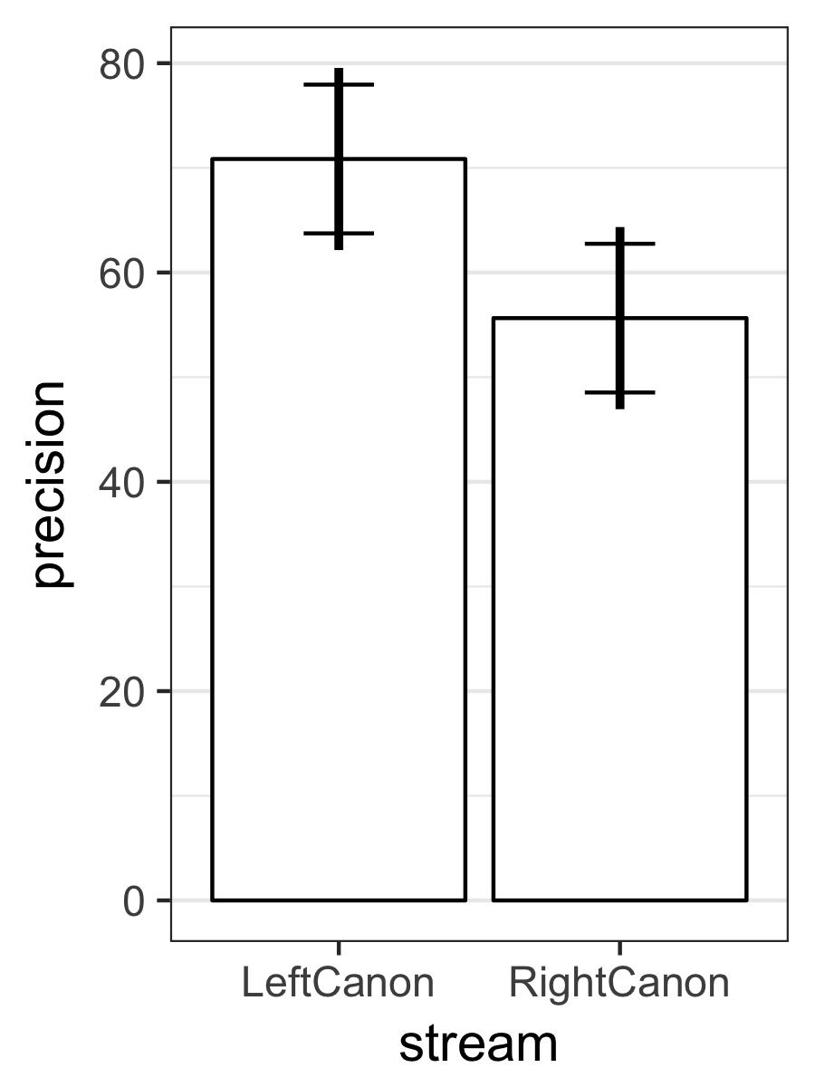

### References

This script uses the *reshape2* package to convert data from wide to long format, the *PoweR* package to perform the normality tests, *HLMdiag* to create the QQplots, *ggplot2* for all plots, *gtable* and *gridExtra* to combine multiple plots into one, *car* to perform Levene's test, *MBESS* to calculate effect sizes and their confidence intervals, *WRS* for the robust statistics, *BayesFactor* for the bayes factor, and *BEST* to calculate the Bayesian highest density interval.

Auguie, B. (2012). *gridExtra: functions in Grid graphics*. R package version 0.9.1, URL: <http://CRAN.R-project.org/package=gridExtra>.

Baguley, T. (2012). Calculating and graphing within-subject confidence intervals for ANOVA. *Behavior research methods*, *44*, 158-175.

Borenstein, M., Hedges, L. V., Higgins, J. P., & Rothstein, H. R. (2009). *Introduction to meta-analysis*. Hoboken, NJ: Wiley.

Box, G. E. P. (1953). Non-normality and tests on variance. *Biometrika*, *40*, 318-335.

Cumming, G. (2012). *Understanding the new statistics: Effect sizes, confidence intervals, and meta-analysis*. New York: Routledge.

Cohen, J. (1988). *Statistical power analysis for the behavioral sciences (2nd ed.)*. Hillsdale, NJ: Erlbaum.

Fox, J. & Weisberg, S. (2011). *An R Companion to Applied Regression, Second edition*. Sage, Thousand Oaks CA. URL: <http://socserv.socsci.mcmaster.ca/jfox/Books/Companion>.

Kelley, K. (2005). The effects of nonnormal distributions on confidence intervals around the standardized mean difference: Bootstrap and parametric confidence intervals. *Educational and Psychological Measurement*, *65*, 51-69.

Kelley, K. (2007). Confidence intervals for standardized effect sizes: Theory, application, and implementation. *Journal of Statistical Software*, *20*, 1-24.

Kelley, K. & Lai, K. (2012). *MBESS. R package version 3.3.3*, URL: <http://CRAN.R-project.org/package=MBESS>.

Kruschke, J. (2010). *Doing Bayesian data analysis: A tutorial introduction with R*. Academic Press.

Kruschke, J. K. (2013). Bayesian estimation supersedes the t-test. *Journal of Experimental Psychology: General*, *142*, 573-603.

Kruschke, J. K., & Meredith, M. (2014). *BEST: Bayesian Estimation Supersedes the t-test*. R package version 0.2.2, URL: <http://CRAN.R-project.org/package=BEST>.

Lakens, D. (2013). Calculating and reporting effect sizes to facilitate cumulative science: a practical primer for t-tests and ANOVAs. *Frontiers in psychology*, *4*.

Loy, A., & Hofmann, H. (2014). HLMdiag: A Suite of Diagnostics for Hierarchical Linear Models. R. Journal of Statistical Software, 56, pp. 1-28. URL: <http://www.jstatsoft.org/v56/i05/>.

McGraw, K. O., & Wong, S. P. (1992). A common language effect size statistic. *Psychological Bulletin*, *111*, 361-365.

Micheaux, PLd. & Tran, V. (2012). PoweR. URL: <http://www.biostatisticien.eu/PoweR/>.

Morey, R. D. (2008). Confidence intervals from normalized data: A correction to Cousineau (2005). *Tutorial in Quantitative Methods for Psychology*, *4*, 61-64.

Morey, R. D. & Rouder, J. N. (2011). Bayes Factor Approaches for Testing Interval Null Hypotheses. *Psychological Methods*, *16*, 406-419

Morey R and Rouder J (2015). *BayesFactor: Computation of Bayes Factors for Common Designs*. R package version 0.9.11-1, URL: <http://CRAN.R-project.org/package=BayesFactor>.

Rochon, J., Gondan, M., & Kieser, M. (2012). To test or not to test: Preliminary assessment of normality when comparing two independent samples. *BMC Medical Research Methodology*, 12:81.

Rouder, J. N., Speckman, P. L., Sun, D., Morey, R. D., & Iverson, G. (2009). Bayesian t-tests for accepting and rejecting the null hypothesis. *Psychonomic Bulletin & Review*, *16*, 752-760

Ruxton, G. D. (2006). The unequal variance t-test is an underused alternative to Student's t-test and the Mann-Whitney U test. *Behavioral Ecology*, *17*, 688-690.

Wickham, H. (2007). Reshaping Data with the reshape Package. *Journal of Statistical Software*, *21*, pp. 1-20. URL: <http://www.jstatsoft.org/v21/i12/>.

Wickham, H. (2009). *ggplot2: elegant graphics for data analysis*. Springer New York. ISBN 978-0-387-98140-6, URL: <http://had.co.nz/ggplot2/book>.

Wickham, H. (2012). *gtable: Arrange grobs in tables*. R package version 0.1.2, URL: <http://CRAN.R-project.org/package=gtable>.

Wilcox, R. R. (2012). *Introduction to robust estimation and hypothesis testing*. Academic Press.

Wilcox, R. R., & Sch?nbrodt, F. D. (2015). *The WRS package for robust statistics in R (version 0.27.5)*. URL: <https://github.com/nicebread/WRS>.

Wilcox, R. R., & Tian, T. S. (2011). Measuring effect size: a robust heteroscedastic approach for two or more groups. *Journal of Applied Statistics*, *38*, 1359-1368.

Yap, B. W., & Sim, C. H. (2011). Comparisons of various types of normality tests. *Journal of Statistical Computation and Simulation*, *81*, 2141-2155.

### Apendix A: Data & Session Information

alldata

## Subject LeftCanon RightCanon diff  
## 1 AA 113.67244 14.991980 98.680459  
## 2 AB 90.92739 17.658884 73.268511  
## 3 AC 79.28069 61.663318 17.617373  
## 4 AD 81.32105 43.449427 37.871620  
## 5 AH 47.93855 75.795999 -27.857447  
## 6 AI 66.40563 10.592779 55.812854  
## 7 AJ 16.70811 91.110710 -74.402597  
## 8 AK 60.32418 73.875581 -13.551400  
## 9 AL 73.81348 58.029162 15.784323  
## 10 AO 68.44288 61.401783 7.041095  
## 11 AU 60.52229 70.654298 -10.132006  
## 12 AV 60.90446 55.162264 5.742196  
## 13 AW 82.10288 74.933576 7.169301  
## 14 AX 84.08007 42.911204 41.168868  
## 15 AZ 90.01224 109.663157 -19.650919  
## 16 BA 76.59290 93.151315 -16.558411  
## 17 BC 65.83123 47.796560 18.034668  
## 18 BD 75.83328 52.452022 23.381260  
## 19 BE 101.77808 9.677907 92.100175  
## 20 BF 88.49539 54.933690 33.561704  
## 21 BG 85.15617 78.161968 6.994206  
## 22 BI 89.28456 74.952281 14.332274  
## 23 BJ 62.36899 48.491842 13.877151  
## 24 BK 47.33163 44.171015 3.160619  
## 25 BN 62.29778 72.625264 -10.327484  
## 26 BO 48.74946 11.791786 36.957677  
## 27 BP 73.20219 7.312541 65.889647  
## 28 BQ 42.52762 95.413741 -52.886124  
## 29 BR 58.46381 50.373642 8.090164  
## 30 BS 70.98365 66.005010 4.978640

sessionInfo()

## R version 3.3.3 (2017-03-06)  
## Platform: x86_64-apple-darwin13.4.0 (64-bit)  
## Running under: OS X Yosemite 10.10.5  
##   
## locale:  
## [1] en_AU.UTF-8/en_AU.UTF-8/en_AU.UTF-8/C/en_AU.UTF-8/en_AU.UTF-8  
##   
## attached base packages:  
## [1] grid parallel stats graphics grDevices utils datasets   
## [8] methods base   
##   
## other attached packages:  
## [1] HLMdiag_0.3.1 gridExtra_2.2.1 gtable_0.2.0   
## [4] ggplot2_2.2.1 BEST_0.5.0 HDInterval_0.1.3   
## [7] BayesFactor_0.9.12-2 Matrix_1.2-10 coda_0.19-1   
## [10] MASS_7.3-47 WRS_0.30.1 MBESS_4.3.0   
## [13] car_2.1-4 PoweR_1.0.5 Rcpp_0.12.11   
## [16] reshape2_1.4.2 R.matlab_3.6.1   
##   
## loaded via a namespace (and not attached):  
## [1] nloptr_1.0.4 plyr_1.8.4 R.methodsS3_1.7.1   
## [4] R.utils_2.5.0 tools_3.3.3 digest_0.6.12   
## [7] lme4_1.1-13 tibble_1.3.3 evaluate_0.10   
## [10] nlme_3.1-131 lattice_0.20-35 mgcv_1.8-17   
## [13] rlang_0.1.1 yaml_2.1.14 SparseM_1.77   
## [16] mvtnorm_1.0-6 stringr_1.2.0 knitr_1.16   
## [19] rjags_4-6 MatrixModels_0.4-1 gtools_3.5.0   
## [22] rprojroot_1.2 nnet_7.3-12 pbapply_1.3-2   
## [25] RLRsim_3.1-3 rmarkdown_1.5 minqa_1.2.4   
## [28] magrittr_1.5 scales_0.4.1 backports_1.1.0   
## [31] htmltools_0.3.6 splines_3.3.3 pbkrtest_0.4-7   
## [34] colorspace_1.3-2 labeling_0.3 quantreg_5.33   
## [37] stringi_1.1.5 lazyeval_0.2.0 munsell_0.4.3   
## [40] R.oo_1.21.0

Copyright ? 2015 Daniel Lakens

Lakens, D. (2015). The perfect *t*-test. Retrieved from <https://github.com/Lakens/perfect-t-test>. <doi:10.5281/zenodo.17603>

This program is free software: you can redistribute it and/or modify it under the terms of the GNU Affero General Public License as published by the Free Software Foundation, either version 3 of the License, or (at your option) any later version.

This program is distributed in the hope that it will be useful, but WITHOUT ANY WARRANTY; without even the implied warranty of MERCHANTABILITY or FITNESS FOR A PARTICULAR PURPOSE. For more information, see the [GNU Affero General Public License](http://www.gnu.org/licenses/)