Alex Honeygosky

<https://github.com/alexhoneygosky/CitySim9003>

CS 1632 - DELIVERABLE 2: Unit Testing CitySim9003

**Issues Faced**

Throughout this project, I battled trying to figure out how much I should break my code out into different functions while not being overly simple with my methods and classes. Once I got to the testing portion of this project, I found that I handled the structure of my code pretty well. The only hang up that I had in testing is when I was writing the “testNoRoutes” function in TestTraverseCity.java. There was no issue testing the valid route test, but I think the reason I could not test the no routes function properly is because of the way I set up my mocks and thus, the way that I set up my code in the beginning. In hindsight, using TDD for this project would have helped me avoid the problem with that test, but with the time constraints of other classes, I was unable to follow that process the way I would have wanted. Lastly, the only concern that I had through the entire process of this project is that I hope that the tests that I wrote were sufficient for the methods that I wrote for the program.

**Screenshots**

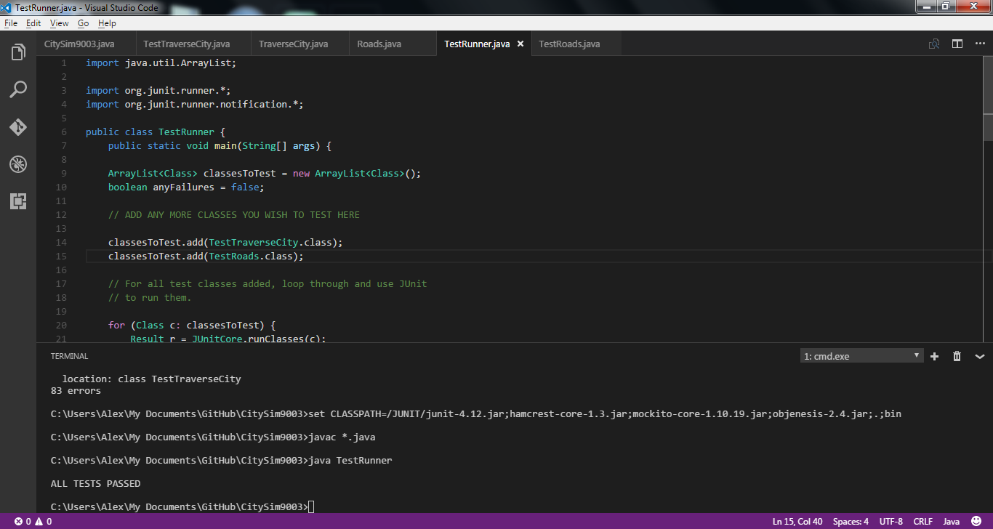

To ensure that all of my unit tests passed for this project, I used the TestRunner.java program that Professor Laboon wrote because it would tell me if there was an error with one of my tests. Above is a screenshot of me running the TestRunner.java file to check that all tests passed. In the same screenshot, you can see that I included both .class files that have all of my tests within them.

