3/23/2017

Milestone 4

Comp 1536

Alex Hosseini

Hao Guan

Hao Tang

Greg Torney

Xiaoan Yang

Content s

Validation Requirements 3

Implement validation requirements 4

Test Form 4

JavaScript widget 4

Testing with JavaScript disabled 5

Published site 5

Changes from previous milestones 5

Outstanding work 5

Appendix I 6

Milestone One 6

Milestone Two 8

Milestone Three 17

# Validation Requirements

We used recommendations online to decide what types of strings we will accept. Our forms are very limited; we used RegExp to ensure the strings inputted match our defined requirements.

|  |
| --- |
| **FORM on page:** contact.html |
| **Field ID** | **Data Format or RegExp** | **Explanation** |
| inputEmail | ^([a-zA-Z0-9_.+-])+\@(([a-zA-Z0-9-])+\.)+([a-zA-Z]{2,4}\b)+$ | Letters, numbers, _, -,+, . 1 or more times  followed by @ once  followed by letters, numbers, or –, 1 or more times  followed by a . 1 or more times  ending with 2 to 4 letters |
| inputSubject | Not blank | Subject field should not be blank |
| textArea | Not blank | Message should not be blank |

|  |
| --- |
| **FORM on page:** signup.html |
| **Field ID** | **Data Format or RegExp** | **Explanation** |
| inputEmail | ^([a-zA-Z0-9_.+-])+\@(([a-zA-Z0-9-])+\.)+([a-zA-Z]{2,4}\b)+$ | Letters, numbers, _, -,+, . 1 or more times  followed by @ once  followed by letters, numbers, or –, 1 or more times  followed by a . 1 or more times  ending with 2 to 4 letters |
| inputUser | ^[A-z0-9_.-]{4,12}$ | At least 4 characters Less than 17 characters  Uppercase and lowercase letters  Numbers  No symbols (excludes: - , _, and .) |
| inputPassword | ^(?=.*[A-Za-z])(?=.*\d)(?=.*[$@$!%*#?&])[A-Za-z\d$@$!%*#?&]{8,}$ | At least 8 characters  At least 1 number  At least 1 symbol (e.g. !, #, $) |

|  |
| --- |
| **FORM on page:** login.html |
| **Field ID** | **Data Format or RegExp** | **Explanation** |
| inputEmail | ^([a-zA-Z0-9_.+-])+\@(([a-zA-Z0-9-])+\.)+([a-zA-Z]{2,4}\b)+$ | Letters, numbers, _, -,+, . 1 or more times  followed by @ once  followed by letters, numbers, or –, 1 or more times  followed by a . 1 or more times  ending with 2 to 4 letters |
| inputPassword | Not blank | Subject field should not be blank |

# Implement validation requirements

Upon submission of each form, a function named formValidate() is called which checks the fields as described above. If there are any errors, on-form error messages in red are displayed.

Forms do not submit unless all error messages have been cleared

# Test Form

We had 3 classmates use our forms. The responses were similar throughout. They were all understanding of the regular expression demands. One person suggested we add a character limit to the username, so we can appropriately fit the username onto certain web pages.

|  |
| --- |
| **FORM ON PAGE:** signup.html |
| **FIELD LEVEL TESTING** | | | |
| **Field ID** | | **Problem** | **Improvements** |
| inputUser | | No limit to characters entered | Added a character limit of 16 |

# JavaScript widget

We added a tooltip the username input on signup.html

It will let people know the requirements before they may get an error, which will lower frustration.

## Testing with JavaScript disabled

Form submission works normally without JavaScript. The tooltip styling does not. The native HTML tooltip shows up which is hard to read and has a longer delay to popup than with jQuery.

# Published site

We found it difficult to assess our time. There were things that you only realize during development, that they must be implemented or changed. For example, after we finished the website, we realized last minute that the home page does not at all tell the user that the website is about recipes. We plan to change this by the next milestone. We are thinking about a full span carousel.

We also ended up changing the layout of the recipe page, and continent pages as we were not happy with how they appeared when finished.

Things like this made it difficult to add onto our already tight schedules.

However, in the end we are still all satisfied with how has turned out.

# Changes from previous milestones

Homepage layout(headings).

Fixed continent page layout as discussed with Dr. Yu.

Recipe page layout.

Added 2 recipes to most continents so we could display 5 total on each continent page.

# Outstanding work

Some styling is not perfect.

Code should be cleaned up.

Add 2 more recipes to Africa and Antarctica.

Maybe find better images.

MySQL implementation with forums and users.

# Appendix I

# Milestone One

**1.  Topic**

**1.1 The Purpose**

The purpose of our website is to supply its users with recipes from all around the world; It will showcase different recipes from select continents. Users will be able to comment, rate, and suggest other recipes. In addition to this, there will be a forum space where users can communicate their thoughts to the whole community.

**1.2 Our Goals**

The goals of the website are strictly non-profit. We simply want to act as a medium for people to discover new recipes across the globe, and collaborate.

**1.3 Target Audience**

Our target audience is the world. There are no barriers of gender, age, income, education, or ethnicity when it comes to cooking.

**1.4 Aims and Accomplishments**

We aim to build a large user base that visit the website at least once a month. We intend to allow users to supply new recipes, so if the website does not establish a stable user base, it may not succeed.

**1.5 Required Content**

We will need to find media from all around the world. Each continent will need a text description of the culture and cuisine. Alongside this, continents will need photos illustrating their culture, and at least one photo showcasing a dish that we can provide a recipe for.

**1.6 Factors of Success**

The most important factor for this website to succeed is our execution. Since our target is almost everyone, the website should attract a large amount of users and thereon carry itself. The website must be aesthetically pleasing, universal, and functional, while the recipes must be easy to follow and of course, tasteful.

**1.7 Competition**

[Allrecipes.com](http://Allrecipes.com) and the [foodnetwork.com](http://www.foodnetwork.com) are the first two websites to show up when you search for “recipes”. We do not like how several recipes are pressed onto the user. We find the websites hard to navigate and very scattered. Both websites are not symmetrical, which we feel is unappetizing.

Filled with articles, videos, and prompts to subscribe, the websites are distasteful

We will aim for a minimalistic, symmetrical design, with recipes as the sole attraction.

**2.  Functional Requirements**

**2.1 Forms**

We plan to implement two forms. One form will be required upon signing up.

Elements for signing up will be basic: an email input (required), a username (required), password (required), country, and subscription check box. The only detail we will display online from a user is their username to display who submitted the recipe.

Another form will be used on a “contact us/submit a recipe” page. This form will have an email input(required), a name input(required), and a textarea(required) that will function as the body of an email. All recipes submitted to us will be considered. If we deem them tasty, we will publish them.

**2.2 Lists**

We plan to include a list of our top 10 dishes across the globe, chosen by us. This would be updated monthly with just a few dishes changing from the list. Also, we will implement a list view of all the dishes on our website, sorted by continent.

2.3 User Input

Our website will allow users to submit their own recipes through the contact/submit page. Another way that users can interact with our website is by commenting on recipes on the recipes page, and the users will also be able to reply to other users’ comments.

**3.  Work Plan**

**3.1 Divide and Conquer**

We are scattered among 3 different sets, so we are using WhatsApp to communicate daily. We plan to meet every Wednesday at 15:00, as that time works for everyone. The work will be spread evenly between each member, working together on the landing page, and then dividing up the continents. This will include gathering media, recipes, and other relatable information for each continent .

# Milestone Two

In the previous milestone, we decided the topic of our website and set the goals and purpose. For this milestone, we will proceed further and construct the basic structure of our website.

In the first section, we will propose a site map that demonstrates the essential components and the overall flow of our website, then the next section will focus on the layout for each proposed webpage.

**Site map and navigation**

Our website follows a shallow hierarchy design. From the home page, the user will be able to navigate to all the parts of the website. The home page offers a clickable area in the center that directs a user to one of the seven continents page. In addition to this, navigation bar can lead users to a page with all the recipes available, organized by continent.

The continents page and list view page will lead the user to the lowest level of our website --- the recipes page. We strive to design an easy-to-navigate website that allows the visitors to find the information they want.

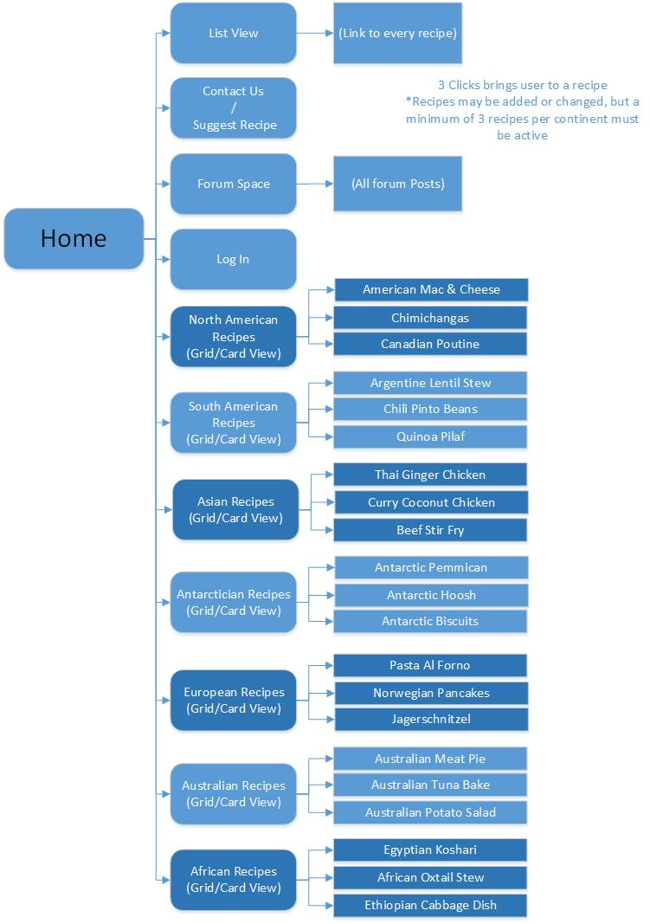

**Page Layout**

Our website will have 8 types of pages: the home page, list view page, contact page, forum page, forum post page, log in page, continent view page and the recipe page. All the pages will employ a single to three column design for simplicity and visual continuity.

For responsiveness and a fluid-width layout, we will be using Bootstrap as a framework.

Print layouts will include all content minus images, the navigation bar, and the footer.

We used Visio to create the wireframe for all the pages as listed below:

2.1 Home Page

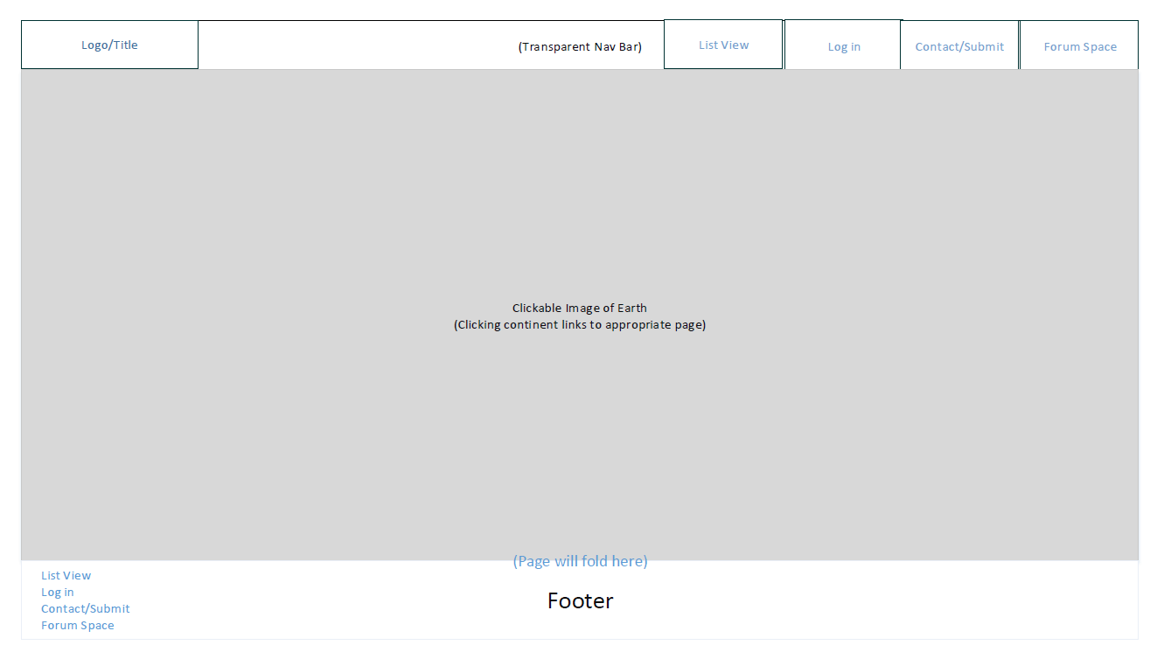

**2.2 List View Page**

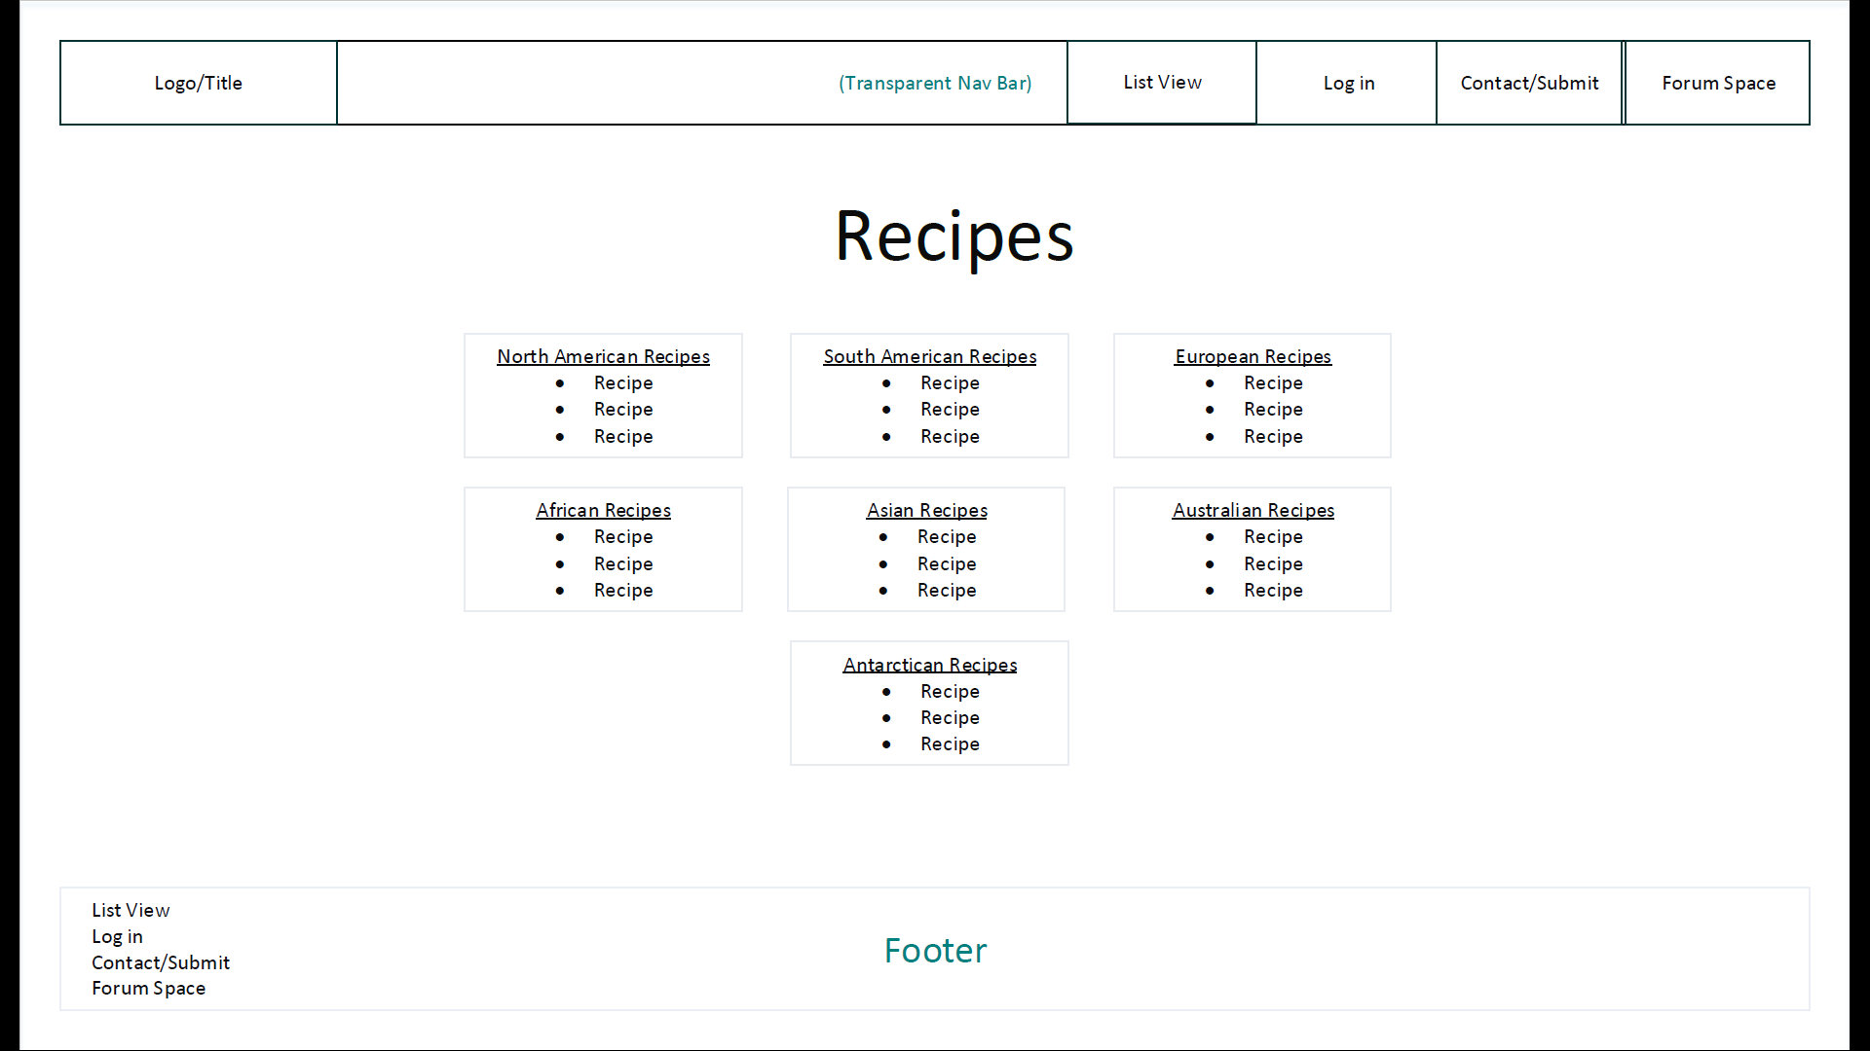

**2.3 Contact Page**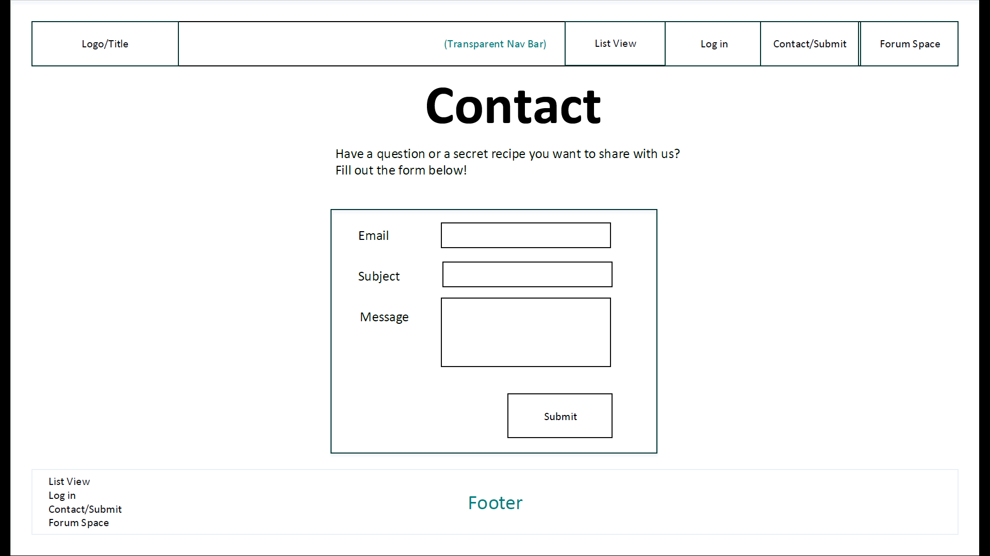

**2.4 Forum Page**

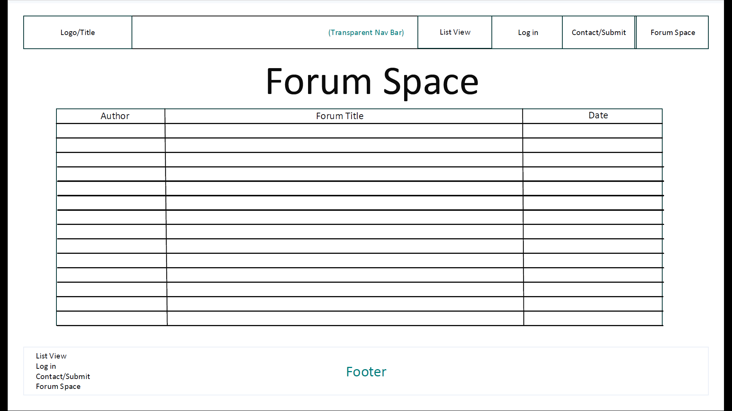

**2.5 Forum Post**

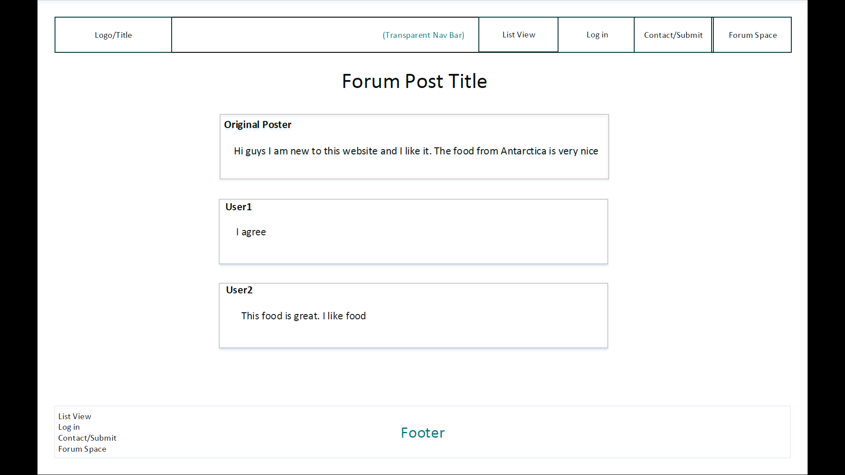

**2.6 Login Page**

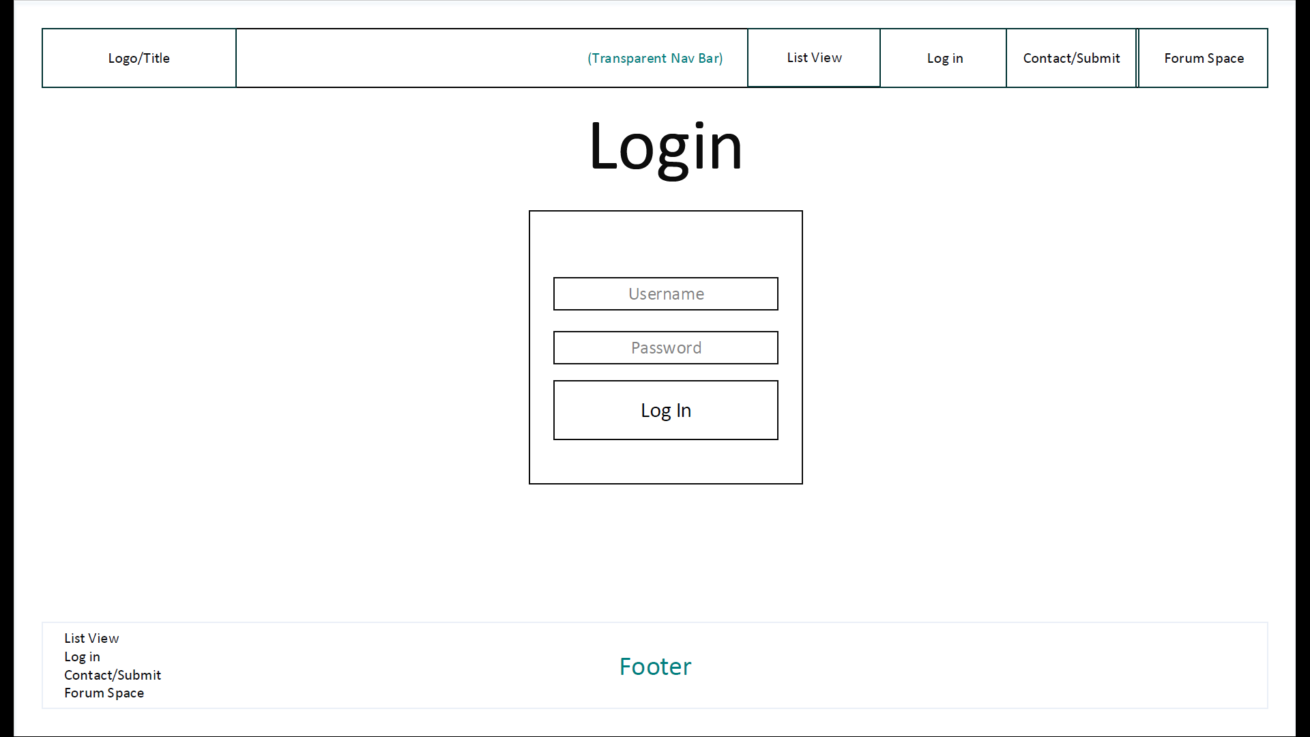

**2.7 Continent Grid View**

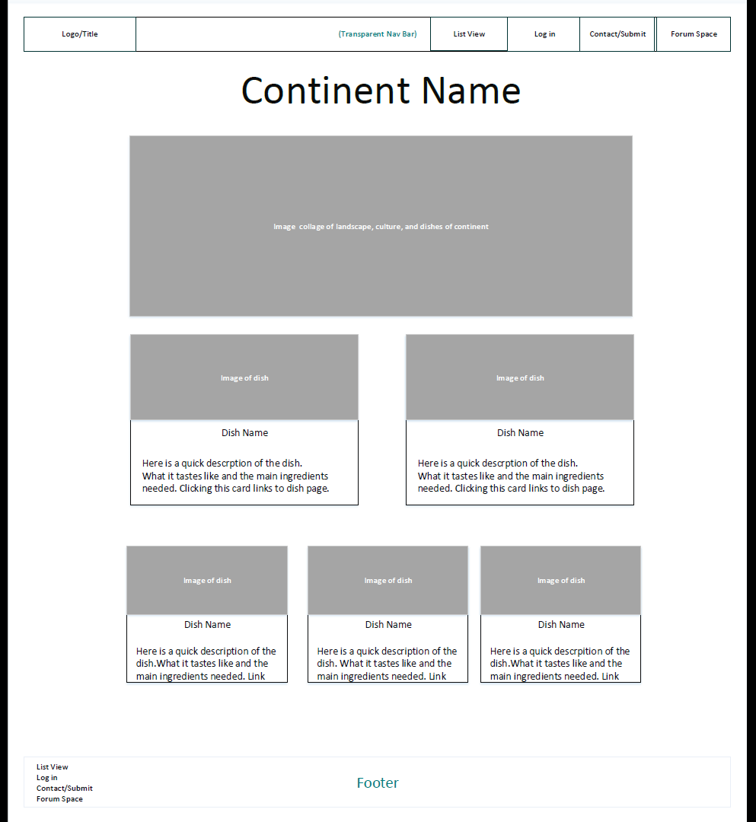

**2.8 Recipe Page**

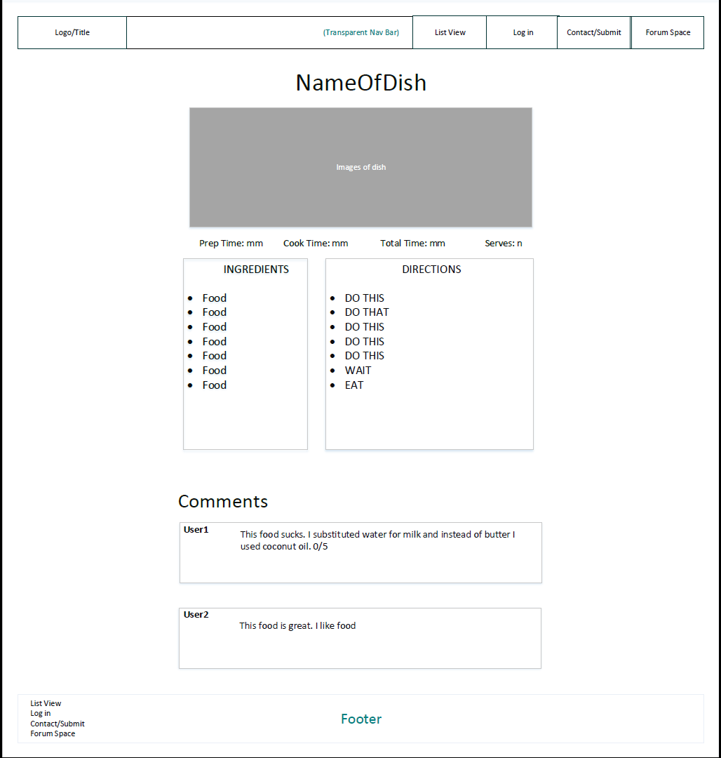

**Color Scheme**

Due to the nature of our website, we plan to direct the visitor’s attention to the images of dishes by supporting our colorful dish images with a white background. For the main theme, we have decided to use a serial of colors shown below. These earthly colors are not bright enough to steal attention from our dishes; they provide a warm atmosphere which is ideal for food and is consistent with the dish per continent format.

These colors will mainly be used on our logo, and to accent the webpage.

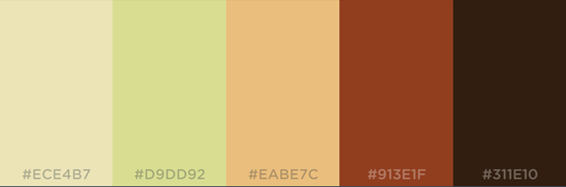

**Reasons and Best Practices**

Our webpage is designed to be minimalistic, so any user can navigate and find information with ease. In accordance with this principle, the one to three column design with Bootstrap keeps the user easily focused on what is in front of them; a user can find any recipe within three clicks.

Accessibility is another important aspect of our website. We will code following all W3C guidelines for accessibility.

# Milestone Three

**1. Technical design**

**1.1 Project Directory**

We created a folder called G5 to store our entire team project. The folder contains 10 subfolders.

* images/ - Stores the images used
* style/ - Stores the base.css file
* prototypes/ - Stores the prototype pages that were used to build the site
* africa/, antarctica/, asia/, australia/, europe/, north-america/, and south-america/ Each folder stores its respective landing page and recipes
* G5 contains web pages that are in the main navigation bar

**1.2 Filenames**

We named our files based on the subject and content. The file names for all the main pages are:

* index.html - Home page
* listview.html - List view page for all recipes
* login.html - Login page
* contact - Contact page
* forum.html - Forum page
* forum-post-prototype.html - Forum post format page
* signup.html - Signup page

Other than those listed above. The page for each continent is named index.html in its respective folder, and the name of each recipe page is the name of the dish.

**1.3 Styling**

The global font we chose is Montserrat with fall back on Arial and generic sans-serif.

Using Bootstrap 4.0 as a framework, we did not have to edit much of the headings, or lists for now. Bootstrap’s grid system and predefined classes were very useful to us.

The main navigation bar is consistent with the wireframe. We used Bootstrap’s nav and nav-link classes.

The footer varies slightly from the wireframe. With A/B testing we concluded it is more visually appealing this way.

We followed the appropriate style and accessibility guidelines. Our defined class names are coherent, and our code has been cleaned up by dirtymarkup.com.

**2. Stylesheet**

All our styles are defined in css/base.css as required.

Page specific stylings are separated by comments.

Bootstrap cards were used to showcase recipes on continent pages. Alongside this, we added a simple animation with CSS called hvr-grow which can be demonstrated on any continent page.

**3. Prototypes**

We have two prototype pages that were used in creating recipe pages and continent pages.

We tested how these pages display on IE9, Firefox, Chrome and Microsoft Edge. They all render equivalently.

We also have forum-prototype-page.html which shows how a forum post will appear once we implement MySQL appropriately.

**4. Remaining Pages**

login.html, contact.html, and signup.html use forms which post to http://webdevfoundations.net/scripts/formdemo.asp for now.

When we cover JavaScript, we will add client side validation to the forms and

functionality to the home page navigation. Hence the temporary links.

**5. Testing**

**5.1 A/B testing**

We conducted an internal A/B testing on the main color scheme of our website with:

A: The dark gray default Bootstrap colour.

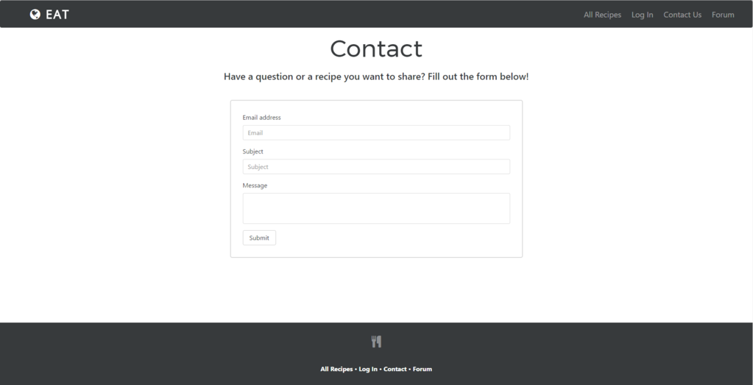

B: A proposed color from milestone 2

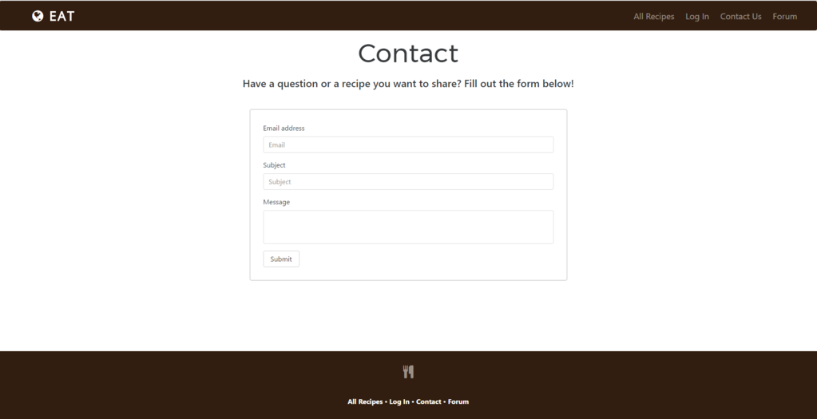

A total number of 5 people voted in this test, the result is:

A: 1

B: 4

For now, we have decided the brown colour. We will conduct further A/B testing when the website is fully developed.

**5.2 Browser Testing**

We tested our website thoroughly on the most common browsers:

* Firefox
* Chrome
* IE
* Microsoft Edge

All webpages displayed as intended.

**6. Summary**

**6.1 URL**

Our in-progress website can be viewed at http://79.170.40.34/eat.com/

**6.2. Tasks completed**

We used GitHub to work together with our conflicting schedules.

We have completed the skeleton layout of our website including tables and forms, so every page is working functionally, without JavaScript.

We’ve imported the google font Montserrat, and font awesome icons.

Our pages are equipped with JavaScript, jQuery, and Tether; we will be employing these libraries in the next milestone

**6.3 Issues Encountered**

We encountered an issue on IE9 where a display bullet was not displaying properly. This was fixed using the &bull; entity.

Some small validator errors on a few pages.

**6.4 Outstanding Work**

For next the milestone we will add favicons, content, colour, and complete all JavaScript dependent functionality and ensure full validation of our web pages. The subsequent milestone will require us to use a MySQL database to store users and forum posts.

Some pages do not validate completely due to reasons including: improper nesting of anchor elements, and not accepting ‘ | ‘ in the import statement: <link href=

"https://fonts.googleapis.com/css?family=Montserrat|Open+Sans|Roboto" rel="stylesheet">

**6.5 Screenshots**

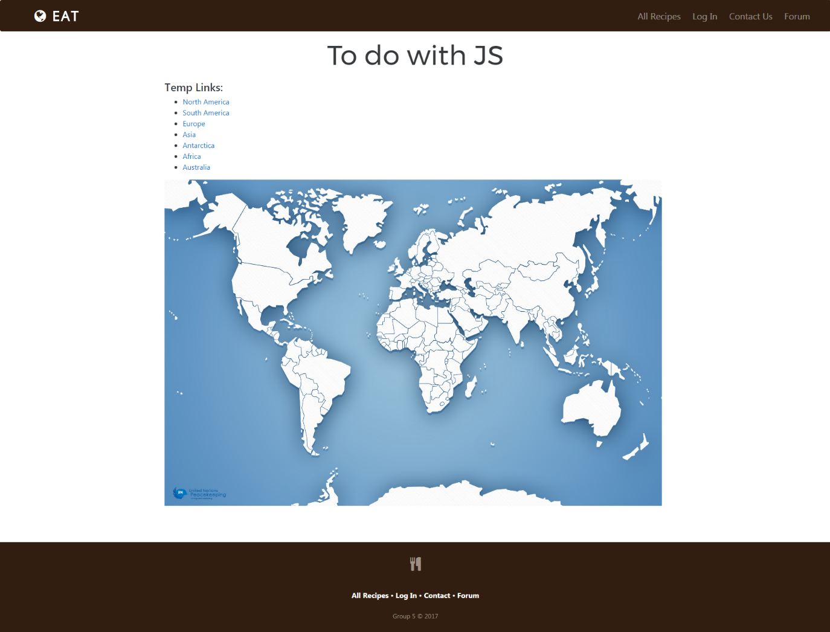

Figure 1: Screenshot of home page. We intend to have a clickable image of earth with animations.

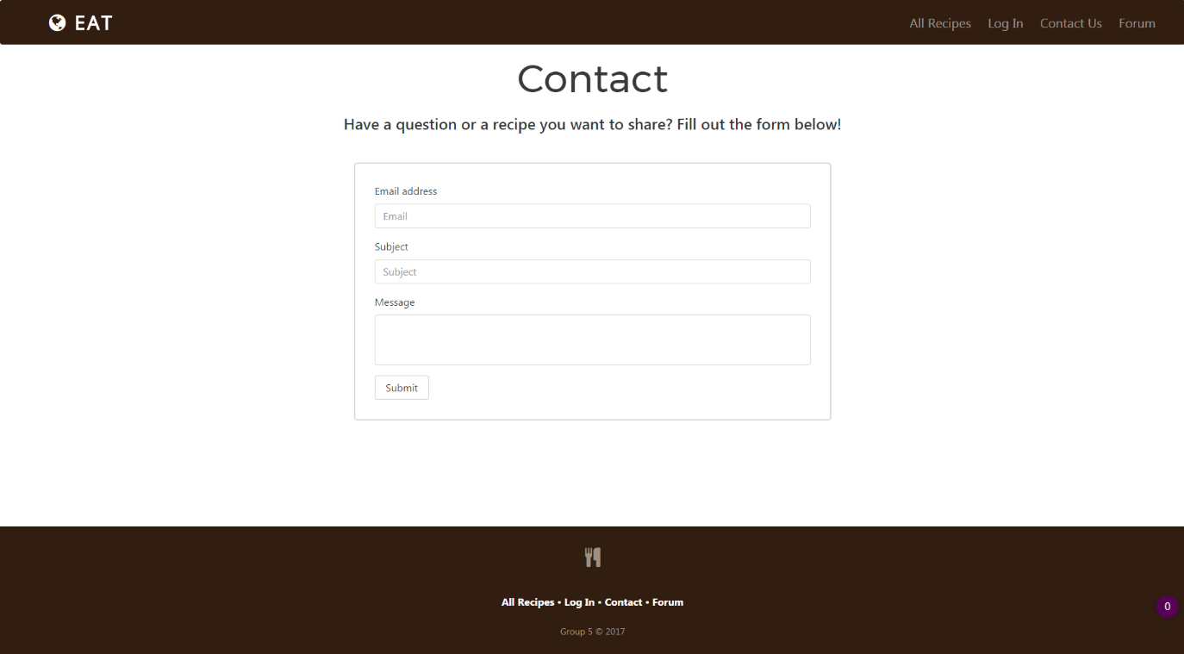

Figure 2: Screenshot of contact.html with a functioning form

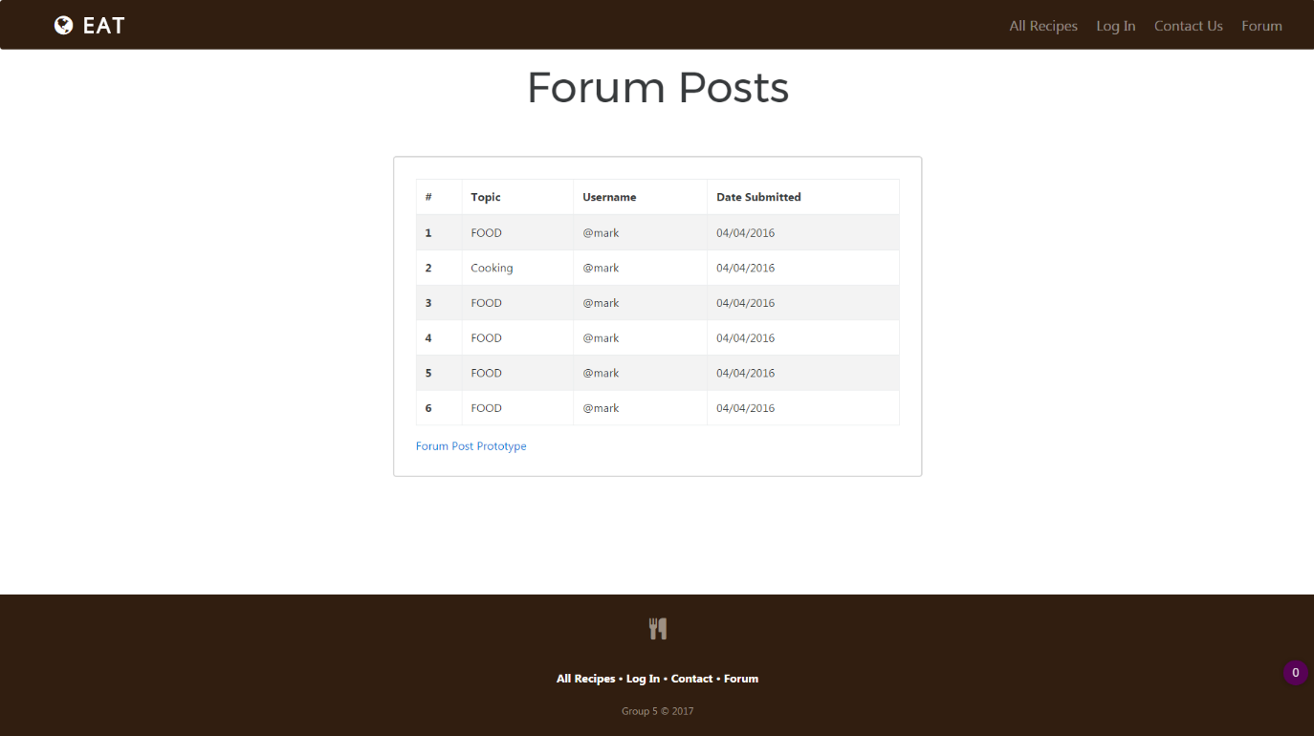

Figure 3: Screenshot of forum.html showcasing use of a table