Documentation for TSP Berlin 52
Simulated Annealing:
Step 1 : Generate a random TSP Tour ( an eulerian graph basically)
Step 2: Implement a function that calculates the length of the tour
Step 3: Generate a modified TSP Tour applying an improvement ( I applied 2-opt improvement -> choose randomly 2 points: a_{i},a_{j} and reverse the order of all the points existing in [i,j] – this is for eliminating the crossover roads that are obviously longer)
Step 4: Make the acceptance function - best explanation here : https://algorithmafternoon.com/books/simulated_annealing/chapter02/
Step 5: Set the temperature and the decreasing rate. I set them at : T = 5000.0, alfa = 0.99999. While the temperature remains greater than 0.01, repeat step 2,3,4 . Decrease the temperature at every entrance in the While, no matter if the TSP Tour was replaced with a worse one, a better one, or not replaced at all.
Tips: Do NOT draw all the iterations because it takes too much time (my choice was : step = 3000). Round the distances for obtaining the optimal result - 7542
Used:
- VS Code
- Libraries : pygame, random, copy, math - https://www.pygame.org/docs/
- Berlin52 – the file :
https://github.com/pdrozdowski/TSPLib.Net/blob/master/TSPLIB95/tsp/berlin52.tsp
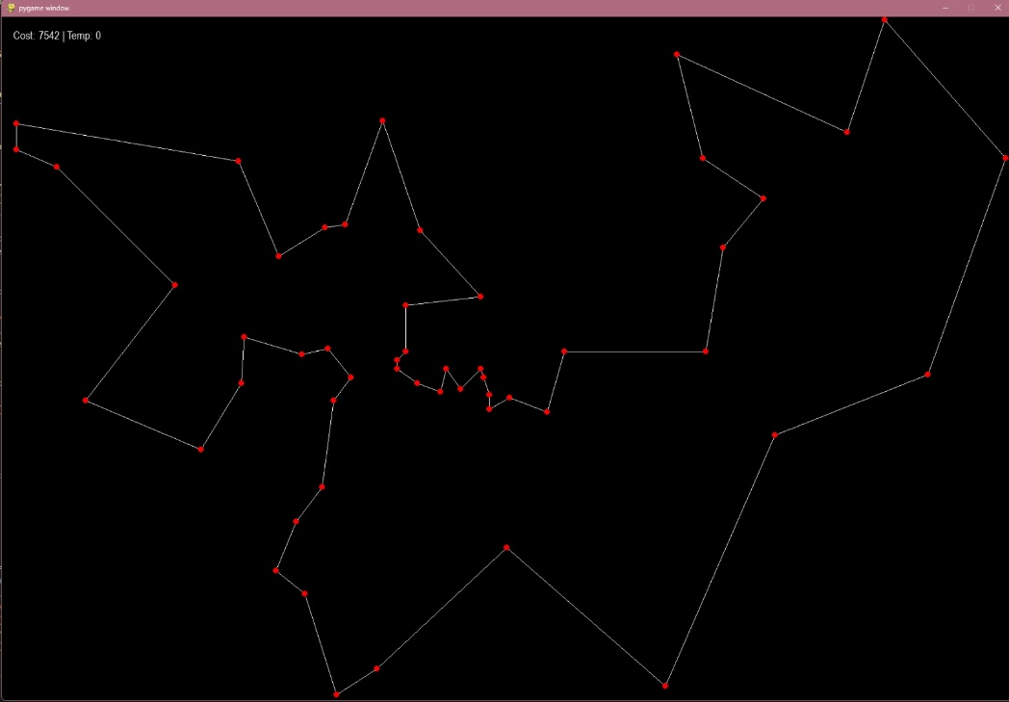
Bibliography:
https://algorithmafternoon.com/books/simulated_annealing/chapter02/
https://www.baeldung.com/cs/simulated-annealing
https://www.youtube.com/watch?v=GiDsjIBOVoA
https://www.youtube.com/watch?v=0rPZSyTgo-w

https://www.scirp.org/html/3-1040110_19930.htm
https://towardsdatascience.com/tabu-search-simply-explained-ee2852339d78/

https://www.youtube.com/watch?v=u7bQomllcJw

