MODULE NAME: EMBEDDED SYSTEM DEVELOPMENT

MODULE CODE: ITLES801

RFQF LEVEL: 8

DEPART: ICT

PROGRAM: B-TECH IT

MODULE LEADER: YANKURIJE Madeleine

CAT (PRACTICE)

DATE: 18/02/2025

QI.TO DRAW Circuit diagram in Easy EDA result

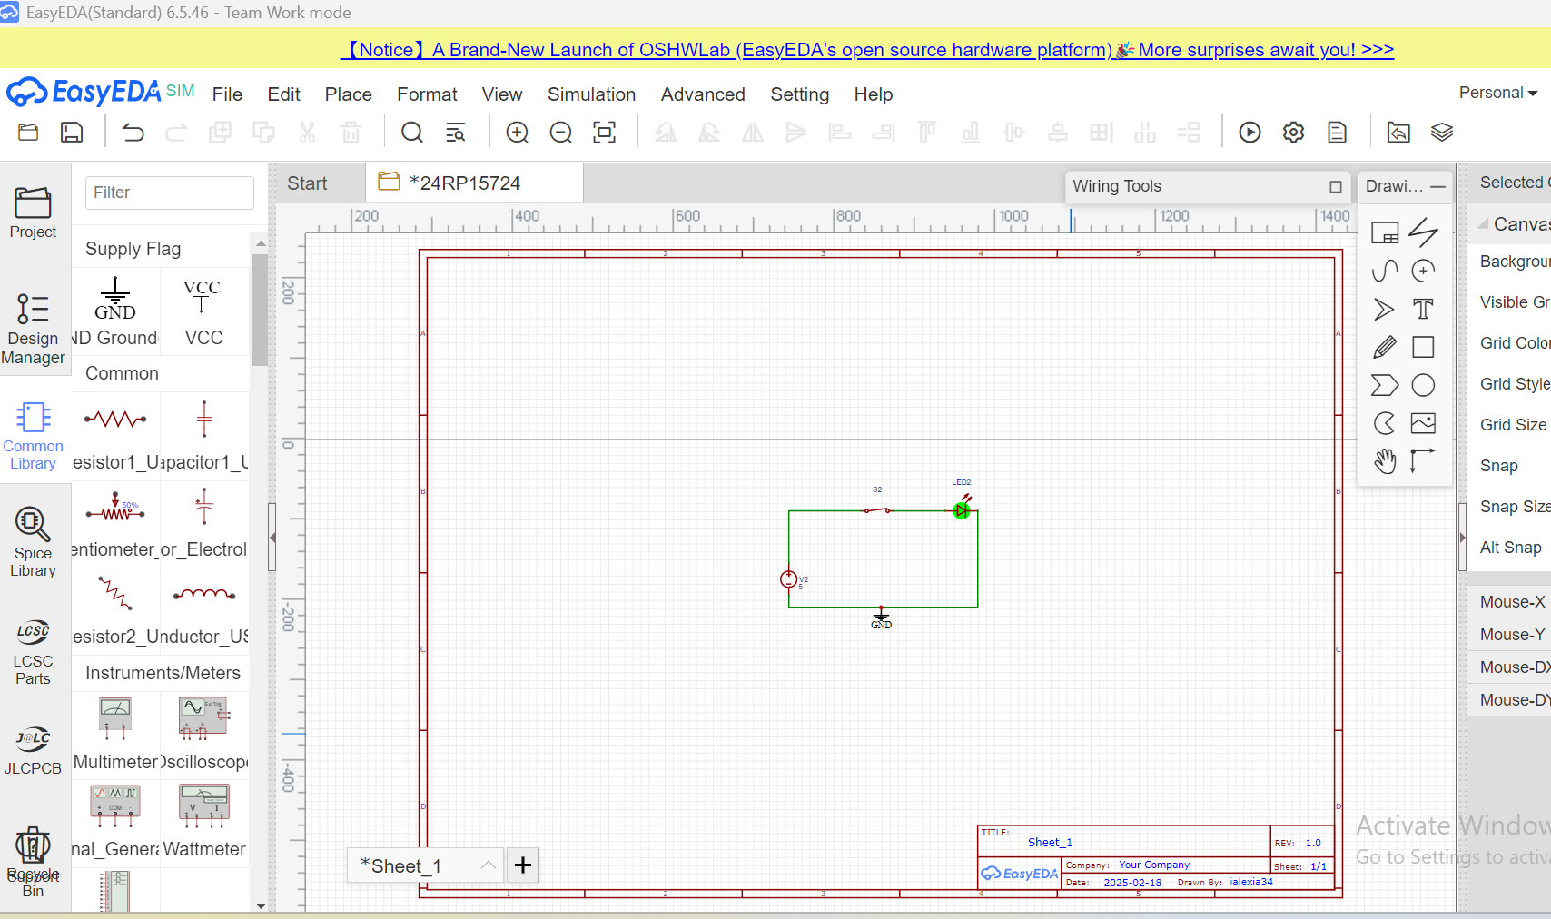

QII.TO connect 3 Led to 3Resistances with and switch on one battery and simulate your project in Frizing software.

Result

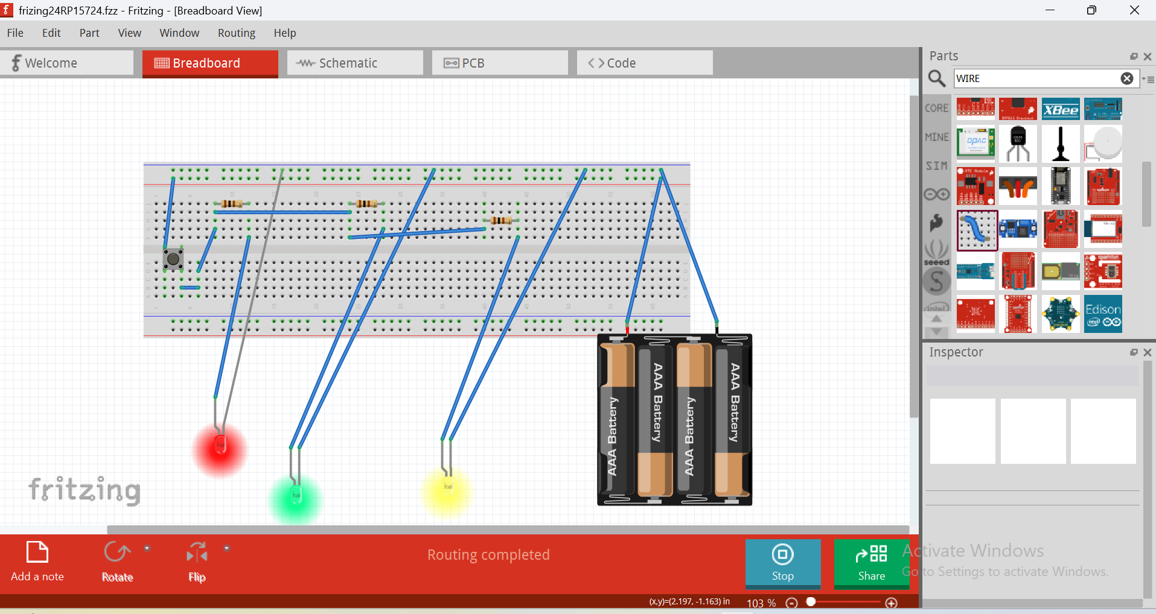

QIII.SHOW SIMULATION OUTPUT OF LOGIC GATE Circuit Diagram by using proteus software

1. input(0,0)

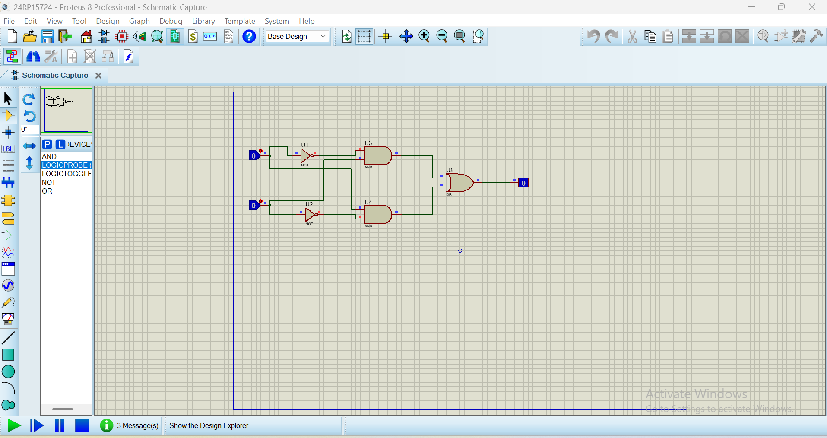

2.input(0,1)

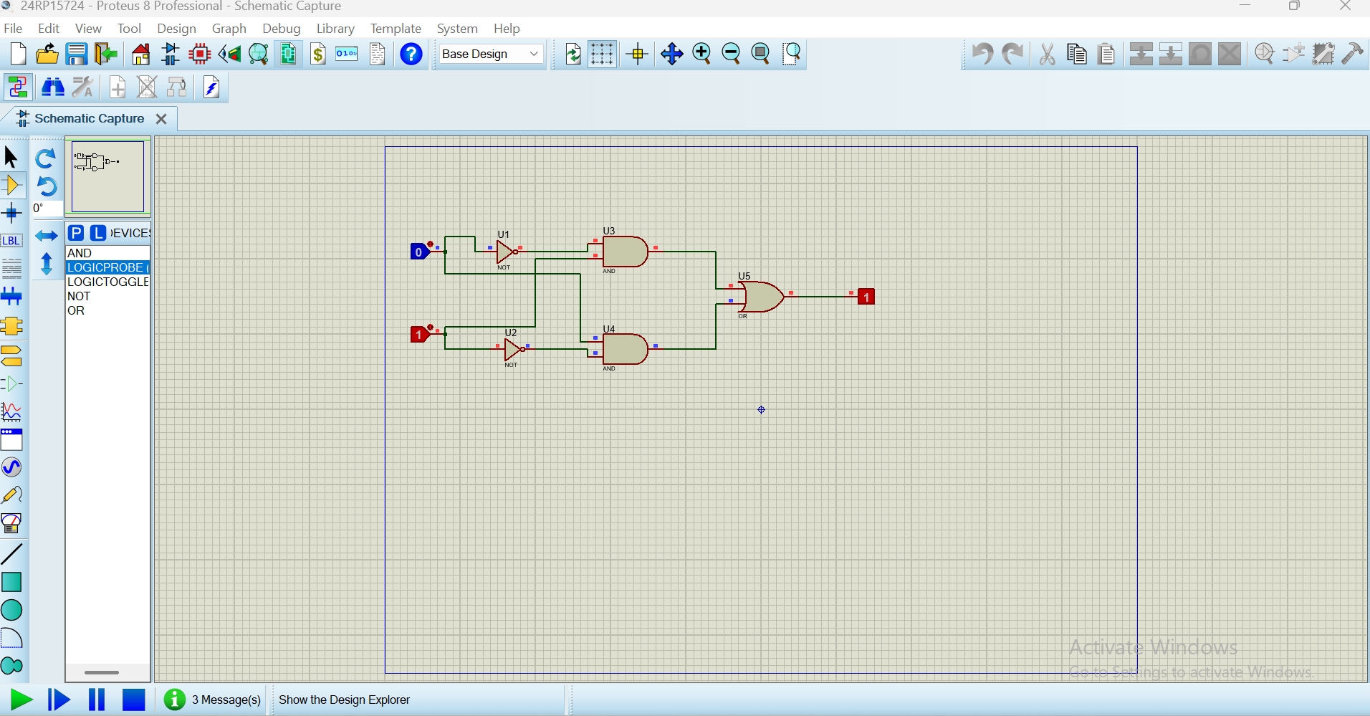

1. input(1,0)

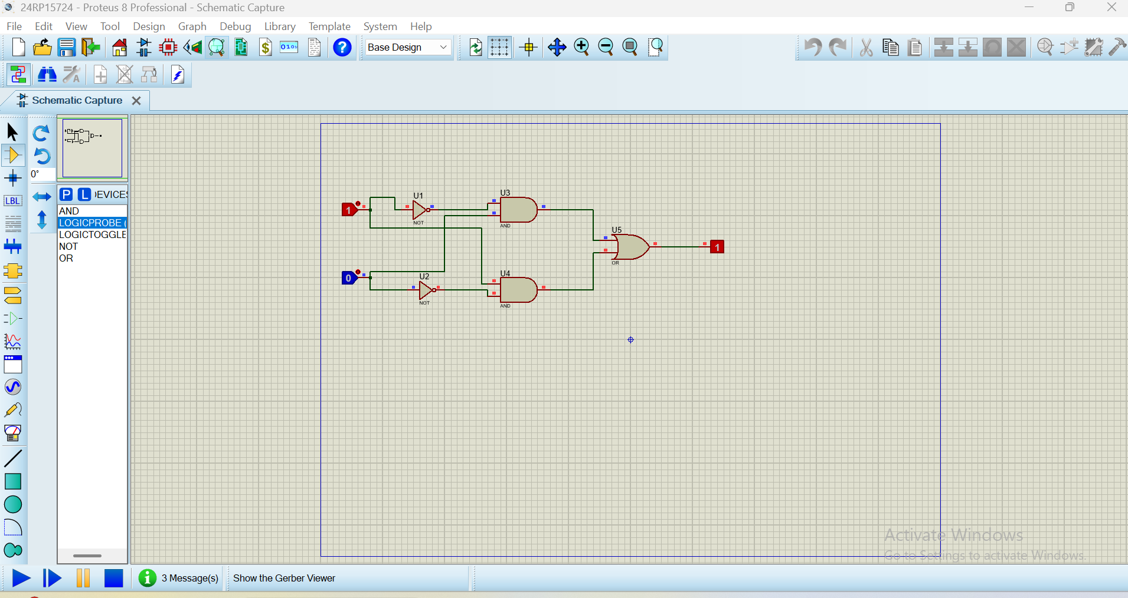

1. input (1,1)

