Curvilinear Particle Dynamics for DEM and Particle-Based Methods: Simplifying Complex Boundaries with Coordinate Maps
Alessio Alexiadis
School of Chemical Engineering, University of Birmingham, Edgbaston, Birmingham, United Kingdom

Abstract
Particle-based simulations such as the Discrete Element Method (DEM) can become expensive when particles interact with complex, rough, moving or deforming boundaries. In standard Cartesian DEM, these boundaries are usually represented by explicit wall elements, so particle-wall contact requires repeated geometric checks against the wall discretisation. This work proposes an alternative formulation in which particle positions and velocities are advanced directly in curvilinear coordinates. A coordinate map is chosen so that the physical boundary becomes a simple fixed coordinate surface, while the geometric complexity is transferred into the map, the metric and the resulting geometric acceleration terms. The formulation is validated against Cartesian reference simulations and then applied to irregular two- and three-dimensional drums, rough walls with macroscopic asperities, and time-dependent deforming boundaries. The results show that the curvilinear formulation becomes advantageous when the boundary is more economically represented by map parameters than by explicit wall elements. Although developed here for DEM, the formulation is general and may be extended to other particle-based methods in which boundaries play a direct role in the dynamics.
Keywords: Discrete Element Method; Curvilinear coordinates; Complex boundaries; Boundary-fitted coordinates; Particle-based methods

1. Introduction
In many particle-based methods, and particularly in the Discrete Element Method (DEM), particles are tracked in Cartesian coordinates, and domain boundaries are represented by geometric primitives such as planes, triangles, wall segments or surface elements. Particle-wall contact is evaluated by testing the particle position against the relevant wall elements, and a contact force is applied wherever overlap is detected (e.g. Ariane et al., 2018; Daraio et al., 2020). This works well for simple geometries such as boxes, cylinders, drums and chutes. It can become expensive and challenging when the boundary is irregular, rough, moving or deforming. For a complex surface with $N_{∂Ω}$ boundary elements, the particle-wall search cost grows with $N_{∂Ω}$, and a moving or deforming boundary may require repeated updates of the wall representation and associated search structures.

In this paper, we look at the problem from a different angle. What if the space itself could be warped, so that in the warped space the boundary straightens into a simple wall? Through a suitable change of variables, an irregular physical boundary can be made simple, even trivial, in the new coordinates. The geometric complexity of the wall is absorbed into the map that defines this change of variables, and into the new metric structure it induces. This has consequences for the equations of motion, which must now carry additional terms that account for how the space stretches and bends from point to point. This study shows that, for systems with complex boundaries, the boundary simplification can outweigh the additional cost of the curvilinear formulation.

The idea of choosing coordinates to fit a boundary is not new. Body-fitted coordinates have long been used in continuous solvers, from CFD (Thompson et al., 1974) to Lattice Boltzmann Method (LBM) (Reyes et al., 2022), to turn complex domains into simpler computational ones avoiding staircase approximations of curved boundaries. Their use in particle-based systems, however, is far less explored. In Particle-In-Cell (PIC) methods, curvilinear grids simplify the electromagnetic field near complex boundaries (Fichtl et al., 2012; Croonen et al., 2024). In those methods, however, particles feel only a shared field, not a direct force from a neighbouring particle or a wall, as they do in DEM. Fujioka et al. (2025) used vertical coordinate transformations in Smoothed Particle Hydrodynamics (SPH) to flatten a complex seabed. There, however, curvilinear coordinates enter only the gradient operators used to estimate pressure and velocity. Particle position and velocity are still solved directly in physical space. Curvilinear coordinates also appear in DEM-related studies, but usually where DEM is coupled with CFD, and the map serves only the fluid solver, while particle motion and contact remain in physical Cartesian coordinates (e.g. Ushijima et al., 1999).

To the best of our knowledge, no previous work has advanced discrete, contact-bearing particle dynamics directly in curvilinear coordinates. In the studies mentioned above, the coordinate transformation affects either the field or differential operators, as in PIC, SPH and LBM, or the continuum solver, together with auxiliary operations such as localisation, contact search and interpolation, as in CFD-DEM coupling. In all these cases, the particle equations of motion remain written in physical space. The aim here is not merely to locate particles more easily inside a complex geometry, but to change the coordinate space in which the particles move. In that space, the wall is no longer represented primarily as a collection of external geometric elements to be searched at every timestep; it becomes part of the coordinate description of the system. With this approach, a complex physical boundary that may require many wall elements can be reduced, for the particle dynamics, to a simple coordinate surface such as $r=1$.

The paper is organised as follows. Section 2 develops the theoretical framework: the equations of motion in curvilinear coordinates, the geometric acceleration term, and the pullback of wall and particle-particle contact forces through the Jacobian and metric tensor. Section 3 validates the formulation against a Cartesian reference, first for a single particle and then for a multiparticle system. Section 4 works through four case studies, each pushing the method a little further: irregular boundaries, macroscopic wall roughness, moving and deforming boundaries, and three-dimensional cases. Section 5 discusses under what conditions a map stays valid as particles move, and how a suitable map can be chosen in practice.

2. Methodology
2.1 Newtonian mechanics in curvilinear coordinates
Let $q∈Ω_{q}$ denote curvilinear coordinates and $x∈Ω_{x}$ physical Cartesian coordinates. Particle positions can be converted from one coordinate system to the other by means of a smooth map

$$x=Φ\left(q\right)$$ | (1)

that associates each point in the curvilinear coordinate space with a unique position in physical Cartesian space. The Jacobian matrix of the map is

$$J\left(q\right)=\frac{∂Φ}{∂q}.$$ | (2)

Its columns are the physical tangent vectors associated with the coordinate directions, so an infinitesimal coordinate displacement $dq$ corresponds to the physical displacement

$$dx=J\left(q\right) dq.$$ | (3)

In Cartesian coordinates, the equations of motion for a particle of mass $m$ subject to a total physical force $f$ are

$$\dot{x}=v,$$ | (4)
$\ddot{x}=\frac{f}{m}$. | (5)

We now express these equations in curvilinear coordinates (Goldstein et al. 2001). Differentiating Eq. (1) in time and using Eq. (2) gives

$$\dot{x}=J\left(q\right) \dot{q.}$$ | (6)

The components of $\dot{q}$ are coordinate velocities in curvilinear space. Differentiating Eq. (6) once more, noting that $J\left(q\right)$depends on the particle position, and using the product rule, we obtain:

$$\ddot{x}=J\ddot{q}+\dot{J} \dot{q},$$ | (7)

where, for a time-independent map, $\dot{J}$ is

$$\dot{J}=\frac{∂J_{ij}}{∂q_{k}}{\dot{q}}_{k}.$$ | (8)

In this article, matrix notation is generally used because it is more compact. However, in a few instances, index notation is preferred to avoid ambiguity. In case of Eq. (8), for instance, $\frac{∂J_{ij}}{∂q_{k}}$ is a third-order tensor, so the contraction with ${\dot{q}}_{k}$ is more easily expressed in index notation.

Substituting Eq. (7) into Eq. (5), multiplying by $J^{-1}$, and rearranging for $\ddot{q}$, we obtain the equations of motion in curvilinear coordinates,

$$\ddot{q}=J^{-1}\frac{f}{m}-J^{-1}\dot{J} \dot{q.}$$ | (9)

In Cartesian coordinates the acceleration is determined entirely by the physical forces $f$ acting on the particle. In curvilinear coordinates, the additional term $J^{-1}\dot{J} \dot{q}$ appears because the coordinate basis varies from point to point. This geometric term is not a physical force contribution; it is a purely kinematic (geometric) acceleration. It accounts for the fact that a straight path in physical space may appear curved when expressed in curvilinear coordinates. It ensures that, in the absence of physical forces, a particle follows a geodesic, that is, the straightest possible path in physical space as seen from the curvilinear perspective. It is the same mechanism that produces the centripetal term in polar coordinates.

The idea of this study is to define a curvilinear coordinate map in which a geometrically complex physical boundary corresponds to a simple coordinate surface. Consider a DEM simulation where particles are confined within a closed container whose wall is described by a complex, irregular surface $f(x,y,z)=0$. We seek a change of coordinates from $x≡(x, y, z)$ to $q≡(r,θ, φ)$ such that

$$x=r B\left(θ, φ\right),$$ | (10)

where $r$ is a radial-like coordinate, $θ$ and $φ$ are angular-like coordinates, and the vector-valued function $B(θ,φ)$ traces the physical boundary surface as $θ$ and $φ$ vary over their respective ranges. In physical space the wall may be highly irregular; in curvilinear coordinates it corresponds to the coordinate surface

$$r =1,$$ | (11)

regardless of the shape of $B(θ,φ)$. Moreover, for each particle, the radial coordinate always satisfies $r>0$, while the angles $θ,φ$ are periodic by construction. So, the complex physical domain is transformed into a periodic box with a wall at $r =1$. The full geometric complexity of the boundary has been transferred from the boundary condition into the coordinate map and the geometric acceleration terms that appear in Eq. (9).
The dynamics are integrated in curvilinear coordinates, because there the wall geometry is simple. But not every part of the calculation becomes simpler in curvilinear space. Overlaps, for instance, are more easily calculated in physical space, since radii and distances do not depend on the local metric there. After $q$ and $\dot{q}$ are updated, we can easily recover $x$ through Eqs. (3) and (6), keeping track of both coordinate systems as the simulation advances. This lets different parts of the algorithm use whichever system is simplest, as long as the final forces are converted back into curvilinear form before integrating the equations of motion. This amounts to a sort of ‘double-entry bookkeeping’, in which both coordinate representations are kept and used according to convenience. The extra cost remains small, and in any case unavoidable, since physical coordinates are needed at the end of the simulation for output and interpretation. But the gain is considerable: there is, for instance, no need to track how particle radii change locally, or to replace Verlet and cell-list routines with curvilinear equivalents.
2.2 Particle-wall interaction in curvilinear coordinates
The particle–wall interaction is modelled as a spring–damper contact force,

$$f_{w}=\left(k_{w}δ-γ_{w}v_{n}\right)n,$$ | (12)

where $δ$ is the physical penetration distance, $n$ is the unit normal pointing into the domain, and
$$v_{n}=v⋅n$$ | (13)

is the normal component of the particle velocity in physical space. The curvilinear solver must advance the same motion in $q$, which requires expressing the wall force of Eq. (12) in curvilinear form. The key advantage is that, regardless of how complex or irregular the physical boundary may be, the coordinate map is constructed so that the wall always corresponds to the fixed coordinate surface $r=1$. Contact detection therefore reduces only to checking whether $r>1$. This is different from using the same boundary parametrisation directly in a Cartesian solver. In Cartesian coordinates, a parametric wall $B(θ,φ)$ would still require, for each particle near the wall, finding the closest boundary point by solving ${(θ,φ)}^{*}=arg⁡\underset{θ,φ}{min⁡}\left\|x_{p}-B(θ,φ)\right\|.$ For a complex boundary this closest-point problem may be nonlinear, may have multiple local minima, and usually requires an additional search or projection step. In the curvilinear formulation, the wall parameter is already part of the particle coordinate. A particle at $(r,θ,φ)$ is associated locally with the wall point $(1,θ,φ)$, so wall crossing is detected by a coordinate condition rather than by a global closest-point search.

Since many of the examples of this study are two-dimensional, for the moment, we will assume the particle position in Cartesian coordinates is $x=\left(x,y\right)$ and in curvilinear coordinates is $q=\left(r,θ\right)$, where $θ$ denotes the coordinates along the wall. The associated point of the computational wall in curvilinear coordinates is simply

$$q_{w}=\left(1,θ\right).$$ | (14)

If a particle at $q$ penetrates the wall, the coordinate overlap vector is

$$η_{q}=q-q_{w}$$ | (15)

For the moment, we assume that penetration is calculated with respect to the centre of the particle. In a subsequent section, we will use a better approximation considering the radius of the particle. The physical displacement corresponding to Eq. 15 is obtained from the local linearisation of the map:

$$η_{x}≈Jη_{q}.$$ | (16)

In physical space, the force must be perpendicular to the boundary and point in the opposite direction of $η_{x}$. Therefore, the inward physical normal and the physical penetration distance are

$$n=-\frac{η_{x}}{∥η_{x}∥},$$ | (17)
$$δ=∥η_{x}∥.$$ | (18)

The elastic part of the wall force $f_{w,e}= k_{w}δn$ is then

$$k_{w}δn=k_{w}∥η_{x}∥\left(-\frac{η_{x}}{∥η_{x}∥}\right)=-k_{w}η_{x}.$$ | (19)

Using the local relation between $η_{x}$ and $η_{q}$, the elastic force, in curvilinear coordinates, becomes

$$f_{w,e}=-k_{w}Jη_{q}.$$ | (20)

Now let us move to the damping term $f_{w,d}=\left(γ_{w}v_{n}\right)n$of the wall force, which is obtained from the physical velocity

$$v=J\dot{q}$$ | (21)

and from the normal velocity

$$v_{n}=v⋅n=-\frac{v⋅η_{x}}{δ}.$$ | (22)

Substituting this expression into the damping part of Eq. (12) gives

$$f_{w,d}=-γ_{w}\frac{v⋅η_{x}}{δ^{2}}η_{x}.$$ | (23)

Using the local approximation in Eq. (18),

$$δ^{2}={\left(Jη_{q}\right)}^{T}\left(Jη_{q}\right).$$ | (24)

Introducing the metric tensor $G$, which describes how physical distances are measured in the curvilinear coordinate system (Kreyszig, 1991)

$G=J^{T}J$, | (25)

the physical penetration depth becomes

$$δ=\sqrt{η_{q}^{T}Gη_{q}}.$$ | (26)

By substituting, in Eq. (23), Eq.s (16), (21) and (26), the damping force can be written in terms of curvilinear quantities as

$$f_{w,d}=-γ_{w}\frac{{\dot{q}}^{T}Gη_{q}}{η_{q}^{T}Gη_{q}}Jη_{q}.$$ | (27)

Adding the elastic and damping contributions together gives the total wall reaction force

$$f_{w}=-\left(k_{w}+γ_{w}\frac{{\dot{q}}^{T}Gη_{q}}{η_{q}^{T}Gη_{q}}\right)Jη_{q}.$$ |  | (28)

The contribution of this physical force to the curvilinear equation is obtained by multiplying by the inverse Jacobian and dividing by the particle mass:

$$a_{w,q}=\frac{1}{m}J^{-1}f_{w}.$$ | (29)

Any additional physical force, such as gravity, is included in the curvilinear equations of motion by the same mechanism: the physical force is multiplied by $J^{-1}/m$

Using the local cancellation between the Jacobian and its inverse, the soft-wall acceleration contribution in curvilinear coordinates is

$$a_{w,q}=-\frac{1}{m}\left(k_{w}+γ_{w}\frac{{\dot{q}}^{T}gη_{q}}{η_{q}^{T}gη_{q}}\right)η_{q}.$$ | (30)

This equation can be further simplified if the map $Φ$ is chosen, as in Eq. 10, in such a way that the boundary in curvilinear system reduces to the line $r=1$, In this case

$$η_{q}=\left(\begin{aligned}r-1 \\ 0\end{aligned}\right)$$ | (31)

and Eq. 30 simplifies to

$$a_{w,r}=-\frac{{\left(r-1\right)k}_{w}+γ_{w}\frac{g_{rr}\dot{r}+g_{rθ}\dot{θ}}{g_{rr}}}{m} (for r>1)$$ | (32)
and

$$a_{w,θ}=0,$$ | (33)

where $g_{rr}$ and $g_{rθ}$ are the entries of the first column of the metric tensor $G$.

2.3 Particle-particle interaction in curvilinear coordinates
Finally, we need to specify how particle-particle contacts are transformed in the curvilinear formulation. The derivation follows the same logic as the wall-particle contact law introduced above, so we do not repeat all steps. The main differences are the definition of the overlap and the fact that a particle-particle force acts on two particles. For particles $i$ and $j$, the contact law is defined in physical space. The centre-to-centre distance is

$$l_{ij}=∥x_{j}-x_{i}∥,$$ | (34)
and the overlap is

$$δ_{ij}=a_{i}+a_{j}-l_{ij},$$ | (35)

where $a_{i}$ and $a_{j}$ are the radii of particles $i$ and $j$. A contact is active only when $δ_{ij}>0$. The unit normal is

$$n_{ij}=\frac{x_{j}-x_{i}}{l_{ij}},$$ | (36)

and the relative particle velocity is

$$v_{ij}=\left(v_{j} − v_{i}\right)⋅n_{ij}.$$ | (37)

Using the same type of spring-dashpot equation we used for the particle-wall contact, the particle-particle contact force becomes

$$f_{ij}=k_{c}δ_{ij}- γ_{c}v_{ij}.$$ | (38)

Accounting for Newton’s third law, the contact forces between particle $i$ and $j$ in physical space are

$$f_{ij}=-f_{ij}n_{ij},{ f}_{ji}=f_{ij}n_{ij}.$$ | (39)
When the coordinate transformation is applied, these forces are transformed into curvilinear coordinates by multiplication with the inverse Jacobian:

$${\left.{\ddot{q}}_{i}\right|}_{contact}=\frac{1}{m_{i}}J^{-1}(q_{i})f_{ij},$$ | (40)
and
$${\left.{\ddot{q}}_{j}\right|}_{contact}=\frac{1}{m_{j}}J^{-1}(q_{j})f_{ji}.$$ | (41)

It is worth noting that, while the physical force pair in Cartesian coordinates is equal and opposite ($f_{ji}=-f_{ij}$), the corresponding curvilinear accelerations is not. This is because the inverse Jacobian $J^{-1}$ must be evaluated at $q_{i}$ for particle $i$ and at $q_{j}$ for particle $j$, and in general $J^{-1}(q_{i})≠J^{-1}(q_{j})$.

The examples and case studies discussed in the next section only consider translational motion (i.e., particle rotation is neglected) and relatively simple contact models. These are not intrinsic limitations: rotation and more sophisticated contact models can be derived in curvilinear coordinated following the same ‘double-entry bookkeeping’ procedure described above.
3. Validation
3.1 Single trajectory
We first validate the curvilinear formulation using a single particle moving under gravity inside a circular soft wall. The same system is simulated in Cartesian and in polar coordinates. The purpose at this stage is not to demonstrate a computational advantage, but to verify that the curvilinear formulation reproduces the same physical trajectory when mapped back to Cartesian space. We use a circular wall for the validation because it is one of the few boundaries with a complete, exact representation in both coordinate systems: a circle in physical space, and a straight line, $r=1$, in polar space. This lets the two solvers be compared on equal terms, without either one carrying an error from approximating the boundary.

The circular wall has radius $R=20$, the particle radius is $r_{p}=0.20$, and the particle mass is $m=1.0$. Since these simulations do not refer to any specific physical system, all quantities are expressed in dimensionless units. The initial position is $\left(x_{0},y_{0})=(0,1\right)$ and the initial velocity is $\left(v_{x,0},v_{y,0})=(10,20\right)$. Gravity is set to $\left(0,-9.81\right)$. The wall is modelled as a spring-dashpot contact with stiffness $k_{w}=2×{10}^{5}$ (so wall is nearly rigid) and damping coefficient $γ_{w}=20$. The simulations are run for a total time $T=10.0$ with a timestep $Δt={10}^{-4}$. For the circular validation problem we use in this section, the map is the standard polar map scaled by the circle radius $R$ so that, in the curvilinear system, the boundary is at $r=1$:

$$x=ϕ\left(r,θ\right)=R\left(\begin{matrix}rcosθ \\ rsinθ\end{matrix}\right).$$ | (42)

Its Jacobian is

$$J=\frac{∂x}{∂q}=R\left(\begin{matrix}cosθ & -rsinθ \\ sinθ & rcosθ\end{matrix}\right)$$ | (43)

and the metric tensor is

$$G=J^{T}J=R^{2}\left(\begin{matrix}1 & 0 \\ 0 & r^{2}\end{matrix}\right).$$ | (44)

Therefore, using polar coordinates, Eq. 32 simplifies to

$$a_{w,r}=-\frac{{\left(r-1\right)k}_{w}+γ_{w}\dot{r}}{m} (for r>1).$$ | (45)

The dynamics of the same single particle is calculated first with a solver that integrates the equation of motion in Cartesian coordinates, and then with a solver that integrates it in polar coordinates. The trajectory computed by the polar solver is then mapped back to Cartesian coordinates for comparison.

Figure 1 compares the Cartesian trajectory with the mapped-back polar trajectory. The two curves overlap closely over the entire simulation, even after repeated wall impacts, verifying that the polar solver recovers the correct physical motion. Checking a single trajectory is a strict test: trajectories are sensitive to round-off and discretisation errors. The close agreement over the full interval confirms that the curvilinear solver reproduces the correct physics.
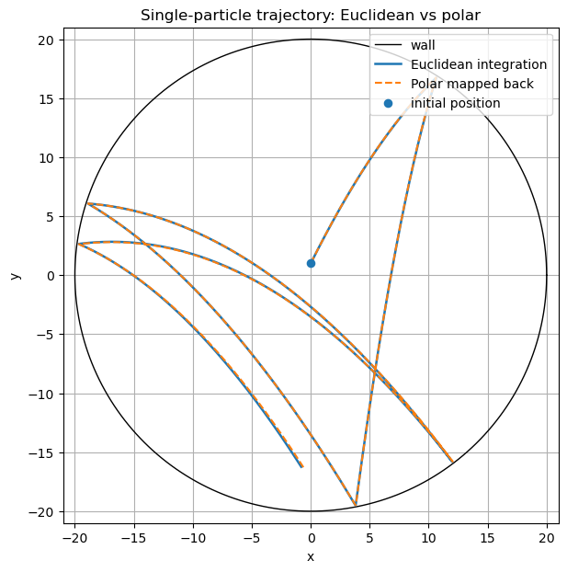
Figure 1. Single-particle trajectory in physical space. The Euclidean (Cartesian) trajectory is compared with the polar trajectory mapped back to Cartesian coordinates.

Figure 2 shows the same trajectory in polar space. The dashed line marks the computational wall at $r=1$. The apparent jumps in the horizontal coordinate are not physical discontinuities. They occur because $θ$ is periodic and is wrapped into the interval $[0,2π)$.

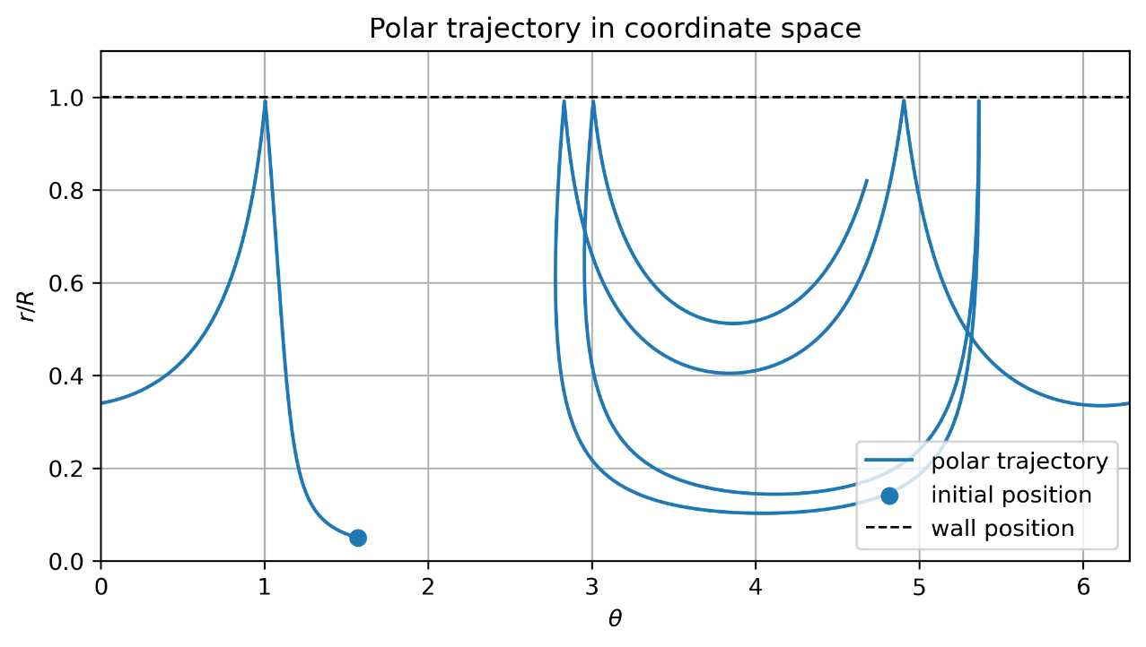
Figure 2. Single-particle trajectory in polar coordinate space with wall located at $r=1$. Apparent jumps in $θ$ are due to angular periodicity, not physical discontinuities.

Small differences between the two solvers accumulate over time. This is expected because the same physical problem is integrated in two different coordinate systems using finite timesteps and finite-precision arithmetic. The differences become more visible near wall impacts, where the force changes rapidly during contact. Figure 3(a) shows the position difference between the Cartesian trajectory and the mapped-back polar trajectory as a percentage of the wall radius. For$∆t={10}^{-4}$ and $T=10$, the maximum difference is about (1.5%) of the wall radius.

The timestep sweep confirms that this difference is mainly numerical. Figure 3(b) compares the Cartesian and polar trajectories at the same timestep. As the timestep is reduced from $∆t={10}^{-3}$ to $∆t={10}^{-4}$, the maximum position difference decreases.

Figure 3(c) compares both solvers against a Cartesian reference solution computed at $∆t=10⁻⁴$. Both solvers converge towards this reference as the timestep is reduced. Figure 3(d) shows the computational time of each solver relative to the Cartesian solver at $∆t=10⁻³$. The polar solver is slower than the Cartesian solver at the same timestep. This is expected: a circular wall is trivial to evaluate in either coordinate system, but the polar solver must still evaluate the geometric acceleration terms in Eq. 9. This test therefore isolates the extra cost of the curvilinear dynamics, in a case where the wall geometry gives no compensating saving.

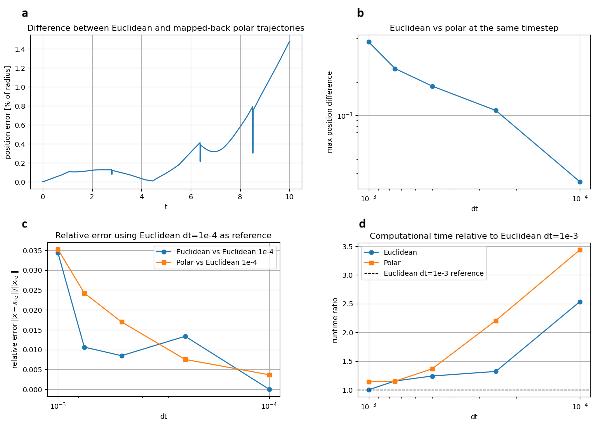
Figure 3. (a) Position difference between the Euclidean (Cartesian) coordinate system and mapped-back polar trajectories over time, as a percentage of the wall radius. (b) Maximum Cartesian–polar position difference at the same timestep, for decreasing dt. (c) Relative error of both solvers against a Cartesian reference solution ($∆t=10⁻⁴$). (d) Runtime relative to the Cartesian solver at $∆t=10⁻³$.

To compare the cost of the boundary representation from the cost of the equations of motion, the Cartesian solver is no longer given the analytic circle. Instead, the wall is approximated by a polygon with increasing resolution, in the way a curved boundary would normally be represented by a mesh or by many local elements. With this element-based wall representation, where each element is a simplex (a segment in two dimensions, a triangle in three), the Cartesian solver must test particle-wall overlap against each element, identify the relevant contact, and compute the local wall normal. Increasing the number of segments improves the approximation of the circle but also increases the contact-detection cost. The curvilinear solver is unaffected by this choice: the physical boundary, whatever its shape or resolution, is always represented by the fixed computational wall $r=1$, so contact detection does not depend on how many segments the physical wall has.

Figure 4(a) shows the maximum trajectory error of the segment-wall Cartesian solver, relative to the circular-wall trajectory, as the number of boundary segments increases. The error decreases as the number of segments increases, though not monotonically: small changes in impact position and wall normal can be amplified by repeated collisions. Figure 4(b) shows the corresponding computational cost, normalised by the polar solver runtime. At low boundary resolution, the segment-wall solver is cheaper, since it has few elements to check. As the number of segments increases, its runtime grows and eventually exceeds the polar solver runtime. This crossover happens well before the segment-wall solver reaches high accuracy. The red marker in Figure 4(a) shows the resolution at which the segment-wall solver becomes slower than the polar solver: at this resolution, its trajectory error is still about 25% of the wall radius.

Reaching the lowest segment-wall error in this test requires 1024 boundary segments, at roughly three times the polar solver runtime. The polar solver pays a fixed overhead for the coordinate transformation and the geometric acceleration terms, but the wall itself remains the simple coordinate surface $r=1$, regardless of the resolution needed to represent it in Cartesian coordinates. Therefore, for complex boundaries that demand a fine explicit representation, the curvilinear solver becomes increasingly competitive, and eventually advantageous, as the required number of wall elements grows.

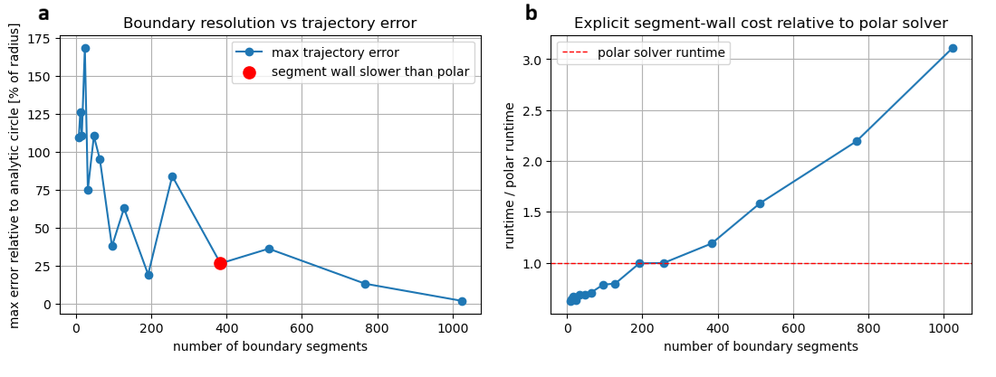
Figure 4. (a) Maximum trajectory error of the segment-wall Cartesian solver, relative to the analytic circular-wall solution, as a function of the number of boundary segments. The red marker indicates the resolution at which the segment-wall solver is slower than the polar solver. (b) Runtime of the segment-wall solver normalised by the polar solver runtime under the same conditions. The dashed red line marks the polar solver runtime.

3.2 Multiparticle systems
We now extend the validation from one particle to a multiparticle system. In this case, the trajectory of a single labelled particle is no longer a robust validation target. After many particle-particle and particle-wall collisions, small numerical differences are amplified, and two equivalent simulations may separate at the level of individual paths. The validation, therefore, focuses on integral and statistical quantities, such as the total kinetic energy.

Since the system includes dissipative forces, without external forcing, the dashpot terms would remove kinetic energy, and the particles would eventually settle. To compare the Cartesian and curvilinear formulations over a sustained time interval, energy must therefore be injected into the system. For this reason, the circular container is prescribed to oscillate vertically with amplitude $A$ and angular frequency $ω$

$$s\left(t\right)=Asin\left(ωt\right)e_{y},$$ | (46)

where $e_{y}$ is the unit vector in the $y$ direction. The oscillation supplies energy to the particles, while the dashpot terms dissipate it. The system can therefore reach a statistically steady state. The validation is performed by running the Cartesian and polar solvers from the same initial condition and comparing the total kinetic energy.

The wall-contact law itself is unchanged. The wall's geometry in the solver does not move; only its effect on the particle, through the spring-dashpot force, accounts for the motion. (The wall's physical position will be used only to visualise the Cartesian solver's results, not in the contact law itself.) This is done by measuring the particle position and velocity relative to the instantaneous wall centre,

$$x_{\text{rel}}=x-s(t),v_{\text{rel}}=v-\dot{s}(t),$$ | (47)

and computing the overlap and normal velocity from these relative quantities,

$$δ=r+r_{p}-\left|x_{\text{rel}}\right|,v_{n}=v_{\text{rel}}⋅n,$$ | (48)

exactly as for a static wall (Eq. 12). The same spring-dashpot force is therefore applied in both solvers. In the Cartesian solver, this force is applied directly in physical coordinates; in the curvilinear solver, it is transformed through the metric-dependent mapping described earlier.

In the following simulations, the wall stiffness is $k_{w}=1.0×{10}^{4}$, the damping coefficient is $γ_{w}=5$, the wall oscillation amplitude is $A = 0.5$, and the angular frequency is $ω = 2π$. The time step is $Δt=1.0×{10}^{-4}$ and the simulation runs to $T=10$.

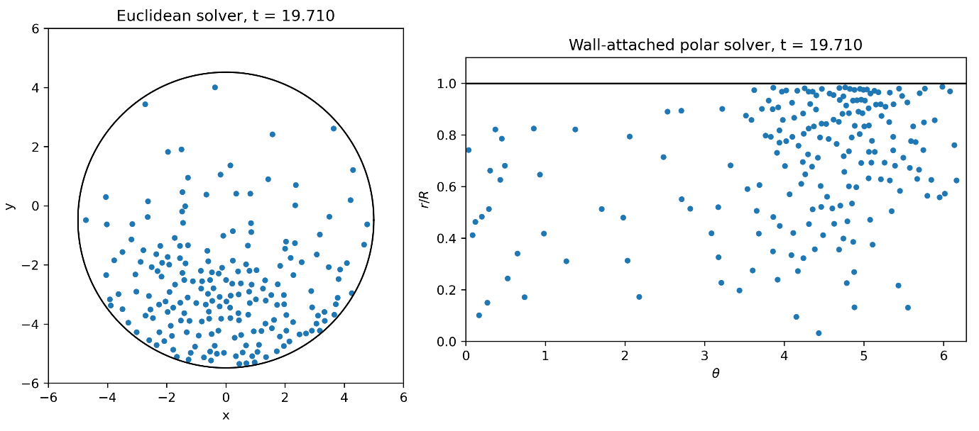
Figure 5. Snapshot of the multiparticle simulation at the same instant, obtained with (a) the Cartesian solver and (b) the curvilinear solver.

Figure 5 compares a snapshot of the two solvers at the same instant. In the Cartesian solver (Figure 5a), the boundary is drawn at its current physical position, to show the simulation as it visually appears: a container oscillating around its particles. This is a visualisation choice only; the solver itself does not move any wall geometry, and computes contact through the time-dependent force described above. In the curvilinear solver (Figure 5b), the wall is drawn fixed, to emphasise that this solver's boundary is fixed by construction: the computational wall remains $r=1$ throughout the simulation. Video 1 shows the full dynamics in both coordinate systems.

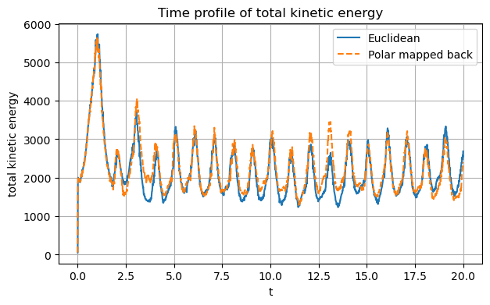
Figure 6. Time evolution of the total kinetic energy for the multiparticle simulation. Comparison between Cartesian and polar solver results.

Figure 6 compares the total kinetic energy of the multiparticle system computed with the Cartesian and polar solvers. The agreement indicates that, although individual particle trajectories may separate over time, the two solvers describe comparable system-level dynamics.

4. Discussion and Results
Having validated the curvilinear formulation against the Cartesian solver for the circular-wall case, we now apply the method to geometries where it can offer a genuine advantage: boundaries that are irregular, complex, or expensive to represent with explicit wall elements. For these cases, the curvilinear change of variables is no longer the simple polar map used above. Case study 1 examines rotating drums with complex Fourier-generated boundaries. Case study 2 introduces a hybrid approach, using the curvilinear solver only near the wall. Case study 3 considers moving and deforming boundaries, and Case study 4 presents a three-dimensional example. In each case, the physical boundary is complex in Cartesian coordinates but maps to a simple coordinate surface, with periodic boundary conditions in the remaining directions.

4.1 Case study 1: rotating drums with irregular shapes
Nine closed wall boundaries are generated by a truncated Fourier parametrisation of a radial map. The coordinate map $Φ$ takes the form

$$x=Φ(r,θ)=r B(θ),r∈[0,1],θ∈[0,2π),$$ | (49)

where $B(θ)=(X(θ), Y(θ)),$ and $X(θ)$ and $Y(θ)$ are independent truncated Fourier series with $K=6$ harmonics,

$${X(θ)=a_{0}+\sum_{k=1}^{K}{\left(a_{k}cos⁡kθ+b_{k}sin⁡kθ\right)} \atop Y(θ)=c_{0}+\sum_{k=1}^{K}{\left(c_{k}cos⁡kθ+d_{k}sin⁡kθ\right)}}$$ | (50)

Each of the nine boundaries is generated with ${a_{0},b_{0},c_{0},d}_{0}= 0$, $a_{1}= 1$ and $b_{1},c_{1},d_{1}= 0$ so the base shape is a unit circle. The coefficients $a_{k}, b_{k}, c_{k}, d_{k}$ for $k≥2$ are then drawn randomly, producing irregular, random closed shapes. Table 1 lists the Fourier coefficients used to generate the nine boundaries shown in Figure 7.

Table 1. Fourier coefficients used to generate the nine boundaries shown in Figure 7 (Eq. 51). For all shapes, ${a_{0},b_{0},c_{0},d}_{0}= 0$, $a_{1}= 1$ and $b_{1},c_{1},d_{1}= 0$. Only the coefficients for $k ≥ 2$are listed.
 | Shape 1 | Shape 2 | Shape 3 | Shape 4 | Shape 5 | Shape 6 | Shape 7 | Shape 8 | Shape 9
a2 | -0.1092 | 0.0525 | -0.0427 | -0.0293 | 0.0893 | -0.0192 | 0.0971 | 0.1186 | 0.1205
a3 | 0.1111 | 0.0612 | 0.1753 | -0.0779 | -0.0681 | -0.0980 | 0.0702 | -0.0211 | 0.0267
a4 | 0.0149 | 0.1002 | -0.0133 | -0.0408 | 0.0005 | 0.0111 | -0.0101 | -0.0083 | 0.0424
a5 | 0.0147 | -0.0165 | 0.0665 | 0.0158 | -0.0580 | 0.0064 | 0.0311 | -0.0426 | 0.0172
a6 | -0.0300 | -0.0243 | 0.0115 | -0.0240 | 0.0094 | -0.0075 | 0.0074 | 0.0442 | -0.0160
b2 | -0.1546 | 0.0630 | 0.0396 | 0.0344 | 0.0941 | -0.1282 | 0.0357 | -0.0544 | 0.0379
b3 | -0.0442 | 0.0327 | 0.0503 | 0.0049 | -0.0639 | 0.0762 | -0.1118 | -0.0119 | 0.0141
b4 | 0.0022 | 0.0068 | -0.1112 | 0.0193 | 0.0041 | -0.0251 | -0.0584 | 0.0514 | -0.0167
b5 | 0.0169 | 0.0151 | 0.0111 | -0.0200 | 0.0487 | 0.0401 | 0.0128 | 0.0109 | 0.0298
b6 | -0.0109 | 0.0378 | 0.0115 | 0.0287 | -0.0328 | 0.0454 | -0.0055 | -0.0161 | 0.0119
c2 | -0.0254 | -0.0359 | -0.1528 | 0.1635 | -0.1533 | 0.0178 | 0.0541 | -0.0719 | -0.0300
c3 | 0.1257 | -0.0837 | 0.0013 | 0.0019 | -0.0562 | -0.0202 | 0.0829 | -0.1165 | 0.0473
c4 | 0.0006 | -0.0662 | 0.0482 | -0.0236 | -0.0479 | 0.0539 | -0.0896 | 0.0238 | -0.0050
c5 | 0.0105 | 0.0402 | 0.0258 | -0.0030 | 0.0063 | 0.0838 | 0.0375 | 0.0307 | -0.0481
c6 | -0.0243 | 0.0274 | 0.0022 | -0.0021 | -0.0020 | 0.0063 | -0.0396 | -0.0268 | 0.0341
d2 | -0.0758 | -0.1590 | 0.1187 | 0.0534 | -0.0983 | 0.0258 | -0.0186 | -0.0597 | 0.1689
d3 | -0.0298 | 0.0063 | -0.1467 | -0.0971 | 0.0721 | -0.0047 | -0.0210 | -0.0616 | 0.0419
d4 | -0.0620 | -0.0238 | 0.1050 | 0.0929 | -0.0490 | 0.0868 | -0.0255 | 0.0012 | 0.0432
d5 | 0.0273 | -0.0418 | -0.0271 | -0.0398 | 0.0328 | 0.0310 | -0.0102 | 0.0367 | -0.0039
d6 | -0.0625 | 0.0503 | -0.0983 | -0.0702 | -0.0784 | -0.0056 | -0.0038 | 0.0355 | -0.0064

4.1.1 Particle initialization in the mapped domain
Generating initial particle configurations inside a complex physical domain is not trivial. The coordinate transformation can also be used to simplify this task. Since the curvilinear domain $Ω_{q}$ is a simple box, a tempting approach would be to distribute particles uniformly in $Ω_{q}$and then map them to physical space using $Φ$. However, this does not generally produce a uniform particle distribution in the physical domain. The reason is that the mapping locally stretches or compresses space. The local change of area or volume is

$$dV_{x}=\left|det(J)\right| dV_{q},$$ | (51)

where $dV_{x}$ is a small volume in physical space and $dV_{q}$ the corresponding volume in curvilinear space. Therefore, to obtain a particle distribution that is uniform in the physical domain, particles must be sampled in $Ω_{q}$with probability density

$$p(q)∝\left|det(J)\right|.$$ | (52)

Regions with a large $\left|\det{(J)}\right|$ correspond to larger physical areas and therefore receive more particles, whereas regions with a small $\left|\det{(J)}\right|$ receive fewer particles. Sampling according to $\left|\det{(J)}\right|$ compensates for this distortion, producing a uniform distribution after mapping back to physical space. Figure 7 shows the non-uniform distribution in the curvilinear domain (red particles), proportional to $\left|\det{(J)}\right|$, and the uniform distribution obtained after mapping the particles back to physical space (blue particles).

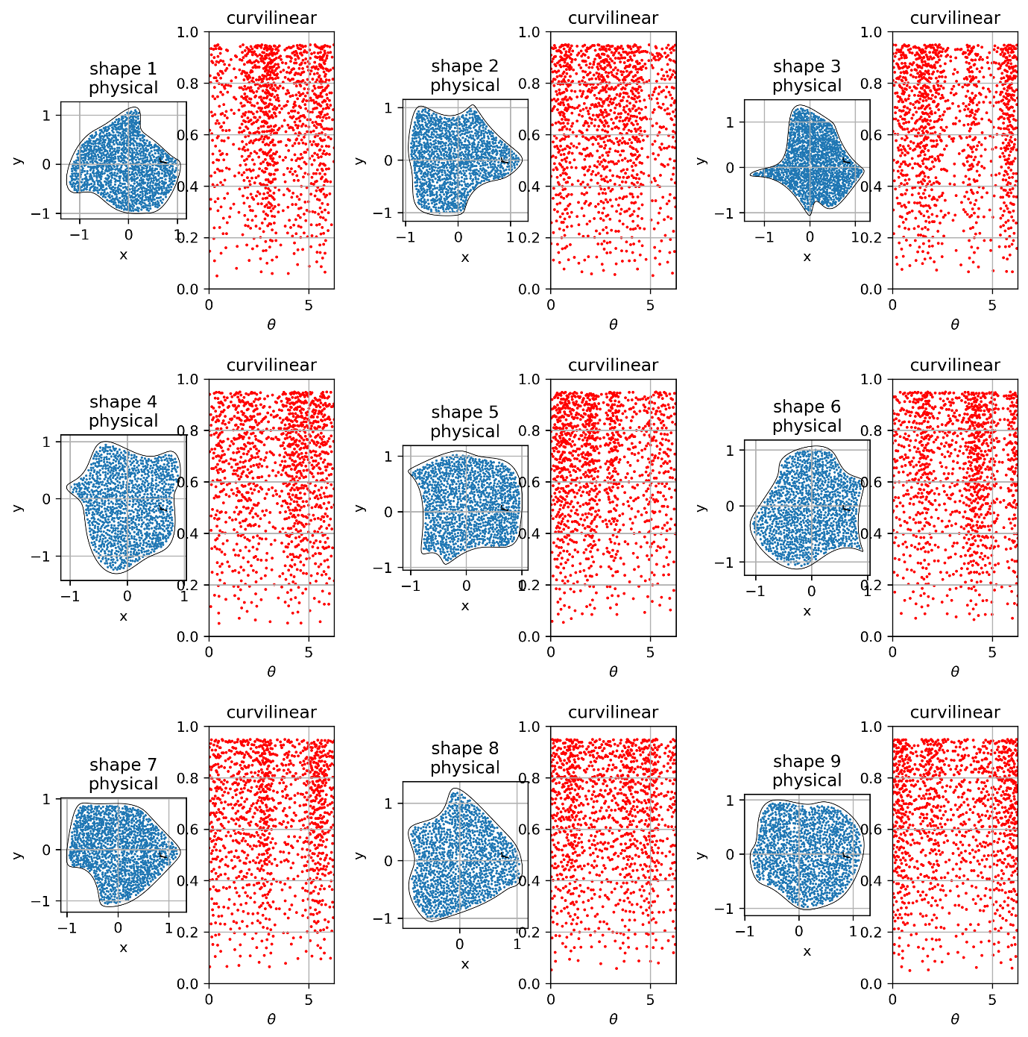
Figure 7. Particle initialization in nine different mapped geometries. Particles are sampled in the curvilinear domain with probability density proportional to $\left|\det{(J)}\right|$ and then mapped to physical space. The resulting distributions are approximately uniform in the physical domain, while the corresponding distributions in curvilinear coordinates reflect the local stretching and compression induced by the curvilinear transformation.

4.1.2 Simulations
The system is simulated using the curvilinear solver for a total time $T=10.0$ with timestep $Δt=2×{10}^{-4}$. Particle–particle and particle–wall contacts are modelled by the spring–dashpot law introduced in Section 2.2, with stiffness $k_{c}=k_{w}=2×{10}^{4}$and damping coefficient $γ_{c}=γ_{w}=15$. In the simulation, the container rotates moving and mixing the particles inside. This is achieved with a gravity that rotates in the body frame as
$$g(t)=g_{0}(cos⁡ωt, sin⁡ωt),$$ | (53)

with $g_{0}=9.81$ and $ω=2π×0.25$ corresponding to the container rotating at 0.25 revolutions per unit time.

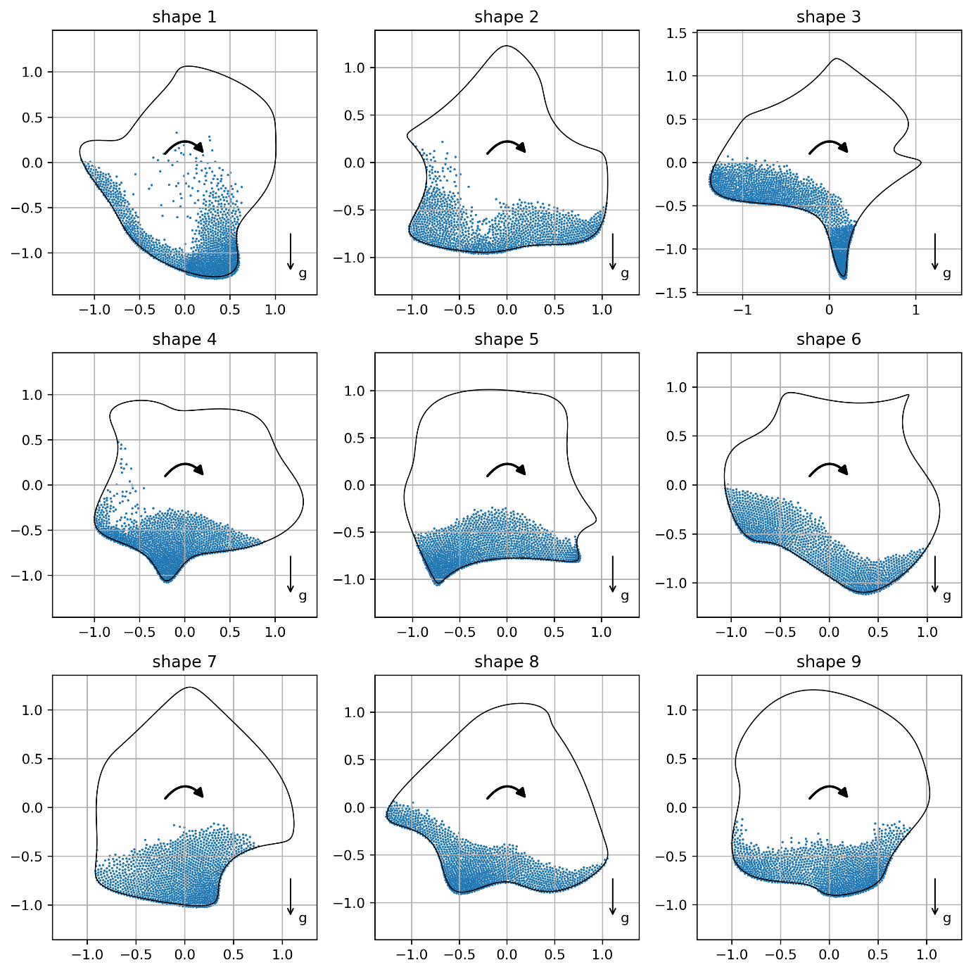
Figure 8. Simulation Screenshot in Cartesian coordinates. The boundary appears to rotate in this lab-framed visual representation, but it is fixed in the computational frame, where rotation is introduced through a rotating gravity vector.

All nine shapes are simulated with identical material and numerical parameters. The solver itself computes in curvilinear coordinates, with gravity rotating in the body frame as in Eq. 54; gravity is incorporated into the curvilinear equations of motion through the same Jacobian-based mapping used for the other forces.
Figure 8 shows the result mapped back to physical (Cartesian) coordinates. In the simulation, rotation is achieved through Eq. 53 rotating gravity; the wall itself never moves. For visualisation only, Figure 8 applies the inverse rotation $R(-ωt)$ to the system, so that the boundary, rather than the gravity vector, appears to rotate. Video 2 shows the full simulations in this physical, lab-frame view.
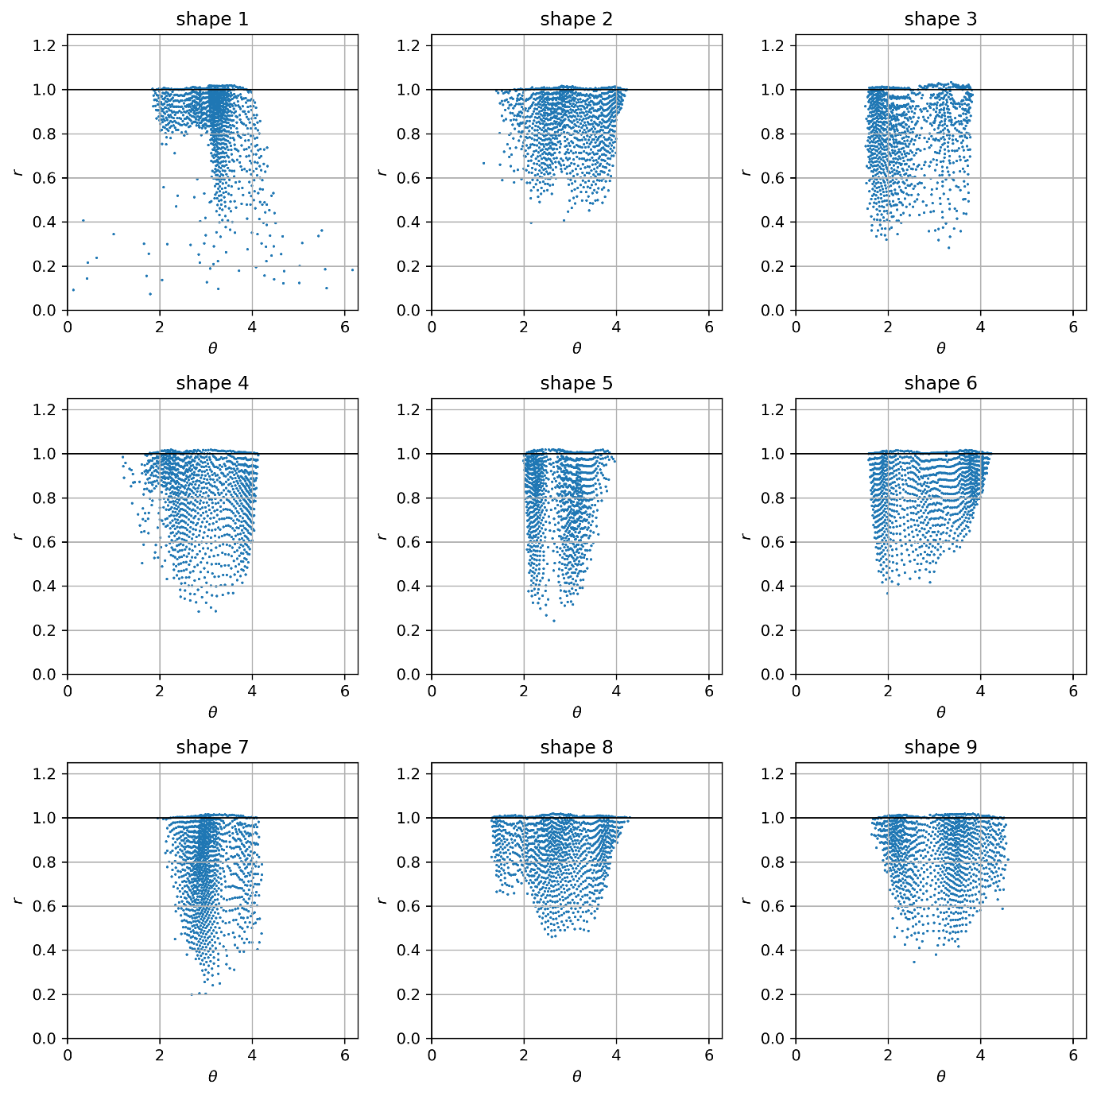
Figure 9. Particle configurations in curvilinear coordinates. The boundary is fixed at $r=1$, as seen by the solver during the simulation.

Figure 9 shows the same solution directly in the curvilinear $(θ,r)$ coordinates used internally by the solver, the inverse rotation $R(-ωt)$ is not applied. This makes explicit the central advantage of the curvilinear formulation: no matter how complex the physical boundary, it always maps to the simple fixed line $r=1$ for the whole duration of the simulation. Video 3 shows the full simulations in this curvilinear view.

In Figure 9, several particles appear to sit slightly above $r=1$. This is a consequence of the soft-wall model used in this first case study. The wall force is activated only when the particle centre crosses the computational boundary, and the overlap in Eq. 18 is computed without subtracting the particle radius. This is a deliberate simplification used in this first case study and will be corrected in the next case study. This centre-based particle-wall overlap occurs in both Cartesian and curvilinear space. However, in Figure 9 it appears larger, because distances in the curvilinear plane are not physical Euclidean distances. A small physical displacement near the wall can appear as a larger displacement in the curvilinear system, depending on the local metric. Similarly, particles are drawn with uniform markers in Figure 9, but a fully consistent rendering would require position-dependent particle sizes, since the curvilinear metric varies across the domain.

4.1.3 Computational complexity: segment walls versus mapped boundaries
The relative efficiency of the Cartesian and curvilinear formulations depends on how compactly each representation can describe the boundary. Consider a two-dimensional domain containing $N$ particles enclosed by a fixed wall (the extension to three dimensions is straightforward). We compare two boundary descriptions: an explicit approximation by $N_{s}$ straight segments, used with a standard Cartesian solver, and a Fourier-series parametrisation with $N_{f}$ harmonics, used to define the curvilinear coordinate map. In the Cartesian approach, each particle must be tested against every wall segment to determine whether contact has occurred. Without acceleration structures, this check scales as $O(NN_{s})$ per timestep. In the curvilinear formulation, the boundary corresponds to a fixed coordinate surface, so contact detection reduces to a single coordinate inequality per particle, giving $O(N)$. However, the curvilinear equations of motion contain geometric acceleration terms $J^{-1}\dot{J}\dot{q}$ (Eq. 8) that depend on the coordinate map and its derivatives. When the map is a truncated Fourier series, evaluating these terms costs $O(N_{f})$ per particle, since the series and its derivatives are sums of $N_{f}$ terms; the total overhead is therefore $O(NN_{f})$. The overall wall-related cost is thus $O(NN_{s})$ for the segment-based solver and $O(NN_{f})$ for the curvilinear solver. The comparison reduces to whether $N_{s}$ or $N_{f}$ is smaller, that is, whether the boundary is more compactly represented by line segments or by Fourier modes. A domain bounded by a small number of flat faces needs few segments but may need many Fourier modes; in this case the Cartesian description is preferable. Conversely, a smoothly curved or irregular boundary that demands a fine polygonal approximation may be captured by relatively few Fourier coefficients, making the curvilinear formulation more efficient.

4.1.4 Deforming particles and singularities
A key practical consequence of the curvilinear formulation is that particle shapes are deformed in curvilinear space. A particle that is circular in physical space appears as a distorted shape in curvilinear coordinates, and this distortion varies from point to point. Computing overlaps directly in curvilinear coordinates would therefore require tracking position-dependent particle shapes, which would complicate contact detection significantly. In our implementation, this is avoided by keeping both coordinate systems available, using each where it is simplest, as described in Section 2.2. The resulting forces are pulled back to curvilinear coordinates via the inverse Jacobian $J^{-1}$, so that the equations of motion (Eq. 9) remain in curvilinear form. This also simplifies neighbour search and Verlet-list construction for particle–particle contacts, which in curvilinear space would need to account for position-dependent metric distortions. By working with physical positions for these routines, we reuse standard Cartesian algorithms without modification. The only additional cost is storing both curvilinear and physical coordinates for each particle, which is already needed for visualisation, since results are typically viewed in physical space.

An additional benefit of keeping both coordinate representations available is that this strategy naturally handles coordinate singularities. Near the origin of the polar map, for example, the Jacobian determinant vanishes and the curvilinear equations become singular. We avoid (regularize) the singularity by switching coordinate systems locally. A particle is integrated in Cartesian coordinates whenever it enters a small cap around the origin, and is returned to curvilinear coordinates once it moves back out.

This dual-coordinate bookkeeping means that, in principle, we can switch between coordinate descriptions locally wherever it is advantageous. In the next case study, we exploit this directly: particles in the bulk are integrated in Cartesian coordinates, while those near the wall are advanced in curvilinear coordinates.

4.2 Case study 2: granular flow in a rough trapezium (hybrid approach)
The second case study considers a two-dimensional section of a conical-frustum mixer, represented in cross-section by a trapezium. This gives a simple 2D section of conical vessels commonly used in powder processing and often studied with DEM (Neoh at al. 2026). Wall roughness affects granular motion, and it can change particle trajectories and segregation patterns in granular mixing systems (D'Ortona et al. 2015).

When the roughness size is small relative to the particle diameter, its effect can be captured by an effective friction coefficient, without resolving the wall shape. However, if the roughness is comparable to the particle diameter, a particle can fit into individual asperities, and the roughness must be resolved geometrically. This second case can benefit from the curvilinear formulation since, as we saw in Case study 1, a well-designed curvilinear transformation can transform a complex boundary into a trivial one.

The trapezium is constructed with straight sides, then perturbed with a sinusoidal mode to add roughness with amplitude and wavelength comparable to the particle diameter. An amplitude parameter sets the height of the undulations; a frequency parameter sets their number along the boundary.

This geometry creates a trade-off. A Cartesian solver can represent the trapezium's straight sides with only four wall segments, while a Fourier description would need at least 60 modes to capture the same corners: for the smooth shape, segments are more compact. For the roughness, this reverses: a single Fourier mode describes the sinusoidal perturbation naturally, while resolving it in Cartesian coordinates means dividing each side into many elements, with the number growing with the roughness frequency. Neither representation suits the full geometry: Cartesian coordinates handle the straight sides well but struggle with roughness, while Fourier coordinates handle the roughness well but are inefficient for the corners.

For this reason, we use a hybrid formulation. Particles are integrated in Cartesian coordinates in the interior, where the curvilinear map gives no advantage, and switch to curvilinear coordinates near the wall, where the roughness is encoded analytically. The solver avoids the extra geometric curvilinear forces in the bulk, and the rough wall is described by a simple coordinate surface, not many explicit elements.

4.2.1 The hybrid approach
Unlike the global Fourier map used in Case study 1, the hybrid approach uses a separate boundary-fitted coordinate patch for each side of the trapezium; the curvilinear description is applied only in a thin layer near the wall. Each side of the trapezium has its own local curvilinear patch, with coordinates $(u, v)$. The coordinate $u∈[0,1]$ runs along the side, while $v∈[0,1]$ runs across the patch (Figure 10).

For a patch $e$, let $s_{e}(u)$ be the straight supporting side and $n_{e}$ the inward unit normal. The rough wall is

$$b_{e}\left(u\right)=s_{e}\left(u\right)-h_{e}\left(u\right)n_{e},$$ | (55)

where $h_{e}(u)$ is the sinusoidal roughness profile. The inner edge of the patch is a scaled copy of the straight supporting side,

$$c_{e}\left(u\right)=αs_{e}\left(u\right),$$ | (56)

where $α$ is a constant scaling factor (here $α=0.5$). The patch map then interpolates linearly between the rough wall $b_{e}\left(u\right)$ and the inner curve $c_{e}\left(u\right)$

$$Φ_{e}(u,v)=(1-v)b_{e}(u)+vc_{e}(u).$$ | (57)

Thus, in the $(u,v)$ coordinates, $v=0$ is the rough physical wall and $v=1$ is the inner boundary of the map. However, the actual switching between Cartesian and curvilinear coordinates occurs before the particle reaches $v=1$, based on the particle's physical distance from the wall. The map is therefore defined over a larger region than the actual curvilinear layer, for convenience; only a smaller portion of it, near the wall, is used in practice.

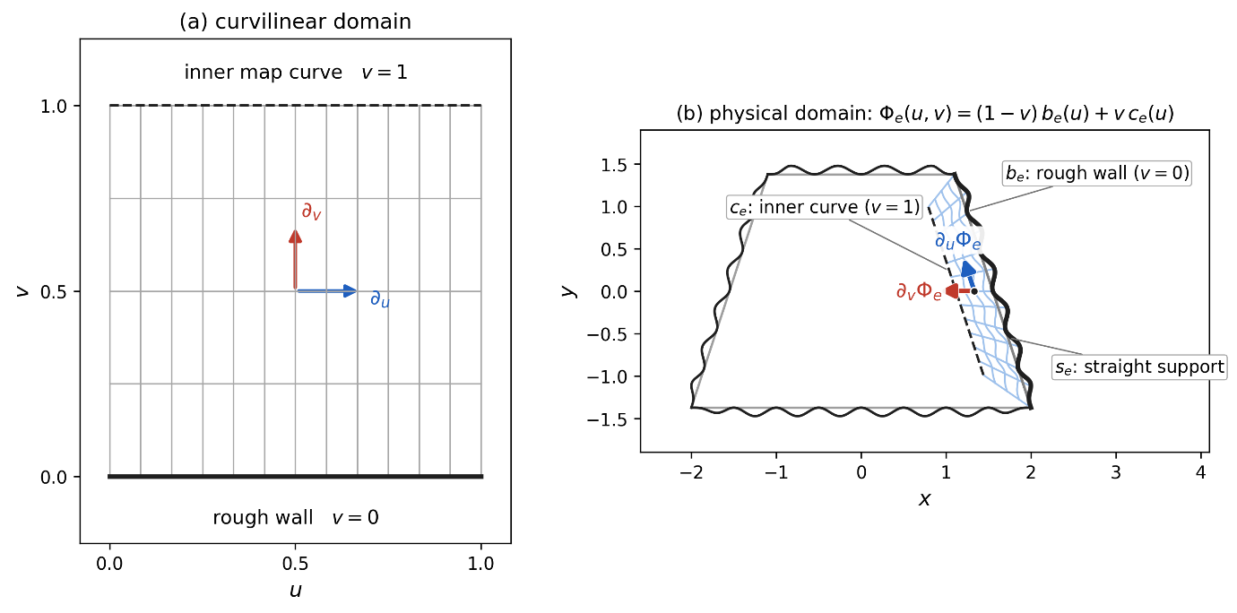
Figure 10. Local wall-patch map. The curvilinear coordinates of one wall patch $e$, shown for a slanted side. (a) The curvilinear domain, with $u$ along the side and $v$ across the patch. (b) Its image under $Φ_{e}$, drawn against the full trapezium: the rough wall $b_{e}$ at $v = 0$ (solid) and the inner curve $c_{e}$ at $v = 1$ (dashed), marking the edge of the patch map.

The switching is controlled by the particle's clearance from the nearest wall. A Cartesian particle enters the curvilinear wall layer when this clearance satisfies $d_{i}≤2a_{i}$, where $a_{i}$ is the particle radius. Once in the curvilinear layer, the particle remains there until its clearance becomes larger than $d_{i}>2.5a_{i}$. In the intermediate band, $2a_{i}<d_{i}≤2.5a_{i}$, the particle keeps its current coordinate description. This hysteresis prevents repeated switching when a particle moves close to the edge of the wall layer. The switching surface (the red dotted line in Figure 11) lies inside the map, at some $v<1$, and is independent of the map's inner boundary at $v=1$.

4.2.2 Finite-radius wall contact correction
For a finite-radius particle, the centre-based overlap used in Section 2.2 is no longer sufficient. Contact starts before the particle centre reaches the wall. The overlap is therefore written as
$$δ_{i}=a_{i}-d_{i},$$ | (58)

where $a_{i}$ is the particle radius and $d_{i}$ is the normal distance from the particle centre to the wall. A contact is active when $δ_{i}>0$; if $d_{i}≥a_{i}$, the particle does not touch the wall, and no wall force is applied. The distance $d_{i}$ is obtained by locating the closest point on the wall, $x_{w}$, and projecting the displacement from $x_{w}$ to the particle centre onto the inward unit normal $n$ at that point

$$d_{i}=\left(x_{i}-x_{w}\right)⋅n,$$ | (59)

Using the local linearisation already introduced in Eq. (16),

$$x_{i}-x_{w}≈J(q_{w})(q_{i}-q_{w})=J(q_{w})η_{q},$$ | (60)

so that

$$d_{i}≈\left[J(q_{w})η_{q}\right]⋅n.$$ | (61)

The radius-aware overlap is therefore

$$δ_{i}=a_{i}-\left[J(q_{w})η_{q}\right]⋅n.$$ | (62)

Once this corrected overlap is used, the rest of the wall model is unchanged.

4.2.3 Simulation
The hybrid solver is tested with $N=200$ particles. The trapezium has bottom width $4.0$, top width $2.3$, and height $2.7$. The roughness sinusoidal amplitude is $A_{r}=0.08$, and frequency is $f=2.0$. The particles have radius $a=0.05$, mass $m=1$. Particle-particle and particle-wall contacts use the same spring-dashpot parameters, $k=k_{w}={10}^{5},γ=γ_{w}=30.$ The timestep is $Δt={10}^{-4},$ and the simulation runtime $T=5.$

The vessel motion is imposed using the same moving-frame formulation introduced earlier, with vertical displacement amplitude $x_{A}=(0, 0.3)$, and angular frequency $ω=8π.$ Figure 11 shows one snapshot at $t=1.5$. The left panel shows the physical configuration, with the rough wall in black and the boundary at which particles switch from Cartesian to curvilinear coordinates (labelled 'mode threshold' in the figure) in red. The right panel shows the same particles in wall-patch coordinates. Video 4 shows the full dynamics in both coordinate systems.
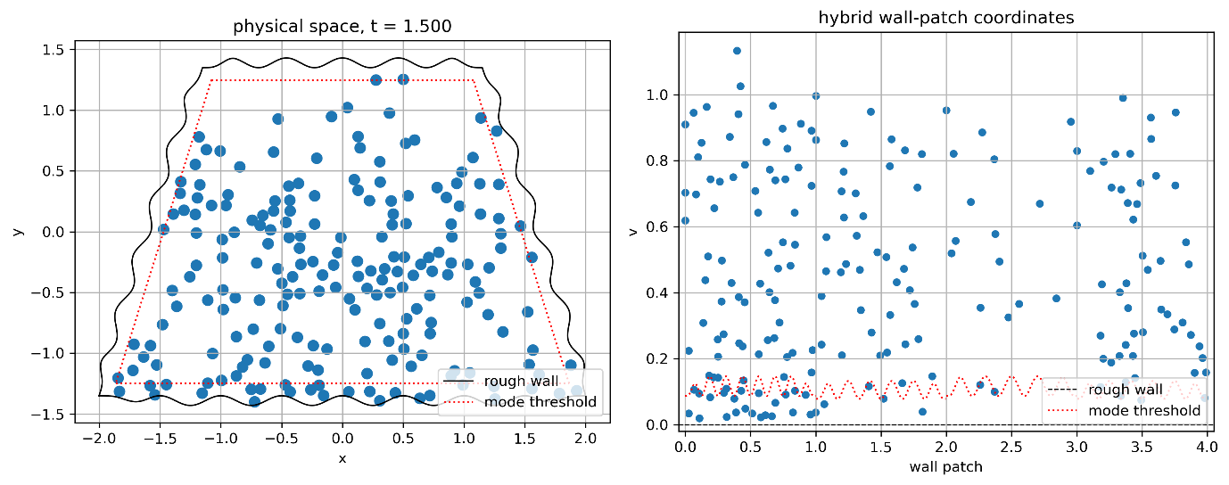
Figure 11. Hybrid simulation at $t=1.5$, shown in physical space and in wall-patch coordinates. The red dotted line marks the boundary at which particles switch from Cartesian to curvilinear coordinates.

4.3 Case study 3: deforming boundaries
The derivation presented so far assumes a time-independent coordinate map, $x = Φ(q)$. This is sufficient for fixed boundaries and for moving-frame formulations where the geometry remains unchanged. However, it is not sufficient for deforming boundaries. In this case, if we still want to make sure the boundary maps to a simple line $r=1$ at all times, we need to change the map with time to compensate for the deformation of the boundary in physical space. Thus, the map

$$x=Φ\left(t, q\right)$$ | (63)

and consequently, the Jacobian $J\left(t, q\right)$ are now also time dependent. Based on this, we can follow the derivation of Section 2, where $\dot{x}$ and $\ddot{x}$ were derived for the curvilinear system. As before, we differentiate the map Eq. (63)

$$\dot{x}=\frac{dΦ}{dt}=\frac{∂Φ}{∂t}+J \dot{q.}$$ | (64)

If we compare Eq.64 with Eq. 6, we see the new quantity $\frac{∂Φ}{∂t}$, absent for the time-independent case. This is the so-called grid velocity, i.e. the physical velocity of a point that is fixed in curvilinear coordinates. Differentiating again, we obtain

$$\ddot{x}=\frac{d}{dt}\left(\frac{∂Φ}{∂t} + J\dot{q}\right)$$ | (65)

The first term gives
$$\frac{d}{dt}\left(\frac{∂Φ}{∂t}\right)=\frac{∂^{2}Φ}{∂t^{2}}+\frac{∂}{∂q}\left(\frac{∂Φ}{∂t}\right)\dot{q}=\frac{∂^{2}Φ}{∂t^{2}}+\frac{∂J}{∂t}\dot{q.}$$ | (66)

The second term gives

$$\frac{d}{dt}(J\dot{q})=\dot{J} \dot{q}+J\ddot{q.}$$ | (67)

In this case, however, $\dot{J}$ is different from Eq. 8, because also the Jacobian is time-dependent

$${\dot{J}}_{ij}=\frac{∂J_{ij}}{∂t}+\frac{∂J_{ij}}{∂q_{k}}{\dot{q}}_{k}.$$ | (68)

As in Eq. (8), index notation is used here only to make clear that the contraction in the second term is between the coordinate derivative index $k$and the velocity component ${\dot{q}}_{k}$. The resulting quantity ${\dot{J}}_{ij}$is again a matrix. For simplicity, in the rest of the text we will use the shorthand

$$\frac{∂J}{∂q}\dot{q}=\frac{∂J_{ij}}{∂q_{k}}{\dot{q}}_{k},$$ | (69)

where the contraction ambiguity is resolved by the index notation. Substituting Eq. 66 and Eq. 67 into Eq. 65

$$\ddot{x}=\frac{∂^{2}Φ}{∂t^{2}}+\frac{∂J}{∂t}\dot{q}+\left(\frac{∂J}{∂t} + \frac{∂J}{∂q}\dot{q}\right) \dot{q}+J\ddot{q,}$$ | (70)

which simplifies to

$$\ddot{x}=\frac{∂^{2}Φ}{∂t^{2}}+2\frac{∂J}{∂t}\dot{q}+\left(\frac{∂J}{∂q}\dot{q}\right) \dot{q}+J\ddot{q}$$ | (71)

and therefore

$$\ddot{q}=J^{-1}\left[\frac{f}{m}-\frac{∂^{2}Φ}{∂t^{2}}-2\frac{∂J}{∂t}\dot{q}-\left(\frac{∂J}{∂q}\dot{q}\right) \dot{q}\right].$$ | (72)

Eq. 72 replaces Eq. 9. They both have the same geometric acceleration $\left(\frac{∂J}{∂q}\dot{q}\right) \dot{q}$ term, but Eq. 72 has the terms $\frac{∂^{2}Φ}{∂t^{2}}$ and $2\frac{∂J}{∂t}\dot{q}$ analogous to Euler and Coriolis terms in moving coordinate systems.

The finite-radius wall-contact correction derived in Section 4.2.2 remains largely unchanged. The overlap is still computed from Eq. (58), using the centre-wall distance defined by Eq. (59). Likewise, the local linearisation of Eq. (60) and the metric-based distance expression of Eq. (61) remain valid, with the only modification that the Jacobian and metric tensor are now evaluated at the current time. Consequently, the radius-corrected overlap of Eq. (62) is unchanged in form. The main difference arises in the damping contribution. In the time-independent formulation, the particle velocity entering Eq. (21) is given by Eq. (6). For a time-dependent map, we should use Eq. (64) instead.

The wall remains the fixed coordinate surface $r=1$ throughout the simulation. The purpose of the time-dependent map is precisely to ensure that, despite the deformation of the physical boundary, its curvilinear representation remains unchanged. However, the physical image of this surface evolves through the map $Φ(t,q)$. A point fixed on the computational wall therefore has the physical velocity

$${\dot{x}}_{w}=\frac{∂Φ}{∂t}(t,q_{w}),$$ | (73)

where $q_{w}$ denotes the wall point identified in Eq. (59). Since the wall corresponds to the fixed computational surface $r=1$, the wall coordinates $q_{w}$ are constant in time. The normal velocity entering Eq. (22) must be computed from the relative velocity between the particle and the physical image of the wall,

$$v_{n}=(\dot{x}-{\dot{x}}_{w})⋅n.$$ | (74)

Substituting Eq. (64) gives

$$v_{n}=\left(\frac{∂Φ}{∂t}+J\dot{q}-\frac{∂Φ}{∂t}(t,q_{w})\right)⋅n.$$ | (75)

Eq. (22) is therefore replaced by the above expression. The damping force is then obtained from Eq. (23) exactly as in the time-independent case. Apart from this modification of the normal velocity, the derivation remains unchanged.

Finally, the particle-particle contact law in Section 2.3 is only indirectly affected by the time-dependent map. The distance, overlap, normal direction, and force are still given by Eqs. (34)-(39). The only modification is that the physical positions and velocities entering these equations must be obtained from the time-dependent map. Thus, Eq. (37) must use the velocity from Eq. (64), evaluated separately for particles $i$ and $j$. Once the physical force pair has been computed, the pullback to curvilinear coordinates follows Eqs. (40)-(41), with $J_{i}^{-1}$and $J_{j}^{-1}$evaluated at the current time.

4.3.1 Simulation
The boundary is described by a time-dependent curve defined as

$$B(t,θ)=\left(\begin{aligned}B_{x}(t,θ) \\ B_{y}(t,θ)\end{aligned}\right),$$ | (76)

with
$$B_{x}(t,θ)=acos⁡θ+αcos⁡(3θ)+ε_{x}sin⁡θcos⁡(Mθ-ωt),$$ | (77)
and
$$B_{y}(t,θ)=sin⁡θ\left[b-ε_{y}cos⁡(Mθ-ωt)\right].$$ | (78)

where $a=3.0,α=-0.2,b=0.6,ε_{y}=0.25,ε_{x}=0.08,M=3,ω=2.0$.

The corresponding interior map is therefore

$$\begin{aligned}x(t,r,θ)=rB_{x}(t,θ), \\ y(t,r,θ)=rB_{y}(t,θ).\end{aligned}$$ | (79)

This defines a basic elongated shape with the time-dependent term in $B_{y}$ imposing a travelling contraction in the vertical direction and the additional time-dependent term in $B_{x}$ introducing a smaller horizontal deformation.

The simulation uses $N=1000$ particles with radius $r_{p}=0.02$ and mass $m=1.0$. The time step is $Δt={10}^{-4}$, and the total simulation time $T=15$. Particle–particle and particle–wall stiffness and damping coefficient are $k_{c}=k_{w}={10}^{4}$ and $γ_{c}=γ_{w}=20$.

Figure 12 shows the simulation at two different times, both in curvilinear coordinates and in physical space obtained by mapping the curvilinear solution through $Φ(t,q)$. The curvilinear plots show how the geodesics of the induced time-dependent metric change as the map evolves. Video 5 shows the full simulation in both coordinate systems.

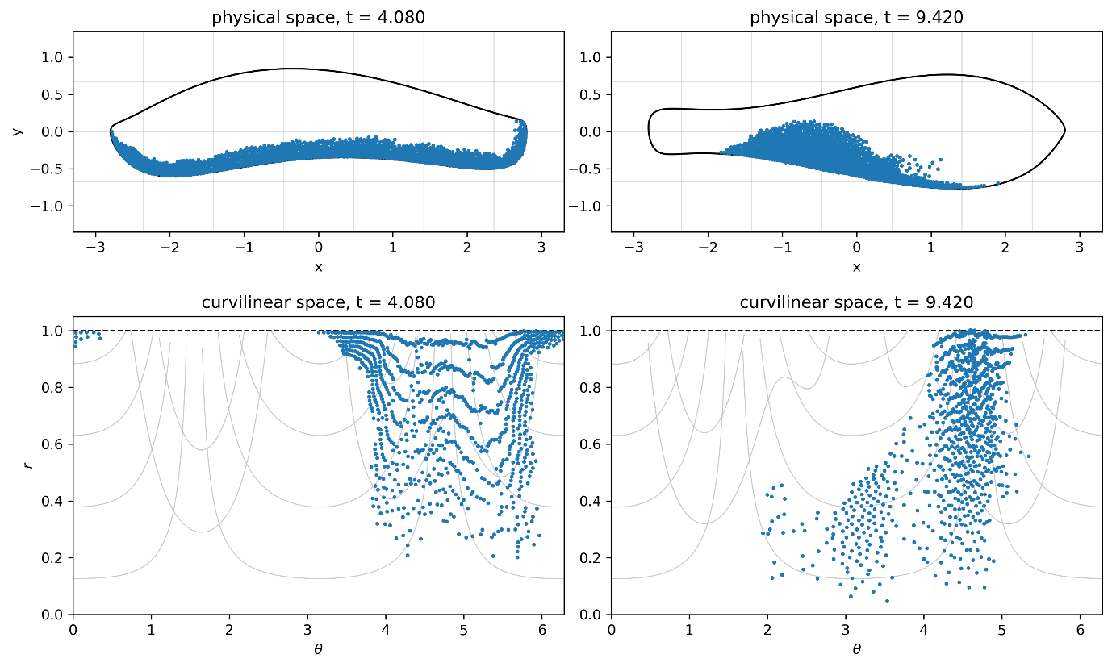
Figure 12: Simulation snapshots at two times in curvilinear space and in the corresponding physical space. The curvilinear plots also show the evolving geodesics of the time-dependent metric.

4.4 Case study 4: Three-dimensional case
The test geometry is a three-dimensional container $B(θ,ϕ)$ with a localised " cat-ears " deformation, shown in Figure 13.
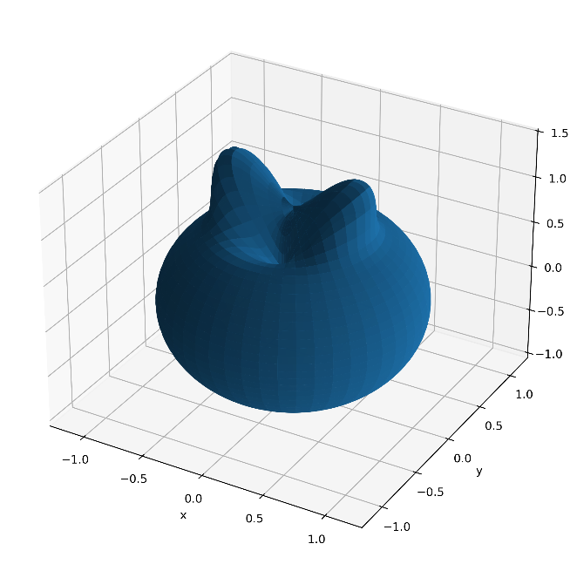
Figure 13. Three-dimensional "cat-ears" shaped container used in Case Study 4.

The boundary surface is

$$\begin{aligned}B_{x}\left(θ,ϕ\right)=R\left(θ,ϕ\right)sinϕ cosθ, \\ B_{y}\left(θ,ϕ\right)=R\left(θ,ϕ\right)sinϕ sinθ, \\ B_{z}\left(θ,ϕ\right)=R\left(θ,ϕ\right)\cos{ϕ}. \end{aligned}$$ | (80)

with

$$R\left(θ,ϕ\right)=R_{0}\left[1+ε\exp\left(\frac{{\left(ϕ-ϕ_{0}\right)}^{2}}{σ^{2}}\right)\cos\left(2θ\right)\right].$$ | (81)

where $R_{0}=1.0$, $ε=0.55$, $ϕ_{0}=0.35$, and $σ=0.20$.

A curvilinear map is then constructed in the form $x=B\left(θ,ϕ\right)$ following Eq. (10), with
$0≤r≤1,$ $0≤θ<2π$, $0≤ϕ≤π$.

Under this transformation, the complex physical boundary is mapped onto the simple coordinate surface $r=1$. The computational coordinates are written as $(r,θ,ϕ)$, with the container wall represented by the fixed surface $r=1$. The azimuthal coordinate $θ$ is periodic on $[0,2π)$. The polar coordinate $ϕ$ is kept in the standard spherical interval $[0,π]$. When a timestep carries a particle outside this interval, the coordinate representation is folded back into the spherical chart. Crossing $ϕ=0$ is represented by

$$(θ,ϕ)≡(θ+π,-ϕ),$$ | (82)

while crossing $ϕ=π$ is represented by

$$(θ,ϕ)≡(θ+π,2π-ϕ).$$ | (83)

In both cases$,$ $\dot{ϕ}$ changes sign.

As in the two-dimensional polar formulation, the coordinate system contains singular regions. In the present three-dimensional case, the singularity occurs along the line joining the north and south poles. To avoid numerical difficulties, the same strategy used in the two-dimensional simulations is adopted. Particles entering a small neighbourhood of this singular region are temporarily integrated in Cartesian coordinates. Once they move away from the singularity, they are mapped back into the curvilinear representation, and the integration continues in curvilinear space.

The simulation uses $N=350$ particles of radius $a=0.045$ and mass $m=1.0$. Particle-particle and particle-wall interactions are modelled using the same spring-dashpot law as in the previous case studies, with $k_{contact}=k_{w}={10}^{4}$ and $γ_{contact}=γ_{w}=15$. The timestep is $Δt={10}^{-4}$and the total simulation time is $T_{max}=20$. Mixing is generated through the rotating-gravity formulation introduced in Case Study 1, with $g=9.81$and $ω=2π×0.25$. This corresponds to a rotation about the $y$-axis while the container remains fixed in the computational frame.

Figure 14 shows two snapshots of the simulation in both physical and curvilinear coordinates. As in the previous case studies, the dynamics itself is computed in curvilinear coordinates and the physical-space particle positions are obtained by mapping the curvilinear solution back to Cartesian coordinates for visualisation. Video 6 shows the complete particle dynamics in both coordinate systems.

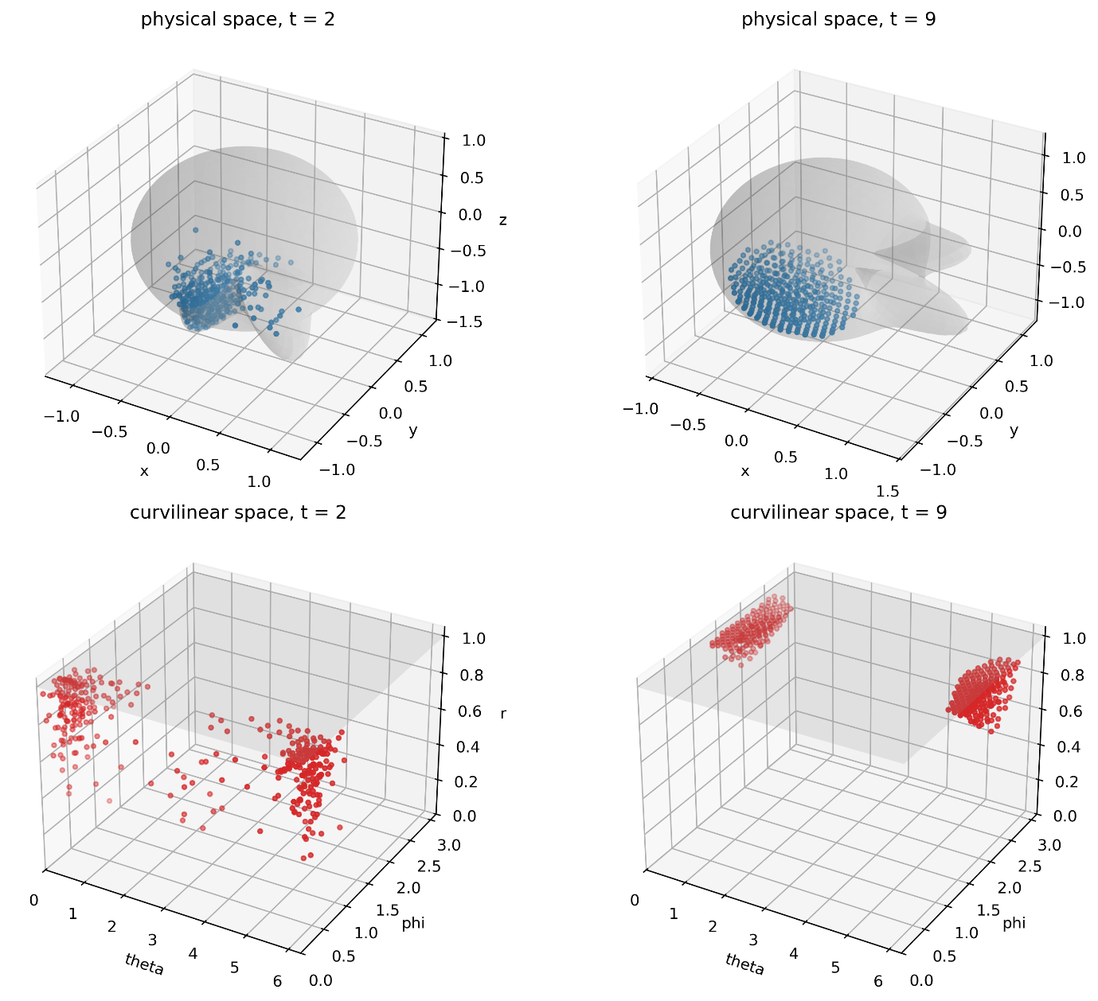
Figure 14. Simulation snapshot shown in physical and curvilinear coordinates. The wall corresponds to the surface $r=1$in curvilinear space.

5. Further considerations on the map
The proposed method is based on finding a coordinate map that makes the boundary treatment simpler. This is often the result of a compromise. Working in curvilinear coordinates introduces additional geometric terms into the equations of motion, as shown in Eq. (9), and the metric must be evaluated at every particle position. In exchange, the physical boundary becomes trivial: a complex wall is reduced to the simple coordinate surface $r = 1$. Whether this trade-off is worthwhile depends on the problem, but it also depends on a more basic requirement: the map itself must remain a valid diffeomorphism, with a positive Jacobian everywhere is used.

5.1 Folding and the star-like constructions
Most of the case studies use a radial map of the form $x=rB(s)$, valid when the boundary is ‘star-like’ with respect to the origin, that is, when every ray from the origin crosses the boundary exactly once. The Jacobian of this map is proportional to

$$det⁡J_{Φ}∝B(s)×\frac{∂B}{∂s}.$$ | (84)

The map degenerates when this cross product vanishes,

$$B\left(s\right)×\frac{∂B}{∂s}=0,$$ | (85)

which means the boundary tangent is parallel to the radial vector (Figure 15a). This condition marks the local failure of the radial star-like parametrisation and typically appears in domains with deep concavities. It holds for all Case Studies except Case Study 2 where a different approach is necessary.

5.2 What folding means
Once the Jacobian changes sign, the map is no longer injective: the computational domain folds over itself, so particles that are far apart in physical space can be mapped to nearby, or even identical, curvilinear coordinates (Figure 15b). This breaks the basic assumption that locality in curvilinear space reflects locality in physical space, on which both the contact model and the streamline-based coordinate recovery depend.

5.3 Singularities versus folding, and the hybrid approach
It is important to distinguish two types of map degeneracy. A singularity, such as the origin in polar coordinates, is an isolated point pr region where coordinate lines converge; it can be regularised by switching locally to Cartesian integration, as done in this work. On the other hand, folding cannot be regularised; it must be avoided for the map to work.

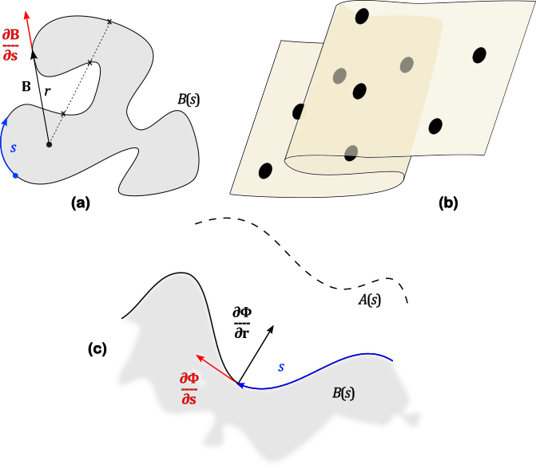
Figure 15. Schematic illustration of map degeneracy and folding. In a radial construction, $x=rB(s)$, the map degenerates when the boundary tangent $∂B/∂s$ becomes parallel to the radial vector $B(s)$ (a). In this case, distant physical regions may be mapped to nearby or overlapping curvilinear coordinates (b). For a general wall-fitted map, the coordinate directions $∂Φ/∂s$ and $∂Φ/∂r$ must remain transverse and not overlap.

This distinction motivates the hybrid approach in Case Study 2. A general boundary-fitted map can be built from a local frame at the wall, with a tangential direction $∂Φ/∂s$ and a second direction $∂Φ/∂r$ (Figure 15c). $∂Φ/∂r$ can be constructed perpendicular to $∂Φ/∂s$ at the wall, but this only guarantees the map is non-degenerate locally. Nothing stops the coordinate lines from converging and crossing further into the domain. For this reason, the curvilinear description in Case Study 2 is applied only in a layer near the wall, where bijectivity can be guaranteed, while the bulk is integrated in Cartesian coordinates.

5.4 Finding a good map
Constructing a suitable map raises two distinct questions. The first is theoretical: does a non-folding map always exist, and can it be found? For star-like domains a radial construction is sufficient. For more irregular geometries, a valid map may exist in principle, but constructing one in practice can be difficult. This is a known issue in grid generation, isogeometric analysis and geometric parametrisation, where approaches based on positive-Jacobian spline construction, harmonic or optimisation-based parametrisation, domain decomposition, and foldover-free mesh untangling have been developed (Lin, Huang and Hu, 2018; Pan, Chen and Tong, 2019; Garanzha et al., 2021).

The second question is practical: the boundary must be parametrised compactly. The method is only advantageous if $B(s)$ requires fewer parameters than an explicit wall mesh would. Fourier series, used here for convenience, are not the only option; radial basis functions, Chebyshev series, splines and NURBS are all suitable, and the best choice depends on the character of the boundary.

6. Conclusion
We have developed a DEM formulation in which particle position and velocity are advanced in curvilinear coordinates $q$, so that a complex physical boundary becomes the fixed coordinate surface $r=1$. This simplifies the wall treatment, but it does not mean that every part of the calculation is best performed in curvilinear space. Particle overlaps and particle-particle contacts are still simpler in physical space $x$, where particles remain circular and distances are Euclidean. For this reason, the solver keeps both descriptions: it advances $q$, but recovers $x$ whenever the physical contact geometry is more convenient. This conversion is an extra cost, but it is only a local map evaluation, and physical coordinates must, in any case, be recovered for visualisation and analysis. In this way, the method keeps standard DEM tools such as Verlet lists, circular particles and Euclidean overlaps, while replacing a complex wall discretisation with a simple coordinate surface.

The formulation was validated against a Cartesian reference both for individual trajectories and for multiparticle systems. The comparison also showed the central trade-off: as the number of explicit wall elements needed to approximate the boundary increases, the Cartesian wall treatment becomes more expensive, while the curvilinear wall remains the same coordinate surface. Beyond a certain boundary resolution, the map-based formulation becomes advantageous. More generally, the method is useful when the boundary is more compactly described by a valid map than by explicit wall elements. In standard Cartesian DEM, boundaries are usually represented by piecewise straight segments or surface elements. For polyhedral or faceted geometries, this may already be the most compact and natural description, and there is little reason to replace it. The present method becomes useful when the boundary is more naturally described by a compact parametrisation, such as Fourier modes, radial basis functions, splines, polynomials or another analytic map. In those cases, approximating the boundary by many straight elements can be more expensive than using the parametrisation directly, and the curvilinear formulation provides a way to do so.

The method was then applied to irregular Fourier-generated boundaries, rough walls with macroscopic asperities, time-dependent deforming boundaries, and three-dimensional cases. In every case, however complex or time-dependent the physical boundary, it mapped to the same fixed coordinate surface for the duration of the simulation.
A practical limitation could be the construction of the map itself. As discussed in Section 5, the map must not fold in the region where it is used. For domains with the appropriate topology, a smooth non-folding map should always exist but finding one that is also compact and cheap to evaluate can be difficult. This is especially true for highly deformed three-dimensional geometries with deep concavities, narrow passages or choke points. In such cases, a practical solution can be a local hybrid approach, such as the one used in Case Study 2.

For simplicity, we have not considered particle rotation in our DEM formulation. In principle, these could be added using the same double-entry bookkeeping strategy implemented here. The same logic could also be extended to other particle-based methods in which boundaries play a direct role in the dynamics. The method may also be useful for parametric shape optimisation: if the boundary depends smoothly on parameters such as Fourier coefficients, spline control points or radial-basis-function weights, these parameters can be varied while keeping the computational wall fixed at $r=1$ in curvilinear space. This avoids rebuilding an explicit wall mesh at each step and could support gradient-based optimisation.

7. Data and code accessibility
The code used in this study is available in the GitHub repository Curvilinear_DEM (Alexiadis, 2026): https://github.com/alexiada/Curvilinear_DEM. It is written in Python and uses NumPy, Numba, Matplotlib and Jupyter. The implementation was adapted and substantially extended from the DEM code developed by Alexiadis (2023). The code is distributed under the GNU General Public License v3.0 (GPLv3) and is provided without warranty.

8. References
- Alexiadis, A. (2023) ‘A minimalistic approach to physics-informed machine learning using neighbour lists as physics-optimized convolutions for inverse problems involving particle systems’, Journal of Computational Physics, 473, 111750.
- Ariane, M., Sommerfeld, M. and Alexiadis, A. (2018) 'Wall collision and drug-carrier detachment in dry powder inhalers: using DEM to devise a sub-scale model for CFD calculations', Powder Technology, 334, pp. 65-75.
- Croonen, J., Pezzini, L., Bacchini, F. and Lapenta, G. (2024) ‘An exactly energy-conserving electromagnetic particle-in-cell method in curvilinear coordinates’, The Astrophysical Journal Supplement Series, 271(2)
- Daraio, D., Villoria, J., Ingram, A., Alexiadis, A., Stitt, E.H. and Marigo, M. (2020) 'Investigating grinding media dynamics inside a vertical stirred mill using the discrete element method: effect of impeller arm length', Powder Technology, 364, pp. 1049-1061.
- D’Ortona, U., Thomas, N., Zaman, Z. and Lueptow, R.M. (2015) ‘Influence of rough and smooth walls on macroscale flows in tumblers’, Physical Review E, 92, 062202.
- Fichtl, C.A., Finn, J.M. and Cartwright, K.L. (2012) 'An arbitrary curvilinear coordinate method for Particle-In-Cell modeling', arXiv preprint, arXiv:1201.1476.
- Fujioka, S., Tsuji, K., Mitsume, N. and Asai, M. (2025) 'A generalized vertical coordinate transformation based on SPH(2) for efficient free surface flow simulations', Journal of Computational Physics, 543, 114407.
- Goldstein, H., Poole, C.P. and Safko, J.L. (2001) Classical Mechanics. 3rd edn. San Francisco: Addison Wesley. ISBN 9780201657029.
- Garanzha, V., Kaporin, I., Kudryavtseva, L., Protais, F., Ray, N. and Sokolov, D. (2021) ‘Foldover-free maps in 50 lines of code’, arXiv. Available at: https://arxiv.org/abs/2102.03069
- Lin, H., Huang, H. and Hu, C. (2018) ‘Constructing trivariate B-splines with positive Jacobian by pillow operation and geometric iterative fitting’, arXiv. Available at: https://arxiv.org/abs/1811.12597
- Kreyszig, E. (1991) Differential Geometry. New York: Dover Publications. ISBN 9780486667218.
- Neoh, N., Barter, F.J., Wiggin, A., Grogan, J., Bazin, N., Bolton, P., Phillips, O. and Windows-Yule, C. (2026) ‘Discrete element method investigation into the mixing of cohesive and non-cohesive particles in a resonant acoustic mixer’, Powder Technology, article 122869.
- Pan, M., Chen, F. and Tong, W. (2020) ‘Volumetric spline parameterization for isogeometric analysis’, Computer Methods in Applied Mechanics and Engineering, 359, 112769. doi: 10.1016/j.cma.2019.112769.
- Reyes Barraza, J. A., & Deiterding, R. (2022). A curvilinear lattice Boltzmann scheme for thermal flows. Mathematics and Computers in Simulation, 202, 405–420.
- Thompson, J.F., Thames, F.C. and Mastin, C.W. (1974) 'Automatic numerical generation of body-fitted curvilinear coordinate system for field containing any number of arbitrary two-dimensional bodies', Journal of Computational Physics, 15(3), pp. 299-319.
- Ushijima, S., Tanaka, N. and Yoneyama, N. (1999) 'Lagrangian approach for solid-particles in gas-solid flows in a 3D complicated-shaped domain', Annual Journal of Hydraulic Engineering, 43, pp. 515-520.

