**ENGR 102 Sect 508**

**Lab 2b**

**100+5 extra points**

**Reading assignment:**

|  |  |
| --- | --- |
| **Lecture Slides** | **L01- L02** |
| **zyBook chapters 1-2** | **Complete all participation and challenge activities** |

***Attention!!***

***For submission: pdf/word file and all py-files as asked in the assignment. No pictures by the phone – it is impossible to read. You will be allowed to resubmit and reupload HW as many times as you want to within the due date/time, only last submission will be graded. No late submissions.***

***For submission you may use this file as template: rename file including your name. Do not forget to put your name inside of this file as well.***

***For this submission use Individual Header. Submit individually.***

**Assignment: Writing your Programs – To Do individually, in lab or outside**

You are to write the following 3 programs (though one of them has 3 versions), each of which should be done individually. Once the programs are written, you should submit 5 programs.

**Program 1: [3x8=24 points]**

Begin with Program 1 from Activity 4 of last week’s Lab (1b). You are to convert that program to a new program that produces identical output. However, for all of the calculations, you are to instead create variables for all values that are either constants or are values that might vary in the calculation. As an example, if you previously had a line like:

print(3+2)

you would want to change it to a sequence of assignments such as:

a = 3

b = 2

c = a+b

print(c)

Please note the following:

1. Your print statements should each print just a single variable.
2. You should pick good names for your variables.
3. You do not have to perform the entire computation in one line; you can use multiple lines to perform the computation if you want.
4. It is OK to introduce variables to hold values that are not a “final” value. For example, if you were computing the area of a circle, you might store the radius in one variable, then the radius squared in another variable, and then later multiply that by pi to compute the area.

As a reminder, your program was to print the following 10 lines (the first 2 don’t change from before):

1. [1]Your name, UIN, and section number of ENGR 102 that you are enrolled in
2. [1] Summary of the assignment: for example assignment number, or “this program calculates..”
3. [1] A sentence giving some interesting fact about yourself

**What do you need to calculate?**

**(You may choose to put code/output for each task separately or all together, but in that case, you need to put a comment which line on your program calculates what.)**

1. [3] The voltage across a conductor with resistance 20 and a current of 5.
2. [3] The kinetic energy of an object with mass 100 and velocity 21

The Reynolds number for a fluid with velocity 100 and kinematic viscosity 1.2, with characteristic linear dimension 2.5. For this question I need you to add a couple of words about assumptions before you do calculations

1. [3] The energy radiated per unit surface area (across all wavelengths) for a black body with temperature 2200. Use 5.67 x 10-8 for the Stefan-Boltzmann constant.
2. [3] The production of a well after 20 days, if it had an initial production rate of 100, an initial decline rate of 2/day, and a hyperbolic constant of 0.8.
3. [3] The average length of an M/M/1 queue with an arrival rate of 20 and a service rate of 35.
4. [3] The shear stress when a normal stress of 20 is applied to a material with cohesion 2 and angle of internal friction 35 degrees
5. [3] The scattering angle for maximum interference for light of wavelength 7.5 x 10-7 hitting a crystalline lattice with planes separated by a distance 1 x 10-6.

**Put your code/output here:**

*# By submitting this assignment, I agree to the following:  
# “Aggies do not lie, cheat, or steal, or tolerate those who do”  
# “I have not given or received any unauthorized aid on this assignment”  
#  
# Name: ALEXIA PEREZ  
# Section: 508  
# Assignment: LAB 2B  
# Date: 06-09-2018***import** numpy  
**from** math **import** *  
personal_info= (**"Alexia Perez, UIN: 127008512, Section: 508 "**)  
fun_fact= (**"I am 17 years old, I graduated from the Atascocita High School, "  
 "and I am a freshmen in general engineering at Texas A&M UNiversity."**)  
  
print(personal_info)  
print (fun_fact)  
  
*# Ohm's law states that I=V/R , therefore: V=I*R  
#(I assume: voltage is in volts, resistance is in ohms, and current is in watts)  
#The volatge across the conductor is:*I = 5  
R = 20  
V = I*R  
print (V)  
  
*# The Kinetic energy of an object is Ke=1/2*m*v^2.  
# (I assume: Kinetic energy is in Joules, mass is in grams, and velocity is in meters/second)  
# The Kinetic energy of the object is*m=100  
v=21  
Ke=1/2*m*v**2  
print (Ke)  
  
*# The Reynolds number is: Re=VD/μ  
# (I assume that V is in m/s, length(D) is in meters and fluid density(μ) is in kg/m^3)  
# The Reynolds number of the fluid is:*V=100  
D=2.5  
u=1.2  
Re=V*D/u  
print (Re)  
  
*# The Stefan-Boltzmann Law states that P/A=σT^4, since the surface area is 1, A=1, making the equation: P=σT^4 "  
# (I assume: temperature(T) is in Kelvins, surface area(A)= m^2,  
# Stefan-Boltzmann constant (σ) is in watt/meters^2, energy radiated (p) is in watts)  
# therefore the energy radiated per unit surface is:*o=5.67*10**-8 *#scientific notation*T=2200  
P=o*T**4  
print (P)  
  
*# The Arps Hyperbolic Decline Relation formula is: q=qi/((1+bDit)^1/b) therefore  
# I assume: the term b has no units, both the final and initial production rates are in volume(liters)/day ,  
# the initial decline is in decline volume(liters)/day, and time is in days.  
# The production of the well after 20 days is:*qi=100  
b=0.8  
Di=2  
t=20  
q= qi/((1+b*Di*t)**1/b)  
print (q)  
  
  
*# The average lenght of an M/M/1 queue is given by: ρ/(1-p), where p=λ/μ  
# I assume: the lengh of the queue is measured in users/minute  
# the lenght of the M/M/1 queue is:*y= 20/35  
u= 1-y  
p=y/u  
print (p)  
  
*# The Mohr-Coulomb failure criterion can be written as the equation for the line that represents the failure  
# envelope. The general equation is: shear stress= c + normal stress * tan(angle)  
# (I assume that the angle is measured in radians, both the shear and normal stress is measured in Kn/m^2  
# and c(cohesion) is measured in pascals)  
# Therefore, the shear stress of the material is:*c=2  
norm_stress = 20  
tan_angle = tan(35)  
shear_stress = c + norm_stress*tan_angle  
print (shear_stress)  
  
  
*# Bragg's Law states that nλ=2dsinθ where n must equal an integer number and so therefore,  
#(I assume wavelengh is measured in nm, angle is measured in radians, and distance is measured in nm)  
# the scattering angle for max. interference for the light is:*y=7.5*10**-7  
d=10**-6  
scat_angle= asin(y/2*d)  
  
print (scat_angle)

**Output:**

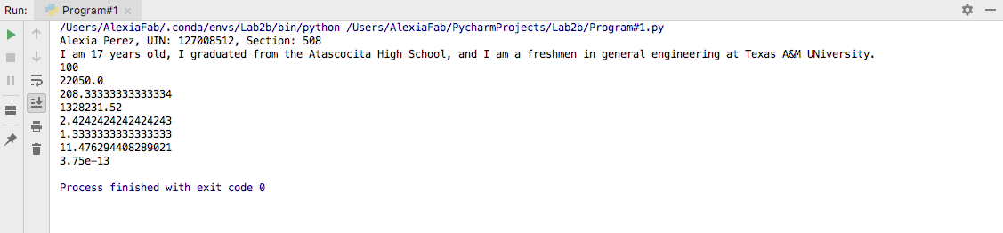

**Program 2 [42 points]:**

In the earlier team project, your team put together a program that interpolated between two values. This was a one dimensional (1D) interpolation, since you were interpolating only a single value, the distance on the track. You are now going to extend that program to one that will linearly interpolate between two points in 3D for air craft. (Comment: you should use the same linear interpolation formula 3 times: for x, for y, and for z variables as functions of time)

1. **[15 points]** Write a program that will take two observed 3D positions at two points in time, and then will calculate the 3D position at a third point in time. You should output the x, y, and z values for that position on separate lines. Begin by identifying the variables you will use, the names for those variables, and the computations that should occur for those variables. Then, write a program that will output the 3D position of the interpolated point on 3 separate lines. Save this program as Program2a.

For this initial program, you can use the following data values (x,y,z):

At time 13, observed position was as (1, 3, 7)

At time 84, observed position was (23, -5, 10)

You want to find the position at time 50

**Put your code/output here:**

*# By submitting this assignment, I agree to the following:  
# “Aggies do not lie, cheat, or steal, or tolerate those who do”  
# “I have not given or received any unauthorized aid on this assignment”  
#  
# Name: ALEXIA PEREZ  
# Section: 508  
# Assignment: LAB 2B  
# Date: 06-09-2018***import** numpy  
**from** math **import** *  
  
*#In this problem we will be calculating the position between two given points  
#at any specific moment in time within a given interval.  
  
#initial time = Ta*Ta=13  
*#initial position = Xa*Xa=(1)  
*#final time = Tb*Tb=84  
*#final position = Xb*Xb=(23)  
*#desired time = t*t=50  
*#desired position = x*x = (Xa+((t-Ta)*(Xb-Xa)/(Tb-Ta)))  
print(**"At time"**)  
print(t)  
print(**"the air craft's position in the x-axis will be"**)  
print(x)  
  
  
*#Repeat process to find y-axis coordinate  
  
  
#initial time = Ta*Ta=13  
*#initial position = Ya*Ya=(3)  
*#final time = Tb*Tb=84  
*#final position = Yb*Yb=(-5)  
*#desired time = t*t=50  
*#desired position = y*y = (Ya+((t-Ta)*(Yb-Ya)/(Tb-Ta)))  
print(**"At time"**)  
print(t)  
print(**"the air craft's position in the y-axis will be"**)  
print(y)  
  
  
*#Repeat once again to find z-axis coordinate  
  
  
#initial time = Ta*Ta=13  
*#initial position = Za*Za=(7)  
*#final time = Tb*Tb=84  
*#final position = Zb*Zb=(10)  
*#desired time = t*t=50  
*#desired position = z*z = (Za+((t-Ta)*(Zb-Za)/(Tb-Ta)))  
print(**"At time"**)  
print(t)  
print(**"the air craft's position in the z-axis will be"**)  
print(z)  
  
print (**"Therefore, the coordinates for the air craft at that time will be:"**)  
print(x,y,z)

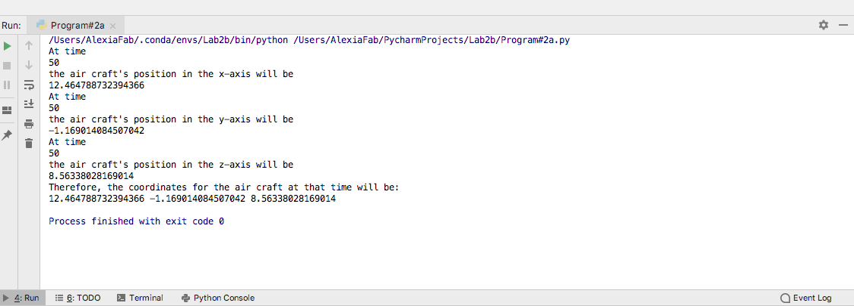

1. **[12 points]** Now, copy Program2a into a new program, Program2b. You are going to modify the program in the following ways:
   1. When outputting the position, follow the output by a line of dashes (“------------------“).
   2. Instead of just computing the interpolation at one point and printing the result, you will now compute it at 5 points. Copy the portion of the code (cut and paste the code) that is needed to recompute interpolation 5 times. You should now interpolate at the times in increments of 1 unit, starting at time 50 (i.e. at times 50, 51, 52, 53, 54), outputting the result each time. The line of dashes will separate each computation.
      1. Note: later we will see how we can do this more efficiently, without cutting-and-pasting code, but for now, cut-and-paste is fine.

**Put your Program2b code/output here:**

*# By submitting this assignment, I agree to the following:  
# “Aggies do not lie, cheat, or steal, or tolerate those who do”  
# “I have not given or received any unauthorized aid on this assignment”  
#  
# Name: ALEXIA PEREZ  
# Section: 508  
# Assignment: LAB 2B  
# Date: 06-09-2018***import** numpy  
**from** math **import** *  
  
*#In this problem we will be calculating the position between two given points  
#at any specific moment in time within a given interval.  
  
#initial time = Ta*Ta=13  
*#initial position = Xa*Xa=(1)  
*#final time = Tb*Tb=84  
*#final position = Xb*Xb=(23)  
*#desired time = t*t=50  
*#desired position = x*x = (Xa+((t-Ta)*(Xb-Xa)/(Tb-Ta)))  
print(**"At time"**)  
print(t)  
print(**"the air craft's position in the x-axis will be"**)  
print(x)  
  
  
*#Repeat process to find y-axis coordinate  
  
  
#initial time = Ta*Ta=13  
*#initial position = Ya*Ya=(3)  
*#final time = Tb*Tb=84  
*#final position = Yb*Yb=(-5)  
*#desired time = t*t=50  
*#desired position = y*y = (Ya+((t-Ta)*(Yb-Ya)/(Tb-Ta)))  
print(**"the air craft's position in the y-axis will be"**)  
print(y)  
  
  
*#Repeat once again to find z-axis coordinate  
  
  
#initial time = Ta*Ta=13  
*#initial position = Za*Za=(7)  
*#final time = Tb*Tb=84  
*#final position = Zb*Zb=(10)  
*#desired time = t*t=50  
*#desired position = z*z = (Za+((t-Ta)*(Zb-Za)/(Tb-Ta)))  
  
print(**"and the air craft's position in the z-axis will be"**)  
print(z)  
  
print (**"Therefore, the coordinates for the air craft at that time will be:"**)  
print(x,y,z)  
print (**"------------------"**)  
  
  
*#initial time = Ta*Ta=13  
*#initial position = Xa*Xa=(1)  
*#final time = Tb*Tb=84  
*#final position = Xb*Xb=(23)  
*#desired time = t*t=51  
*#desired position = x*x = (Xa+((t-Ta)*(Xb-Xa)/(Tb-Ta)))  
print(**"At time"**)  
print(t)  
print(**"the air craft's position in the x-axis will be"**)  
print(x)  
  
  
*#Repeat process to find y-axis coordinate  
  
  
#initial time = Ta*Ta=13  
*#initial position = Ya*Ya=(3)  
*#final time = Tb*Tb=84  
*#final position = Yb*Yb=(-5)  
*#desired time = t*t=51  
*#desired position = y*y = (Ya+((t-Ta)*(Yb-Ya)/(Tb-Ta)))  
print(**"the air craft's position in the y-axis will be"**)  
print(y)  
  
  
*#Repeat once again to find z-axis coordinate  
  
  
#initial time = Ta*Ta=13  
*#initial position = Za*Za=(7)  
*#final time = Tb*Tb=84  
*#final position = Zb*Zb=(10)  
*#desired time = t*t=51  
*#desired position = z*z = (Za+((t-Ta)*(Zb-Za)/(Tb-Ta)))  
  
print(**"and the air craft's position in the z-axis will be"**)  
print(z)  
  
print (**"Therefore, the coordinates for the air craft at that time will be:"**)  
print(x,y,z)  
print (**"------------------"**)  
  
  
*#initial time = Ta*Ta=13  
*#initial position = Xa*Xa=(1)  
*#final time = Tb*Tb=84  
*#final position = Xb*Xb=(23)  
*#desired time = t*t=52  
*#desired position = x*x = (Xa+((t-Ta)*(Xb-Xa)/(Tb-Ta)))  
print(**"At time"**)  
print(t)  
print(**"the air craft's position in the x-axis will be"**)  
print(x)  
  
  
*#Repeat process to find y-axis coordinate  
  
  
#initial time = Ta*Ta=13  
*#initial position = Ya*Ya=(3)  
*#final time = Tb*Tb=84  
*#final position = Yb*Yb=(-5)  
*#desired time = t*t=52  
*#desired position = y*y = (Ya+((t-Ta)*(Yb-Ya)/(Tb-Ta)))  
print(**"the air craft's position in the y-axis will be"**)  
print(y)  
  
  
*#Repeat once again to find z-axis coordinate  
  
  
#initial time = Ta*Ta=13  
*#initial position = Za*Za=(7)  
*#final time = Tb*Tb=84  
*#final position = Zb*Zb=(10)  
*#desired time = t*t=52  
*#desired position = z*z = (Za+((t-Ta)*(Zb-Za)/(Tb-Ta)))  
  
print(**"and the air craft's position in the z-axis will be"**)  
print(z)  
  
print (**"Therefore, the coordinates for the air craft at that time will be:"**)  
print(x,y,z)  
print (**"------------------"**)  
  
  
*#initial time = Ta*Ta=13  
*#initial position = Xa*Xa=(1)  
*#final time = Tb*Tb=84  
*#final position = Xb*Xb=(23)  
*#desired time = t*t=53  
*#desired position = x*x = (Xa+((t-Ta)*(Xb-Xa)/(Tb-Ta)))  
print(**"At time"**)  
print(t)  
print(**"the air craft's position in the x-axis will be"**)  
print(x)  
  
  
*#Repeat process to find y-axis coordinate  
  
  
#initial time = Ta*Ta=13  
*#initial position = Ya*Ya=(3)  
*#final time = Tb*Tb=84  
*#final position = Yb*Yb=(-5)  
*#desired time = t*t=53  
*#desired position = y*y = (Ya+((t-Ta)*(Yb-Ya)/(Tb-Ta)))  
print(**"the air craft's position in the y-axis will be"**)  
print(y)  
  
  
*#Repeat once again to find z-axis coordinate  
  
  
#initial time = Ta*Ta=13  
*#initial position = Za*Za=(7)  
*#final time = Tb*Tb=84  
*#final position = Zb*Zb=(10)  
*#desired time = t*t=53  
*#desired position = z*z = (Za+((t-Ta)*(Zb-Za)/(Tb-Ta)))  
  
print(**"and the air craft's position in the z-axis will be"**)  
print(z)  
  
print (**"Therefore, the coordinates for the air craft at that time will be:"**)  
print(x,y,z)  
print (**"------------------"**)  
  
  
*#initial time = Ta*Ta=13  
*#initial position = Xa*Xa=(1)  
*#final time = Tb*Tb=84  
*#final position = Xb*Xb=(23)  
*#desired time = t*t=54  
*#desired position = x*x = (Xa+((t-Ta)*(Xb-Xa)/(Tb-Ta)))  
print(**"At time"**)  
print(t)  
print(**"the air craft's position in the x-axis will be"**)  
print(x)  
  
  
*#Repeat process to find y-axis coordinate  
  
  
#initial time = Ta*Ta=13  
*#initial position = Ya*Ya=(3)  
*#final time = Tb*Tb=84  
*#final position = Yb*Yb=(-5)  
*#desired time = t*t=54  
*#desired position = y*y = (Ya+((t-Ta)*(Yb-Ya)/(Tb-Ta)))  
print(**"the air craft's position in the y-axis will be"**)  
print(y)  
  
  
*#Repeat once again to find z-axis coordinate  
  
  
#initial time = Ta*Ta=13  
*#initial position = Za*Za=(7)  
*#final time = Tb*Tb=84  
*#final position = Zb*Zb=(10)  
*#desired time = t*t=54  
*#desired position = z*z = (Za+((t-Ta)*(Zb-Za)/(Tb-Ta)))  
  
print(**"and the air craft's position in the z-axis will be"**)  
print(z)  
  
print (**"Therefore, the coordinates for the air craft at that time will be:"**)  
print(x,y,z)  
print (**"------------------"**)

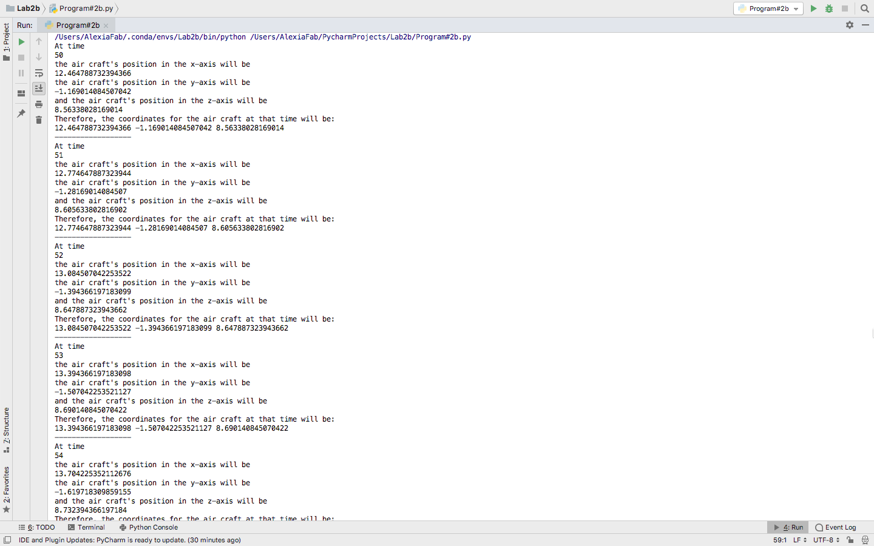

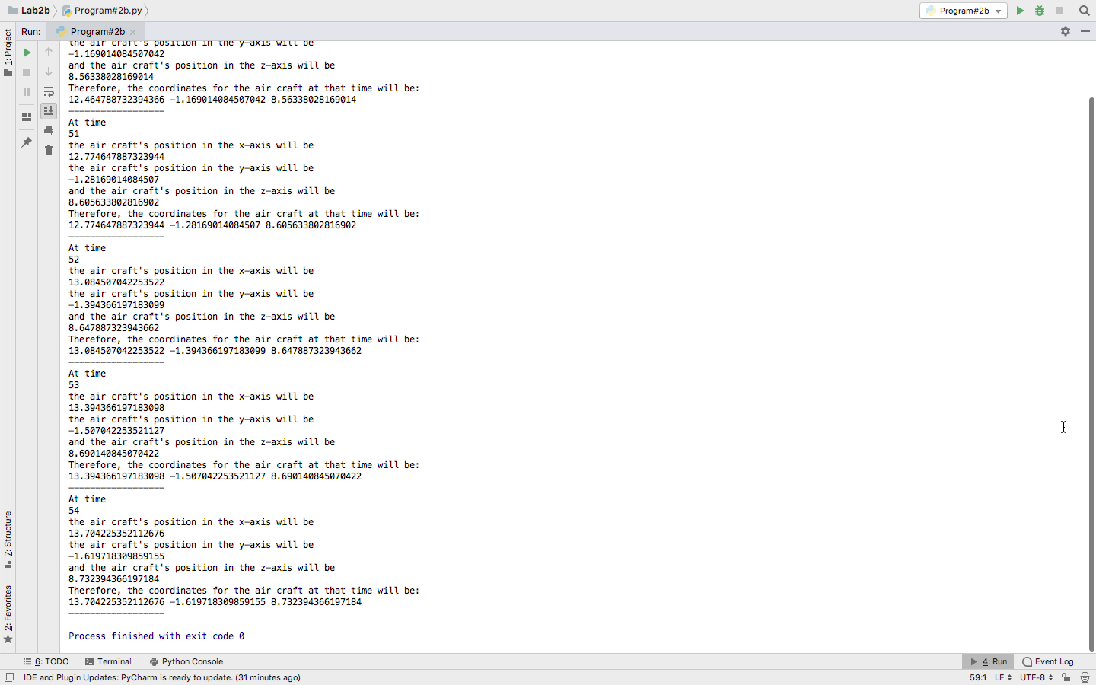

1. **[15 points]** Finally, copy Program2b into a new program, Program2c. Modify the program in the following way:
   1. Create variables for the starting time of interpolation, and the ending time of interpolation.
   2. You should display the results from interpolating at 5 points, evenly spaced from the beginning time to the ending time, inclusive.
   3. Experiment on your own with assigning different values to those variables verify that you are in fact interpolating correctly from one point to another.
   4. For the version you save and turn in, show an interpolation **from time 20 to 50**.

**Put your Program2c code/output here:**

*# By submitting this assignment, I agree to the following:  
# “Aggies do not lie, cheat, or steal, or tolerate those who do”  
# “I have not given or received any unauthorized aid on this assignment”  
#  
# Name: ALEXIA PEREZ  
# Section: 508  
# Assignment: LAB 2B  
# Date: 06-09-2018***import** numpy  
**from** math **import** *  
  
*#In this problem we will be calculating the position between two given points  
#at any specific moment in time within a given interval.  
  
#initial time = Ta*Ta=0  
*#initial position = Xa*Xa=(1)  
*#final time = Tb*Tb=84  
*#final position = Xb*Xb=(23)  
*#desired time = t*t=20  
*#desired position = x*x = (Xa+((t-Ta)*(Xb-Xa)/(Tb-Ta)))  
print(**"At time"**)  
print(t)  
print(**"the air craft's position in the x-axis will be"**)  
print(x)  
  
  
*#Repeat process to find y-axis coordinate  
  
  
#initial time = Ta*Ta=0  
*#initial position = Ya*Ya=(3)  
*#final time = Tb*Tb=84  
*#final position = Yb*Yb=(-5)  
*#desired time = t*t=20  
*#desired position = y*y = (Ya+((t-Ta)*(Yb-Ya)/(Tb-Ta)))  
print(**"the air craft's position in the y-axis will be"**)  
print(y)  
  
  
*#Repeat once again to find z-axis coordinate  
  
  
#initial time = Ta*Ta=0  
*#initial position = Za*Za=(7)  
*#final time = Tb*Tb=84  
*#final position = Zb*Zb=(10)  
*#desired time = t*t=20  
*#desired position = z*z = (Za+((t-Ta)*(Zb-Za)/(Tb-Ta)))  
  
print(**"and the air craft's position in the z-axis will be"**)  
print(z)  
  
print (**"Therefore, the coordinates for the air craft at that time will be:"**)  
print(x,y,z)  
print (**"------------------"**)  
  
  
*#initial time = Ta*Ta=0  
*#initial position = Xa*Xa=(1)  
*#final time = Tb*Tb=84  
*#final position = Xb*Xb=(23)  
*#desired time = t*t=27.5  
*#desired position = x*x = (Xa+((t-Ta)*(Xb-Xa)/(Tb-Ta)))  
print(**"At time"**)  
print(t)  
print(**"the air craft's position in the x-axis will be"**)  
print(x)  
  
  
*#Repeat process to find y-axis coordinate  
  
  
#initial time = Ta*Ta=0  
*#initial position = Ya*Ya=(3)  
*#final time = Tb*Tb=84  
*#final position = Yb*Yb=(-5)  
*#desired time = t*t=27.5  
*#desired position = y*y = (Ya+((t-Ta)*(Yb-Ya)/(Tb-Ta)))  
print(**"the air craft's position in the y-axis will be"**)  
print(y)  
  
  
*#Repeat once again to find z-axis coordinate  
  
  
#initial time = Ta*Ta=0  
*#initial position = Za*Za=(7)  
*#final time = Tb*Tb=84  
*#final position = Zb*Zb=(10)  
*#desired time = t*t=27.5  
*#desired position = z*z = (Za+((t-Ta)*(Zb-Za)/(Tb-Ta)))  
  
print(**"and the air craft's position in the z-axis will be"**)  
print(z)  
  
print (**"Therefore, the coordinates for the air craft at that time will be:"**)  
print(x,y,z)  
print (**"------------------"**)  
  
  
*#initial time = Ta*Ta=0  
*#initial position = Xa*Xa=(1)  
*#final time = Tb*Tb=84  
*#final position = Xb*Xb=(23)  
*#desired time = t*t=35  
*#desired position = x*x = (Xa+((t-Ta)*(Xb-Xa)/(Tb-Ta)))  
print(**"At time"**)  
print(t)  
print(**"the air craft's position in the x-axis will be"**)  
print(x)  
  
  
*#Repeat process to find y-axis coordinate  
  
  
#initial time = Ta*Ta=0  
*#initial position = Ya*Ya=(3)  
*#final time = Tb*Tb=84  
*#final position = Yb*Yb=(-5)  
*#desired time = t*t=35  
*#desired position = y*y = (Ya+((t-Ta)*(Yb-Ya)/(Tb-Ta)))  
print(**"the air craft's position in the y-axis will be"**)  
print(y)  
  
  
*#Repeat once again to find z-axis coordinate  
  
  
#initial time = Ta*Ta=0  
*#initial position = Za*Za=(7)  
*#final time = Tb*Tb=84  
*#final position = Zb*Zb=(10)  
*#desired time = t*t=35  
*#desired position = z*z = (Za+((t-Ta)*(Zb-Za)/(Tb-Ta)))  
  
print(**"and the air craft's position in the z-axis will be"**)  
print(z)  
  
print (**"Therefore, the coordinates for the air craft at that time will be:"**)  
print(x,y,z)  
print (**"------------------"**)  
  
  
*#initial time = Ta*Ta=0  
*#initial position = Xa*Xa=(1)  
*#final time = Tb*Tb=84  
*#final position = Xb*Xb=(23)  
*#desired time = t*t=42.5  
*#desired position = x*x = (Xa+((t-Ta)*(Xb-Xa)/(Tb-Ta)))  
print(**"At time"**)  
print(t)  
print(**"the air craft's position in the x-axis will be"**)  
print(x)  
  
  
*#Repeat process to find y-axis coordinate  
  
  
#initial time = Ta*Ta=0  
*#initial position = Ya*Ya=(3)  
*#final time = Tb*Tb=84  
*#final position = Yb*Yb=(-5)  
*#desired time = t*t=42.5  
*#desired position = y*y = (Ya+((t-Ta)*(Yb-Ya)/(Tb-Ta)))  
print(**"the air craft's position in the y-axis will be"**)  
print(y)  
  
  
*#Repeat once again to find z-axis coordinate  
  
  
#initial time = Ta*Ta=0  
*#initial position = Za*Za=(7)  
*#final time = Tb*Tb=84  
*#final position = Zb*Zb=(10)  
*#desired time = t*t=42.5  
*#desired position = z*z = (Za+((t-Ta)*(Zb-Za)/(Tb-Ta)))  
  
print(**"and the air craft's position in the z-axis will be"**)  
print(z)  
  
print (**"Therefore, the coordinates for the air craft at that time will be:"**)  
print(x,y,z)  
print (**"------------------"**)  
  
  
*#initial time = Ta*Ta=0  
*#initial position = Xa*Xa=(1)  
*#final time = Tb*Tb=84  
*#final position = Xb*Xb=(23)  
*#desired time = t*t=50  
*#desired position = x*x = (Xa+((t-Ta)*(Xb-Xa)/(Tb-Ta)))  
print(**"At time"**)  
print(t)  
print(**"the air craft's position in the x-axis will be"**)  
print(x)  
  
  
*#Repeat process to find y-axis coordinate  
  
  
#initial time = Ta*Ta=0  
*#initial position = Ya*Ya=(3)  
*#final time = Tb*Tb=84  
*#final position = Yb*Yb=(-5)  
*#desired time = t*t=50  
*#desired position = y*y = (Ya+((t-Ta)*(Yb-Ya)/(Tb-Ta)))  
print(**"the air craft's position in the y-axis will be"**)  
print(y)  
  
  
*#Repeat once again to find z-axis coordinate  
  
  
#initial time = Ta*Ta=0  
*#initial position = Za*Za=(7)  
*#final time = Tb*Tb=84  
*#final position = Zb*Zb=(10)  
*#desired time = t*t=50  
*#desired position = z*z = (Za+((t-Ta)*(Zb-Za)/(Tb-Ta)))  
  
print(**"and the air craft's position in the z-axis will be"**)  
print(z)  
  
print (**"Therefore, the coordinates for the air craft at that time will be:"**)  
print(x,y,z)  
print (**"------------------"**)

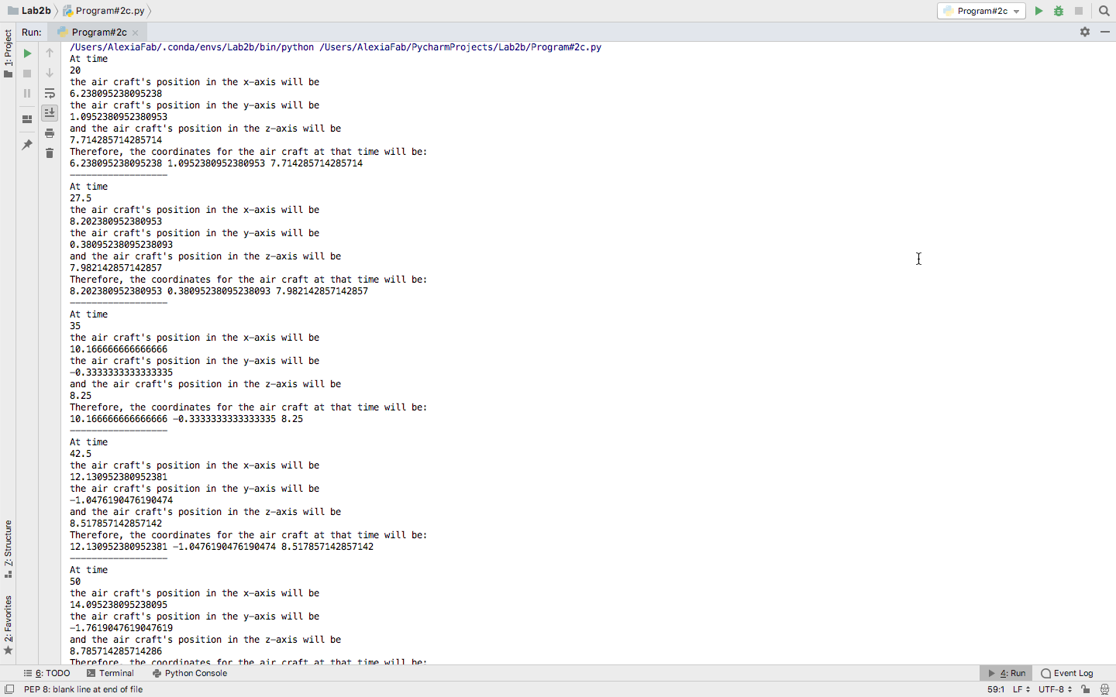

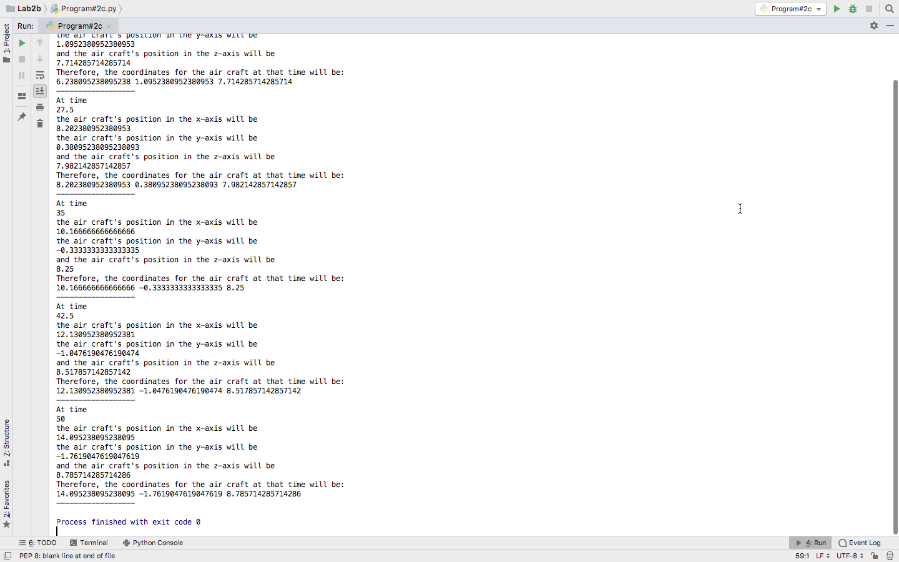

**Program 3 [34 points]:**

You are to create a program consisting of only the following lines of code. You may put these lines of code in any order, and can re-use the lines as frequently as you wish to. There will be more than one way to achieve the result – try to see if you can obtain the output using fewer lines of code.

x = 1

y = 10

z = 0

x = y

x += 1

y += x

y *= x

z += x

z += y

print(z)

Your program should print out the following, when run:

[3 points] 1

[3 points] 3

[3 points] 11

[4 points] 28

[7 points] 123

[7 points] 100000000000000000000000000000000 *[Note: that’s 1032]*

[7 points] 4321

**Put your Program3 code/output here:**

*# By submitting this assignment, I agree to the following:  
# “Aggies do not lie, cheat, or steal, or tolerate those who do”  
# “I have not given or received any unauthorized aid on this assignment”  
#  
# Name: ALEXIA PEREZ  
# Section: 508  
# Assignment: LAB 2B  
# Date: 06-09-2018***import** numpy  
**from** math **import**\*  
x=1  
z=0  
z += x  
print(z)  
print (**"------------------"**)  
  
x += 1  
z += x  
print(z)  
print (**"------------------"**)  
  
y=10  
x=1  
y += x  
z=0  
z += y  
print(z)  
print (**"------------------"**)  
  
x=1  
y += x  
y += x  
y += x  
x += 1  
y *= x  
z=0  
z += y  
print(z)  
print (**"------------------"**)  
  
y=10  
x = y  
y *= x  
z=0  
z += x  
z += x  
x =1  
x += 1  
x += 1  
z += x  
z += y  
print(z)  
print (**"------------------"**)  
  
x=y  
y *= x  
x=y  
y *= x  
x=y  
y *= x  
x=y  
y *= x  
x=y  
z=0  
z += x  
print(z)  
print (**"------------------"**)  
  
y=10  
x=y  
y *= x  
x=1  
x += 1  
x += 1  
y *= x  
x=y  
y=10  
z=0  
z += y  
z += y  
z += x  
x=1  
z += x  
x=y  
y *= x  
y *= x  
x=1  
x += 1  
x += 1  
x += 1  
y *= x  
z += y  
print(z)

**Output:**

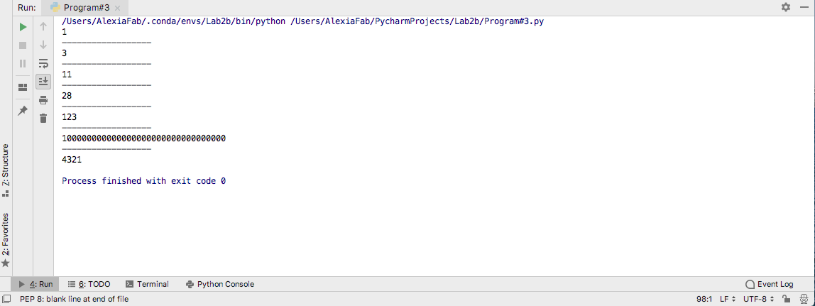

**[5] Extra points**

**From the lab2a**

**Original statement**

You arrive at a racetrack and observe a car moving around a track at what appears to be a constant rate of speed. You would like to be able to predict where the car is at any point in time. To do this, you take a measurement of how far around the track the vehicle has traveled at two points in time. Assume that the track is marked so that you can determine position very precisely. You note the time of this first position measurement. A short while later (before the vehicle has passed the “starting” point on the track), you take a second measurement for how far around the track the vehicle has traveled, again noting the time.

Now, assume that you’d like to reconstruct the position of the vehicle at any time between the first measurement and the second. Since you assume the vehicle is moving at constant speed, this calculation can be found precisely by linear interpolation.

You asked to write a short program that performs linear interpolation to track position of the car. Explain why the formula L=vt did not work for linear interpolation. Here is the scenario:

L1=50m t1=30sec

L2 =615m t2 =45sec

<v>=(615-50)/(45-30)=37m/sec

L(t=37sec) = <v>*t=37*37=1394 m – which is beyond L2= 615m, so it is incorrect.

**Find mistake**